Supplementary information
Morphological Attributes Govern CO₂ Reduction on Mesoporous Carbon Nanosphere with Embedded Axial Co-N₅ Sites

Youzhi Li¹, Bo Wei², Zhongjian Li¹*, Lei Fan¹, Qike Jiang³, Lecheng Lei¹, Ruifeng Zhang²*, Yingying Lu¹*

Supplementary Figure 1. EDX mappings of C, N, Oand Si elements of SiO₂@PANI and EDX spectrum

Supplementary Figure 2. (a)-(c)A typical TEM image of SiO₂@PANI

Supplementary Figure 3. (a)-(b)A typical SEM image of SiO₂@PANI

Supplementary Figure 4. (a)-(b) Low-magnification TEM images of Co-MSPNC

Supplementary Figure 5. (a) High-magnification TEM images of Co-MSPNC and (b) SAED images of Co-MSPNC

Supplementary Figure 6. (a) Schematic illustration of the synthesis process of Co-MSPNC and (b) different measured positions of thickness on HAADF-STEM image of Co-MSPNC-27.

Supplementary Figure 7. Repeated measurement of EDX mappings of C, N, and Co elements of Co-MSPNC-27

Supplementary Figure 8. XRD patterns of Co-MSPNC

Supplementary Figure 9. Raman Shift of Co-MSPNC.

Supplementary Figure 10. XPS survey spectrum of Co-MSPNC-27(a), High resolution XPS Si 2p (b), Co 2p (c)(d) spectra of Co-MSPNC-27

Supplementary Figure 11. Polarization curves of (a) Co-MSPNC-7, (b) Co-MSPNC-43, and (c) Co-MSPNC-27 in Ar-saturated (dash lines) and CO₂-saturated (solid lines) 0.5 M KHCO₃ solution.

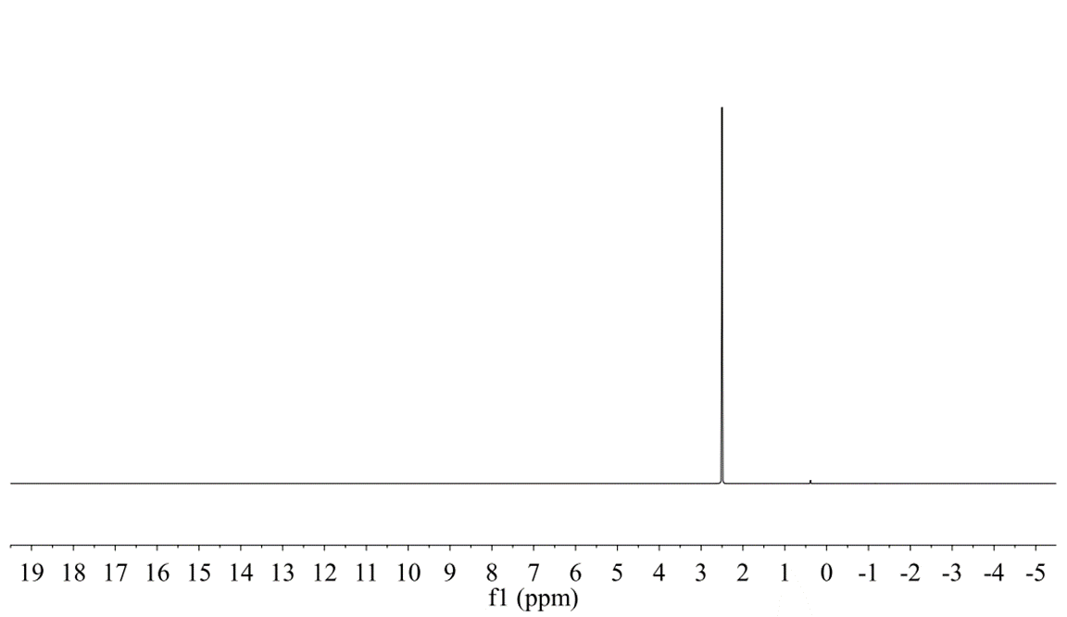
Supplementary Figure 12. NMR spectrum of electrolyte after electrochemical measurement

Supplementary Figure 13. Nyquist plots for Co-MSPNC-7, Co-MSPNC-43 and Co-MSPNC-27

Supplementary Figure 14. ECSAs of (a) Co-MSPNC-7, (b) Co-MSPNC-43 and (c) Co-MSPNC-27 at various scan rates of 5, 10, 20, 40, 60, 80, 100mV s⁻¹

Supplementary Figure 15. (a) A typical HRTEM, (b) HAADF-STEM image, (c) XRD pattern and (d) Raman shift of Co-MSPNC-27 after performance testing and stability test. (e) Co K-edge k³-weighted EXAFS spectra, (f) Fitting curves of the FT-EXAFS spectra for Co-MSPNC-27 after performance testing and stability test.

Supplementary Figure 16. The calculated total energy of Co-N₄ and Co-N₅ structure.

Supplementary Figure 17. The free energy of each intermediate state on the Co atom and N atom in Co-MSPNC-27.

Supplementary Figure 18. Enlarged Co K-edge XANES spectra.

Supplementary Table 1. EXAFS fitting parameters at the Co K-edge for various samples
Sample | Shell | N ª | R (Å) ^{b} | σ² (Å2·10⁻³) ^{c} | ΔE0 (eV) ^{d} | R factor (%)
CoO | Co-O | 4 | 1.95 | 1.7 | 7.4 | 1.3
Co3O4 | Co-O | 4 | 1.91 | 1.78 | 3.2 | 1.2
Cofoil | Co-Co | 9 | 2.29 | 4.49 | 5.6 | 0.9
CoPc | Co-N | 4 | 1.89 | 2.33 | 3.2 | 0.3
Co-MSPNC | Co-N | 5.3 | 2.01 | 13.18 | -4.689 | 0.96

ª N: coordination numbers; ^{b} R: bond distance; ^{c} σ²: Debye-Waller factors; ^{d} ΔE₀: the inner potential correction. R factor: goodness of fit. Ѕ02 was set as 0.93 for Co-N, which was obtained from the experimental EXAFS fit of reference CoPc by fixing CN as the known crystallographic value and was fixed to all the samples.

Supplementary Table 2. Contributions to the free energy from the zero-point energy correction, enthalpic temperature correction, gas correction, entropy, and the calculated total free energy, respectively. The literature entropies taken from NIST are also listed. All values are given in eV.
Gas phase | E_{DFT} | E_{ZPE} | TS | ΔH_{T} | ΔH_{G} | G
CO₂ (g) | -22.95 | 0.31 | 0.67 | 0.10 | 0.13 | -23.08
CO (g) | -14.78 | 0.13 | 0.60 | 0.09 | -0.51 | -15.66
H₂ (g) | -6.83 | 0.27 | 0.41 | 0.09 | -0.06 | -6.95
H₂O (g) | -14.22 | 0.57 | 0.67 | 0.10 | -0.08 | -14.28

Supplementary Table 3. Calculated electronic energy, ZPE, temperature enthalpy correction, and free energy of each CO₂RR intermediate at 0 V (vs. RHE). The calculation of relative free energy uses CO₂(g), H₂(g) and H₂O(l) as the reference states. All values are given in eV.
 | Species | E_{DFT} | E_{ZPE} | ΔH_{T} | G
Co-N₄ | * | -896.30
 | *COOH | -922.51 | 0.51 | 0.11 | -921.89
 | *CO | -911.85 | 0.15 | 0.06 | -911.68
 | *H | -899.56 | 0.16 | 0.01 | -899.35
Co-N₅ | * | -895.09
 | *COOH | -921.70 | 0.62 | 0.11 | -920.98
 | *CO | -910.83 | 0.15 | 0.06 | -910.62
 | *H | -897.88 | 0.18 | 0.01 | -897.69

Supplementary Table 4. The results of energies and magnetic moments convergence test
Cell | E(eV) | mag
2*2*1 | -895.101 | 2
3*3*1 | -895.069 | 2.0036
4*4*1 | -895.093 | 2.0012
5*5*1 | -895.091 | 2.0015
6*6*1 | -895.089 | 2.0028

Supplementary Table5. Unit cell parameters
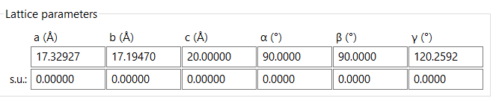

Supplementary Table 6. Comparison of TOF with other Co-based materials reported
Material | F.E._{CO} | E /eV | TOF/h⁻¹ | Ref.
CoFPc | 93% | -0.8 | 5796 | ACS Catal. 2016, 6, 3092-3095
CoPPCl/CNT-OH | 90% | -0.65 | 7560 | Angew. Chem. Int. Ed. 2019, 58, 6595-6599,
CoPPc/CNT | ~90% | -0.5 | 4900 | Chem 2017,3, 652-664
Co-N4 | 82% | -0.8 | 1455 | Appl. Catal. B. 2019,240, 234-240
Al2(OH)2TCPP-  Co | 76% | -0.7 | ~200 | J. Am. Chem. Soc. 2015,137, 14129-14135
CoPc-CN/CNT | 88% | -0.46 | 5040 | Nat. Commun. 2017 8, 14675
NapCo@SNG | 95% | -0.74 | 1620 | Angew. Chem. Int. Ed.2019, 58, 13532-13539,
Co−N5/HNPCSs | 90% | -0.73 | 480.2 | J. Am. Chem. Soc. 2018,140, 4218-4221
Co-MSPNC-27 | 96% | -0.9 | 10118 | This work

