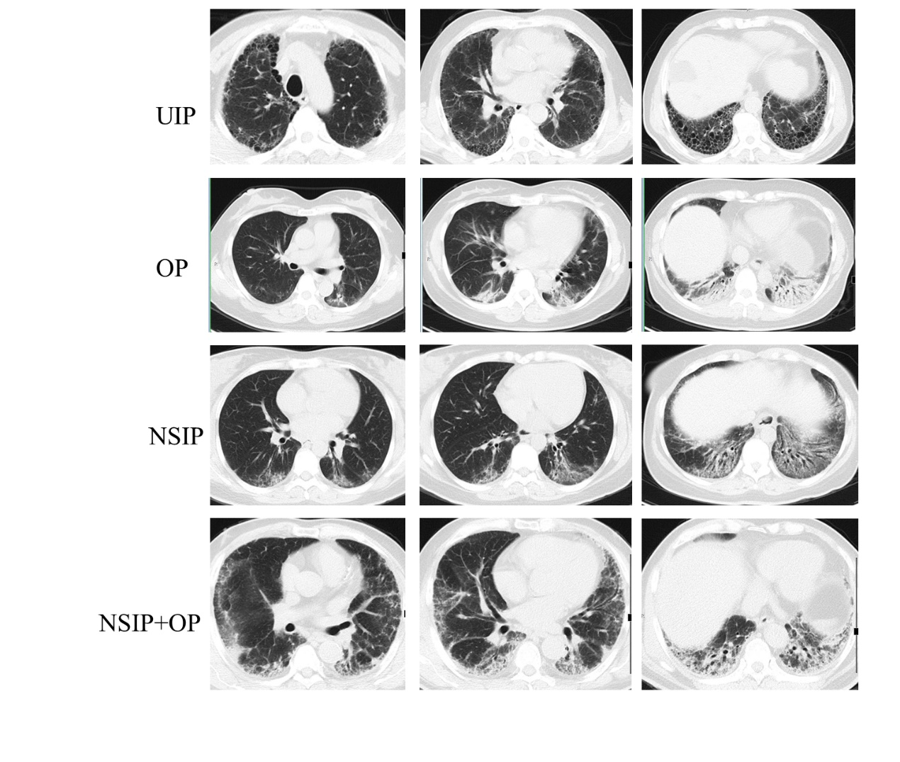

Figure S1. Typical chest CT images of the four pathological types.
Patients with typical CT lesions of UIP, NSIP, OP, and NSIP+OP were selected from the cohort. Three different layers of CT images from these patients are displayed.

