SUPPLIMENTARY FILE
OF
A VALIDATION ON COVID19 COMMUNITY SPREADING: PROBABILISTIC APPROACH

____________________________________________________________________________

Citation (bibtex)
@article{DATTA_2020, doi = {10.31219/osf.io/3f9ct}, url = {https://doi.org/10.31219%2Fosf.io%2F3f9ct}, year = 2020, month = {apr}, publisher = {Center for Open Science}, author = {JAYDIP DATTA}, title = {Divergence {\&}amp$\mathsemicolon$ Probability Density : A Hypothesis} }

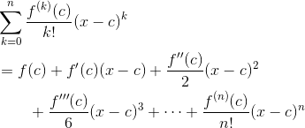
Figure – I

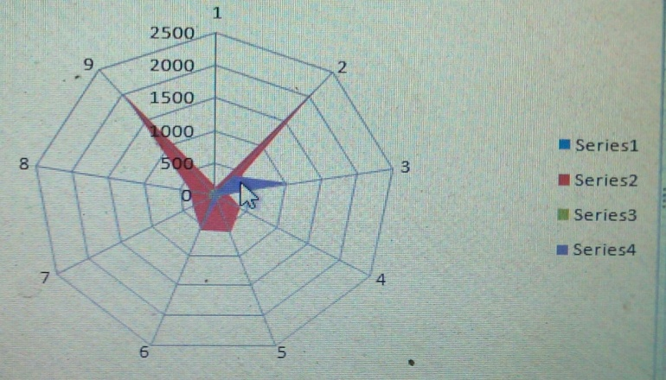

Figure – II

Link Data - https://zenodo.org/record/4492328

