Appendix

Table S1: Six simulation scenarios for studying power of testing treatment effect of intervention B using a constant correlation parameter. In the six scenarios, we vary number of clusters in each sequence ($I$), different coefficients of variation for cluster sizes ($cv$), different ICCs ($α$), different baseline event rates (baseline), different designs in Figure 2 (Design), and varying effect sizes (1-effect size), respectively.
Scenario | $$I$$ | $$cv$$ | $$α$$ | baseline | Design (Figure 2) | 1- effect size
1 | 12,18,36,60 | 0.4 | 0.2 | 0.2 | 1B | ${ e}^{θ_{2}}=0.7$, ${ e}^{θ_{1}}=0.75$
2 | 18 | (0,1,0.1) | 0.2 | 0.2 | 1B
3 | 18 | 0.4 | (0.01,0.1,0.02) | 0.2 | 1B
4 | 18 | 0.4 | 0.2 | (0.1,0.5,0.1) | 1B
5 | 24 | 0.4 | 0.2 | 0.2 | 2A-2F
6 | 18 | 0.4 | 0.2 | 0.2 | 1B | $e^{θ_{2}}=\left(0.4,0.8,0.05\right)$, $e^{θ_{1}}=0.75$

Table S2: Six simulation scenarios for studying power of testing treatment effect of intervention B using two correlation parameters in the common block exchangeable correlation structure ($α_{0}, α_{1}$).
Scenario | $$I$$ | $$cv$$ | $$(α_{0}, α_{1})$$ | baseline | Design (Figure 2) | 1- effect size
1 | 12,18,36,60 | 0.4 | (0.03,0.015) | 0.2 | 1B | ${ e}^{θ_{2}}=0.7$, ${ e}^{θ_{1}}=0.75$
2 | 18 | (0,1,0.1) | (0.03,0.015) | 0.2 | 1B
3 | 18 | 0.4 | $α_{0}$=0.03,0.06,0.1$α_{1}$=(0.01,$α_{0}$,0.01) | 0.2 | 1B
4 | 18 | 0.4 | (0.03,0.015) | (0.1,0.5,0.1) | 1B
5 | 24 | 0.4 | (0.03,0.015) | 0.2 | 2A-2F
6 | 18 | 0.4 | (0.03,0.015) | 0.2 | 1B | $e^{θ_{2}}=\left(0.4,0.8,0.05\right)$, $e^{θ_{1}}=0.75$

Table S3: 19 combinations of the two correlation parameters for simulations using the common block exchangeable correlation structure ($α_{0}, α_{1}$).
Combination index of correlations | $$α_{0}$$ | $$α_{1}$$
1 | 0.03 | 0.01
2 |  | 0.02
3 |  | 0.03
4 | 0.06 | 0.01
5 |  | 0.02
6 |  | 0.03
7 |  | 0.04
8 |  | 0.05
9 |  | 0.06
10 | 0.1 | 0.01
11 |  | 0.02
12 |  | 0.03
13 |  | 0.04
14 |  | 0.05
15 |  | 0.06
16 |  | 0.07
17 |  | 0.08
18 |  | 0.09
19 |  | 0.1

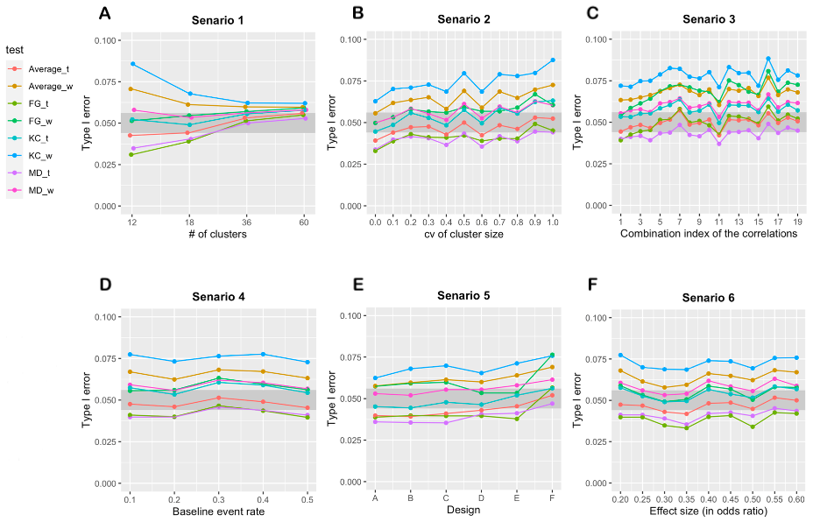

Figure S1 A-F. The empirical type I error rate for testing the treatment effect of B in six different scenarios in Table 2 using the misspecified exchangeable working correlation structure. The gray band in each plot represents 95% confidence interval of the nominal type I error rate 0.05.

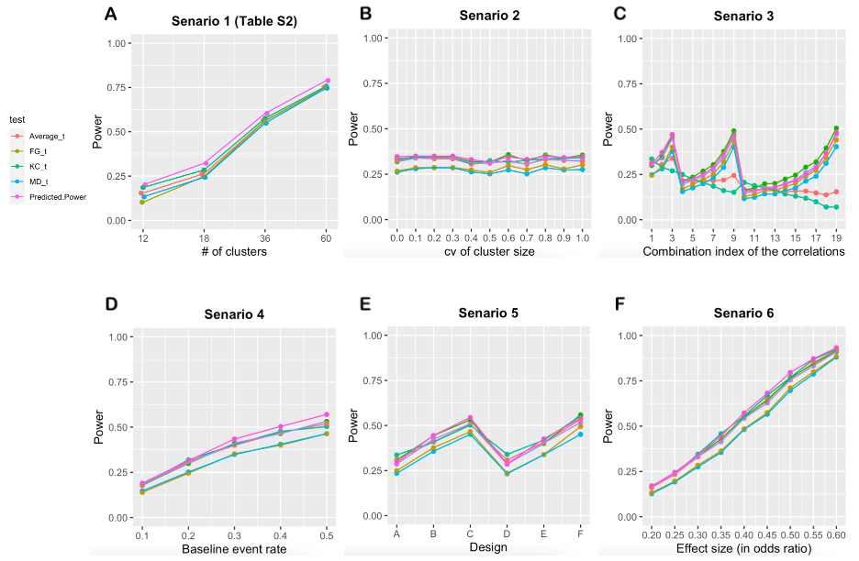
Figure S2 A-F. The statistical power for testing non-zero treatment effect of B in six different scenarios in Table S1 using the true working correlation structure. The empirical power of the eight tests is shown with the predicted power calculated from equation (5).

