**Supplementary Information for**

**Negative Piezoresistive Effect in a Stretchable Device Based on a Soft Tunneling Barrier**

*Soosang Chae1*, Ivan Fotev2,3, Eva Bittrich1, Won Jin Choi4, Petra Uhlmann1,5, Mathias Schubert,1,6,7 Alexej Pashkin2, Andreas Fery1,3\**

1Leibniz-Institut für Polymerforschung Dresden e.V, Hohe Straße 6, 01069 Dresden, Germany

2Institute of Ion Beam Physics and Materials Research, Helmholtz-Zentrum Dresden-Rossendorf, 01328 Dresden, Germany

3Technische Universität Dresden, 01062 Dresden, Germany

4Departement of Materials Science and Engineering, University of Michigan, Ann Arbor, MI, USA

5Department of Chemistry, University of Nebraska-Lincoln, Lincoln, Nebraska 68588, USA

6Department of Electrical and Computer Engineering, University of Nebraska-Lincoln, Lincoln, Nebraska 68588, USA

7Department of Physics, Chemistry and Biology, (IFM), Linkoping University, 58183 Linkoping, Sweden

**This PDF file includes:**

S1. Fabrication details

S2. FEM modeling of thickness thinning of soft barrier layer

S3. Estimation of initial thickness of intermediate layer

S4. Modulation of initial thickness of the soft barrier layer

Supplementary Figs. S1 to S14

Caption for Supplementary Movie 1.

**Other supplementary materials for this manuscript include the following:**

Movie S1

**S1. Fabrication of high-performance nGF piezoresistive stretchable electrode**

The intermediate layer is the key part determining the nGF behavior of the structure. We also used polydimethylsiloxane (PDMS) because of its intrinsic softness, Poisson’s ratio, and appropriate insulating behavior. Interestingly, the diffusion of low-molecular-weight (low-Mw) PDMS from the PDMS substrate through the first deposited metal layer led to the spontaneous formation of a thin PDMS layer on the surface of the first metal layer. Hence, the PDMS substrate used in the present study not only serves as a substrate but also contributes to the formation of the intermediate tunneling barrier layer as a reservoir. The diffusion process generally takes a few weeks when the sample is kept at atmospheric pressure. To accelerate this process, we induced cracking of the first metal thin film and incubated the sample under high vacuum, which dramatically decreased the diffusion time of the PDMS (for details, see the Methods section). Atomic force microscopy (AFM) characterization (Supplementary Fig. 2) of the sample before and after cracking (i, ii), and vacuum incubation (iii, iv) showed the formation of cracks in the metal film; these cracks provided channels for the molecular diffusion while ensuring complete formation of a low-Mw PDMS layer at the surface of the first metal layer. After the formation of the ultra-thin PDMS film, we deposited the second metal thin film in the same manner as the first metal layer (iv). Finally, a high-angle annular dark-field scanning transmission electron microscopy (HAADF-STEM) image of the interface (white dashed-line box in Fig. 1a) and the energy-dispersive X-ray spectroscopy (EDS) line-profile of Si (*i.e.*, the distinguishable atoms of PDMS) confirmed that the thin PDMS intermediate layer existed between the bilayer metal thin film (Fig. 1b). This approach enables us to readily create an ultrathin soft barrier layer without any chemical modifications or surface treatment, which could lead to unwanted electrical impurities that hinder the unambiguous electrical characterization of the system.

**S2. Theoretical thickness thinning of soft barrier layer by FEM**

Finite-element software (COMSOL 5.5) was used to calculate the theoretical thickness change of the Au/nano PDMS/Au/Bulk PDMS structures, which provided insight into the hyperelastic deformation behavior. The width (and length) of the rectangular structure was 100 nm. Because the model system was thin (30 nm of Au and 12 nm of nano-PDMS), a minimum element size of 2.2 nm was used. As a substrate, 50 nm-thick bulk PDMS was adopted. We enforced a boundary condition on either end of the Au/nano PDMS/Au/bulk PDMS structure: at one end we sweep described displacements in the *y*-axis direction; at the opposite end, we place fixed boundary conditions such that no displacement is allowed at the end. Two elastic models were tested for PDMS formation under elongation: the St. Venant Kirchhoff model and the linear elastic model. The St. Venant Kirchhoff model was found to well fit the experimental results as shown in Fig.S8. Lame parameter λ and µ for PDMS were 6.93 GPa and 0.77 GPa, respectively. [1]

[1] F.E. Hizir et al. Deformation of Stamp Features with Slanted Walls during Microcontact Printing, Proceedings of the 2014 COMSOL Conference in Boston https://www.comsol.jp/paper/download/194581/hizir_paper.pdf

**S3. Measurement of initial thickness of the intermediate barrier layer**

We determined the initial thickness of the intermediate PDMS tunneling barrier by spectroscopic ellipsometry. Compared with the thickness evaluated from the cross-sectional HRTEM image (Fig. 1a), the thickness of the nanometric thin film is modeled as an average value over an area of square centimeters from ellipsometric data, resembling the area used for conductance measurements. However, ellipsometric analysis of the real nGF stretchable electrode was not successful because of the intrinsic softness and low reflectivity of the PDMS substrate and the change in optical constants of the first layer of the metal thin film as a consequence of the diffusion of the low-Mw PDMS. To solve this technical problem, we fabricated model samples on rigid Si/SiO2 wafer substrates and formed the thin PDMS layer via the contact printing method. The method is described as follows: First, a cured PDMS slab similar to that used for the nGF sample was prepared. Second, the PDMS slab was contacted with the SiO2/Si wafer and heated at 80 °C for 2 h. The free PDMS oligomer on the surface of the PDMS slab was transferred to the SiO2/Si surface by the driving force of a concentration gradient. Repeating this contact printing (CP in the horizontal axis of Supplementary Fig. 3) increased the thickness of the thin PDMS layer, as shown in Supplementary Fig.3. The thickness was saturated at 12 nm beyond six contact printing cycles because of the equilibrium in the concentration gradient at the interface, which means that the SiO2/Si surface on the wafer substrate was fully covered by the printed PDMS oligomer.

Regarding the real sample of the nGF stretchable substrate, the free PDMS oligomer, which remained inside the bulk PDMS substrate underneath the first metal layer, diffused out and formed the thin intermediate barrier layer. (A description of the fabrication procedure is provided in the main text and in section S1). The driving force of this spontaneous phenomenon is the reduction of the surface are of the Au thin film because the surface energy of the free oligomer is lower than that of the Au. This reaction continued until the surface was fully covered by free PDMS oligomer, similar to that obtained for the aforementioned model sample. The independency of the saturation point on the type of substrate material was demonstrated by water-contact-angle measurements of contact-printed thin PDMS layers on various types of substrates (Supplementary Fig. 12). Irrespective of the materials, the water contact angles were 103° for 24 h of contact-printing time. On the basis of these results, we assumed that the initial thickness of the intermediate PDMS barrier in the nGF electrode had the same thickness as the thin PDMS layer formed by contact-printing on the model sample.

**S4. Modulation of initial thickness of the soft barrier layer**

The experimental conditions of the diffusion process for the soft PDMS barrier layer can modulate the tendency of the nGF transition of the structure. Maintaining the applied strain during the diffusion process gave rise to an increase in the number of voids in the first metal layer because of the separation of metal domains, which accelerates the diffusion of low-Mw PDMS and leads to the formation of the soft barrier layer with higher thickness. Fig. 6b shows the different strains applied during the diffusion process of the soft layer: 0%, 30%, and 80% of applied strain. Depending on the strain, the samples showed different nGF transition tendencies.

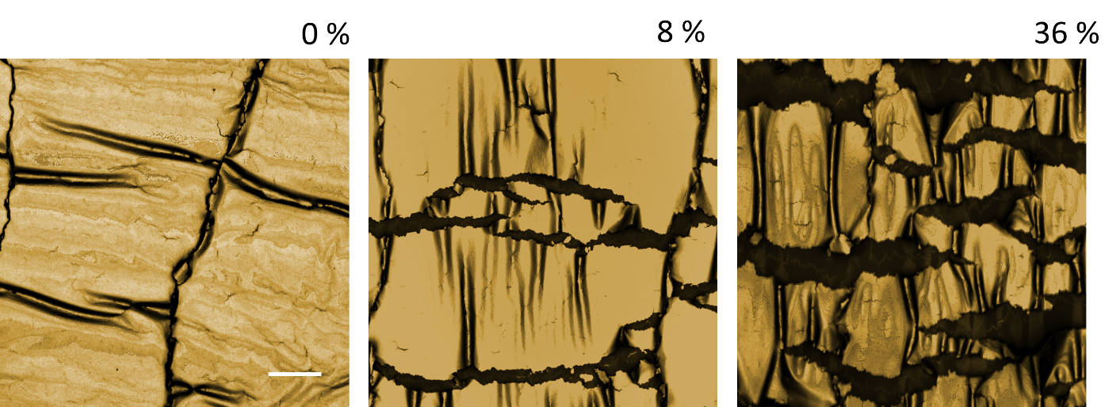

**Supplementary Fig. 1** Optical microscopy image of a metal thin film (Au, 50 nm) deposited onto an elastomer substrate (PDMS) under various applied strains. Scale bar denotes 3 μm.

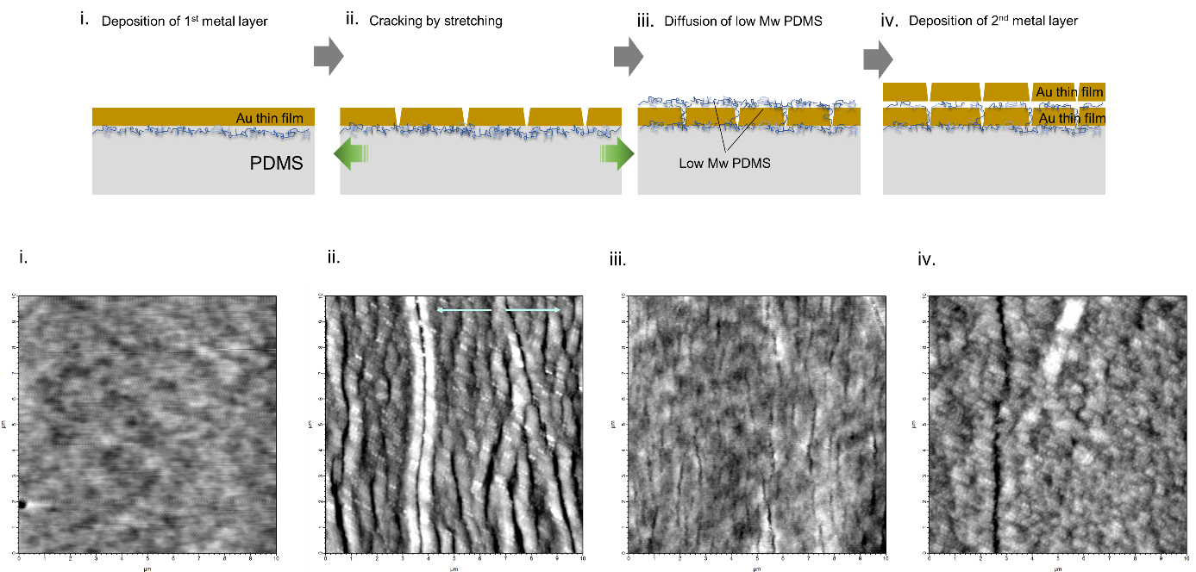

**Supplementary Fig. 2** Schemes (i → iv) showing the fabrication of an nGF stretchable electrode (top-row) and the corresponding AFM images of each process (bottom row). i) No significant features are observed on the surface of first metal layer as it is deposited. ii) Stretching the metal thin film induced lateral cracks perpendicular to the direction of stretching (blue arrows indicate the stretching direction). iii) Incubation of the sample under high vacuum resulted in flatness recovery via the diffusion of low-Mw PDMS and formation of a thin layer. iv) A second metal layer deposited onto the low-Mw PDMS layer covering the first metal layer.

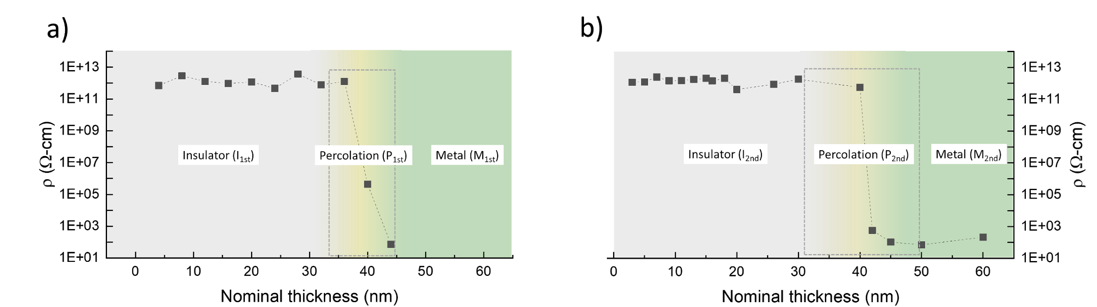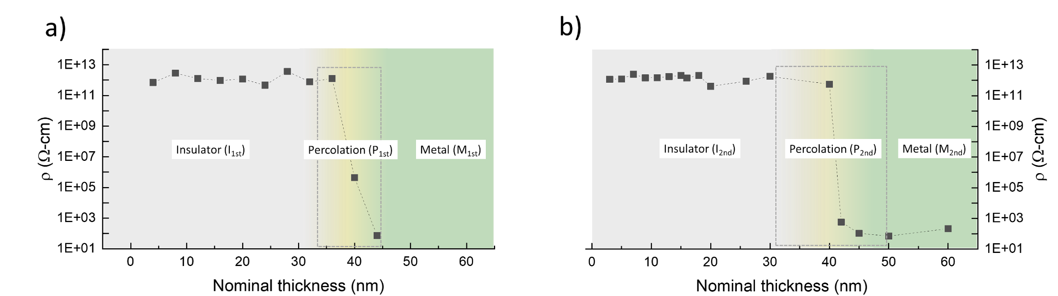

**Supplementary Fig. 3** Determination of the percolation threshold thickness of the (a) first and (b) second metal layers.

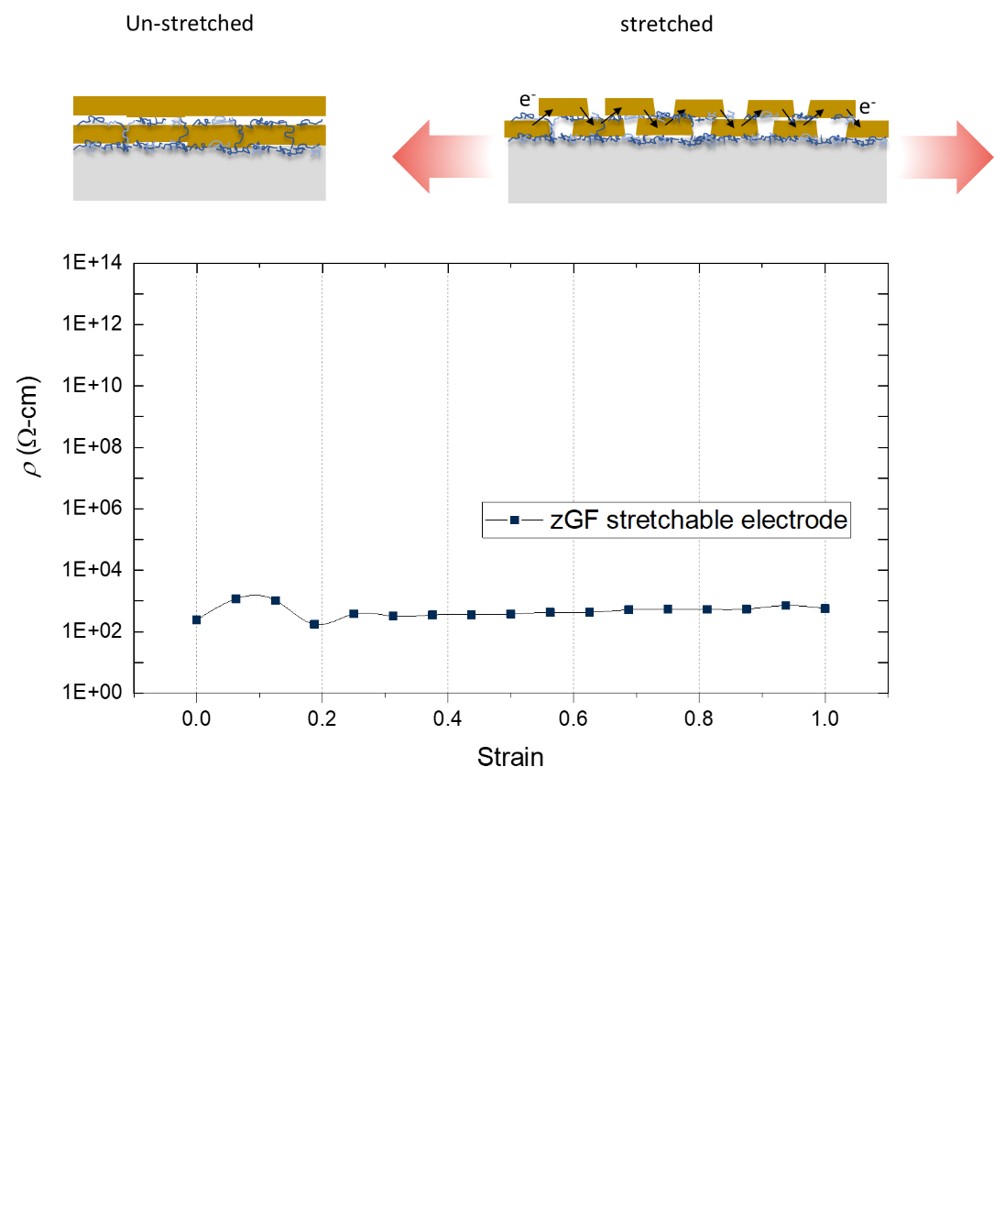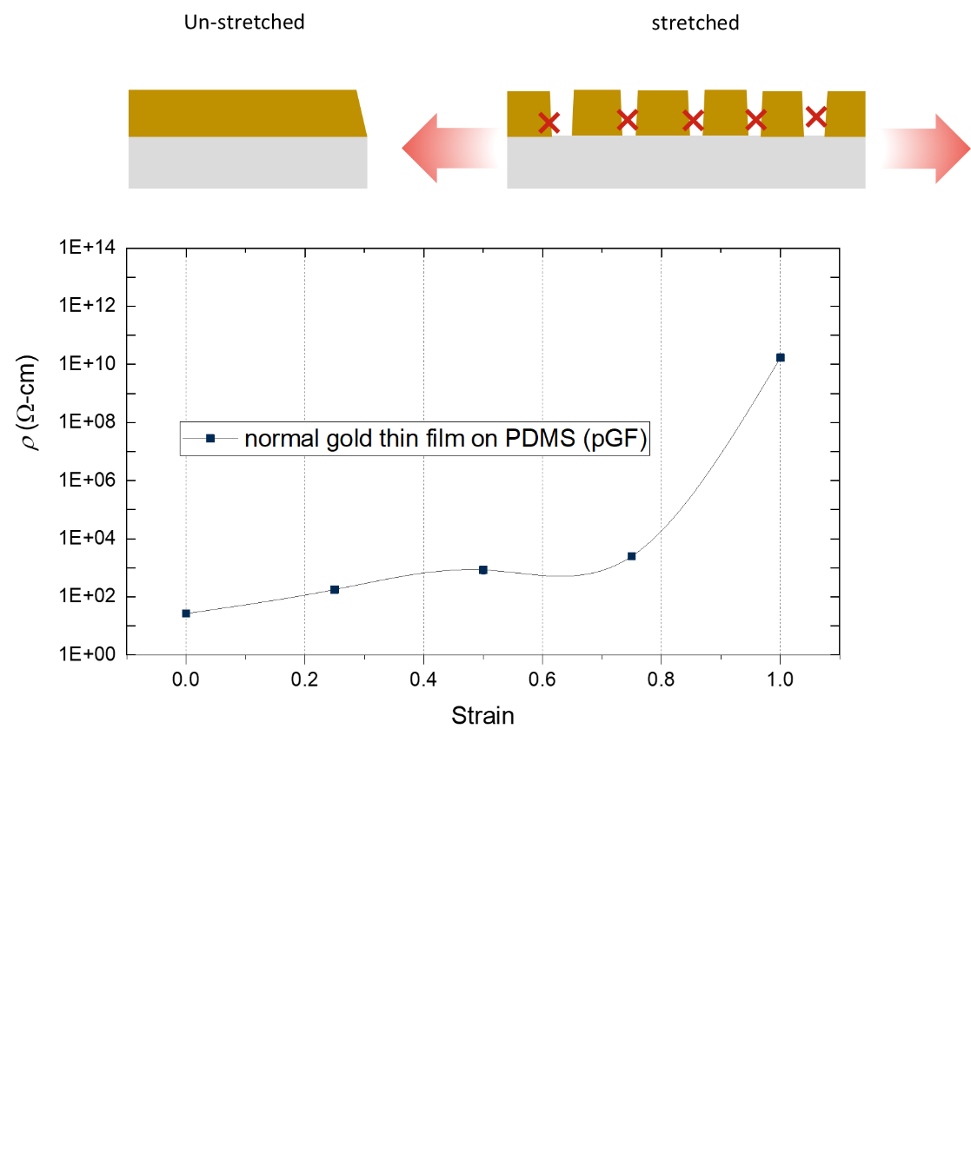

**Supplementary Fig. 4** Comparison of zGF performance of the bilayer metal structure (top) with that of the control sample (bottom), which is a monolayer sample with the same deposition thickness.

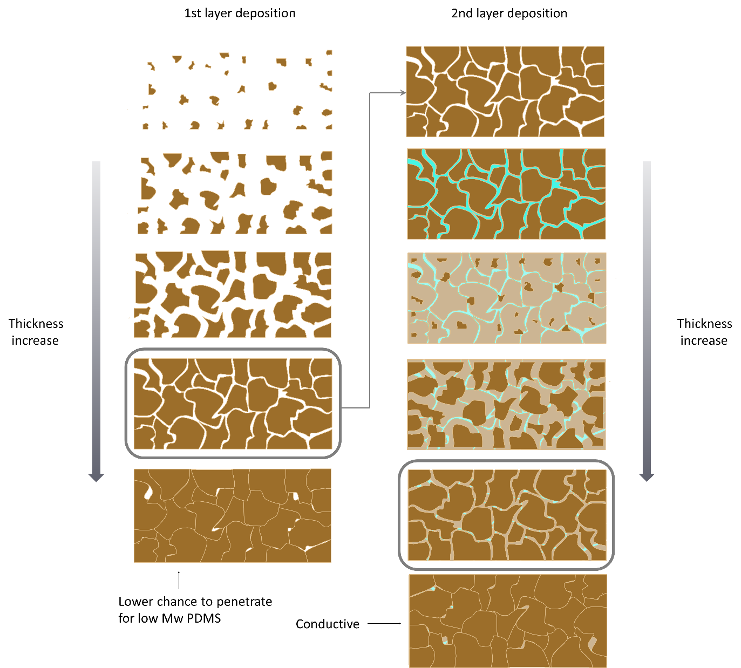

**Supplementary Fig. 5** Optimization of the deposition thickness of the first (left column) and second (right column) layers. Both thicknesses are controlled to show nGF behavior with respect to the percolation thresholds.

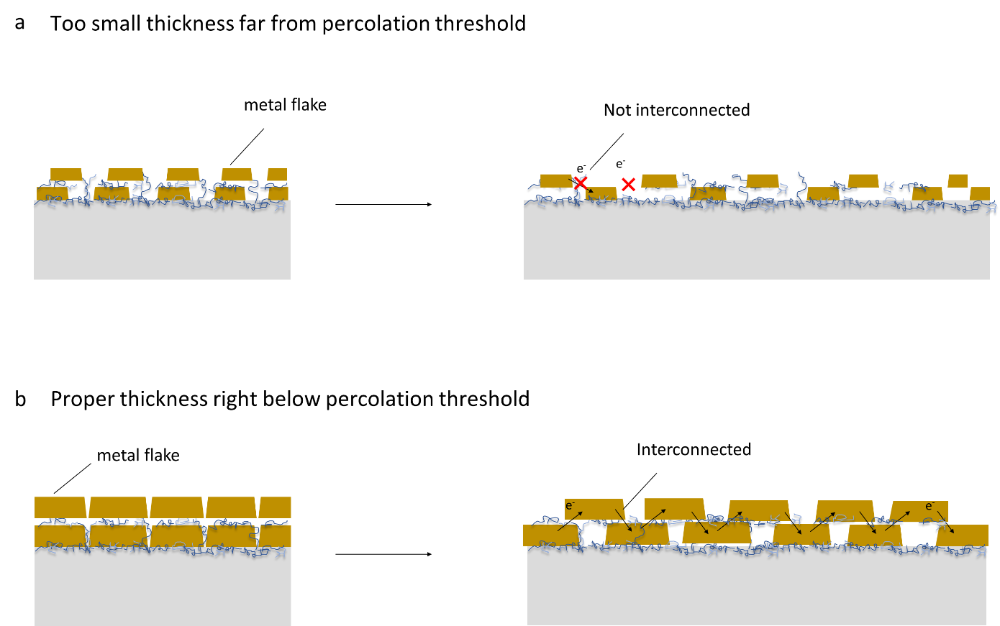

**Supplementary Fig. 6** Optimization of the deposition thickness of each bilayer for percolation when it is stretched.

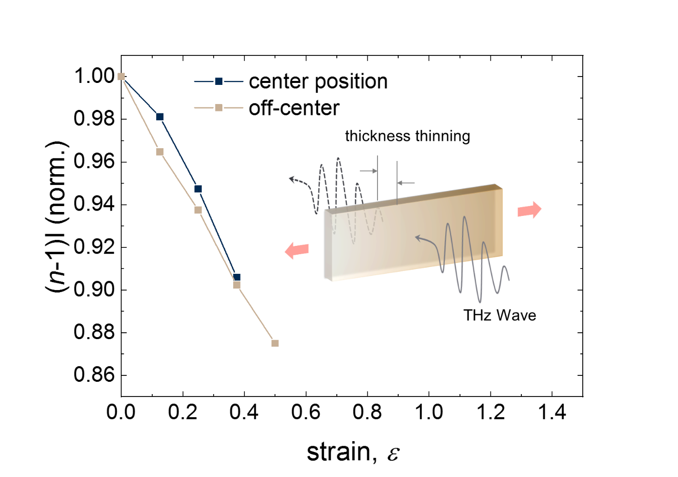**Supplementary Fig. 7** Experimental thickness thinning, as measured by THz-TDS spectroscopy.

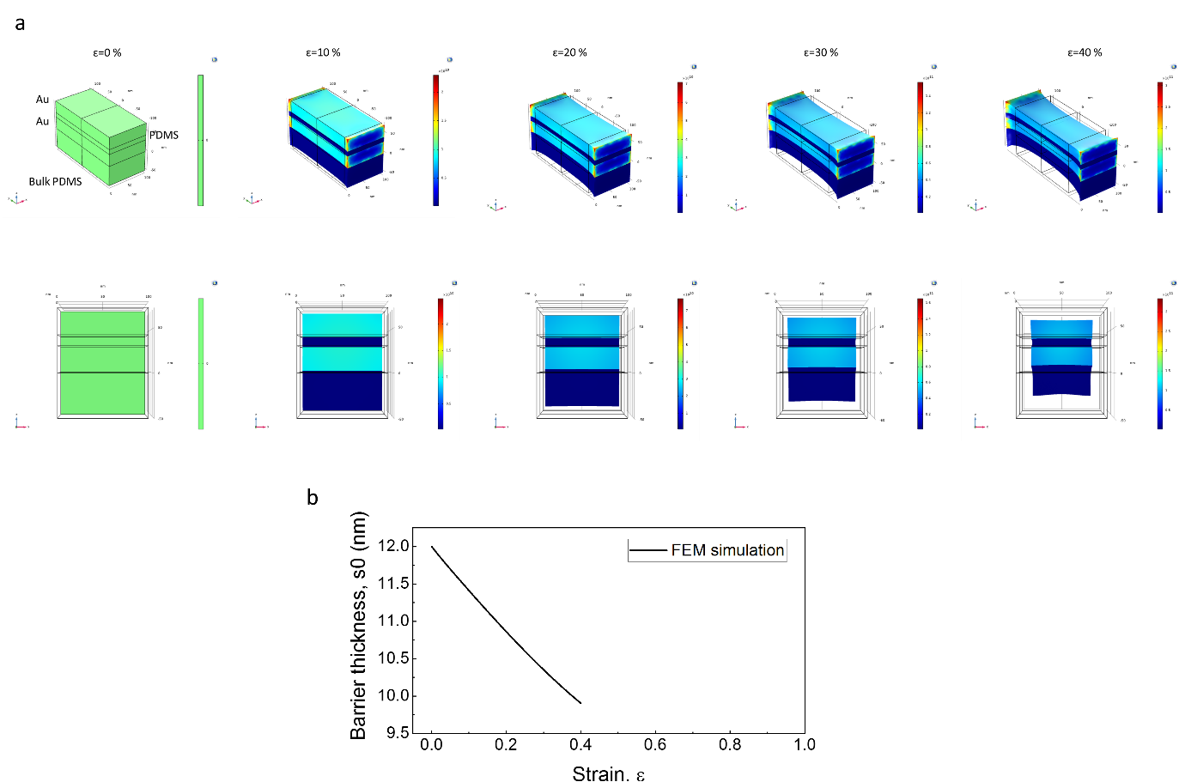

**Supplementary Fig. 8** FEM simulation of Au/PDMS/Au structures.(a) Von Mises stress distribution as the uniaxial strain of the device increases according to the hyperelastic PDMS model (St. Venant Kirchhoff model). (b) The resultant thickness change of the PDMS soft barrier, as extracted from the FEM simulation.

**Supplementary Movie 1** “On” state of an LED bulb upon application of strain to a stretchable bilayer design showing the nGF behavior. The initial “off” state without strain and the switching behavior upon application of strain are shown.

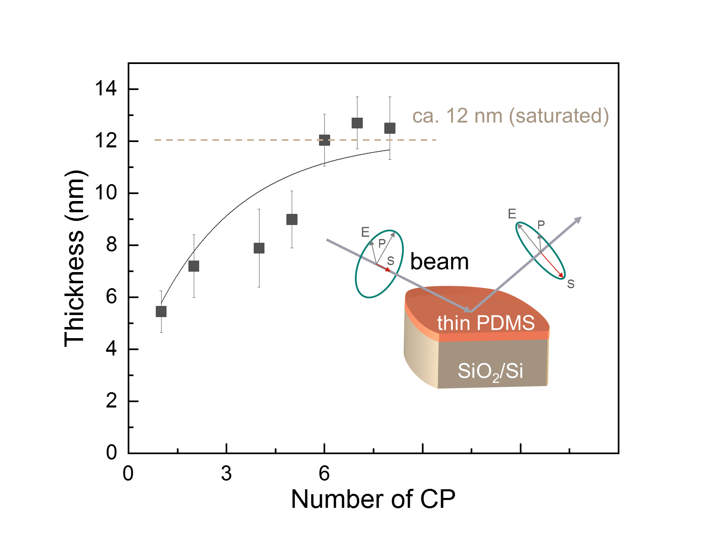**Supplementary Fig. 9** Determination of the initial barrier thickness (*sε*0) measured by ellipsometry of the model sample (details are provided in Supplementary Information S2).

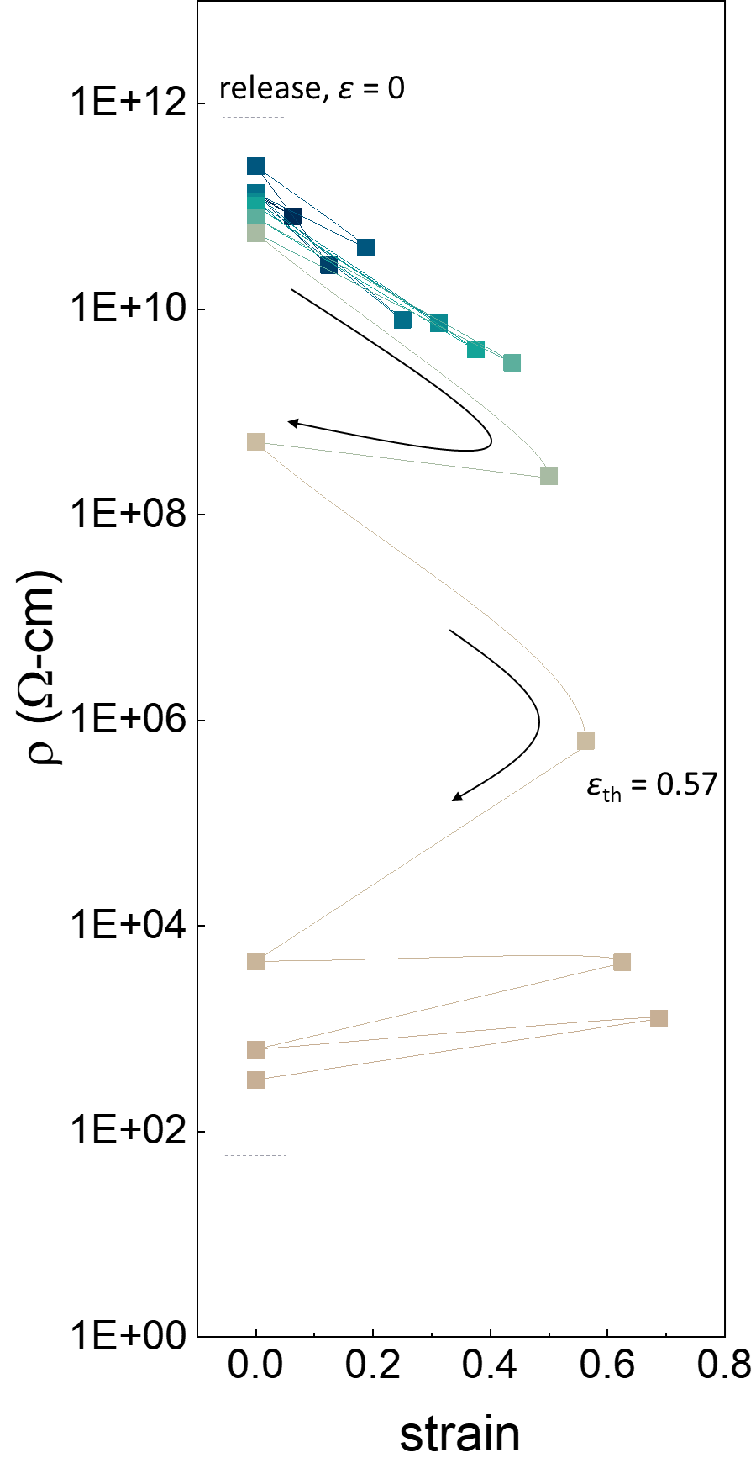

**Supplementary Fig. 10** Irreversibility of the nGF behavior beyond the threshold strain (*ε* = 0.57 for this sample). Presumably, when the strain is released to *ε* = 0, the whole structure is delaminated from the PDMS substrate because of the absence of any adhesive layer (e.g., a thin Ti or Cr layer), leading to structure deformation such as buckling or similar and showing the conversion to the low-resistivity state (ρ < 104 Ω·cm). Note that such reversibility is possible within a certain strain range because of the delamination of the whole layer from the substrate, which can be technically solved if adhesion at the interface between the first metal layer and the elastomer substrate is secure.

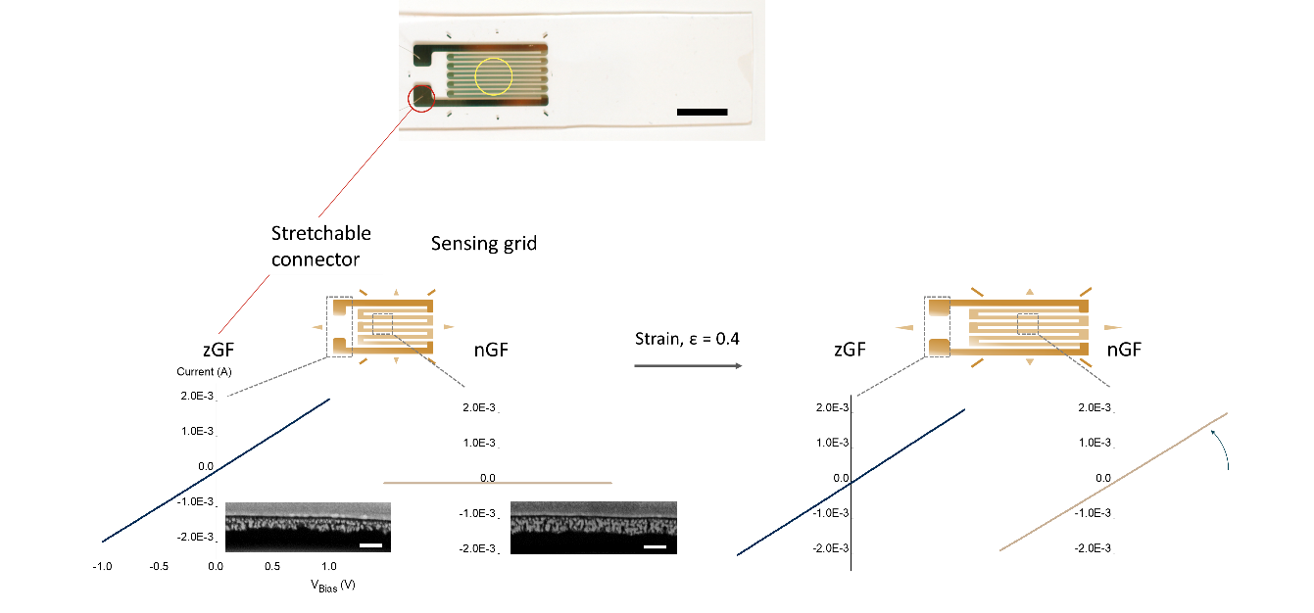

**Supplementary Fig. 11** zGF and nGF behaviors in the fabrication of zero-power strain sensors. The connector electrode (outer line and connector pad) (red circle) is made of the thickness combination of 35 nm (first) and 27.5 nm (second) and exhibits constant high conductivity irrespective of the applied strain of *ε* = 0.4 (black line). For sensing-grid electrodes consisting two combined metal layers of 25 nm (first) and 22 nm (second), the region shows the nGF conversion from insulator to conductor under an applied strain of *ε* = 0.4 (brown line). The inset is cross-sectional SEM images of each region (scale bar denotes 50 nm).

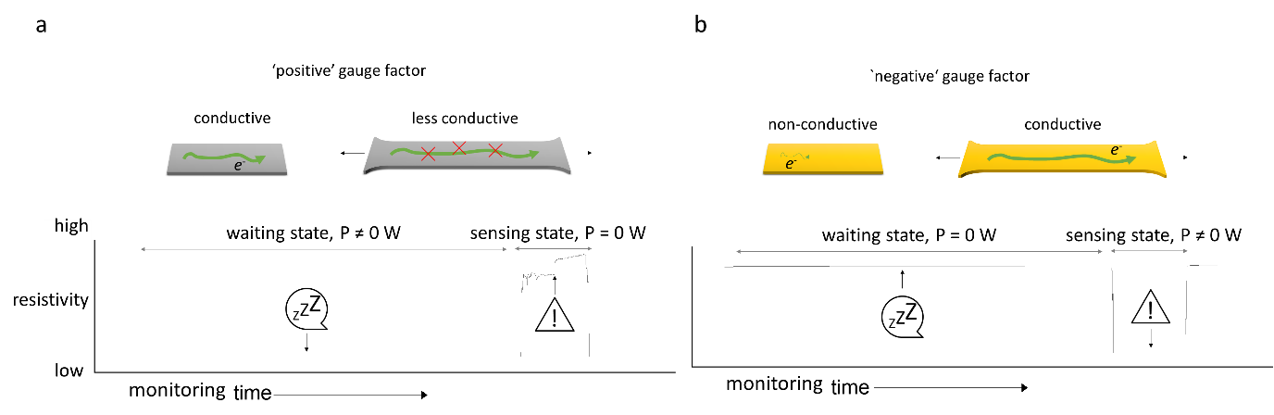

**Supplementary Fig. 12** Comparison of power consumption at strain sensors fabricated with (a) a pGF electrode and (b) an nGF electrode as a function of standby mode time. For the state-of-art in strain sensors, power consumption is inevitable because of the flow of a certain current in normal standby mode; by contrast, in the developed nGF strain sensors, no current flows because of the extremely high resistivity, resulting in zero power consumption during the monitored period.

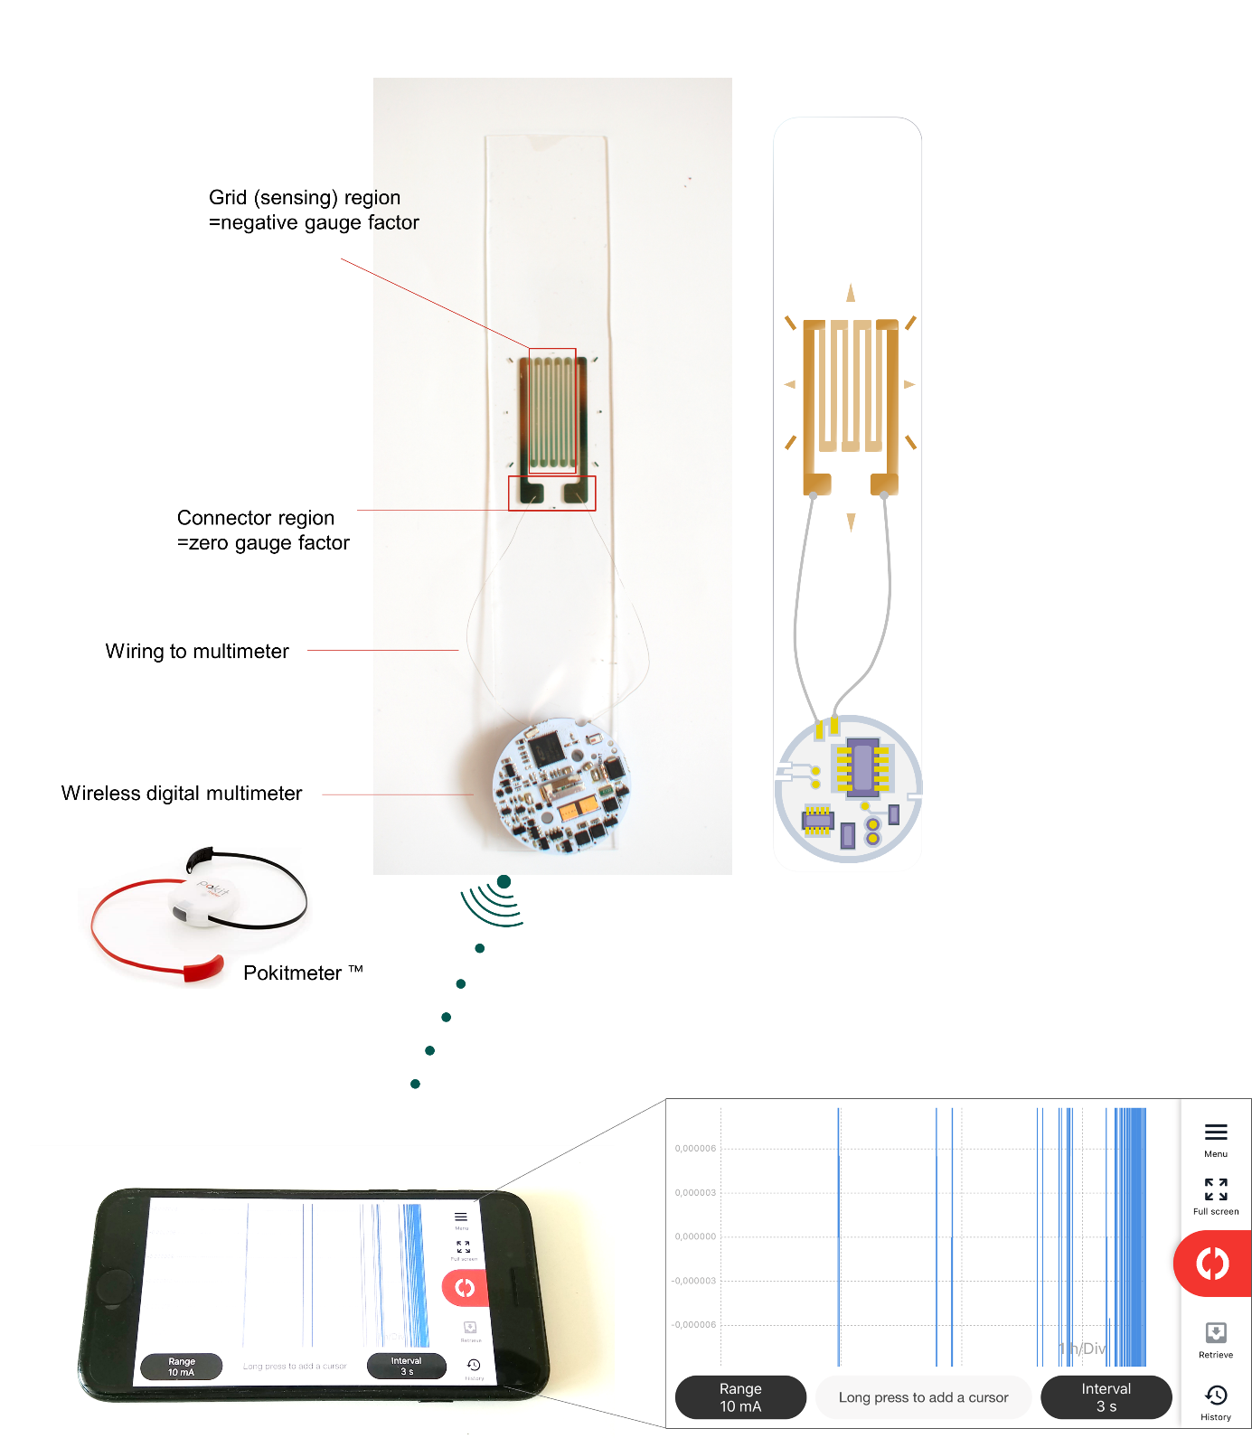

**Supplementary Fig. 13** Demonstration of a zero-power-consumption strain sensor for wireless health monitoring of infrastructure. The patterned electrode of a bimetal layer with a combination of zGF and nGF properties was electrically contacted with a wireless digital multimeter circuit.



**Supplementary Fig. 14** Water contact angle results for a contact-printed low-Mw PDMS layer on the various types of substrates. All of the PDMS layers show the same saturated contact angle of ~103°, which means the printed low-Mw PDMS layer could be derived by the same formation mechanism with same thickness irrespective of the type of material.