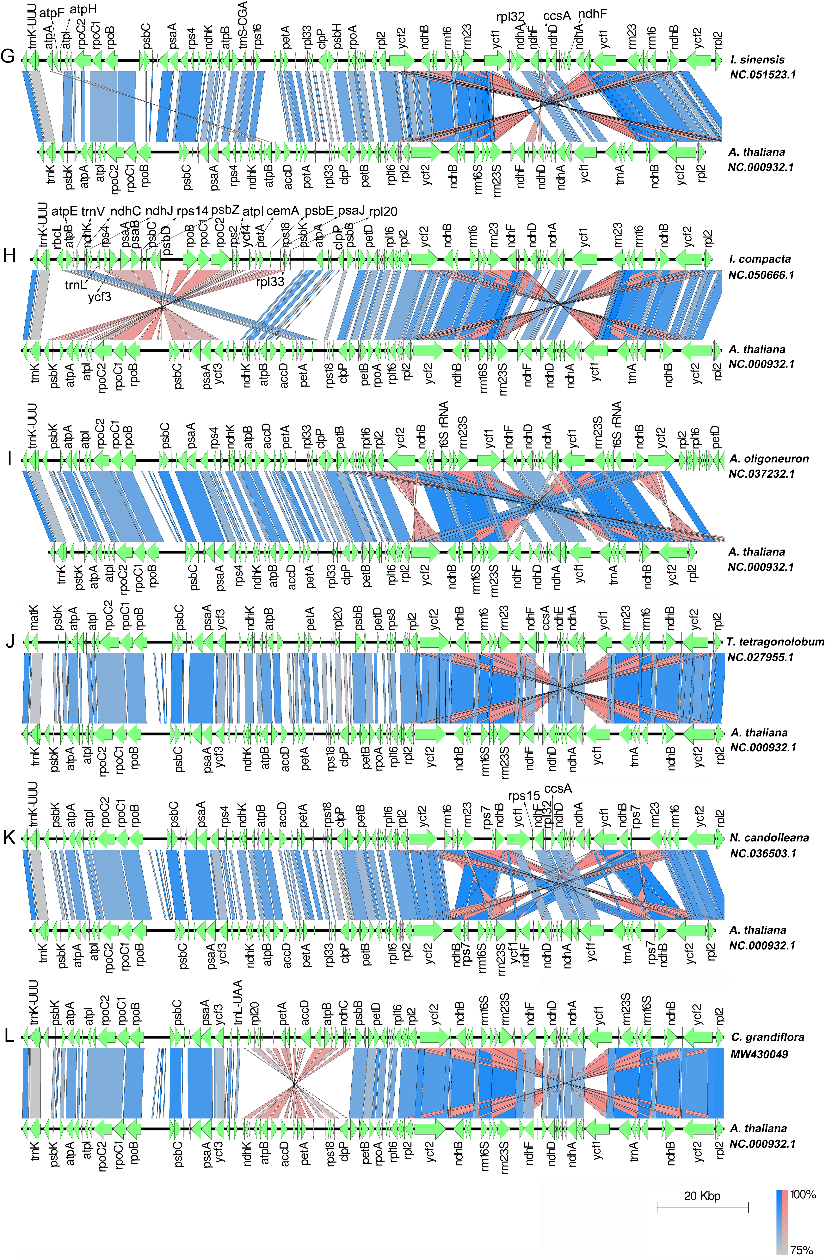
Figure S3. The pannel G to L shown that other 6 types of genome structure respectively from I. sinensis, I. compacta, A. oligoneuron, T. tetragonolobum, N. candolleana, C. grandiflora.

