Section 1. Trial Registration Data Set.
Data Category | Information
Primary registry and trial identifying number | ClinicalTrials.gov (NCT03935776)
Date of registration in primary registry | 02 May 2019
Secondary identifying numbers | WVI-PAD
Source(s) of monetary or material support | Galway University Hospital
Primary sponsor | Ministry of Higher Education and Scientific Research, Libyan Embassy
Secondary sponsor(s) | NA
Contact for public queries | ME, marahelfghi@gmail.com
Contact for scientific queries | ME, marahelfghi@gmail.com
Public title | Risk Factor Modification Programme for Peripheral Arterial Disease Patients
Scientific title | The Effect of Lifestyle and Risk Factor Modification on Occlusive Peripheral Arterial Disease Outcomes: Standard Healthcare vs Structured Programme: for a Randomised Controlled Trial Protocol
Countries of recruitment | Republic of Ireland
Health condition(s) or problem(s) studied | Occlusive Peripheral Arterial Disease
Intervention(s) | -Risk Factor Modification Structured Programme  - Standard healthcare
Key inclusion and exclusion criteria | Inclusion criteria: Ages eligible for study: ≥18years; symptomatic PAD and at least one PAD risk factors.  Exclusion criteria: Asymptomatic PAD; involvement in another clinical trial in the previous six months; legal incapacity; inadequate English language; significant cognitive impairment or mental illness; refusal to participate in a certain part of the intervention; immobility and contraindication to anticoagulation and antiplatelet medications or any of the risk factors treatment
Study type | Treatment
Date of first enrolment | 1 June 2018
Target sample size | 208 patients
Recruitment status | Recruiting
Primary outcome(s) | Achieving one or more target Improvement in lifestyle risk factors. Which includes: Smoking cessation; BMI 20-25 (kg/m^2); HbA1c less than 7% and total Cholesterol less than 5.0 mmol/L
Key secondary outcomes | PAD outcomes are based on the Society for Vascular Surgery (SVS) reporting standards²⁰: These include: Amputation free survival; any intervention, above-ankle amputation, or stenosis; re-intervention or above knee amputation; freedom from MACE and MALE; revascularisation-free survival; health related quality of life.

Section 2. Consent Form for the RCT.

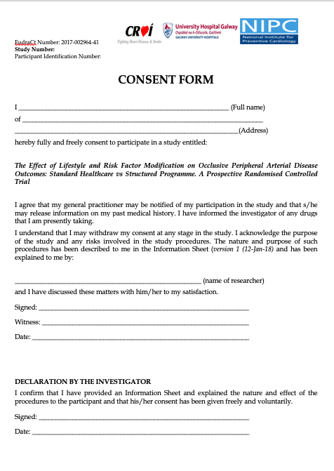

Section 3. Consent Form Checklist for the RCT

