Supplementary List of Figures:
Figure 1. Simple Multilayer Perceptron structure with two hidden layers
Figure 2. Support vector regression working flow chart
Figure 3. Decomposition of Original time series (a) streamflow, (b) temperature (c) precipitation by EMD
Figure 4. Decomposition of Original time series (a) streamflow, (b) temperature (c) precipitation by EEMD
Figure 5. Decomposition of Original time series (a) streamflow, (b) temperature (c) precipitation by ICEEMDAN
Figure 6. FHGs for observed vs all developed RMs and RRMs models during calibration phase
Figure 7. EVA and LVA for all ICEEMDAN based models
Figure 1. Simple Multilayer Perceptron structure with two hidden layers
Figure 2. Support vector regression working flow chart

Figure 3. Decomposition of Original time series (a) streamflow, (b) temperature (c) precipitation by EMD
Figure 4. Decomposition of Original time series (a) streamflow, (b) temperature (c) precipitation by EEMD
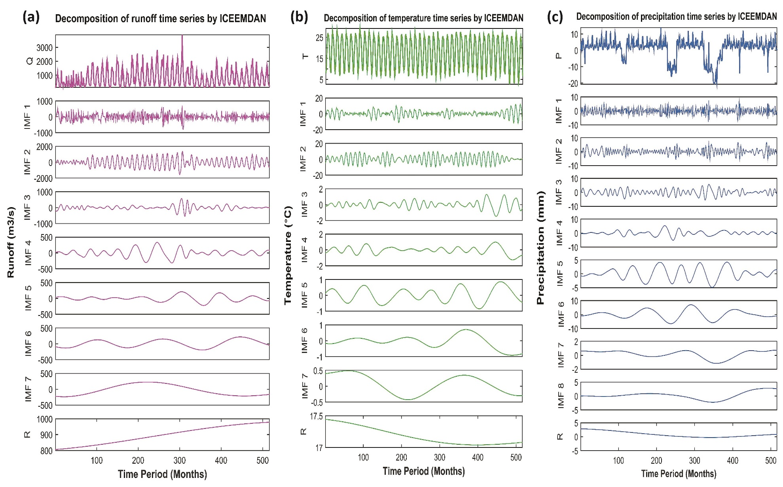
Figure 5. Decomposition of Original time series (a) streamflow, (b) temperature (c) precipitation by ICEEMDAN

Figure 6. FHGs for observed vs all developed RMs and RRMs models during calibration phase
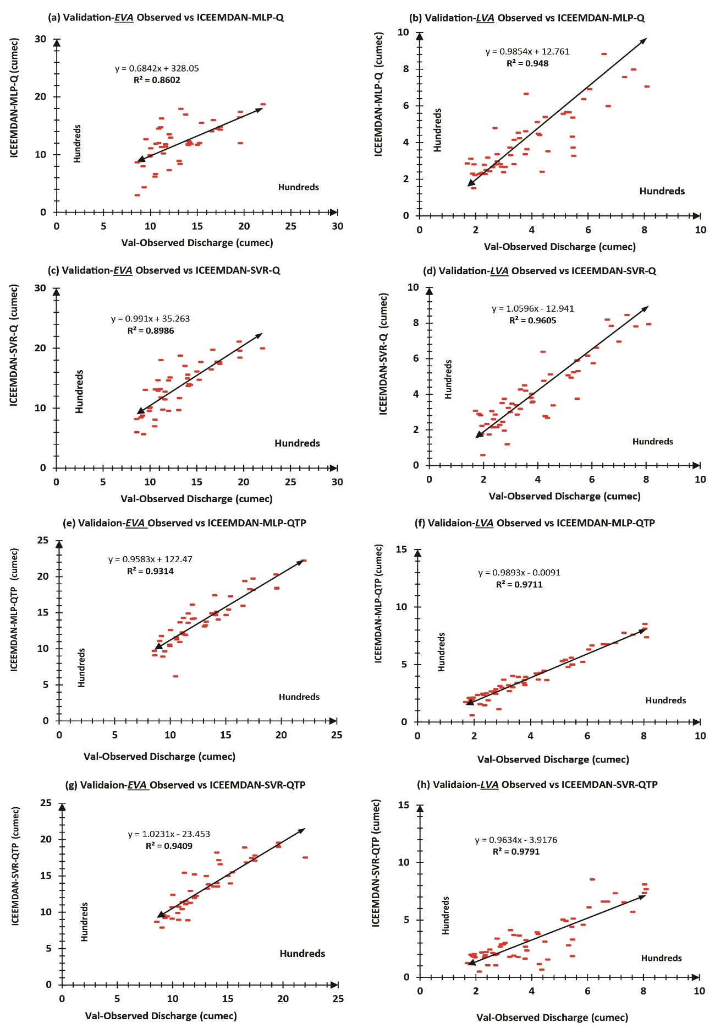
Figure 7. EVA and LVA for all ICEEMDAN based models
Supplementary List of Tables:

Table: 1 Climatic station with their corresponding statistical details, Mangla watershed
Table 2. Developed runoff models (RMs), single Input variable (SIV) and their corresponding inputs
Table 3. Developed rainfall runoff models (RRMs), multiple Input variables (MIV) and their corresponding inputs
Table 4. Inter-comparison of PEC as well as EVA and LVA for optimum SVR-QTP based models

Table: 1 Climatic station with their corresponding statistical details, Mangla watershed
No. | Station | Duration  (Years) | Lat.  (dd) | Lon.  (dd) | Precipitation |  |  |  |  | Temperature
 |  |  |  |  | Mean  (mm) | SD | C_{v} | C_{s} | C_{k} | Mean  (C˚) | SD | C_{v} | C_{s} | C_{k}
1 | Balakot | 1971-2013 | 34.6 | 73.4 | 1493 | 90.3 | -23.7 | -10.6 | 114 | 18.6 | 7.48 | 0.40 | -0.11 | -1.18
2 | Gharidopatta | 1971-2013 | 34.2 | 73.6 | 1291 | 89.6 | -21.9 | -10.7 | 116.4 | 16.8 | 49.9 | 2.95 | -19.8 | 399
3 | Kotli | 1971-2013 | 33.5 | 73.9 | 1142 | 10.6 | 3.33 | 6.22 | 57.21 | 21.9 | 7.26 | 0.33 | -0.21 | -1.1
4 | Murree | 1971-2013 | 34.4 | 73.5 | 1314 | 11.9 | 2.9 | 6.18 | 63.9 | 13.0 | 6.62 | 0.50 | -0.41 | -0.82
5 | Muzaffarabad | 1971-2013 | 34.0 | 73.8 | 1145 | 292 | -3.24 | -2.77 | 5.71 | 20.6 | 7.70 | 0.37 | -0.20 | -1.19
6 | Bagh | 1971-2013 | 33.3 | 73.3 | 1243 | 9.37 | 2.78 | 5.15 | 44.3 | 17.9 | 7.77 | 0.43 | -0.38 | -0.65
7 | Gujar Khan | 1971-2013 | 34.0 | 74.0 | 850 | 7.29 | 3.85 | 6.82 | 65.2 | 18.0 | 43.6 | 2.42 | -11.2 | 129
8 | Kallar | 1971-2013 | 33.4 | 73.4 | 923 | 7.12 | 3.89 | 5.82 | 37.3 | 23.0 | 8.0 | 0.34 | 4.3 | 162
9 | Mangla | 1971-2013 | 31.1 | 73.6 | 877 | 8.47 | 3.96 | 6.77 | 61.0 | 15.9 | 37.1 | 2.32 | -12.7 | 171
10 | Naran | 1971-2013 | 34.9 | 73.7 | 1695 | 418 | -1.90 | -1.32 | -0.25 | 12.1 | 9.37 | 0.77 | -0.13 | -0.79
11 | Plandri | 1971-2013 | 34.2 | 73.6 | 1390 | 120 | 59.7 | 62.0 | 38.5 | 17.5 | 6.87 | 0.414 | -0.30 | -0.87
12 | Rawalakot | 1971-2013 | 33.9 | 73.4 | 1369 | 9.03 | 3.35 | 8.18 | 101 | 14.8 | 8.00 | 0.45 | 0.04 | -0.45

Table 2. Developed runoff models (RMs), single Input variable (SIV) and their corresponding inputs
 | Runoff Models (RMs)
S.no | Model | SIV | Selected Inputs for each model
01 | MLP-Q | streamflow (Q) | (Qt-1, Qt-2, Qt-3, Qt-6, Qt-7, Qt-10, Qt-11, Qt-12 + Q-Observation)
02 | SVR-Q | streamflow (Q) | (Qt-1, Qt-2, Qt-3, Qt-6, Qt-7, Qt-10, Qt-11, Qt-12 + Q-Observation)
03 | EMD-MLP-Q | streamflow (Q) | Qt-1(IMF1–IMF7, r), Qt-2(IMF1–IMF7, r), Qt-3(IMF1–IMF7, r), Qt-6(IMF1–IMF7, r), Qt-7(IMF1–IMF7, r), Qt-10(IMF1–IMF7, r), Qt-11(IMF1–IMF7, r), Qt-12(IMF1–IMF7, r) + Q-Observation
04 | EMD-SVR-Q | streamflow (Q) | Qt-1(IMF1–IMF7, r), Qt-2(IMF1–IMF7, r), Qt-3(IMF1–IMF7, r), Qt-6(IMF1–IMF7, r), Qt-7(IMF1–IMF7, r), Qt-10(IMF1–IMF7, r), Qt-11(IMF1–IMF7, r), Qt-12(IMF1–IMF7, r) + Q-Observation
05 | EEMD-MLP-Q | streamflow (Q) | Qt-1(IMF1–IMF9, r), Qt-2(IMF1–IMF9, r), Qt-3(IMF1–IMF9, r), Qt-6(IMF1–IMF9, r), Qt-7(IMF1–IMF9, r), Qt-10(IMF1–IMF9, r), Qt-11(IMF1–IMF9, r), Qt-12(IMF1–IMF, r) + Q-Observation
06 | EEMD-SVR-Q | streamflow (Q) | Qt-1(IMF1–IMF9, r), Qt-2(IMF1–IMF9, r), Qt-3(IMF1–IMF9, r), Qt-6(IMF1–IMF9, r), Qt-7(IMF1–IMF9, r), Qt-10(IMF1–IMF9, r), Qt-11(IMF1–IMF9, r), Qt-12(IMF1–IMF9, r) + Q-Observation
07 | ICEEMDAN-MLP-Q | streamflow (Q) | Qt-1(IMF1–IMF8, r), Qt-2(IMF1–IMF8, r), Qt-3(IMF1–IMF8, r), Qt-6(IMF1–IMF8, r), Qt-7(IMF1–IMF8, r), Qt-10(IMF1–IMF8, r), Qt-11(IMF1–IMF8, r), Qt-12(IMF1–IMF8, r) + Q-Observation
08 | ICEEMDAN-SVR-Q | streamflow (Q) | Qt-1(IMF1–IMF8, r), Qt-2(IMF1–IMF8, r), Qt-3(IMF1–IMF8, r), Qt-6(IMF1–IMF8, r), Qt-7(IMF1–IMF8, r), Qt-10(IMF1–IMF8, r), Qt-11(IMF1–IMF8, r), Qt-12(IMF1–IMF8, r) + Q-Observation

Table 3. Developed rainfall runoff models (RRMs), multiple Input variables (MIV) and their corresponding inputs
 | Rainfall Runoff Models (RRMs)
no | Model | MIV | Selected Inputs for each model
01 | MLP-QTP | streamflow (Q)  Temperature (T)  Precipitation (P) | Qt-1, Qt-2, Qt-3, Qt-6, Qt-7, Qt-10, Qt-11, Qt-12,Tt-1, Tt-2, Tt-3, Tt-4, Tt-8, Tt-9, Tt-10, Tt-11, Tt-12, Pt-1, Pt-9, Pt-11, Pt-12+ (Q-T-P-Observation)
02 | SVR-QTP | streamflow (Q)  Temperature (T)  Precipitation (P) | Qt-1, Qt-2, Qt-3, Qt-6, Qt-7, Qt-10, Qt-11, Qt-12,Tt-1, Tt-2, Tt-3, Tt-4, Tt-8, Tt-9, Tt-10, Tt-11, Tt-12, Pt-1, Pt-9, Pt-11, Pt-12+(Q-T-P-Observation)
03 | EMD-MLP-QTP | streamflow (Q)  Temperature (T)  Precipitation (P) | Qt-1(IMF1–IMF7, r), Qt-2(IMF1–IMF7, r), Qt-3(IMF1–IMF7, r), Qt-6(IMF1–IMF7, r), Qt-7(IMF1–IMF7, r), Qt-10(IMF1–IMF7, r), Qt-11(IMF1–IMF7, r), Qt-12(IMF1–IMF7, r), Tt-1(IMF1–IMF7, r), Tt-2(IMF1–IMF7, r), Tt-3(IMF1–IMF7, r), Tt-4(IMF1–IMF7, r), Tt-8(IMF1–IMF7, r), Tt-9(IMF1–IMF7, r), Tt-10(IMF1–IMF7, r), Tt-11(IMF1–IMF7, r), Tt-12(IMF1–IMF7, r), Pt-1(IMF1–IMF7, r), Pt-9(IMF1–IMF7, r), Pt-11(IMF1–IMF7, r), Pt-12(IMF1–IMF7, r) +(Q-T-P-Observation)
04 | EMD-SVR-QTP | Discharge (Q)  Temperature (T)  Precipitation (P) | Qt-1(IMF1–IMF7, r), Qt-2(IMF1–IMF7, r), Qt-3(IMF1–IMF7, r), Qt-6(IMF1–IMF7, r), Qt-7(IMF1–IMF7, r), Qt-10(IMF1–IMF7, r), Qt-11(IMF1–IMF7, r), Qt-12(IMF1–IMF7, r), Tt-1(IMF1–IMF7, r), Tt-2(IMF1–IMF7, r), Tt-3(IMF1–IMF7, r), Tt-4(IMF1–IMF7, r), Tt-8(IMF1–IMF7, r), Tt-9(IMF1–IMF7, r), Tt-10(IMF1–IMF7, r), Tt-11(IMF1–IMF7, r), Tt-12(IMF1–IMF7, r), Pt-1(IMF1–IMF7, r), Pt-9(IMF1–IMF7, r), Pt-11(IMF1–IMF7, r), Pt-12(IMF1–IMF7, r) +(Q-T-P-Observation)
05 | EEMD-MLP-QTP | Discharge (Q)  Temperature (T)  Precipitation (P) | Qt-1(IMF1–IMF9, r), Qt-2(IMF1–IMF9, r), Qt-3(IMF1–IMF9, r), Qt-6(IMF1–IMF9, r), Qt-7(IMF1–IMF9, r), Qt-10(IMF1–IMF9, r), Qt-11(IMF1–IMF9, r), Qt-12(IMF1–IMF9, r), Tt-1(IMF1–IMF9, r), Tt-2(IMF1–IMF9, r), Tt-3(IMF1–IMF9, r), Tt-4(IMF1–IMF9, r), Tt-8(IMF1–IMF9, r), Tt-9(IMF1–IMF9, r), Tt-10(IMF1–IMF9, r), Tt-11(IMF1–IMF9, r), Tt-12(IMF1–IMF9, r), Pt-1(IMF1–IMF9, r), Pt-9(IMF1–IMF9, r), Pt-11(IMF1–IMF9, r), Pt-12(IMF1–IMF9, r) +(Q-T-P-Observation)
06 | EEMD-SVR-QTP | Discharge (Q)  Temperature (T)  Precipitation (P) | Qt-1(IMF1–IMF9, r), Qt-2(IMF1–IMF9, r), Qt-3(IMF1–IMF9, r), Qt-6(IMF1–IMF9, r), Qt-7(IMF1–IMF9, r), Qt-10(IMF1–IMF9, r), Qt-11(IMF1–IMF9, r), Qt-12(IMF1–IMF9, r), Tt-1(IMF1–IMF9, r), Tt-2(IMF1–IMF9, r), Tt-3(IMF1–IMF9, r), Tt-4(IMF1–IMF9, r), Tt-8(IMF1–IMF9, r), Tt-9(IMF1–IMF9, r), Tt-10(IMF1–IMF9, r), Tt-11(IMF1–IMF9, r), Tt-12(IMF1–IMF9, r), Pt-1(IMF1–IMF9, r), Pt-9(IMF1–IMF9, r), Pt-11(IMF1–IMF9, r), Pt-12(IMF1–IMF9, r) +(Q-T-P-Observation)
07 | ICEEMDAN-MLP-QTP | Discharge (Q)  Temperature (T)  Precipitation (P) | Qt-1(IMF1–IMF8, r), Qt-2(IMF1–IMF8, r), Qt-3(IMF1–IMF8, r), Qt-6(IMF1–IMF8, r), Qt-7(IMF1–IMF8, r), Qt-10(IMF1–IMF8, r), Qt-11(IMF1–IMF8, r), Qt-12(IMF1–IMF8, r), Tt-1(IMF1–IMF8, r), Tt-2(IMF1–IMF8, r), Tt-3(IMF1–IMF8, r), Tt-4(IMF1–IMF, r), Tt-8(IMF1–IMF8, r), Tt-9(IMF1–IMF8, r), Tt-10(IMF1–IMF8, r), Tt-11(IMF1–IMF8, r), Tt-12(IMF1–IMF8, r), Pt-1(IMF1–IMF8, r), Pt-9(IMF1–IMF8, r), Pt-11(IMF1–IMF8, r), Pt-12(IMF1–IMF8, r) +(Q-T-P-Observation)
08 | ICEEMDAN-SVR-QTP | Discharge (Q)  Temperature (T)  Precipitation (P) | Qt-1(IMF1–IMF8, r), Qt-2(IMF1–IMF8, r), Qt-3(IMF1–IMF8, r), Qt-6(IMF1–IMF8, r), Qt-7(IMF1–IMF8, r), Qt-10(IMF1–IMF8, r), Qt-11(IMF1–IMF8, r), Qt-12(IMF1–IMF8, r), Tt-1(IMF1–IMF8, r), Tt-2(IMF1–IMF8, r), Tt-3(IMF1–IMF8, r), Tt-4(IMF1–IMF, r), Tt-8(IMF1–IMF8, r), Tt-9(IMF1–IMF8, r), Tt-10(IMF1–IMF8, r), Tt-11(IMF1–IMF8, r), Tt-12(IMF1–IMF8, r), Pt-1(IMF1–IMF8, r), Pt-9(IMF1–IMF8, r), Pt-11(IMF1–IMF8, r), Pt-12(IMF1–IMF8, r) +(Q-T-P-Observation)

Table 4. Inter-comparison of PEC as well as EVA and LVA for optimum SVR-QTP based models
S.no | Model | Variable | MAE | RMSE | R² | MAPE | NSCE | EVA-CP/VP  AP% | LVA  CP/VP AP%
01 | SVR | QTP | 120.43 | 200.81 | 0.87 | 17.21 | 0.85 | 83/84 | 92/93
02 | EMD-SVR | QTP | 120.04 | 176.53 | 0.91 | 18.4 | 0.88 | 85/87 | 94/96
03 | EEMD-SVR | QTP | 77.03 | 107.94 | 0.96 | 12.5 | 0.96 | 86/90 | 95/96
04 | ICEEMD-SVR | QTP | 59.56 | 91.82 | 0.97 | 8.75 | 0.97 | 88/94 | 97/97

