|  |  |  |  |
| --- | --- | --- | --- |
| **Tab.1** Primers for genetic markers of conjugate transfer of donor bacteria | | | |
| Genes | Sequence（5ʹ-3ʹ） | Length（bp） | Tm（℃） |
| *trbC* | F：TAATACGACTCACTATAGGG | 999 | 60 |
| R：TGCTAGTTATTGCTCAGCGG |
| *traF* | F：TGCGAAACTGGCTGAACACTACG | 143 | 62 |
| R：TAATCACGCCATCCACGGAAACG |

|  |  |  |  |
| --- | --- | --- | --- |
| **Tab.2** Regulatory gene primers sequence | | | |
| Genes | Sequence（5ʹ-3ʹ） | Length（bp） | Tm（℃） |
| *GAPDH* | F：GCTGAACGTGATCCGGCTAACC  R：CGTCAGTCAGGAACAGACCAGTTG | 85 | 60 |
| *lexA*  *recA* | F：TTCAGGCGCTTAACGGTAACTTCG  R：GGATGGTGACTTGCTGGCAGTG  F：GCTGGACCCAATCTACGCAC  R：CCAGGGCGTCACAGATTTCC | 99  166 | 60  59 |
| *dpiA* | F：AAGAGCCTGGTGTGCAACATACG  R：ATTCAAGATAACGCCTGGCAGTGG | 84 | 60 |
| *dpiB* | F：TGCCGCCAGGACTGGATAGC  R：ATCACCACATCATCGCCTTCATCG | 142 | 61 |
| *rpoS* | F：CTGGCGTTGCTGGACCTTATCG  R：ATCCACCAGGTTGCGTATGTTGAG | 110 | 60 |
| *Hu* | F：AGTGGCCGAAGACGCTGATATTAG  R：CCGCCGCGATCTGGATGTTC | 194 | 60 |

**Tab.3**  The primers of resistance genes and plasmids in *E. coli* QALAK1-2

|  |  |  |  |
| --- | --- | --- | --- |
| Genes | Sequence（5ʹ-3ʹ） | Tm（℃） | length（bp） |
| qnrA | F：TCAGCAAGAGGATTTCTCA | 52 | 627 |
| R：GGCAGCACTATTACTCCCA |
| tetA | F：GCTACATCCTGCTTGCCTTC | 62 | 210 |
| R：CATAGATCGCCGTGAAGAGG |
| blaCTX-M-9G | F：GTGACAAAGAGAGTGCAACGG | 63 | 857 |
| R：ATGATTCTCGCCGCTGAAGCC |
| fosA3 | F：GCGTCAAGCCTGGCATTT | 57.5 | 282 |
| R：GCCGTCAGGGTCGAGAAA |
| IncI2 | F：TTACAGTGCAAGCTAAGTGCAG | 55 | 615 |
| R：GATTCACGGTCCCATATCGT |
| IncFIB | F：GGAGTTCTGACACACGATTTTCTG | 60 | 702 |
| R：CTCCCGTCGCTTCAGGGCATT |
| GFP | F：TAATACGACTCACTATAGGG | 55 | 999 |
| R：TGCTAGTTATTGCTCAGCGG |
| mcr-1 | F：CGCATAATTTTTTATATCA | 53 | 1600 |
| R：AGTAGGCGTTTATTTGAT |
| oqxA | F：GATCAGTCAGTGGGATAGTTT | 51 | 670 |
| R：TACTCGGCGTTAACTGATTA |

Table 4 E. coli FTK conjugants resistance genes and plasmid identification primers

|  |  |  |  |
| --- | --- | --- | --- |
| Genes | Sequence（5ʹ-3ʹ） | Tm（℃） | length（bp） |
| qnrB | F：GATCGTGAAAGCCAGAAAGG | 53 | 469 |
| R：ACGATGCCTGGTAGTTGTCC |
| tetA | F：GCTACATCCTGCTTGCCTTC | 62 | 210 |
| R：CATAGATCGCCGTGAAGAGG |
| blaCTX-M-9G | F：GTGACAAAGAGAGTGCAACGG | 63 | 857 |
| R：ATGATTCTCGCCGCTGAAGCC |
| fosA3 | F：GCGTCAAGCCTGGCATTT | 57.5 | 282 |
| R：GCCGTCAGGGTCGAGAAA |
| IncI2 | F：TTACAGTGCAAGCTAAGTGCAG | 55 | 615 |
| R：GATTCACGGTCCCATATCGT |
| IncHI2 | F：TTTCTCCTGAGTCACCTGTTAACAC | 60 | 644 |
| R：GGCTCACTACCGTTGTCATCCT |
| IncY | F：AATTCAAACAACACTGTGCAGCCTG | 60 | 765 |
| R：GCGAGAATGGACGATTACAAAACTTT |
| mcr-1 | F：CGCATAATTTTTTATATCA | 53 | 1600 |
| R：AGTAGGCGTTTATTTGAT |
| oqxA | F：GATCAGTCAGTGGGATAGTTT | 51 | 670 |
| R：TACTCGGCGTTAACTGATTA |
| oqxB | F：TTCTCCCCCGGCGGGAAGTAC  R: CTCGGCCATTTTGGCGCGTA | 65 | 512 |



**Fig.1** Indole standard curve

Concentration

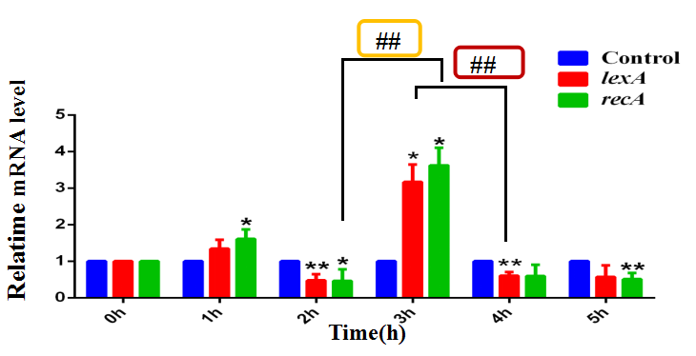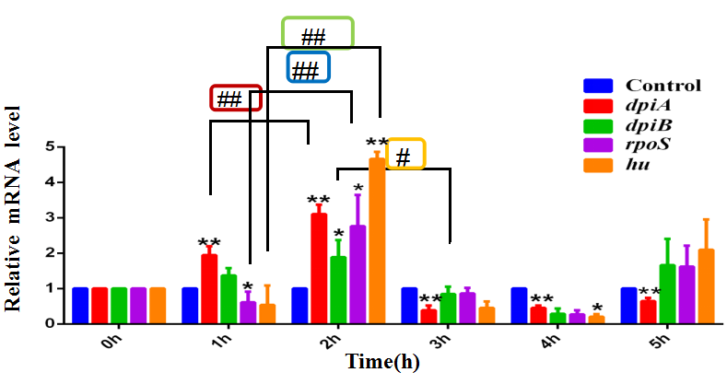

A

B

Note: A: In the RecA-dependent pathway, 0.01 μg/mL CTX induced 3h, vs control group, *lexA、recA* mRNA increased, 4h significantly decreased, and the SOS reaction was established. B: In the RecA-independent pathway, 0.01 μg/mL CTX induced later, vs control group, *dpiA*, *dpiB*, *rpoS*, and *hu* mRNA increased at 2h, and then gradually decreased from 3h-4h, SOS reaction was established. * vs control group (0h group), #group comparsion*/#*P*<0.05 **/##*P*<0.01.

**Fig.2** Relative quantification of mRNA of SOS response regulatory genes in *E. coli* BL21

|  |  |  |  |
| --- | --- | --- | --- |
| **Tab.5** Theprimers of *ibpA, acrEF, mtr* | | | |
| Genes | Sequence（5ʹ-3ʹ） | Tm /℃ | length（bp） |
| *ibpA* | F：TCAGCAAGAGGATTTCTCA | 61.5 | 98 |
| R：GGCAGCACTATTACTCCCA |
| *acrE* | F：GCTACATCCTGCTTGCCTTC | 60 | 140 |
| R：CATAGATCGCCGTGAAGAGG |
| *acrF* | F：GTGACAAAGAGAGTGCAACGG | 62 | 129 |
| R：ATGATTCTCGCCGCTGAAGCC |
| *mtr* | F：ACCTTCGCAGAGATGTCACTAAACG | 59.6 | 85 |
| R：TCAACCACACCACAAACGCTACC |

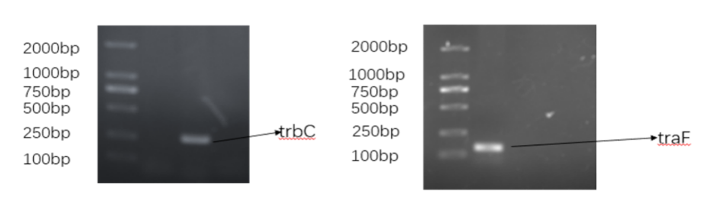

Note: A、B-Agarose electrophoresis of *trbC* and *traF* genes in *E. coli* QALAK1-2

C:Agarose electrophoresis diagram of *E. coli* QALAK1-2 resistance genes and plasmids

M:DL2000 Marker；1:*mcr-1*-1600bp；2:*tetA*-210bp；3:*qnrA*-627bp；4:IncI2-615bp；

5: *blaCTX-M-9G* -857bp;6:*fosA3*-282bp;7:IncFIB-702bp

**Fig.4** Agarose electrophoresis diagram of *E. coli* QALAK1-2 related gene

A

B

C

GAPDH

RecA

LexA

Con 1h 2h 3h 4h 5h

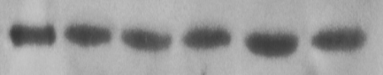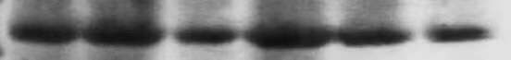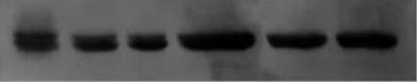

37kD

38kD

22kD

**A**

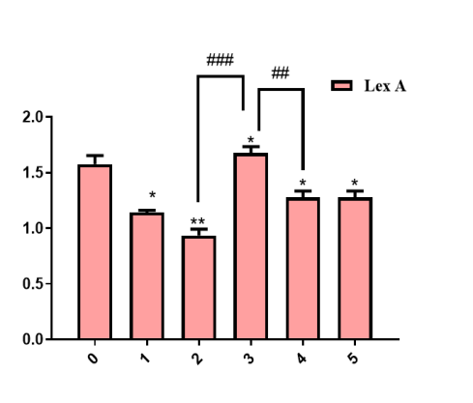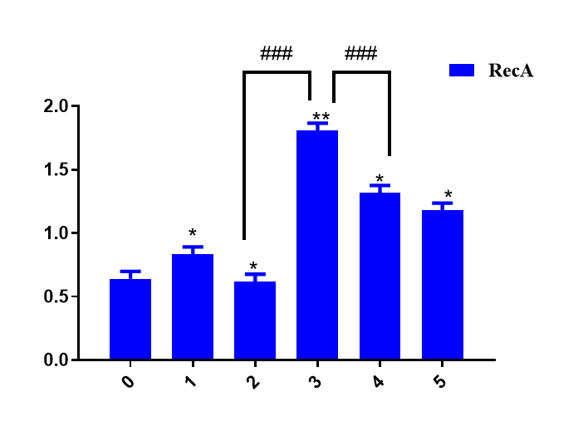

Time/h

Time/h

B

C

A: LexA, RecA SDS-PAGE electropherogram, GAPDH was internal reference, Control group: without drug (0 hour).

B: LexA gray value comparison chart, vs 0h, \**P*<0.05, \*\**P*<0.01; 4h vs3h, ##*P*<0.01; 2h vs 3h, ###*P*<0.001.

C: RecA gray value comparison Figure, vs 0h, \**P*<0.05, \*\**P*<0.01; 4h vs3h, ###P<0.001; 2h vs 3h,###*P*<0.001.

SOS response was established after 4h.

**Fig.3** Expression of LexA and RecA protein in *E. coli* BL21 induced by 0.01μg / mL CTX

A: 1:1 10-12h uninduced B: 1:1 10~12h induce C:1:1 15~18h uninduced D:1:1 15~18h induce

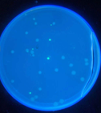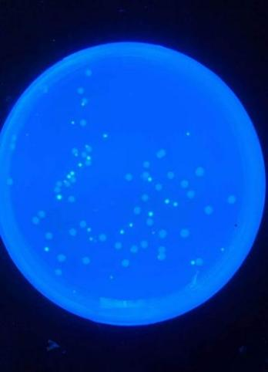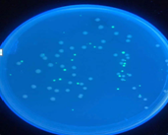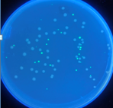

E: 1:2 10~12h uninduced F: 1:2 10~12h induce G: 1:2 15~18h uninduced H: 1:2 15~18h induce

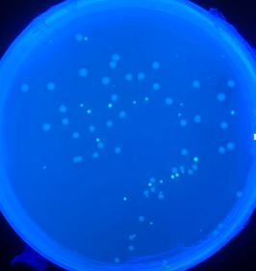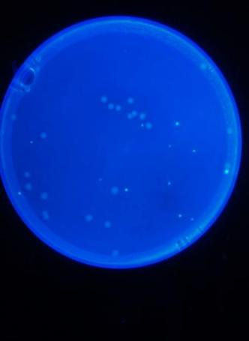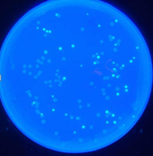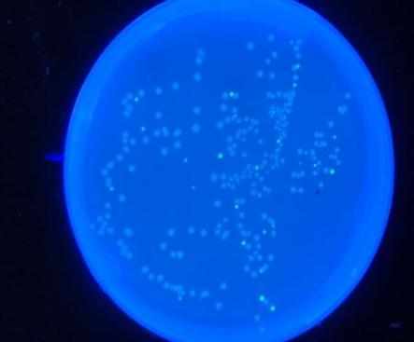

Green fluorescent colonies are conjugator colonies , ↓shown; white colonies are donor colonies; ABCD: recipient :donor to 1:1; EFGH: recipient :donor to 1:2

**Fig.5** The conjugant colonies screening on LB plates

Left: Green fluorescent colonies derived from Fig.6 BCF: lane1-GFP (999bp), lane2-*blaCTX-M-9G* (857bp), lane3-IncFIB (702bp).

Right: Green fluorescent colony from Fig6D, G&H: lane1-GFP (999bp); lane2-*blaCTX-M-9G* (857bp), lane3-IncI2 (615bp), lane4-IncFIB (702bp), lane5-*mcr-1* (1600bp), lane6-*tetA*(210bp); lane7-*fosA3*(282bp); 8: *qnrA* (627bp)

**Fig.6** Identification of conjugates resistance genes and plasmids

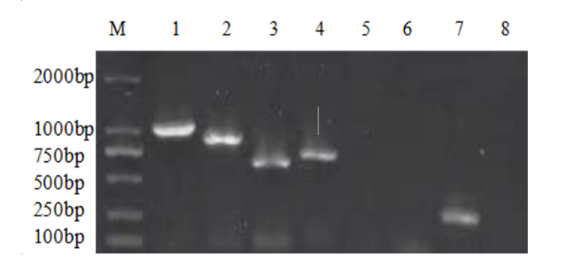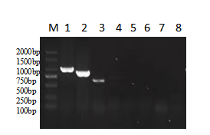

CTX 15h

CTX 5h

Control

(Without CTX)

Standard

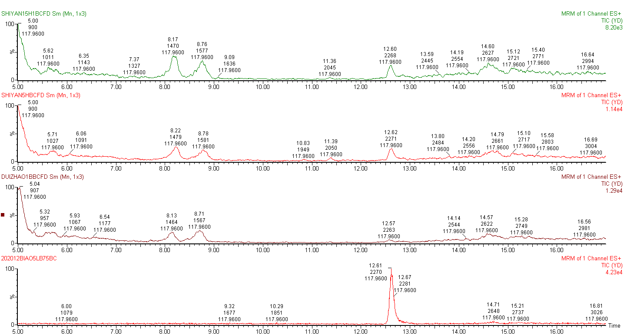

Note: → the HPLC-MS ion current peak of indole

**Fig.7** The total ion chromatogram for the determination of the indole concentration in the culture medium of the recipient bacteria BL21

Note: *vs* control group(0h), \**P*<0.05;\*\**P*<0.01.

**Fig.8** Reltive quantification of*tnaA* mRNA of BL21

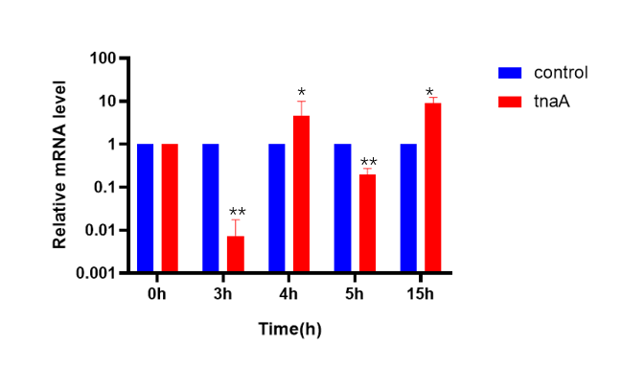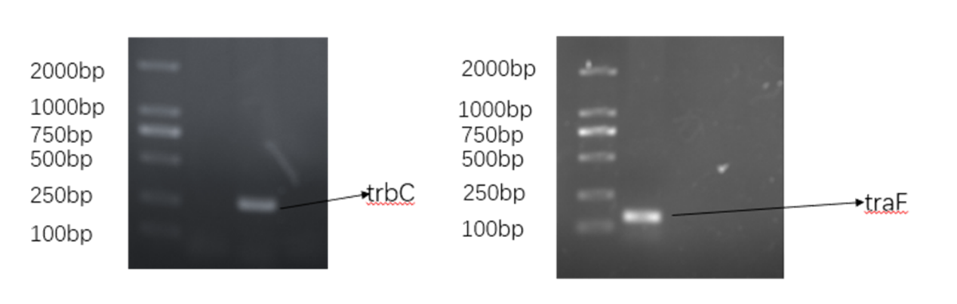

**Fig.9**Agarose electrophoresis of *trbC* and *traF* genes in *E. coli* FTK

**Tab.6** The reagents and manufacturers

|  |  |
| --- | --- |
| Reagent name | Manufacturer |
| Kanamycin | Shanghai Shenggong Bioengineering Co., Ltd |
| Cefotaxime Sodium | Shanghai Shenggong Bioengineering Co., Ltd |
| Lysozyme | Shanghai Shenggong Bioengineering Co., Ltd |
| SanPrep column plasmid DNA small quantity extraction kit | Shanghai Shenggong Bioengineering Co., Ltd |
| Column bacterial genomic DNA Extraction Kit | Shanghai Shenggong Bioengineering Co., Ltd |
| Column bacteria gene total RNA extraction and Purification Kit | Shanghai Shenggong Bioengineering Co., Ltd |
| One step synthesis of premixed reagents for removing the first strand of genomic cDNA by Fastking | Beijing Tiangen Biochemical Technology Co., Ltd |
| Super real fluorescent quantitative premixed reagent | Beijing Tiangen Biochemical Technology Co., Ltd |
| Bacterial protein extraction kit | Shanghai Shenggong Bioengineering Co., Ltd |
| Rapid preparation kit for SDS-PAGE modified acrylamide gel | Shanghai Shenggong Bioengineering Co., Ltd |
| DAB reagent kit | Beijing solab biological Co., Ltd |
| 4S green plus nucleic acid dye | Shanghai Shenggong Bioengineering Co., Ltd |
| DL2000 DNA Marker | Shanghai Shenggong Bioengineering Co., Ltd |
| LB broth medium | Qingdao Haibo biological Co., Ltd |
| LB solid medium | Qingdao Haibo biological Co., Ltd |
| MH broth (MHB) medium | Qingdao Haibo biological Co., Ltd |
| MH agar (MHA) medium | Qingdao Haibo biological Co., Ltd |
| 2×Taq Master Mix | Shanghai Shenggong Bioengineering Co., Ltd |
| MH agar (MHA) medium | Beijing siliang long term Biotechnology Co., Ltd |
| Fluorescent quantitative PCR octet | Axygen company |
| Calcium chloride | Beijing Chemical Reagent Factory |

**Tab.7** Basic information of main instruments

|  |  |  |
| --- | --- | --- |
| Instrument name | Model | Manufacturer |
| Digital display blast drying oven | GZX-9070 MBE | Shanghai bosun Industrial Co., Ltd. medical equipment factory |
| TECAN microplate reader | 200 PRO | TECAN (Shanghai) Trading Co., Ltd |
| High speed table centrifuge | HH-S6 | Anke company |
| Ice maker | IMS-200 | Changshu Xueke Electric Appliance Co., Ltd |
| Electronic balance | JJ50 | Changshu Shuangjie testing instrument factory |
| Ultra-low temperature freezer | EDC-810 | Sanyo, Japan |
| Haier household microwave oven | TGL-16G | Qingdao Jiaonan Haier Microwave Products Co., Ltd |
| Gradient PCR instrument | MDF-U5086W | Dongsheng innovation |
| Horizontal electrophoresis apparatus | DW-25W388(9H) | Beijing Liuyi Instrument Factory |
| Gene amplification instrument | ETC811 | Suzhou Dongsheng Xingye Scientific Instrument Co., Ltd |
| Micro centrifuge | EW-6000 | Dongsheng innovation Biotechnology Co., Ltd |
| Real time PCR | Q2000 | Somerfield company |
| Digital constant temperature water bath | HH-2 | Changzhou huapuda Teaching Instrument Co., Ltd |
| Digital display electric heating incubator | HPX-9052 MBE | Shanghai bosun Industrial Co., Ltd. medical equipment factory |
| Chemiluminescence gel imaging system | ChemStudio | Jena analytical instruments AG |
| Temperature controlled shaker | JK-SI-98A | Shanghai Jingxue Scientific Instrument Co., Ltd |
| Digital display electric heating incubator | 303-4A | Shanghai Sunshine Experimental Instrument Co., Ltd |
| Thermo biosafety cabinet | 1384-2-A2 | Beijing CHENGMAO Xingye Technology Development Co., Ltd |

**Tab.8** MS operating conditions

|  |  |  |
| --- | --- | --- |
| Project | Mass spectrometry conditions | Carrier gas |
| Capillary electrochemistry | 2.5KV |  |
| Cone voltage | 30V |  |
| Extraction voltage | 3V |  |
| Source temperature | 150℃ |  |
| Dissolved gas temperature | 350℃ | Nitrogen |
| Cone Gas Flow | 50L/h |  |
| Dissolved gas flow freqency | 600L/h | Nitrogen |
| Impact gas velocity | 0.18L/h | Nitrogen |

**Tab.9** Liquid phase conditions

|  |  |  |  |
| --- | --- | --- | --- |
| Time | Current Speed | A% | B% |
| 0 | 0.3 | 90 | 10 |
| 5 | 0.3 | 50 | 50 |
| 11 | 0.3 | 0 | 100 |
| 12 | 0.3 | 90 | 10 |
| 17 | 0.3 | 90 | 10 |

Note: A-0.1% formic acid, B-methan ol, flow freqency of 0.3mL/min.