Table s1 Pharmaceutical ingredients of Qinzhuliangxue granules
Chinese name | Chinese name (Pinyin) | Pharmaceutical name | English name | Dosage (grams)
黄芩 | Huangqin | Scutellaria baicalensis Georgi | Radix scutellariae | 15
珍珠母 | Zhenzhumu | Margaritifera Concha | mother-of-pearl | 30
牡丹皮 | Mudanpi | Paenoina suffruticosa Andr | Cortex moudan | 15
紫草 | Zicao | Lithospermum erythrorhizon Sieb. et Zucc. | Radix arnebiae | 12
防风 | Fangfeng | Saposhnikovia divaricata (Trucz.) Schischk. | Divaricate saposhniovia root | 12
灵磁石 | Lingcishi | Magnetite | Magnetitum | 30
生牡蛎 | Shengmuli | Ostrea gigas Thunberg | Oyster shell | 30
生米仁 | Shengmiren | Semen Coicis | Coix seed | 30
生甘草 | Shenggancao | Glycyrrhiza uralensis Fisch. | Radix glycyrrhizae | 9

Table s2 Demographic characteristics of patients with eczema participating in a multi-center clinical research study in China in 2017
Variables | Total  (n=270) | TCM  (n=87) | WM  (n=92) | TCM+WM  (n=91)
Age (years), median (IQR) | 53 (36–61) | 49 (35–61) | 51 (35–61) | 54 (38–61)
Gender, n(%)
Male | 150 (55.56) | 55 (63.22) | 49 (53.26) | 46 (50.55)
Female | 120 (44.44) | 32 (36.78) | 43 (46.74) | 45 (49.45)
Marital status, n(%)
Unmarried | 33 (12.22) | 13 (14.94) | 11 (11.96) | 9 (9.89)
Married | 237 (87.78) | 74 (85.06) | 81 (88.04) | 82 (90.11)
Ethnicity, n(%)
Han | 270 (100.00) | 87 (100.00) | 92 (100.00) | 91 (100.00)
Others | 0 (0.00) | 0 (0.00) | 0 (0.00) | 0 (0.00)
Weight (kg), mean (SD) | 64.46 (10.60) | 64.87 (11.11) | 64.75 (11.40) | 63.76 (9.25)
Height (cm), mean (SD) | 167.38 (7.56) | 168.29 (8.11) | 167.16 (7.52) | 166.71 (7.05)
BMI, mean (SD) | 22.93 (2.86) | 22.80 (2.88) | 23.07 (3.02) | 22.91 (2.70)
Eczema duration (months), median (IQR) | 6 (0–23) | 5 (0–24) | 6 (1–23) | 4 (0–26)
Concomitant diseases, n(%)
Asthma | 11 (4.07) | 7 (8.05) | 2 (2.17) | 2 (2.20)
Allergic rhinitis | 23 (8.52) | 9 (10.34) | 7 (7.61) | 7 (7.69)
Urticaria | 15 (5.56) | 6 (6.90) | 5 (5.43) | 4 (4.40)
Breath (/min), median (IQR) | 18 (17–19) | 18 (17–19) | 18 (17–19.5) | 18 (17–19)
Resting Pulse (/min),median (IQR) | 78 (72–80) | 78 (74–80) | 78 (72–80) | 77 (71–80)
Systolic pressure (mmHg), median (IQR) | 110 (80–120) | 110 (80–120) | 110 (80–124) | 110 (80–120)
Diastolic pressure (mmHg), median (IQR) | 84 (75–120) | 85 (78–120) | 80 (74–120) | 82 (76–120)
Normal ECG, n(%)
Yes | 233 (86.30) | 70 (80.46) | 84 (91.30) | 79 (86.81)
No | 37 (13.70) | 17 (19.54) | 8 (8.70) | 12 (13.19)
Patient type
Outpatient | 260 (96.30) | 82 (94.25) | 89 (96.74) | 89 (97.80)
Inpatient | 10 (3.70) | 5 (5.75) | 3 (3.26) | 2 (2.20)
IQR, interquartile range; SD, standard deviation; TCM, traditional Chinese medicine; WM, Western medicine.

Table s3 Demographic characteristics of patients with eczema from different clinical research centers in China in 2017
Variable | Center A (n=38) | Center B  (n=43) | Center C  (n=38) | Center D  (n=31) | Center E  (n=17) | Center F  (n=53) | Center G  (n=50)
Age (years), median (IQR) | 45.5 (37–55) | 50 (30–63) | 47 (30–60) | 48 (36–63) | 60 (52–62) | 54 (41–60) | 59 (38–62)
Gender, n(%)
Male | 19 (50.00) | 24 (55.81) | 11 (28.95) | 21 (67.74) | 10 (58.82) | 34 (64.15) | 31 (62.00)
Female | 19 (50.00) | 19 (44.19) | 27 (71.05) | 10 (32.26) | 7 (41.18) | 19 (35.85) | 19 (38.00)
Marital status, n(%)
Unmarried | 5 (13.16) | 9 (20.93) | 6 (15.79) | 2 (6.45) | 1 (5.88) | 4 (7.55) | 6 (12.00)
Married | 33 (86.84) | 34 (79.07) | 32 (84.21) | 29 (93.55) | 16 (94.12) | 49 (92.45) | 44 (88.00)
Ethnicity, n(%)
Han | 38 (100.00) | 43 (100.00) | 38 (100.00) | 31 (100.00) | 17 (100.00) | 53 (100.00) | 50 (100.00)
Others | 0 (0.00) | 0 (0.00) | 0 (0.00) | 0 (0.00) | 0 (0.00) | 0 (0.00) | 0 (0.00)
Weight (kg), mean (SD) | 64.44 (10.72) | 63.00 (11.66) | 62.03 (10.12) | 69.74 (8.89) | 64.29 (5.53) | 65.65 (9.11) | 63.00 (12.71)
Height (cm), mean (SD) | 166.89 (7.24) | 167.08 (7.95) | 163.87 (6.55) | 168.26 (7.87) | 167.41 (6.14) | 170.28 (8.46) | 167.02 (6.48)
BMI, mean (SD) | 23.06 (2.98) | 22.44 (2.88) | 23.03 (3.03) | 24.61 (2.51) | 23.02 (2.57) | 22.58 (2.21) | 22.46 (3.26)
Eczema duration (months), median (IQR) | 1 (1–2) | 50 (23–120) | 2 (0–6) | 0 (0–0) | 85 (8–267) | 10 (4–12) | 12 (3–30)
Concomitant diseases, n(%)
Asthma | 1 (2.63) | 1 (2.33) | 0 (0.00) | 1 (3.23) | 0 (0.00) | 0 (0.00) | 8 (16.00)
Allergic rhinitis | 3 (7.89) | 4 (9.30) | 6 (15.79) | 1 (3.23) | 2 (11.76) | 1 (1.89) | 6 (12.00)
Urticaria | 3 (7.89) | 1 (2.33) | 5 (13.16) | 1 (3.23) | 0 (0.00) | 0 (0.00) | 5 (10.00)
Patient type
Outpatient | 38 (100.00) | 43 (100.00) | 34 (89.47) | 31 (100.00) | 17 (100.00) | 47 (88.68) | 50 (100.00)
Inpatient | 0 (0.00) | 0 (0.00) | 4 (10.53) | 0 (0.00) | 0 (0.00) | 6 (11.32) | 0 (0.00)
Group
TCM | 13 (34.22) | 14 (32.56) | 11 (28.95) | 9 (29.03) | 6 (35.29) | 18 (33.96) | 16 (32.00)
WM | 12 (31.58) | 14 (32.56) | 14 (36.84) | 12 (38.71) | 6 (35.29) | 17 (32.08) | 17 (34.00)
TCM+WM | 13 (34.21) | 15 (34.88) | 13 (34.21) | 10 (32.26) | 5 (29.41) | 18 (33.96) | 17 (34.00)
IQR, interquartile range; SD, standard deviation; TCM, traditional Chinese medicine; WM, Western medicine.

Table s4 Treatment responses in patients with eczema participating in a multi-center clinical research study in China in 2017
Evaluation index | TCM  (n=87) | WM  (n=92) | TCM+WM  (n=91) | P
Primary Index- EASI decrease rate, n (%) |  |  |  | 0.582
EASI 95 in week 2 | 1 (1.15) | 0 (0.00) | 1 (1.10)
EASI 60 in week 2 | 4 (4.60) | 9 (9.78) | 8 (8.79)
EASI 30 in week 2 | 82 (94.25) | 83 (90.22) | 82 (90.11)
Total effective rate in week 2 | 5.75 (0.86–10.64) | 9.78 (3.71–15.85) | 9.89 (3.76–15.02) | 0.242
EASI 95 in week 4 | 0 (0.00) | 3 (3.26) | 3 (3.30)
EASI 60 in week 4 | 24 (27.59) | 16 (17.39) | 18 (19.78)
EASI 30 in week 4 | 63 (72.41) | 73 (79.35) | 70 (76.92)
Total effective rate in week 4 | 27.59 (18.19–36.98) | 20.65 (12.38–28.92) | 23.08 (14.42–31.73)
EASI 95 in week 6 | 4 (4.60) | 8 (8.70) | 4 (4.40) | 0.446
EASI 60 in week 6 | 27 (31.03) | 28 (30.43) | 36 (39.56)
EASI 30 in week 6 | 56 (64.37) | 56 (60.87) | 51 (56.04)
Total effective rate in week 6 | 35.63 (25.57–45.70) | 39.13 (29.16–49.10) | 43.96 (33.76–54.15) | 0.812
EASI 95 in week 8 | 9 (10.34) | 13 (14.13) | 14 (15.38)
EASI 60 in week 8 | 39 (44.83) | 35 (38.04) | 37 (40.66)
EASI 30 in week 8 | 39 (44.83) | 44 (47.83) | 40 (43.96)
Total effective rate in week 8 | 55.17 (44.72–65.62) | 52.17 (41.97–62.38) | 56.04 (45.85–66.24) | 0.593
EASI 95 in follow up week 2 | 14 (16.09) | 19 (20.65) | 21 (23.08)
EASI 60 in follow up week 2 | 42 (38.04) | 35 (38.04) | 38 (41.76)
EASI 30 in follow up week 2 | 31 (41.30) | 38 (41.30) | 32 (35.16)
Total effective rate in follow up week 2 | 64.37 (54.30–74.43) | 58.70 (48.63–68.76) | 64.84 (55.02–74.65) | 0.103
EASI 95 in follow up week 4 | 20 (22.99) | 28 (30.43) | 36 (39.56)
EASI 60 in follow up week 4 | 40 (45.98) | 37 (40.22) | 26 (28.57)
EASI 30 in follow up week 4 | 27 (31.03) | 27 (29.35) | 29 (31.87)
Decrease in EASI=(EASI baseline score–EASI after treatment)/EASI baseline score × 100%. The criteria for efficacy were as follows: (I) EASI 95, EASI decrease rate ≥ 95%; (II) EASI 60, EASI decrease rate 60%–94%; and (III) EASI 30, EASI decrease rate <60%.
EASI (Eczema Area and Severity Index)

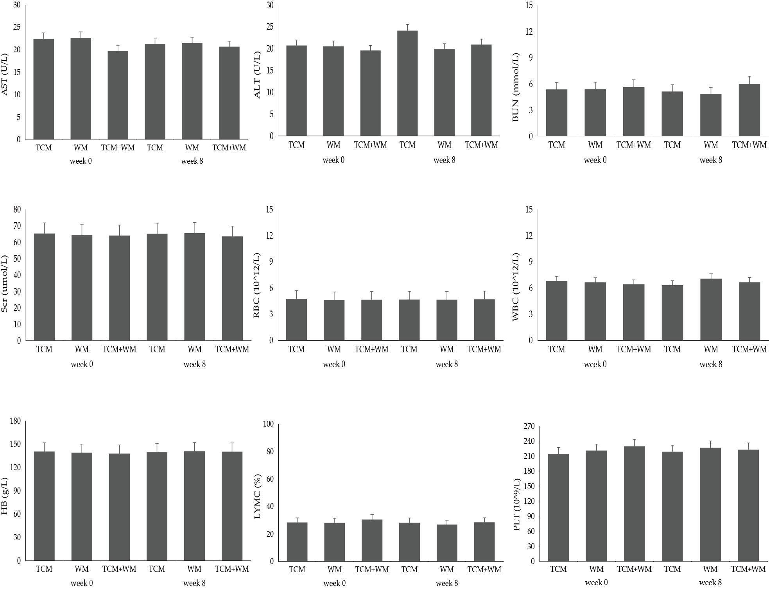

Figure s1 Laboratory test results for patients with eczema treated with traditional Chinese medicine (TCM), Western medicine (WM), and TCM+WM in a multi-center clinical research study in China in 2017
ALT, alanine aminotransferase; AST, aspartate aminotransferase; BUN, urea nitrogen; Scr, serum creatinine concentration; RBC, red blood cell; WBC, white blood cell; Hb, hemoglobin; LYMC, leukomonocyte cell; PLT, platelet

