Supplementary Information

Hyperbolic Metamaterials via Hierarchical Block Copolymer Nanostructures

Irdi Murataj,^{1,2} Marwan Channab,^{1,2} Eleonora Cara,¹ Candido F. Pirri,² Luca Boarino,¹ Angelo Angelini,¹ & Federico Ferrarese Lupi^{1*}

¹Advanced Materials and Life Science Division, Istituto Nazionale Ricerca Metrologica, Strada delle Cacce 91, 10135, Torino, Italy
²Dipartimento di Scienza Applicata e Tecnologia, Politecnico di Torino, Corso Duca degli Abruzzi, 24, 10129, Torino, Italy

Corresponding author e-mail: f.ferrareselupi@inrim.it

Supplementary Fig. 1 Color coding. a SEM micrograph of a dewetted droplet edge and b relative false-color map to identify the lamellar orientations.

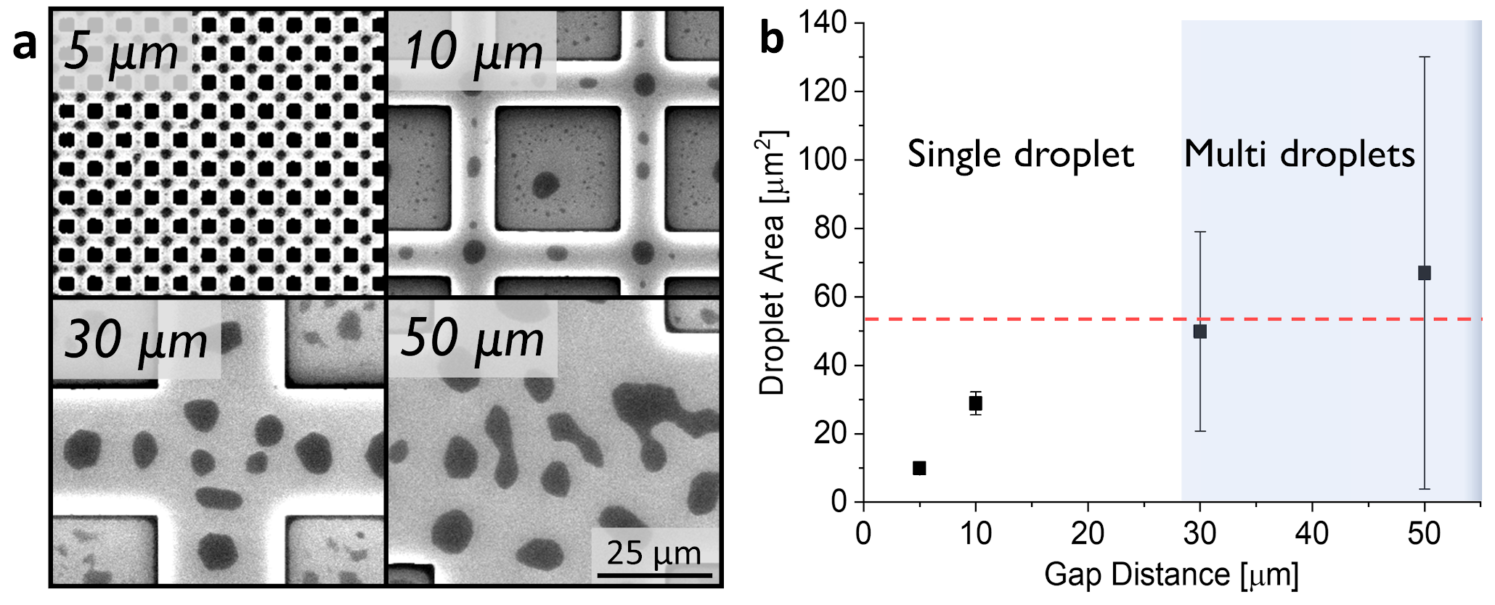

Supplementary Fig. 2 Effect of graphoepitaxy dimensions. a SEM micrographs of dewetting process over topographical patterns with different gap distances (5, 10, 30, 50 µm) and b relative droplet area.

Supplementary Fig. 3 Simulation model. Sketch of the cross-sectional view of the HMM.

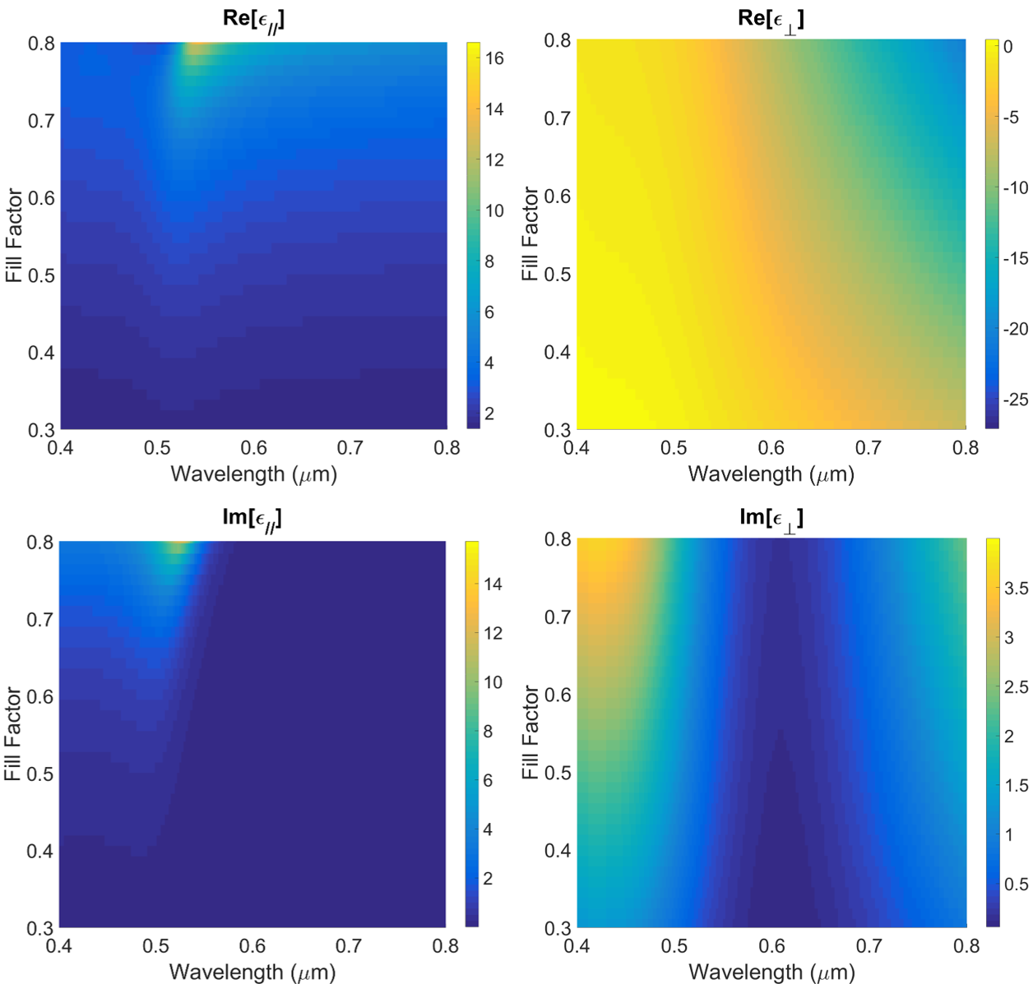
Supplementary Fig. 4 Electrical permittivity components. False color map of the real and imaginary part of the in-plane (left) and out-of-plane (right) permittivity components computed for different wavelengths and different fill factors in the effective medium approximation. The fill factor is calculated as f = d_{Au}/L₀, where d_{Au} is the width of the gold lamella and L₀ is the period of the nanopattern.

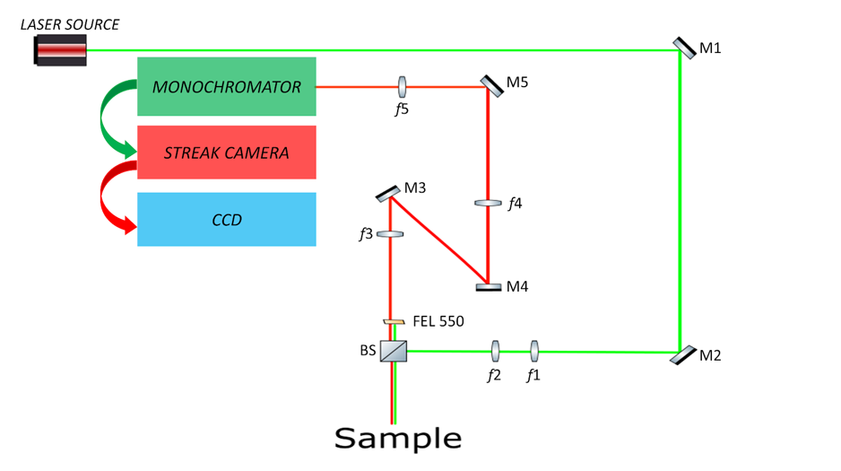
Supplementary Fig. 5 The fluorescence lifetime characterization setup. The laser source is a Tsunami from Spectra-Physics that can provide 10 ps laser pulses centered at 490 nm with an 80 MHz repetition rate. The pulses are directed towards a beam expander formed by two lenses (f1 and f2) to adjust the laser collimation. Afterwards, a beam splitter (BS) reflects the laser pulses that is focused on the sample by a 20x objective. The sample is positioned on a microscope stage that allows for double side imaging: from one side the sample surface can be imaged in white light with a 100x microscope objective (Nikon 100x 0.95 NA), from the other side we employ a Nikon 20x 0.40 NA objective through which the laser pulses are focused on the sample surface and fluorescence is collected. The collected fluorescence passes through a long pass filter (FEL 550 from Thorlabs) that filters out the reflected laser pulses and is then injected into a monochromator (Princeton Instruments Acton SpectraPro SP-2300) after passing through a set of lenses (f3, f4 and f5). The monochromator is coupled to a Hamamatsu universal streak camera that allows for time-resolved fluorescence decay measurements.

