Production, purification and characterization of mannanase obtained from Pichia kudriavzevii strain AUMC 10190 isolated from citrus wastes

Folake T. Afolabi ^{*1} and Yetunde Z. Jimoh²
Department of Microbiology, Faculty of Science, University of Ibadan, Ibadan, Nigeria
Correspondence:
E-mail: folakeojo1@yahoo.com
Tel: +23408034218552
Co-Author E-mail: jimyet4luv@yahoo.com

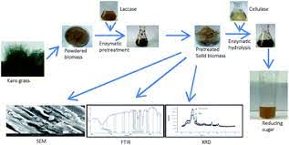

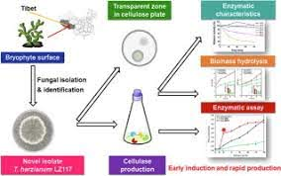

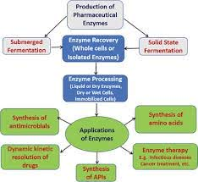

Citrus fruit peels yeast inside conical flask mannanase
Incubation period, pH, temperature, carbon and nitrogen source were optimized

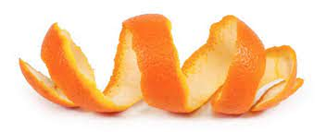
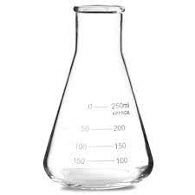
yeast
mannanase
Incubation period, pH, temperature, carbon, nitrogen source

Therefore, it can be concluded that Pichia kudriavzevii (AUMC 10190) isolated from citrus waste is potential yeast for the production of mannanase under suitable condition for higher yield.
Keywords: Gum Arabic, Mannanase, Pichia kudriavzevii (AUMC 101190), Yeasts

