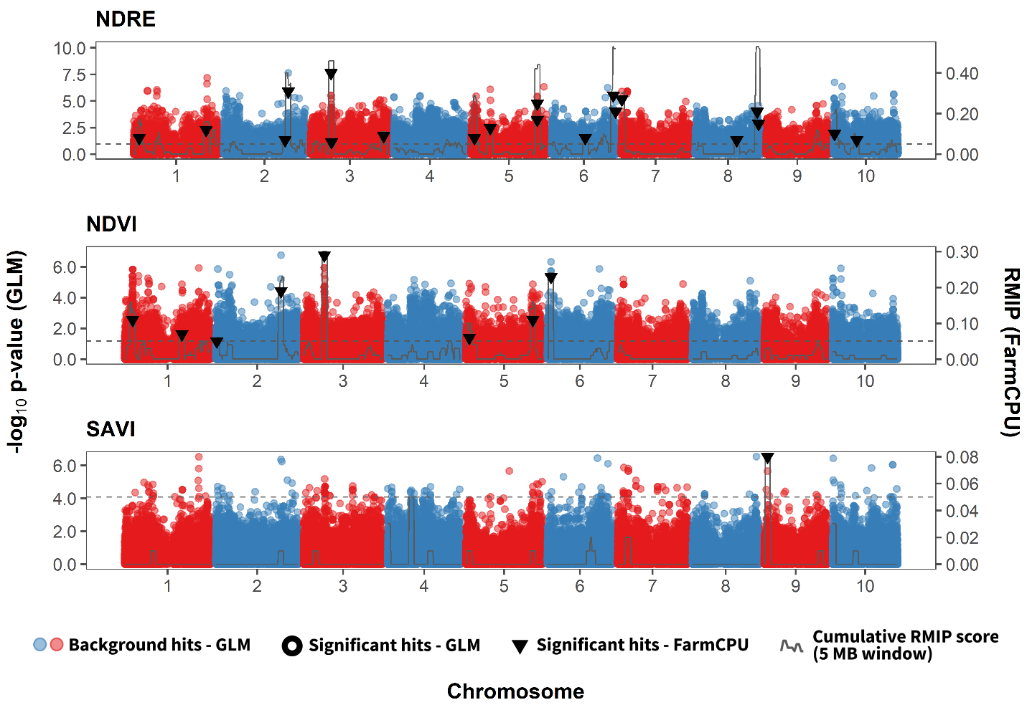
Supplementary Fig. S1: Genome-wide association for Unmanned Aircraft Systems-based reflectance indices without using flowering time as a covariate. Data was taken on Aug 25, 2020 at Tifton, GA. Red and blue markers indicate associations from a generalized linear model (GLM), plotting according to their physical location and -log10 (raw) p-value; SNPs with significant empirical p-values (≤0.01) are circled. The Resample Model Inclusion Probability (RMIP) from 100 FarmCPU iterations is plotted on the right axis, with significant individual SNPs (RMIP ≥ 0.05) as triangles. The total RMIP in a 5-Mb sliding window is shown as a gray line to show where several weak loci indicate a significant but poorly resolved locus.

