Supplementary information

Skyrmion phase in MnSi thin films grown on sapphire by a conventional sputtering

Won-Young Choi ª, Hyun-Woo Bang ª, Seung-Hyun Chun ^{b}, Sunghun Lee ^{b,*}, and Myung-Hwa Jung ^{a,*}
ª Department of Physics, Sogang University, Seoul 04107, Korea
^{b} Department of Physics, Sejong University, Seoul 05006, Korea

*E-mail: kshlee@sejong.ac.kr(S.L.) or mhjung@sogang.ac.kr(M.H.J.)

KEYWORDS: MnSi, Sputtering, Polycrystal, Skyrmion, Topological Hall effect

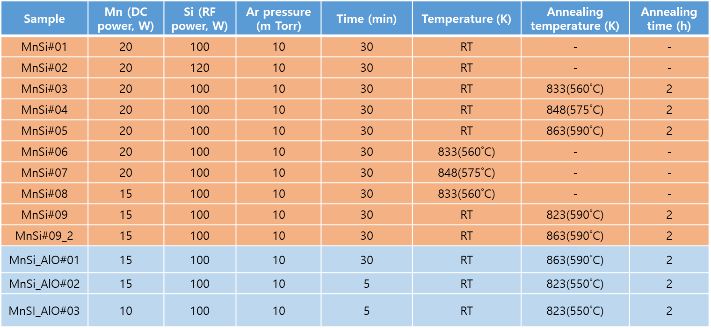
Table S1. Growth conditions for MnSi on Si (001) and Al₂O₃ substrates, varying Mn power/growth temperature/annealing temperature.

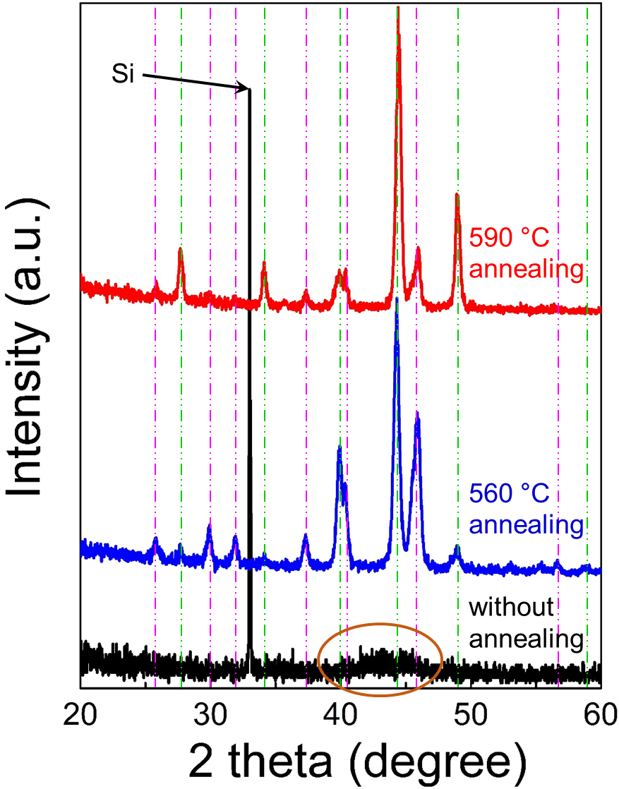
Figure S1. XRD patterns of MnSi films on Si (001) substrate. By examining the annealing treatment, initially deposited amorphous MnSi (brown open circle in black XRD line) turned into crystallized MnSi phase after annealing treatment over specific temperature. Magenta and green dotted lines indicate Mn₅Si₃ and MnSi phase, respectively.

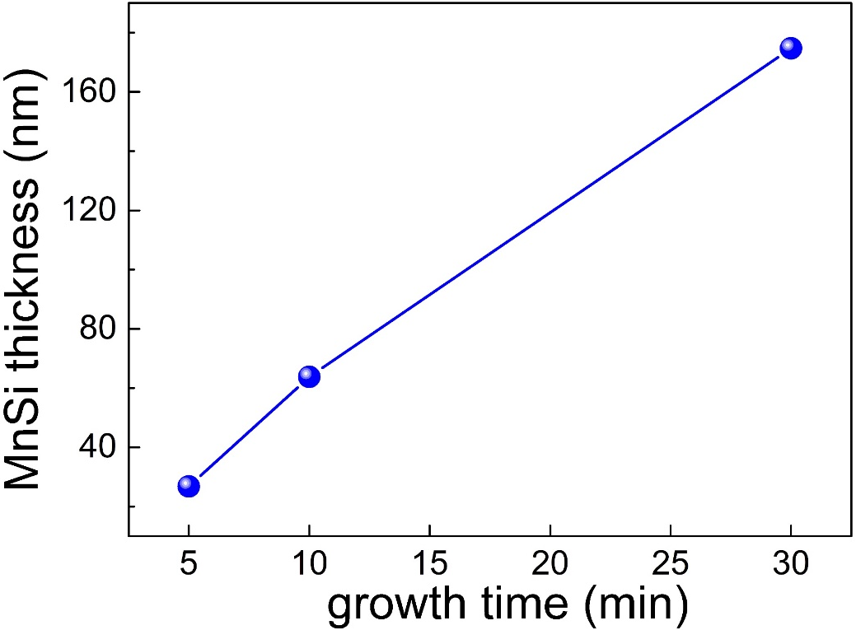
Figure S2. Thickness of MnSi films regarding of growth time in conventional sputtering, showing linear behavior.

