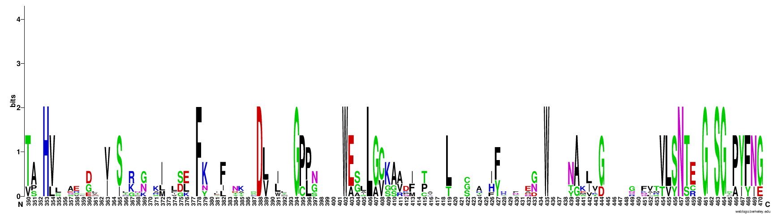
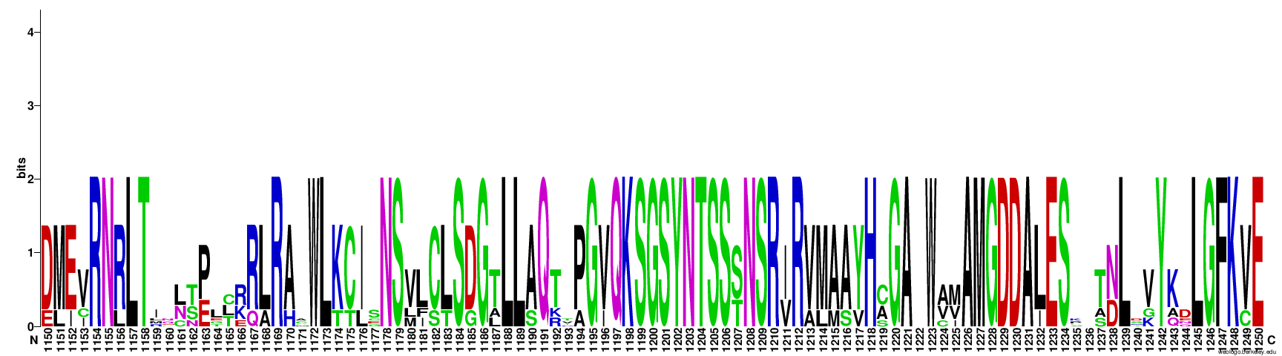
A
B

Fig. S1 Conserved H(X₂₅)D(_{X70–80})GXSG domain (A) and GXXXTXXXN(X_{25–40})GDD motif (B) determined in the P1 and P1−P2 proteins, respectively of the identified viruses. The sequence logos were generated using the webserver WebLogo 3.

