Supplemental Figure 1. Multivariable Cox regression analysis for effect of downstaging of T-stages on (A) all causes of death, (B) locoregional recurrence (LRR)-free survival, (C) distant metastasis (DM)–free survival, and (D) disease-free (DF) survival.
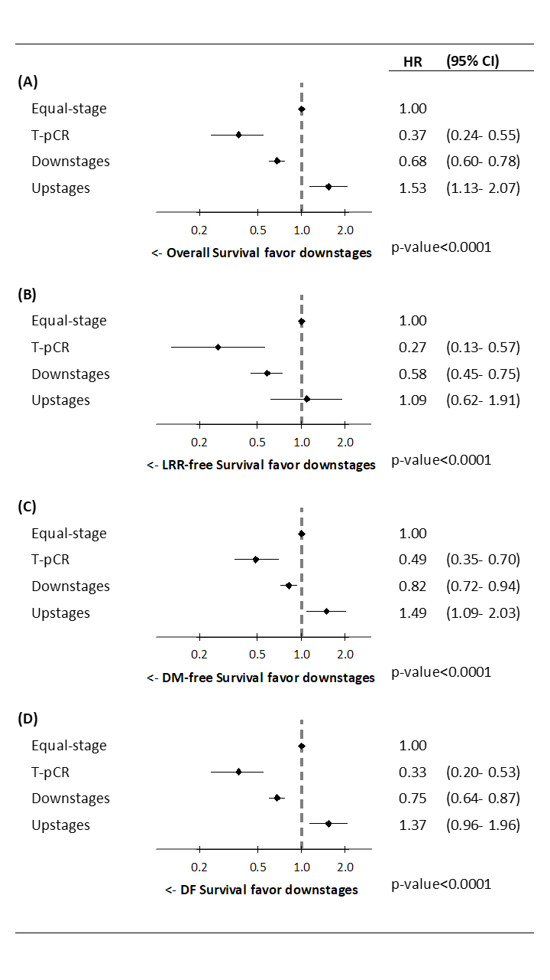
Adjusted hazard ratio: All variables presented in Table 2 were used in the multivariate analysis.
HR, hazard ratio; CI, confidence interval; RT, radiation therapy; T, tumor; N, nodal

Supplemental Figure 2. Multivariable Cox regression analysis for effect of downstaging of N-stage on (A) all causes of death, (B) locoregional recurrence (LRR)-free survival, (C) distant metastasis (DM)–free survival, and (D) disease-free (DF) survival. 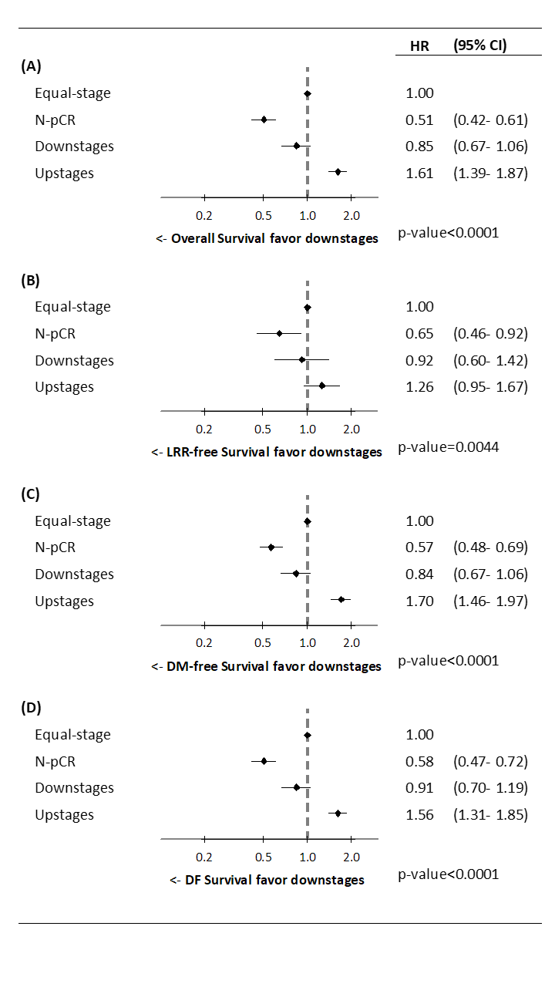
Adjusted hazard ratio: All variables presented in Table 2 were used in the multivariate analysis.
HR, hazard ratio; CI, confidence interval; RT, radiation therapy; T, tumor; N, nodal

