Zn²⁺ -Schiff’s base complex acts as the molecular switch “On-Off-On” and a fluorescence probe toward Cu²⁺ and Ag⁺ ions
Shaaban A. Elroby^{1, 2*}, Bashair Abdullah Banaser^{1*}, Saadullah G Aziz¹, Abdesslem Jedidi¹, Walid I Hassan¹, Osman I Osman^{1,3}
¹Chemistry Department, Faculty of Science, King Abdulaziz University, Jeddah, 21589, Saudi Arabia
²Chemistry Department, Faculty of Science, Beni-Suef University, Beni-Suef, 62511, Egypt ³Chemistry Department, Faculty of Science, University of Khartoum, 11111, Khartoum, Sudan

Table S1: Geometry optimized structures and minimum energies in the gas phase and methanol as a solvent of all the possibilities of the protonation/deprotonation of E-CIS using B3LYP/6-311++G** level of theory.
 |  | Relative energies (kcal/mol)
E-CIS | Structure | Gas Phase | Solvent Phase (Methanol)
H₂L | 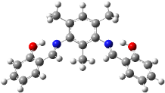 | 0 |  | 0
HL⁻¹ | 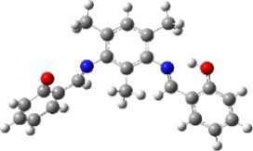 | 325.159 |  | 306.852
L⁻² | 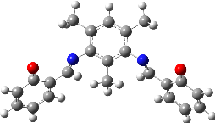 | 750.439 |  | 615.901
H₃L⁺¹ | 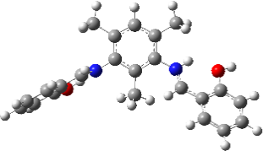 | -240.587 |  | -275.539
H₄L⁺² | 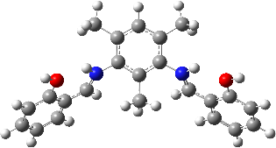 | -429.782 |  | -547.377

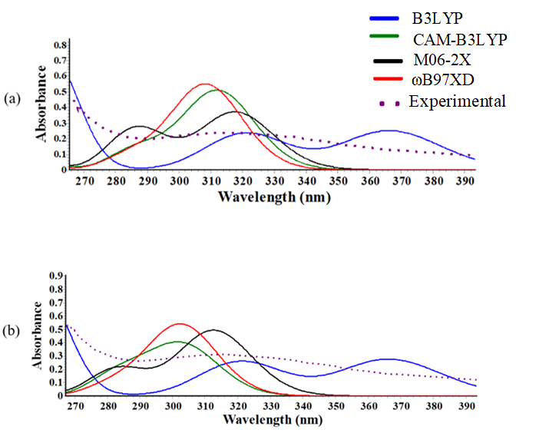
Figure S1: The simulation of UV-Vis spectra of E-CIS with different TDDFT functionals with 6-311++G** basis set (a) the optimized structure comes from the B3LYP/6-311++G** level of theory. (b) The optimized structures come from the different DFT functionals.

Table S2: Natural transition orbitals visualization of E-CIS tautomer emission obtained by using TDDFT/B3LYP/6-311++G** level of theory in the gas-phase and methanol as a solvent.
Gas Phase |  | Methanol
Particle | Hole | Particle | Hole
(λ = 451.560 nm) $π^{*}⟶n$ |  | (λ = 497.631 nm) $π^{*}⟶n$
 |  | 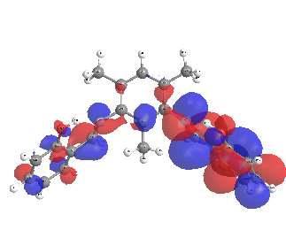 | 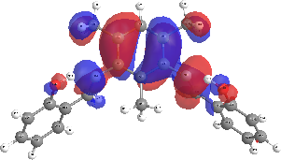
(λ = 440.318 nm) $π^{*}⟶n$ |  | (λ = 455.475 nm) $π^{*}⟶n$
 |  | 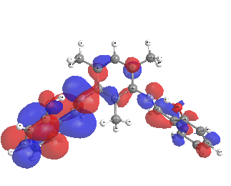 | 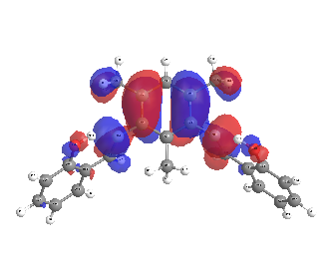

Table S3: Selected bond lengths (Ǻ) and bond angles (°) of E-CIS and K-CIS tautomers in S₀ and S₁ states obtained by using DFT/TDDFT/B3LYP/6-311++G** levels of theory
 | Gas-phase |  |  |  | Methanol
 | E-CIS |  | K-CIS |  | E-CIS |  | K-CIS
 | S₀ | S₁ | S₀ | S₁ | S₀ | S₁ | S₀ | S₁
O47–H48 | 0.993 | 0.990 | 1.685 | 1.699 | 0.998 | 0.995 | 1.750 | 1.756
H48–N20 | 1.745 | 1.761 | 1.045 | 1.043 | 1.716 | 1.732 | 1.037 | 1.036
N20–C22 | 1.284 | 1.285 | 1.329 | 1.327 | 1.285 | 1.285 | 1.322 | 1.321
C22–C24 | 1.452 | 1.45 | 1.396 | 1.398 | 1.454 | 1.453 | 1.404 | 1.405
C24–C25 | 1.419 | 1.419 | 1.466 | 1.466 | 1.418 | 1.418 | 1.459 | 1.459
C25–O47 | 1.341 | 1.342 | 1.262 | 1.262 | 1.384 | 1.348 | 1.272 | 1.273
O47–H48–N20 | 147.39 | 146.83 | 140.17 | 139.74 | 148.34 | 147.60 | 138.07 | 138.00

Table S4: Optimized structures and Binding energy/kcal/mol for the studied complexes using B3LYP/LANL2DZ/6-311++G** level of theory in the gas phase and methanol
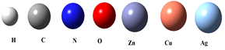
Complex | Symbol | Optimized structure | Gas Phase | Methanol | water
[Zn₂L₂]⁰ | 1 | 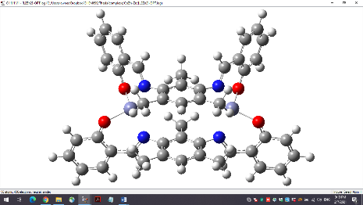 | -886.686 | -210.952 | -172.059
[Cu₂L₂]⁰. H₂O | 2S |  | -954.698 | -2.707 | -410.133
[Cu₂L₂]⁰. H₂O | 2T |  | -986.647 | -33.719 | -438.747
[Ag₂L₂]⁰ | 3 | 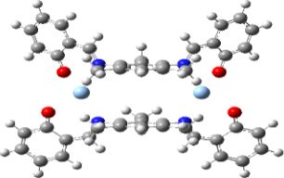 | -27.399 | 327.961 | -82.615
[AgZnL₂]⁻¹. H₂O | 4 | 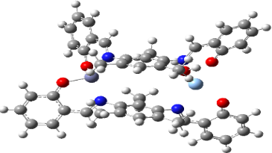 | -467.373 | 283.409 | -129.389
[CuZnL₂]⁰ | 5 | 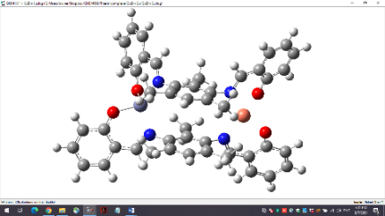 | -943.543 | 79.807 | -302.893
[AgCuL₂]⁻¹ | 6 | 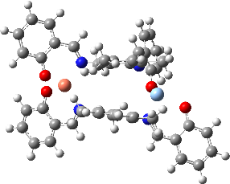 | -539.838 | 134.357 | -262.858
[Zn₂L₂]⁰. [Ag⁺]₂ (S) | 7S | 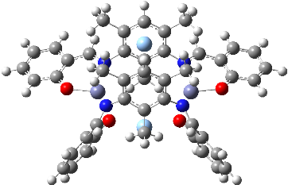 | -971.876 | 202.352 | -170.553
[Zn₂L₂]⁰. [Cu⁺²] | 8D | 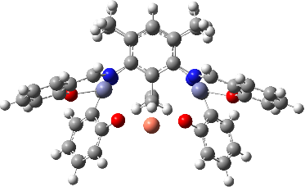 | -969.017 | -142.191 | -121.043
[Zn₂L₂]⁰. [Cu⁺²] | 8U | 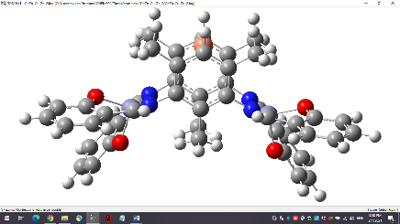 | -1263.477 | 76.666 | -291.567
[Zn₂L₂]⁰. [Cu⁺²]₂ (T) | 9T |  | -1254.250 | 71.540 | -306.244

Table S5: Optimized geometric parameters of L⁻² ligand and metal complexes obtained by using DFT/B3LYP/LANL2DZ/6-311++G** level of theory (bond lengths in Å and bond angles in degrees).

Bond Parameters | L⁻² | Zinc complexes |  |  |  |  | Copper complexes
 |  | 1 |  | 7 | 8D | 8T | 2S / 2T
L⁻²  O47-C25  N20=C22  O47-C25-C24  N20=C22-C24 | Theoretical | Theoretical | Exp. | Theoretical |  |  | Theoretical | Exp.
 | 1.250 | 1.320 | - | 1.320 | 1.31 | 1.32 | 1.32 / 1.32 | -
 | 1.280 | 1.320 | - | 1.330 | 1.31 | 1.32 | 1.31 / 1.31 | -
 | 124.8 | 122.73 | - | 122.34 | 122.19 | 122.05 | 121.5 / 121.05 | -
 | 128.9 | 128.15 | - | 129.29 | 128.58 | 128.11 | 128.46 / 128.75 | -
Zn1-Zn31  N3-Zn1  O5-Zn1  N3-(Ag97 or Cu97)  N3-(Ag98 or Cu97)  O5-M-N3  O5-M-N2  N2-Zn1-N3  O5-Zn1-O6  Ag97-N3-Ag98  N2-(Ag97 or Cu97)-N3 | - | 6.722 | 7.141 | 5.73 | 5.48 | 6.67 | 6.89 / 6.90 | --
 | - | 2.091 | 2.016 | 2.09 | 2.08 | 2.09 | 2.051 / 2.065 | 1.955
 | - | 1.981 | 1.907 | 1.93 | 1.98 | 1.97 | 1.972 / 1.947 | 1.965
 | - | - | - | 4.22 | - | 4.12 | - | -
 | - | - | - | 4.66 | 4.55 | - | - | -
 | - | 89.80 | 96.07 | 92.79 | 90.87 | 89.55 | 87.25 / 86.16 | 94.30
 | - | 127.76 | 122.55 | 113.89 | 114.88 | 128.38 | 143.51 / 156.80 | 141.90
 | - | 122.58 | 111.73 | 134.88 | 134.15 | 123.76 | 115.25 / 110.59 | 104.00
 | - | 103.62 | 108.44 | 111.37 | 108.44 | 101.25 | 89.92 / 86.3 | 90.70
 | - | - | - | 87.73 | - | - | - | -
 | - | - | - | 53.01 | 54.12 | 52.34 | - | -

Table S6. Energies of HOMOs , LUMOs and E_{g}=LUMO-HOMO are calcualted using DFT/B3LYP/LANL2DZ/6-311++G** level of theory in the gas-phase.
 | HOMO | LUMO | E_{g}
ECIS | -6.023 | -1.961 | 4.062
L⁻² | 0.509 | 3.641 | 3.132
1 | -5.616 | -2.029 | 3.587
2S | -4.699 | -4.252 | 0.447
2T | -5.541 | -1.963 | 3.578
3 | -0.289 | 3.052 | 3.341
4 | -2.149 | -0.085 | 2.064
5 | -5.612 | -2.017 | 3.595
6 | -2.2 | -0.008 | 2.192
7 | -10.111 | -7.616 | 2.495
8D | -10.832 | -7.128 | 3.704
8U | -10.518 | -7.249 | 3.269
9T | -15.312 | -12.331 | 2.981
9S | -15.357 | -15.045 | 0.312

Table S7: Electronic absorption energy (nm/eV), corresponding oscillator strengths, assignments and coefficients of the ligand and its complexes obtained by using TDDFT/B3LYP/LANL2DZ/6-311++G** level of theory.
Compound | Exp. λ _{(nm)} | λ _{(nm)} | $$E_{ex.}(eV)$$ | f | Assignment | Coefﬁcient
E-CIS | 314 | 314.467 | 3.943 | 0.033 | H→L | 0.52
 | 258 | 257.460 | 4.816 | 0.148 | H-4→L | 0.59
1 | 398 | 396.358 | 3.128 | 0.099 | H→L+1 | 0.48
 | 278 | 275.559 | 4.499 | 0.012 | H-1→L+4 | 0.53
2S | 325  274 | 328.995 | 3.769 | 0.002 | H-4→L+4 | 0.62
 |  | 275.326 | 4.503 | 0.002 | H-3→L | 0.42
2T |  | 326.585 | 3.796 | 0.005 | H-5α→L+1α | 0.45
 |  | 276.585 | 4.483 | 0.009 | H-7ꞵ→ L+4ꞵ | 0.55
7 | 323 | 322.290 | 3.847 | 0.066 | H-10→L | 0.31
 | 278 | 278.493 | 4.452 | 0.023 | H-6→ L+4 | 0.38
8D | 357  281 | 356.278 | 3.480 | 0.001 | Lꞵ→ H-2ꞵ | 0.96
 |  | 286.863 | 4.322 | 0.004 | L+1ꞵ →H-10ꞵ | 0.52
8U |  | 359.606 | 3.448 | 0.000 | L+2α →H-3α | 0.38
 |  | 292.121 | 4.244 | 0.005 | Lꞵ→ H-3ꞵ | 0.82

Table S8: Natural transition orbitals (NTO) visualization of complexes in gas-phase and solution (methanol) obtained by using TDDFT/B3LYP/ LANL2DZ /6-311++G** method
Complex | Absorptions in the gas-phase |  |  | Absorptions in solution (Methanol)
 | Hole | Particle |  | Hole | particle
1 | (λ = 396.358 nm) n$⟶π^{*}$ |  |  | (λ = 387.120 nm) n$⟶π^{*}$
 | 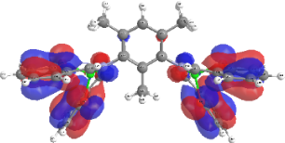 |  | 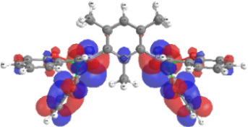 | 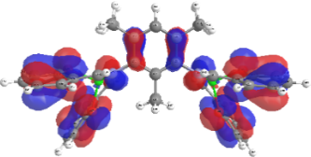 | 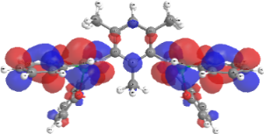
 | (λ = 275.559 nm) $π⟶π^{*}$ |  |  | (λ = 285.950 nm) $π⟶π^{*}$
 | 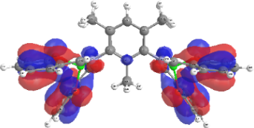 | 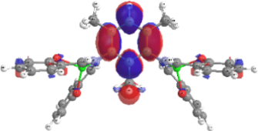 |  | 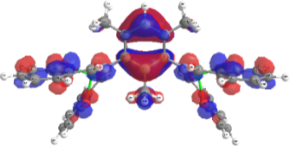 | 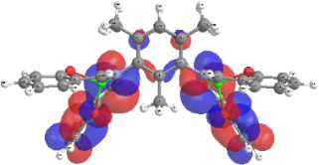
7 | (λ = 322.290 nm) n$⟶π^{*}$ |  |  | (λ = 325.061 nm) n$⟶π^{*}$
 | 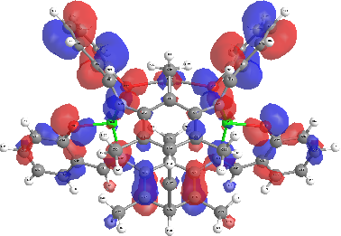 | 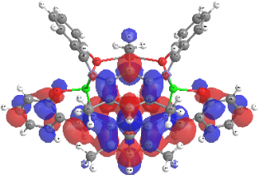 |  | 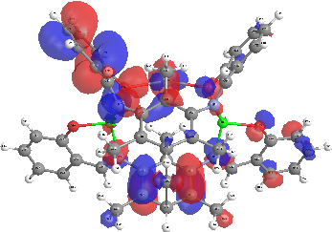 | 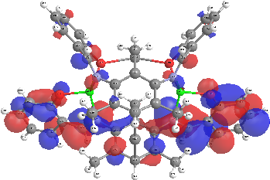
 | (λ = 278.493 nm) $π⟶π^{*}$ |  |  | (λ = 278.199 nm) $π⟶π^{*}$
 | 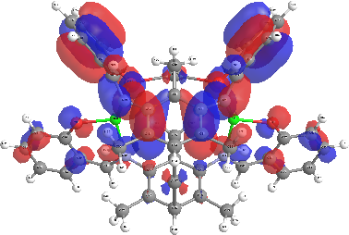 | 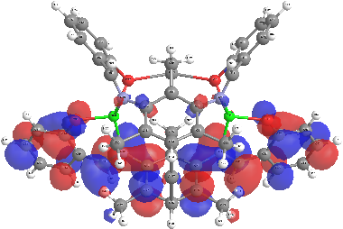 |  | 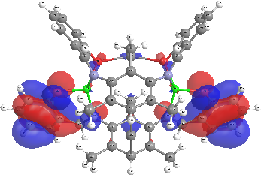 | 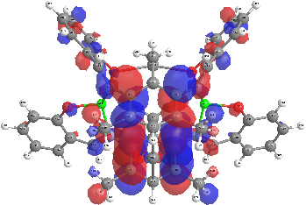
8D | (λ = 356.278 nm) n$⟶π^{*}$ |  |  | (λ = 358.815 nm) n$⟶π^{*}$
 | 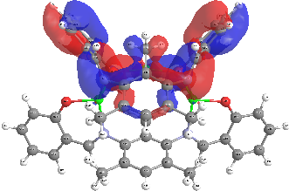 | 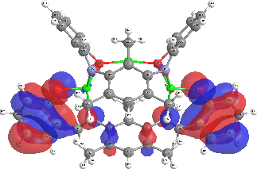 |  | 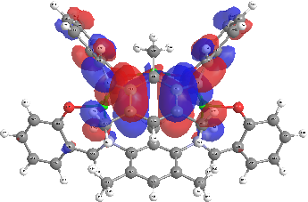 | 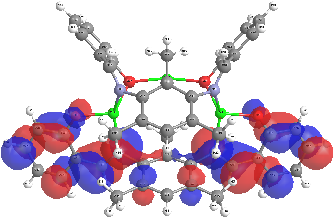
 | (λ = 286.863 nm) $π⟶π^{*}$ |  |  | (λ = 288.989 nm) $π⟶π^{*}$
 | 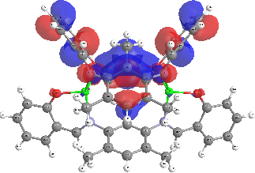 | 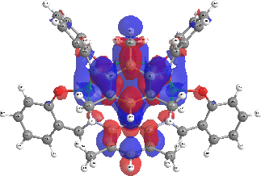 |  | 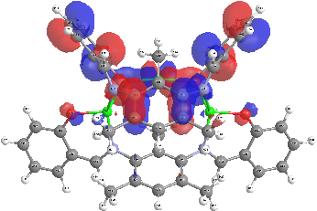 | 