Supplementary material
A soil-borne Mn(II)-oxidizing bacterium of Providencia sp. exploits a strategy of superoxide production coupled to hydrogen peroxide consumption to generate Mn oxides
Sha Chen, Zhexu Ding, Jinyuan Chen, Jun Luo, Xiaofang Ruan, Zongpei Li, Fengfeng Liao, Jing He, Ding Li*
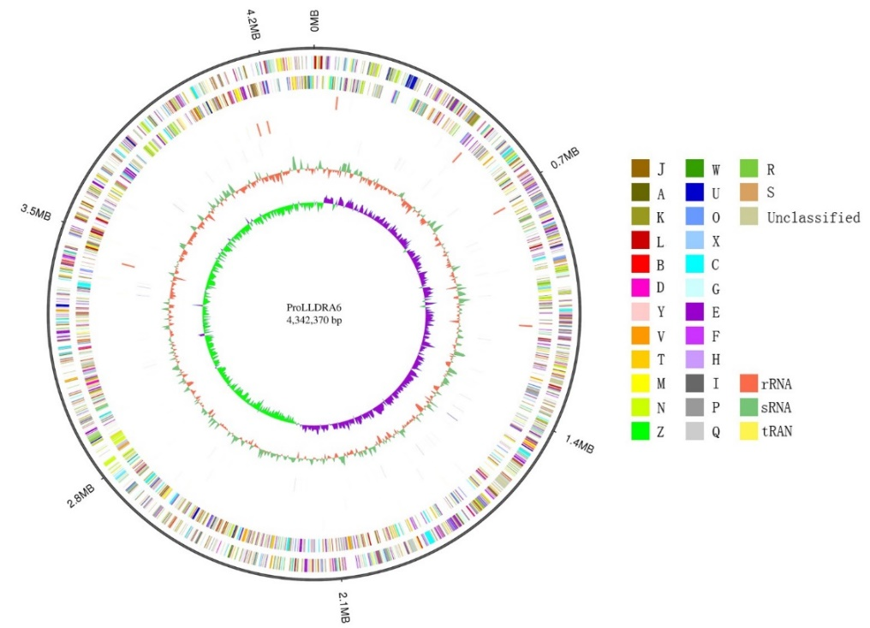

Fig. S1. Circular representation of the chromosome genome for Providencia sp. LLDRA6. The distribution of the circle from outer to inner indicates forward/reverse strand genes (colored according to cluster of orthologous groups of proteins, COG), forward/reverse strand ncRNAs, repeat sequences, GC-skew, and genome size, respectively. According to COG analysis, uppercases on the right denote as follows. A: RNA processing and modification; B: Chromatin structure and dynamics; C: Energy production and conversion; D: Cell division; E: Amino acid metabolism; F: Nucleotide metabolism; G: Carbohydrate metabolism; H: Coenzyme metabolism; I: Lipid metabolism; J: Translation; K: Transcription; L: DNA replication, recombination and repair; M: Cell wall/membrane biogenesis; N: Cell motility; O: Posttranslational modification; P: Inorganic ion metabolism; Q: Secondary metabolites biosynthesis and catabolism; R: General function; S: Function unknown; T: Signal transduction mechanisms; U: Intracellular secretion; V: Defense mechanisms; W: Extracellular structures; X: Mobilome: prophages, transposons; Z: Cytoskeleton.

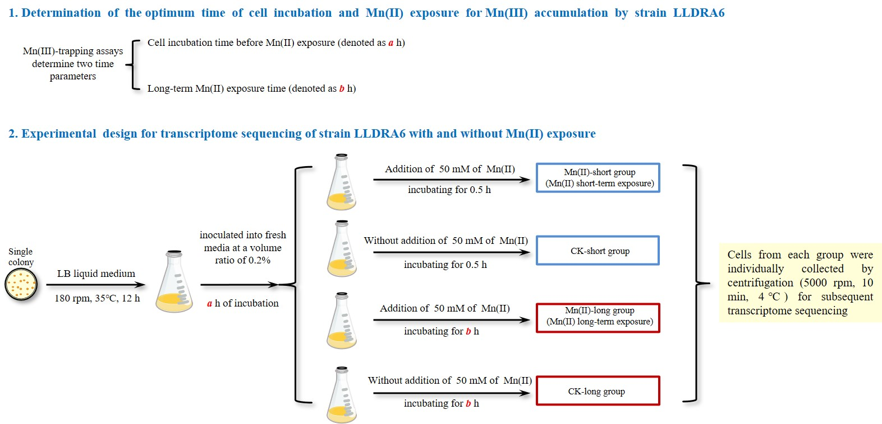

Fig. S2. The flowchart of experimental design for transcriptome sequencing of strain LLDRA6 with and without Mn(II) exposure.

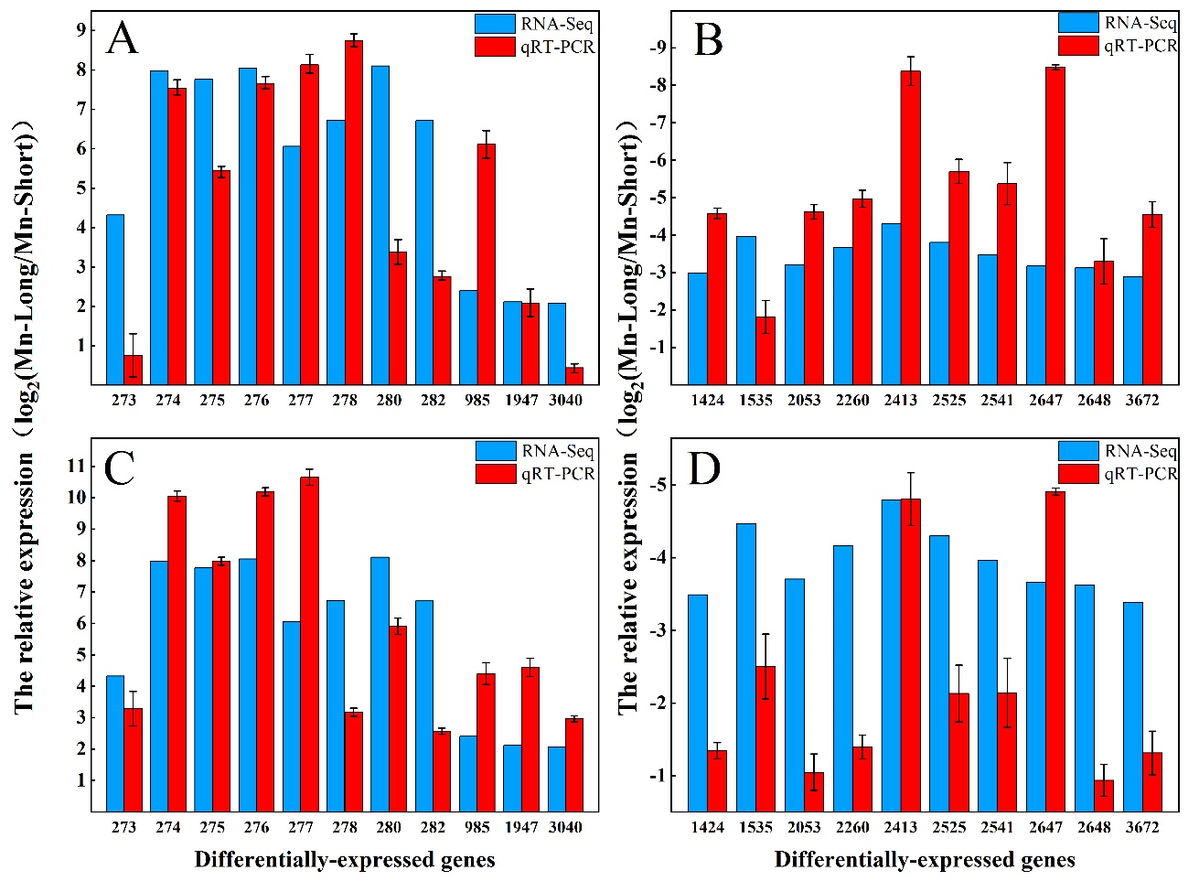
Fig. S3. A total of 21 genes upregulated or downregulated between long-term Mn(II) exposure and short-term Mn(II) exposure were chosen to validate the RNA-seq data by qRT-PCR. The red column represents log₂-transformed mean value obtained from three independent biological replicates of qRT-PCR data. The error bar shows standard deviation (SD). The blue column represents log₂(fold change) value based on RNA-seq data. The 16s rRNA gene was used as an internal control for 11 upregulated genes (A) and 10 downregulated genes (B), respectively. The gyrA gene was used as an internal control for 11 upregulated genes (C) and 10 downregulated genes (D), respectively. The numbers on the bottom of figures represent selected genes as described in Table S2.

Table S1. Principle features of the genome of Providencia sp. LLDRA6.
Feature | Chromosome
Genome size (bp) | 4,342,370
Illumina Data (Mb) | 1,131 (260X)
PacBio Data (Mb) | 1,497 (344X)
GC content (%) | 40.18
Total number of genes | 3,956
Genes with predicted functions | 3,818 (96.51%)
Total number of ncRNAs | 116
Repeat number | 185
CRISPR number | 5
Prophage number | 4
Note: "X" stands for sequencing depth, the amount of sequenced reads divided by genome size.

Table S2. List of primers used for quantitative real time PCR (qRT-PCR).
Gene ID | Orthology | Primer sequences (5′-3′)  Forward primer/Reverse primer
ProLLDRA6GL000273 | paaX | GCAGCTCCTAGCAGTGCTCAAG
 |  | TGGTGGTAGTGCTCTGCAACTTG
ProLLDRA6GL000274 | paaK | GTGGACACTCACTCACGCTTACG
 |  | AGGAACCGCGAAGGTATTGAAGG
ProLLDRA6GL000275 | paaJ | GCCGTTATGGTGGTGCTCTGTC
 |  | GCCATTCTTGCGACATTACGGTTG
ProLLDRA6GL000276 | paaI | TGCTGCTGTTGCATCCAGTT
 |  | ACGTCCGGAGAACCAAGCTA
ProLLDRA6GL000277 | paaH | ACCGACAACGCCATGTGTTACG
 |  | TGATGACCTGCCGCCAATTGC
ProLLDRA6GL000278 | paaG | AATGTGACGGCCAGTGACCAAG
 |  | CCAGCTAATGCAATGGCAGCAC
ProLLDRA6GL000280 | paaE | ATTGCGTCAAGGAGCTGATCTGC
 |  | AATCGAGCACGACACCATCGC
ProLLDRA6GL000282 | paaC | TTACTGGCGAGCTGTTCCATGC
 |  | ACCTAGATGCTCAGTGTGATTGCC
ProLLDRA6GL000985 | aroF, aroG, aroH | GCTCGTGGTATGTGGTCCTTGTTC
 |  | CCATCGCAGGATCGCTGATTAGTC
ProLLDRA6GL001947 | oppA, mppA | AGGCGTTGCTACTGGCTTAATGG
 |  | GCCAGCGCAGATTCAGGAACC
ProLLDRA6GL003040 | sucD | CGTGAAGCCGTAGAAGCGACTG
 |  | AACCGTCAGCATATCCAGTGTTGG
ProLLDRA6GL001424 | grcA | GCCGACTGTACGTGTTGAAGGTG
 |  | CGTTGCTGCTCTGGTGTCAGTG
ProLLDRA6GL001535 | hutU, UROC1 | GGTTCCGATGCGGTATCAGATTGG
 |  | TGCGATACGTTCAGCAGCTTCATC
ProLLDRA6GL002053 | Unknown | TCAGGGCTCCCTTTTCGTTCA
 |  | TAGACCCAAGCGGGTGGAAC
ProLLDRA6GL002260 | ipdC | GCCTCATACGCCGCAGATGG
 |  | TTGTACTCCACTTGCTGGCATCC
ProLLDRA6GL002413 | Unknown | GCGTCACTCAACAAACCACC
 |  | GGCGGAGTAACAGCATTGGT
ProLLDRA6GL002525 | fliC | AACAACCTGAGTGCTGCACGTAG
 |  | AACGCAACAGGCTCAGAACACC
ProLLDRA6GL002541 | Unknown | TGCGGCATCTGTTGTTCCATT
 |  | CGCCGCTTTACCACTTTCCA
ProLLDRA6GL002647 | mgtA, mgtB | ACCTTGTTTTCCCTTGCCGT
 |  | TGCACAGAACATCCATCGCC
ProLLDRA6GL002648 | mgtC | ATGGCTGGTCTTCGCACTAATGC
 |  | ACCACAGTGTTGCCGCTGTATTC
ProLLDRA6GL003672 | Unknown | TAATGGCCCGAATAGCGGTG
 |  | GTCACATTGAGGCCGTTCCA
 | 16s rRNA | CTACACATGCAGTCGAGCGG
 |  | CATCCGATAGCGCAAGGACC
 | gyrA | ATCCTGGACATGCAGTTGCG
 |  | GTCCACGATTTCGGCGAGTT

Table S3. A total of 547 DEGs were identified between Mn(II)-short group and Mn(II)-long group.
Table S4. 300 DEGs were identified as the ones that were only caused by Mn(II) exposure.
Table S5. Transcriptional profiles of putative Mn(II)-oxidizing proteins.

Gene ID | Annotation | CK-short_mean  TPM | CK-long_mean  TPM | Mn(II)-short_mean  TPM | Mn(II)-long_mean  TPM | log₂(CK-long/CK-short) | log₂(Mn(II)-long/Mn(II)-short)
ProLLDRA6GL001078 | MCOs (CotA) | 115.37 | 106.99 | 540.3 | 78.32 | -0.10 | -2.78
ProLLDRA6GL003204 | MCOs (CotA) | 255.14 | 336.62 | 394.59 | 378.71 | 0.39 | -0.06
ProLLDRA6GL000992 | Laccase | 52.24 | 92.60 | 145.56 | 181.85 | 0.82 | 0.32
Table S6. Transcriptional profile of catalase gene.
Gene ID | Annotation | CK-short_mean  TPM | CK-long_mean  TPM | Mn(II)-short_mean  TPM | Mn(II)-long_mean  TPM | log₂(Mn(II)-short/CK-short) | log₂(Mn(II)-long/CK-long)
ProLLDRA6GL001630 | Catalase | 2519.53 | 2129.90 | 3327.57 | 4505.28 | 0.40 | 1.08

