Supplementary Information
Giant optical anisotropy in transition metal dichalcogenides for the next-generation photonics
G.A. Ermolaev^{1,2}, D.V. Grudinin¹, Y.V. Stebunov³, K.V. Voronin^{1,2}, V.G. Kravets⁴, J. Duan^{5,6}, A.B. Mazitov^{1,7}, G.I. Tselikov¹, A. Bylinkin^{1,8}, D.I. Yakubovsky¹, S.M. Novikov¹, D.G. Baranov^{9,1}, A.Y. Nikitin^{10,11,1}, I.A. Kruglov^{1,7}, T. Shegai⁹, P. Alonso-González^{5,6}, A.N. Grigorenko⁴, A.V. Arsenin^{1,12}, K.S. Novoselov^{13,3,14}, V.S. Volkov^{1,12}*
¹Center for Photonics and 2D Materials, Moscow Institute of Physics and Technology, Dolgoprudny 141700, Russia.
²Skolkovo Institute of Science and Technology, Moscow 121205, Russia.
³National Graphene Institute (NGI), University of Manchester, Manchester M13 9PL, UK.
⁴Department of Physics and Astronomy, University of Manchester, Manchester M13 9PL, UK.
⁵Department of Physics, University of Oviedo, Oviedo 33006, Spain.
⁶Center of Research on Nanomaterials and Nanotechnology, CINN (CSIC-Universidad de Oviedo), El Entrego 33940, Spain.
⁷Dukhov Research Institute of Automatics (VNIIA), Moscow 127055, Russia.
⁸CIC nanoGUNE BRTA, Donostia-San Sebastián 20018, Spain.
⁹Department of Physics, Chalmers University of Technology, Göteborg 412 96, Sweden.
¹⁰Donostia International Physics Center (DIPC), Donostia-San Sebastián 20018, Spain.
¹¹IKERBASQUE, Basque Foundation for Science, Bilbao 48013, Spain.
¹²GrapheneTek, Skolkovo Innovation Center, Moscow 143026, Russia.
¹³Department of Materials Science and Engineering, National University of Singapore, Singapore 117574, Singapore.
¹⁴Chongqing 2D Materials Institute, Liangjiang New Area, Chongqing 400714, China.
*e-mail: volkov.vs@mipt.ru

S1. Crystal characterization of 2H-MoS₂
Bulk MoS₂ is found to exist in three polymorphic states (different stacking sequences of monolayers with the same structure) shown in Figure S1: 1T (tetragonal), 2H (hexagonal), and 3R (rhombohedral) with the integer referring to the number of layers in the unit cell. To verify our sample’s crystal structure, we performed Raman spectroscopy at 532 and 632.8 nm with x-ray diffraction characterization shown in Figure S2. Raman spectra allows easily to distinguish 1T-phase since it has fundamental modes E_{1g} = 292 cm⁻¹ and A_{1g} = 402 cm⁻¹,¹ whereas their positions E_{1g} = 383 cm⁻¹ and A_{1g} = 408 cm⁻¹ for 2H- and 3R-states are the same owing to their similar in-plane atoms arrangement.² Luckily, Lee and co-workers thoroughly analyzed Raman spectra for these phases.³ They proved that the presence of 3R-phase in 2H-configuration is accompanied by the significant magnification of intensities for a- and b-peaks at λ_{exc} = 632.8 nm (see Figure S2a-b), which is absent in our case. Thus, it validates 2H-MoS₂ purity of the samples. As an additional verification, we performed x-ray diffraction (XRD) analysis and unambiguously checked the crystal structure because 2H- and 3R-configurations result in different diffraction^{4,5} patterns shown in Figure S2b. Apart from crystal structure, XRD also provides information about crystallographic parameters, which in our case a = b = 0.310 ± 0.005 nm and c = 1.229 ± 0.001 nm.
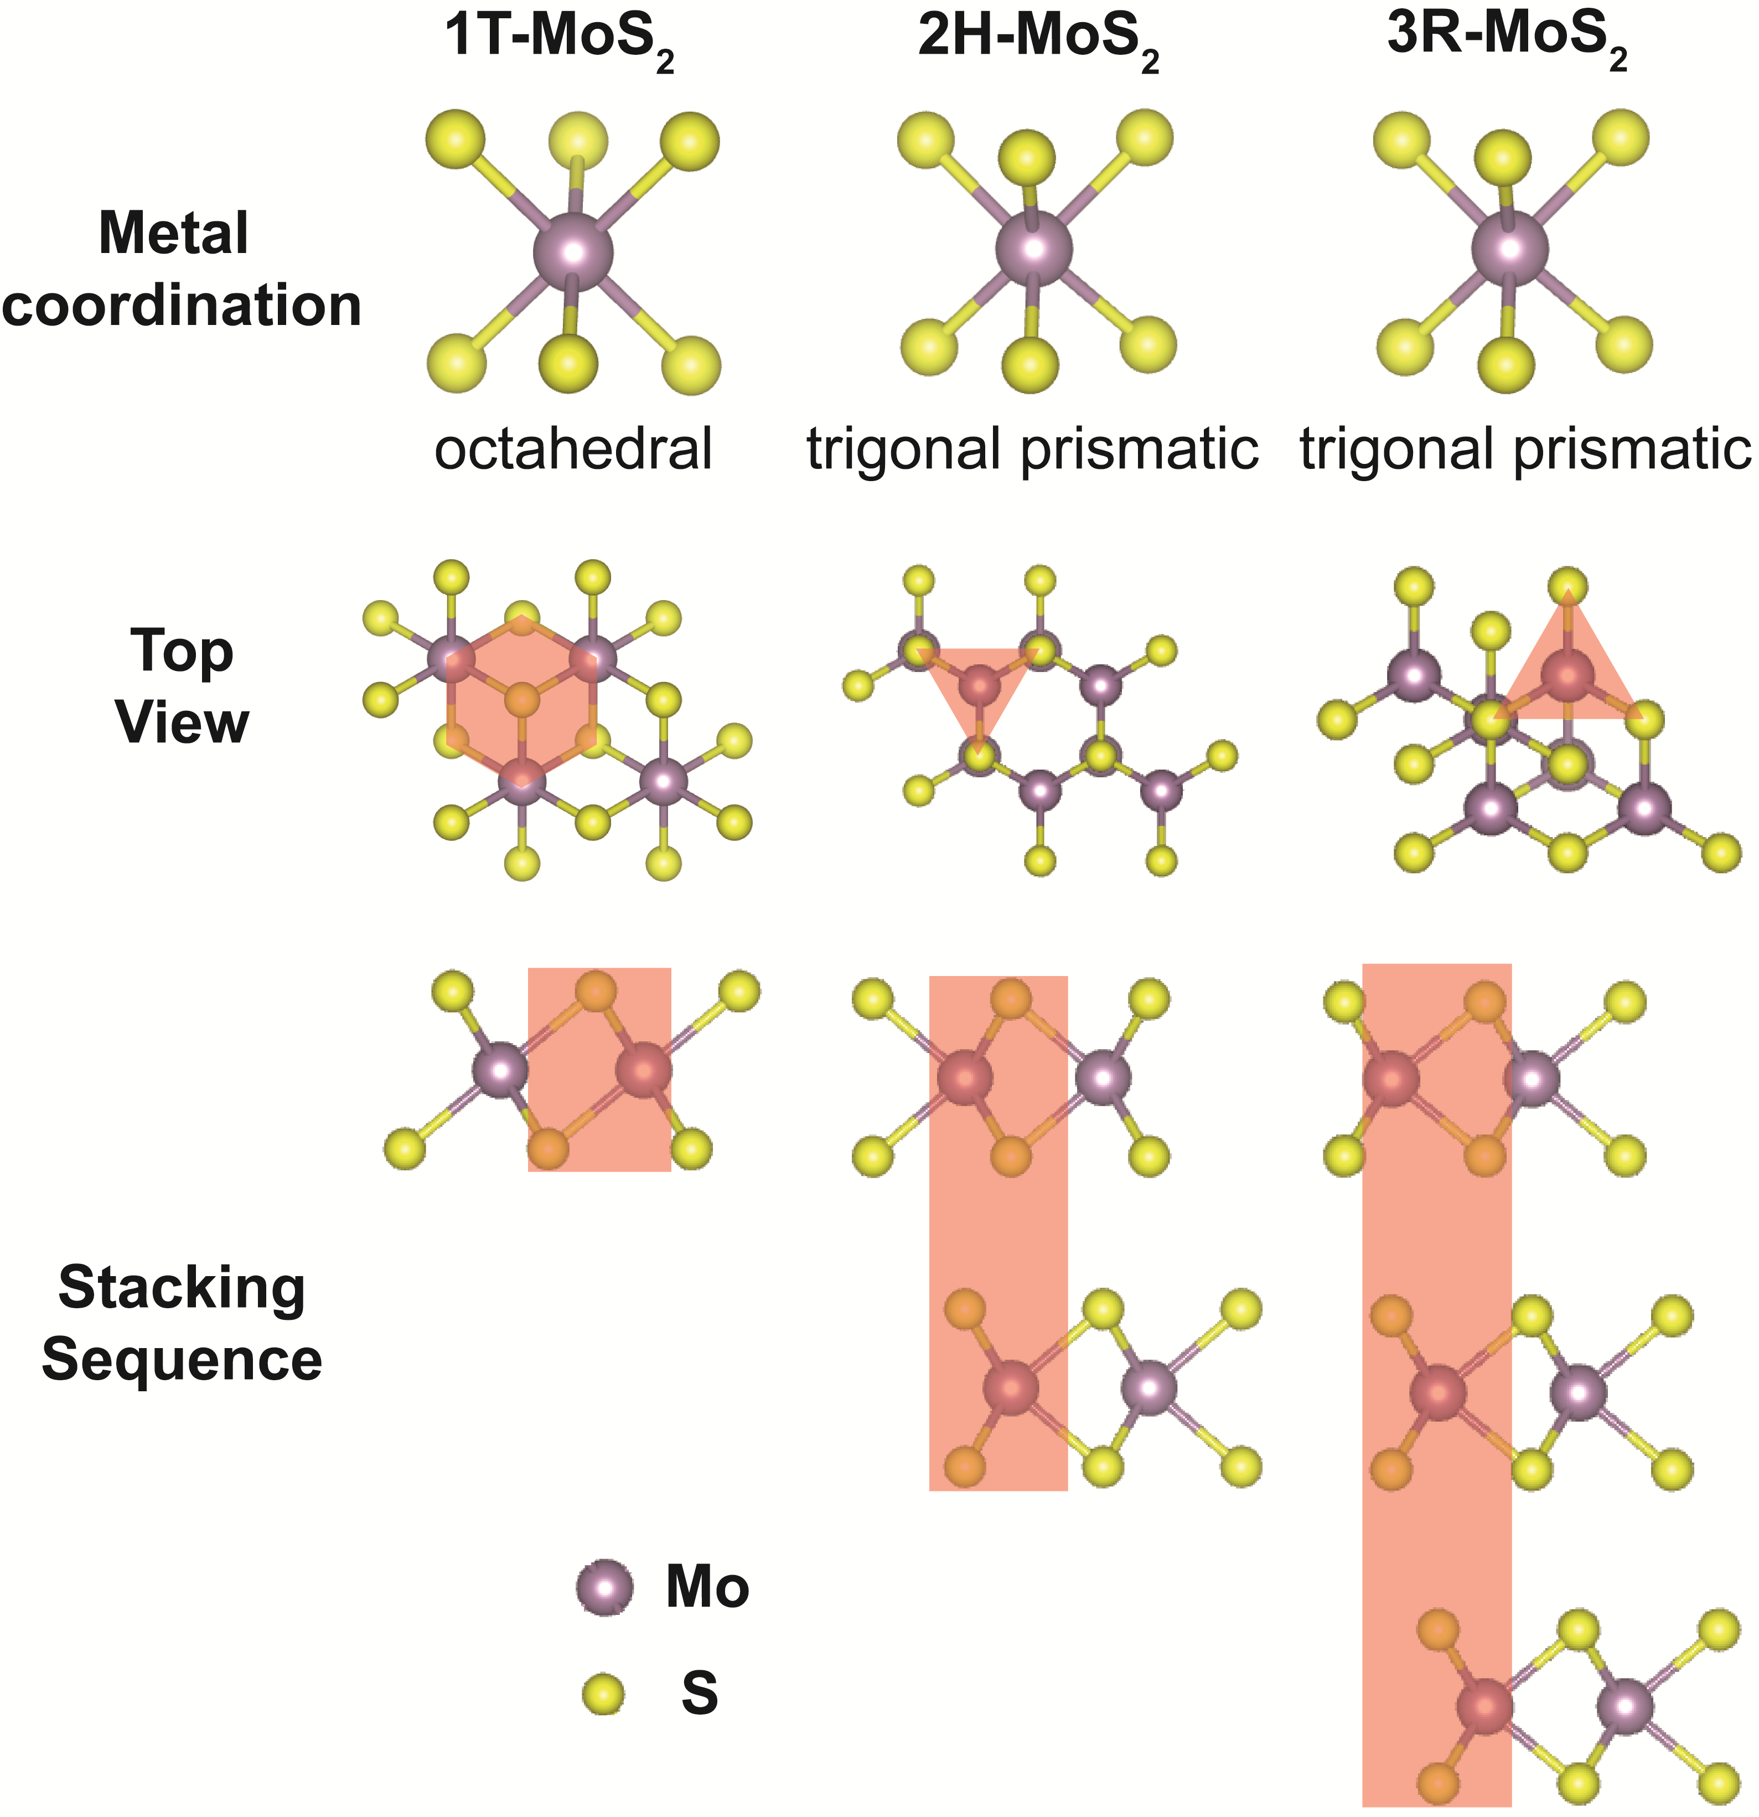
Figure S1. Crystal structure of the MoS₂ polytypes: 1T-, 2H-, and 3R-configurations. The red boxes denote the unit cell.
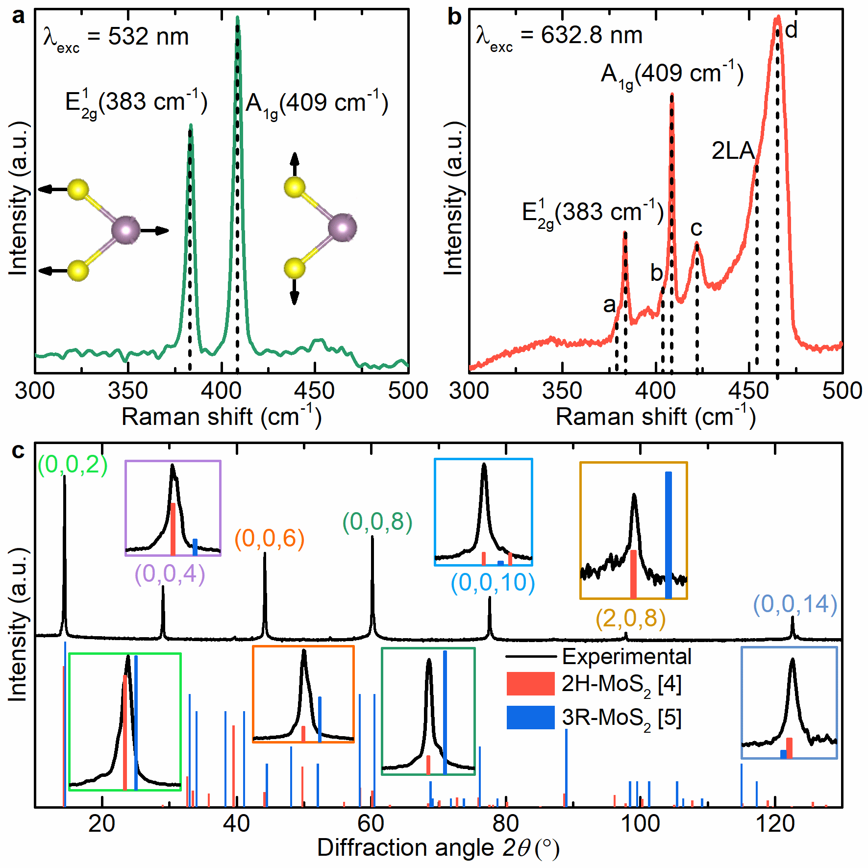
Figure S2. Crystal characterization. Raman spectra in a non-resonant (excitation wavelength does not induce exciton) and b resonant (excitation wavelength induces exciton) conditions. The positions of two first-order Raman modes, namely $E_{2g}^{1}$ and $A_{1g}$, correspond to 2H-MoS₂. c X-ray measurements using Cu-Kα radiation (λ = 0.1542 nm) allows to distinguish 2H- from 3R-configuration^{4,5} of MoS₂. The insets in (c) shows the magnified diffraction orders.

S2. Ellipsometry measurements and analysis
We characterize the far-field optical response of MoS₂ through imaging spectroscopic ellipsometry,⁶ which configuration is schematically shown in Figure S3. The major advantage of imaging over conventional ellipsometry is multiple samples measurements within the same field of view, as illustrated in Figure 1b. As a result, we have multiple spectra in Figure S4 for the same system MoS₂/SiO₂/Si, but with different thicknesses (104 and 126 nm). Therefore, we model them simultaneously with equal dielectric permittivities. Such an approach gives the most accurate results since it increases data reliability and reduces the correlation between fitting parameters. At the same time, to adequately describe optical constants, it is imperative to obtain a good initial guess for refractive indices for software to find the right answer and a physical model. To overcome the first problem we proceeded in the following way: in the transparent range (800 – 1700 nm) both in-plane and out-of-plane components were described by a Cauchy model A + B/λ², then we performed Kramers-Kronig consistent B-spline expansion⁷ for the whole spectral interval (360 – 1700 nm) for in-plane dielectric permittivity. Later we leveraged the Tauc-Lorentz oscillator model to describe in-plane dielectric response by fitting the B-spline result:⁸
$ε_{2}=\left\{\begin{aligned}\frac{1}{E}∙\frac{AE_{0}C{\left(E-E_{g}\right)}^{2}}{{\left(E^{2}-E_{0}^{2}\right)}^{2}+C^{2}E^{2}} for E>E_{g} \\ 0 for E< E_{g}\end{aligned}\right.$,
where E is the photon energy, A is the strength of the oscillator, C is the broadening term, E_{g} is the optical band gap, and E₀ is the peak central energy with the real part of dielectric function derived from the expression of ε₂ using Kramers-Kronig integration. Finally, we fitted the spectra in Figure S4 by varying the parameters of the Tauc-Lorentz oscillators and Cauchy model with the results collected in Table S1.

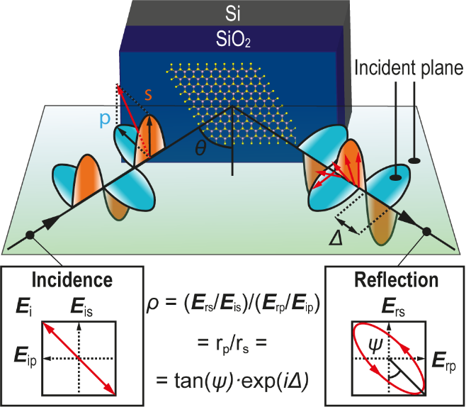
Figure S3. The scheme of spectroscopic ellipsometry measurements.
Figure S4. a-d Experimentally measured (solid lines) and calculated by Fresnel Formulas⁹ (dashed lines) for regions of interest (ROIs) 1 and 2 (shown in Figure 1b) ellipsometric parameters Ψ and Δ for the system MoS₂/SiO₂/Si at three incident angles (50°, 60°, and 65°). The asymmetrical interference-like peak at around 900 nm for ROI 1 and around 1100 nm for ROI 2 is induced by interference enhancement in SiO₂ caused by splitting the incident beam into ordinary and extraordinary rays. This prominent asymmetry for Ψ stems from giant anisotropy between the c-axis and ab-plane.
In general, the fitting procedure described above could be summarized in 3 steps, which could be successfully applied to similar TMDCs such as MoSe₂, WSe₂, WS₂, and MoTe₂ in 2H-configuration. Note that we include in the physical model finite coherence of the light source (bandwidth equals 5 nm for 360 – 1000 nm and 15 nm for 1000 – 1700 nm) to include the device nonidealities:
Step 1 (Transparent fitting region): In the transparent range (800 – 1700 nm), both in-plane and out-of-plane components were described by a Cauchy model A + B/λ². The fitting of $Ψ$ and Δ by Levenberg–Marquardt algorithm results in optical constants presented in Figure S5:
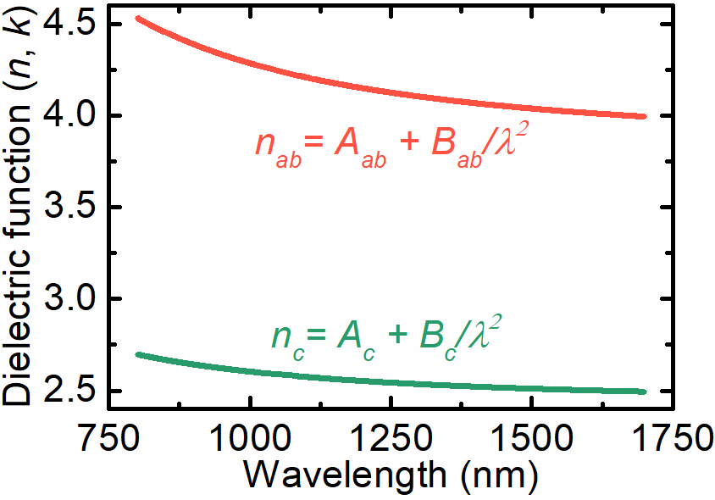
Figure S5. Optical constants of MoS₂ along the ab-plane and c-axis after step 1 with Cauchy parameters A_{ab} = 3.84, B_{ab} = 0.44 µm², A_{c}= 2.44, B_{c} = 0.17 µm².
Step 2 (Wavelength expansion): Next, the ab-plane dielectric function is approximated by Kramers-Kronig B-splines⁷ placed equidistantly in the considered wavelength range with the step of 0.05 eV, with subsequent expansion of the optical constants fitting to the whole wavelength interval (360 – 1700 nm) by the method described in the work of Mohrmann and et al.⁷:
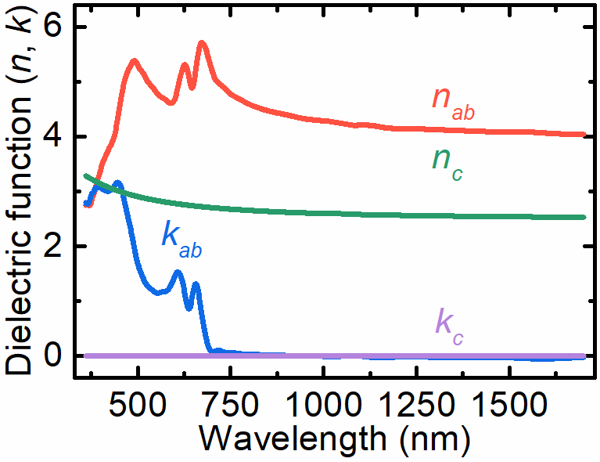
Figure S6. Optical constants of MoS₂ along the ab-plane (B-splines) and c-axis (Cauchy function) after step 2.
Step 3 (Tauc-Lorentz description): Although the previous step already gives decent results, it is worth describing optical constants using the material properties since the B-spline approach tends to provide unphysical optical constants.⁷ In the case of TMDCs, the best dielectric function for describing their dielectric function is the Tauc-Lorentz oscillator model.⁸ It also allows for obtaining more accurate values (Figure 2a) because of the reduction number of the fitting parameters (from 57 to 21) with the best values collected in Table S1.
Table S1. Tauc-Lorentz parameters of the oscillators (excitons) describing the in-plane dielectric response of MoS₂ with ε∞ = 5.26 ± 0.19 and ultraviolet pole (unbroadened oscillator) placed at 15 eV with amplitude equals to 228 ± 8 that affects the real part of the optical constants by accounting for a strong absorption outside the measured spectrum. In contrast, the resulting Cauchy model for the out-of-plane component has A = 2.463 ± 0.009 and B = (119 ± 9)∙10³ nm².
Oscillator | A | E₀ | C | E_{g}
 | eV | eV | meV | eV
#1 (A-exciton) | 308 ± 6 | 1.852 ± 0.002 | 67 ± 5 | 1.761 ± 0.009
#2 (B-exciton) | 135 ± 5 | 2.006 ± 0.006 | 148 ± 14 | 1.82 ± 0.03
#3 (C-exciton) | 19.3 ± 0.5 | 2.662 ± 0.005 | 380 ± 27 | 1.24 ± 0.12
#4 (C’-exciton) | 69 ± 7 | 2.99 ± 0.03 | 1348 ± 39 | 1.31 ± 0.03

S3. Interference enhancement for anisotropic optical constants determination
Identification of anisotropic properties of high index semiconductors by traditional techniques such as reflectance, transmission, and ellipsometry is a tedious task owing to the low sensitivity of the signal to the out-of-plane permitting to a determination of only in-plane dielectric response.¹⁰ To overcome this obstacle, we used interference enhancement method. In the approach, the sample of interest is placed on SiO₂/Si wafer. The SiO₂ layer accomplishes two functions. First of all, it increases sensitivity to the p- and s-polarization reflection at the interface MoS₂/SiO₂ due to their large difference in their refractive indices (n_{ab} ~ 4 and n_{c} ~ 2.5 for MoS₂ and n ~ 1.4 for SiO₂). Secondly, oxide produces interference peaks (at 950 and 1090 nm in Figure S2a-b), which depends on MoS₂ and SiO₂ thicknesses, allowing to implement Step 1 of the fitting procedure because of the major difference between isotropic and anisotropic treatment in the peak vicinity as illustrated in Figure S7.
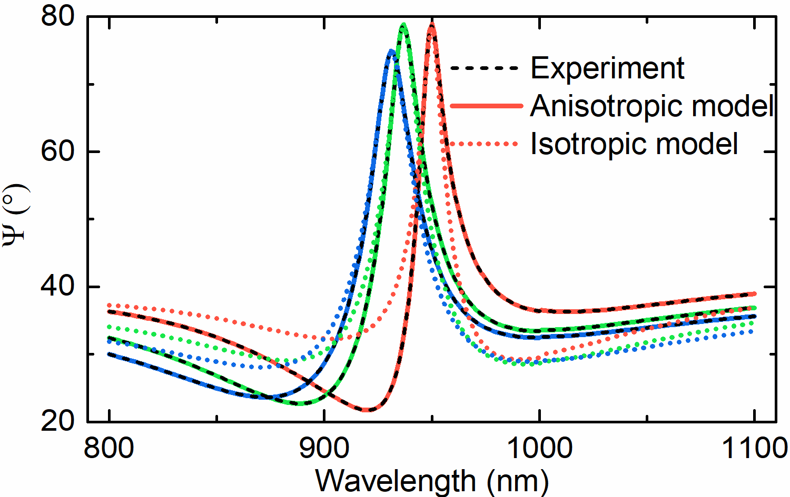
Figure S7. Interference peak caused by the SiO₂ layer in MoS₂ (104 nm)/SiO₂ (285 nm)/Si system. The giant anisotropy in MoS₂ transforms almost symmetrical peak into asymmetrical.
S4. Dielectric permittivity of MoS₂ from first principles
The comparison of the experimental data with first-principle calculations (see Methods) is presented in Figure S8. Our experimental results qualitatively and in the infrared region, even quantitatively agree with the first-principles calculations, which further validate our findings. The small mismatch is likely attributed to the approximations used in DFT analysis since near-field measurements reproduced our dielectric function at 1470 – 1570 and 632.8 nm in the main text. Surprisingly, the in-plane component of the dielectric permittivity tensor is better described by the microscopic dielectric function, whereas the out-of-plane component is better described by the macroscopic dielectric function (for the rigorous definitions of micro- and macroscopic dielectric response see the book of Bechstedt¹¹). Clearly, our findings indicate that for layered materials, the physical origins for the spectral behavior of the in-plane and out-of-plane components of the dielectric permittivity tensor are different and cannot be treated in the same way. To date, the authors believe that this phenomenon stems from the similarity of ab-plane to monolayer structure, where the local effects (microscopic) play a significant role in optical response. Still, further studies are needed to clarify the observed effect, which is fundamental for ab initio study of the layered materials.
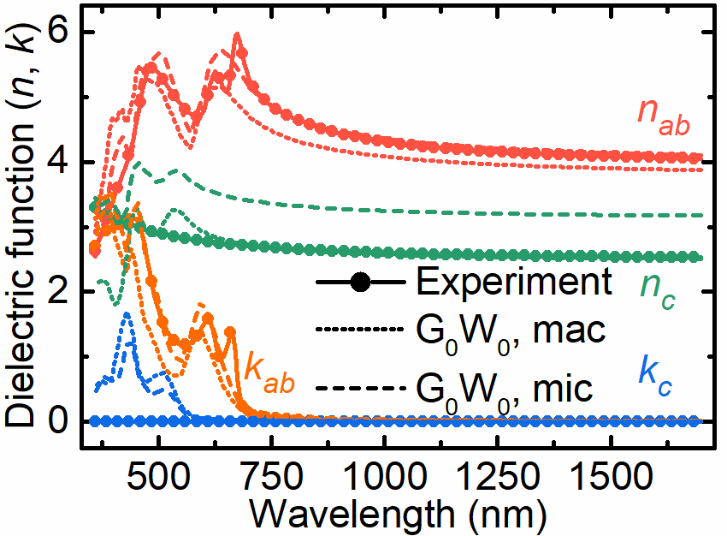
Figure S8. Comparison between experimental and DFT predicted macroscopic (mac) and microscopic (mic) optical constants along the crystallographic ab-plane and c-axis.
S3. Near-field imaging of a planar waveguide mode within MoS₂ flake and extreme skin depth in silicon
To analyze the planar waveguide modes in MoS₂ flake and silicon waveguide on MoS₂ with extreme skin-depth at multiple wavelengths, we performed scattering-type near-field optical microscopy (s-SNOM), which scheme is presented in Figure S9. The resulting signals are an oscillation of light intensity induced by the tip and edge-scattered photons, as clearly seen in Figures S10-12. To analyze the effective mode index, we carried out the complex Fourier transformation (FT). Unlike the widely used real FT, it takes into account the real and imaginary signals at the same time and thus more precise, as could be understood from Figure S13. Furthermore, it provides additional information about the predominant scattering mechanism. Mainly, there are no peaks for the negative values of q in Figures S10-12c, indicating that no modes propagate in the backward direction (from the edge to the tip).
Besides, it is worth to discuss the absence of TM₃, TM₂, and TM₀ modes at λ = 632.8 nm in the measured signal in Figure S5a. The first two TM₃ and TM₂ could not propagate because their figure of merit or, in other words, the possible number of observed fringes, is less than unity; while the coupling efficiency f with an s-SNOM tip for TM₀ (f = 0.016) is much lower than for TM₁ (f = 0.043) as demonstrated in Figure S14, thus explaining the predominant behavior of TM₁ in the measured signal in Figure S11.
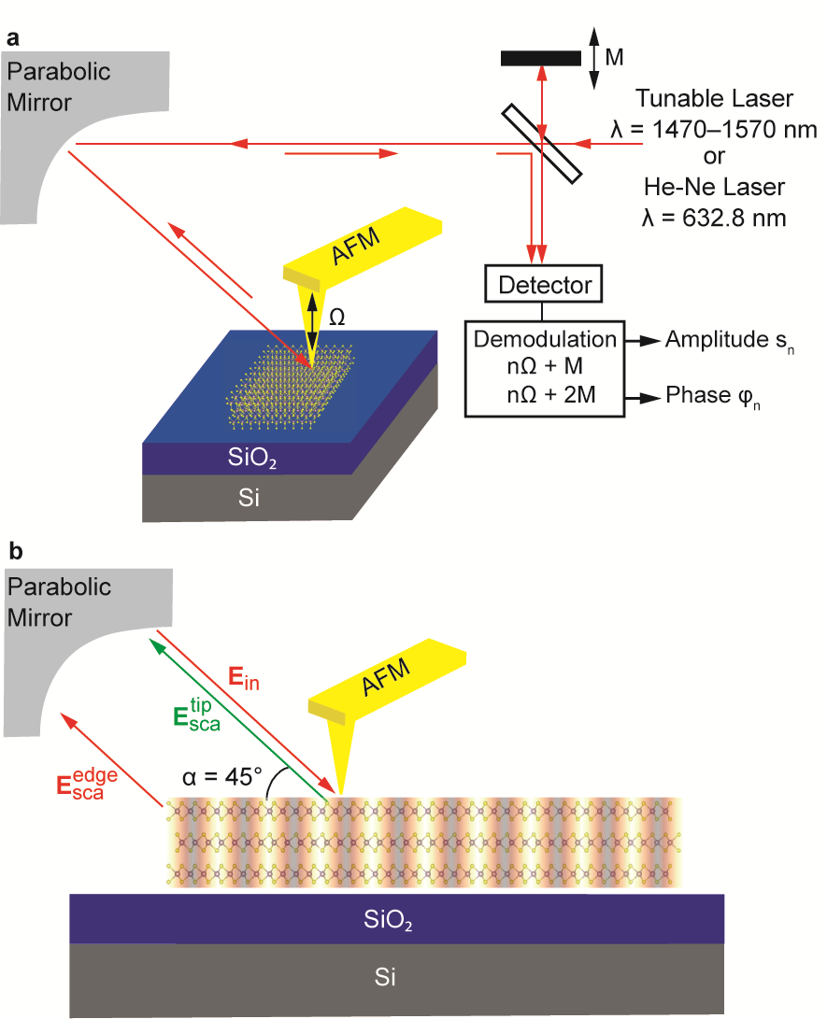
Figure S9. a Schematic of the s-SNOM experimental configuration used to image MoS₂ flake. A metalized AFM tip is illuminated by p-polarized light of wavelength λ. It launches a planar waveguide mode, which interferes with the illuminating plane wave and gets scattered at the sample edge to the far-field, where a distant detector collects it. b Illustration of waveguide mode tip excitation and following scattering at the flake’s edge.
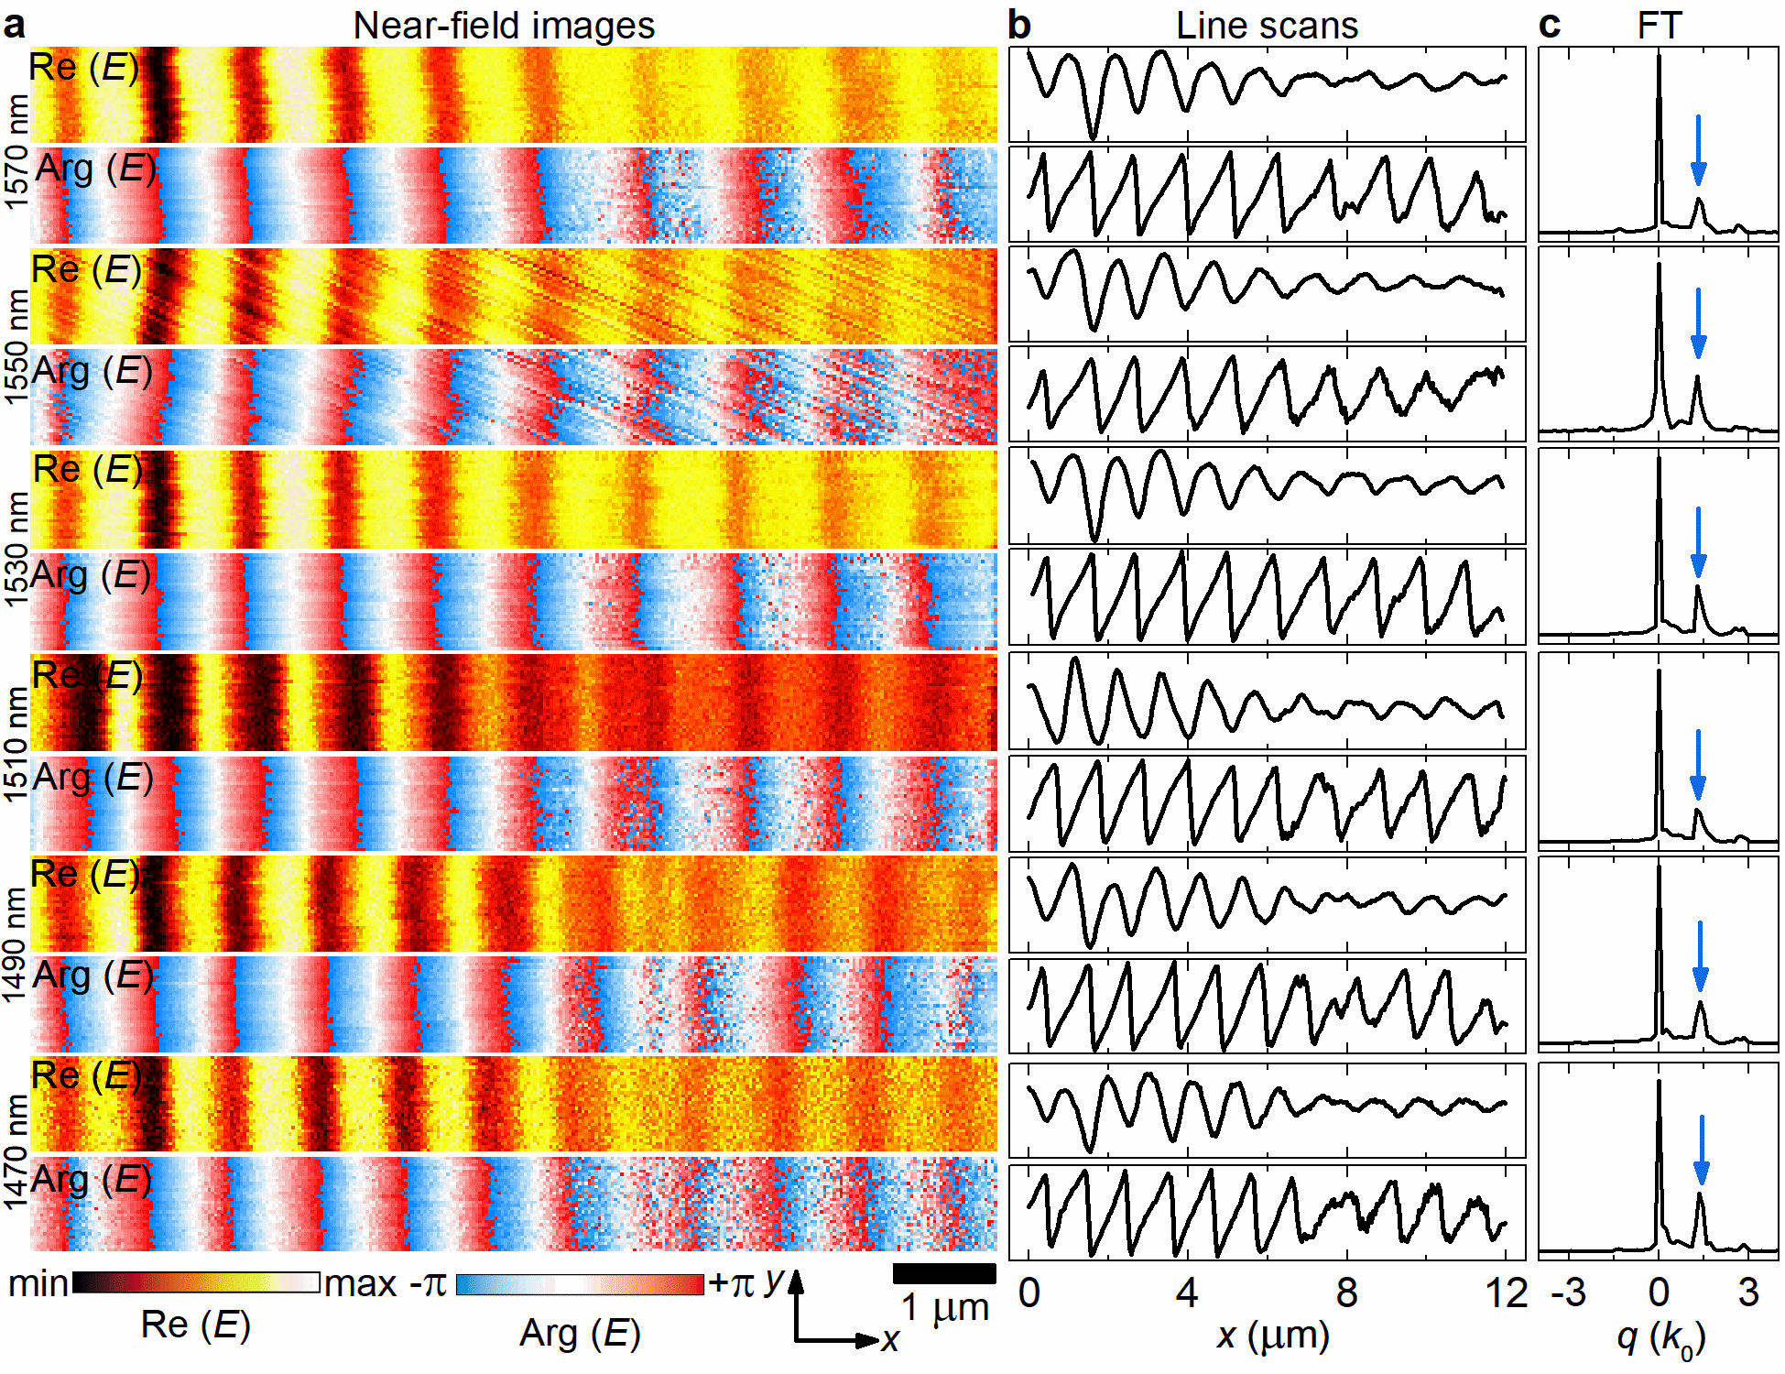
Figure S10. a Near-field images, real part Re(E) and phase Arg(E), of electric field E taken at 1570 – 1470 (from top to bottom) in an area of the image in Figure 3b, indicated by a blue rectangular. b x-line scans taken from (a) and averaged over 1.2 µm along the y-axis. c Fourier transform (FT) amplitude of the complex near-field signal in (b), the blue arrow marks the peak associated with waveguide mode.
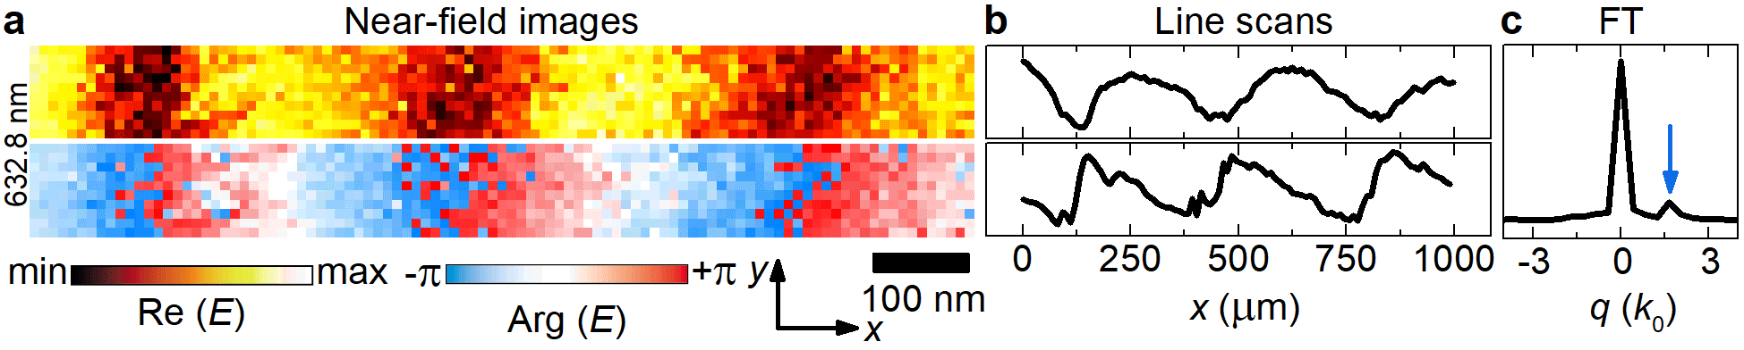
Figure S11. a Near-field images, real part Re(E) and phase Arg(E), of electric field E taken at 632.8 nm in an area of the image in Figure 3b, indicated by a blue rectangular. b x-line scans taken from (a) and averaged over 1.2 µm along the y-axis. c Fourier transform (FT) amplitude of the complex near-field signal in (b), the blue arrow marks the peak associated with waveguide mode.
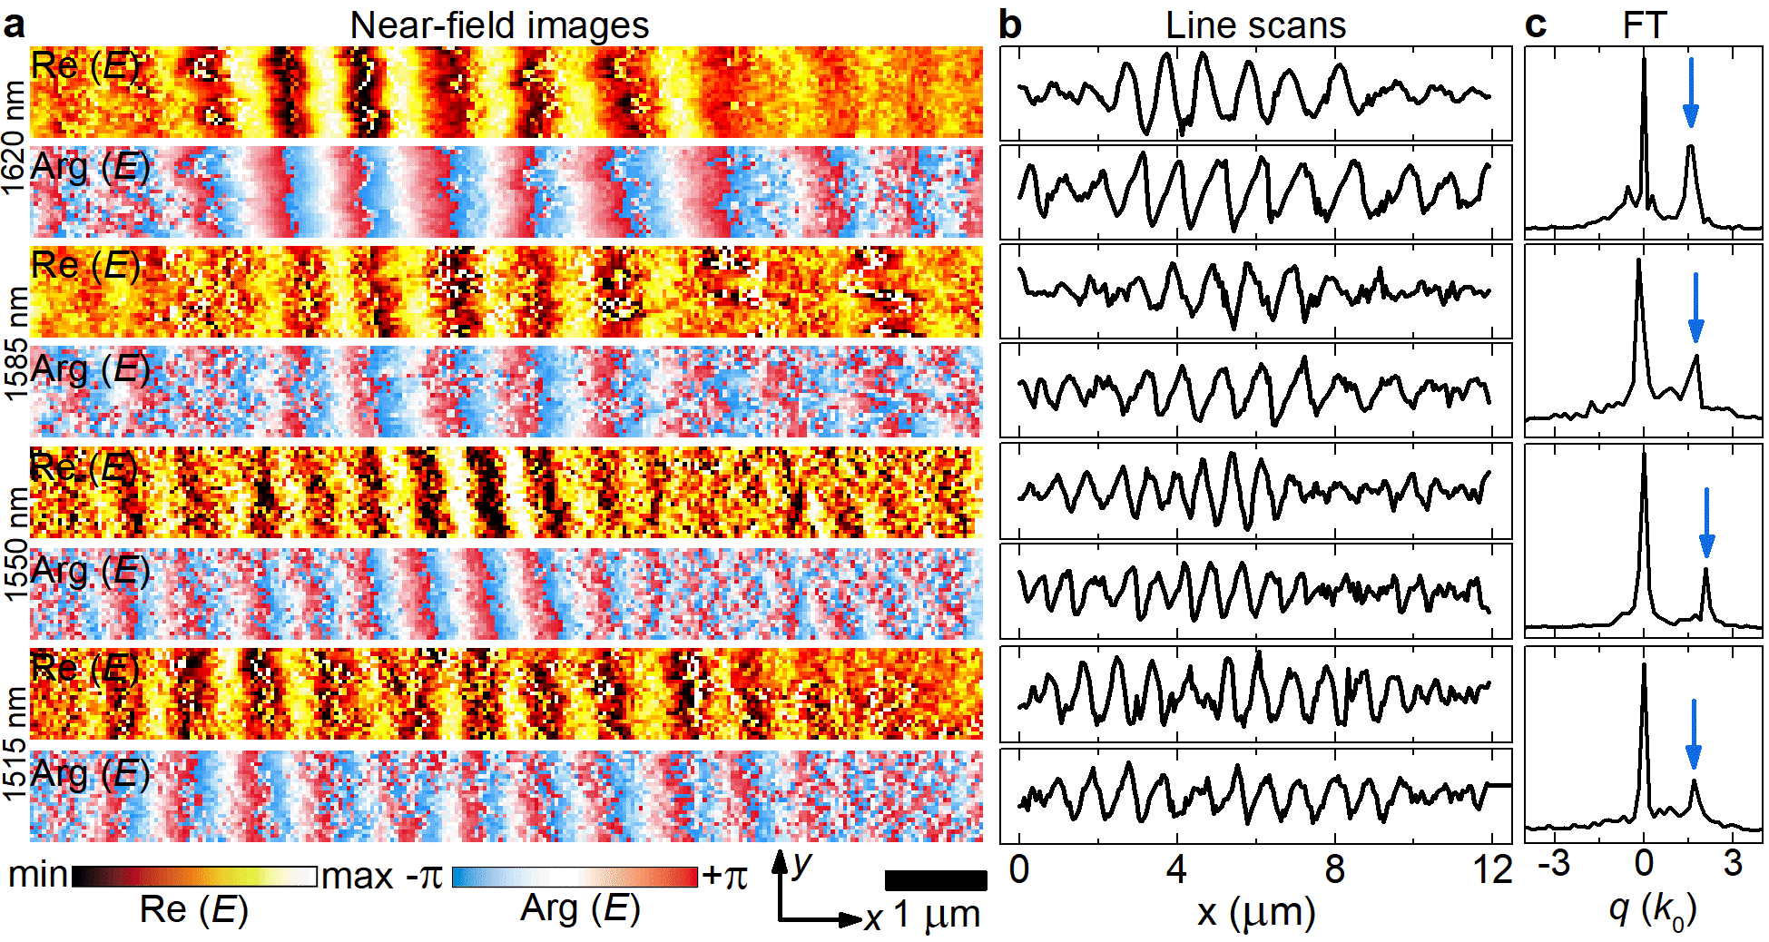
Figure S12. a Near-field images, real part Re(E) and phase Arg(E), of electric field E taken at 632.8 nm in an area of the image in Figure 5g-h, indicated by a green rectangular. b x-line scans taken from (a) and averaged over 1.2 µm along the y-axis. c Fourier transform (FT) amplitude of the complex near-field signal in (b), the blue arrow marks the peak associated with waveguide mode.
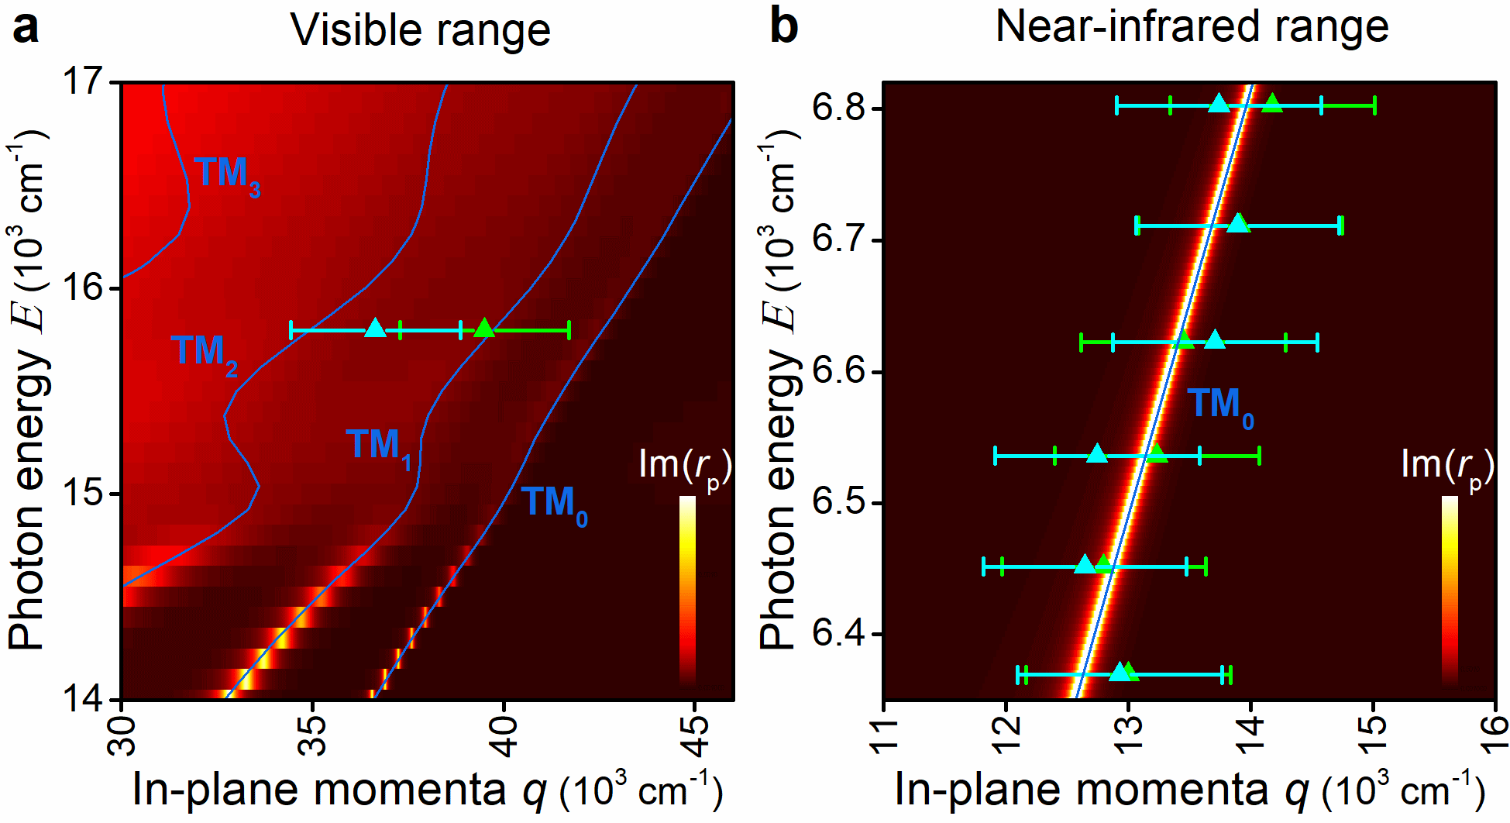
Figure S13. Comparison of the different analyses of near-field signal with green and cyan triangles corresponding to complex and real FT, respectively, for a visible and b near-infrared wavelength ranges. Meanwhile, in the near-infrared interval, different approaches yield the same result; for visible range, the difference is striking with complex FT, giving much better agreement with the theory prediction.
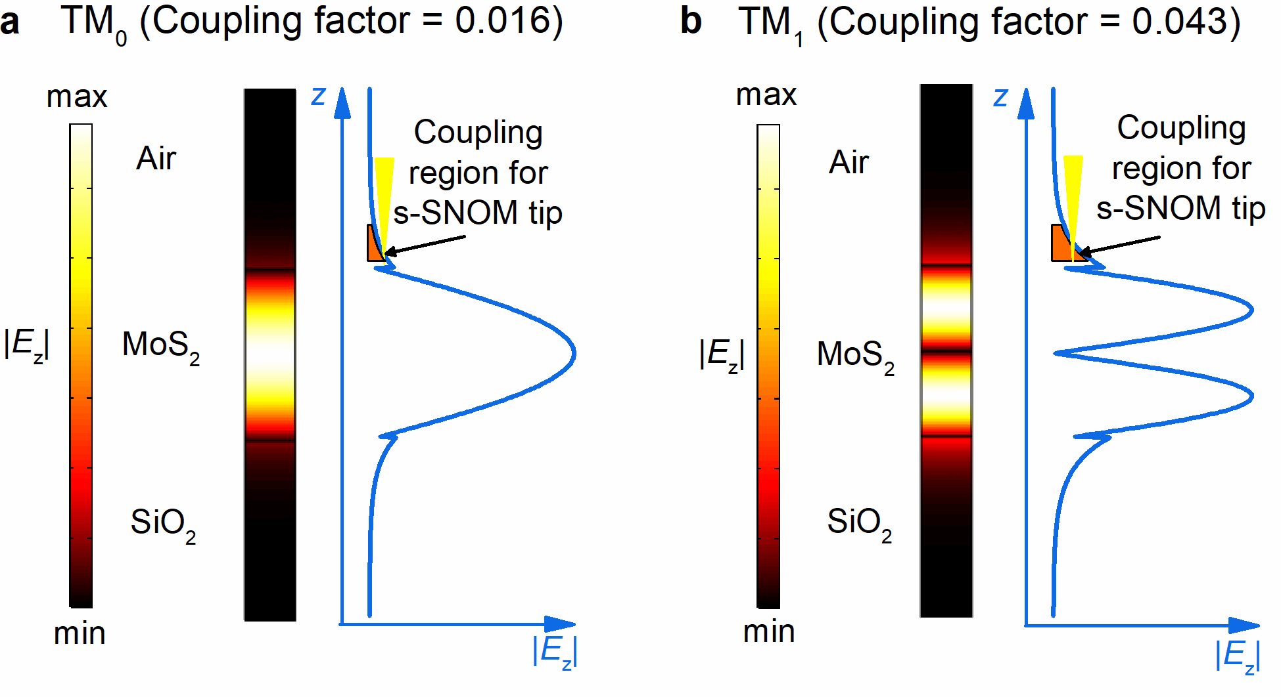
Figure S14. Coupling efficiency comparison of waveguide near-field with s-SNOM tip at λ = 632.8 nm for a TM₀ and b TM₁ modes. Clearly, the coupling factor for TM₁ (0.043) is much higher than for TM₀ (0.016), thus explaining the predominant behavior in the measured signal for TM₁ in Figure S5.

REFERENCES
1. Fang, Y. et al. Structure Re-determination and Superconductivity Observation of Bulk 1T MoS₂ . Angew. Chemie 130, 1246–1249 (2018).
2. Placidi, M. et al. Multiwavelength excitation Raman scattering analysis of bulk and two-dimensional MoS₂: Vibrational properties of atomically thin MoS₂ layers. 2D Mater. 2, 35006 (2015).
3. Lee, J. U. et al. Raman Signatures of Polytypism in Molybdenum Disulfide. ACS Nano 10, 1948–1953 (2016).
4. Mcmurdie, B. H. F. et al. Standard X-Ray Diffraction Powder Patterns from The JCPDS Research Associateship — International Centre for Diffraction Data Ammonium Hydrogen Phosphate , NH₄H₂PO₄ Barium Magnesium Germanium Oxide ,. Powder Diffr. 1, 334–345 (1986).
5. Takeuchi, W. Nowacki, Detailed crystal structure of rhombohedral MoS₂ and systematic deduction of possible polytypes of molybdenite, Schweizerische Mineral. Und Petrogr. Mitteilungen 44, 105–120 (1964).
6. Funke, S. et al. Imaging spectroscopic ellipsometry of MoS2. J. Phys. Condens. Matter 28, 385301 (2016).
7. Mohrmann, J., Tiwald, T. E., Hale, J. S., Hilfiker, J. N. & Martin, A. C. Application of a B-spline model dielectric function to infrared spectroscopic ellipsometry data analysis. J. Vac. Sci. Technol. B 38, 014001 (2020).
8. Ermolaev, G. A., Yakubovsky, D. I., Stebunov, Y. V., Arsenin, A. V. & Volkov, V. S. Spectral ellipsometry of monolayer transition metal dichalcogenides: Analysis of excitonic peaks in dispersion. J. Vac. Sci. Technol. B 38, 014002 (2020).
9. Hecht, E. Optics (Pearson, Harlow, 2016).
10. Ermolaev, G. A. et al. Broadband optical properties of monolayer and bulk MoS₂. npj 2D Mater. Appl. 4, 1–6 (2020).
11. Bechstedt, F. Many-Body Approach to Electronic Excitations: Concepts and Applications (Springer, Berlin, 2014).

