Table S1. Specific primers of genes
Primers | The sequence
ACTIN-F | CCTTGCTGGTCGTGACCTTACTGA
ACTIN-R | CTCTCAGCACCGATCGTGATCACT
AUX1-F | CCGAGCTGGACGGCGATGTACG
AUX1-R | CATGTGCGGCGGCTGCAGCT
PIN1-F | TACTCCGAGACCTTCCAACTACG
PIN1-R | TCCACCGCCACCACTTC
PIN2-F | TTCACTATCAACACTGCCTAA
PIN2-R | CCCACGGAACTCAAACA
PIN3-F | CGAATACTCTGGTTCCCTCAT
PIN3-R | GCTTCCCGTCGTCACCTA

Table S2. Particle-size distribution of LDH-lactate-NS obtained at 0℃, 15℃, 25℃
LDH-lactate-NS obtained at 0℃
 | Size (d.nm): | % Volume: | St Dev (d.nm):
Peak 1: | 38.24 | 92 | 10.02
Peak 2: | 207.3 | 0.8 | 67.82
Peak 3: | 5294 | 7.2 | 706.9
LDH-lactate-NS obtained at 15℃
 | Size (d.nm): | % Volume: | St Dev (d.nm):
Peak 1: | 483.2 | 5.7 | 100.2
Peak 2: | 42.63 | 94.3 | 7.361
Peak 3: | 0 | 0 | 0
LDH-lactate-NS obtained at 25℃
 | Size (d.nm): | % Volume: | St Dev (d.nm):
Peak 1: | 61.18 | 96.3 | 39.47
Peak 2: | 5116 | 3.7 | 538.7
Peak 3: | 0 | 0 | 0

Table S3. Germination rate of Arabidopsis seeds
date  Sample | 3 day | 4 day | 5 day | 6 day | 7 day
CK | 95.07 ± 2.85 % | 99.26 ± 1.48 % | 99.26 ± 1.48 % | 99.26 ± 1.48 % | 99.26 ± 1.48 %
LDH=1 μg/ml | 95.63 ± 2.92 % | 97.75 ± 2.89 % | 97.75 ± 2.89 % | 97.75 ± 2.89 % | 97.75 ± 2.89 %
LDH=10 μg/ml | 97.13 ± 2.22 % | 97.81 ± 1.47 % | 98.57 ± 1.66 % | 99.24 ± 1.52 % | 99.24 ± 1.52 %
LDH=100 μg/ml | 98.65 ± 1.57 % | 99.29 ± 1.43 % | 99.29 ± 1.43 % | 99.29 ± 1.43 % | 99.29 ± 1.43 %
LDH=300 μg/ml | 95.00 ± 4.40 % | 96.39 ± 4.31 % | 97.10 ± 3.35 % | 97.10 ± 3.35% | 97.10 ± 3.35 %
RM=1 μg/ml | 96.37 ± 2.82 % | 97.87 ± 2.63 % | 100.00 % | 100.00 % | 100.00 %
RM=10 μg/ml | 94.91 ± 3.63 % | 98.61 ± 2.78 % | 98.61 ± 2.78 % | 98.61 ± 2.78 % | 98.61 ± 2.78 %
RM=100 μg/ml | 81.58 ± 9.03 % | 94.64 ± 3.25 % | 97.65 ± 3.03 % | 97.65 ± 3.03 % | 97.65 ± 3.03 %
RM=300 μg/ml | 0.00 % | 3.69 ± 1.93 % | 9.33 ± 5.08 % | 19.55 ± 2.28 % | 23.39 ± 5.12 %

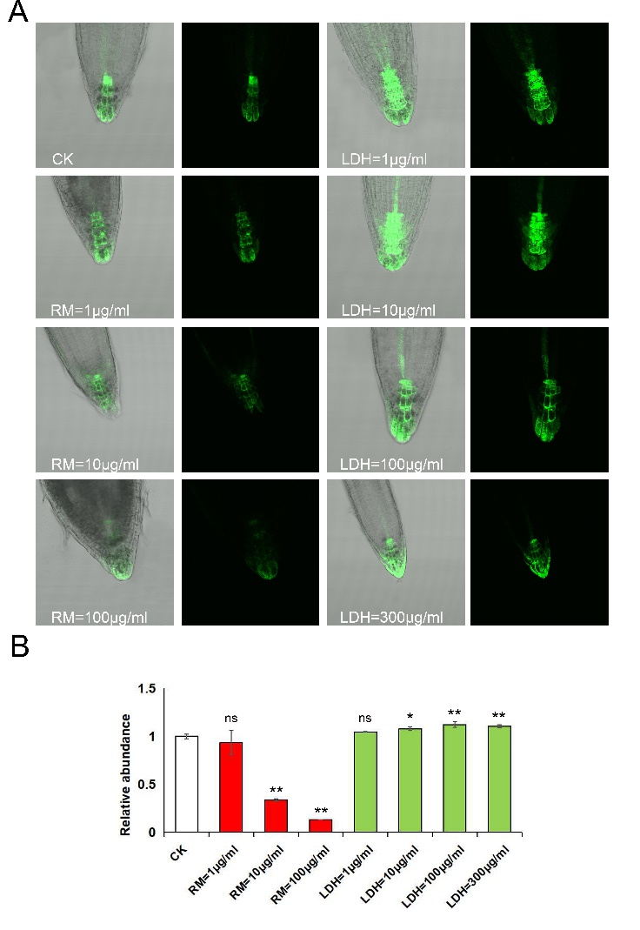
Figure S1. DR5pro:GFP observation and determination of IAA content in the root. (A) DR5pro:GFP fluorescence observed by confocal microscopy; (B) Relative abundance of auxin content. Values are means ± SD (n = 3). CK, Control check. ns > 0.05, **P < 0.01, *P < 0.05, Student’s t-test.
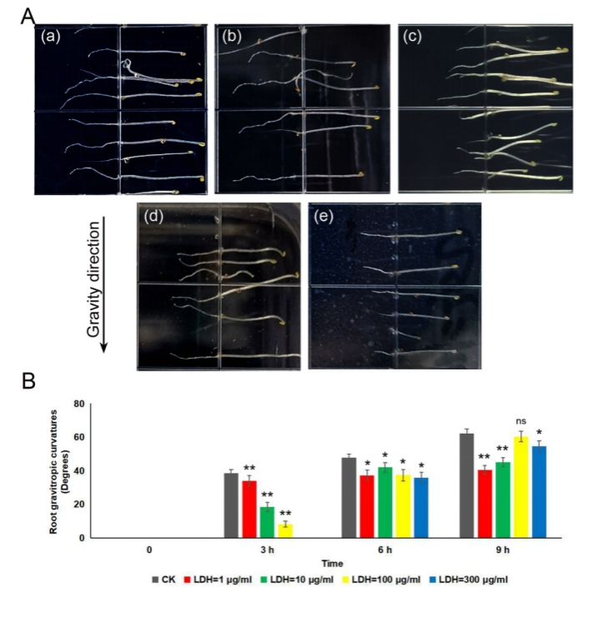
Figure S2. Effect of various concentrations of LDH-Lactate-NS on root geotropism of A. thaliana. (A) After rotation of 90°, the root tip bending Angle after 3 hours (a)CK; (b)LDH=1 µg/ml; (c)LDH=10 µg/ml; (d)LDH=100 µg/ml; (e)LDH=300 µg/ml; (B) Geotropism experiment statistics of root tip bending angles of CK and LDH. Error bars represent SD. ns＞0.05, *P<0.05, **P<0.01, Student’s t-test.

