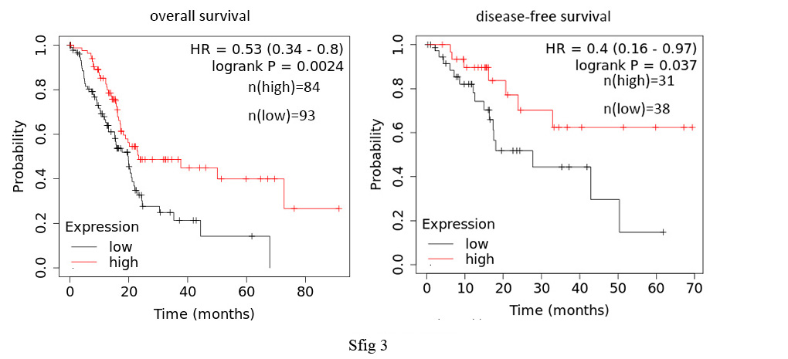
Figure S3. The survival prognosis of NRF1 gene expression in PAAD are given by Kaplan-Meier.

