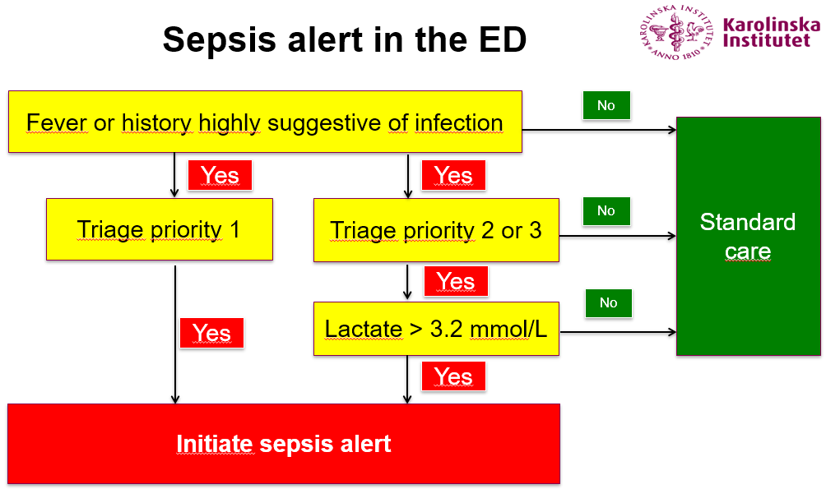
Additional file 1: Criteria for initiation of the sepsis alert. Triage priority refers to RETTS priority (Fig. S2)

