Supplementary information
Thermal plasticity in coral reef symbionts is mediated by oxidation of membrane lipids
M. T. Botana^{1*}; A.B. Chaves-Filho²; A. Inague²; A. Z. Güth¹; F. Saldanha-Corrêa¹; M.N. Müller³; P.Y.G. Sumida¹; S. Miyamoto²; M. Y. Kellermann⁴; R. C. Valentine⁵; M.Y. Yoshinaga^{2**}

1. Supplementary figures
2. Supplementary tables

1. Supplementary figures
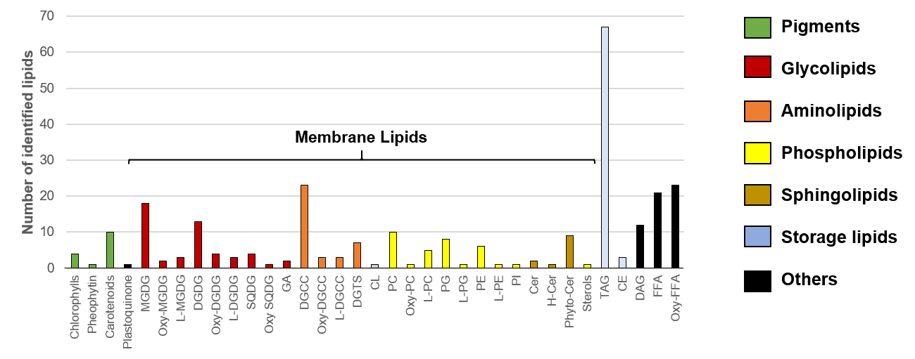
Figure S1: Diversity of lipid compounds (total of 276) identified in Symbiodiniaceae (S. microadriaticum, B. minutum and C. goreaui) sorted into their respective lipid subclasses. Abbreviations represent: MGDG: monogalactosyldiacylglycerol; DGDG: digalactosyldiacylglycerol; SQDG: sulfoquinovosyldiacylglycerol; GA: Glucoronic Acid; DGCC: 1,2-diacylglyceryl-3-(Ocarboxyhydroxymethylcholine; DGTS: diacylglyceroltrimethylhomoserine; CL: cardiolipin; PC: phosphatidylcholine; PG: phosphatidylglycerol; PE: phosphatidyletanolamina; PI: phosphatidylinositol; Cer: ceramide; Phyto Cer: phyto ceramide; H-Cer: Hexosyl-ceramide; TAG: triacylglycerol; CE: cholesterol ester and DAG: diacylglycerol; FFA: free fatty acids; Oxy-FFA: oxidizided FFA.Oxidized polyunsaturated fatty acids bonded to membrane lipids are abbreviated as Oxy-. Lyso-membrane lipids are abbreviated as L-. Compounds are detailed in Table S1.
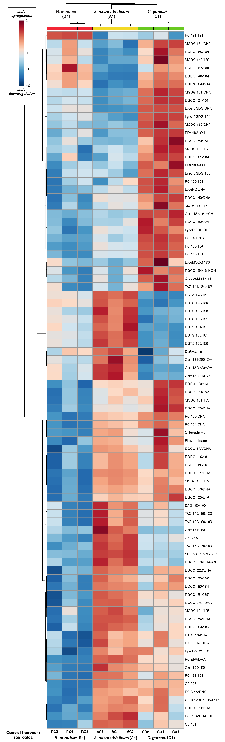
Figure S2: Most significantly different lipid compounds among Symbiodiniacea species growing at 22 ˚C (controls) sampled at T_{4.} A total of 86 lipids are listed for the triplicates of each species (columns). Each colored cell on the heatmap corresponds to normalized concentrations. Log transformation was used for data normalization. Red indicates upregulation, whereas blue indicates downregulation. Symbiodiniaceae species (S. microadriaticum – A1; B. minutum – B1 and C. goreaui – C1). Statistically significance was determined via Tukey’s HSD, p < 0.01
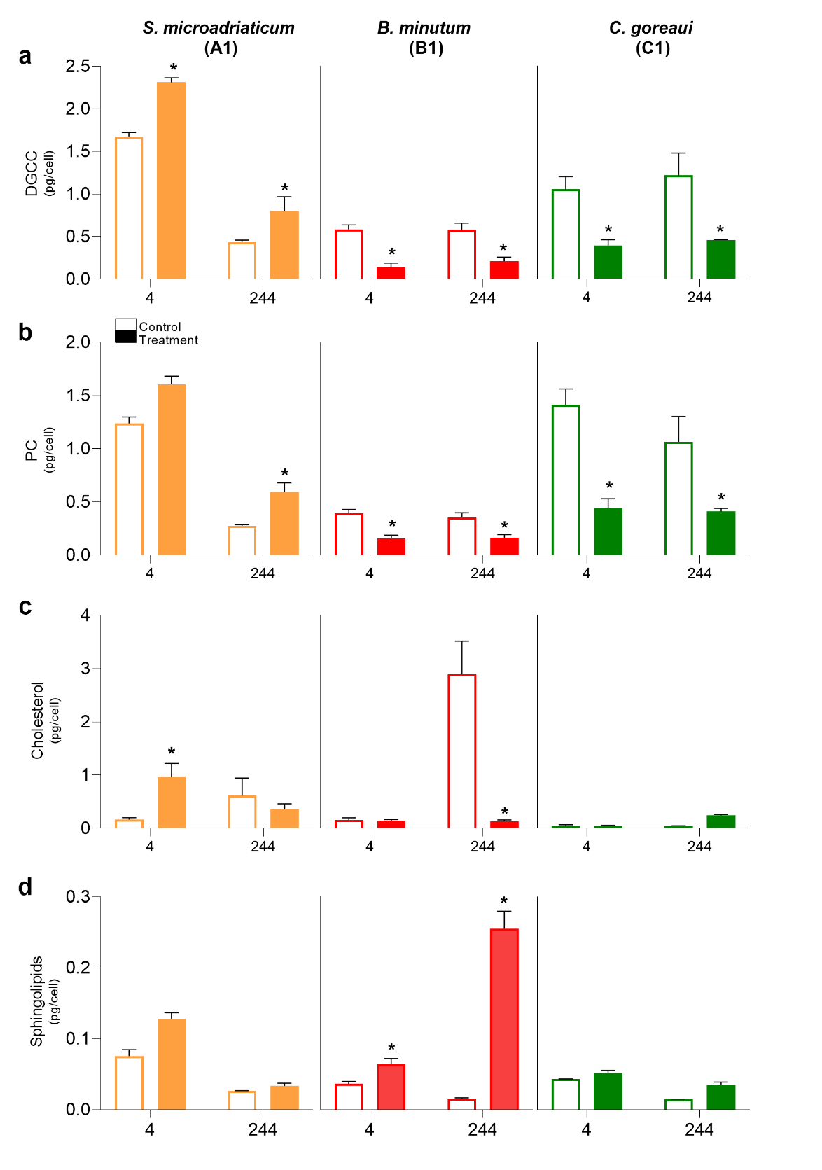
Figure S3: Variation of DGCC, PC, cholesterol and sphingo - membrane lipids in Symbiodiniacea after heat shock. Graphs show both control (empty bars) and heat shock treatment (filled bars) for each Symbiodiniaceae species (S. microadriaticum – A1 (yellow); B. minutum – B1 (red) and C. goreaui – C1 (green)) - at each specific analyzed time T₄ (end of heat shock) and T₂₄₄ (end of experiment). Asterisks (*) indicate significant pairwise differences (Tukey’s HSD, p < 0.01) for Heat shock [Spp.] factor. Statistical indicators are given in Table S4.
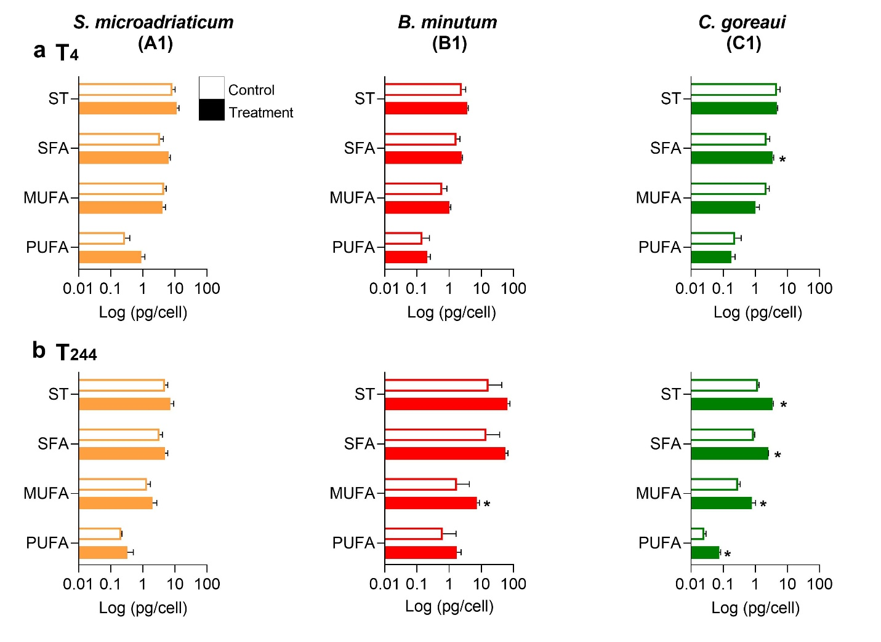Figure S4: Variation of storage lipids in Symbiodiniacea after heat shock. Graphs show both control (empty bars) and heat shock treatment (filled bars) at a) T₄ (end of heat shock) and b) T₂₄₄ (end of experiment) for each Symbiodiniaceae species (S. microadriaticum – A1 (yellow); B. minutum – B1 (red) and C. goreaui – C1 (green)). Asterisks (*) indicate significant pairwise differences (Tukey’s HSD, p < 0.01) for Heat shock [Spp.] factor. Statistical indicators are given in Table S4.

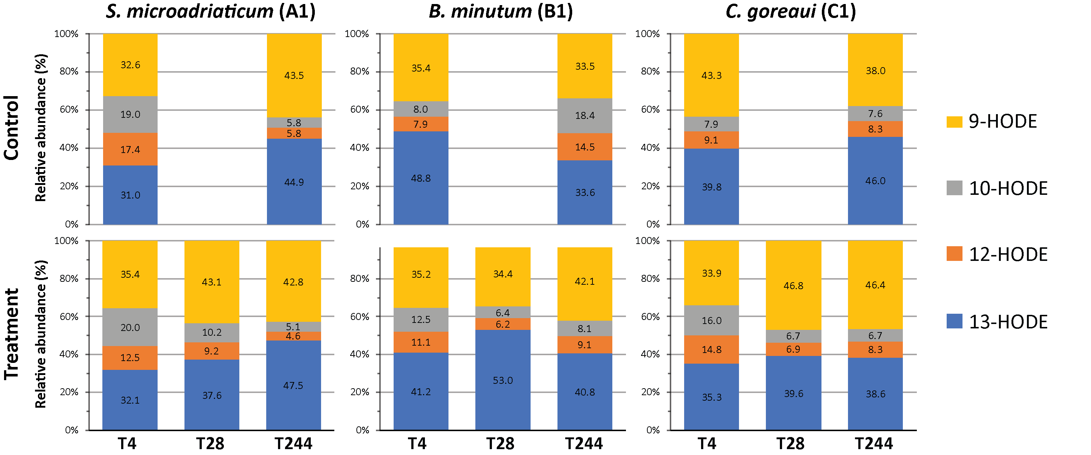
Figure S5: Mean relative percentages of all identified isomers of hydroxyoctadienoic acid (HODEs) found in Symbiodiniaceae species. Upper and lower panels show data obtained from the biomass of control and heat shock treatment triplicates for each species, respectively, at all different sampling times (T₄, T₂₈ and T₂₄₄).

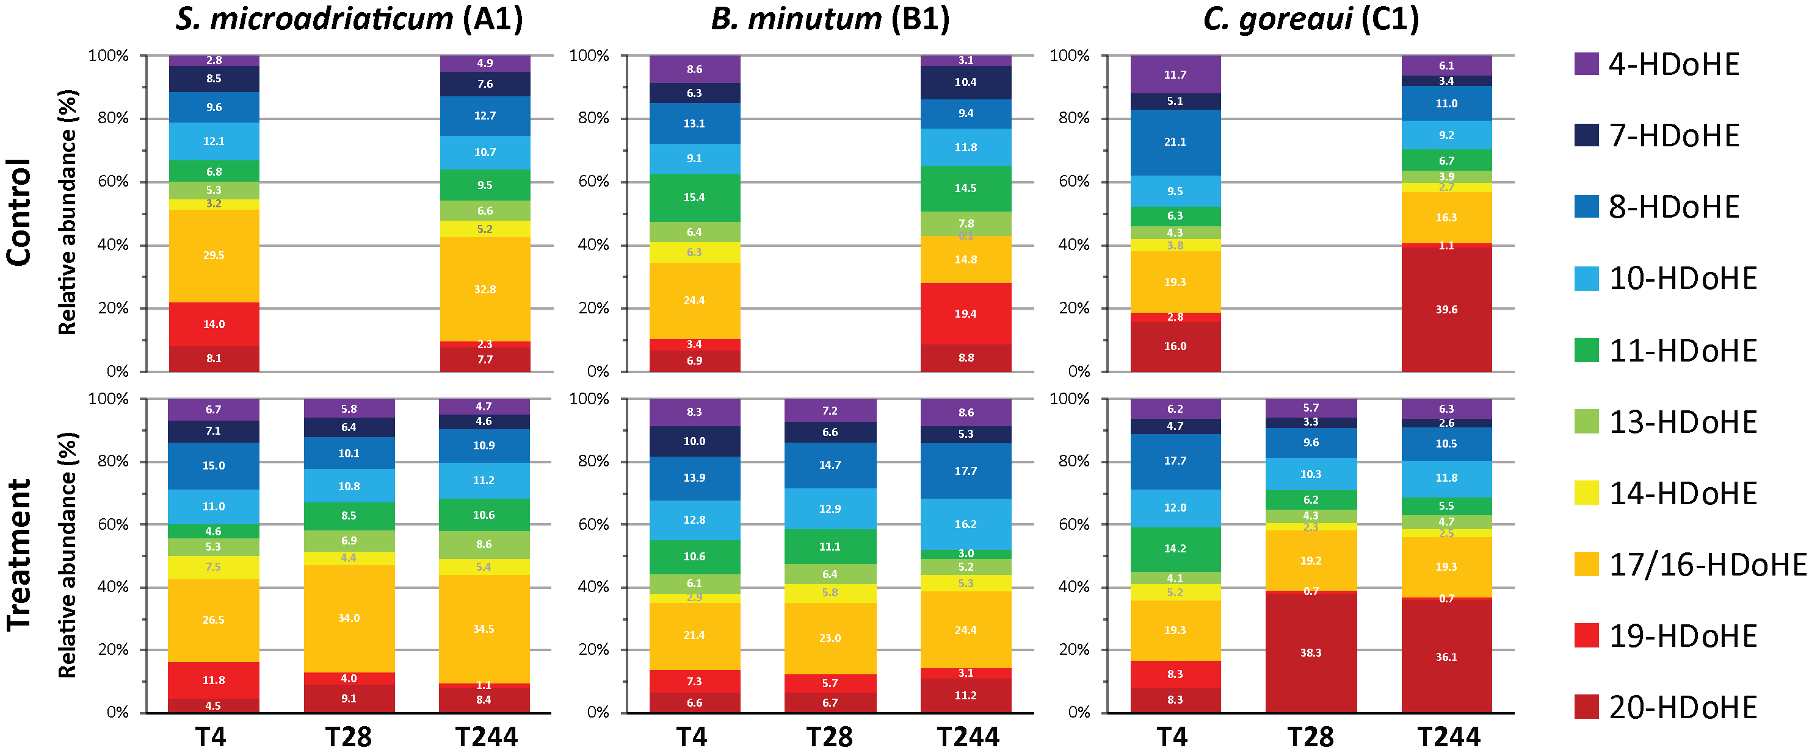
Figure S6: Mean relative percentages of all identified isomers of Hydroxydocosahexaenoic acid (HDoHE) found in Symbiodiniaceae species. Upper and lower panels show data obtained from the biomass of control and heat shock treatment triplicates for each species, respectively, at all different sampling times (T₄, T₂₈ and T₂₄₄).

2. Supplementary tables

Table S1: List of all identified lipid species and pigments sorted into main lipid classes.

Table S2: One-way ANOVA for differences among Symbidionaceae species in the abundance of lipid classes (membrane lipids, storage lipids, pigments and total sums of DAG and FFA), total sums of main n3-PUFA (18:4, 18:5, DHA) in membrane lipids and membrane saturation and oxidation (SFA,MUFA, PUFA and oxi-PUFA) represented in Figure 1. Tests were performed using MetaboAnalyst 4.0 (Chong et al., 2019). F values stand for F ratio; p represents probability > F; FDR: adjusted p-value for false discovery rate and Tukey’s HSD post-hoc pairwise comparisons between Symbidionaceae species with three levels: [S. microadriaticum (A1), B. minutum (B1) and C. goreaui (C1)]. Only results significantly different are shown. Species showed into the same brackets were not significantly different. Analyses of all compounds had one degree of freedom.
 | F | p | FDR | Tukey's HSD
Membrane lipids | 51.22 | 0.00016 | 0.00084 | [C1, A1], B1
Storage Lipids | 17.31 | 0.00321 | 0.00804 | [C1, A1], B1
(18:5) | 48.62 | 0.00019 | 0.00053 | [C1, A1], B1
(18:4) | 43.53 | 0.00026 | 0.00053 | [C1, A1], B1
PUFA | 59.93 | 0.00015 | 0.00061 | [C1, A1], B1
SFA | 14.07 | 0.00542 | 0.01085 | [C1, A1], B1

Table S3: Two-way nested ANCOVA: covariable (Time) – Heat shock nested within Species for cell densities presented in Figure 2. Table shows mean square values (MS); degrees of freedom (df); F ratios and probability > F and Tukey’s HSD post-hoc pairwise comparisons between the analyzed factors. Factors are: Symbidionaceae species with three levels [S. microadriaticum (A1), B. minutum (B1) and C. goreaui (C1)]; Heat shock with two levels [control (C) and treatment (T)] and Time (in hours) for all data series. From left to right we show species and Tukey’s HSD from the least impacted to the most impacted by heat shock. Representations into the same brackets were not significantly different.

 | MS | df | F | p | Tukey's HSD
Time | 160.25 | 2 | 170.21 | <0.01* | N/A
Species | 12.85 | 2 | 13.65 | <0.01* | C1, [A1, B1]
Heat shock [Species] | 24.75 | 3 | 26.29 | <0.01* | [C1(C),C1(T), B1(C), A1(C)], A1(T), B1(T)

Table S4: Results of 3-way mixed ANOVAs on the quantity (pg/cell) of different lipid compounds and groups. Factors are: Species (Spp.) with three levels (S. microadriaticum, B. minutum and C. goreaui), Heat shock (HS) with two levels (Control and Treatment) and Time (Ti) with two levels (T₄ and T₂₄₄). HS and Ti are orthogonal and nested into species. df stands for degrees of freedom; F stands for F ratio and p is the level of significance.

Table S5: Results of 2-way crossed ANOVAs on the quantity (pg/cell) of different lipid compounds and groups in each analyzed Symbiodiniaceae species (S. microadriaticum, B. minutum and C. goreaui). Factor are: Heat shock (HS) with two levels (Control and Treatment) and Time (Ti) with two levels (T₄ and T₂₄₄). df stands for degrees of freedom; F stands for F ratio and p is the level of significance.

Tables S6: Pairwise tests from Similarity Percentages (SIMPER) analysis for the 20 lipid compounds with the largest contributions to dissimilarities between different comparisons among all Symbiodiniaceae species, between heat shock treatment and control populations.

Table S7: Internal standards used for quantification of different lipid groups as described in the material and methods section. Asterisks (*) indicates lipids that had an external calibration curve. APL = Avanti Polar Lipids.
Internal Standard | Work concentration  (µg / mL) | Quantified lipid classes | Source
Ceramide (d18:1/17:0) | 10 | Cer | APL
PC (17:0/17:0) | 10 | PC, PI*, amino*, glyco*, cholesterol* | APL
PE (17:0/17:0) | 10 | PE | APL
PG (17:0/17:0) | 10 | PG | APL
Lyso PC (17:0) | 10 | Lysos, pigments*, plastoquinone, FFA* | APL
TAG (17:0/17:0/17:0) | 10 | TAG, DAG* | APL
CE (10:0) | 10 | CE | APL
PA (17:0/17:0) | 10 | N/A | APL
SM (d18:1/17:0) | 10 | N/A | APL
Lyso PE (17:1) | 10 | N/A | APL
CL (14:0/14:0/14:0/14:0) | 10 | N/A | APL
PC (14:0/14:0) | 10 | N/A | APL
PE (14:0/14:0) | 10 | N/A | APL
TAG (14:0/14:0/14:0) | 10 | N/A | APL

Table S8: Additional standards used for quantification of PI, glycolipids, aminolipids and FFA with external calibration curves in negative ion mode.
Standard | Slope | r² | Calibrated range  (µg / mL) | Correction factor
Lyso PC (17:0) IS | 288815 | 0.998 | 2.5 - 0.02 | N/A
PC (17:0/17:0) IS | 3105425 | 0.984 | 2.5 - 0.02 | N/A
PI | 48891 | 0.992 | 2.5 - 0.02 | 0.169
FFA | 261446 | 0.996 | 2.5 - 0.02 | 0.905
Glycolipids
MGDG (14:0/16:0) | 2470009 | 0.999 | 2.5 - 0.02 | 0.795
DGDG (16:0/18:0) | 4606643 | 0.986 | 2.5 - 0.02 | 1.480
SQDG (17:1/17:2) | 2770039 | 0.966 | 2.5 - 0.02 | 0.892
Amino lipids
DGTS (16:0/16:0) | 4724832 | 0.909 | 2.5 - 0.02 | 1.52

External calibration curves relative to Lyso PC (17:0) internal standard (IS) were used for FFA to determine specific response factors. For PI, glycolipids and aminolipids calibration curves were relative to PC (17:0/17:0) IS. Calibrations used 11 different concentrations. Each point on dilution curves had half the concentration of the previous point and lower limits were defined based on MS inferior limit of detection. Correction factors were calculated by the ratio of the slope of each external standard against each specific internal standard (Lyso PC (17:0) and PC (17:0/17:0) as explained above.

Table S9: Additional standards used for quantification of pigments, cholesterol, and DAG with external calibration curves in positive ion mode.
Standard | Slope | r² | Calibrated range  (µg / mL) | Correction factor
Lyso PC (17:0) IS | 1123 | 0.997 | 2.5 - 0.02 | N/A
TAG (17:0/17:0/17:0) IS | 300000 | 0.957 | 2.5 - 0.02 | N/A
Pigments
Chlorophyll-a | 776 | 0.995 | 2.5 - 0.02 | 0.691
Chlorophyll-b | 305 | 0.998 | 2.5 - 0.02 | 0.272
Chlorophyll-c2 | 177 | 0.995 | 2.5 - 0.02 | 0.157
Divinyl chlorophyll- a | 776 | 0.991 | 2.5 - 0.02 | 0.691
Pheophytin - a | 776 | 0.990 | 2.5 - 0.02 | 0.691
Peridinin | 731 | 0.985 | 2.5 - 0.02 | 0.651
Lutein | 731 | 0.922 | 2.5 - 0.02 | 0.165
Diatoxanthin | 1280 | 0.982 | 2.5 - 0.02 | 1.140
Diadinoxanthin | 731 | 0.993 | 2.5 - 0.02 | 0.651
Dinoxanthin | 731 | 0.932 | 2.5 - 0.02 | 0.651
Pyrroxanthin | 731 | 0.899 | 2.5 - 0.02 | 0.651
Violaxanthin | 731 | 0.991 | 2.5 - 0.02 | 0.651
Zeaxanthin | 731 | 0.998 | 2.5 - 0.02 | 0.651
Fucoxanthin | 1846 | 0.998 | 2.5 - 0.02 | 1.643
19-but-fucoxanthin | 1019 | 0.997 | 2.5 - 0.02 | 0.907
Cholesterol | 188 | 0.983 | 2.5 - 0.02 | 0.167
DAG | 29400 | 0.973 | 2.5 - 0.02 | 0.098

Except for DAG that used TAG (17:0/17:0/17:0) internal standard (IS), all other external calibration curves were relative to Lyso PC (17:0) IS to determine specific response factors. Calibrations used 11 different concentrations. Each point on dilution curves had half the concentration of the previous point and lower limits were defined based on MS inferior limit of detection. Correction factors were calculated by the ratio of the slope of each external standard against each specific internal standard (TAG (17:0/17:0/17:0) and Lyso PC (17:0) ISs) as explained above.

Table S10 Specific fragments and retention time of HDoHE and HODE isomers.
Precursor ion (m/z) | Compound | Specific fragment (m/z) | Internal standard | Collision energy (eV) | Retention time (min)
343.2 | 20-HDoHE | 241.1962 | 5-HETE-d8 | 25 | 3.48
343.2 | 19-HDoHE | 273.1860 | 5-HETE-d8 | 25 | 3.45
343.2 | 17/16-HDoHE | 233.1547 + 245.1547 | 5-HETE-d8 | 25 | 3.61
343.2 | 14-HDoHE | 234.1261 | 5-HETE-d8 | 25 | 3.76
343.2 | 13-HDoHE | 193.1234 | 5-HETE-d8 | 25 | 3.68
343.2 | 11-HDoHE | 165.0921 | 5-HETE-d8 | 25 | 3.85
343.2 | 10-HDoHE | 153.0921 | 5-HETE-d8 | 25 | 3.78
343.2 | 8-HDoHE | 109.0659 | 5-HETE-d8 | 25 | 3.97
343.2 | 7-HDoHE | 113.0608 | 5-HETE-d8 | 25 | 3.93
343.2 | 4-HDoHE | 101.0244 | 5-HETE-d8 | 25 | 4.24
295.2 | 13-HODE | 183.1027 | 9-HODE-d4 | 30 | 3.49
295.2 | 12-HODE | 195.1391 | 9-HODE-d4 | 30 | 3.41
295.2 | 10-HODE | 183.1391 | 9-HODE-d4 | 30 | 3.54
295.2 | 9-HODE | 171.1027 | 9-HODE-d4 | 30 | 3.56

