Supplementary Information for
Anticorrosive, Multi-band 5G Wireless Communication and THz Electromagnetic-Interference Shielding with Graphene Assembled Film
Rongguo Song¹, Boyang Mao^{2,3}*, Zhe Wang^{1,4}, Ning Zhang¹, Ran Fang¹, Jingwei Zhang¹, Yuen Wu⁵, Qi Ge³, Konstantin. S. Novoselov^{2,3,6,7}* and Daping He^{1,4}*
¹ Hubei Engineering Research Center of RF-Microwave Technology and Application, Wuhan University of Technology, Wuhan 430070, China
² National Graphene Institute, University of Manchester, Oxford Road, Manchester M13 9PL, UK
³ Chongqing 2D Materials Institute, Liangjiang New Area, Chongqing 400714, China
⁴ State Key Laboratory of Silicate Materials for Architectures, Wuhan University of Technology, Wuhan 430070, China
⁵ School of Chemistry and Materials Science, iChEM, CAS Center for Excellence in Nanoscience, University of Science and Technology of China, Hefei National Laboratory for Physical Sciences at the Microscale, Hefei 230026, China
⁶ Department of Materials Science and Engineering, National University of Singapore, Singapore 117575, Singapore
⁷ Centre for Advanced 2D Materials, National University of Singapore, Singapore 117546, Singapore

Characterization
Transmission electron microscope (TEM) images were measured by Talos F200S. Optical Microscope images were recorded by OLYMPUS IX73. X-ray diffraction (XRD) patterns were recorded in a Polycristal PANalytical X'Pert Pro apparatus using Ni-filtered Cu Ka radiation. The SAXS images were measured by Anton Paar SAXSpoint 2.0. Raman spectra were measured using an excitation wavelength of 457.9 nm provided by a Spectra-Physics Model 2025 argon ion laser. Structural information was analysed with a JEOL JEM6700 scanning electron microscopy (SEM).
Materials
Copper foil was purchased from BLING Flagship store, Shanghai. FR-4, Silica gel film, Rogers 5880, PET were purchased from Wuxi Chengyi Education Technology Co., Ltd.

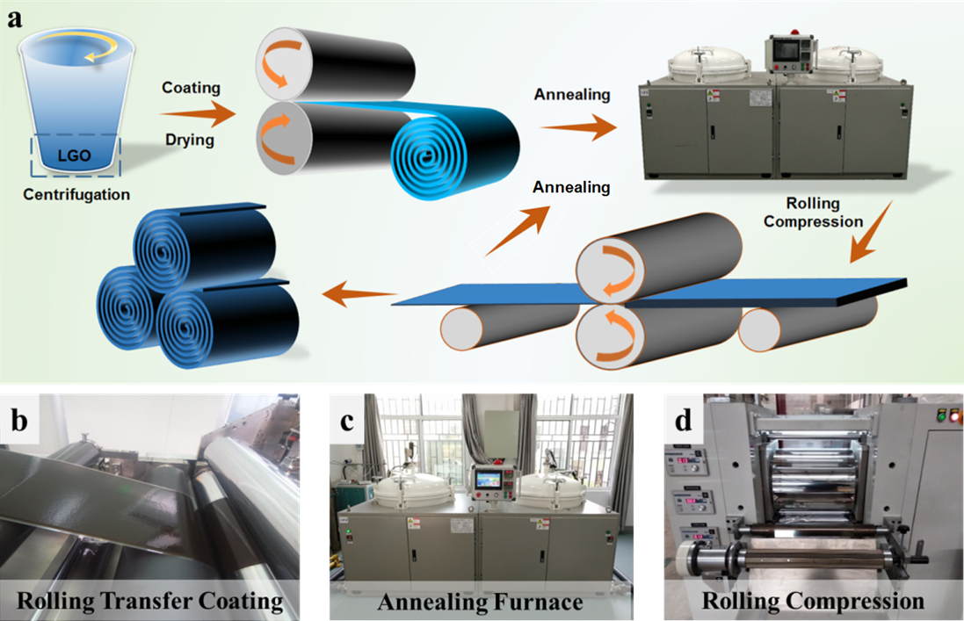
a
- (a) The fabrication process of GAF; (b) Coating; (c) Annealing; (d) Rolling Compression.
Figure S1 (a) shows the large scale fabrication process of flexible large flake size graphene assemble film. The large flake size graphene oxide (LGO) was separated from lower layer of graphene oxide suspension after centrifugation. Large flake size graphene assemble flexible film was prepared through pre-metered roll transfer coating of LGO hydrogel (3 wt.%) on a self-released substrate such as polyethylene terephthalate (PET) film, as shown in Figure S1 (b). Subsequently, the LGO hydrogel on substrate was keep under mild heating condition (70-80 ℃) until drying. Thereafter, a soft, dark brown free-standing and paper-like graphene oxide film (LGO film) could be easily peeled off from the PET substrate. And then, LGO film was thermally annealed (2850˚C) in Ar atmosphere between graphite plates for reduction and graphitic crystallisation in graphitization furnace, as shown in Figure S1(c). After thermal reduction, a rolling compression with the pressure of 300 MPa was further introduced to obtain the primary annealing graphene assembled film (GAF) (Figure S1(d)). Followed by the rolling compression, a secondary high temperature (2850˚C), Figure S1(c), annealing process in Ar atmosphere was carried out to remove the structural damage during the rolling process to further increase the electrical conductivity.

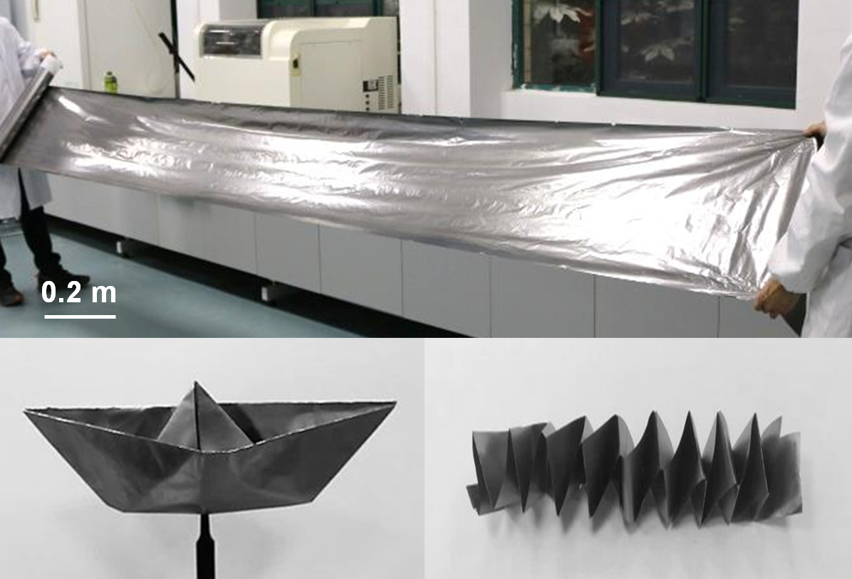
- Digital photographs of LGO films and GAFs
Figure S2 show GAFs can be folded into a boat or a spring shape to present its durability and flexibility.

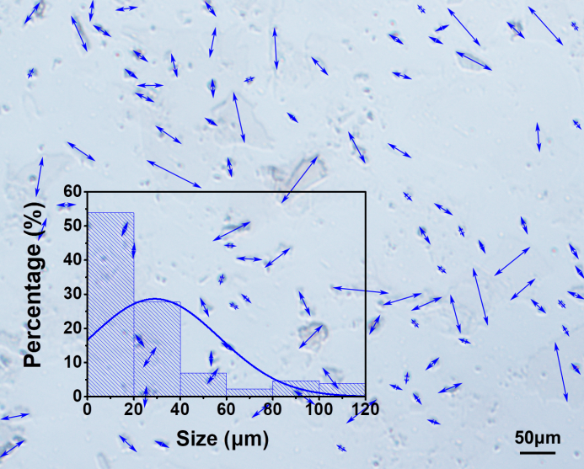
- Optical microscope images of typical-sized GO sheets and corresponding size distributions
Figure S3 shows the statistic study of typical-sized GO sheets. It can be found from the Figure S3 that TGO with the lateral size < 60 μm accounts for 98.4 %, and 81.5% of TGO are smaller than 40 μm according to cumulative distribution statistics.

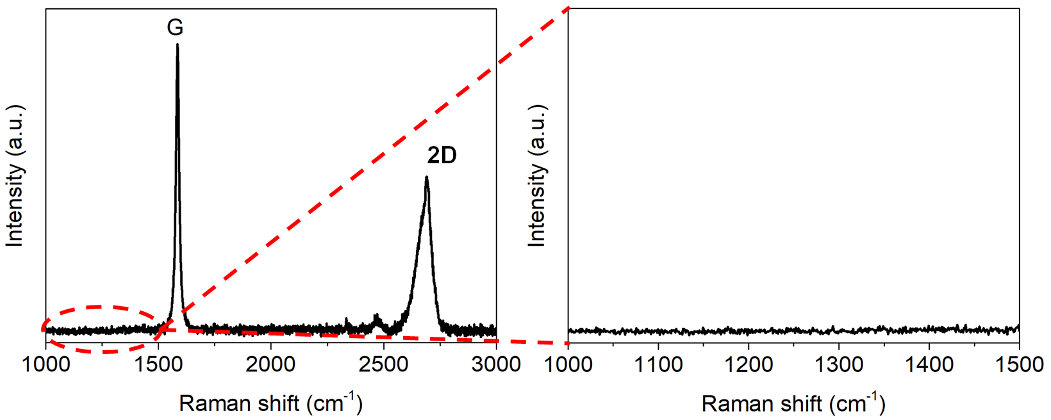
- Raman spectroscopy of GAF
Figure S4 shows the Raman spectroscopy of GAF. The G band (1584 cm⁻¹) and 2D band (2687 cm⁻¹) are found, no obvious D band has been observed referring the elimination of lattice defects and formation of characteristic sp² hybridized lattices. In addition, the XRD pattern of GAF in main text exhibits a sharp diffraction peak at 26.5°, suggesting a d₀₀₂ = 0.34 nm; the peak (004) confirms the highly graphitized structure.
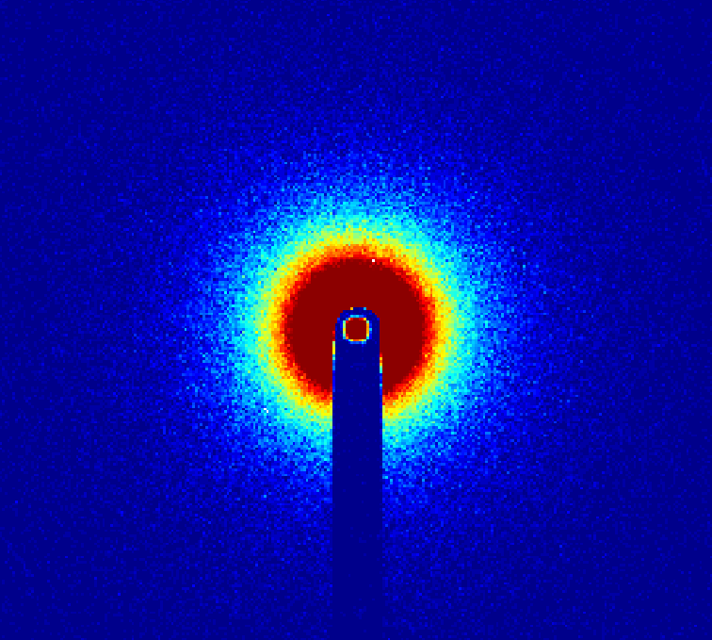
- The SAXS pattern of TGF
Figure S5 shows the small-angle x-ray scattering (SAXS) pattern of TGF recorded by Small-angle X-ray Scattering System (Anton Paar SAXSpoint 2.0). The SAXS pattern of TGF shows a circular scattering pattern which means the flake orientation in TGF film showing less orientation or random assembling.

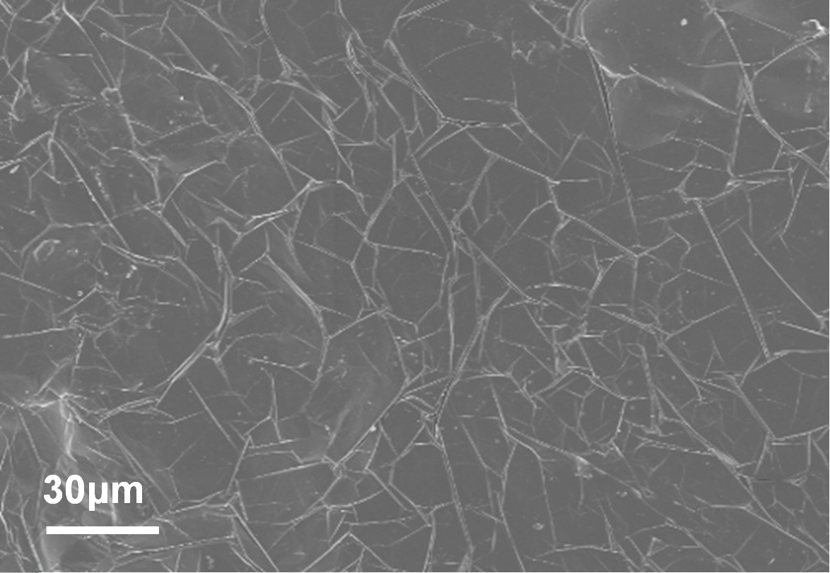
- Surface SEM image of GAF
Figure S6 is the top view GAF SEM image, microfolds are uniformly distributed on the GAF surface ascribing to the synergistic effect of graphene nanosheets stacking, conversion from oxygen-containing functional groups to gases and finally to the micro-cavity which was evolved into microfolds.

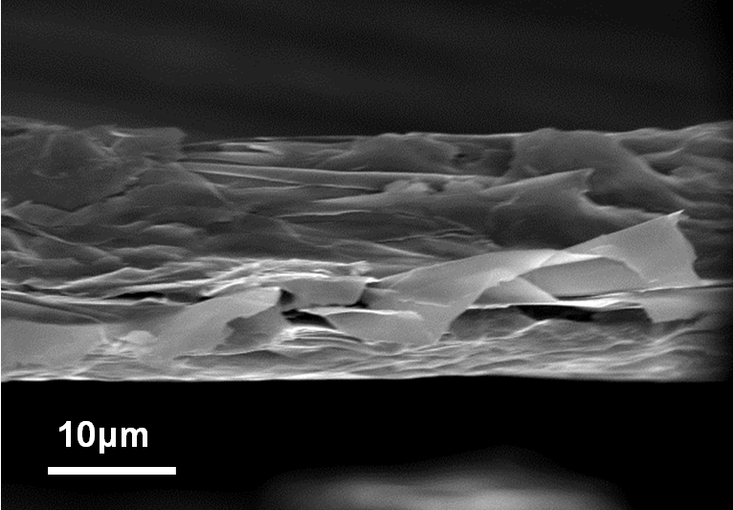
- The cross-section SEM imange of GAF
As shown in Figure S7 , the cross-section SEM image of the GAF characterises a thin film/laminate structure with a thickness of ~19 ± 0.5 μm.
Test of conductivity and surface resistance of GAF:
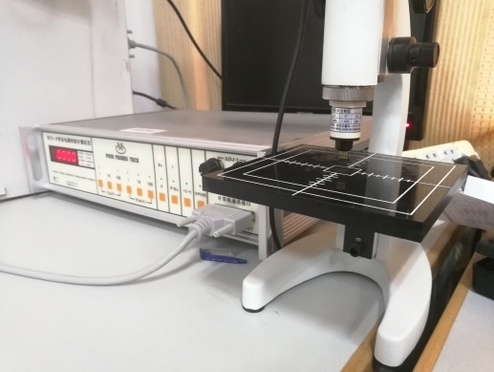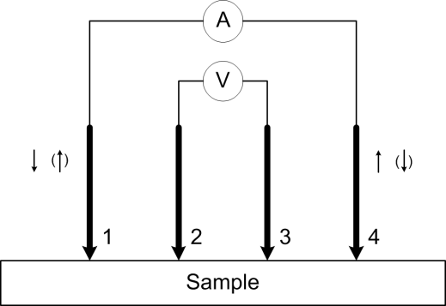
- The Digital photo and testing principle schematic of four probes tester
The instrument used to test conductivity is four probes tester, as shown in Figure S8 . The specific test method is as follows:
Sample: 10mm x 10mm;
Probe spacing: S=1mm
1. Surface resistivity test
(1) The current I is from probe 1 to probe 4, and the voltage between probe 2 and 3 is V₂₃₊;
(2) Reversing the current, I is from probe 4 to probe 1, and the voltage between probe 2 and 3 is V₂₃₋;
(3) Calculating the mean value of positive and backward voltage: V₂₃= (V₂₃₊ + V₂₃₋) /2;
(4) Calculating the surface resistance (R□): R□=K×(V₂₃ / I);
where K is correction factor.
2. Conductivity test
(1) Calculating the volume resistivity: ρ= R□×W×F (W /S)/ 10 (Ω·cm);
where W is the thickness of the sample obtained from SEM cross section images, F(W/S) is the thickness correction factor.
(2) Calculating the conductivity: σ =1 / ρ.
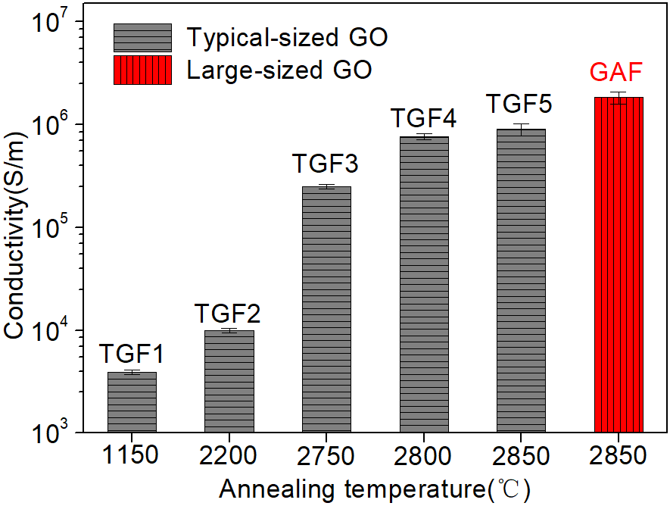
- Conductivity of graphene film made from different temperature as well as GO precursor size
As shown in Figure S9 , the electrical conductivity of flexible graphene assembled film were improved by increasing the annealing temperature, this is attributed to the elimination of disturbing oxygen containing groups caused residual defects exist in original GO film and recrystallisation. The annealed temperatures increased from 1150, 2200, 2750, 2800, to 2850 ℃, corresponding to a growing conductivity of 3.9×10³, 1×10⁴, 2.5×10⁵, 7.6×10⁵, and 9×10⁵ S/m, labelled as TGF1, TGF2, TGF3, TGF4, TGF5 respectively. Figure S9 also shows the comparison of GAF made of large flake size GO presents a conductivity up to 2.58×10⁶ S/m, which is 3 times higher than the typical flake size GO made film annealed at same temperature.

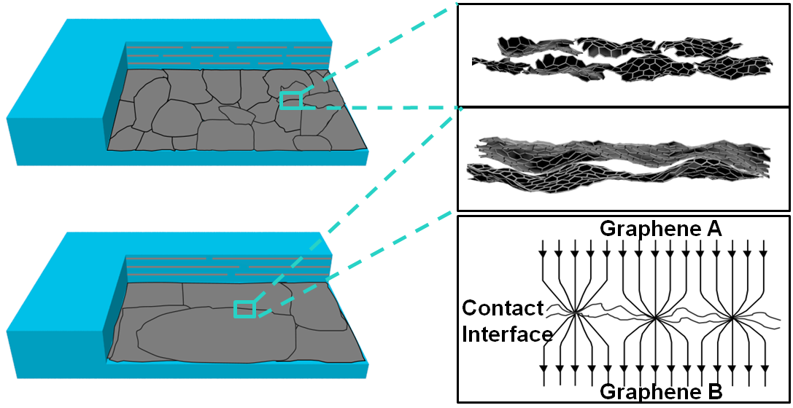
- The proposed mechanism of electron transfer paths within GAF and TGF layered structures
The level of contact resistance dominates the film electrical conductivity. The adjacent graphene nanosheets interact with each other via van der Waals forces with an atomically clean inter-face free of disordered chemical bonds, in this case, the actual electron flow channel is smaller than the contact area when the current passed through the two contact surfaces. GAF has less connection boundaries compared with the TGF within the transverse connection due to the large in-plane crystallite size, therefore when the current passes through the contact surface, the contact resistance increases with the contraction of the current line, thus having a higher electrical conductivity. As shown in Figure S10 , TGF has more connection boundaries compared with the GAF within the transverse connection due to the smaller in-plane crystallite size, thus, having a lower electrical conductivity.

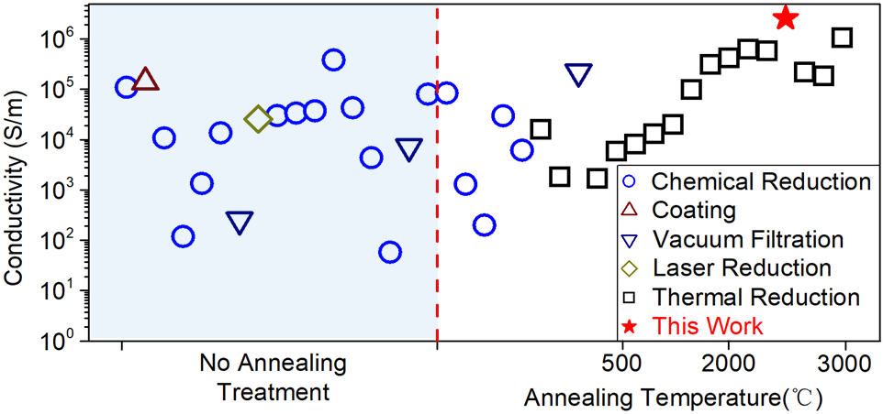
- Comparison of graphene’s conductivity in references to the result in this work
As presented in Figure S11 , the GAF exhibited a metal-like electrical conductivity, which is higher than other methods fabricated graphene film reported in literature.
Table S1 Summary of conductivity and thickness of grapheme film and grapheme paper
Method | Annealing Temperature (℃) | Conductivity  (S/m) | Thickness  (μm) | Reference
Thermal Reduction | 2850 | 2580000 | 19 | This Work
Chemical Reduction | Room Temperature | 110000 | 7.1 | 1
Coating | Room Temperature | 140000 | 20 | 2
Chemical Reduction | Room Temperature | 10800 | 13 | 3
Chemical Reduction | Room Temperature | 119 | 54 | 4
Chemical Reduction | Room Temperature | 1350 | 8 | 5
Chemical Reduction | Room Temperature | 13640 | 6.19 | 6
Vacuum Filtration | Room Temperature | 253 | 5 | 7
Laser Reduction | Room Temperature | 2560 | / | 8
Chemical Reduction | Room Temperature | 30000 | 2.4 | 9
Chemical Reduction | Room Temperature | 33700 | 7.3 | 10
Chemical Reduction | Room Temperature | 37400 | 6.5 | 11
Chemical Reduction | Room Temperature | 385000 | 12 | 12
Chemical Reduction | Room Temperature | 43000 | 1.9 | 13
Chemical Reduction | Room Temperature | 4382 | 25 | 14
Chemical Reduction | Room Temperature | 58 | 2.9 | 15
Vacuum Filtration | Room Temperature | 7300 | 10 | 16
Chemical Reduction | Room Temperature | 80200 | 8 | 17
Chemical Reduction | Room Temperature | 84500 | 6.5 | 18
Chemical Reduction | 70 | 1300 | / | 19
Chemical Reduction | 80 | 200 | 2.2 | 20
Chemical Reduction | 100 | 29800 | 2.6 | 21
Chemical Reduction | 100 | 6180 | 1.2 | 22
Thermal Reduction | 150 | 16000 | 2.56 | 23
Thermal Reduction | 200 | 1800 | 10 | 24
Vacuum Filtration | 340 | 220000 | 36 | 25
Thermal Reduction | 500 | 1700 | 9.9 | 26
Thermal Reduction | 500 | 5900 | 6 | 27
Thermal Reduction | 700 | 8100 | 6 | 28
Thermal Reduction | 1000 | 13140 | / | 29
Thermal Reduction | 1000 | 20000 |  | 30
Thermal Reduction | 2000 | 100000 | 8.4 | 31
Thermal Reduction | 2000 | 311300 | 1.25 | 32
Thermal Reduction | 2400 | 420000 | 21.93 | 33
Thermal Reduction | 2700 | 630000 | 1.48 | 34
Thermal Reduction | 2700 | 577000 | / | 35
Thermal Reduction | 2850 | 223000 | 31.7 | 36
Thermal Reduction | 3000 | 1060000 | 10 | 37
Thermal Reduction | 3000 | 183000 | 9 | 38
Table S2 Summary of conductivity and thickness of carbon-based materials, MXene and metals
Materials | Conductivity (S/m) | Thickness (μm) |  | Reference
Graphene ink | 43000 | 50 | 39
Graphene ink | 43000 | 6 | 40
Graphene ink | 71300 | 7.8 | 41
Graphene ink | 44700 | 20 | 42
Graphene ink | 88100 | 14.7 | 43
Graphene ink | 24000 | 3 | 44
Carbon nanotube | 3620 | 50 | 45
Carbon nanotube | 35000 | 12 | 46
Carbon nanotube | 130000 | 10 | 47
MXene | 650000 | / | 48
MXene | 300000 | 2.5 | 49
MXene | 400000 | 6 | 50
MXene | 22000 | 2 | 51
MXene | 650000 | 0.1 | 52
MXene | 226100 | / | 53
MXene | 8800 | 2 | 54
MXene | 330000 | 7 | 55
Al | 35300000 | / | /
Fe | 10200000 | / | /
Cu | 57100000 | / | /
Ag | 60600000 | / | /
Au | 41700000 | / | /

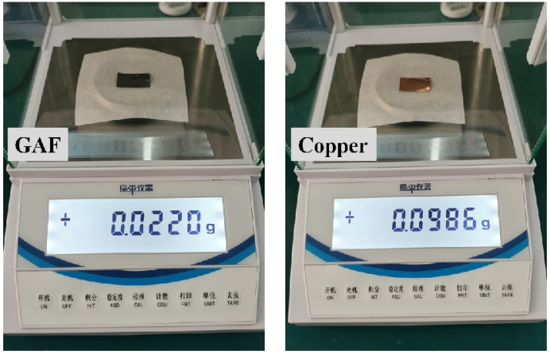
- Apprent density comparison between GAF and copper foil
GAF and copper foil with an area of 20 mm × 30 mm is used to measure the weight, and then to calculate the apparent density. As shown in the Figure S12 , the weight of GAF (with the thickness of 19 μm) is 0.0220 g; the copper foil (with the thickness of 19 μm) has a weight of 0.0986 g. According to the calculation formula of the density (ρ=m/v, ρ: density, m: mass, v: volume), the apprent density of the GAF is 1.92 g/cm³, and the copper foil is 8.65 g/cm³.

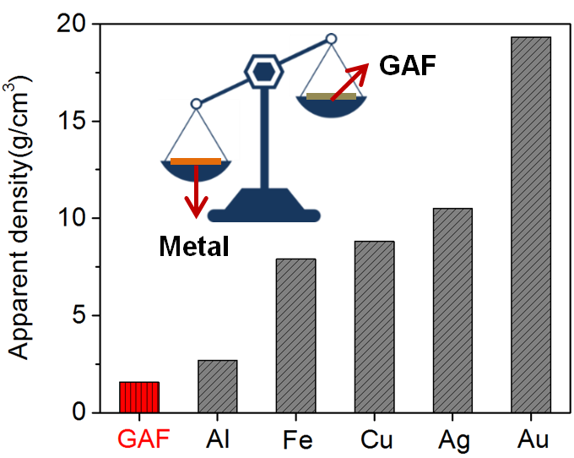
- Apprent density comparison between GAF and metal materials
The apparent density of GAF shown in Figure S13 , 1.92 g/cm³, is significantly lower compared with metals such as gold (Au) of 19.32 g/cm³, silver (Ag) of 10.5 g/cm³, copper (Cu) of 8.65 g/cm³, aluminium (Al) of 2.7 g/cm³ and iron (Fe) of 7.9 g/cm³.

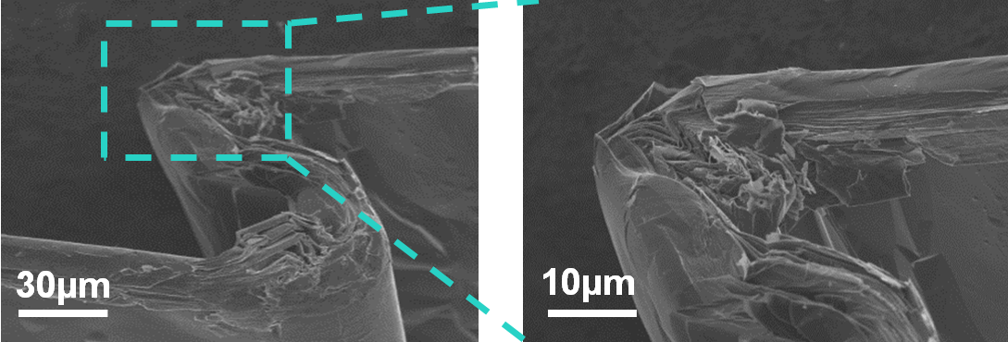
- Cross section SEM images of GAF
Figure S14 shows the cross section SEM images indicate that the durability of GAF that can endure a zigzag folding without any breakage.

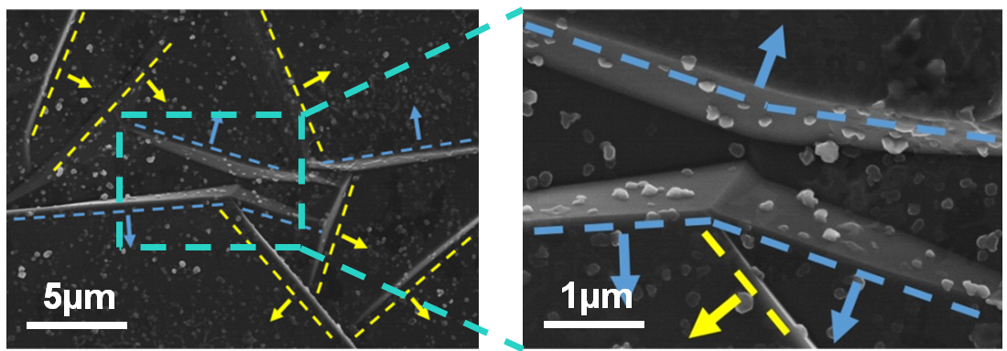
- Surface SEM images of GAF
In Figure S15 , the blue and yellow lines represent the local microfolds in different directions, while blue and yellow arrows indicate the unfolding direction of microfolds when suffering external force.

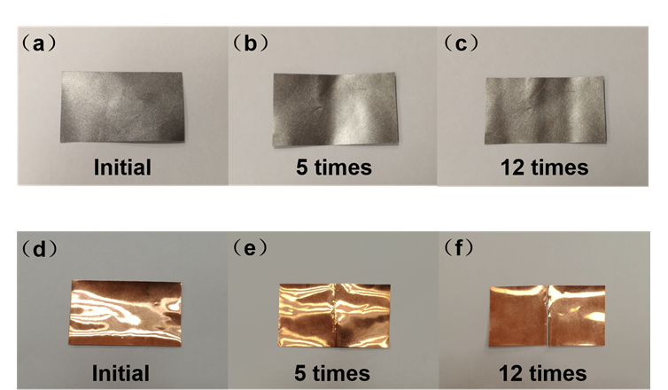
- Mechanical stability test of GAF and copper foil
A fold test of GAF and copper foil was designed to investigate the excellent flexibility and mechanical stability of GAF. As shown in Figure S16 , the copper foil cracked after 5 folds and was completely broken after 12 folds, whereas the GAF barely changed after 12 folds, demonstrating that the GAF has better mechanical stability than the copper foil.

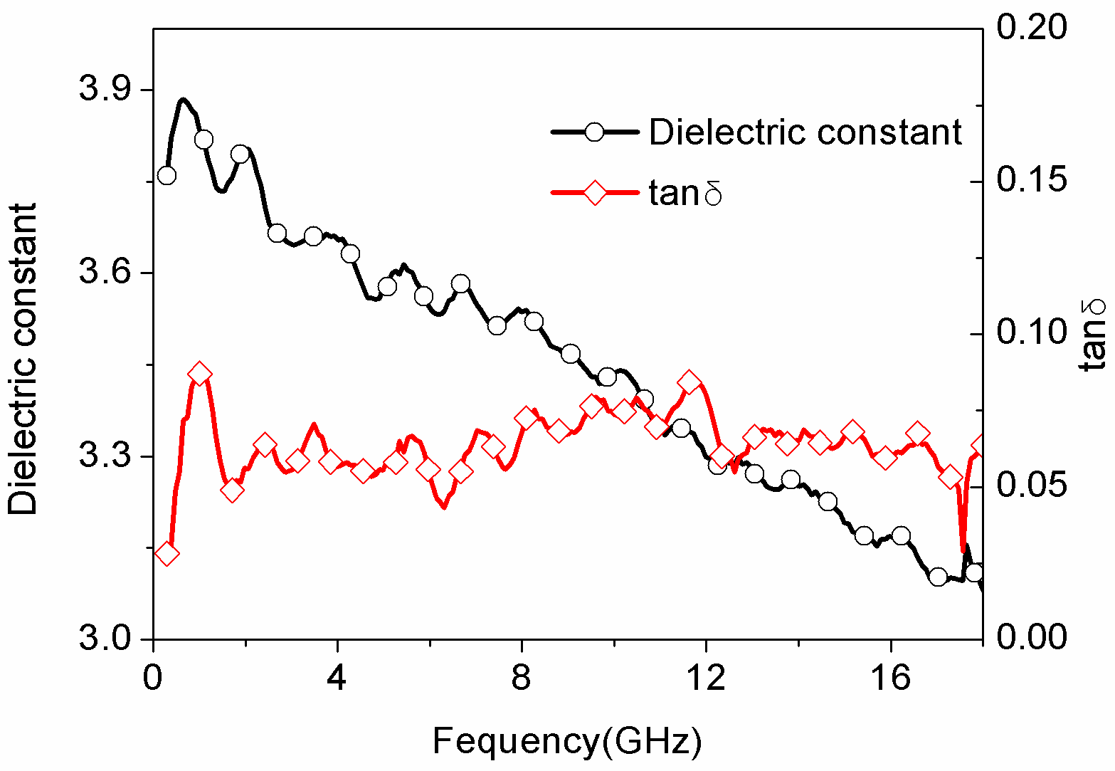
- The dielectric constant and loss tangent of the silica gel film
The dielectric constant and loss tangent of the substrate influence RF and microwave circuit matching, particularly for passive microwave devices such as transmission lines and antennas. The coplanar waveguide transmission line, quarter-wave short-circuit resonator, and wearable antenna all have silica gel substrates. The relationship between the dielectric constant and the loss tangent in the 30 MHz - 18 GHz frequency band is shown in Figure S17 . The dielectric constant gradually decreases as frequency increases, and the loss tangent remains nearly constant at around 0.06. A change in the dielectric constant misaligns the passive device with the connector, and a larger loss tangent increases the loss of the dielectric substrate, both of which increase device losses.

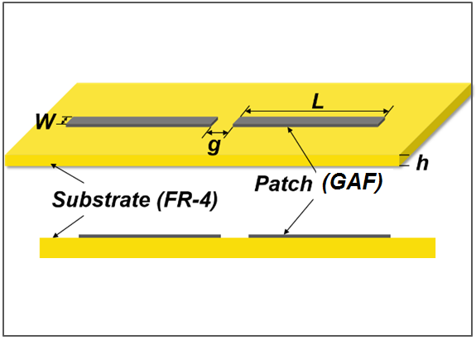
- The disgned structure of GAF dipole antenna
Figure S18 shows the structure of GAF dipole antenna. The dipole antenna was designed on the FR-4 substrate having a thickness (h) of 1.6 mm and dielectric constant of 4.4. Both the width (W) of the arm and the gap (g) between the two arms were 3.53 mm, and the arm length (L) was 63.95 mm.

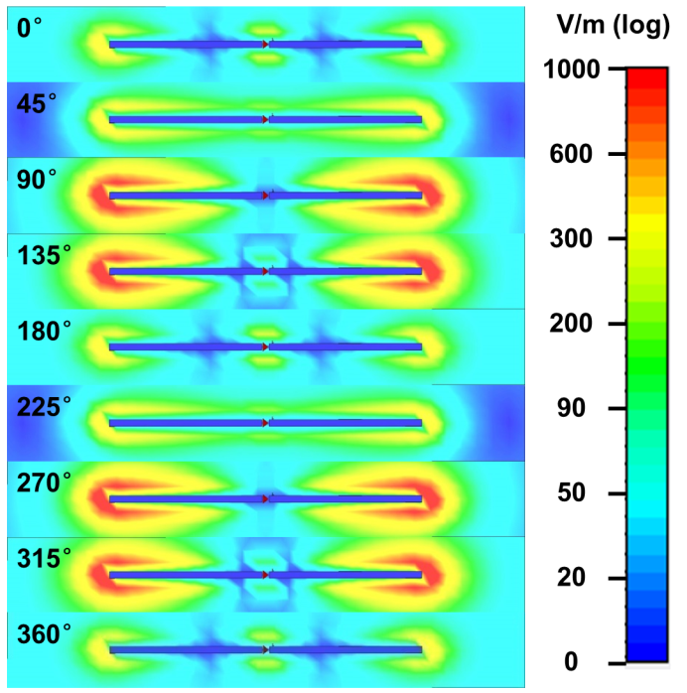
- The E-field distribution of GAF dipole antenna at different phases
Figure S19 is the simulated electric field distribution of GAF dipole antenna at different phases. The value of the E-field distribution changed periodically with π, indicating that the current on the GAF dipole antenna was sinusoidally distributed, which was consistent with the current distribution theory of the dipole antenna.

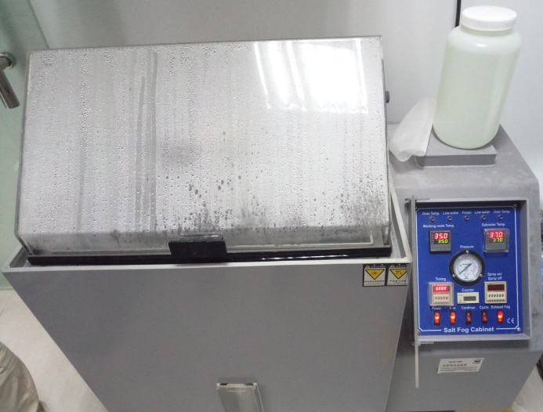
- Salt spray experiment environment
Figure S20 is a digital photograph of a salt fog cabinet (Anhui Lianruan Education Technology Co., Ltd.), which serves as the antenna's salt spary experiment environment. Tested for one week and two weeks, the GAF antenna and copper antenna were placed in the salt fog carbinet at a temperature of 35 °C. The solution is a sodium chloride aqueous solution with a concentration of 5%, a PH of 6.8, and a sedimentation rate of 1.5mL/h.80 cm².

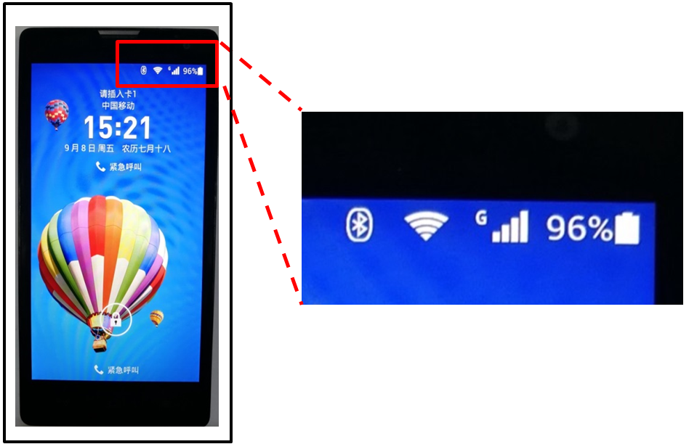
- The working state of the GAF antennas phone
Figure S21 show the GAF antennas can work steadily in mobile phone. The Bluetooth switch, WIFI signal and main communication signal indicates the GAF antennas can offer stable performance in a mobile phone.

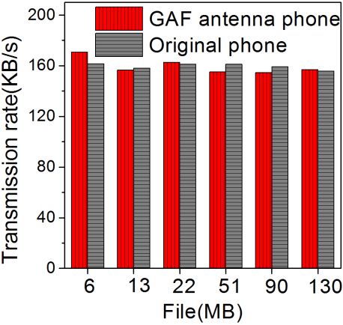
- Comparison of Bluetooth transmission rates between GAF antennas phone and original phone
To quantify the performance of the GAF antenna, a set of Bluetooth transmission rate comparison experiments were designed, as in Figure S22 , the GAF antennas phone has a similar transmission rate to the original phone.

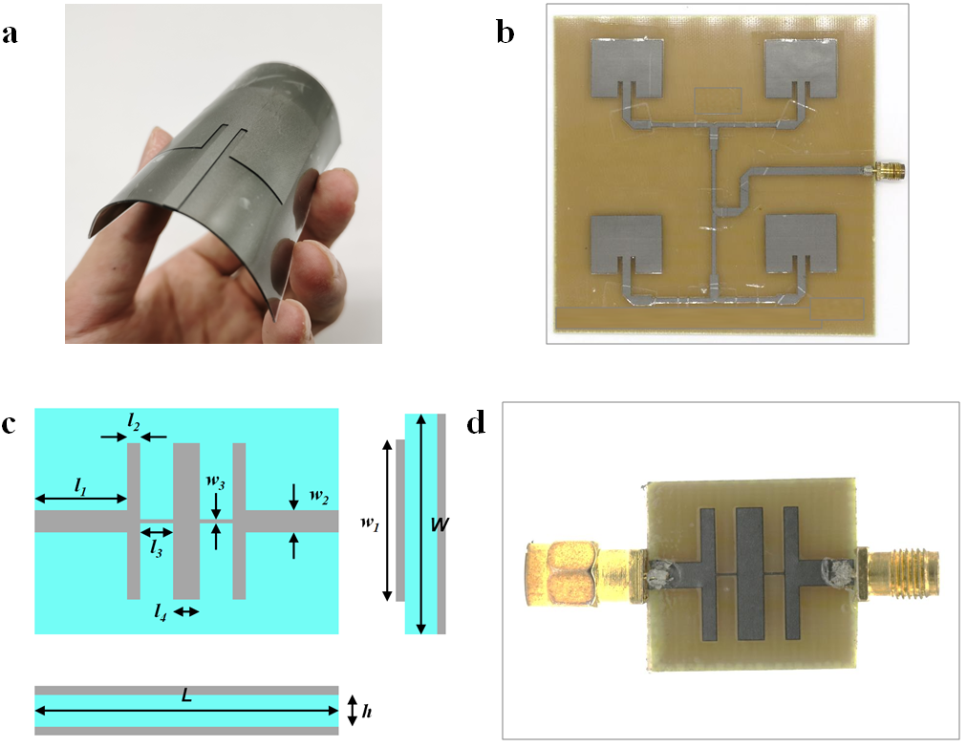
- The structure and digital photo of (a) flexible GAF wearable antenna; (b) 2×2 GAF antenna array and (c, d) GAF filter
As shown in Figure S23 , the wearable GAF antenna is designed on the silica gel film with a thickness of 1.5 mm. The 2×2 antenna array was designed on the FR-4 substrate. The length and width of element patch were 28.53 mm and 37.26 mm, respectively. The substrate of GAF filter is FR-4 with thickness of 1.6mm. The GAF filter is a fifth-order Chebyshev low-pass filter with a 3 dB cut-off frequency of 3.5 GHz. The filter is a microstrip structure, and the input port and output port impedance are both 50 ohms. The optimized dimensions are L=34.1mm, l₁=6.5mm, l₂=1.75mm, l₃=2.46mm, l₄=3.2mm, W=24.6m, w₁=15.72mm, w₂=3.06mm, w₃=0.24mm. The microstrip line and ground are made of flexible GAF.

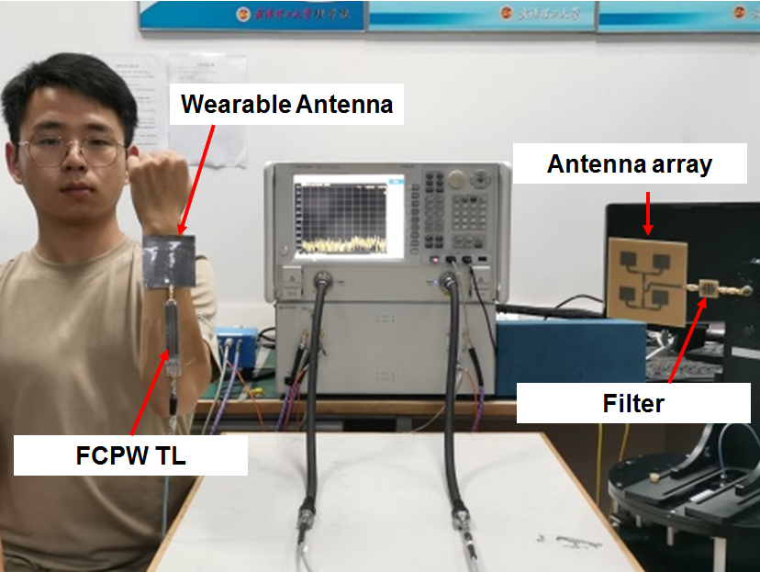
- Communication system demonstration of GAF WCE (wearable antenna, FCPW TL, antenna array, filter)
As presented in Figure S24 , a communication system integrated with all GAF electronics is demonstrated. The wearable GAF antenna, connecting with GAF FCPW TL, as the receiver. The GAF antenna array connecting with a low-pass filter to suppress harmonic radiation is fabricated as a transmitter.

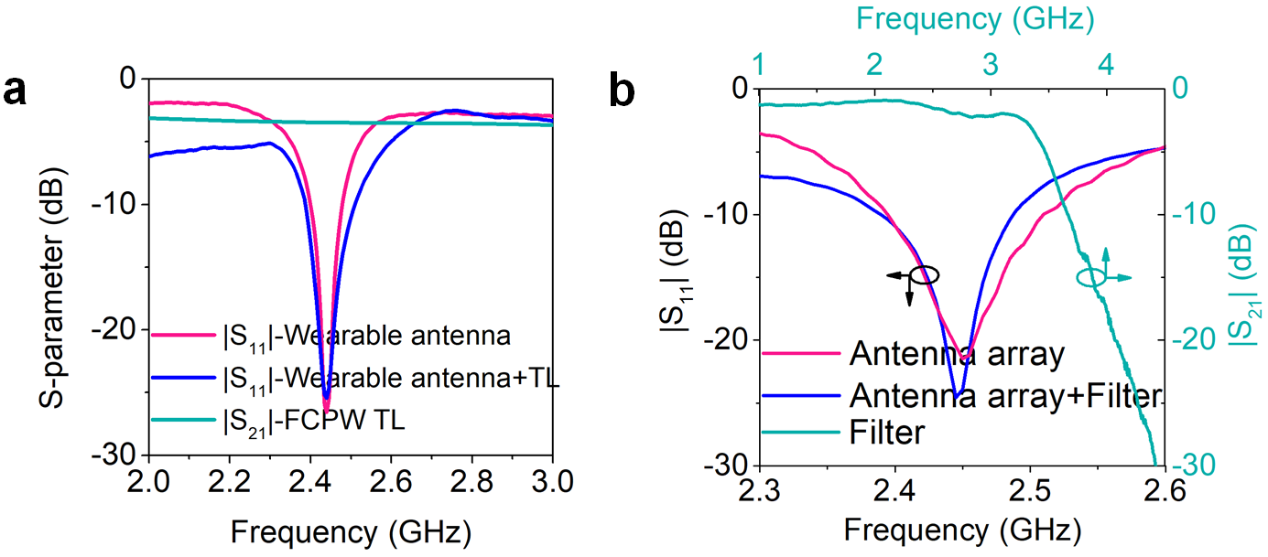
- Measured S-parameters of GAF WCE
The wearable antenna resonates at 2.45 GHz, as shown in Figure S25 . After connecting TL, the |S₁₁| of antenna remains constant. Figure S25 also shows the transmission coefficient of FCPW TL. At the transmitting side, the |S₁₁| of the GAF antenna array and the |S₂₁| of the GAF filter are shown in Figure S25 . Before and after connecting the filter, the GAF antenna array works at 2.45 GHz to ensure the frequency matching with the receiver. In Figure S25 , the |S₂₁| of the GAF low pass filter between 1 GHz to 4.5 GHz is depicted, which shows promising filtering performance.

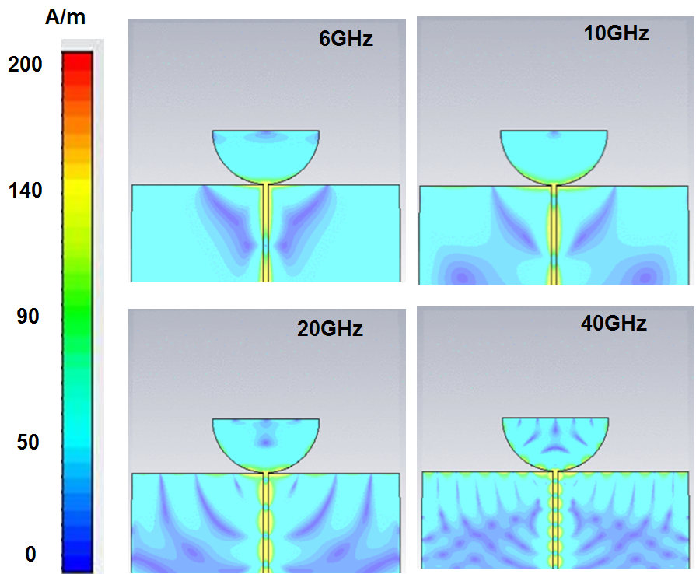
- Surface current distribution of the UWB antenna at 6 GHz, 10 GHz, 20 GHz and 40 GHz
We carried out simulated surface current distribution of the UWB antenna at 6 GHz, 10 GHz, 20 GHz, and 40 GHz to provide insights into the radiation characteristics, as shown in Figure S26 , this demonstrates that the GAF UWB antenna is working in its fundamental resonance mode at low frequency band and higher resonance mode at high frequency band.

- The digital photo of GAF millimeter wave antenna array
The GAF millimeter wave antenna array with the geometrical dimensions of 135 mm × 95 mm × 0.54 mm, as shown in Figure S27 . The GAF antenna array has 140 antenna elements (14 × 10) with spacing of 3/4λ.
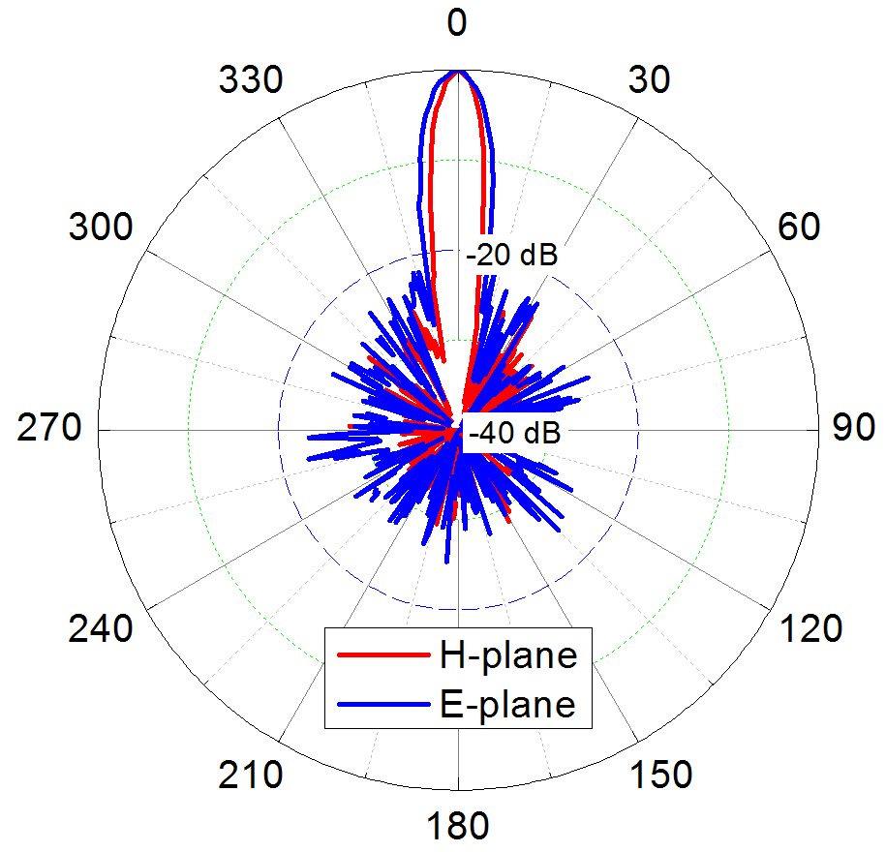
- The measured radiation patterns of GAF millimeter wave antenna array.
Figure S28 depicts the measured E-plane and H-plane radiation patterns. The beam width and sidelobe level of E-plane and H-plane are 8.5 °, - 21.76 dB and 5.9 °, - 24.94 dB, respectively.

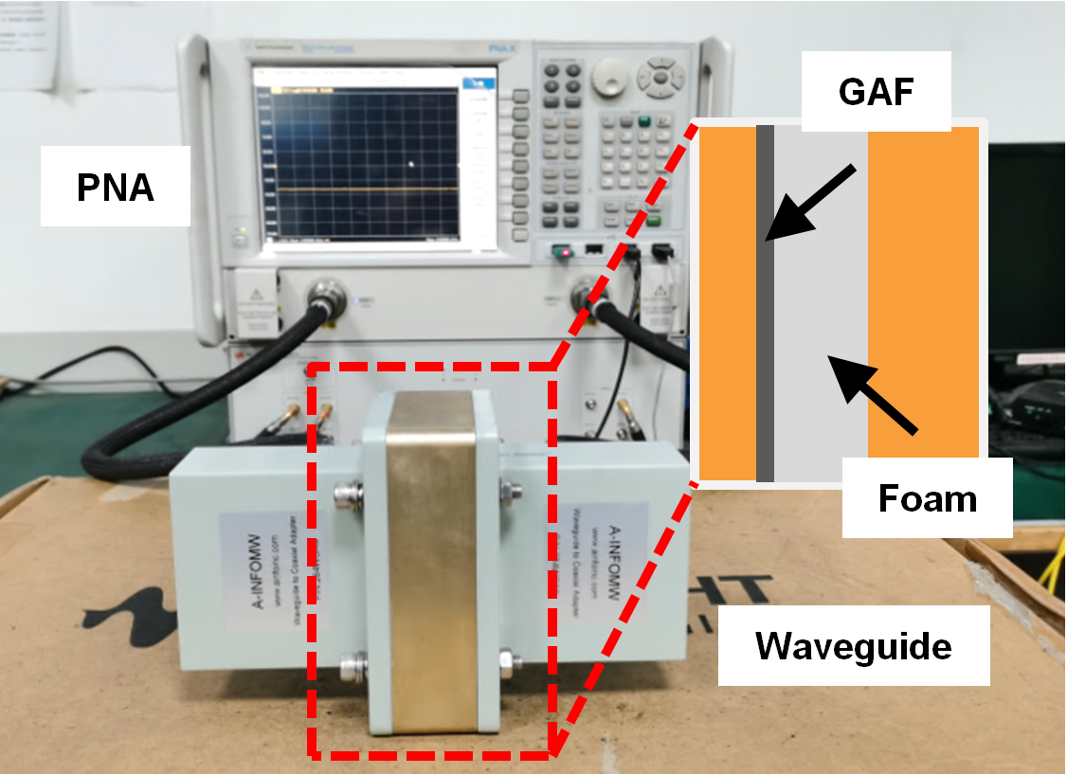
- The test environment of rectangular waveguide method
Figure S29 is the EMI SE's actual rectangular waveguide method test environment. The transmission and reflection coefficients of the rectangular waveguide test sample are recorded using a vector network analyzer (Keysight PNA N5247A). The EMI SE, reflectance, and transmittance of the test sample can all be calculated using the S-parameter.

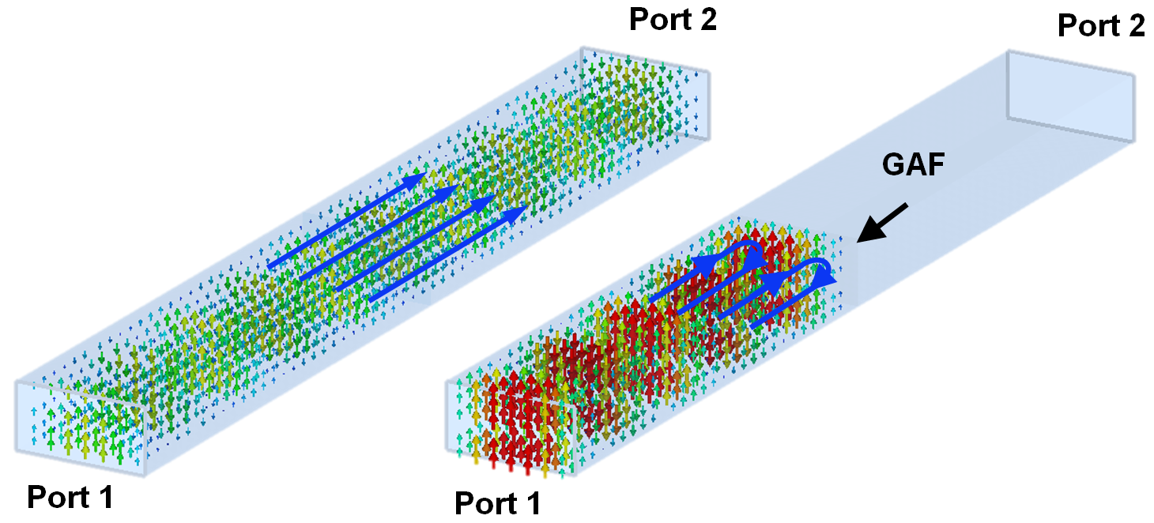
- The simulated result of GAF EMI SE in rectangular waveguide
The EMI performance of GAF is simulated by rectangular waveguide method, as shown in Figure S30 . When there is no GAF, the electromagnetic wave in the rectangular waveguide passes through from port 1 to port 2 with no reflection and energy loss. On the other hand, when electromagnetic wave reach the surface of the GAF, electromagnetic waves exhibit strong shielding characteristics, and most energy reflect by the GAF, which proves GAF has excellent EMI shielding performance.

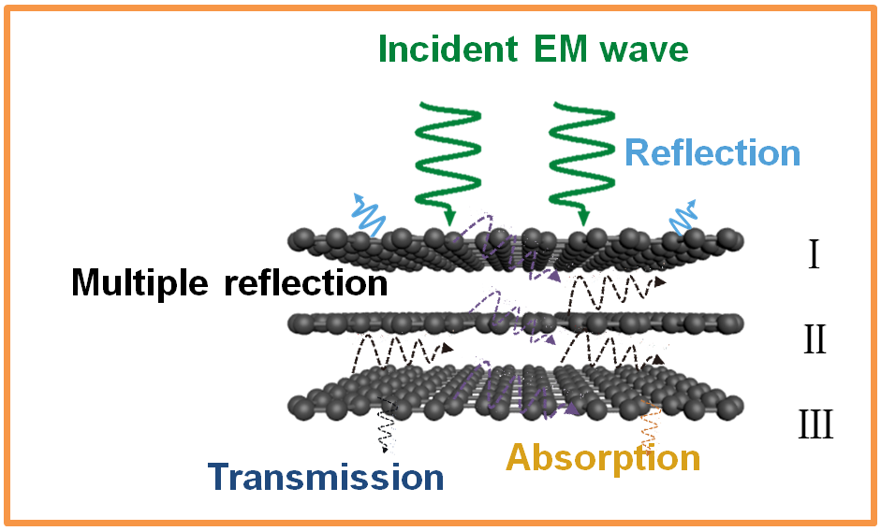
- The EMI shielding mechanism of GAF
Figure S31 illustrates the EMI shielding mechanism of GAF. The majority of the electromagnetic energy is reflected back by the GAF's surface, and only a small portion of the electromagnetic wave passes through the surface and enters the GAF's interior. GAF is a multilayer laminate structure with a certain resistance; electromagnetic energy enters the GAF and is converted into heat energy before being consumed after multiple reflections.

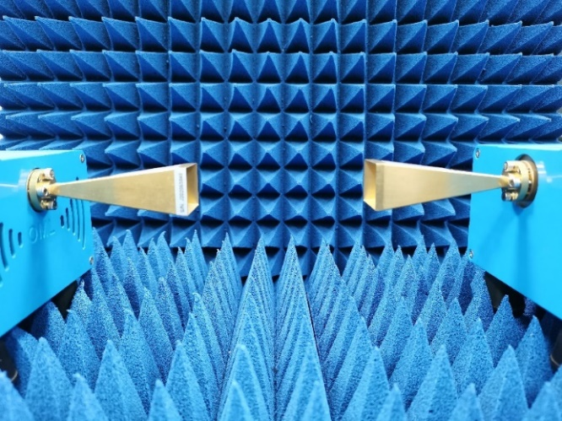
- The test environment of free space method
Figure S32 shows the free space method test environment of EMI SE. The two ports of the vector network analyzer (Keysight PNA N5247A, N5256AW10, N5256AW03) are connected to the horn antenna to measure the EMI SE of GAF.

Table S3 Summary of conductivity and thickness of graphene-based films and papers
Materials | Thickness  (mm) | EMI SE  (dB) | SE/t  (dB/mm) | Frequency  band (GHz) | Reference
Graphene based | 0.2 | 63 | 315 | 8-12 | 56
Graphene based | 2 | 25 | 12.5 | 8-12 | 57
Graphene based | 0.024 | 24 | 1000 | 8-12 | 58
Graphene based | 1 | 56 | 56 | 8-12 | 59
Graphene based | 0.025 | 52 | 2080 | 1-18 | 60
Graphene based | 0.05 | 20 | 400 | 5.4-59.6 | 61
Graphene based | 0.03 | 26.5 | 883.33 | 8-12 | 62
Graphene based | 0.3 | 25.2 | 84 | 8.2-59.6 | 63
Graphene based | 0.25 | 85 | 340 | 8-12 | 64
Graphene based | 2 | 70.37 | 35.18 | 8.2-12.4 | 65
Graphene based | 0.0125 | 52 | 4160 | 12-18 | 66
Graphene based | 0.043 | 48.3 | 1123.25 | 8.2-12.4 | 67
Graphene based | 0.12 | 105 | 875 | 2-18 | 68
Graphene based | 0.03 | 40.1 | 1336.66 | 12.4-18 | 69
Graphene based | 0.035 | 27.4 | 782.85 | 8.2-12.4 | 70
Graphene based | 2.5 | 27.6 | 11.04 | 8-12 | 71
Graphene based | 5 | 47.8 | 9.56 | 8-18 | 72
Graphene based | 5 | 40 | 8 | 8-18 | 73
Graphene based | 0.05 | 60 | 1200 | 8-12 | 74
Graphene based | 0.3 | 24 | 80 | 8.2-12.4 | 75
Graphene based | 0.8 | 21 | 26.25 | 8-12 | 76
Graphene based | 0.8 | 70 | 87.5 | 8-12 | 77
Graphene based | 1.6 | 36 | 22.5 | 8.2-12.4 | 78
Graphene based | 1.6 | 91.9 | 57.43 | 8-12 | 79
Graphene based | 1 | 20 | 20 | 8-12 | 80
Graphene based | 1 | 38 | 38 | 0.5-4 | 81
Graphene based | 2.3 | 12.8 | 5.56 | 8-12 | 82
Graphene based | 2.5 | 18 | 7.2 | 8-12 | 83
Graphene based | 2.5 | 23 | 9.2 | 8-12 | 84
Graphene based | 2.5 | 29 | 11.6 | 8.2-12.4 | 85
Graphene based | 2.5 | 45.1 | 18.04 | 8.2-12.4 | 86
Graphene based | 2 | 54.2 | 27.1 | 8-12 | 87
Graphene based | 0.6 | 34 | 56.66 | 100-800 | 88
Graphene based | 0.37 | 72.1 | 194.86 | 100-1000 | 89
Graphene based | 0.033 | 60 | 1818.18 | 200-2000 | 90
MXene based | 0.06 | 59 | 983.33 | 8-12 | 91
MXene based | 0.35 | 80 | 228.57 | 8-12 | 92
MXene based | 0.009 | 27 | 3000 | 2-18 | 93
MXene based | 0.045 | 92 | 2044.44 | 8.2-12.4 | 49
MXene based | 0.06 | 70 | 1166.66 | 8.2-12.4 | 50
MXene based | 0.047 | 22 | 468.08 | 8.2-12.4 | 94
MXene based | 2 | 50 | 25 | 8.2-12.4 | 95
MXene based | 0.04 | 116 | 2900 | 8.2-12.4 | 96
Other carbon based | 2 | 52.4 | 26.2 | 8-12 | 97
Other carbon based | 4 | 90 | 22.5 | 8-12 | 98
Other carbon based | 0.35 | 34 | 97.14 | 8-12 | 99
Other carbon based | 0.36 | 106 | 294.44 | 8-12 | 100
Other carbon based | 2 | 40.1 | 20.05 | 8-12 | 101
Other carbon based | 1 | 67.3 | 67.3 | 8.2-12.4 | 102
Other carbon based | 3.1 | 130 | 41.93 | 1-2 | 103
Other carbon based | 0.8 | 24 | 30 | 8.2-12.4 | 104
Other carbon based | 1.8 | 54.8 | 30.44 | 8-12 | 105
Other carbon based | 0.03 | 34.9 | 1163.33 | 8.2-12.4 | 106
This work | 0.015 | 104.5 | 6966.66 | 2.6-325 | /
This work | 0.05 | 127.3 | 2546 | 2.6-325 | /

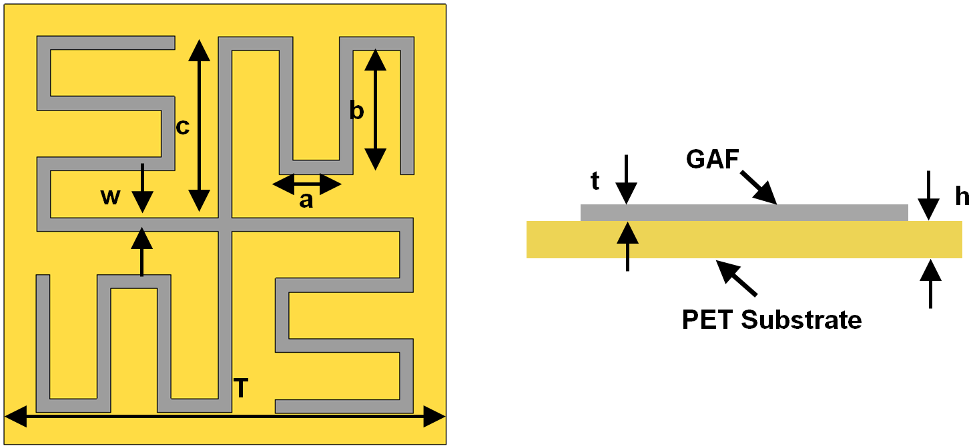
- The structure of GAF miniaturized FSS
Figure S33 shows the structure of GAF miniaturized FSS that works at 3.5 GHz. The dimension of the FSS periodic element is 16mm×16mm, which is only 0.18λ (λ is the wavelength in free space at 3.5 GHz).

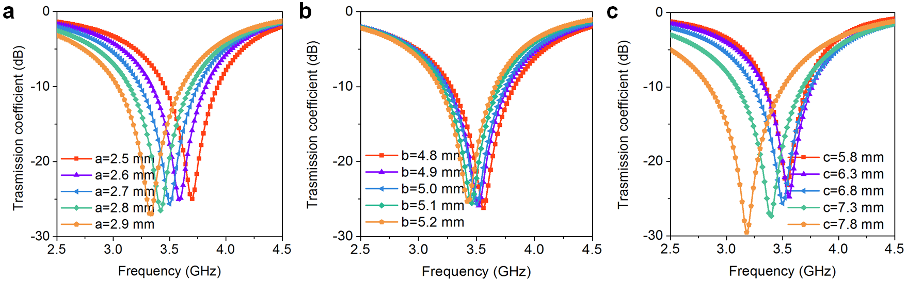
- The GAF FSS frequency response of different parameter values
Figure S34 show the design and optimization process, and the frequency response of different parameter values to GAF FSS. The optimized parameter values are shown in Table S4.

Table S4 The optimized parameter values of GAF FSS.
Parameter | Value (mm) | Parameter | Value (mm)
a | 2.7 | b | 5
c | 6.8 | w | 0.5
T | 16 | t | 0.015
h | 0.06

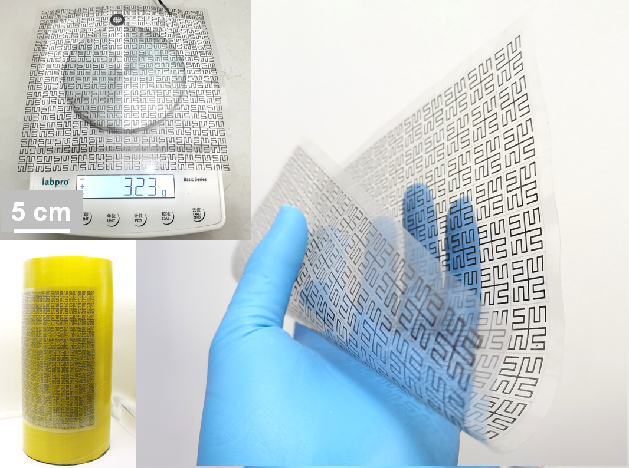
- The digital photo of GAF FSS

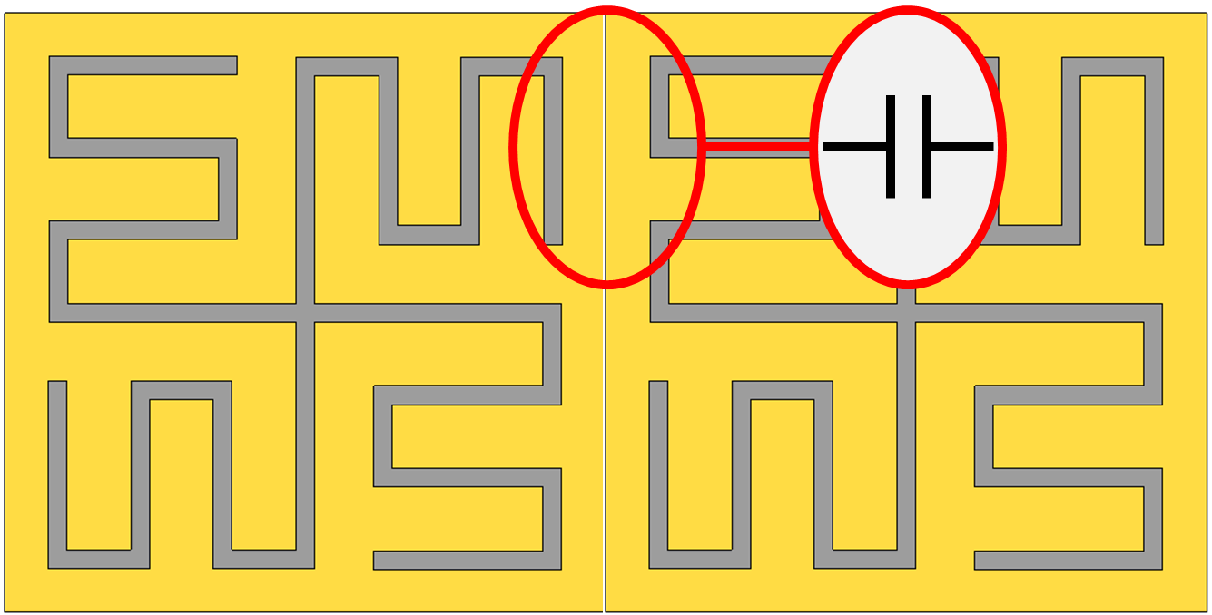
- The bending line structure of FSS
The miniaturization of FSS is realized through the bending line structure. Moreover, due to the presence of the bending line, the edge of the periodic element structure has a strong parasitic capacitance, which can further miniaturize the FSS, as shown in Figure S36 . In addition, strong parasitic capacitance can improve the angular stability of FSS.

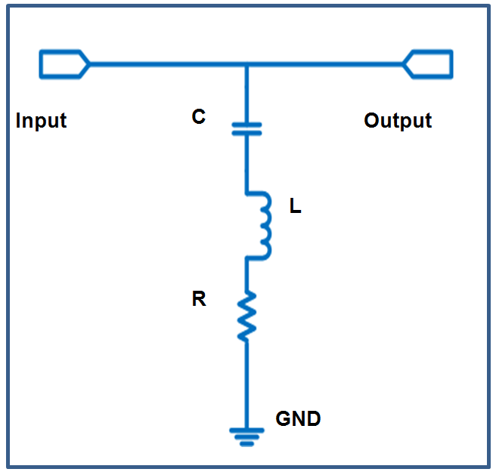
- The equivalent circuit diagram of GAF FSS element
Figure S37 illustrates the equivalent circuit diagram of GAF FSS element. The patch-type FSS periodic element is equivalent to a series circuit of resistance (R), inductance (L) and capacitance (C), where L and C represent the resonant frequency information, and R represents the Q value of the periodic element. The RLC values are extracted by using optimization algorithm to adjust the circuit calculated results in ADS software to match the EM simulated results of CST software. The optimized RLC values of periodic element are L=20.91nH, C=0.1003pF, and R=9.05 ohms, respectively.

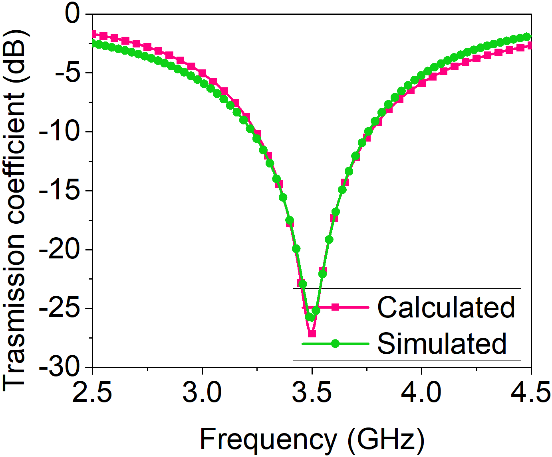
- The simulated and calculated transmission coefficient results of GAF FSS
Figure S38 is the transmission coefficient results of the periodic element, which calculated the equivalent circuit by ADS software and simulated the actual model by CST software. The FSS resonates at 3.5 GHz, and the calculated results are consistent with the simulation results. The E-field distribution can further analyze the working mechanism of FSS.

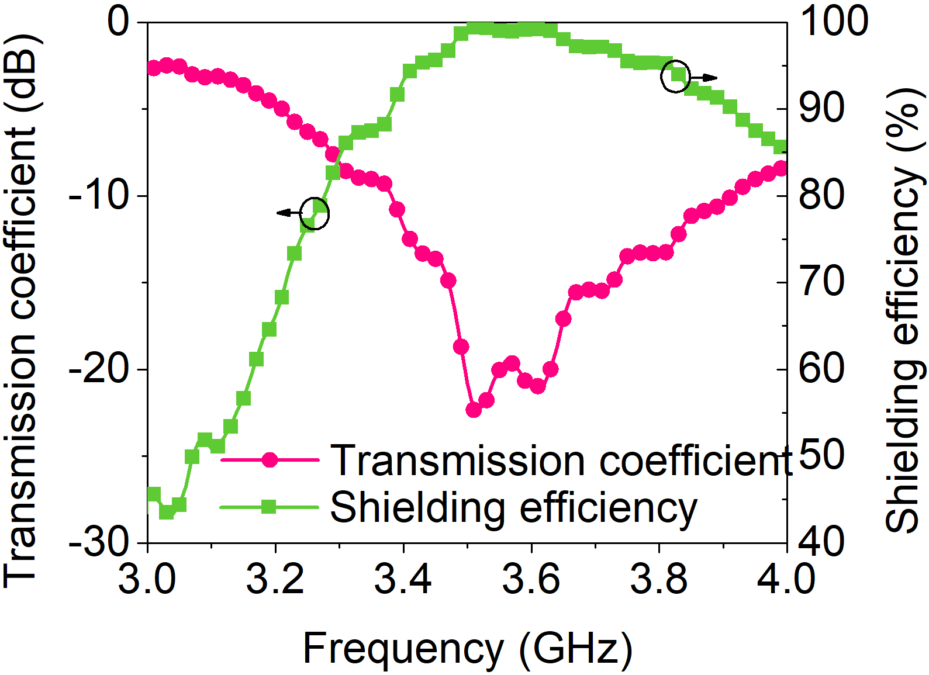
- The measured transmission coefficient and shielding efficiency of GAF FSS under 3.38 - 3.91 GHz
The measured transmission coefficient and shielding efficiency of GAF FSS under normal incidence of electromagnetic wave is shown in the Figure S39 . In the 3.38 - 3.91 GHz frequency band, the transmission coefficient of GAF FSS is less than -10 dB, which means that FSS can shield more than 90% of electromagnetic waves. In particular, GAF FSS can shield 99.4% of electromagnetic waves at 3.5 GHz. Outside of this frequency band, electromagnetic waves can pass GAF FSS in a large proportion, proving that GAF FSS has good frequency selection characteristics.

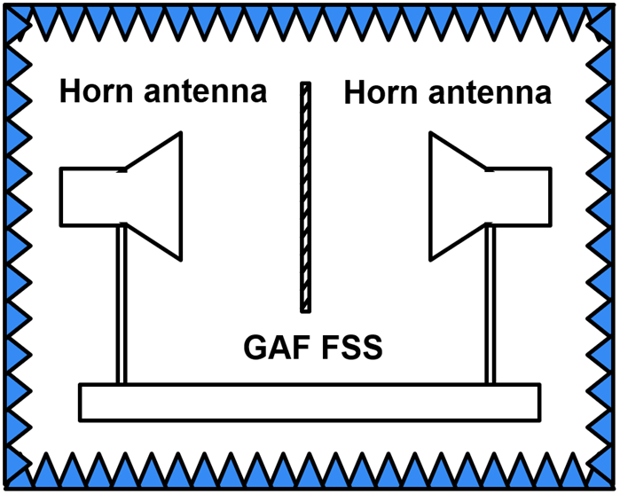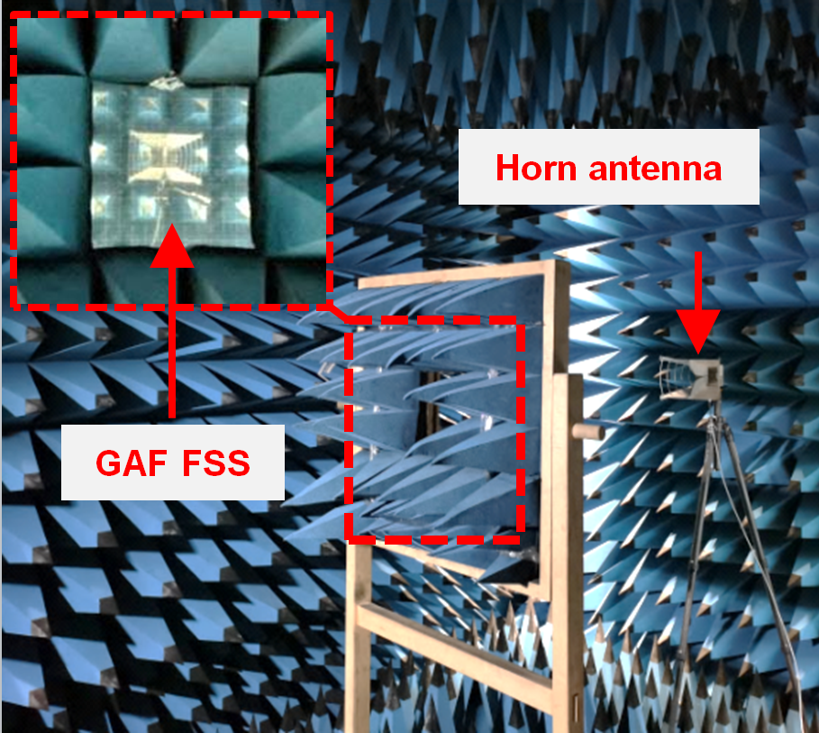
- The GAF FSS measurement environment in microwave anechoic chamber
The performances of GAF FSS were measured in the microwave anechoic chamber to avoid the influence of external electromagnetic wave, as shown in Figure S40 . The two horn antennas were placed in opposite directions. The vector network analyzer (Keysight PNA N5247A) records the reflection coefficient and transmission coefficient of the two antennas to calculate the frequency response of the GAF FSS. Firstly, the transmission coefficient of the two horn antennas without FSS was measured. The GAF FSS was then placed between the two horn antennas, and the transmission coefficient was measured again. Subtracting two results was the corresponding transmission coefficient for GAF FSS.

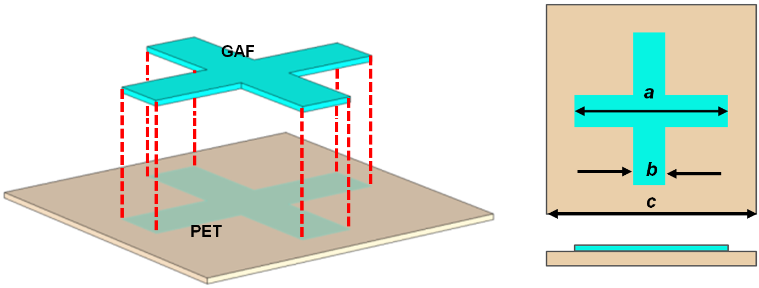
- The structure of GAF millimeter wave FSS
Figure S41 show the structure of low profile and ultra-wideband flexible millimeter wave FSS with the thickness of 0.138λ. The parameter dimensions of FSS element are a=2.26 mm, b =0.5 mm and c =3 mm.

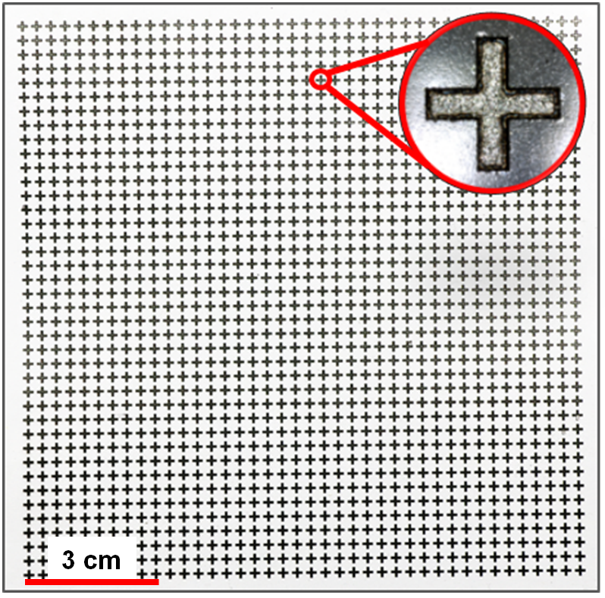
- The digital photo of GAF millimeter wave FSS

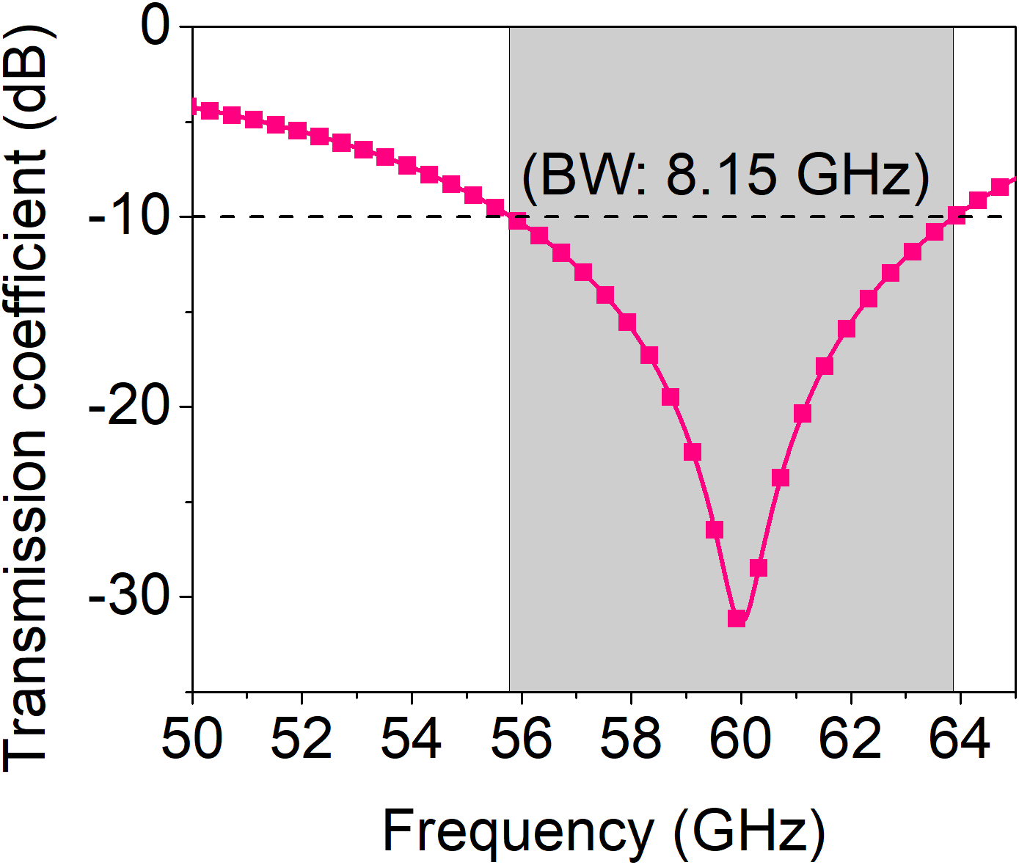
- The simulated transmission coefficient results of GAF FSS
Figure S43 illustrates the simulated transmission coefficient of GAF FSS. GAF FSS covers a wide -10 dB bandwidth of 8.16 GHz between 55.76 GHz and 63.92 GHz.

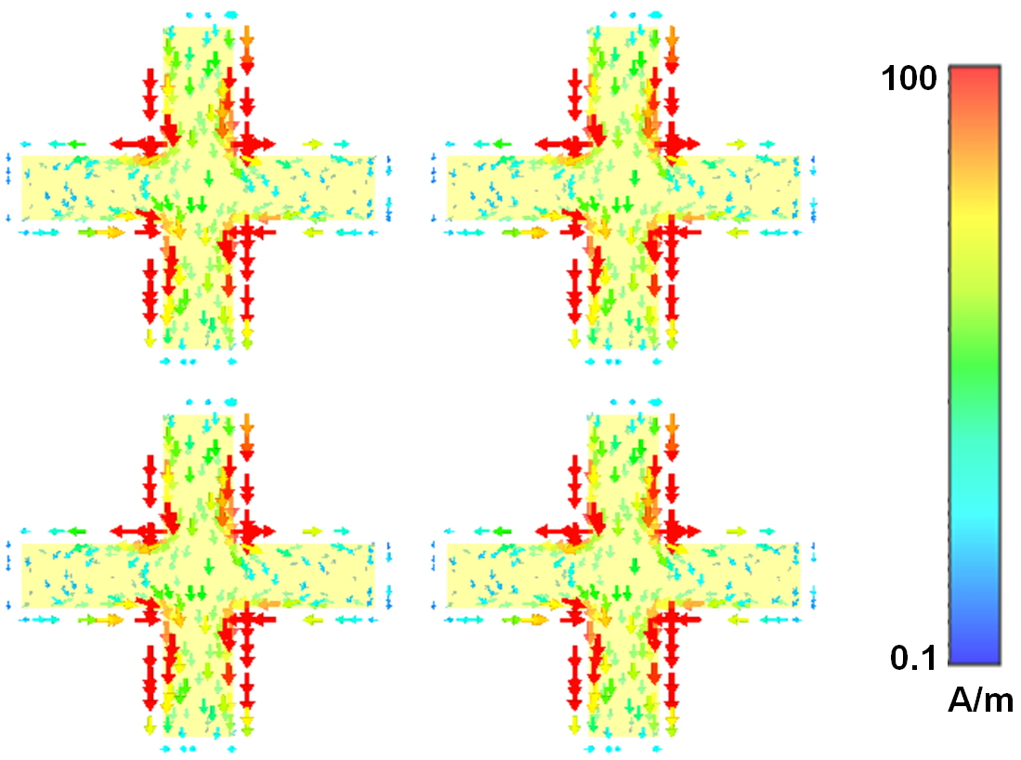
- Surface current distribution of GAF FSS at 60 GHz
Figure S44 is the surface current distribution of the GAF millimeter wave FSS at 60 GHz. It can be clearly seen that the FSS resonates at 60 GHz and generates a strong induced current, which shows that the GAF FSS generates a strong induced current and hinders the passage of electromagnetic waves at 60 GHz.

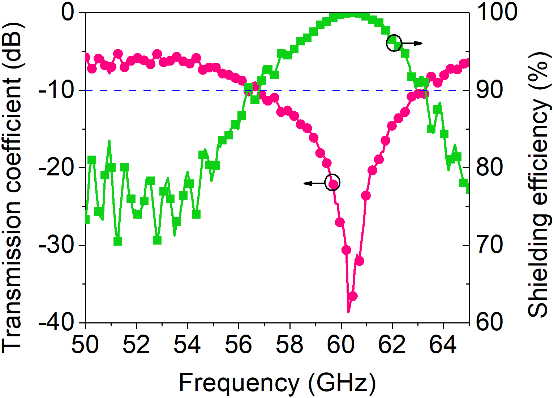
- Transmission coefficient and shielding efficiency of GAF FSS in 50-65 GHz
Figure S45 shows the measured transmission coefficient and shielding efficiency of GAF millimeter wave FSS under normal incidence of electromagnetic wave. The GAF FSS can shield 99.9% of electromagnetic waves at 60 GHz.

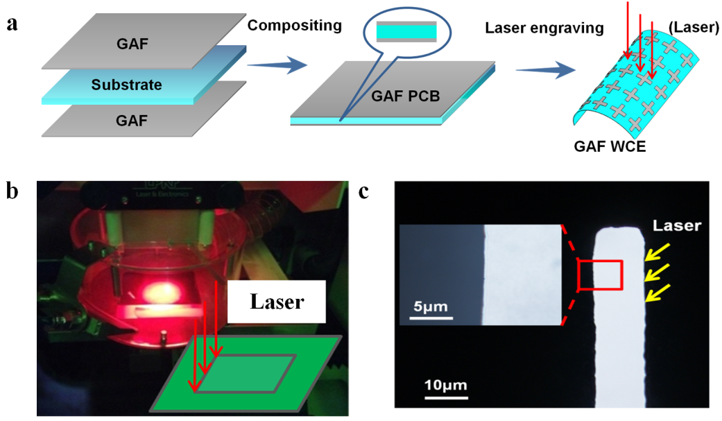
- Preparation diagram of GAF WCE
Patterned GAF ECE reported in this study are cut by a LPKF laser engraver machine with processing resolution in micrometre scale. Figure S46 (a) shows the fabrication process of GAF WCE. The GAF were combined with dielectric substrate (FR-4, Silica gel film, Rogers 5880, PET) to form GAF PCB. The carving patch of the device dimensions output by the simulation software are calculated using LPKF CircuitPro PL 2.0 to adapt the laser engraving machine. Laser engraving machine (LPKF Laser & Electronics ProtoLaser S) fabricated the GAF WCE in one step refer to the calculated laser path (Figure S46 (b)). LPKF laser engraver machine with high cutting precision (Figure S46 (c)) is used to manufacture the GAF WCE.
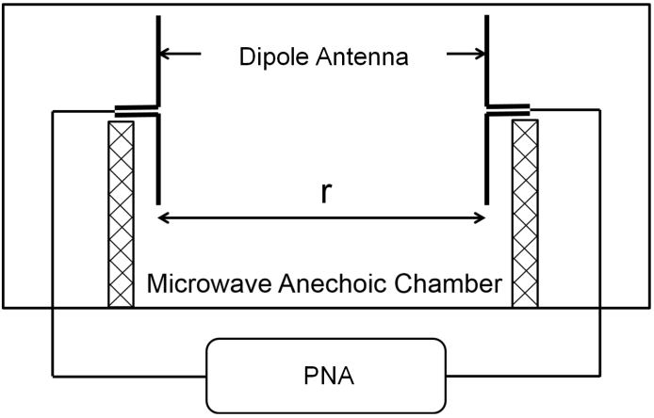
- The schematic diagram of dipole antennas gain test
Due to the limitation of experimental equipment, the method of measuring the gain of the dipole antenna is to place two dipole antennas with the same structure and size in the microwave anechoic chamber, one of which acts as radiating antenna and the other as a receiving antenna. As shown in Figure S47 , the distance of two antennas is r. The transmission coefficient (|S₂₁|) of the two antennas is measured using two ports of the vector network analyzer. Then, the gain can be calculated by the |S₂₁|. Before measurement, calibration is required to compensate the loss of the coaxial connection and the adapter before using the PNA. Hence, the PNA is calibrated with the 85058B calibration of Keysight.

References
1. Wen, Y., Wu, M., Zhang, M., Li, C. & Shi, G. Topological Design of Ultrastrong and Highly Conductive Graphene Films. Adv. Mater. 29, 1702831 (2017).
2. Feng, S., Yao, T., Lu, Y., Hao, Z. & Lin, S. Quasi-industrially produced large-area microscale graphene flakes assembled film with extremely high thermoelectric power factor. Nano Energy. 58, 63-68 (2019).
3. Aksu, Z. & Alanyalıoğlu, M. Fabrication of free-standing reduced graphene oxide composite papers doped with different dyes and comparison of their electrochemical performance for electrocatalytical oxidation of nitrite. Electrochim. Acta. 258, 1376-1386 (2017).
4. Yun, X., Xiong, Z., Tu, L., Bai, L. & Wang, X. Hierarchical porous graphene film: An ideal material for laser-carving fabrication of flexible micro-supercapacitors with high specific capacitance. Carbon. 125, 308-317 (2017).
5. Hu, K. et al. Written-in Conductive Patterns on Robust Graphene Oxide Biopaper by Electrochemical Microstamping. Angewandte Chemie International Edition. 52, 13784-13788 (2013).
6. Ming, P. et al. Nacre-inspired integrated nanocomposites with fire retardant properties by graphene oxide and montmorillonite. J. Mater. Chem. A. 3, 21194-21200 (2015).
7. Park, S. et al. The effect of concentration of graphene nanoplatelets on mechanical and electrical properties of reduced graphene oxide papers. Carbon. 50, 4573-4578 (2012).
8. Zhang, Y. et al. Direct imprinting of microcircuits on graphene oxides film by femtosecond laser reduction. Nano Today. 5, 15-20 (2010).
9. Li, C. & Shi, G. Functional Gels Based on Chemically Modified Graphenes. Adv. Mater. 26, 3992-4012 (2014).
10. Zhang, M., Huang, L., Chen, J., Li, C. & Shi, G. Ultratough, Ultrastrong, and Highly Conductive Graphene Films with Arbitrary Sizes. Adv. Mater. 26, 7588-7592 (2014).
11. Tan, Z., Zhang, M., Li, C., Yu, S. & Shi, G. A General Route to Robust Nacre-Like Graphene Oxide Films. ACS Appl. Mater. Inter. 7, 15010-15016 (2015).
12. Sadak, O., Sundramoorthy, A. K. & Gunasekaran, S. Facile and green synthesis of highly conducting graphene paper. Carbon. 138, 108-117 (2018).
13. Ni, H. et al. Robust Bioinspired Graphene Film via π–π Cross-linking. ACS Appl. Mater. Inter. 9, 24987-24992 (2017).
14. Hou, M., Xu, M. & Li, B. Enhanced Electrical Conductivity of Cellulose Nanofiber/Graphene Composite Paper with a Sandwich Structure. ACS Sustain. Chem. Eng. 6, 2983-2990 (2018).
15. Yang, X. et al. Ordered Gelation of Chemically Converted Graphene for Next-Generation Electroconductive Hydrogel Films. Angewandte Chemie International Edition. 50, 7325-7328 (2011).
16. Li, D., Muller, M. B., Gilje, S., Kaner, R. B. & Wallace, G. G. Processable aqueous dispersions of graphene nanosheets. Nat. Nanotechnol. 3, 101-105 (2008).
17. Zhang, M. et al. Multifunctional Pristine Chemically Modified Graphene Films as Strong as Stainless Steel. Adv. Mater. 27, 6708-6713 (2015).
18. Moon, I. K., Lee, J., Ruoff, R. S. & Lee, H. Reduced graphene oxide by chemical graphitization. Nat. Commun. 1, (2010).
19. Šimek, P., Sofer, Z., Jankovský, O., Sedmidubský, D. & Pumera, M. Oxygen-Free Highly Conductive Graphene Papers. Adv. Funct. Mater. 24, 4878-4885 (2014).
20. Xu, Y., Bai, H., Lu, G., Li, C. & Shi, G. Flexible Graphene Films via the Filtration of Water-Soluble Noncovalent Functionalized Graphene Sheets. J. Am. Chem. Soc. 130, 5856-5857 (2008).
21. Pei, S., Zhao, J., Du, J., Ren, W. & Cheng, H. Direct reduction of graphene oxide films into highly conductive and flexible graphene films by hydrohalic acids. Carbon. 48, 4466-4474 (2010).
22. Yan, J. et al. Highly Conductive Graphene Paper with Vertically Aligned Reduced Graphene Oxide Sheets Fabricated by Improved Electrospray Deposition Technique. ACS Appl. Mater. Inter. 11, 10810-10817 (2019).
23. Park, S. et al. Colloidal Suspensions of Highly Reduced Graphene Oxide in a Wide Variety of Organic Solvents. Nano Lett. 9, 1593-1597 (2009).
24. Liu, F., Song, S., Xue, D. & Zhang, H. Folded Structured Graphene Paper for High Performance Electrode Materials. Adv. Mater. 24, 1089-1094 (2012).
25. Wu, H. & Drzal, L. T. Graphene nanoplatelet paper as a light-weight composite with excellent electrical and thermal conductivity and good gas barrier properties. Carbon. 50, 1135-1145 (2012).
26. Compton, O. C., Dikin, D. A., Putz, K. W., Brinson, L. C. & Nguyen, S. T. Electrically Conductive “Alkylated” Graphene Paper via Chemical Reduction of Amine-Functionalized Graphene Oxide Paper. Adv. Mater. 22, 892-896 (2010).
27. Chen, H., Müller, M. B., Gilmore, K. J., Wallace, G. G. & Li, D. Mechanically Strong, Electrically Conductive, and Biocompatible Graphene Paper. Adv. Mater. 20, 3557-3561 (2008).
28. Vallés, C., David Núñez, J., Benito, A. M. & Maser, W. K. Flexible conductive graphene paper obtained by direct and gentle annealing of graphene oxide paper. Carbon. 50, 835-844 (2012).
29. Su, Q. et al. Composites of Graphene with Large Aromatic Molecules. Adv. Mater. 21, 3191-3195 (2009).
30. Kong, Q. et al. Hierarchical Graphene-Carbon Fiber Composite Paper as a Flexible Lateral Heat Spreader. Adv. Funct. Mater. 24, 4222-4228 (2014).
31. Shen, B., Zhai, W. & Zheng, W. Ultrathin Flexible Graphene Film: An Excellent Thermal Conducting Material with Efficient EMI Shielding. Adv. Funct. Mater. 24, 4542-4548 (2014).
32. Chen, Y. et al. Reduced Graphene Oxide Films with Ultrahigh Conductivity as Li-Ion Battery Current Collectors. Nano Lett. 16, 3616-3623 (2016).
33. Liu, Y. et al. Rapid roll-to-roll production of graphene films using intensive Joule heating. Carbon. 155, 462-468 (2019).
34. Wang, Y. et al. Reduced graphene oxide film with record-high conductivity and mobility. Mater. Today. 21, 186-192 (2018).
35. Rozada, R., Paredes, J. I., Villar-Rodil, S., Martínez-Alonso, A. & Tascón, J. M. D. Towards full repair of defects in reduced graphene oxide films by two-step graphitization. Nano Res. 6, 216-233 (2013).
36. Teng, C. et al. Ultrahigh Conductive Graphene Paper Based on Ball-Milling Exfoliated Graphene. Adv. Funct. Mater. 27, 1700240 (2017).
37. Peng, L. et al. Ultrahigh Thermal Conductive yet Superflexible Graphene Films. Adv. Mater. 29, (2017).
38. Xin, G. et al. Large-Area Freestanding Graphene Paper for Superior Thermal Management. Adv. Mater. 26, 4521-4526 (2014).
39. Huang, X. et al. Binder-free highly conductive graphene laminate for low cost printed radio frequency applications. Appl. Phys. Lett. 106, 203105 (2015).
40. Huang, X. et al. Highly Flexible and Conductive Printed Graphene for Wireless Wearable Communications Applications. Sci. Rep.-Uk. 5, (2016).
41. Pan, K. et al. Sustainable production of highly conductive multilayer graphene ink for wireless connectivity and IoT applications. Nat. Commun. 9, (2018).
42. Li, X. et al. Self-reinforcing graphene coatings on 3D printed elastomers for flexible radio frequency antennas and strain sensors. Flexible and printed electronics. 2, 35001 (2017).
43. He, P. et al. Screen-Printing of a Highly Conductive Graphene Ink for Flexible Printed Electronics. ACS Appl Mater Interfaces. 11, 32225-32234 (2019).
44. Majee, S., Liu, C., Wu, B., Zhang, S. L. & Zhang, Z. B. Ink-jet printed highly conductive pristine graphene patterns achieved with water-based ink and aqueous doping processing. Carbon. 114, 77-83 (2017).
45. Jia, L. et al. A strong and tough polymer–carbon nanotube film for flexible and efficient electromagnetic interference shielding. J. Mater. Chem. C. 5, 8944-8951 (2017).
46. Di, J. et al. Ultrastrong, Foldable, and Highly Conductive Carbon Nanotube Film. ACS Nano. 6, 5457-5464 (2012).
47. Sreekumar, T. V. et al. Single-Wall Carbon Nanotube Films. Chem. Mater. 15, 175-178 (2003).
48. Zhang, X., Zhang, Z. & Zhou, Z. MXene-based materials for electrochemical energy storage. J. Energy Chem. 27, 73-85 (2018).
49. Shahzad, F. et al. Electromagnetic interference shielding with 2D transition metal carbides (MXenes). Science. 353, 1137-1140 (2016).
50. Liu, J. et al. Hydrophobic, Flexible, and Lightweight MXene Foams for High-Performance Electromagnetic-Interference Shielding. Adv. Mater. 29, 1702367 (2017).
51. Ling, Z. et al. Flexible and conductive MXene films and nanocomposites with high capacitance. Proceedings of the National Academy of Sciences. 111, 16676-16681 (2014).
52. Dillon, A. D. et al. Highly Conductive Optical Quality Solution-Processed Films of 2D Titanium Carbide. Adv. Funct. Mater. 26, 4162-4168 (2016).
53. Yan, J. et al. Flexible MXene/Graphene Films for Ultrafast Supercapacitors with Outstanding Volumetric Capacitance. Adv. Funct. Mater. 27, 1701264 (2017).
54. Zhao, M. et al. Flexible MXene/Carbon Nanotube Composite Paper with High Volumetric Capacitance. Adv. Mater. 27, 339-345 (2015).
55. Liu, J. et al. Ultrastrong and Highly Conductive MXene‐Based Films for High‐Performance Electromagnetic Interference Shielding. Advanced Electronic Materials. 6, 1901094 (2020).
56. Lai, D., Chen, X. & Wang, Y. Controllable fabrication of elastomeric and porous graphene films with superior foldable behavior and excellent electromagnetic interference shielding performance. Carbon. 158, 728-737 (2020).
57. Liu, H. et al. Novel 3D network porous graphene nanoplatelets /Fe3O4/epoxy nanocomposites with enhanced electromagnetic interference shielding efficiency. Compos. Sci. Technol. 169, 103-109 (2019).
58. Li, Y. et al. Ultrathin carbon foams for effective electromagnetic interference shielding. Carbon. 100, 375-385 (2016).
59. Xing, C. et al. Ultralight and flexible graphene foam coated with Bacillus subtilis as a highly efficient electromagnetic interference shielding film. Appl. Surf. Sci. 491, 616-623 (2019).
60. Zhang, T. et al. Ultrafast microwave reduction process for high-quality graphene foam with outstanding electromagnetic interference shielding and good adsorption capacity. FlatChem. 17, 100117 (2019).
61. Shen, B. et al. Strong flexible polymer/graphene composite films with 3D saw-tooth folding for enhanced and tunable electromagnetic shielding. Carbon. 113, 55-62 (2017).
62. Zhang, L. et al. Polydopamine decoration on 3D graphene foam and its electromagnetic interference shielding properties. J. Colloid Interf. Sci. 493, 327-333 (2017).
63. Shen, B. et al. Microcellular graphene foam for improved broadband electromagnetic interference shielding. Carbon. 102, 154-160 (2016).
64. Li, J., Huang, L., Yuan, Y., Li, Y. & He, X. Mechanically strong, thermally conductive and flexible graphene composite paper for exceptional electromagnetic interference shielding. Materials Science and Engineering: B. 263, 114893 (2021).
65. Fang, H. et al. In-situ grown hollow Fe3O4 onto graphene foam nanocomposites with high EMI shielding effectiveness and thermal conductivity. Compos. Sci. Technol. 188, 107975 (2020).
66. Wan, Y. et al. Graphene paper for exceptional EMI shielding performance using large-sized graphene oxide sheets and doping strategy. Carbon. 122, 74-81 (2017).
67. Liu, Y. et al. Graphene enhanced flexible expanded graphite film with high electric, thermal conductivities and EMI shielding at low content. Carbon. 133, 435-445 (2018).
68. Xi, J. et al. Graphene aerogel films with expansion enhancement effect of high-performance electromagnetic interference shielding. Carbon. 135, 44-51 (2018).
69. Zhang, N. et al. Flexible and transparent graphene/silver-nanowires composite film for high electromagnetic interference shielding effectiveness. Science Bulletin. 64, 540-546 (2019).
70. Li, L. et al. Flexible and alternant-layered cellulose nanofiber/graphene film with superior thermal conductivity and efficient electromagnetic interference shielding. Composites Part A: Applied Science and Manufacturing. 139, 106134 (2020).
71. Bi, S., Zhang, L., Mu, C., Liu, M. & Hu, X. Electromagnetic interference shielding properties and mechanisms of chemically reduced graphene aerogels. Appl. Surf. Sci. 412, 529-536 (2017).
72. Wan, Y. et al. Ultralight, super-elastic and volume-preserving cellulose fiber/graphene aerogel for high-performance electromagnetic interference shielding. Carbon. 115, 629-639 (2017).
73. González, M., Baselga, J. & Pozuelo, J. Modulating the electromagnetic shielding mechanisms by thermal treatment of high porosity graphene aerogels. Carbon. 147, 27-34 (2019).
74. Zhang, L. et al. Preparation and characterization of graphene paper for electromagnetic interference shielding. Carbon. 82, 353-359 (2015).
75. Song, W. et al. Magnetic and conductive graphene papers toward thin layers of effective electromagnetic shielding. J. Mater. Chem. A. 3, 2097-2107 (2015).
76. Li, Y. et al. Polyimide/graphene composite foam sheets with ultrahigh thermostability for electromagnetic interference shielding. Rsc Adv. 5, 24342-24351 (2015).
77. Agnihotri, N., Chakrabarti, K. & De, A. Highly efficient electromagnetic interference shielding using graphite nanoplatelet/poly(3,4-ethylenedioxythiophene)–poly(styrenesulfonate) composites with enhanced thermal conductivity. Rsc Adv. 5, 43765-43771 (2015).
78. Kong, L. et al. Macroscopic bioinspired graphene sponge modified with in-situ grown carbon nanowires and its electromagnetic properties. Carbon. 111, 94-102 (2017).
79. Wu, Y. et al. Ultralight Graphene Foam/Conductive Polymer Composites for Exceptional Electromagnetic Interference Shielding. ACS Appl. Mater. Inter. 9, 9059-9069 (2017).
80. Chen, Z., Xu, C., Ma, C., Ren, W. & Cheng, H. Lightweight and Flexible Graphene Foam Composites for High-Performance Electromagnetic Interference Shielding. Adv. Mater. 25, 1296-1300 (2013).
81. Yousefi, N. et al. Highly Aligned Graphene/Polymer Nanocomposites with Excellent Dielectric Properties for High-Performance Electromagnetic Interference Shielding. Adv. Mater. 26, 5480-5487 (2014).
82. Ling, J. et al. Facile Preparation of Lightweight Microcellular Polyetherimide/Graphene Composite Foams for Electromagnetic Interference Shielding. ACS Appl. Mater. Inter. 5, 2677-2684 (2013).
83. Shen, B., Zhai, W., Tao, M., Ling, J. & Zheng, W. Lightweight, Multifunctional Polyetherimide/Graphene@Fe3 O4 Composite Foams for Shielding of Electromagnetic Pollution. ACS Appl. Mater. Inter. 5, 11383-11391 (2013).
84. Gavgani, J. N., Adelnia, H., Zaarei, D. & Moazzami Gudarzi, M. Lightweight flexible polyurethane/reduced ultralarge graphene oxide composite foams for electromagnetic interference shielding. Rsc Adv. 6, 27517-27527 (2016).
85. Yan, D. et al. Efficient electromagnetic interference shielding of lightweight graphene/polystyrene composite. Journal of Materials Chemistry. 22, 18772 (2012).
86. Yan, D. et al. Structured Reduced Graphene Oxide/Polymer Composites for Ultra-Efficient Electromagnetic Interference Shielding. Adv. Funct. Mater. 25, 559-566 (2015).
87. Xu, F. et al. Superflexible Interconnected Graphene Network Nanocomposites for High-Performance Electromagnetic Interference Shielding. ACS Omega. 3, 3599-3607 (2018).
88. Zdrojek, M. et al. Graphene-based plastic absorber for total sub-terahertz radiation shielding. Nanoscale. 10, 13426-13431 (2018).
89. Dong, S., Shi, Q., Huang, W., Jiang, L. & Cai, Y. Flexible reduced graphene oxide paper with excellent electromagnetic interference shielding for terahertz wave. Journal of Materials Science: Materials in Electronics. 29, 17245-17253 (2018).
90. Pavlou, C. et al. Effective EMI shielding behaviour of thin graphene/PMMA nanolaminates in the THz range. Nat. Commun. 12, (2021).
91. Zhang, Y. et al. Ti3C2Tx/rGO porous composite films with superior electromagnetic interference shielding performances. Carbon. 175, 271-280 (2021).
92. Uzun, S. et al. Highly conductive and scalable Ti3C2T -coated fabrics for efficient electromagnetic interference shielding. Carbon. 174, 382-389 (2021).
93. Xiang, C. et al. Lightweight and ultrathin TiO2-Ti3C2TX/graphene film with electromagnetic interference shielding. Chem. Eng. J. 360, 1158-1166 (2019).
94. Cao, W. et al. Binary Strengthening and Toughening of MXene/Cellulose Nanofiber Composite Paper with Nacre-Inspired Structure and Superior Electromagnetic Interference Shielding Properties. ACS Nano. 12, 4583-4593 (2018).
95. Zhao, S. et al. Highly Electrically Conductive Three-Dimensional Ti3 C2 Tx MXene/Reduced Graphene Oxide Hybrid Aerogels with Excellent Electromagnetic Interference Shielding Performances. ACS Nano. 12, 11193-11202 (2018).
96. Iqbal, A. et al. Anomalous absorption of electromagnetic waves by 2D transition metal carbonitride Ti3CNTx (MXene). Science. 369, 446 (2020).
97. Wei, B., Zhang, L. & Yang, S. Polymer composites with expanded graphite network with superior thermal conductivity and electromagnetic interference shielding performance. Chem. Eng. J. 404, 126437 (2021).
98. Zhang, J. et al. Homogeneous silver nanoparticles decorating 3D carbon nanotube sponges as flexible high-performance electromagnetic shielding composite materials. Carbon. 165, 404-411 (2020).
99. Qu, M. et al. High reliable electromagnetic interference shielding carbon cloth with superamphiphobicity and environmental suitability. Carbon. 174, 110-122 (2021).
100. Jia, L. et al. Stretchable and durable conductive fabric for ultrahigh performance electromagnetic interference shielding. Carbon. 144, 101-108 (2019).
101. Chang, C., Yue, X., Hao, B., Xing, D. & Ma, P. Direct growth of carbon nanotubes on basalt fiber for the application of electromagnetic interference shielding. Carbon. 167, 31-39 (2020).
102. Zhu, S. et al. Cake-like flexible carbon nanotubes/graphene composite prepared via a facile method for high-performance electromagnetic interference shielding. Carbon. 145, 259-265 (2019).
103. Electromagnetic interference shielding reaching 130 dE8 using flexible graphite..
104. Song, Q. et al. Carbon Nanotube-Multilayered Graphene Edge Plane Core-Shell Hybrid Foams for Ultrahigh-Performance Electromagnetic-Interference Shielding. Adv. Mater. 29, (2017).
105. Lu, D. et al. Flexible, lightweight carbon nanotube sponges and composites for high-performance electromagnetic interference shielding. Carbon. 133, 457-463 (2018).
106. Liu, Y. et al. Hydrated aramid nanofiber network enhanced flexible expanded graphite films towards high EMI shielding and thermal properties. Compos. Sci. Technol. 168, 28-37 (2018).

* Boyang Mao: maoboyang@gmail.com * Konstantin. S. Novoselov: konstantin.novoselov@manchester.ac.uk
* Daping He: hedaping@whut.edu.cn

