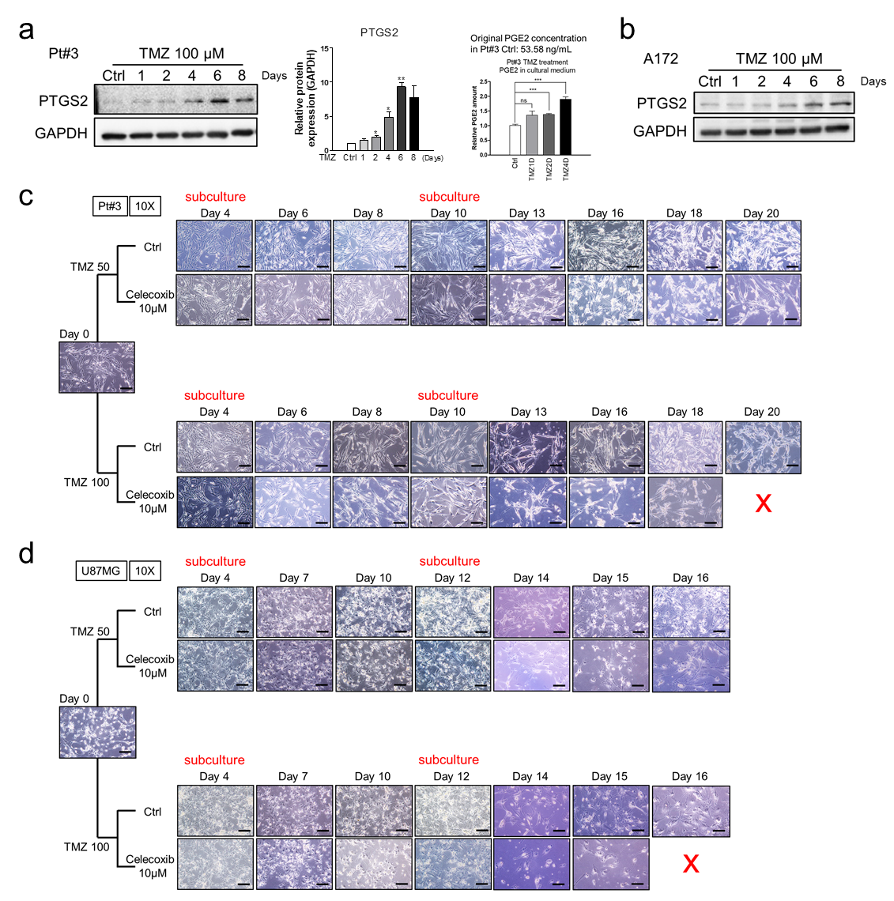
Supplementary Figure 2. Effect of celecoxib on cellular response to TMZ. (a), (b) After treatment with TMZ for indicated time interval, cell lysates were collected for Western blotting using indicated antibodies. The level of PGE2 was confirmed by ELISA. Data with quantification were analyzed by two-tailed unpaired Student’s t test (n=2). (c), (d) U87MG cells and Pt#3 were cultured in the presence of TMZ with or without celecoxib for indicated time period, and morphology was photographed under 10X magnification. “Red X” means no survival cells in the culture dishes. The scale bar is 0.2 mm.

