**Supplementary material to:**

**Visible-light responsive Cu-MOF-NH2 for highly efficient**

**aerobic photocatalytic oxidation of benzyl alcohol**

**Samira Abdel-Azim1,Delvin Aman*b,c, , Eric Van Steen**d, HowaidaAbd El Salame**

a Process development division, Egyptian Petroleum Research Institute (EPRI), Nasr city, 11727, Cairo, Egypt.

b Catalysis laboratory, refining department, Egyptian Petroleum Research Institute (EPRI), Nasr city, 11727, Cairo, Egypt

c EPRI-Nanotechnology Center, Egyptian Petroleum Research Institute (EPRI), Nasr City, 11727, Cairo, Egypt, E-mail: [delvin.aman@epri.sci](mailto:delvin.aman@epri.sci).

d Catalysis Institute, Department of Chemical Engineering, Univerity of Cape Town, Private Bag X3, Rondebosch 7701, South Africa, E-mail: [eric.vansteen@uct.ac.za](mailto:eric.vansteen@uct.ac.za).

eAnalysis and Evaluation Division, Egyptian Petroleum Research Institute, Nasr City, 11727, Cairo, Egypt.

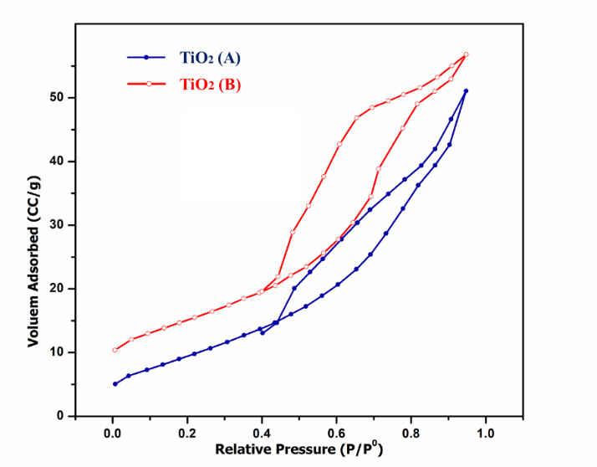

**Figure S1:** N2 adsorption/desorption isotherms (left) and BJH pore size distribution (right) for TiO2(A) and TiO2(B).

** C:\Users\delvin\OneDrive\Desktop\New folder (2)\Presentation2.tif**

**Figure S2:** N2 adsorption/desorption isotherms (left) and BJH pore size distribution (right) for (a) pristine Cu-MOF and (b) Cu-MOF -NH2**.**