Additional file 3
Gating strategy
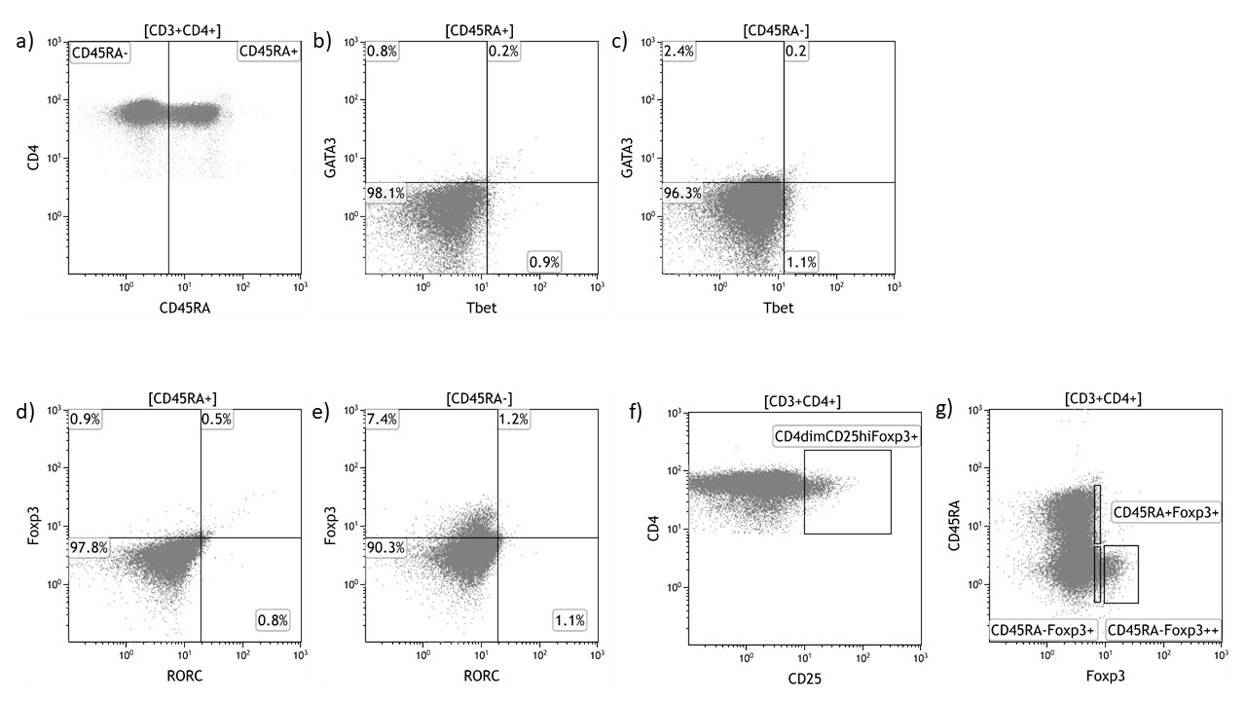Gating strategy to identify T helper cell populations from flow cytometry analysis. A gate was set to isolate the lymphocyte population by measuring forward scatter (FSC) on the X axis (size) and side scatter (SSC) on the Y axis (granularity). To define T lymphocytes, a gate was set for CD3⁺CD4⁺ cells. The lymphocyte gate was also used to define CD3⁺CD4⁺ T helper (Th) cells. a) Naïve (CD45RA⁺) and memory (CD45RA⁻) Th cells were defined by their expression of CD45RA. b) To define Th1 and Th2 cells, the populations were gated on expression of the intracellularly expressed Th cell lineage markers, T-box expressed in T cells (Tbet), a transcription factor expressed by Th1, and GATA binding protein 3 (GATA3), a key transcription factor in Th2 cells. Cells in the naïve population were not expected to express the markers, and a gate was set in that population (maximum 1% and minimum 0.6% cells positive for the markers). In the memory population (c) The gate from the naïve population was used to define cells expressing Tbet and GATA3. d) and e) A similar strategy was used to define Th17 cells as RORC⁺ CD45RA⁻ cells. f) T regulatory cells were defined as CD4^{dim}CD25^{hi}Foxp3⁺ cells. g) In addition, two T regulatory subpopulations were isolated from the CD3⁺CD4⁺ Th cell population, depending on their expression of the transcription factor forkhead box P3 (FoxP3) and CD45RA. CD3⁺CD4⁺CD45RA^{+/-}Foxp3^{+/++}, i.e. resting and activated Tregs, respectively

