Table S1: Summary of the samples collected and processed in this study for Symbiodiniaceae cell density and viability (Figure 2), culturing, and community composition based on the internal transcribed spacer-2 (ITS-2) region of rDNA (Figure 3). Pocillopora spp. = Pocillopora species complex; Porites lobata spp. = Porites lobata species complex.
Sample category and type | Code | Symbiodiniaceae cell density & viability |  |  | Symbiodiniaceae culturing |  |  | Symbiodiniaceae community composition  (>1,000 ITS-2 reads)
 |  | Back reef | Fore reef | total | Back reef | Fore reef | total | Back reef | Fore reef | total
Obligate corallivores
Amanses scopas | AMSC | 0 | 7 | 7 | 0 | 6 | 6 | 0 | 7 | 7
Chaetodon lunulatus | CHLU | 7 | 1 | 8 | 5 | 1 | 6 | 7 | 1 | 8
Chaetodon ornatissimus | CHOR | 6 | 8 | 14 | 6 | 7 | 13 | 6 | 8 | 14
Chaetodon reticulatus | CHRE | 3 | 8 | 11 | 3 | 7 | 10 | 3 | 8 | 11
Category sum |  | 16 | 24 | 40 | 14 | 21 | 35 | 16 | 24 | 40
Facultative corallivores
Chaetodon citrinellus | CHCI | 6 | 0 | 6 | 6 | 0 | 6 | 6 | 0 | 6
Chaetodon pelewensis | CHPE | 0 | 8 | 8 | 0 | 4 | 4 | 0 | 8 | 8
Chlorurus spilurus | CHSP | 0 | 8 | 8 | 0 | 8 | 8 | 0 | 8 | 8
Category sum |  | 6 | 16 | 22 | 6 | 12 | 18 | 6 | 16 | 22
Grazer/detritivores
Ctenochaetus flavicauda | CTFL | 0 | 8 | 8 | 0 | 8 | 8 | 0 | 7 | 7
Ctenochaetus striatus | CTST | 6 | 0 | 6 | - | - | - | 6 | 0 | 6
Category sum |  | 6 | 8 | 14 | 0 | 8 | 8 | 6 | 7 | 13
Sediment and water
Sediment | SED | 6 | 6 | 12 | - | - | - | 6 | 6 | 12
Water | WAT | 6 | 6 | 12 | - | - | - | 3 | 4 | 7
Category sum |  | 12 | 12 | 24 | - | - | - | 9 | 10 | 19
Corals
Acropora hyacinthus | ACR | - | - | - | - | - | - | 6 | 5 | 11
Pocillopora spp. | POC | - | - | - | - | - | - | 6 | 6 | 12
Porites lobata spp. | POR | - | - | - | - | - | - | 6 | 6 | 12
Category sum |  | - | - | - | - | - | - | 18 | 17 | 35

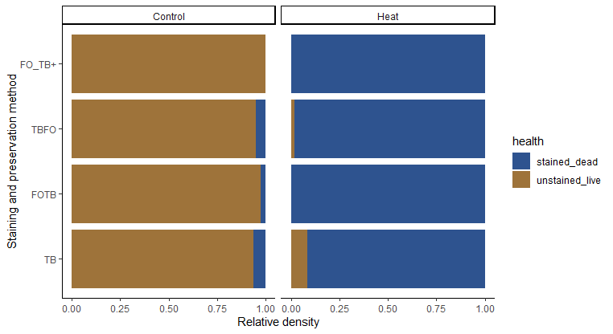
Cell viability

Figure S1: Hemocytometry with trypan blue stain accurately differentiates live and dead Symbiodiniaceae cells that were fixed in 10% formalin. We conducted a replicated experiment to confirm that hemocytometry of formalin-fixed samples in conjunction with the trypan blue stain assay accurately parses dead and live Symbiodiniaceae cells. Cultures of three Symbiodiniaceae strains (Breviolum sp. Mf1.5b, Symbiodinium microadriaticum, and Fugacium kawagutii) were sampled and half of each sample was kept at room temperature (Control) or exposed to 80˚C for one hour (Heat) similar to (Franklin et al., 2006). The following staining and preservation methods were tested: FO_TB+: immediately fixed in 10% formalin and stained with trypan Blue after 48 hours; TBFO: First stained with trypan blue and fixed with formalin after five minutes; FOTB: Fixed with 10% formalin and stained with trypan blue immediately afterward; TB: Stained with trypan blue and not fixed. The fraction of live Symbiodiniaceae cells differed between the heat and control treatment (two-way ANOVA: df=1, F=1263.5, p<0.001) but not between staining and preservation methods (df=3, F=0.2, p=0.889). These results indicate that preservation with 10% formalin and staining with trypan blue is an appropriate method for quantifying live and dead Symbiodiniaceae cells.

Table S2: Results of pairwise Dunn tests on Symbiodiniaceae cell densities between species, sediment and water samples (Figure 2). We controlled for false positives with the Benjamini-Hochberg procedure. Significant p-values (<0.05) are bolded. Overall Kruskal-Wallis test results: chi-squared=85.2132, df=10, p-value=0. Included samples (and sample sizes) for each sample type are as follows: Obligate corallivores (Obl): Amanses scopas, AMSC (7); Chaetodon lunulatus, CHLU (8); Chaetodon ornatissimus, CHOR (14); Chaetodon reticulatus, CHRE (11). Facultative corallivores (Fac): Chaetodon pelewensis, CHPE (8); Chaetodon citrinellus, CHCI (6); and Chlorurus spilurus CHSP (8). Grazer/Detritivores (Gra): Ctenochaetus flavicauda, CTFL (8); and Ctenochaetus striatus, CTST (6). Sediment and water (Env): Sediment, SED (12); Water, WAT (12).
Species comparison | Species diets | Z statistic | Adjusted p-value
AMSC - CHLU | Obl - Obl | -1.67 | 0.0771
AMSC - CHOR | Obl - Obl | -1.52 | 0.0978
AMSC - CHRE | Obl - Obl | -2.10 | 0.0363
CHLU - CHOR | Obl - Obl | 0.36 | 0.3961
CHLU - CHRE | Obl - Obl | -0.33 | 0.4005
CHOR - CHRE | Obl - Obl | -0.77 | 0.2880
AMSC - CHCI | Obl - Fac | 0.19 | 0.4494
AMSC - CHPE | Obl - Fac | -0.46 | 0.3640
AMSC - CHSP | Obl - Fac | 1.75 | 0.0683
CHLU - CHPE | Obl - Fac | 1.25 | 0.1516
CHLU - CHSP | Obl - Fac | 3.54 | 0.0007
CHOR - CHPE | Obl - Fac | 1.06 | 0.1996
CHOR - CHSP | Obl - Fac | 3.64 | 0.0005
CHRE - CHSP | Obl - Fac | 4.14 | 0.0001
AMSC - WAT | Obl - Env | 3.09 | 0.0032
AMSC - SED | Obl - Env | 2.39 | 0.0213
CHLU - WAT | Obl - Env | 5.11 | 0.0000
CHLU - SED | Obl - Env | 4.38 | 0.0000
CHOR - WAT | Obl - Env | 5.53 | 0.0000
CHOR - SED | Obl - Env | 4.68 | 0.0000
CHRE - WAT | Obl - Env | 5.95 | 0.0000
CHRE - SED | Obl - Env | 5.15 | 0.0000
AMSC - CTFL | Obl - Gra | 2.20 | 0.0306
AMSC - CTST | Obl - Gra | 2.16 | 0.0323
CHLU - CTFL | Obl - Gra | 4.00 | 0.0002
CHLU - CTST | Obl - Gra | 3.83 | 0.0003
CHOR - CTFL | Obl - Gra | 4.16 | 0.0001
CHOR - CTST | Obl - Gra | 3.91 | 0.0002
CHRE - CTFL | Obl - Gra | 4.64 | 0.0000
CHRE - CTST | Obl - Gra | 4.37 | 0.0000
CHCI - CHLU | Fac - Obl | -1.79 | 0.0646
CHCI - CHOR | Fac - Obl | -1.66 | 0.0762
CHCI - CHRE | Fac - Obl | -2.21 | 0.0311
CHPE - CHRE | Fac - Obl | -1.68 | 0.0777
CHCI - CHPE | Fac - Fac | -0.63 | 0.3296
CHCI - CHSP | Fac - Fac | 1.49 | 0.1021
CHPE - CHSP | Fac - Fac | 2.29 | 0.0265
CHCI - WAT | Fac - Env | 2.73 | 0.0088
CHCI - SED | Fac - Env | 2.06 | 0.0388
CHPE - WAT | Fac - Env | 3.74 | 0.0004
CHPE - SED | Fac - Env | 3.00 | 0.0041
CHSP - WAT | Fac - Env | 1.23 | 0.1543
CHSP - SED | Fac - Env | 0.50 | 0.3619
CHCI - CTFL | Fac - Gra | 1.91 | 0.0528
CHCI - CTST | Fac - Gra | 1.90 | 0.0524
CHPE - CTFL | Fac - Gra | 2.75 | 0.0086
CHPE - CTST | Fac - Gra | 2.66 | 0.0101
CHSP - CTFL | Fac - Gra | 0.46 | 0.3691
CHSP - CTST | Fac - Gra | 0.55 | 0.3570
WAT - SED | Env - Env | -0.82 | 0.2772
CTFL - WAT | Gra - Env | 0.72 | 0.3000
CTFL - SED | Gra - Env | -0.01 | 0.4968
CTST - WAT | Gra - Env | 0.53 | 0.3557
CTST - SED | Gra - Env | -0.14 | 0.4625
CTFL - CTST | Gra - Gra | 0.12 | 0.4608

Table S3: Mean relative abundances of genes associated with five Symbiodiniaceae genera identified in this study per sample type (e.g., Amanses scopas feces) and overall sample category (e.g., obligate corallivores) (Figure 3). Included samples (and sample sizes) for each sample category are as follows: Corals: Acropora hyacinthus, ACR (11); Pocillopora spp. = Pocillopora species complex, POC (12); Porites lobata spp. = Porites lobata species complex, POR (12). Obligate corallivores: Amanses scopas, AMSC (7); Chaetodon lunulatus, CHLU (8); Chaetodon ornatissimus, CHOR (14); Chaetodon reticulatus, CHRE (11). Facultative corallivores: Chaetodon pelewensis, CHPE (8); Chaetodon citrinellus, CHCI (6); and Chlorurus spilurus CHSP (8). Grazer/Detritivores: Ctenochaetus flavicauda, CTFL (6); and Ctenochaetus striatus, CTST (6). Sediment and water: Sediment, SED (12); Water, WAT (7).
Species | Code | Symbiodiniaceae genus
 |  | Symbiodinium | Breviolum | Cladocopium | Durusdinium | Fugacium
Corals
Acropora hyacinthus | ACR | 0.53 | 0.00 | 0.08 | 0.39 | 0.00
Pocillopora spp. | POC | 0.00 | 0.00 | 0.89 | 0.11 | 0.00
Porites lobata spp. | POR | 0.00 | 0.00 | 0.98 | 0.02 | 0.00
Obligate corallivores
Amanses scopas | AMSC | 0.01 | 0.00 | 0.72 | 0.27 | 0.00
Chaetodon lunulatus | CHLU | 0.00 | 0.00 | 0.87 | 0.13 | 0.00
Chaetodon ornatissimus | CHOR | 0.00 | 0.00 | 0.96 | 0.04 | 0.00
Chaetodon reticulatus | CHRE | 0.00 | 0.00 | 0.98 | 0.02 | 0.00
Category average |  | 0.00 | 0.00 | 0.91 | 0.09 | 0.00
Facultative corallivores
Chaetodon citrinellus | CHCI | 0.08 | 0.00 | 0.81 | 0.11 | 0.00
Chaetodon pelewensis | CHPE | 0.00 | 0.00 | 0.72 | 0.28 | 0.00
Chlorurus spilurus | CHSP | 0.01 | 0.00 | 0.26 | 0.73 | 0.00
Category average |  | 0.03 | 0.00 | 0.58 | 0.39 | 0.00
Grazer/detritivores
Ctenochaetus flavicauda | CTFL | 0.03 | 0.00 | 0.08 | 0.89 | 0.00
Ctenochaetus striatus | CTST | 0.18 | 0.00 | 0.14 | 0.66 | 0.02
Category average |  | 0.10 | 0.00 | 0.11 | 0.78 | 0.01
Sediment and seawater
Sediment | SED | 0.15 | 0.02 | 0.66 | 0.13 | 0.04
Water | WAT | 0.19 | 0.02 | 0.70 | 0.08 | 0.00
Category average |  | 0.17 | 0.02 | 0.68 | 0.11 | 0.02

Table S4: Results from pairwise PERMANOVA tests on Symbiodiniaceae community composition at the genus level, based on Bray-Curtis distances (Figure 3). Samples were randomly subsampled from each sample category (n=12 each, see Supplementary Materials for sample names). We controlled for false positives with the Benjamini-Hochberg procedure. Significant p-values (<0.05) are bolded. Overall test results: df=6, F=17.3, R²=0.58, p=0.001 (PERMANOVA). Acropora: Acropora hyacinthus; Pocillopora spp. = Pocillopora species complex; Porites lobata spp. = Porites lobata species complex.
Comparisons | R² | Adjusted p-value
Obligate corallivore vs Facultative corallivore | 0.20 | 0.025
Obligate corallivore vs Grazer/detritivore | 0.80 | 0.002
Obligate corallivore vs Sediment and water | 0.14 | 0.020
Obligate corallivore vs Acropora hyacinthus | 0.49 | 0.002
Obligate corallivore vs Pocillopora spp. | 0.03 | 0.431
Obligate corallivore vs Porites lobata spp. | 0.11 | 0.129
Facultative corallivore vs Grazer/detritivore | 0.50 | 0.002
Facultative corallivore vs Sediment and water | 0.09 | 0.117
Facultative corallivore vs Acropora hyacinthus | 0.32 | 0.002
Facultative corallivore vs Pocillopora spp. | 0.16 | 0.049
Facultative corallivore vs Porites lobata spp. | 0.39 | 0.002
Grazer/detritivore vs Sediment and water | 0.51 | 0.002
Grazer/detritivore vs Acropora hyacinthus | 0.26 | 0.014
Grazer/detritivore vs Pocillopora spp. | 0.82 | 0.002
Grazer/detritivore vs Porites lobata spp. | 0.90 | 0.002
Sediment and water vs Acropora hyacinthus | 0.28 | 0.002
Sediment and water vs Pocillopora spp. | 0.14 | 0.006
Sediment and water vs Porites lobata spp. | 0.25 | 0.002
Acropora hyacinthus vs Pocillopora spp. | 0.49 | 0.002
Acropora hyacinthus vs Porites lobata spp. | 0.57 | 0.002
Pocillopora spp. vs Porites lobata spp. | 0.33 | 0.009

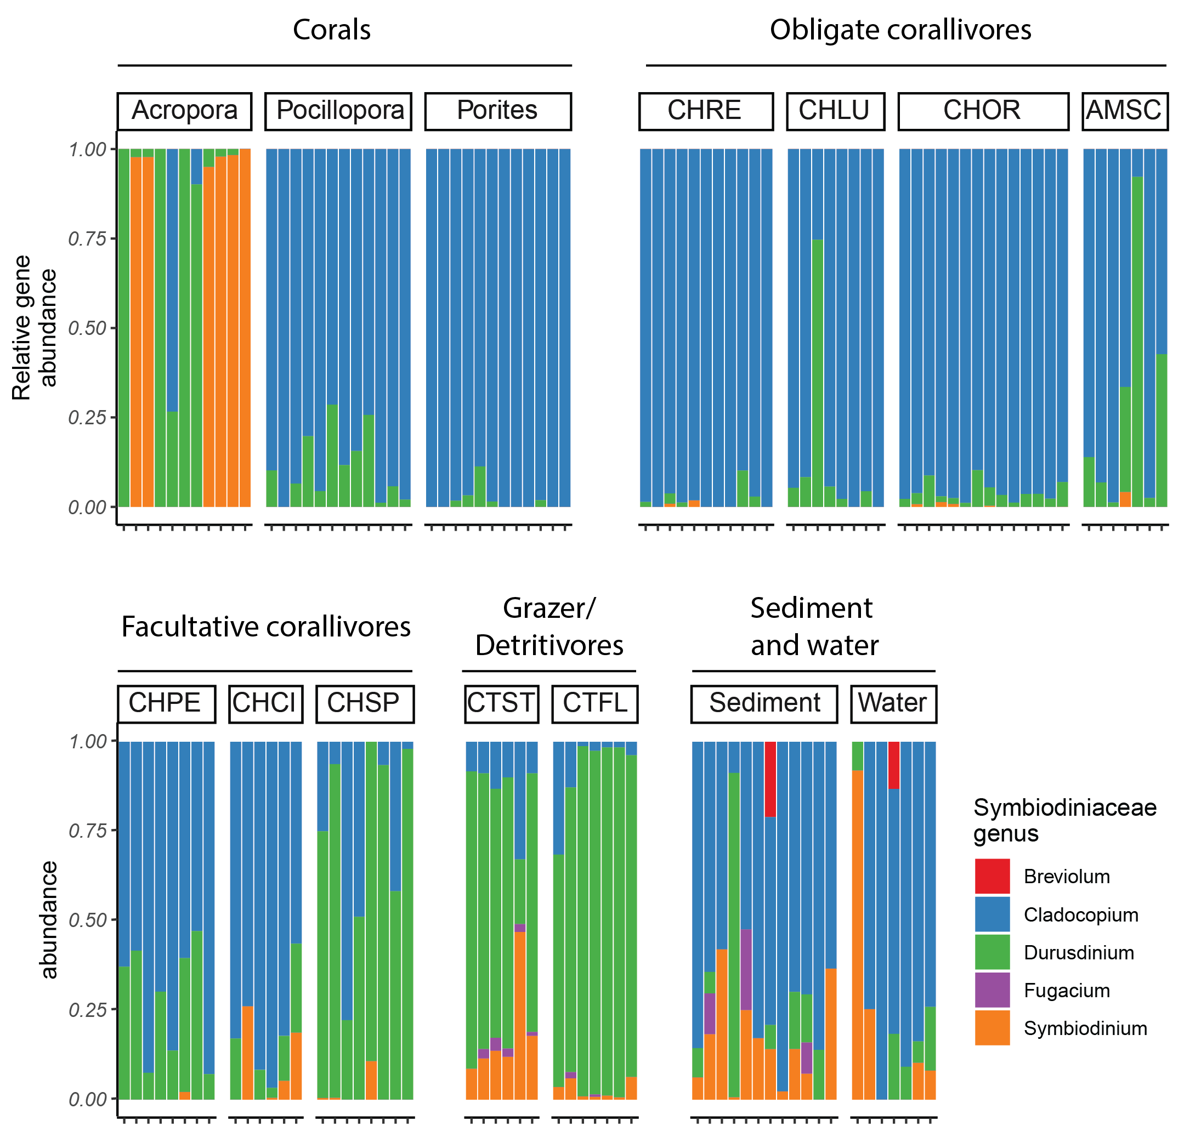
Figure S2: The communities of Symbiodiniaceae in obligate corallivore (coral-eating animal) feces are most similar to the communities of Symbiodiniaceae in two locally abundant coral species. Relative abundance of hits to a given Symbiodiniaceae genus in corals, obligate corallivore feces, facultative corallivore feces, grazer/detritivore feces, and reef-associated sediment and water (all included samples had >1,000 reads). Each bar represents one fecal sample from one fish or coral individual, or a separate sediment or water sample. Included samples (and sample sizes) for each sample category in the figure are as follows: Corals: Acropora hyacinthus, Acropora (11); Pocillopora species complex, Pocillopora (12); Porites lobata species complex, Porites (12). Obligate corallivores: Amanses scopas, AMSC (7); Chaetodon lunulatus, CHLU (8); Chaetodon ornatissimus, CHOR (14); Chaetodon reticulatus, CHRE (11). Facultative corallivores: Chaetodon pelewensis, CHPE (8); Chaetodon citrinellus, CHCI (6); and Chlorurus spilurus CHSP (8). Grazer/Detritivores: Ctenochaetus flavicauda, CTFL (6); and Ctenochaetus striatus, CTST (6). Sediment and water: Sediment, SED (12); Water, WAT (7). For data used see Additional file 2.

Table S5: Overview of values used in bootstrap estimate of reef-scale Symbiodiniaceae dispersal (Figure 4). Fecal samples were used to calculate mean densities of live Symbiodiniaceae cells and mean fecal densities. Fish densities were calculated from the MCR LTER dataset (http://mcrlter.msi.ucsb.edu/cgi-bin/showDataset.cgi?docid=knb-lter-mcr.6 accessed February 14, 2020). Data on fecal pellet sizes and egestion rates were collected during in situ fish follows. Obl: obligate corallivore; Fac: facultative corallivore. See Supplementary Methods for additional details.
Species | Diet | Live Symbiodiniaceae density (cells g⁻¹) |  |  | Fecal pellet  size (cm) |  |  | Fecal sample  density (g cm⁻¹) |  |  | Fish density (individuals 250 m⁻²) |  |  | Egestion rate (h⁻¹)
 |  | N | mean | sd | N | mean | sd | N | mean | sd | N | mean | sd | Estimate
CHOR | Obl | 8 | 4.56E+06 | 3.08E+06 | 6 | 5.08 | 2.59 | 3 | 0.14 | 0.02 | 8 | 9.88 | 3.52 | 1.34
CHRE | Obl | 8 | 9.22E+06 | 1.94E+06 | 2 | 4.50 | 0.50 | 3 | 0.18 | 0.03 | 8 | 5.25 | 2.66 | 1.08
CHCI | Fac | 6 | 1.22E+06 | 1.78E+06 | 4 | 2.75 | 1.03 | 4 | 0.04 | 0.06 | 8 | 1.13 | 1.54 | 0.97

