Supplementary Information for

Optoelectrical nanomechanical resonators made from multilayered 2D materials

Joshoua Condicion Esmenda,^{1,} ^{2,} ³ Myrron Albert Callera Aguila,^{1,} ^{2,} ^{3,} Jyh-Yang
Wang,³ Teik-Hui Lee,³ Yen-Chun Chen,³ Chi-Yuan Yang,³ Kung-Hsuan Lin,³ Kuei-Shu Chang-Liao,¹ Sergey Kafanov,⁴ Yuri Pashkin,⁴ and Chii-Dong Chen³
¹⁾Department of Engineering and System Science, National Tsing Hua University, Hsinchu 30013, Taiwan
²⁾Nano-Science and Technology Program, Taiwan International Graduate Program, Academia Sinica, Taipei 11529, Taiwan
³⁾Institute of Physics, Academia Sinica, Taipei 11529, Taiwan
⁴⁾Department of Physics, Lancaster University, LA1 4YB, Lancaster, United Kingdom
Supplementary Note 1. Dry deterministic transfer
As shown in Figure S1a, bulk two-dimensional materials are exfoliated by using 3% polydimethylsiloxane (PDMS) cured on flexible and transparent commercially available cellulose acetate sheets (CAS), also commonly known as transparencies. The bulk is mechanically exfoliated similar to the Scotch tape method but we opted to use PDMS to control the viscosity (stickiness) for our purposes. When the desired flake thickness (estimated from its optical transparency) is achieved, the target flake is then transferred onto a less viscous 9% PDMS cured on an ordinary microscope slide. The slide with the target flake is then mounted onto a microscope stage. As shown in Figure S1 b, the target chip is then placed onto another stamping stage where the chip and the target flake can be aligned independently, while a live feedthrough the objective lens underneath is used to monitor the stamping process [1,2]. Through this dry deterministic transfer, we are able to avoid exposing the 2D material to any wet solvents that might compromise the material’s unique mechanical properties. All the fabrication steps are shown in Figure S1.
Supplementary Note 2. Chip Fabrication
40 nm Au and 20 nm Cr electrodes are lithographically patterned on 7 mm x 7 mm x 0.65 mm p-doped Si chips with a thermally grown 543 nm SiO₂ layer. The chip is then cleaned through ultrasonication for 10 minutes in acetone, 2 minutes in IPA, and 1 minute in DI water. The drums' spacer is then made by spin coating the chip with an e-beam resist. The resist is then exposed with the drum hole and contact window patterns in the electron-beam writer. After the development, the resist is baked at 180 C for 9 minutes to make it harder. The spacer thickness is measured with a commercial stylus profilometer to be 285±10 nm. Bulk 2D materials purchased from HQ Graphene are exfoliated and transferred onto the patterned drum holes and contact window using the aforementioned deterministic dry PDMS stamp transfer process [1,2].
Supplementary Note 3. Mechanical Detection and Actuation
A continuous-wave green laser beam (532 nm), with a power of 800 µW and beam diameter of about 1.8 µm, was focused on the drumhead and the intensity modulation caused by the interfering reflections from the semi-transparent flake in this case, and the gold electrode underneath was captured by an avalanche photodetector. The driving of the mechanical drums was done using the electromotive scheme by supplying a voltage from a function generator with an oscillating component (V_{ac}) with a frequency close to the mechanical resonance frequency of the drum, and a dc component (V_{dc}). The dc component of the applied voltage allowed amplification of the ac component, which improved the signal-to-noise ratio without the need of strong drive that might result in the non-linear regime of the resonator [4]. A lock-in amplifier recorded the signal from the avalanche photodetector with a reference signal coming from the function generator. All measurements were done at room temperature (≈ 25 C) with a vacuum box pressure of about 10⁻⁷ mbar.

Supplementary Note 4. Formulation of DC dependence of mechanical amplitude
For an electrostatically actuated circular plate, the time dependent part, $z_{ac}\left(t\right)$, of the out-of-plane (z direction) displacement is described by the following equation [3]:
$ρh\frac{∂^{2}z_{ac}\left(t\right)}{{∂t}^{2}}{+D∇}^{4}z_{ac}\left(t\right)=\frac{ε_{0}{[V_{dc}+V_{ac}(t)]}^{2}}{2{[g_{0}-z_{ac}(t)]}^{2}}$, (1)
where $ρ$ is the mass density of the material, h is the flake thickness, D is the flexural rigidity and g₀ is the distance between the drumhead and the bottom electrode at $V_{dc}=0$. The term on the right-hand side is the electrostatic force per unit area due to the applied voltage $V_{dc}+V_{ac}(t)$. To obtain the equation describing the mechanical vibration due to $V_{ac}(t)$, we expand ${[g_{0}-z_{ac}(t)]}^{2}$ in the force term at $g_{0}$ using Taylor series. Accordingly, Eq. (1) can be re-written as follows:
$ρh\frac{∂^{2}z_{ac}}{{∂t}^{2}}{+D∇}^{4}z_{ac}=\frac{ε_{0}{[V_{dc}+V_{ac}(t)]}^{2}}{2}\left[\frac{1}{{g_{0}}^{2}}+\frac{{2z}_{ac}}{{g_{0}}^{3}}+\frac{{{3z}_{ac}}^{2}}{{g_{0}}^{4}}+…\right]$. (2)
Under the condition of $V_{dc}≫V_{ac}(t)$ and $z_{dc}≫z_{ac}$, the first order approximation of Eq. (2) is given below:
$ρh\frac{∂^{2}z_{ac}\left(t\right)}{{∂t}^{2}}{+D∇}^{4}z_{ac}\left(t\right)-\frac{ε_{0}{V_{dc}}^{2}}{{g_{0}}^{3}}z_{ac}\left(t\right)=\frac{ε_{0}V_{dc}}{{g_{0}}^{2}}V_{ac}(t)$, (3)
which is the equation describing $z_{ac}(t)$ under the AC driving voltage $V_{ac}(t)$. The third term on the left-hand side of Eq. (3) is responsible for the additional change of mechanical properties of the pre-stressed plate due to $V_{dc}$. Clearly, the term on the right-hand side is the AC force per unit area, $F_{ac}(t)=ε_{0}V_{dc}V_{ac}/{g_{0}}^{2}$. To account for losses, we also include the damping term $γ_{eff}\frac{∂z_{ac}\left(t\right)}{∂t}$, where $γ_{eff}$ is the effective damping parameter:
$m_{eff}\frac{∂^{2}z_{ac}\left(t\right)}{{∂t}^{2}}+γ_{eff}\frac{∂z_{ac}\left(t\right)}{∂t}+{k'}_{eff}z_{ac}\left(t\right)=\frac{ε_{0}{V_{dc}V}_{ac}}{{g_{0}}^{2}}\cos{(ωt)}$. (4)
which is the equation of motion of a damped harmonic oscillator under the external harmonic force.
Assuming $z_{ac}$ is a harmonic function oscillating at $ω$, Eq.(4) can be turned into:
$-ω^{2}z_{ac}\left(ω\right)+\frac{{iωγ}_{eff}}{m_{eff}}z_{ac}\left(ω\right)+ω_{0}^{2}z_{ac}\left(ω\right)=\frac{{\sqrt{2π}ε}_{0}{V_{dc}V}_{ac}}{{4m_{eff}g_{0}}^{2}}[δ(ω-ω_{0})+δ(ω+ω_{0})]$ (5)
Then solving for $z_{ac}\left(ω\right)$, we obtain:
$z_{ac}\left(ω\right)=\frac{{\sqrt{2π}ε}_{0}{V_{dc}V}_{ac}}{{4m_{eff}g_{0}}^{2}}(\frac{1}{(ω_{0}^{2}-ω^{2}+iγω)})[δ(ω-ω_{0})+δ(ω+ω_{0})]$ (6)
And then finally, when $ω = ω_{0}$:
${z_{ac}\left(ω\right) =z}_{mn} = \frac{{\sqrt{2π}ε}_{0}V_{ac}V_{dc}}{{8πm}_{eff}g_{0}^{2}{γ_{mn}f}_{mn}}$ (7)

Supplementary Note 5. Multilayered NMR model
For multilayer structures, it is common to discuss what mechanical regime the resonator operates in. These regimes are the modulus dominated regime when the resonator is more commonly referred to as a plate or disk, and the tension dominated regime when the resonator is called a membrane. One criterion to determine whether the drum is a plate or a membrane is the diameter to thickness ratio, or the aspect ratio [5]. Another, more accurate method of judging about the resonator’s behavior is to use the frequency spacing between the mechanical modes. Table S1 shows the comparison between the experimentally determined frequency spacing for Device A and the theoretically predicted spacing for a plate and membrane of a circular geometry [6]. According to this criterion, Device A is closer to a plate. However, the most accurate criterion is to understand how flexural rigidity, D, and tension, T, affect the parameter $r\sqrt{T/D}$, where r is the radius of the drum [7]. If this parameter is below 1, then the drum is a plate and if it is more than 10, then the drum is a membrane. For Device A, the frequency ratios lie somewhere in between those predicted for a plate and a membrane. Therefore, it will be helpful to have a model that describes the transition from the plate to the membrane behavior. And this will be shown by the tensioned plate model.
 | Device A | Plate [5] | Membrane [5]
$$f_{1}/f_{0}$$ | 1.91 | 2.08 | 1.59
$$f_{2}/f_{0}$$ | 2.10
$$f_{3}/f_{0}$$ | 2.84 | 3.41 | 2.14
Table S1. Comparison of the frequency ratios of the measured mechanical modes to the theoretically predicted ratios for the plate and membrane resonators.
The resonance frequency of mode (m,n) of the NMR is described by the following equation derived in the main article:

$f_{mn}=\sqrt{\frac{λ_{p,mn}^{4}D}{4π^{2}R^{4}ρh}+\frac{λ_{m,mn}^{2}T_{initial}}{8π^{3}R^{3}hρ}+\frac{dC}{{dg}_{0}}\frac{λ_{m,mn}^{2}V_{dc}^{2}}{16π^{3}R^{3}hρ}}$. (8)
This equation gives explicit dependence of f_{mn} on device parameters. Figure S2 shows how the shift of the resonance frequency depends on the radius and thickness. Figure S3, on the other hand, shows how material properties such as elastic modulus and density affect the resonance frequency shift. Lastly, the dependence of the frequency shift on the built-in tension is shown in Figure S4. As an important note, the following are the values set for parameters in the equation unless they are parameterized: radius = 10 um, thickness = 30 nm, built-in tension = 47.38 mN, and differential motional capacitance = 417.3 nF/m.

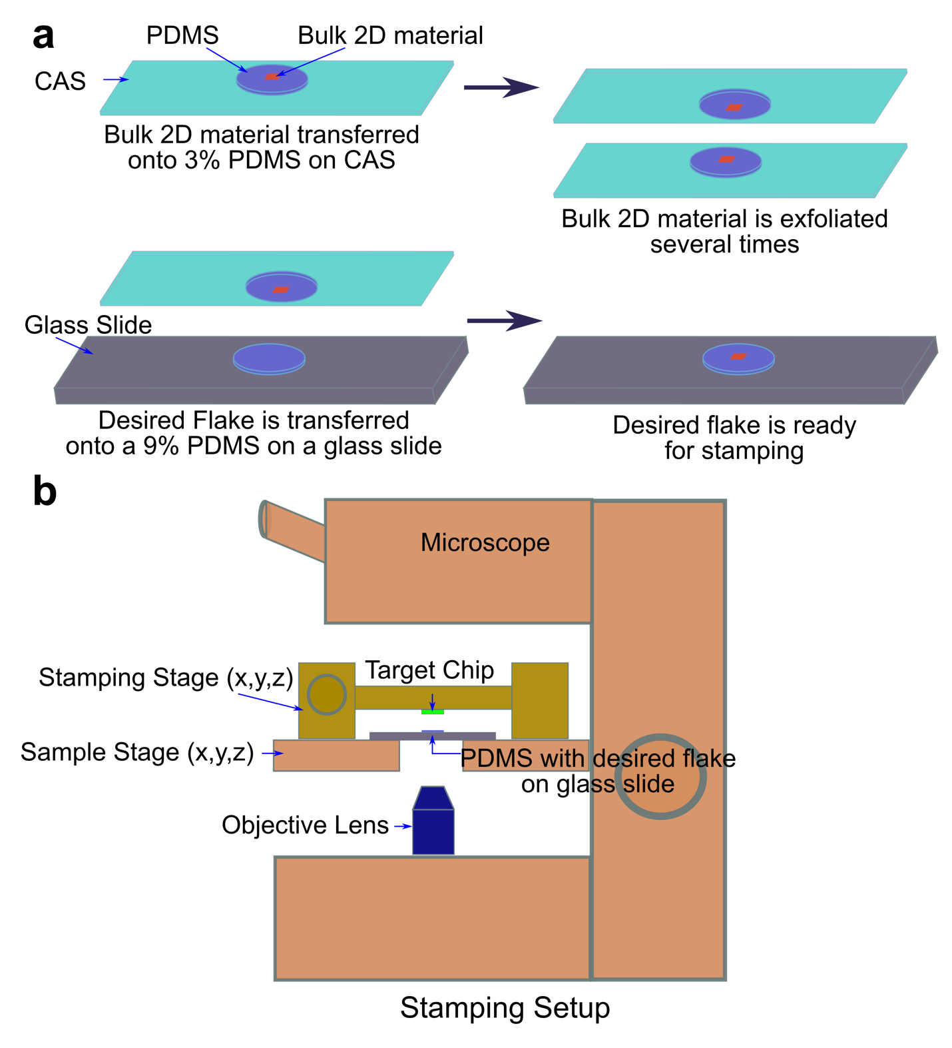
Figure S1. Dry deterministic transfer. (a) Major steps in preparing a suitable flake for stamping; (b) Key components of the stamping setup.
Figure S2. Dependence of mechanical frequency of the fundamental mode on the drumhead thickness and radius for graphite (red) and NbSe₂ (blue) resonators.

Figure S3. Dependence of mechanical frequency of the fundamental mode on the material elastic modulus and density for multilayered 2D material resonators.
Figure S4. Dependence of mechanical frequency of the fundamental mode on the built-in tension for graphite (red) and NbSe₂ (blue) resonators.
References:
[1] A. Castellanos-Gomez, M. Buscema, R. Molenaar, V. Singh, L. Janssen, H. S. van der Zant, and G. A. Steele, “Deterministic transfer of two-dimensional materials by all-dry viscoelastic stamping,” 2D Materials 1, 011002 (2014).
[2] G. Pande, J.-Y. Siao, W.-L. Chen, C.-J. Lee, R. Sankar, Y.-M. Chang, C.-D. Chen, W.-H. Chang, F.-C. Chou, and M.-T. Lin, “Ultralow Schottky barriers in hexagonal boron nitride-encapsulated monolayer WSe2 tunnel field-effect transistors,” ACS Applied Materials & Interfaces 12, 18667–18673 (2020).
[3] Q.-A. Huang, Micro electro mechanical systems (Springer, 2018).
[4] Lee J, Wang Z, He K, Yang R, Shan J, Feng PX. Electrically tunable single-and few-layer MoS2 nanoelectromechanical systems with broad dynamic range. Science advances. 2018 Mar 1;4(3)
[5] Mehta P. Vibrations of thin plate with piezoelectric actuator: theory and experiments (Doctoral dissertation, Clemson University).
[6] Schmid S, Villanueva LG, Roukes ML. Fundamentals of nanomechanical resonators. Berlin: Springer; 2016.
[7] Van Suu TL, Durand S, Bruneau M. On the modelling of clamped plates loaded by a squeeze fluid film: application to miniaturised sensors. Acta Acustica united with Acustica. 2010 Sep 1;96(5):923-35.

