Supplementary File 3: Post Hoc Testing for Physical Activity and Screen Time Scheduling
ONE WAY ANOVA ASSESSMENT OF PA TIME SCHEDULED BY SES TERTILE
ANOVA
 |  | Sum of Squares | df | Mean Square | F | Sig.
BSC_totalPA | Between Groups | 3980.841 | 2 | 1990.420 | 1.581 | .207
 | Within Groups | 463326.572 | 368 | 1259.040
 | Total | 467307.412 | 370
ASC_totalPA | Between Groups | 5539.342 | 2 | 2769.671 | 1.908 | .150
 | Within Groups | 528442.675 | 364 | 1451.766
 | Total | 533982.016 | 366

Multiple Comparisons
Tukey HSD
Dependent Variable | (I) SES_Index | (J) SES_Index | Mean Difference (I-J) | Std. Error | Sig. | 95% Confidence Interval
 |  |  |  |  |  | Lower Bound | Upper Bound
BSC_totalPA | 1.00 | 2.00 | -7.76996 | 4.86309 | .248 | -19.2140 | 3.6740
 |  | 3.00 | -6.41786 | 4.32904 | .300 | -16.6051 | 3.7694
 | 2.00 | 1.00 | 7.76996 | 4.86309 | .248 | -3.6740 | 19.2140
 |  | 3.00 | 1.35210 | 4.58809 | .953 | -9.4448 | 12.1490
 | 3.00 | 1.00 | 6.41786 | 4.32904 | .300 | -3.7694 | 16.6051
 |  | 2.00 | -1.35210 | 4.58809 | .953 | -12.1490 | 9.4448
ASC_totalPA | 1.00 | 2.00 | -7.49823 | 5.10381 | .307 | -19.5092 | 4.5128
 |  | 3.00 | -8.46834 | 4.63967 | .163 | -19.3871 | 2.4504
 | 2.00 | 1.00 | 7.49823 | 5.10381 | .307 | -4.5128 | 19.5092
 |  | 3.00 | -.97011 | 5.04093 | .980 | -12.8331 | 10.8929
 | 3.00 | 1.00 | 8.46834 | 4.63967 | .163 | -2.4504 | 19.3871
 |  | 2.00 | .97011 | 5.04093 | .980 | -10.8929 | 12.8331
ONE WAY ANOVA ASSESSMENT OF PA TIME SCHEDULED BY STATE
ANOVA
 |  | Sum of Squares | df | Mean Square | F | Sig.
BSC_totalPA | Between Groups | 34641.673 | 7 | 4948.810 | 3.903 | .000
 | Within Groups | 530023.820 | 418 | 1268.000
 | Total | 564665.493 | 425
ASC_totalPA | Between Groups | 33527.056 | 7 | 4789.579 | 3.311 | .002
 | Within Groups | 601719.583 | 416 | 1446.441
 | Total | 635246.639 | 423

Multiple Comparisons
Tukey HSD
Dependent Variable | (I) state of Australia | (J) state of Australia | Mean Difference (I-J) | Std. Error | Sig. | 95% Confidence Interval
 |  |  |  |  |  | Lower Bound | Upper Bound
BSC_totalPA | Australian Capital Territory | New South Wales | -8.58000 | 14.88211 | .999 | -53.9161 | 36.7561
 |  | Northern Territory | 16.50000 | 21.56231 | .995 | -49.1864 | 82.1864
 |  | Queensland | -28.14706 | 15.04164 | .572 | -73.9692 | 17.6751
 |  | South Australia | -5.66038 | 14.94308 | 1.000 | -51.1822 | 39.8615
 |  | Tasmania | -11.25000 | 19.23105 | .999 | -69.8345 | 47.3345
 |  | Victoria | -9.46721 | 15.23549 | .999 | -55.8799 | 36.9454
 |  | Western Australia | -4.50000 | 15.92482 | 1.000 | -53.0126 | 44.0126
 | New South Wales | Australian Capital Territory | 8.58000 | 14.88211 | .999 | -36.7561 | 53.9161
 |  | Northern Territory | 25.08000 | 16.24019 | .783 | -24.3933 | 74.5533
 |  | Queensland | -19.56706* | 5.00616 | .003 | -34.8176 | -4.3165
 |  | South Australia | 2.91962 | 4.70173 | .999 | -11.4035 | 17.2427
 |  | Tasmania | -2.67000 | 12.98630 | 1.000 | -42.2308 | 36.8908
 |  | Victoria | -.88721 | 5.56155 | 1.000 | -17.8297 | 16.0552
 |  | Western Australia | 4.08000 | 7.23952 | .999 | -17.9741 | 26.1341
 | Northern Territory | Australian Capital Territory | -16.50000 | 21.56231 | .995 | -82.1864 | 49.1864
 |  | New South Wales | -25.08000 | 16.24019 | .783 | -74.5533 | 24.3933
 |  | Queensland | -44.64706 | 16.38651 | .118 | -94.5661 | 5.2720
 |  | South Australia | -22.16038 | 16.29608 | .875 | -71.8040 | 27.4832
 |  | Tasmania | -27.75000 | 20.30024 | .872 | -89.5917 | 34.0917
 |  | Victoria | -25.96721 | 16.56462 | .769 | -76.4289 | 24.4945
 |  | Western Australia | -21.00000 | 17.20077 | .925 | -73.3996 | 31.3996
 | Queensland | Australian Capital Territory | 28.14706 | 15.04164 | .572 | -17.6751 | 73.9692
 |  | New South Wales | 19.56706* | 5.00616 | .003 | 4.3165 | 34.8176
 |  | Northern Territory | 44.64706 | 16.38651 | .118 | -5.2720 | 94.5661
 |  | South Australia | 22.48668* | 5.18458 | .000 | 6.6926 | 38.2807
 |  | Tasmania | 16.89706 | 13.16881 | .905 | -23.2198 | 57.0139
 |  | Victoria | 18.67985* | 5.97533 | .040 | .4769 | 36.8828
 |  | Western Australia | 23.64706* | 7.56203 | .039 | .6105 | 46.6837
 | South Australia | Australian Capital Territory | 5.66038 | 14.94308 | 1.000 | -39.8615 | 51.1822
 |  | New South Wales | -2.91962 | 4.70173 | .999 | -17.2427 | 11.4035
 |  | Northern Territory | 22.16038 | 16.29608 | .875 | -27.4832 | 71.8040
 |  | Queensland | -22.48668* | 5.18458 | .000 | -38.2807 | -6.6926
 |  | Tasmania | -5.58962 | 13.05612 | 1.000 | -45.3631 | 34.1839
 |  | Victoria | -3.80684 | 5.72269 | .998 | -21.2402 | 13.6265
 |  | Western Australia | 1.16038 | 7.36403 | 1.000 | -21.2730 | 23.5938
 | Tasmania | Australian Capital Territory | 11.25000 | 19.23105 | .999 | -47.3345 | 69.8345
 |  | New South Wales | 2.67000 | 12.98630 | 1.000 | -36.8908 | 42.2308
 |  | Northern Territory | 27.75000 | 20.30024 | .872 | -34.0917 | 89.5917
 |  | Queensland | -16.89706 | 13.16881 | .905 | -57.0139 | 23.2198
 |  | South Australia | 5.58962 | 13.05612 | 1.000 | -34.1839 | 45.3631
 |  | Victoria | 1.78279 | 13.38980 | 1.000 | -39.0073 | 42.5728
 |  | Western Australia | 6.75000 | 14.16921 | 1.000 | -36.4144 | 49.9144
 | Victoria | Australian Capital Territory | 9.46721 | 15.23549 | .999 | -36.9454 | 55.8799
 |  | New South Wales | .88721 | 5.56155 | 1.000 | -16.0552 | 17.8297
 |  | Northern Territory | 25.96721 | 16.56462 | .769 | -24.4945 | 76.4289
 |  | Queensland | -18.67985* | 5.97533 | .040 | -36.8828 | -.4769
 |  | South Australia | 3.80684 | 5.72269 | .998 | -13.6265 | 21.2402
 |  | Tasmania | -1.78279 | 13.38980 | 1.000 | -42.5728 | 39.0073
 |  | Western Australia | 4.96721 | 7.94063 | .999 | -19.2227 | 29.1572
 | Western Australia | Australian Capital Territory | 4.50000 | 15.92482 | 1.000 | -44.0126 | 53.0126
 |  | New South Wales | -4.08000 | 7.23952 | .999 | -26.1341 | 17.9741
 |  | Northern Territory | 21.00000 | 17.20077 | .925 | -31.3996 | 73.3996
 |  | Queensland | -23.64706* | 7.56203 | .039 | -46.6837 | -.6105
 |  | South Australia | -1.16038 | 7.36403 | 1.000 | -23.5938 | 21.2730
 |  | Tasmania | -6.75000 | 14.16921 | 1.000 | -49.9144 | 36.4144
 |  | Victoria | -4.96721 | 7.94063 | .999 | -29.1572 | 19.2227
ASC_totalPA | Australian Capital Territory | New South Wales | 23.34677 | 13.87336 | .698 | -18.9174 | 65.6109
 |  | Northern Territory | 31.60714 | 19.68349 | .747 | -28.3571 | 91.5714
 |  | Queensland | 26.43293 | 14.08704 | .568 | -16.4822 | 69.3481
 |  | South Australia | 31.52228 | 13.96876 | .320 | -11.0325 | 74.0771
 |  | Tasmania | -23.75000 | 20.53969 | .944 | -86.3226 | 38.8226
 |  | Victoria | 37.10821 | 14.22652 | .156 | -6.2318 | 80.4483
 |  | Western Australia | 19.78448 | 15.18823 | .898 | -26.4854 | 66.0543
 | New South Wales | Australian Capital Territory | -23.34677 | 13.87336 | .698 | -65.6109 | 18.9174
 |  | Northern Territory | 8.26037 | 14.77496 | .999 | -36.7504 | 53.2712
 |  | Queensland | 3.08615 | 5.41335 | .999 | -13.4052 | 19.5775
 |  | South Australia | 8.17550 | 5.09765 | .748 | -7.3541 | 23.7051
 |  | Tasmania | -47.09677 | 15.89775 | .063 | -95.5281 | 1.3345
 |  | Victoria | 13.76143 | 5.76659 | .251 | -3.8060 | 31.3289
 |  | Western Australia | -3.56229 | 7.84488 | 1.000 | -27.4611 | 20.3366
 | Northern Territory | Australian Capital Territory | -31.60714 | 19.68349 | .747 | -91.5714 | 28.3571
 |  | New South Wales | -8.26037 | 14.77496 | .999 | -53.2712 | 36.7504
 |  | Queensland | -5.17422 | 14.97578 | 1.000 | -50.7968 | 40.4484
 |  | South Australia | -.08487 | 14.86458 | 1.000 | -45.3687 | 45.1990
 |  | Tasmania | -55.35714 | 21.15911 | .153 | -119.8168 | 9.1025
 |  | Victoria | 5.50107 | 15.10706 | 1.000 | -40.5215 | 51.5236
 |  | Western Australia | -11.82266 | 16.01598 | .996 | -60.6142 | 36.9689
 | Queensland | Australian Capital Territory | -26.43293 | 14.08704 | .568 | -69.3481 | 16.4822
 |  | New South Wales | -3.08615 | 5.41335 | .999 | -19.5775 | 13.4052
 |  | Northern Territory | 5.17422 | 14.97578 | 1.000 | -40.4484 | 50.7968
 |  | South Australia | 5.08935 | 5.65338 | .986 | -12.1333 | 22.3120
 |  | Tasmania | -50.18293* | 16.08456 | .040 | -99.1834 | -1.1825
 |  | Victoria | 10.67528 | 6.26324 | .684 | -8.4052 | 29.7558
 |  | Western Australia | -6.64844 | 8.21686 | .993 | -31.6805 | 18.3836
 | South Australia | Australian Capital Territory | -31.52228 | 13.96876 | .320 | -74.0771 | 11.0325
 |  | New South Wales | -8.17550 | 5.09765 | .748 | -23.7051 | 7.3541
 |  | Northern Territory | .08487 | 14.86458 | 1.000 | -45.1990 | 45.3687
 |  | Queensland | -5.08935 | 5.65338 | .986 | -22.3120 | 12.1333
 |  | Tasmania | -55.27228* | 15.98107 | .014 | -103.9574 | -6.5871
 |  | Victoria | 5.58593 | 5.99249 | .983 | -12.6697 | 23.8416
 |  | Western Australia | -11.73779 | 8.01240 | .826 | -36.1470 | 12.6714
 | Tasmania | Australian Capital Territory | 23.75000 | 20.53969 | .944 | -38.8226 | 86.3226
 |  | New South Wales | 47.09677 | 15.89775 | .063 | -1.3345 | 95.5281
 |  | Northern Territory | 55.35714 | 21.15911 | .153 | -9.1025 | 119.8168
 |  | Queensland | 50.18293* | 16.08456 | .040 | 1.1825 | 99.1834
 |  | South Australia | 55.27228* | 15.98107 | .014 | 6.5871 | 103.9574
 |  | Victoria | 60.85821* | 16.20686 | .005 | 11.4852 | 110.2312
 |  | Western Australia | 43.53448 | 17.05728 | .177 | -8.4293 | 95.4982
 | Victoria | Australian Capital Territory | -37.10821 | 14.22652 | .156 | -80.4483 | 6.2318
 |  | New South Wales | -13.76143 | 5.76659 | .251 | -31.3289 | 3.8060
 |  | Northern Territory | -5.50107 | 15.10706 | 1.000 | -51.5236 | 40.5215
 |  | Queensland | -10.67528 | 6.26324 | .684 | -29.7558 | 8.4052
 |  | South Australia | -5.58593 | 5.99249 | .983 | -23.8416 | 12.6697
 |  | Tasmania | -60.85821* | 16.20686 | .005 | -110.2312 | -11.4852
 |  | Western Australia | -17.32373 | 8.45375 | .450 | -43.0775 | 8.4300
 | Western Australia | Australian Capital Territory | -19.78448 | 15.18823 | .898 | -66.0543 | 26.4854
 |  | New South Wales | 3.56229 | 7.84488 | 1.000 | -20.3366 | 27.4611
 |  | Northern Territory | 11.82266 | 16.01598 | .996 | -36.9689 | 60.6142
 |  | Queensland | 6.64844 | 8.21686 | .993 | -18.3836 | 31.6805
 |  | South Australia | 11.73779 | 8.01240 | .826 | -12.6714 | 36.1470
 |  | Tasmania | -43.53448 | 17.05728 | .177 | -95.4982 | 8.4293
 |  | Victoria | 17.32373 | 8.45375 | .450 | -8.4300 | 43.0775
*. The mean difference is significant at the 0.05 level.

KRUSKALL – WALLIS TESTING OF ST TIME SCHEDULED BY SES TERTILE
BSC ST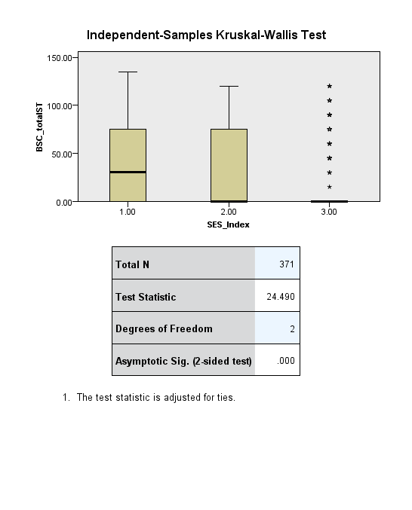 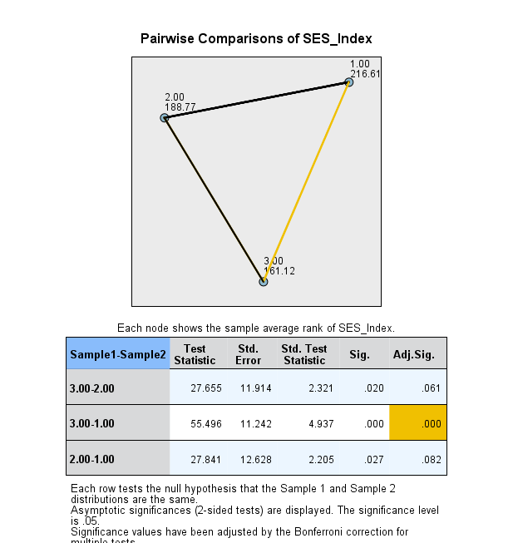

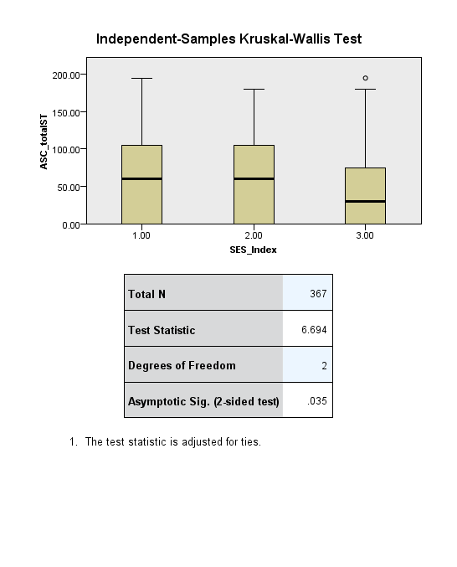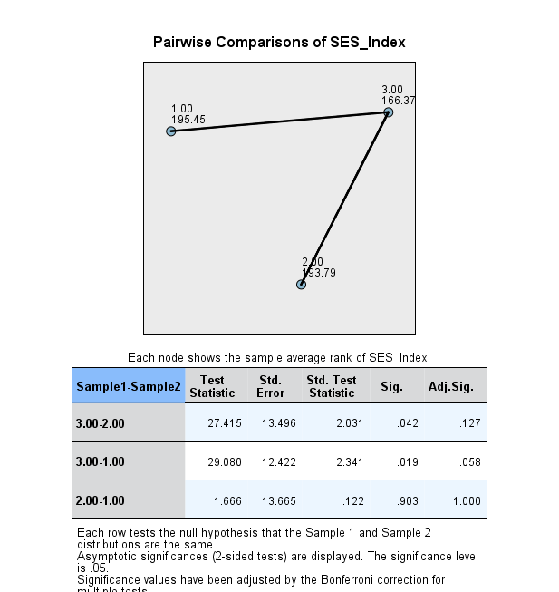
ASC ST

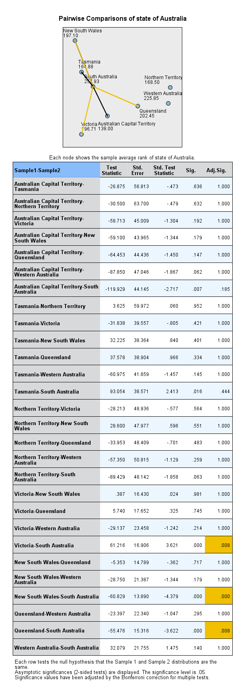
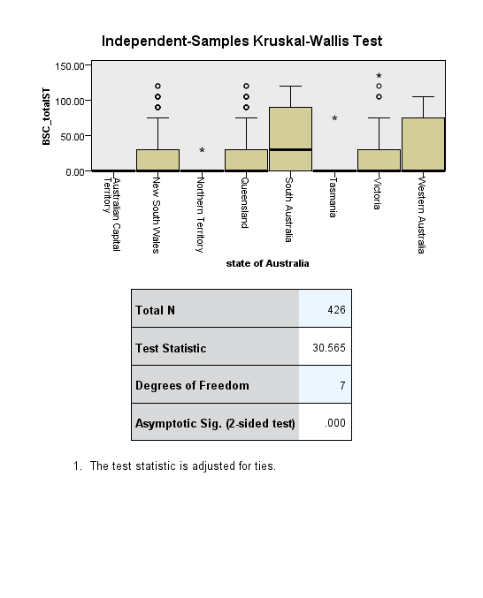
KRUSKALL – WALLIS TESTING OF ST TIME SCHEDULED BY STATE
