Nanoscale Infrared Spectroscopy Reveals Nanoplastics at 5000 m Depth in the South Atlantic Ocean

Florian Meirer^{1,§,}*, Iris C. ten Have^{1,§}, Ramon Oord¹, Erik R. Zettler², Erik van Sebille³, Linda A. Amaral-Zettler², and Bert M. Weckhuysen^{1,}*

¹ Inorganic Chemistry and Catalysis, Utrecht University, Utrecht, 3584CG, The Netherlands.
² NIOZ Royal Netherlands Institute for Sea Research, Den Burg, 1790AB, The Netherlands.
³ Institute for Marine and Atmospheric Research, Utrecht University, Utrecht, 3584CC, The Netherlands.
⁴ Department of Freshwater and Marine Ecology, Institute for Biodiversity and Ecosystem Dynamics, University of Amsterdam, Amsterdam, 1090 GE, The Netherlands.

§These authors contributed equally
*f.meirer@uu.nl, b.m.weckhuysen@uu.nl

Supplementary Information
S1 Materials and Methods
1.1 Infrared spectroscopy band assignments
The band assignments of reference infrared (IR) spectra are displayed in Figure S1 and listed in Table S1.

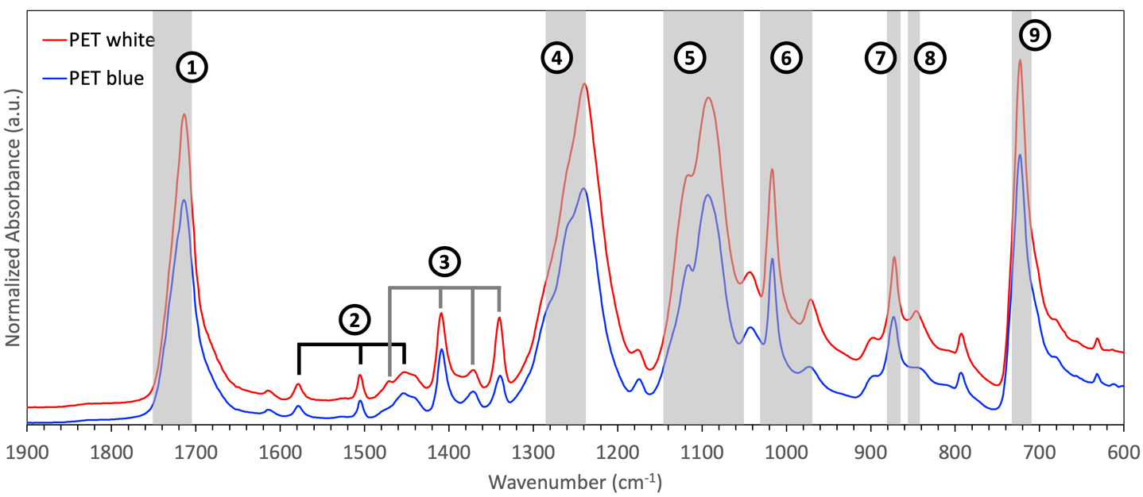
Figure S1 | Reference spectra recorded using ATR-IR for white and blue colored bulk PET. The bands are indicated according to Table S1 and based on references ^{1–7}.

Number | Band (cm⁻¹) | Assignment | Intensity
1 | 1750 – 1712 | Stretching (ν) of C=O ^{1–7} | Very strong
2 | 1577-80, 1504, 1453 | ν of C=C in aromatic ring ^{1,3} | Very weak
3 | 1470-79, 1408-10, 1372, 1340-42  1453, 1410, 1342 | Bending (δ, asymmetrical and symmetrical in plane) of C-H ^{1,4}  ν of the C-O group deformation of the O-H group ⁵ and bending and wagging vibrational modes of the ethylene glycol segment ^{3,4,6} | Weak – Medium
4 | 1283  1252,1240  1235 | O-CH₂ stretching ⁷  ν of C-O in terephthalate group ^{1–3}  ester group stretching ⁶ | Very strong
5 | 1134, 1118-24 (shoulder), 1090-98, 1050 | Methylene group (1090) ⁶ and ν of ester C-O (1118, 1096, 1050) and terephthalate group (1124) ^{1–3,5} | Strong
6 | 1016, 970 | δ (in plane) C-H aromatic ring ^{1,5} | Medium
7 | 870-72 | δ (out of plane) C-H aromatic ring ^{1,3} | Medium
8 | 847-48 | Rocking of C-H(-CH2-) ^{1,3} | Weak
9 | 719-723  712-730 ³ | Wagging of C-H aromatic ring ^{1,2,5}  Interaction of polar ester groups and benzene rings ⁵ | Very strong
Table S1. Main IR absorption band assignments for identifying PET (for a general discussion see also reference ⁷); the number corresponds to the labels in Figure S1.

The characteristic molecular vibrations of PET as listed in Table S1 have previously been reported to undergo changes upon degradation of the polymer ^{4–6,8}. Polymer degradation proceeds via both abiotic pathways and biotic pathways (e.g. by microorganisms) ^{9,10}. Although beyond the scope of this study, the impact of the (marine) biosphere on polymer degradation is significant ⁹. Microbes may even be able to provide novel enzymes towards recycling of depolymerization of polymers to monomers, as has been shown for PET ^{10,11}. In case of the abiotic pathways, degradation can be brought about by e.g. water (hydrolysis), light, or heat. For example, the C=O stretching peak around 1725 cm⁻¹, denoted as 1 in Figure S1 and Table S1, has been reported to broaden ^{4,5} and/or split into multiple peaks ^{4,8}. In the case of hydrolytic degradation, which is particularly relevant in aquatic environments, terminal terephthalic acid groups can be formed. These groups display a C=O stretching vibration around 1745 cm⁻¹ ⁴. Hydrolysis also induces changes in the ethylene glycol segment of PET. The CH₂ wagging vibration around 1370 cm⁻¹ (trans) was reported to decrease, while the CH₂ wagging vibration around 1340 cm⁻¹ (cis) increased during degradation ⁴, suggesting a more crystalline PET structure upon degradation. Besides, a decrease in peak intensity has been reported for the O-CH₂ stretching vibration around 1280 cm⁻¹ ^{4,8} and the terephthalate group around 1100-1150 cm⁻¹ ⁴. An increase in peak intensity was reported for the terephthalate C-O stretching vibration around 1240-1250 cm⁻¹. The peaks denoted as 1, 3, 4, and 5 in Figure S1 and Table S1 were therefore used as age markers during the PiFM IR spectral analysis of the lab-generated PET nanoplastics, as well as PET nanoplastics from the ocean.

1.2 Reference spectra of bulk PET, PS, and PE recorded by ATR-IR and PiFM

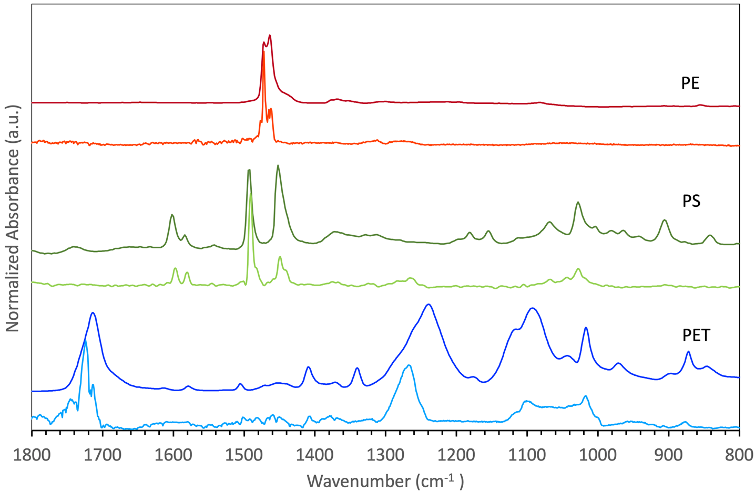
Figure S2 | Reference spectra recorded for bulk PE, PS, and PET using both ATR-IR (top plot: dark red, dark green, dark blue) and PiFM (bottom plot: light red, light green, light blue). PiFM spectra were recorded for large and thick (several µm) pieces of plastics, therefore the broad Si-O vibrations from the silicon dioxide surface layer of the sample carrier that fall in the region of 1000-1100 cm⁻¹ ^{12–15} and are often seen in spectra recorded for nanoplastics ¹⁶ are not present here (see also Section S2).

S2 Nanoplastics found in the South Atlantic Ocean
Note that broad Si-O vibrations from the silicon dioxide surface layer of the sample carrier fall in the region of 1000-1100 cm⁻¹ ^{12–15} and often contribute to PiFM spectra of nanoplastics ¹⁶. Furthermore, the region between 1180-1300 cm⁻¹ overlaps with bands related to the deformation of the CH₃ group connected to the Si atom of silicone oil,¹⁷ a contamination that cannot be excluded to be present on some AFM tips. It is therefore difficult to assign bands in this region unambiguously, which is why these regions were not used in our identification of nanoplastics.

2.1 Polyethylene terephthalate nanoplastics from the South Atlantic Ocean

Figure S3 shows the nanoplastics that were identified as polyethylene terephthalate (PET) and found close to the ocean floor (5179 m). We particularly used the characteristic C=O stretching vibration ~1725 cm⁻¹, the wagging modes of the ethylene glycol segment ~1360-1370 cm⁻¹, the C-O stretching vibration ~1240 cm⁻¹, and the O-CH₂ stretching vibration ~1280 cm⁻¹ to identify the PET nanoplastics. Some of the PiFM IR point spectra displayed a considerable amount of noise between 1350 and 1600 cm⁻¹, which originates from water ¹⁸. This water signal could either be water vapor present in the sample compartment and sensed by the AFM tip or water absorbed by the PET nanoplastics. Note that no pre-treatments, such as filtering and pre-concentration, were performed prior to the PiFM measurements. We opted for this, as we noticed that a filtering step with a 0.22 μm filter (polytetrafluoroethylene (PTFE)) and a concentration step with tangential flow filtration (TFF) ^{19,20} removed a large fraction of the material under study. For example, another sample collected during the research cruise 64PE448 taken at a different location close to the ocean floor (at 3508 m depth at -29.875° S and -11.585° E) was filtered with a 0.22 μm filter and concentrated 50-fold via TFF. After this pre-treatment, we only detected one particle that could be identified as PET nanoplastic (Figure S4) during 2 separate measurements (scanning a total surface of 1225 μm²). This was considerably less (approximately a factor 500) compared to the unfiltered sample taken at 5179 m depth at -32.171° S and 6.287° E. Interestingly, most PET nanoparticles identified in Figure S3 seem to be aggregated together with other (organic/biological) matter, which may be the reason for their removal during pre-filtration treatments.

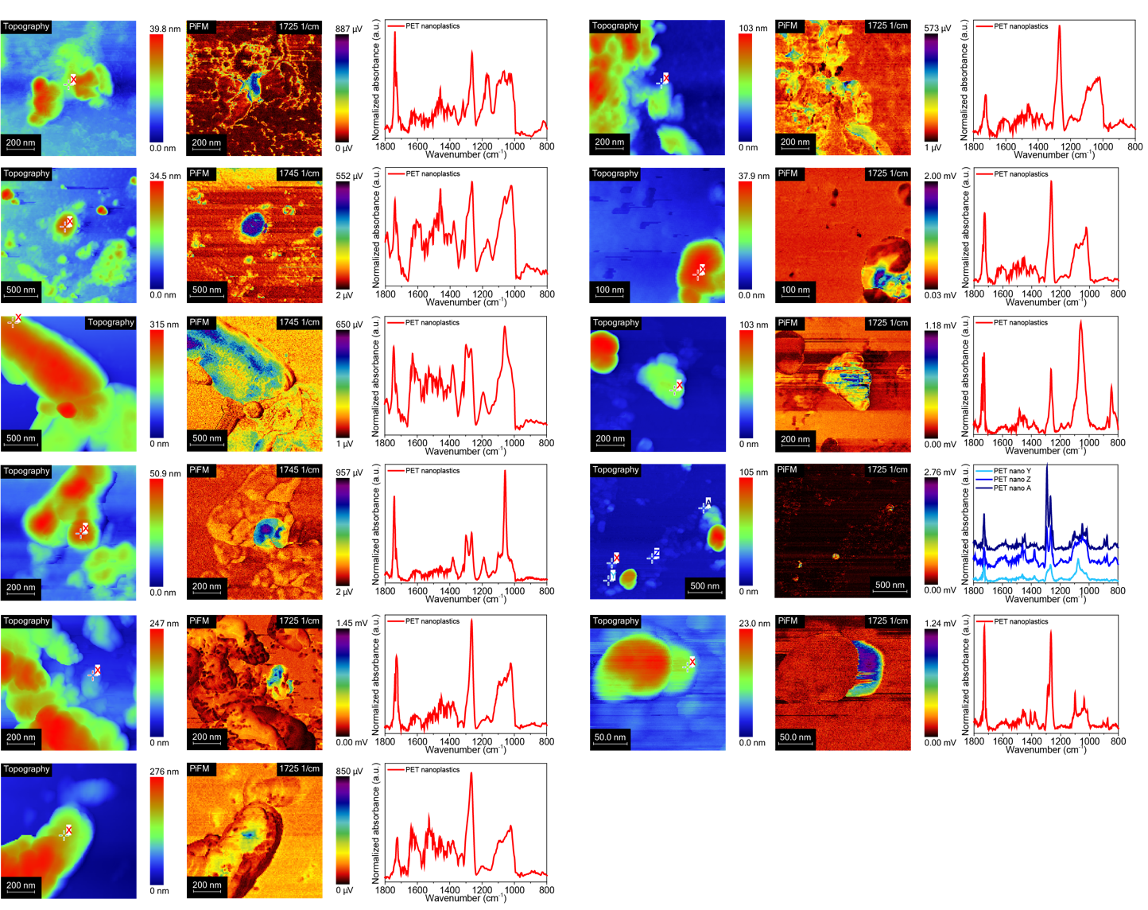
Figure S3 | Polyethylene terephthalate nanoplastics found close to the ocean floor. Each column shows the AFM topographic images (left) and IR maps recorded at the C=O stretching peak at 1725 cm⁻¹ or 1745 cm⁻¹ (middle) of PET nanoplastics (n=12) found at the bottom of the ocean (5179 m). Panels on the right of each column display the corresponding PiFM point spectra of the respective PET nanoplastic (the measurement position is indicated in the topographic map). Row 3 from the top in the left column was classified as a microplastic and not counted as a nanoplastic particle. Row 4 from the top in the right column contains 4 PET nanoplastics (X, Y, Z, and A); one of them (X) is magnified in the row below that (row 5 from the top in the right column).

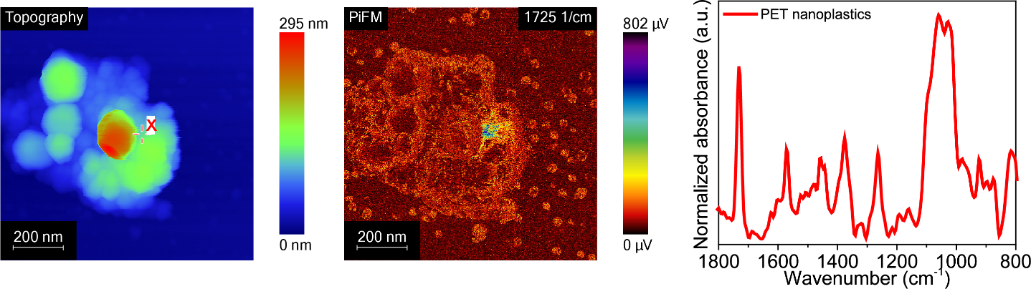
Figure S4. | Polyethylene terephthalate nanoplastic found in a filtered sample. AFM topographic image (left) and IR map recorded at the C=O stretching peak at 1725 cm⁻¹ (middle) of PET nanoplastics found at 3508 m depth at -29.875° S and -11.585° E. The panel on the right displays the corresponding PiFM point spectrum (the measurement position is indicated in the topographic map). The sample was filtered with a 0.22 μm filter and concentrated 50-fold using tangential flow filtration (TFF). The mapped area therefore shows an agglomerate of particles that are smaller than 200 nm.

2.2 Polystyrene and nylon nanoplastics from the South Atlantic Ocean

Figures S5 and S6 show the nanoplastics that were identified as polystyrene (PS) or nylon and found both close to the ocean floor (5179 m) and in the pycnocline (60 m) respectively.
The IR maps were recorded either at the C-H bending peak at 1430-1450 cm⁻¹ (C-H bending vibrations attached to the PS aromatic ring structure), at the C=C ring stretch at 1490 cm⁻¹, or the COO⁻ stretching peak at 1540-1560 cm⁻¹ ^{1,2,21}.
All particles show the bands in the 1430-1600 cm⁻¹ region that are typically used to identify PS, however, all show signs of degradation to different degrees. The point spectrum that was found to be most similar to the one of a pure PS reference spectrum is displayed in the top row of Figure S6 and indicates a particle found in the pycnocline that seemed to be in its original chemical state, i.e. no oxidative degradation had occurred. All other PiFM point spectra show strong peaks in the 1540-1560 cm⁻¹ region, originating from the asymmetric stretching of a carboxylate ion group (RCOO⁻) and indicating oxidative degradation ^{21,22}. The particle shown in the second row of Figure S5 additionally shows a strong peak at 1630 cm⁻¹, indicating chain scission ^{23,24}.

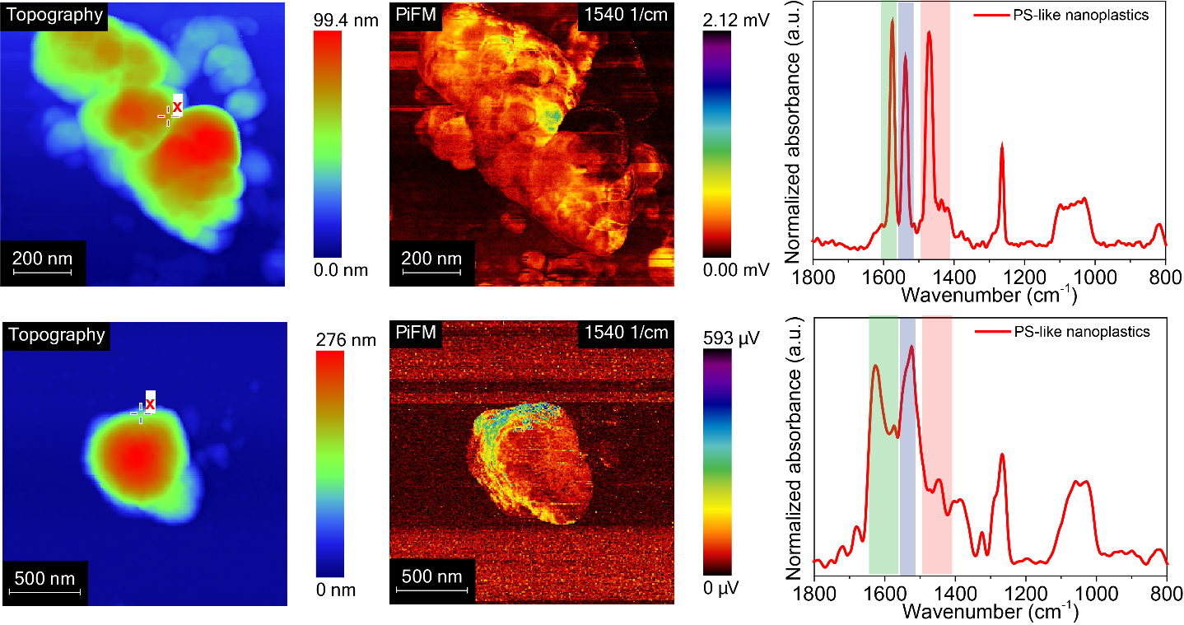
Figure S5 | Polystyrene nanoplastics found close to the ocean floor (5179 m). AFM topographic images (left) and IR maps recorded at the COO⁻ stretching peak at 1540 cm⁻¹ ^{21,22}(middle). The panels on the right display the corresponding PiFM point spectra of the PS-like nanoplastics from the pycnocline (60 m); point spectra locations are indicated in the topography maps.

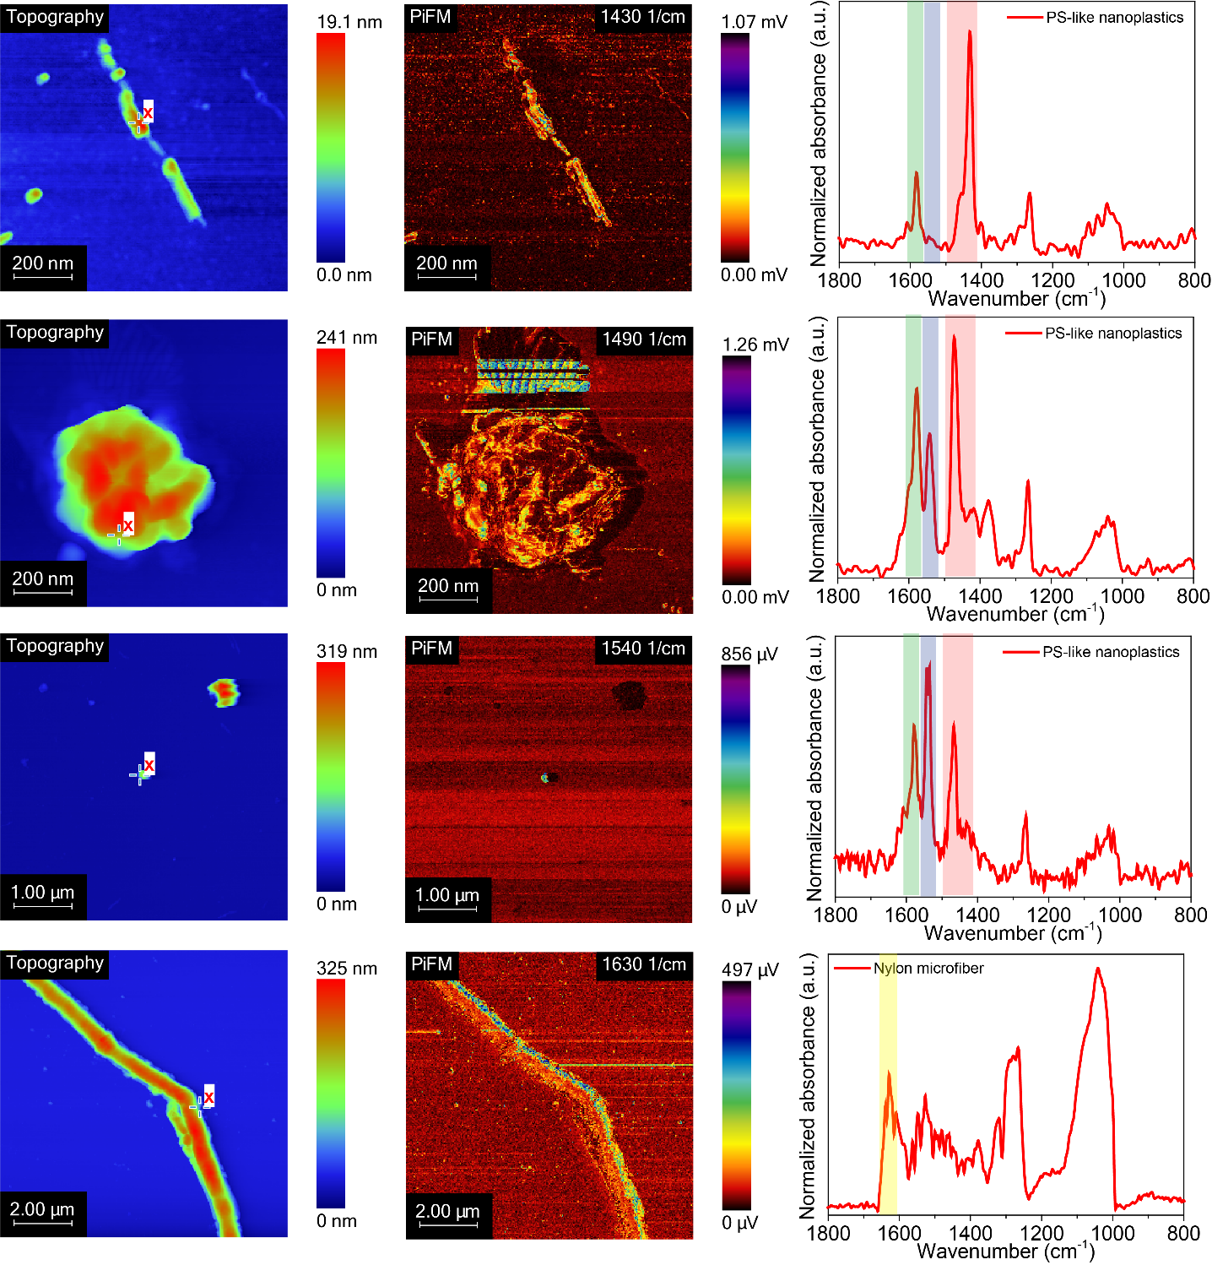
Figure S6 | Polystyrene nanoplastics and a Nylon microfiber found in the pycnocline. AFM topographic images (left) and IR maps recorded at the C-H bending peak at 1430 cm⁻¹, at the C=C ring stretch at 1490 cm⁻¹, and the COO⁻ stretching peak at 1540 cm^{-1 1,2,21} for the PS nanoplastics found in the pycnocline at 60 m depth (middle). The bottom row displays the topographic map (left) and IR image at the C=O stretching vibration at 1630 cm⁻¹ ²(middle) of a Nylon microfiber found in the pycnocline sample. The panels on the right display the corresponding PiFM point spectra; the location where point spectra were recorded is indicated with in the topography maps.

2.3 Polyethylene nanoplastics from the South Atlantic Ocean

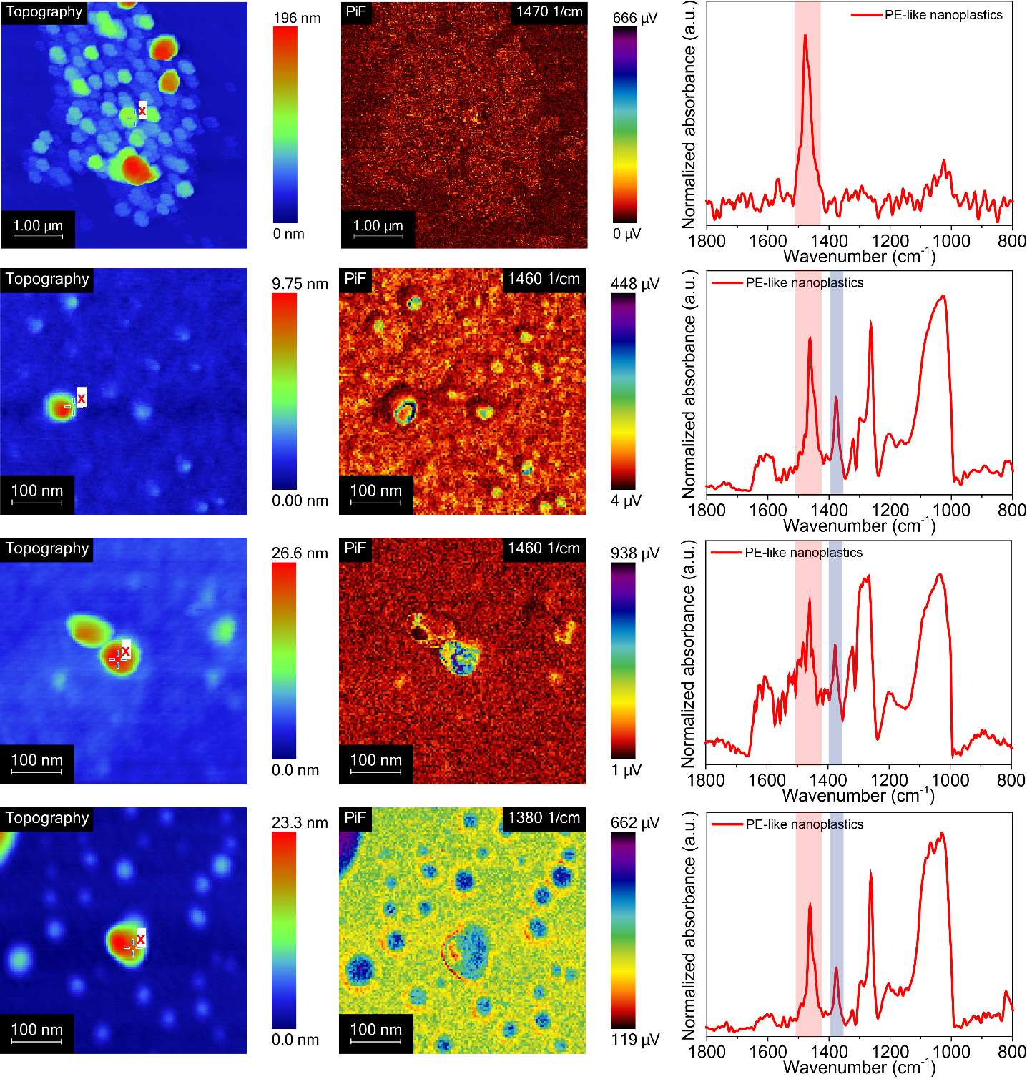
Figure S7 | Polyethylene nanoplastics found in the pycnocline. AFM topographic images (left) and IR maps recorded at the polyethylene (PE) C-H₂ bending peak at 1460-1470 cm⁻¹ ^{2,22} and the C-H₃ bending peak at 1380 cm⁻¹ ²²(middle), the latter indicating PE degradation (middle bottom). Panels right display the corresponding PiFM point spectra of the PE nanoplastics from the pycnocline (60 m); locations indicated with red x in the topography maps. The C-H₂ bending peak at 1460-1470 cm⁻¹ is indicated with a red bar and the C-H₃ bending peak at 1380 cm⁻¹ with a blue bar in the spectra.

2.4 Fibers from the South Atlantic Ocean surface
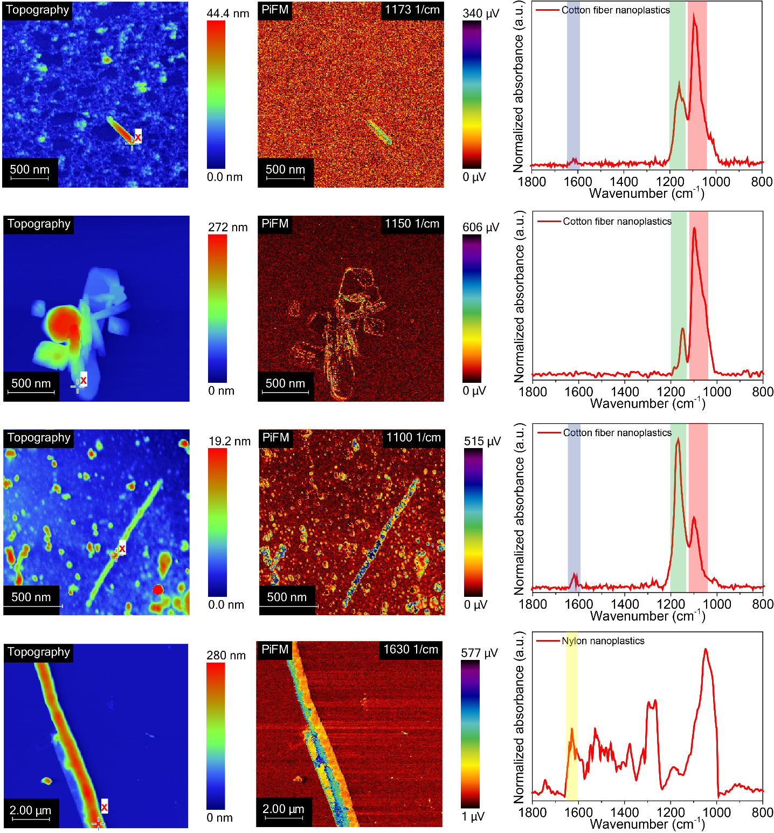
Figure S8 | Cellulose and Nylon fibers found at the ocean surface. AFM topographic images (left) and IR maps recorded at the S=O stretch vibration at 1173 cm⁻¹ (middle top), the C-O-C stretch vibration at 1150 cm⁻¹ (middle 2nd from top), and 1100 cm⁻¹ ^{22,25}(middle 3rd from top) of sulfonated cellulose. Cellulose fibers, e.g. synthetic cotton, are often sulfonated to make them flame-resistant. The bottom row displays an AFM topographic image (left) of a Nylon fiber and the corresponding IR map recorded at the C=O stretch vibration at 1630 cm⁻¹ ²(middle). Panels right display the corresponding PiFM point spectra of the fibers from the ocean surface (5 m); location indicated with a red x in the topography maps.

2.5 Estimating nanoplastic concentrations in the South Atlantic Ocean
From the data collected with PiFM, we estimated the concentrations of nanoplastic particles in the South Atlantic Ocean (Table S2). For this, we prepared 3 SiO₂/Si(100) sample carriers per sample with each 10 μL of the respective sample. For every carrier, we recorded PiFM maps on multiple locations. Next, we assessed the number of particles found in all individual scans (N.B. this could also be 0) and then calculated the average number of particles per μm² for each sample carrier assuming equal distribution after spin coating. From this particle number surface density, we estimated the total number of particles on the whole sample carrier, in turn providing the number of particles in the spin coated volume. From this the particle number per unit volume (here mL) was calculated for each sample carrier, which provided average and standard deviation because three repetitive measurements (3 sample carriers) were made for all samples (different depths). The result of this estimation is provided in Table S2 and only reported for PET, where a significant number of particles was found.

Depth | Polymer | Particles | Total area scanned (μm²) | Concentration (particles/mL) | Quantity (ng/mL)ª
5179 m (bottom) | PET | 12 | 1925 | 8.56*10⁷ ± 4.12*10⁷ | 52.7 ± 29.8
Table S2. Estimated concentrations of the PET nanoplastics found in the South Atlantic Ocean,
ª Assuming 100 nm (diameter) spheres and a density of 1.38 g/cm³ for PET.

The values we obtained in this way for PET nanoplastics at the bottom of the South Atlantic Ocean, are in the same range as those reported by an earlier study (10⁷-10⁹ particles per mL) that investigated nanoplastics in aquatic environments at different locations in Sweden using nanoparticle tracking analysis (NTA)²⁶, which does not discriminate between plastic species.
Larger microplastics (PE, PS, and PP), on the other hand, have been reported in much lower concentrations of 10⁻³-10⁻⁴ particles per mL in the Atlantic Ocean at 10-270 m depth ²⁷. The nature of the nanoplastics we found in the pycnocline (60 m depth) in this study matched well with the PE and PS microplastics found by Pabortsava et al at similar depths ²⁷. In oceanic surface waters, microfibers have been found in concentrations of 10⁻²-10⁻⁵ fibers per mL and 80% of the synthetic fibers were cellulosic ²⁸. The nature of the microfibers found there also corresponds well with the nanosized cellulose fibers that we found here in the surface layer of the South Atlantic Ocean. However, to further substantiate our estimated concentrations (note that estimating concentrations was not the purpose of this study), the results should be complemented with a bulk method that can assess very low concentrations of nanoplastics reliably. For example, Materić et al. used thermal desorption−proton transfer reaction−mass spectrometry (TD-PTR-MS) to detect micro- and nanoplastics in alpine snow ^{29,30}. After filtering the snow samples with a 0.2 μm filter, they found concentrations of PET nanoplastics between 4.6 and 23.6 ng/mL in alpine snow ²⁹. If we assume in our data an average PET nanoparticle size of 100 nm and a density of 1.38 g/cm³, we arrive at an estimated quantity of 52.7 ng/mL PET nanoplastics at the bottom of the South Atlantic Ocean. This is of the same order of magnitude as determined by Materić et al. ²⁹.

S3. PET nanoplastics formed during degradation experiments in the laboratory
3.1 End group ratio analysis
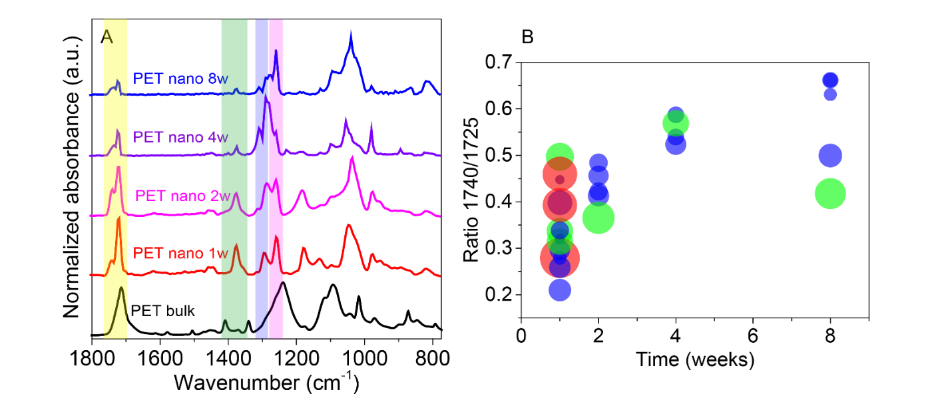
Figure S9 | A) Average PiFM point spectra of PET nanoplastics after 1, 2, 4, and 8 weeks of aging. (B) Ratio of the peak intensity of the 1740 and 1725 cm⁻¹ absorption bands versus aging time indicating hydrolysis as the dominant degradation mechanism. Bubble diameters in B) indicate each particle’s size, where particle diameters from 0-350 nm are indicated in blue, those between 351-450 nm in green, and particles with diameters >450 nm in red.
Sample name | 1740/1725 ratio | N | Average diameter (nm)
PET 1w | 0.35 ± 0.08 | 15 | 325 ± 125
PET 2w | 0.43 ± 0.04 | 5 | 304 ± 80.6
PET 4w | 0.55 ± 0.03 | 4 | 278 ± 64.5
PET 8w | 0.58 ± 0.11 | 5 | 271 ± 104
PET pH=12; 4w | 1.08 ± 0.17 | 4 | 50.7 ± 31.0
PET bulk | 0.38 ± 0.01 | 12 | N.A.
Table S3. Ratios between 1740 and 1725 cm⁻¹ absorption bands for lab-degraded PET samples.

3.2 PET Nanoplastic Formation at pH = 12
To verify our hypothesis that hydrolysis was indeed a degradation mechanism resulting in the formation of PET nanoplastics, we also aged PET in a basic environment at pH=12. One would expect a higher rate of degradation in this case, since hydrolysis is catalyzed by OH⁻ ⁴. The results obtained by PiFM again showed the formation of nanoplastics (Figure S10). The PiFM spectrum of the PET nanoplastic after 4 weeks of aging (Figure S10C) shows that the ratio between the peaks at 1740 and 1725 cm⁻¹ was significantly increased in comparison to the peak ratios found for the samples that were aged in neutral environments. This increase of the ratio from 0.55 ± 0.03 in a neutral environment to 1.08 ± 0.17 at pH=12 (see also Table S3) proves that the hydrolysis rate was much higher at pH=12 and consequently more terminal terephthalic acid groups had been formed.
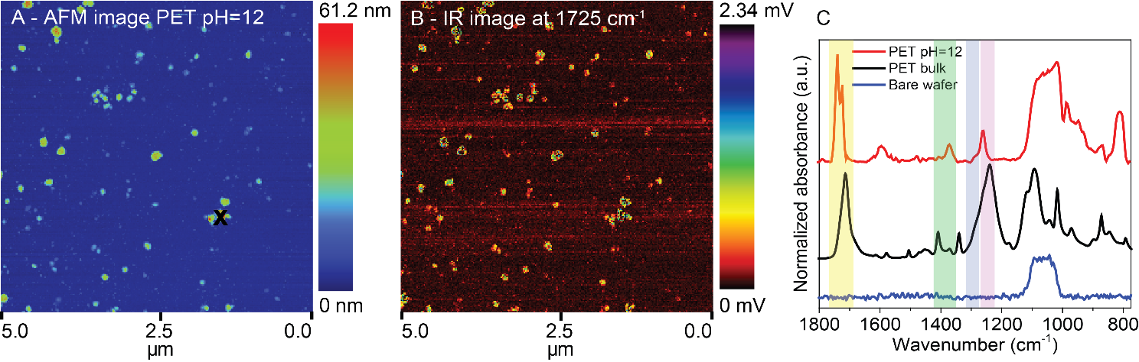
Figure S10 | (A) AFM topographic image of PET nanoplastics after 4 weeks of aging at pH=12. (B) Corresponding IR image at the C=O stretching peak at 1725 cm⁻¹. (C) PiFM point spectra obtained on the PET nanoplastic particles (red), ATR-IR bulk reference (black) and on a bare SiO₂/Si(100) wafer (blue).
3.3 Particle size analysis and concentrations of PET nanoplastics from PiFM images
PSD and concentrations of the PET nanoplastics were determined via PiFM images recorded at 1725 cm⁻¹. The resulting particle diameters are pixel-based values. Further details about the methodology of obtaining PSD from PiFM images can be found in reference ¹⁶. We prepared 2-4 SiO₂/Si(100) sample carriers per sample with each 10 μL of the respective sample. As mentioned above, of every carrier, we recorded PiFM maps on multiple locations. Next, we assessed the number of particles found in all individual scans (N.B. this could also be 0) and then calculated the average number of particles per μm² for each sample carrier assuming equal distribution after spin coating. From this particle number surface density, we estimated the total number of particles on the whole sample carrier, in turn providing the number of particles in the spin coated volume. From this the particle number per unit volume (here mL) was calculated for each sample carrier, which provided average and standard deviation because multiple repetitive measurements (multiple wafers) were made for all samples (weeks 1, 2, 4, 8). For the 2 weeks sample no average and standard deviation was determined as only one wafer was analyzed.

The results of the analysis are presented in Figure 2B (main text) and Table S4 and clearly showed that the mean nanoparticle size of aging PET decreased from 130 nm to 54.6 nm going from week 1 to week 8. We also saw that the concentration increased from 7.50*10⁸ particles/mL to above 10⁹ particles/mL within 4 weeks. Moreover, when we compared PET nanoplastics after 4 weeks of aging in a neutral environment to PET after 4 weeks of aging at pH=12 we saw that the mean particle sizes were similar at 62.1 nm and 61.4 nm, respectively. This suggests that the mean nanoplastic particle size is not necessarily related to the hydrolysis rate. However, the particle concentration was almost a factor 2 higher at pH=12 (2.03*10⁹ particles/mL) compared to the neutral aging environment (1.31*10⁹ particles/mL). This confirms that the presence of OH⁻ catalyzes degradation of PET into nanoplastics via the hydrolysis mechanism.

Sample | Number of particles | Total area scanned (μm²) | Concentration (particles/mL) | Quantity (μg/mL)ª
PET 1w | 86 | 3429 | 2.89*10⁸ ± 3.88*10⁷ | 0.46 ± 0.06
PET 2w | 8 | 55 | 1.20*10⁹ ± n.a. | n.a.
PET 4w | 100 | 875 | 1.31*10⁹ ± 2.12*10⁸ | 0.23 ± 0.04
PET 8w | 109 | 1976 | 1.09*10⁹ ± 1.48*10⁹ | 0.13 ± 0.17
PET pH=12 | 200 | 601 | 2.03*10⁹ ± 2.11*10⁹ | 0.34 ± 0.35
Table S4. Estimated concentrations of PET nanoplastics produced in lab-based experiments in salt-water and in the absence of light. ª A density of 1.38 g/cm³ was used to determine the quantity of PET.

PiFM images recorded at 1725 cm⁻¹ were used for the PSD and concentrations, but when this information was linked to the AFM topographic images, the 3D shape of the PET nanoplastic particles could also be analyzed. When the Z height was plotted versus the XY diameter (Figure 2D, main text) we noticed that all particles were relatively flat, i.e. the XY diameter was mostly larger than the Z height of a particle. We also noticed that the aspect ratio (XY/Z) increased with the particle size, which means that larger particles are flatter compared to smaller ones. For example, particles between 15 and 30 nm in XY are on average 16 ± 2.5 nm in Z with an aspect ratio XY/Z=1.4 ± 0.3, whereas particles larger than 400 nm in XY are on average only 88 ± 32 nm in Z with an aspect ratio XY/Z=5.9 ± 2.0. To indicate the difference between naturally formed nanoplastics and reference materials used in e.g. toxicology studies, polystyrene (PS) size standards (20, 70, 150, and 400 nm) ¹⁶ were also plotted in Figure 2D (main text). The sizes of the PS standards were determined in our previous study, using a semi-automated script ¹⁶. When the PS particles agglomerated, the segmentation threshold had to be increased to enable the script to recognize individual particles. Therefore, the spread in XY was relatively large. These findings indicate that “real-life nanoplastics” have a significantly different shape than the nanoscale polymer beads used as reference material in laboratory studies ^{31,32}.

3.4 Polarizer experiments
A spectral detail that stood out in the analysis of PET nanoplastics (see Figure S11) was the omnipresent peak around 1740 cm⁻¹. This peak was not seen in the ATR-IR spectrum of bulk PET (black line) and we assigned this peak to C=O stretching vibrations of terminal terephthalic acid groups, that originated from hydrolysis. Bulk PET also contains carboxylic acid end groups, but the ratio between carboxylic acid carbonyl groups and ester carbonyl bonds is much lower than that of PET nanoplastics due to much longer polymer chains in bulk PET. Besides, PiFM is a near-field technique with a probing depth of ~30 nm and PiFM spectra are therefore, unlike bulk techniques, dominated by the signal of surface groups.
To investigate whether the peak at 1740 cm⁻¹ is a local effect of molecular orientation, we have also recorded PiFM spectra using only s-polarized IR light. In both cases, i.e. using non-polarized and s-polarized light, both the peaks at 1725 and 1740 cm⁻¹ are still present (see Figure S12), but the ratio 1740/1725 increases from 0.63 to 0.91 when using s-polarized light only. This could indicate that the vibration probed at 1740 cm⁻¹ has a preferential orientation parallel to the sample surface. It is however not straightforward to generalize this hypothesis to all PET nanoplastics, since PiFM spectra are recorded very locally.

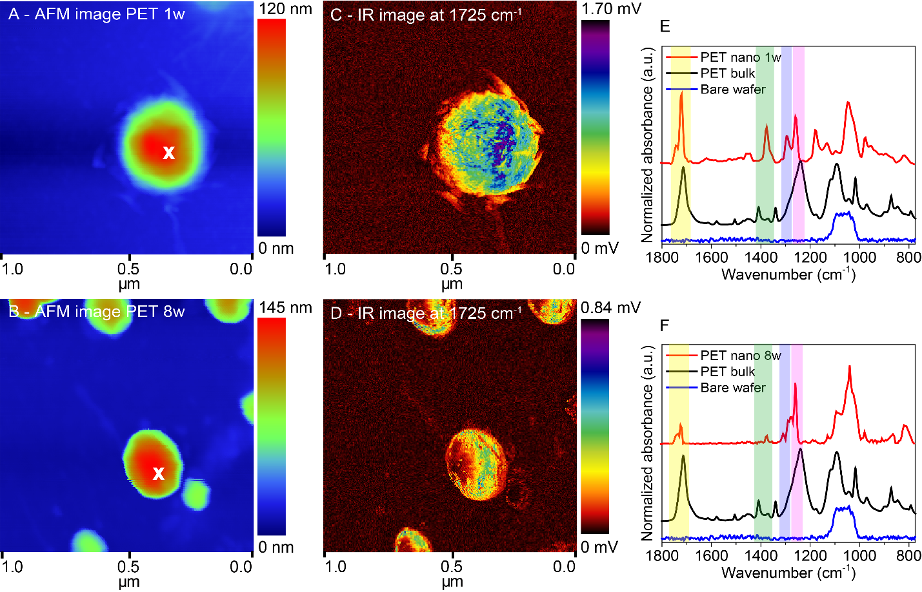
Figure S11 | AFM topographic images (A, B) and IR maps recorded at the C=O stretching peak at 1725 cm⁻¹ of PET nanoplastics (C, D) found in samples aged for 1 week (A, C) and 8 weeks (B, D). Panels E and F display the corresponding PiFM IR point spectra of PET nanoplastics indicated in red and compared with PiFM IR point spectra recorded for the bare SiO₂/Si(100) wafer that was used as the sample carrier (blue). The positions of the point spectra are indicated in the topographic maps. The PiFM IR spectra are further compared to bulk reference spectra recorded with ATR-IR (black) for pure PET. The colored regions in the spectra indicate the C=O stretching peak (yellow), the wagging vibration modes of the ethylene glycol segment (green), the C-O stretching vibrations (blue), and the vibrations from the terephthalate group (magenta).
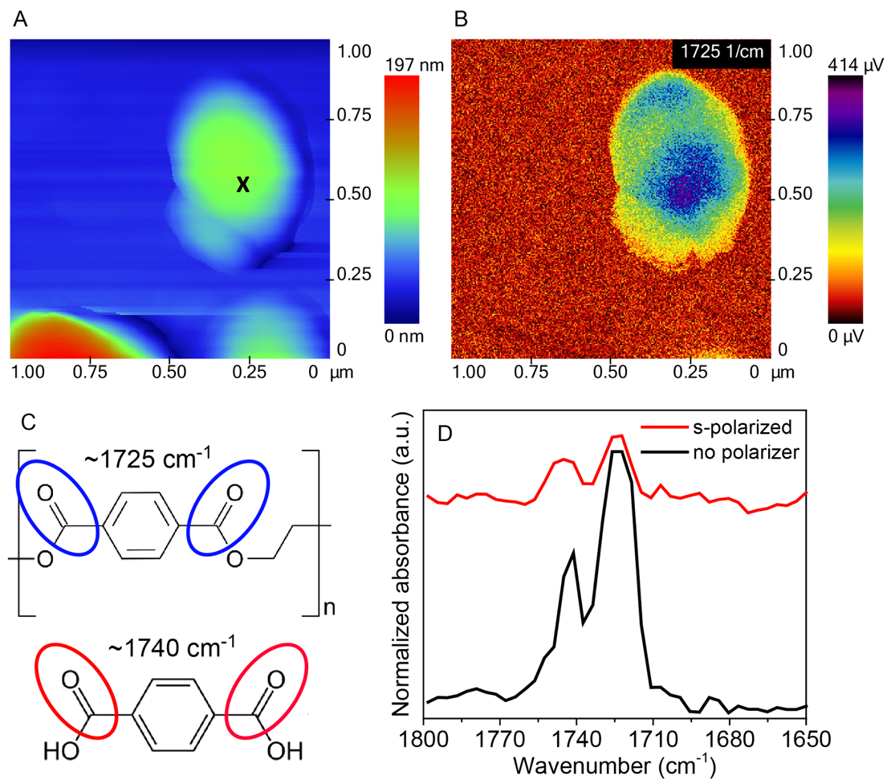
Figure S12 | (A) AFM image of PET 8w and (B) corresponding IR image at 1725 cm⁻¹. (C) PET and terephthalic acid molecules indicating which vibrations cause the absorption bands at 1725 and 1740 cm⁻¹, respectively. (D) PiFM point spectra (black X in (A) indicates where the spectra were taken) with and without polarizer. Note that s-polarized light has an intensity that is only ~10% of the non-polarized light. Therefore, the signal of the red spectrum in D is much lower and the noise is higher than of the black spectrum.

References
1. Chércoles Asensio, R., San Andrés Moya, M., De La Roja, J. M. & Gómez, M. Analytical characterization of polymers used in conservation and restoration by ATR-FTIR spectroscopy. Anal. Bioanal. Chem. 395, 2081–2096 (2009).
2. Jung, M. R. et al. Validation of ATR FT-IR to identify polymers of plastic marine debris, including those ingested by marine organisms. Mar. Pollut. Bull. 127, 704–716 (2018).
3. Pereira, A. P. dos S., Silva, M. H. P. da, Lima Júnior, É. P., Paula, A. dos S. & Tommasini, F. J. Processing and Characterization of PET Composites Reinforced With Geopolymer Concrete Waste. Mater. Res. 20, 411–420 (2017).
4. Sammon, C., Yarwood, J. & Everall, N. FT-IR study of the effect of hydrolytic degradation on the structure of thin PET films. Polym. Degrad. Stab. (2000).
5. Edge, M., Wiles, R., Allen, N. S., McDonald, W. A. & Mortlock, S. V. Characterisation of the species responsible for yellowing in melt degraded aromatic polyesters - I: Yellowing of poly(ethylene terephthalate). Polym. Degrad. Stab. 53, 141–151 (1996).
6. Chen, Z., Hay, J. N. & Jenkins, M. J. The thermal analysis of poly(ethylene terephthalate) by FTIR spectroscopy. Thermochim. Acta 552, 123–130 (2013).
7. Nishikida, K. & Coates, J. Infrared and Raman Analysis of Polymers. in Handbook of plastics analysis (eds. Lobo, H. & Bonilla, J. V.) (2003).
8. Nguyen-Tri, P. & Prud’homme, R. E. Nanoscale analysis of the photodegradation of polyester fibers by AFM-IR. J. Photochem. Photobiol. A Chem. 371, 196–204 (2019).
9. Zettler, E. R., Mincer, T. J. & Amaral-Zettler, L. A. Life in the “Plastisphere”: Microbial Communities on Plastic Marine Debris. Environ. Sci. Technol. 47, 7137–7146 (2013).
10. Yang, Y., Yang, J. & Jiang, L. A bacterium that degrades and assimilates poly(ethylene terephthalate). Science 353, 759 (2016).
11. Knott, B. C. et al. Characterization and engineering of a two-enzyme system for plastics depolymerization. Proc. Natl. Acad. Sci. U. S. A. 117, 25476–25485 (2020).
12. Ogata, Y. H. Characterization of porous silicon by infrared spectroscopy. (Springer, 2014).
13. Gupta, P., Dillon, A. C., Bracker, A. S. & George, S. M. FTIR studies of H2O and D2O decomposition on porous silicon surfaces. Surf. Sci. 245, 360–372 (1991).
14. Rinoud, H. Infrared absorption spectrum of silicon dioxide. J. Am. Ceram. Soc. 48, 595–599 (1965).
15. Lucovsky, G., et al. Oxygen-bonding environments in glow-discharge-deposited amorphous silicon-hydrogen alloy films. Phys. Rev. B 28, 3225 (1983).
16. C. ten Have, I. et al. Photoinduced Force Microscopy as an Efficient Method Towards the Detection of Nanoplastics. Chemistry–Methods 1, 205–209 (2021).
17. Mandrile, L. et al. Direct detection and quantification of molecular surface contaminants by infrared and Raman spectroscopy. Anal. Methods 7, 2813–2821 (2015).
18. NIST Chemistry WebBook, https://webbook.nist.gov/cgi/inchi?ID=C7732185&Type=IR-SPEC&Index=0.
19. Petrusevksi, B., Bolier, G., van Breemen, A. N. & Alaerts, G. J. Tangential flow filtration: a method to concentrate freshwater algae. Water Res. 29, 1419–1424 (1995).
20. Busatto, S. et al. Tangential Flow Filtration for Highly Efficient Concentration of Extracellular Vesicles from Large Volumes of Fluid. Cells 7, 273 (2018).
21. Vilaplana, F., Ribes-Greus, A. & Karlsson, S. Degradation of recycled high-impact polystyrene. Simulation by reprocessing and thermo-oxidation. Polym. Degrad. Stab. 91, 2163–2170 (2006).
22. Coates, J. Interpretation of Infrared Spectra, A Practical Approach. in Encyclopedia of analytical chemistry: applications, theory and instrumentation (ed. Meyers, R. A.) 10815–10837 (John Wiley & Sons, Ltd, 2006).
23. Chen, K. & Vyazovkin, S. Mechanistic differences in degradation of polystyrene and polystyrene-clay nanocomposite: Thermal and thermo-oxidative degradation. Macromol. Chem. Phys. 207, 587–595 (2006).
24. Hermán, V. et al. Core double-shell cobalt/graphene/polystyrene magnetic nanocomposites synthesized by in situ sonochemical polymerization. RSC Adv. 5, 51371–51381 (2015).
25. Gaspar, D. et al. Nanocrystalline cellulose applied simultaneously as the gate dielectric and the substrate in flexible field effect transistors. Nanotechnology 25, (2014).
26. Gallego-Urrea, J. A., Tuoriniemi, J., Pallander, T. & Hassellöv, M. Measurements of nanoparticle number concentrations and size distributions in contrasting aquatic environments using nanoparticle tracking analysis. Environ. Chem. 7, 67–81 (2010).
27. Pabortsava, K. & Lampitt, R. S. High concentrations of plastic hidden beneath the surface of the Atlantic Ocean. Nat. Commun. 11, 1–11 (2020).
28. Suaria, G. et al. Microfibers in oceanic surface waters: A global characterization. Sci. Adv. 6, 1–9 (2020).
29. Materić, D. et al. Micro-and Nanoplastics in Alpine Snow: A New Method for Chemical Identification and (Semi)Quantification in the Nanogram Range. Environ. Sci. Technol. 54, 2353–2359 (2020).
30. Holzinger, R., Ludewig, E., Brunner, D. & Thomas, R. Nanoplastics transport to the remote, high-altitude Alps. Environ. Pollut. 117697 (2021). doi:10.1016/j.envpol.2021.117697
31. Gigault, J. et al. Current opinion: What is a nanoplastic? Environ. Pollut. 235, 1030–1034 (2018).
32. Wagner, S. & Reemtsma, T. Things we know and don’t know about nanoplastic in the environment. Nat. Nanotechnol. 14, 300–301 (2019).

