Supplementary information
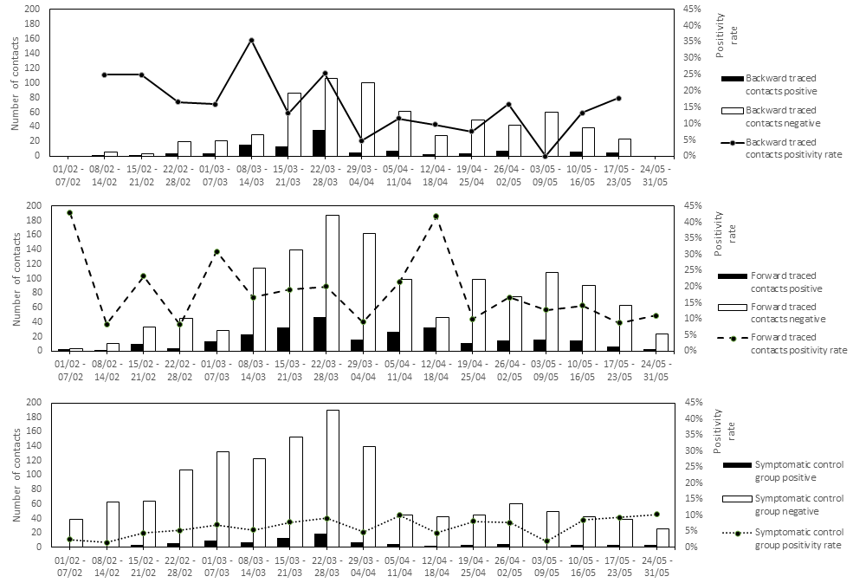
Supplementary Figure 1. Evolution of control group and contact outcomes over the course of the main study period from February 1st to May 31st 2021. (a) Backward traced contacts. (b) Forward traced contacts. (c) Symptomatic control group.

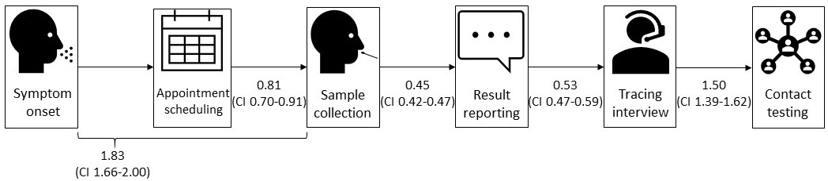
Supplementary Figure 2. Schematic representation of delay times (in days) of the different steps in the manual test and trace cascade for cases included in the main analysis. The short delay between symptom onset and sampling highlights the population’s tendency to rapidly self-refer for testing, supported by community engagement and risk communication¹. The delay was shorter than it was nationally². Only instances in which symptom onset preceded sampling were taken into account. The short delay between appointment scheduling and sample collection reflects highly accessible testing. Only symptomatic individuals were taken into account since they required a test as soon as possible after symptom development. The short delay between sample collection and result reporting results from frequent transport of samples from the testing centre to the lab, rapid turn-around-times and automated result reporting. The short delay between result reporting and both the tracing interview and the first testing of a contact result from the recruitment of a flexible workforce, the introduction of extended timetable for tracing (9AM - 9PM daily) and the active support of self-tracing and digital contact tracing through community engagement and risk-communication. Only contacts who were tested in the university test centre were included when computing the latter delay period.

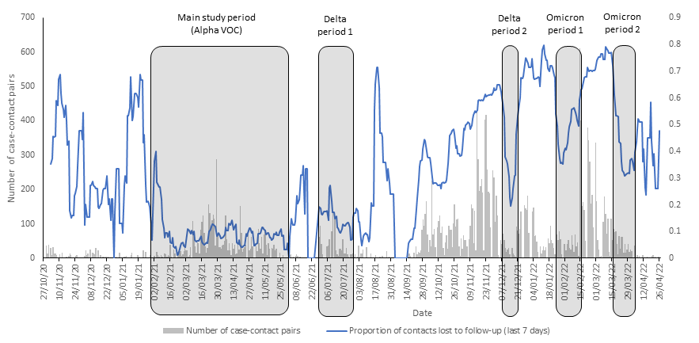
Supplementary Figure 3. Evolution of the number of case-contact pairs and lost to follow-up rate in the study population. The lost to follow-up rate was used as a marker to select periods of interest for analysing the impact of changes in dominant circulating variant of concern (VOC). Grey columns show the number of case-contact pairs identified daily by the university contact tracing team. The trajectory shows a run-in period during the second wave of COVID-19 in the fall of 2020, during which there was likely significant under-detection of cases and contacts³. The third (Alpha VOC), fourth (Delta VOC) and fifth (Omicron VOC) waves can be seen in spring 2021, fall 2021 and winter 2021-2022, respectively. The proportion of contacts lost to follow-up is shown in blue. In addition to the initial analysis focusing on the Alpha dominant period (from February 1st until May 31st2021), periods of interest were selected during the clear dominance of a particular VOC (Supplementary Figure 9) if they were characterised by a low lost to follow-up rate. Amongst other factors, the epidemiological trajectory, the availability of contact tracing manpower and government-mandated testing policies determined whether contacts were systematically followed up and their outcomes recorded.

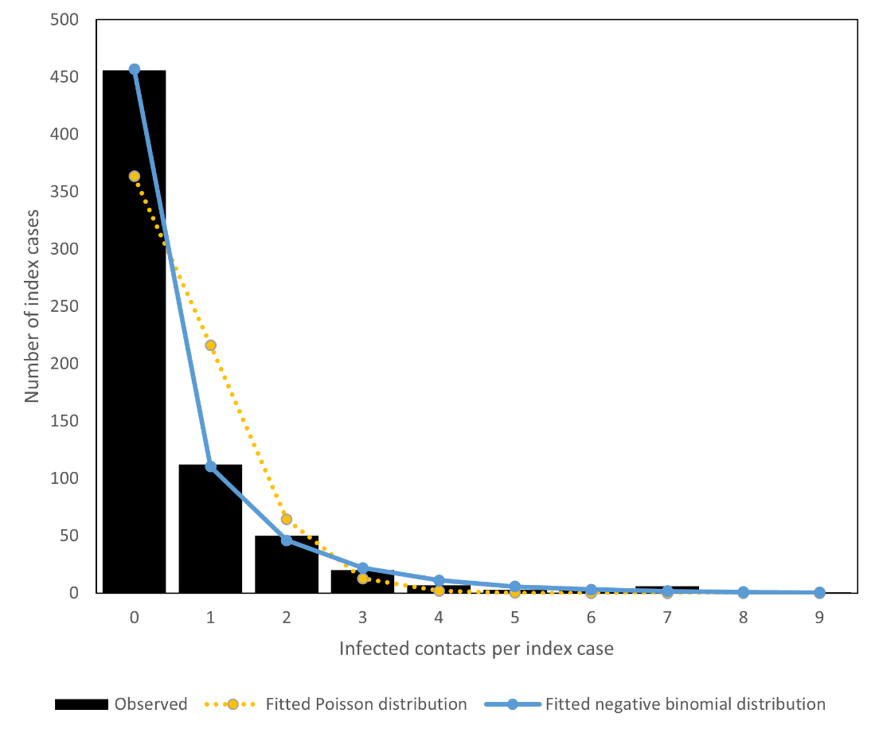
Supplementary Figure 4 shows the distribution of the number of infected contacts per index case. A Poisson distribution (reflecting homogenous distribution of infections, yellow on the graph) does not fit our data well. The data does fit with a negative binomial distribution (blue on the graph) with reproduction number Rt=0.595 (average infected contacts per case) and dispersion parameter k=0.407. These results indicate a degree of superspreading similar to what has been described in literature^{4–6}.

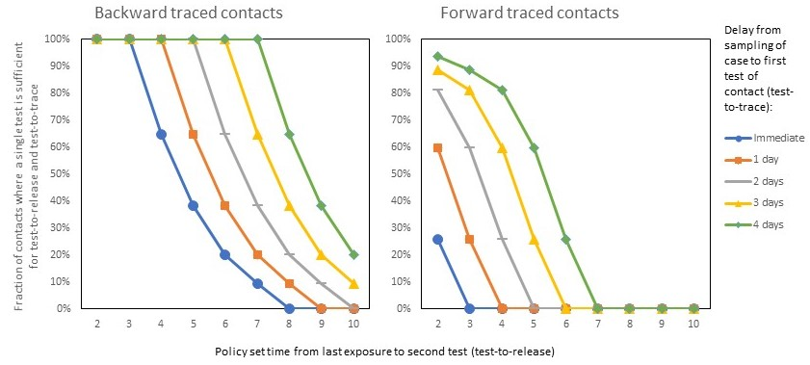
Supplementary figure 5. Simulation of the number of tests required for identified contacts of a case, based on last exposure dates of contacts in the main study period. The simulation shows the influence of delays between sampling of an index case and the first test of their contact. The policy set minimal delay required between last exposure and “test to release” is shown on the x-axis. This delay is ideally chosen based on sensitivity of the diagnostic test and the accepted risk of post-quarantine transmission. The different marker types and line colours correspond to the fraction of contacts requiring only a single test for both “test to trace” and “test to release” purposes, with a tracing and testing delay varying from immediate, which in practice may only be possible with point of care tests, to 4 days. As the delay from testing of an index case to the first test of their contacts increases and as the policy set minimum delay between last exposure and a valid “test to release” is shortened, a higher proportion of individuals can leave quarantine after a single combined “test to trace” and “test to release”. Given identical delays and policy, this percentage is much higher in backward traced contacts than forward traced contacts, due to inherent differences in exposure dates. As a result, the testing burden in backward as opposed to forward traced contacts is lower.

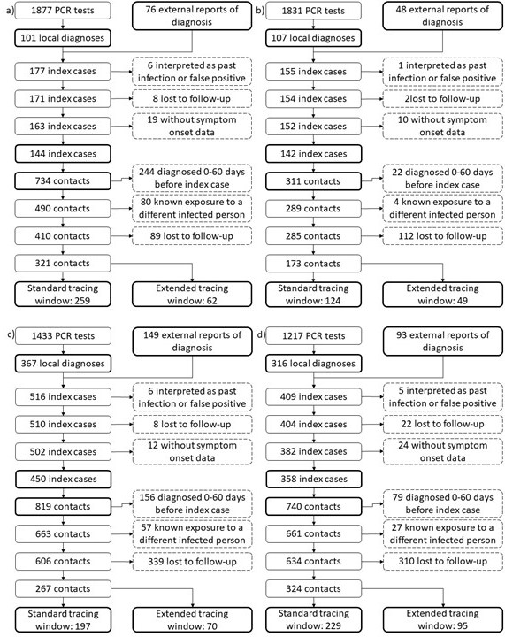
Supplementary Figure 6 Exclusion flow charts for the number of cases and contacts included and excluded in the four periods as highlighted in Supplementary Figure 3. Panels (a), (b), (c) and (d) show the exclusion flowcharts for individuals included during the first Delta dominant, second Delta dominant, Omicron BA.1 dominant and Omicron BA.2 dominant periods, respectively.

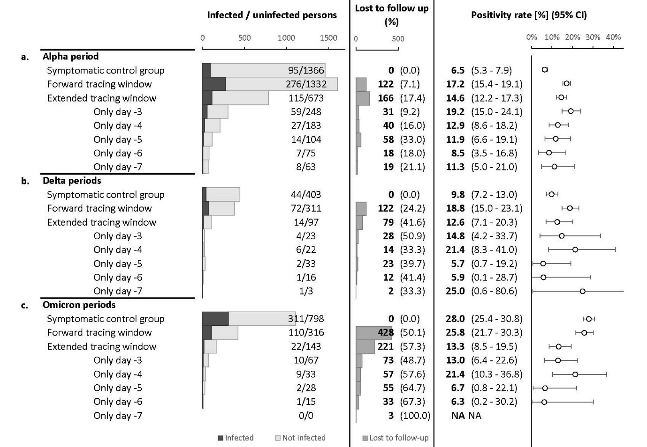
Supplementary figure 7. Outcomes and positivity rates for contacts in the main study period and subsequent periods of interest, each sub-grouped by the day of last exposure to the index case, relative to the index case’s onset or sampling date. Panel (a) repeats the main study outcomes from Figure 3 panels (b) and (c). Panel (b) shows results for the periods with high follow up rates during which the Delta variant was dominant. Panel (c) shows results for the periods with high follow up rates during which the Omicron variant was dominant. Case-contact pairs were included by means of equivalent inclusion and exclusion criteria as during the Alpha period (Figure 3 and Supplementary Figure 6). In addition to lower case numbers, the interpretation of risks in more recent study periods is hindered by higher lost to follow-up rates and reduced reliability of the symptomatic control group.. Both may have resulted from the loosening of government-mandated testing criteria, the reduced tendency of contacts to be tested after vaccination and the rollout of pharmacy-based and self-administered rapid antigen tests, the results of which were not directly captured by our system^{1,2,7,8}.

Supplementary Methods
Target population size estimate
The target population consisted of higher education students living or studying in the city of Leuven, the eight largest city in Belgium at around 102,000 inhabitants. Leuven is located in the province of Flemish Brabant in Belgium, 25 km east of Brussels. Its higher education institutions accommodated 56,390 students on their Leuven campuses in the main study period. The KU Leuven association, the largest institution, had 56,099 students enrolled in its Leuven based campuses at the start of February 2021. Other institutions Vlerick Business School and the Evangelical Theological Faculty had 63 and 228 enrolments respectively.
40,144 students attached to the KU Leuven association had an official address or a student room in the city of Leuven or its surrounding communes. Extrapolated for the other higher education students in the Leuven region, for which we did not have residency addresses available, a total of 40,352 tertiary education students were estimated to have an address in the Leuven area.
Generalised contact restrictions and the limitation of in-person teaching in the main study period likely prompted some students to reside outside of the Leuven area during the second semester of the 2020-2021 academic year, reducing the actual size of the target population. To estimate the true fraction of students present, we looked at our contact tracing information. Any positive case triggered the investigation of students sharing common living areas with the index case. From this data, we calculated that 76.1% of students were physically present at their student room during the study period. When taking this into account, the average target population was estimated at 32,965 students.

General contact restrictions in study period
Existing general contact restrictions have a major impact in any contact tracing program’s effectiveness and efficiency by influencing the type and number of contacts an index case encounters prior to and during their infection.
One measure for assessing general contact restrictions are the Google community mobility reports⁹. In the province of Flemish Brabant, where the city of Leuven represents almost 9% of the population, the frequency of visits during the main study period as a whole was reduced by 31% for retail and recreation, 41% for transit stations and 30% for workplaces in comparison to baseline levels. Visits were increased by 2% for grocery and pharmacy and 59% for parks in comparison to baseline levels. Time spent in residential buildings was increased by 13% during the study period. During later periods, generalized contact restrictions were generally less stringent than they were in the main study period, as can be seen in Supplementary Figure 8 below.
Containment and closure policies can also be summarised by the Oxford COVID-19 Government Response Tracker (OxCGRT) stringency index¹⁰. This is an aggregate score quantifying containment and closure policies, sometimes referred to as lockdown policies. The stringency index varied from 62.96 at the start of the main study period to 75.93 during a period of strengthened measures around Easter and 54.63 from the start of May onwards. The remainder of 2021 and start of 2022 saw a general reduction of the stringency index¹¹.
For tertiary education students specifically, occupancy levels of in-person educational activities were limited to 10% of the usual levels from February until halfway April and increased to 20% thereafter.
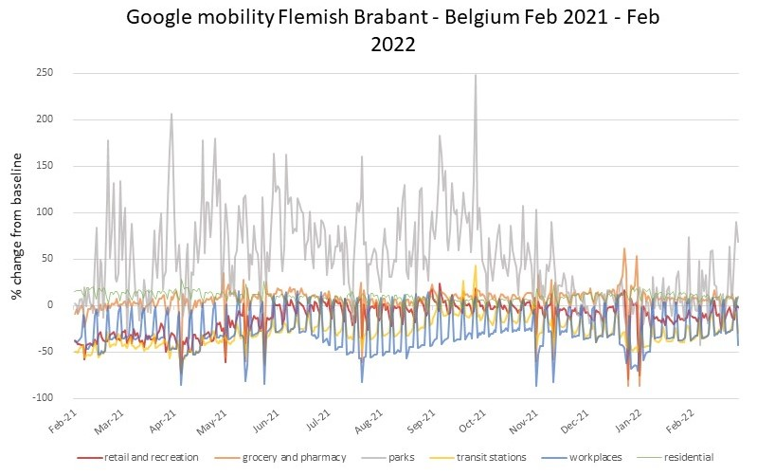
Supplementary Figure 8. Google mobility data between February 1st 2021 and February 31st^{t} 2022 for the region of Flemish Brabant, Belgium. Changes in mobility patterns are expressed as percentage changes in number of visits to particular places of interest, grouped by category, in the region relative to baseline levels at the start of 2020. For the ‘residential’ category, the % change in total time spent as opposed to baseline is shown. They demonstrate the progressive normalisation of mobility patterns over the course of 2021.⁹

Other public health programs focussing on testing & contact tracing
Our program ran in parallel with existing contact tracing programs at the level of the Flemish region and the city of Leuven. During the main study period, the Flemish program focused on contact tracing with testing both immediately and 7 days after exposure for contacts last encountered by the index case up to two days prior to symptom onset or diagnosis². The city of Leuven focused on the containment of clusters of infections in congregate care settings and schools. Outbreaks in student residences were investigated by the KU Leuven contact tracing program.

Variants of SARS-CoV-2 in study cases
Throughout the main study period (February until May 2021), the B.1.1.7 (Alpha) variant was dominant on a national level. This changed in the study periods thereafter (Supplementary Figure 9).

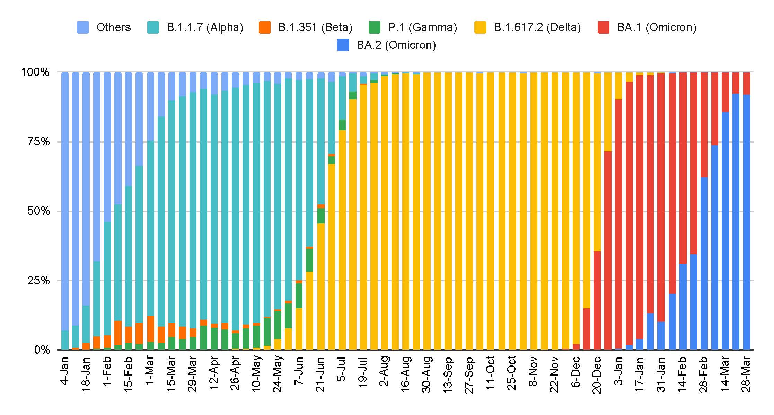
Supplementary figure 9 shows the distribution of variants of concern in Belgium from January 2021 until March 2022¹².

Presence of immunity in the population under study
Test centre data show that the percentage of students reporting having received at least one COVID-19 vaccine increased from 2.8% (18 out of 611 and 118 out of 4211 respectively) in February and March to 8.6% (250 out of 2913) in April and 10.2% (182 out of 1776) in May 2021. These numbers are in line with the data publicly available for the Flemish region, showing that by the start of February, 2.47% of the 18 to 34 year old Flemish had received at least one dose of a COVID-19 vaccine, which increased to 5.46% in the beginning of March, 11.1% in the beginning of April, 13.4% in the beginning of May and 17.1% in the beginning of June¹³. From September onwards, the percentage of students reporting having been fully vaccinated reached 90%. The rollout of booster doses was initiated at the end of 2021. Test centre data show that the percentage of students reporting having received a booster dose of a COVID-19 vaccine increased to 29% in January 2022 and 54% in February 2022 (1010 out of 3500 and 2411 out of 4500 respectively).

References

1. Raymenants, J. et al. Integrated PCR testing and extended window contact tracing system for COVID-19 to improve comprehensiveness and speed.
2. Proesmans, K. et al. COVID-19 contact tracing in Belgium: main indicators and performance, January – September 2021. Arch. Public Heal. 2022 801 80, 1–10 (2022).
3. COVID-19 Data Explorer - Our World in Data. https://ourworldindata.org/explorers/coronavirus-data-explorer?zoomToSelection=true&time=2020-03-01..latest&facet=none&pickerSort=asc&pickerMetric=location&Metric=Confirmed+cases&Interval=7-day+rolling+average&Relative+to+Population=true&Color+by+test+positivity=false&country=USA~GBR~CAN~DEU~ITA~IND.
4. R, L. et al. Epidemiology and transmission dynamics of COVID-19 in two Indian states. Science 370, (2020).
5. Adam, D. C. et al. Clustering and superspreading potential of SARS-CoV-2 infections in Hong Kong. Nat. Med. 26, (2020).
6. Bi, Q. et al. Epidemiology and transmission of COVID-19 in 391 cases and 1286 of their close contacts in Shenzhen, China: a retrospective cohort study. Lancet. Infect. Dis. 20, 911–919 (2020).
7. Procedures - meest recente wijzigingen | Coronavirus Covid-19. https://covid-19.sciensano.be/nl/procedures/home.
8. Centre for Disease Prevention, E. Evaluation of the SARS-CoV-2 testing policy in Belgium.
9. COVID-19 Communitiy Mobility Reports. Google https://www.google.com/covid19/mobility/ (2021).
10. Hale, T. et al. A global panel database of pandemic policies (Oxford COVID-19 Government Response Tracker). Nat. Hum. Behav. 5, (2021).
11. OxCGRT. https://covidtracker.bsg.ox.ac.uk/stringency-scatter.
12. Nevejan, L. et al. Genomic surveillance report - update for Belgium, April 5th 2022.
13. Dashboard Covid Vaccinations Belgium. Sciensano https://covid-vaccinatie.be/en (2021).

