Extended data
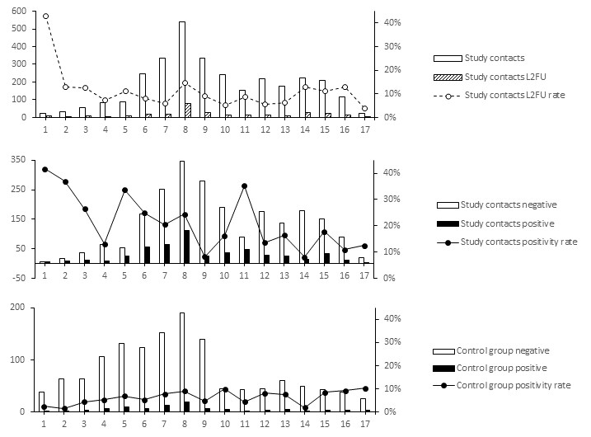
Extended data Fig. 1. Evolution of the lost to follow-up rate and positivity rates over the course of the study period. a) Proportion of contacts lost to follow-up. b) Risk of infection for close contacts. c) Risk of infection in the symptomatic control group.

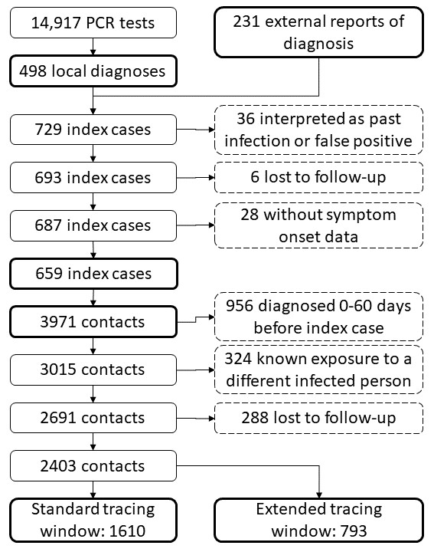
Extended data Fig. 2. Exclusion flow chart for the number of cases and contacts included and excluded.

