Supplementary Material
Table 1 Formula of High-fat diet
Formula | g/kg
Casein | 195
Maltodextrin | 225
Sucrose | 89
Soybean Oil | 33
Lard | 301
Cellulose | 69
Mineral Mix, M1021 | 68
Vitamin Mix, V1010 | 14
L-Cystine | 3
Choline Bitartrate | 3
TBHQ | 0.067
Total | 1000

Table 2 Formula of DFB
Chinese name | Botanical name | Dosage used | Family | Parts used
Dahuang | Rheum palmatum L | 9g | Polygonaceae | Root
Fuzi | Aconitum carmichaeli Debx | 10g | Ranunculaceae | Root
Xixing | Asarum sieboldii Miq | 3g | Aristolochiaceae | Root
Baijiangcao | Herba Patriniae | 10g | Painaceae | Whole grass
Yiyiren | Semen Coicis | 30g | Poaceae | Seed

Table 3 Gradient elution system used for HPLC analyses of DFB
Time(min) | Mobile phase A(%) | Mobile phase B(%) | Flow rate（mL/min） | Voltage(mA)
0 | 80 | 20 | 1.0 | 600
10 | 70 | 30 | 1.0 | 600
20 | 75 | 35 | 1.0 | 600
25 | 60 | 40 | 1.0 | 600
30 | 58 | 42 | 1.0 | 600
40 | 55 | 45 | 1.0 | 600
50 | 50 | 50 | 1.0 | 600
65 | 45 | 55 | 1.0 | 600
75 | 42 | 58 | 1.0 | 600
77 | 37 | 63 | 1.0 | 600
120 | 20 | 80 | 1.0 | 600
125 | 10 | 90 | 1.0 | 600

Table 4 Flow cytometry antibody
Index | Fluorescein | Laser channel | Product number
CD3 | APC-Cy7 | 640 nm | 561042
CD4 | FITC | 488 nm/561nm | 553046
CD8 | Alexa Fluor® 700 | 640 nm | 557959
PD1 | BV421 | 405 nm | 562584
TIM3 | PE | 488 nm/561nm | 566346
CD39 | BV605 | 405 nm | 63-0391-82
IFN-γ | BV605 | 405 nm | 5058400
TNF-α | AF488 | 488 nm/561nm | 557719
TOX | APC | 640 nm | 130-118-335
TCF-1 | AF700 | 640 nm | B8224N-100

Table 5 Auxiliary reagent
Auxiliary reagent | Product number | Product name
Fixed nuclear membrane | 00-5523-00 | eBioscience™ Foxp3 / Transcription Factor Staining Buffer Set
Fixed ruptured membrane | 554714 | Cytofix/Cytoperm Soln Kit
Irritation blocker | 550583 | Leuko Act Cktl With GolgiPlug
Compensating microspheres | A10497 | AbC™ Total Antibody Compensation Bead Kit
Fc BlockTM | 553141 | Purified Rat Anti-Mouse CD16/CD32

Table 6 Elisa Set
Product name | Product number
BD OptEIATM human TGF-β1 ELISA Set |  | Cat 559119
BD OptEIATM Mouse MCP-1 ELISA Set |  | Cat 555260
BD OptEIATM Mouse IL-6 ELISA Set |  | Cat 555240

Table 7 Other reagents
Product name | Category name
In vivo Mab anti-mouse PD1 | BioX Cell(BE0146)
CCR2-RA-[R] | MedChemExpress(HY-50081)
60% high-fat dietary feed | Trophic Animal Feed High-Tech Co.,Ltd,China
D-Luciferin, Potassium Salt | Shanghai Yisheng Biological Technology Co., Ltd.

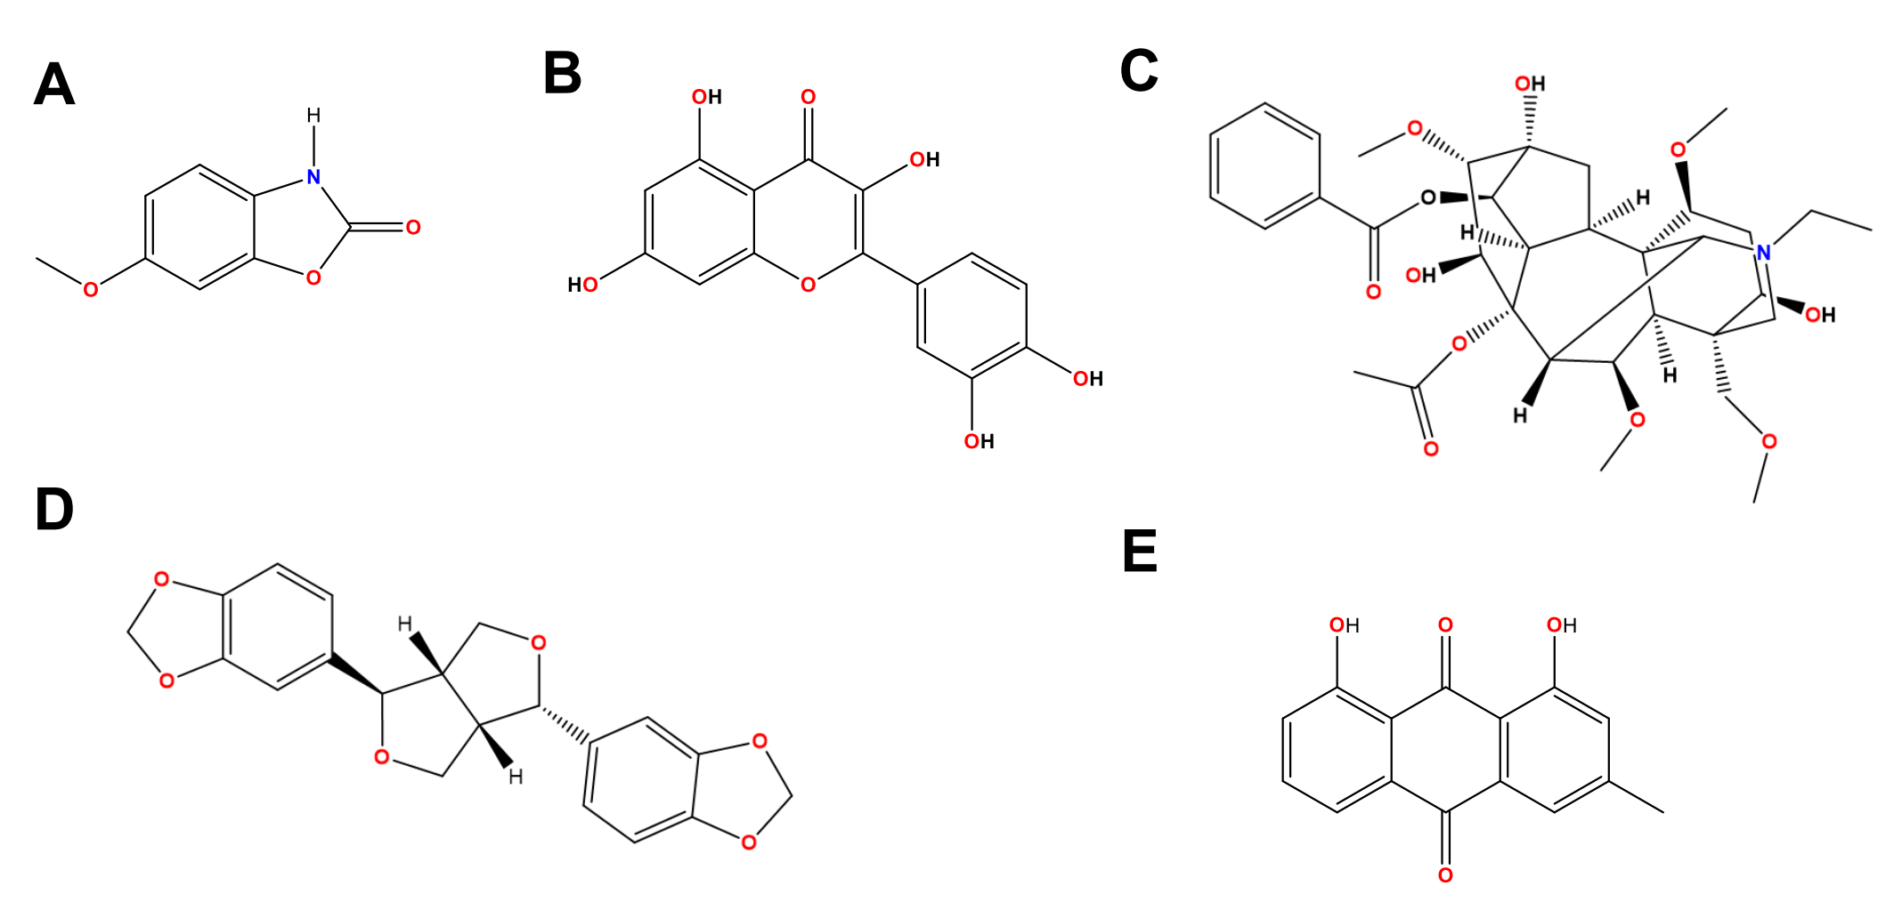
S1. (A)Structure of Coixol(Monomer of Semen Coicis);(B) Structure of Quercetin(Monomer of Herba Patriniae);(C) Structure of Aconitine(Monomer of Aconitum carmichaeli Debx) ;(D) Structure of Asarinin(Monomer of Asarum sieboldii Miq) ;(E)Structure of Chrysophanol ((Monomer of Rheum palmatum L)).

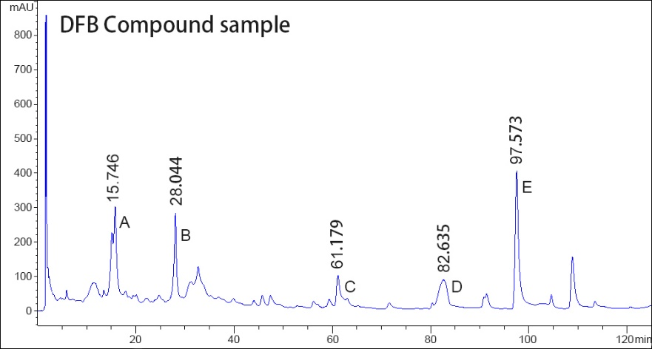
S2. Compositional analysis of DFB by High-Performance Liquid Chromatographic (HPLC) analysis. A: Coixol; B: Quercetin; C: Aconitine; D: Asarinin; E: Chrysophanol.

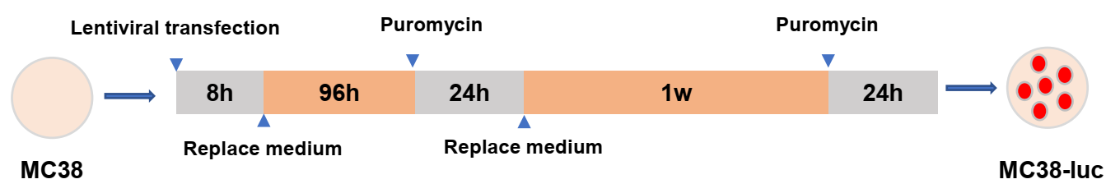
S3. Experimental protocol for MC38-luc cell lines Construct

S4. DFB inhibit the growth of colorectal cancer (A) Flow chart of mouse modeling (B) tumor weight（C）and tumor volume (D) Photograph of tumor in mice. (n=5 mice per group). (E) Weight of tumor. Data were presented as mean± SD (n=5 mice per group); **P<0.01; ***P<0.001.

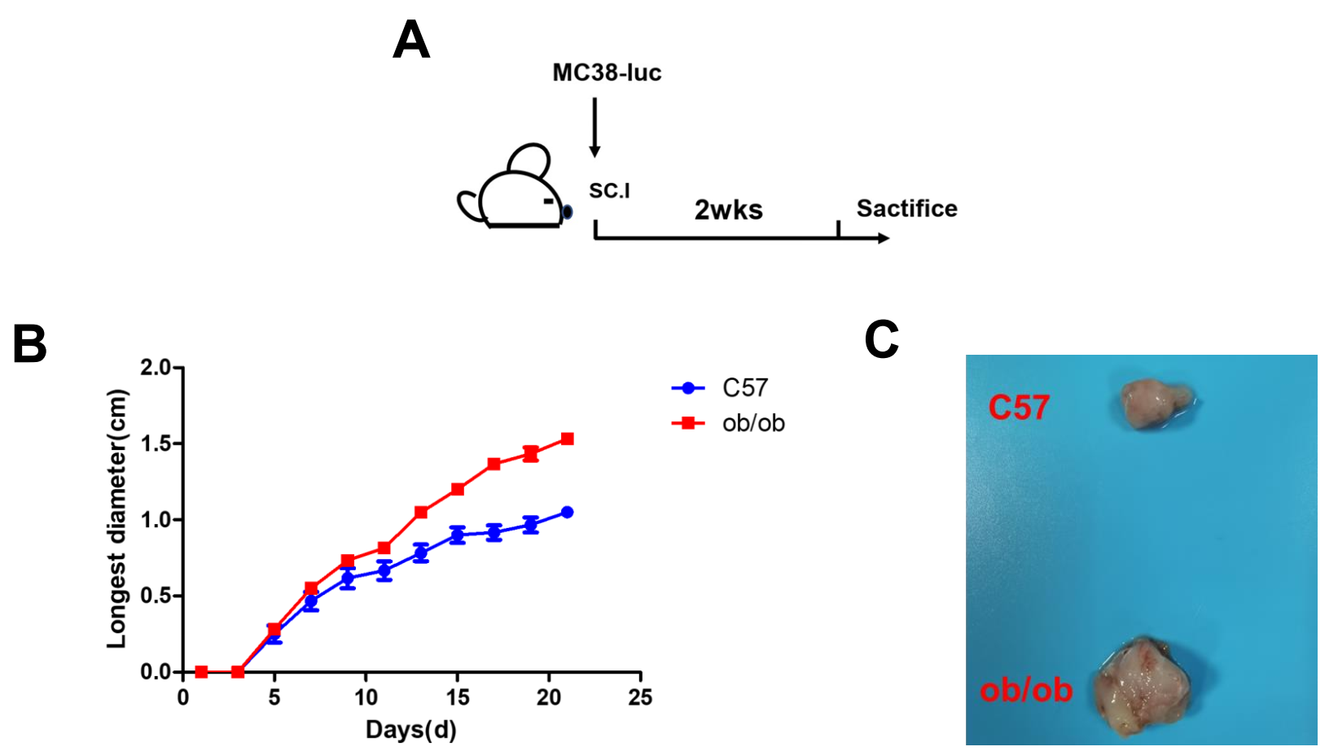
S5. (A) Schematic depicting experimental setup. (B) Changes in the longest diameter of subcutaneous tumors. (C) Picture of tumor after modeling.

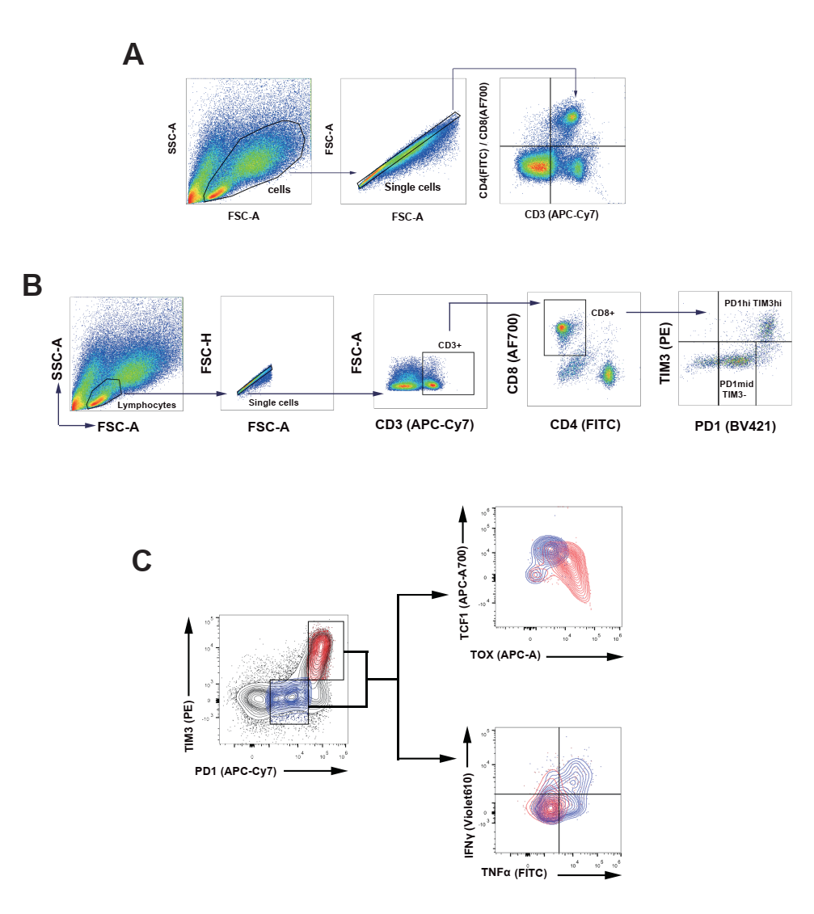
S6. Cell population gate logic diagram in flow cytometry
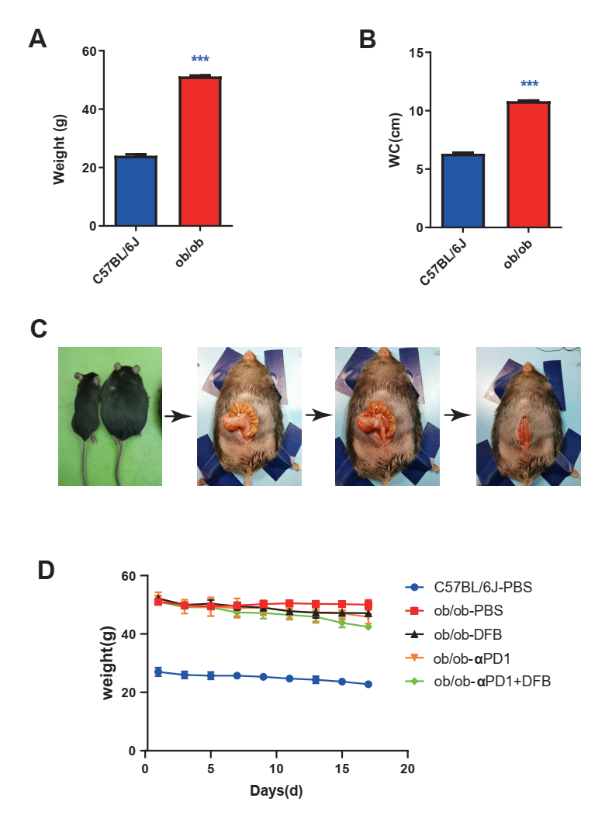
S7. The comparison of weight (A) and abdominal circumference(WC)(B) between C57BL/6J and ob/ob (C) Photograph of Colorectal cancer heterotopic transplantation（D）Changes in mouse body weight during modeling **P<0.01; ***P<0.001.

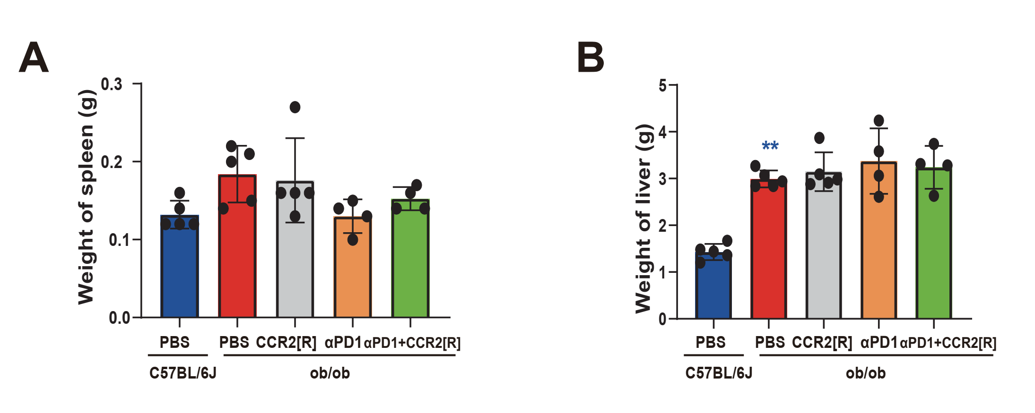
S8. The comparison of weight of spleen(B) and liver(C) during modeling **P<0.01; ***P<0.001.

Blinding
Blinding was not performed in mouse experiments. The investigator needed to know the treatment groups in order to perform the study. Tumor weights (an objective measurement) were carried out only at the study endpoints after mice were euthanized and tumors were
harvested.
Sample size
No sample size calculation was done either for in vitro or in vivo studies. For in vivo studies, sample sizes were determined based on our preliminary experiments. In our experience, n=3-5 mice per group is sufficient to detect meaningful biological differences with good
reproducibility.

