Supplementary Information for
Olefin Oligomerization on Main Group Ga³⁺ and Zn²⁺ Single Site Catalysts

Nicole J. LiBretto^{a,§}, Yinan Xu^{a,§}, Aubrey Quigleyª, Ethan Edwardsª, Rhea Nargundª, Juan Carlos Vega-Vilaª, Arunima Saxenaª, Rajamani Gounderª, Jeffrey Greeleyª, Guanghui Zhang^{a,b*}, Jeffrey T. Miller^{a*}

ª Davidson School of Chemical Engineering, Purdue University, 480 Stadium Mall Drive, West Lafayette, Indiana 47907, United States
^{b} State Key Laboratory of Fine Chemicals, PSU-DUT Joint Center for Energy Research, School of Chemical Engineering, Dalian University of Technology, Dalian, Liaoning 116024, PR China

§ N.L. and Y.X. contributed equally.
Corresponding authors: * gzhang@dlut.edu.cn (G.Z.); mill1194@purdue.edu (J.T.M.)

Table of Contents
General Information……………………………………………………………………………….3
Methods……………………………………………………………………………………………3
Elemental Analysis………………………………………………………………………...3
Catalyst Testing……………………………………………………………………………3
Density Functional Theory………………………………………………………………...3
Catalyst Preparation and Initial Structure………………………………………………………….4
Propane Dehydrogenation and Propylene Hydrogenation………………………………………...7
Olefin Oligomerization……………………………………………………………………………7
Ethylene Oligomerization…………………………………………………………………8
Propylene Oligomerization………………………………………………………………..9
Determination of the Schultz Flory Coefficient…………………………………………..10
Discussion of Oligomerization Products…………………………………………………11
Evidence for Oligomerization Intermediates on Ga/SiO₂ and Zn/SiO₂………………………….11
X-ray Absorption Spectroscopy………………………………………………………….11
Isotopic Exchange………………………………………………………………………..15
Fourier Transform Infrared Spectroscopy………………………………………………..17
Density Functional Theory……………………………………………………………….18
Discussion………………………………………………………………………………………..28
Similarities of Alkane Dehydrogenation, Olefin Hydrogenation and Oligomerization Reactions on Single Site Main Group and Post Transition Metal Catalysts……………..28
References………………………………………………………………………………………..30

General Information
All chemicals were purchased from Sigma-Aldrich and used without further purification. The gases used for the catalytic testing, FTIR, and isotopic exchange experiments were purchased from Indiana Oxygen Company. For propane dehydrogenation 5% C₃H₈/ N₂ was used. For propylene hydrogenation 3% C₃H₆/N₂ and 5% H₂/N₂ were used. For oligomerization 100% C₂H₄ and 100% C₃H₆ were used. For FTIR 100% H₂ and 100% C₂H₄ were used. For isotopic exchange experiments, 5% H₂/Ar and 5% D₂/Ar were used. The gases used for XAS experiments (100% H₂, 100% C₂H₄, and 100% He) were purchased from AirGas, Illinois.

Methods
- Elemental Analysis
Atomic absorption spectroscopic analysis of the Ni, Ga, and Zn loading was carried out on a Perkin-Elmer Analyst 300 Flame Atomic Absorption Spectrometer using air-acetylene flame. The samples were firstly dissolved in 40% HF aqueous solution and diluted to 1-2 ppm. The analysis was done using the 232.0 nm line. The Ni loading in Ni/SiO₂ was 2.7%. The Ga loading in Ga/SiO₂ was 4.0%. The Zn loading in Zn/SiO₂ was 4.0%.

- Catalyst Testing
Propane Dehydrogenation and Propylene Hydrogenation. Catalyst performance tests for hydrogenation and dehydrogenation were performed in a fixed bed reactor with a quartz reactor tube of 3/8-inch OD. Dehydrogenation was performed in 3% C₃H₈ and 2% H₂ balanced in N₂ at 550°C on 1 g of catalyst using varying total flow rates of the same gas composition ranging from 41 ccm to 165 ccm to vary conversion (GHSV = 0.32 s⁻¹ – 1.28 s⁻¹). Before each dehydrogenation test, the catalyst was pretreated in flowing N₂ while the temperature ramped to 550°C. The temperature was stabilized for 1 hour prior to starting the reaction.
Hydrogenation was performed in 1% C₃H₆, 3% H₂, balanced with N₂ at 200°C on 250 mg of catalyst diluted to 1 g with silica using a total flow rate of 104 ccm (GHSV = 0.81 s⁻¹). Before each hydrogenation test, the catalysts were pretreated using one of the following pretreatments: 1) ramped to 200°C in flowing N₂, 2) ramped to 200°C in flowing H₂, or 3) ramped to 550°C in flowing H₂ and then cooled to 200°C for the reaction. In each case, the temperature was stabilized for 1 hour prior to starting the reaction.
Dehydrogenation and hydrogenation products were analyzed with a Hewlett Packard (HP) 6890 Series gas chromatograph (GC) using a flame ionization detector (FID) with a Restek Rt-Alumina Bond/Na2SO4 GC column (30 m in length, 0.32 mm ID, and 0.5 µm film thickness).

- Density Functional Theory
- Periodic amorphous silica model is used to analyze the energetics of ethylene oligomerization. The amorphous model was adapted using models described in literature.¹ To model the four-coordinated Ga sites, Si was substituted with Ga, and an additional proton was added to a nearby oxygen atom to maintain charge balance (all possible sites for adding the proton were considered, and the site with lowest energy was chosen for further analysis). All DFT calculations are performed with self-consistent and periodic density functional theory using Vienna Ab-initio Simulation Package (VASP). The BEEF-vdw exchange-correlation functional using projector augmented wave (PAW) pseudopotentials was used. A dipole correction was applied parallel to the plane of the slab to reduce image−image interaction errors. A cutoff energy of 400 eV was considered with a force-convergence criterion of 20 meV Å⁻¹.

Catalyst Preparation and Initial Structure
Silica supported Ga and Zn single site catalysts were prepared using previously published synthesis methods.^{2,3} Ga/SiO₂ was prepared by impregnation using a citric acid chelating agent. Zn/SiO₂ was prepared using strong electrostatic absorption (SEA). All solutions were pH adjusted to 11. Due to the slightly acidic nature hydroxyl groups on groups on SiO₂, at high pH deprotonation of the SiOH groups leads to a negative surface charge. This allows a strong interaction between the cationic ligands and the negative surface, resulting in homogeneously dispersed metal ions on the SiO₂ surface. Ni/SiO₂ was prepared using a similar procedure to that of Zn/SiO₂. Atomic absorption spectroscopy revealed that the metal content was 2.6 wt%, 4.1 wt%, and 3.1 wt% metal for Ga/SiO₂, Zn/SiO₂, and Ni/SiO₂ respectively.
The pre-reaction catalyst structure was determined by in situ X-ray absorption spectroscopy (XAS), including both XANES and EXAFS on Ga/SiO₂ and Zn/SiO₂ and compared to that of Ni/SiO₂. The catalysts were dehydrated at 550°C in He and compared to known reference compounds at each metal edge (Figure S1). The EXAFS fits of each catalyst are given in Table 1.
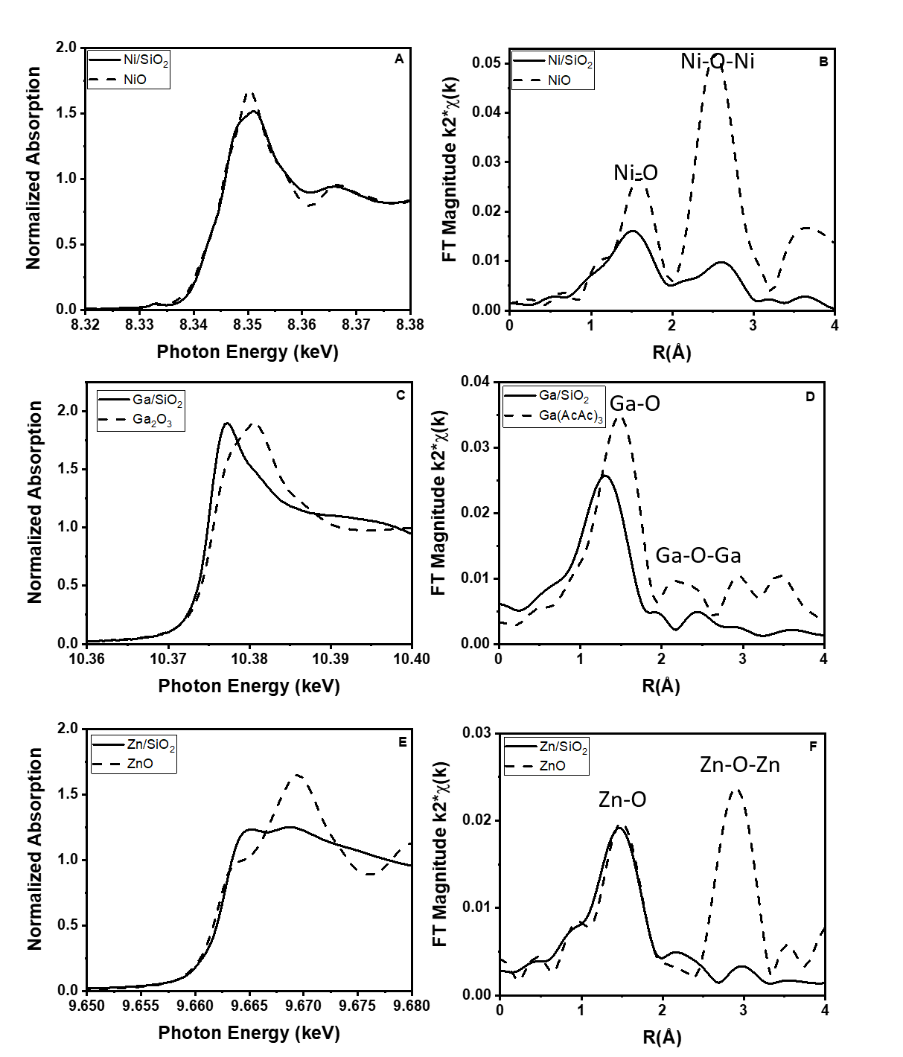
Figure S1. XAS of dehydrated catalyst structures for Ni/SiO₂ (A-B), Ga/SiO₂ (C-D), and Zn/SiO₂ (E-F)

Table S1. EXAFS fits of the as-prepared structures of Ni/SiO₂, Ga/SiO₂, and Zn/SiO₂ after dehydration at 550°C in He compared to bulk references at each edge
Sample | Pre-edge Energy (keV) | XANES Energy (keV) | Scattering Path | CN_{b} | R (Å)_{c} | $Δσ$² (Å²) | $Δ$E_{o} (eV)
NiOª | 8.3335 | 8.3410 | Ni-O | 6.0 | 2.09 | - | - | Ni²⁺  (Oh)
Ni/SiO₂ | 8.3331 | 8.3421 | Ni-O | 4.0 | 2.03 | 0.006 | -1.3 | Ni²⁺  (Td)
Ga₂O₃ª | - | 10.3751 | Ga-O | 3.0 | 2.00 | - | - | Ga³⁺  (Td+Oh)
 |  |  |  | 2.0 | 1.83 | - | -
Ga(AcAc)₃ | - | 10.3793 | Ga-O | 6.0 | 1.93 | - | - | Ga³⁺  (Oh)
Ga/SiO₂ | - | 10.3751 | Ga-O | 4.0 | 1.81 | 0.006 | -2.2 | Ga³⁺  (Td)
ZnOª | - | 9.6625 | Zn-O | 4.0 | 1.98 | - | - | Zn²⁺  (Td)
Zn/SiO₂ | - | 9.6628 | Zn-O | 4.0 | 1.95 | 0.006 | -0.6 | Zn²⁺  (Td)
ª NiO, Ga₂O₃, Ga(AcAc)₃, and ZnO are references of known structures
^{b} The error in CN is $±$10%
^{c} The error in R is $±$0.02 Å

The XANES was used to determine the oxidation state of each catalyst, while the EXAFS was used to identify the coordination environments prior to any catalytic treatment. On Ni/SiO₂, the Ni K-edge XANES pre-edge energy (8.3331 keV) is slightly lower than that of NiO (8.3335 keV) (Figure S1A). The NiO XANES is consistent with Ni²⁺ in an octahedral coordination, while the pre-edge energy of the former is consistent with Ni²⁺ in s tetrahedral geometry.⁴ The first shell EXAFS fit of Ni/SiO₂ has 4 Ni-O bonds at 2.03 Å, while NiO has Ni-O bonds at 2.09 Å (Figure S1B). The EXAFS Ni/SiO₂ and is consistent with the single site Ni²⁺ catalyst previously reported.^{4–6}
Since Ga/SiO₂ and Zn/SiO₂ have d¹⁰-electron configuration, there is no pre-edge feature in the XANES region. The XANES energy relative to known references was used to identify the oxidation state of each catalyst. The XANES energy of Ga³⁺ is also dependent on the coordination geometry^{7,8}. Tetrahedral (Td) Ga³⁺ (10.3745 keV) has a XANES energy, lower than that in octahedral (Oh) coordination (10.3793 keV). Ga₂O₃ has 50% Td and 50% Oh Ga³⁺.⁹ Since the edge energy of Td is lower than Oh Ga³⁺, the XANES of Ga₂O₃ is 10.3751 keV, (Figure S1C). The XANES energy of Ga(AcAc)₃, Oh Ga³⁺ is 10.3765 keV. The XANES energy (10.3751 keV) of Ga/SiO₂ is consistent with Td Ga³⁺.
The Ga coordination geometry also affects the Ga-O bond distance. The bond distance of Ga-O in a Td Ga compound is about 1.83 Å; while in Oh compounds Ga-O bonds are longer, about 1.90-2.00 Å.⁹ The k²-weighted magnitude of the EXAFS of Ga/SiO₂ is lower than that of Ga(AcAc)₃ (6 Ga-O at 1.93 Å) (Figure S1D). The fit of Ga/SiO₂ EXAFS, Table 1, indicates about 4 Ga-O bonds at 1.81 Å, both consistent with Td Ga³⁺. The absence of Ga-O-Ga bonds also suggests isolated Ga³⁺ bound to the support.
Similarly, the XANES energy for Zn/SiO₂ (9.6628 keV) is similar to that of ZnO (9.6625 keV) (Figure S1E) consistent with Zn²⁺ oxidation state. The magnitude of the k²-weighted EXAFS of Zn/SiO₂ has 4 Zn-O bonds at 1.96 Å and is also similar to ZnO (4 Zn-O at 1.98 Å). The absence of Zn-O-Zn higher shell coordination in the catalyst, however, suggests a single site Zn²⁺ structure.

Propane Dehydrogenation and Propylene Hydrogenation
The turnover rate and selectivity for C₃H₈ dehydrogenation was determined with and without H₂ cofeed. Dehydrogenation in the presence of H₂ is a more rigorous way to test for selective performance towards the production of C₃H₆. Both Ga/SiO₂ and Zn/SiO₂ were highly selective towards olefins (> 95%) up to 20% conversion, even in the presence of H₂. High C₃H₆ selectivity was maintained as a function of conversion. In addition, the catalysts were stable under reaction conditions at 550°C for over 6 hours. The turnover rates (TOR) for each catalyst were calculated by normalizing the amount of C₃H₆ production by the moles of metal on the surface of the catalyst (2.6% for Ga/SiO₂ and 4.0% for Zn/SiO₂). The TOR is shown for 10% conversion (Table S2).

Table S2. Initial selectivity and TOR for Ga/SiO₂ and Zn/SiO₂ at 10% conversion during propane dehydrogenation performed at 550°C in 3% C₃H₈ and 2% H₂
 | Without H₂ |  | With H₂
 | Initial Selectivity (%) | TOR (1/h) | Initial Selectivity (%) | TOR (1/s)
Ga/SiO₂ | 97 | 2.1 | 98 | 4.4*10⁻³
Zn/SiO₂ | 99 | 0.9 | 99 | 3.3*10⁻³

The TOR on Ga/SiO₂ and Zn/SiO₂ are of the same order of magnitude, and co-feeding H₂ does not significantly change the TOR during dehydrogenation. These results are consistent with what has previously been reported.^{3,8}
Both catalysts also perform the microscopic reverse reaction of propane dehydrogenation (propylene hydrogenation) at lower reaction temperatures. Propane was the only product indicating few side reactions occurred at 200°C. The influence of H₂ pretreatment on C₃H₆ hydrogenation activity at 200°C was explored to demonstrate how the catalysts behave in the presence of H₂ (Table S3).

Table S3. Initial TORs for Ga/SiO₂ and Zn/SiO₂ at 15% conversion during propylene hydrogenation performed at 200°C in 1% C₃H₆ and 3% H₂ after treatment various pretreatments
Pretreatment | Ga/SiO₂: Initial TOR (1/h) | Zn/SiO₂: Initial TOR (1/h)
200°C N₂ | 8.3*10⁻⁴ | 2.2*10⁻³
200°C H₂ | 6.9*10⁻³ | 4.7*10⁻³
550°C H₂ | 5.8*10⁻³ | 6.7*10⁻³

The initial TOR of the catalysts treated in H₂ at 200°C and 550°C was compared to that of the dehydrated catalyst (200°C N₂). Pretreatment in H₂ leads to higher initial TOR than what was achieved on the dehydrated catalyst. However, after approximately 30 minutes, the TOR for all pretreatment conditions stabilized to approximately the same value.

Olefin Oligomerization
Like the structural characterizations, the catalytic rates and selectivities for propane dehydrogenation and propylene hydrogenation of these Ga/SiO₂ and Zn/SiO₂ catalysts are very similar to reported performance, reaction intermediates and elementary reaction steps suggesting that these may also be catalytic for olefin oligomerization. The catalytic performance in both ethylene and propylene oligomerization was investigated at 250°C.

Ethylene Oligomerization
Ethylene oligomerization was performed at 250°C and 1 atm, where low conversions were achieved. The conversion was varied using different space velocities over 1 g of catalyst. Although Ni/SiO₂ had the potential to reach higher conversions than Ga/SiO₂ and Zn/SiO₂, the conversion was limited to 5% so that direct comparisons in product distributions could be made (Table S4).

Table S4. Product selectivity at varying conversions for each catalyst during ethylene oligomerization at 250°C and 1 atm
Catalyst | Conversion (%)ª | Selectivity (%)
 |  | Ethane (C₂H₆) | Butenes (C₄⁼) | Hexenes (C₆⁼) | Octenes (C₈⁼) | rate  (mol C₄H₈ molM⁻¹ s⁻¹)^{b} | TOR (s⁻¹)^{c}
Ni/SiO₂ | 1 | 1.0 | 89.2 | 9.7 | 0.5 | 8 x 10⁻⁴
 | 2 | 2.6 | 86.5 | 9.6 | 1.0 | 13 x 10⁻⁴
 | 3 | 1.4 | 86.1 | 11.8 | 0.4 | 15 x 10⁻⁴
 | 5 | 1.1 | 85.1 | 13.5 | 0.5 | 10 x 10⁻⁴
Ga/SiO₂ | 1 | 4.5 | 87.0 | 2.6 | 5.8 | 3 x 10⁻⁴ | 4 x 10⁻⁴
 | 2 | 3.3 | 85.2 | 3.6 | 7.9 | 7 x 10⁻⁴ | 9 x 10⁻⁴
 | 3 | 1.8 | 75.9 | 16.8 | 6.4 | 7 x 10⁻⁴ | 9 x 10⁻⁴
Zn/SiO₂ | 1 | 5.7 | 91.5 | 2.8 | 0.0 | 1 x 10⁻⁴ | 5 x 10⁻⁴
 | 2 | 11.6 | 87.3 | 1.1 | 0.0 | 1 x 10⁻⁴ | 5 x 10⁻⁴
 | 3 | 12.5 | 85.5 | 2.0 | 0.0 | 1 x 10⁻⁴ | 5 x 10⁻⁴
ª Conversion was varied using different space velocities over 1g of catalyst in a 3/8 in diameter quartz reactor tube
^{b} Rate was calculated by normalizing the mol C₄H₈/s produced by the total mol of metal on the catalyst ($rate= (mol C_{4}H_{8})/(mol M* s)$)
^{c} TOR was calculated by normalizing the rate by the percent of M-H formed, using the fraction of M-H obtained by H/D exchange experiments (described in Figure S6-S7, Table S9-S10) ($TOR= (mol C_{4}H_{8})/(mol M*\left(\frac{\%M-H}{100}\right)* s)$)

In Table S4-S6, two rates are reported. First, the rate of butene (or dimer) formation, in mol/s, was normalized by the total number of moles M on the catalyst. For Ni/SiO₂ this was 2.7 wt% and for Ga/SiO₂ and Zn/SiO₂, it was 2.6 and 4.0 wt%, respectively. The TOR was reported by normalizing the rate by the amount of M-H formed, as obtained by H/D exchange experiments, described in Figure S6-S7 and Table S9-S10. This value was not obtained for Ni/SiO₂ but was determined to be 70% and 19% for Ga/SiO₂ and Zn/SiO₂, respectively. During oligomerization, the M-H is thought to be the active intermediate. This shows that the rate of Ga/SiO₂ and Ni/SiO₂ are about three times higher than Zn/SiO₂. However, when the rate is normalized by the fraction of M-H formed, the rates are similar.
Like Ni/SiO₂, Zn/SiO₂ favored the formation of butene from ethylene. However, the rate of the latter (1*10⁻⁴ s⁻¹) was lower than the former (10*10⁻⁴ s⁻¹). Ga/SiO₂ (7*10⁻⁴ s⁻¹), on the other hand, had a rate more comparable to that of Ni/SiO₂ and facilitated the formation of higher molecular weight hydrocarbons. To increase the reaction rate, and therefore drive the conversion to a higher value, a higher concentration of ethylene was used by increasing the total reaction pressure to 30.6 atm. Through this, higher molecular weight products in the liquid range were favored. Although Table S5 quantifies only the gas phase products, the liquid products were accumulated and analyzed offline by GC-MS after the reaction to develop a qualitative understanding of the hydrocarbon species being formed.

Table S5. Product selectivity and conversion for ethylene oligomerization at 250°C and 30.6 atm
Catalyst | Conversion (%) | Selectivity (%)
 |  | Ethane (C₂H₆) | Butenes (C₄⁼) | Hexenes (C₆⁼) | Octenes (C₈⁼) | C₁₀+ | rate  (mol C₄H₈ molM⁻¹ s⁻¹) | TOR (s⁻¹)
Ni/SiO₂ | 20.7 | 0.6 | 86.2 | 11.1 | 2.9 | 0.0 | 7 x 10⁻²
Ga/SiO₂ | 20.6 | 0.6 | 74.2 | 16.1 | 4.9 | 4.2 | 8 x 10⁻² | 1 x 10⁻¹
Zn/SiO₂ | 15.2 | 0.5 | 96.0 | 0.8 | 0.0 | 0.0 | 5 x 10⁻² | 3 x 10⁻¹

Here, the reaction rates were improved by two orders of magnitude such that those on all three catalysts were similar (and to the same order of magnitude). Although Ni/SiO₂ formed predominantly butenes (86%), the higher ethylene concentration promoted the formation of some hexenes (11%) and octenes (3%). Zn/SiO₂ almost exclusively produced butenes (96%) with only some hexenes (0.8%) and no octenes. Ga/SiO₂ formed a larger amount of higher molecular weight hydrocarbons than Ni/SiO₂ including 74% butenes, 16% hexenes, 5% octenes, and 4% higher than C10.

Propylene Oligomerization
To further investigate the ability of these single site catalysts to activate C-H bonds, propylene oligomerization was performed at 250°C and 1 atm on Ga/SiO₂ and Zn/SiO₂. Though, the C-H bond activation energy of propylene is lower than that of ethylene, which could lead to higher reaction rates. Through this, the formation of higher molecular weight hydrocarbons is expected (Table S6).

Table S6. Product selectivity at varying conversions for each catalyst during propylene oligomerization at 250°C and 1 atm
Catalyst | Conversion (%)ª | Selectivity (%)
 |  | Methane  (CH₄) | Ethylene (C₂⁼) | Propane (C₃H₈) | Butenes (C₄⁼) | Hexenes (C₆⁼) | Nonenes (C₉⁼) | C₁₂⁺ | rate  (mol C₆H₁₂ molM⁻¹ s⁻¹)^{b} | TOR (s⁻¹)^{c}
Ga/SiO₂ | 1 | 0.1 | 5.5 | 3.9 | 6.3 | 8.9 | 75.1 | 0.2 | 9 x 10⁻⁴ | 1 x 10⁻³
 | 3 | 0.1 | 5.9 | 6.3 | 6.7 | 7.8 | 71.9 | 1.3 | 12 x 10⁻⁴ | 2 x 10⁻³
 | 5 | 0.2 | 7.4 | 5.3 | 7.4 | 16.1 | 52.3 | 11.3 | 9 x 10⁻⁴ | 1 x 10⁻³
 | 8 | 0.2 | 10.4 | 7.7 | 8.9 | 23.5 | 43.4 | 5.9 | 14 x 10⁻⁴ | 2 x 10⁻³
Zn/SiO₂ | 1 | 0 | 3.8 | 9.2 | 3.2 | 50.5 | 28.1 | 5.2 | 8 x 10⁻⁴ | 1 x 10⁻³
 | 3 | 0 | 2 | 6.1 | 1.3 | 52.2 | 29.6 | 8.8 | 7 x 10⁻⁴ | 1 x 10⁻³
 | 5 | 0 | 5.9 | 8.9 | 5.4 | 36.7 | 30.8 | 12.3 | 4 x 10⁻⁴ | 1 x 10⁻³
 | 8 | 0 | 6.2 | 6.2 | 6.6 | 41.4 | 30 | 9.6 | 4 x 10⁻⁴ | 1 x 10⁻³
ªConversion was varied using different space velocities over 1g of catalyst in a 3/8 in diameter quartz reactor tube
^{b} Rate was calculated by normalizing the mol C₆H₁₂/s produced by the total mol of metal on the catalyst ($rate= (mol C_{6}H_{12})/(mol M* s)$)
^{c} TOR was calculated by normalizing the rate by the percent of M-H formed, using the fraction of M-H obtained by H/D exchange experiments (described in Figure S6-S7, Table S9-S10) ($TOR= (mol C_{6}H_{12})/(mol M*\left(\frac{\%M-H}{100}\right)* s)$)

Higher conversion of propylene was observed than ethylene on both Ga/SiO₂ and Zn/SiO₂. In addition, small amounts of products from side reactions were also observed. On Ga/SiO₂, there is a high selectivity towards C₆⁼ (60-80%) and moderate selectivity towards C₉⁼ (5-15%) and higher carbon numbers (1-5%). Zn/SiO₂ had a rate approximately 3 times lower than Ga/SiO₂, but maintained a similar product distribution, however, no products with carbon numbers greater than 9 were observed.

Determination of the Schultz Flory Coefficient
A Schulz Flory coefficient inherently compares the rate of olefin insertion, or propagation (α), and β-hydride elimination, or termination (1- α). α is commonly used to predict the formation of higher molecular weight hydrocarbons on oligomerization catalysts. This means that catalysts with low α favor the formation of lower molecular weight hydrocarbons, and the rate of termination is higher than the rate of propagation. Those with higher α favor the formation of higher molecular weight hydrocarbons, and the rate of propagation is higher than the rate of termination.
The Schultz Flory coefficient (α) was calculated for Ni/SiO₂, Ga/SiO₂, and Zn/SiO₂ during ethylene and propylene oligomerization using the e^{slope} of the Schultz Flory distribution.¹⁰ For ethylene oligomerization, it was found that α_{Ni} ∼ α_{Zn} < α_{Ga}. This is consistent with the product distributions listed in Table S2 and implies that the β-H elimination elementary step on Ni/SiO₂ and Zn/SiO₂ is fast relative to olefin insertion, thus both selectivity favor lower molecular weight products, e.g. C₄⁼. For Ga/SiO₂, the opposite is true. For propylene oligomerization, it was also found that α_{Zn} < α_{Ga} though both values were higher than those on the former. This implies that there is a greater likelihood of making higher molecular weight products with propylene than ethylene and could be due to the lower C-H bond activation energy.¹¹

Discussion of Oligomerization Products
Oligomerization on Ga³⁺ and Zn²⁺ single site catalysts were compared to that on Ni²⁺ all supported on SiO₂ (non-acidic). Silica supported catalysts are not expected to result in products containing odd carbon numbers because cracking (C₈⁼ iC₄⁼ or C₃⁼ + iC₅⁼) is not expected in the absence of H⁺ sites. Consistent with the lack of acidity of the silica support, no isobutene is produced during ethylene oligomerization and higher molecular weight products were not formed during propane dehydrogenation. Each of these catalysts formed varying product distributions of linear olefins including an equilibrium distribution of C₄⁼ (1-butene, cis-2-butene, and trans-2-butene), C₆⁼ and C₈⁼ isomers, in addition to trace amounts of interesting products like methane and ethane. The formation of paraffins could be explained by the formation of butadiene during initiation.

Evidence for Oligomerization Intermediates on Ga/SiO₂ and Zn/SiO₂
X-ray Absorption Spectroscopy (XAS)
In situ XAS on both Ga/SiO₂, and Zn/SiO₂ was performed to capture the conditions at which relevant reaction intermediates (M-H and M-R) were formed. In H₂ with increasing temperatures from room temperature to 550°C, there are continual changes in the shape of the Ga and Zn K-edge XANES. For Ga/SiO₂ (Figure S2a), the white line intensity decreases and there is a formation of a feature before the edge. Similar, though less obvious, changes were observed on Zn/SiO₂ (Figure S2c). Changes in XANES were isolated by subtraction of the dehydrated sample from the sample treated in H₂ (Figure S2b, S2d) and are due to changes in electron density on the active metal center.¹² This has also previously been assigned to formation of Ga³⁺ hydride intermediates.² Zn²⁺ hydrides have also been proposed based on DFT modeling.³ For both catalysts, at 250°C, the changes are small but increase with increasing temperature in H₂.

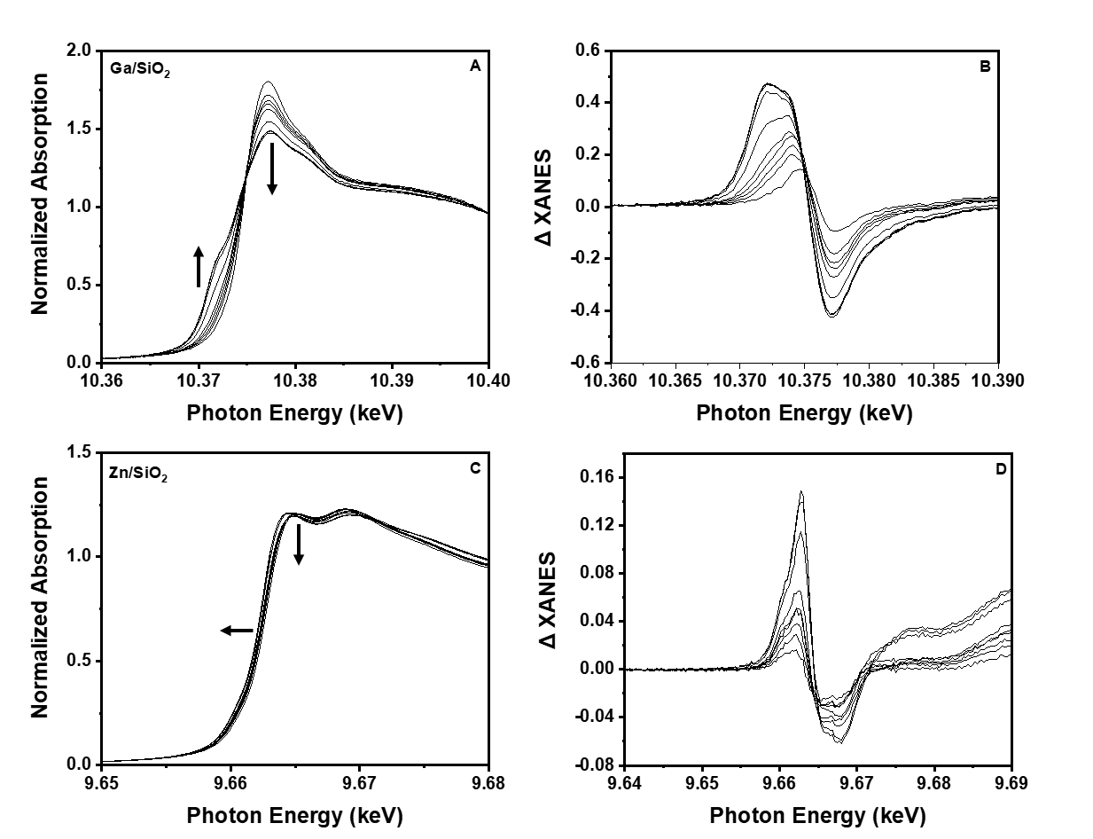
Figure S2. In situ XAS for Ga/SiO₂ and Zn/SiO₂ while the temperature was increased continuously to 550°C in pure H₂ where A) is the normalized Ga K edge XANES with B) the difference between the high temperature scan and dehydrated structure for Ga/SiO₂ C) is the normalized Zn K edge XANES with D) the difference between the high temperature scan and dehydrated structure for Zn/SiO₂

This matches the trends observed in the Fourier transform magnitude (FT mag). With increasing temperature, the intensity of the FT mag decreases, corresponding to a loss of M-O bonds (Figure S3a, S3b). This was fit in Table S7 to show a decrease from 4.0 to 3.2 Ga-O bonds between room temperature to 550°C respectively. There was also a loss of 4.0 to 3.2 Zn-O bonds between room temperature to 550°C respectively.
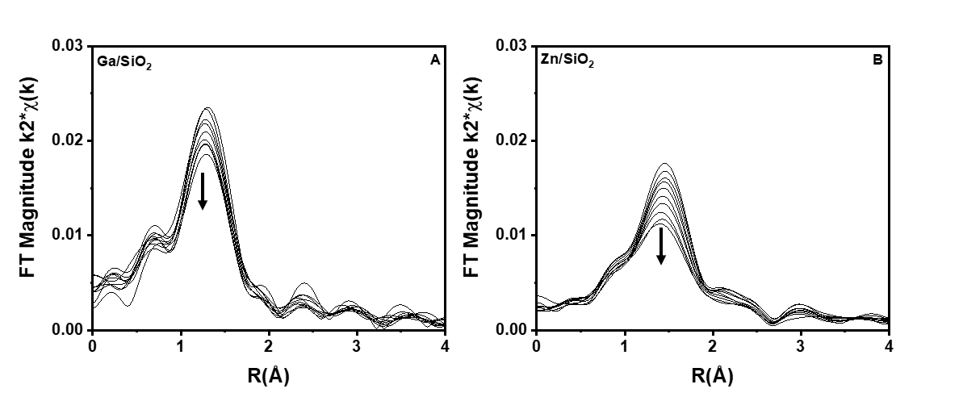
Figure S3. k²-weighted magnitude of the Fourier transform (Δk = 2.7 -10.5 Å⁻¹) for A) Ga/SiO₂ and B) Zn/SiO₂ as the temperature increases to 550°C in pure H₂

When the temperature was decreased to 250°C from 550°C in pure H₂, the changes to the XANES were reversed. This was previously interpreted as a temperature dependent equilibrium between the initial single site structure containing 4 M-O bonds and a metal hydride intermediate containing 3 M-O and 1 M-H bonds.^{8,12} The XANES spectra incrementally shifted back to the initial position while the intensity of the Fourier transform magnitude (EXAFS) continued to increase with decreasing temperature, suggesting an increasing M-O coordination number. When the temperature was stabilized at 250°C in H₂, and the structure stopped changing, the treatment gas composition was switched from pure H₂ to pure C₂H₄, which led to restoration of the XANES spectra back to its original position (Figures S4a and S4c). This suggests that the metal hydride can facilitate olefin insertion thus forming small concentrations of metal alkyls. Likewise, there was a slight increase in the FT mag, suggesting that a new M-C bond was formed (Figure S4b, S4d). Due to the similarly between C and O, M-O and M-C bonds cannot be distinguished by XAS. However, a fit of the FT mag showed that the Ga-O coordination number increased from 3.2 to 3.5 and Zn-O increased from 3.2 to 3.6 after exposure to ethylene (Table S5). However, the XANES and EXAFS spectra are not completely restored to their original position because under the catalytic cycle, there is likely a combination of metal hydride and metal alkyl intermediates which have competing effects on the resulting spectra. These changes were isolated, and a difference analysis was performed to verify the number of new M-C bonds (Figure S5, Table S8).

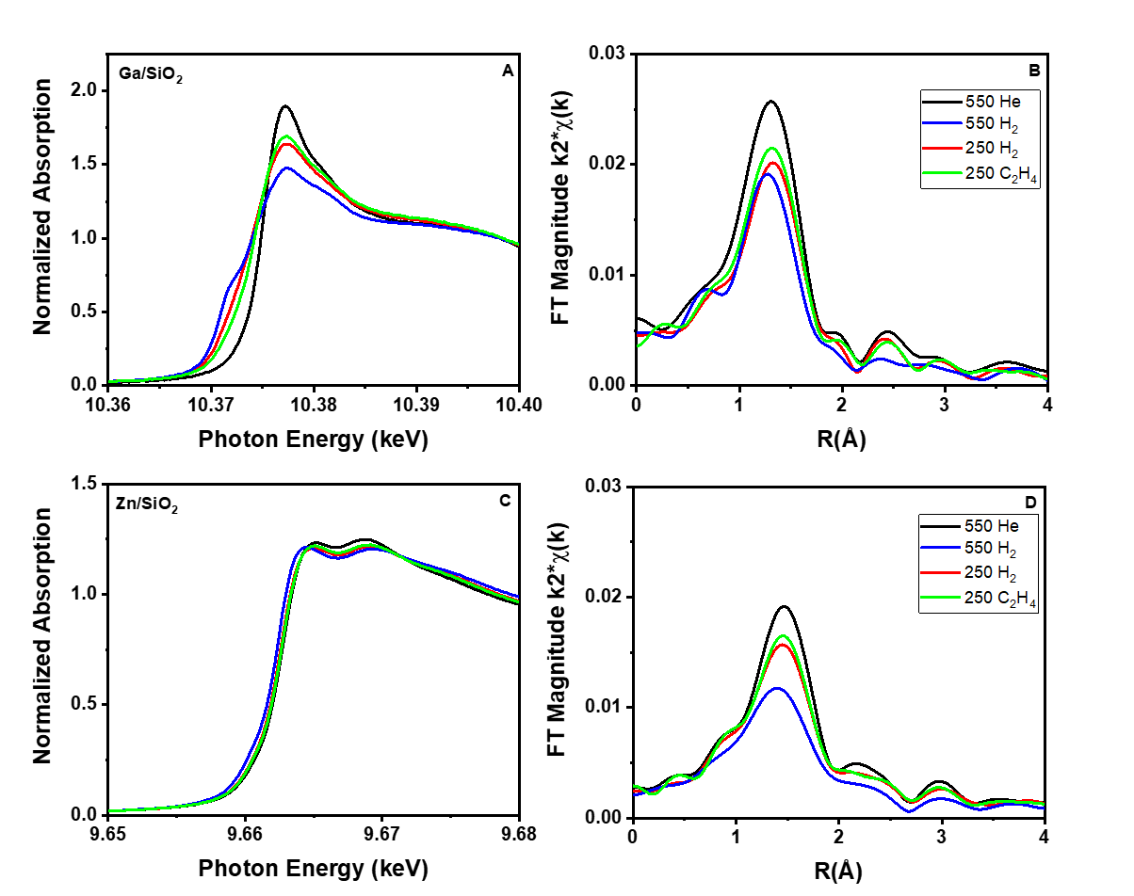
Figure S4. Demonstrates the ability for alkylation on the metal hydride for Ga/SiO₂ ₍A, B) and Zn/SiO₂ (C,D)

Table S7. Ga K and Zn K edge XAS fitting parameters for the metal-oxygen bonds in Ga/SiO₂ and Zn/SiO₂ after treatment in pure H₂ at successively increasing temperatures
Sample | Pretreatment Conditions | XANES Energy (keV) | Scattering Path | CN | R (Å) | $Δσ$² (Å²) | $Δ$E_{o} (eV)
Ga/SiO₂ | ª He 550°Ca | 10.3751 | Ga-O | 4.0 | 1.81 | 0.006 | -2.2
 | H₂ 250°C | 10.3750 | Ga-O | 3.5 | 1.81 | 0.006 | -1.0
 | H₂ 550°C | 10.3747 | Ga-O | 3.2 | 1.80 | 0.004 | -1.9
 | C₂H₄ 250°C | 10.3750 | Ga-O | 3.5 | 1.81 | 0.006 | -2.2
Zn/SiO₂ | ª He 550°C | 9.6628 | Zn-O | 4.0 | 1.95 | 0.006 | -0.6
 | H₂ 250°C | 9.6627 | Zn-O | 3.6 | 1.93 | 0.006 | -0.9
 | H₂ 550°C | 9.6625 | Zn-O | 3.2 | 1.93 | 0.004 | -1.7
 | C₂H₄ 250°C | 9.6627 | Zn-O | 3.4 | 1.93 | 0.006 | -1.0
ª Fits for the dehydrated catalysts were copied from Table S1 and are used for comparison to the fits after treatment

An attempt to deconvolute the M-O and M-C bonds was made through difference analysis. To identify the number of metal carbon bonds, a difference between the C₂H₄ and H₂ treated catalysts at 250°C was performed. Although the resulting feature is small (Figure S5a, S5b)), it can be fit (Table S8) to reveal 0.4 and 0.2 metal-carbon bonds in Ga/SiO₂ and Zn/SiO₂ respectively.

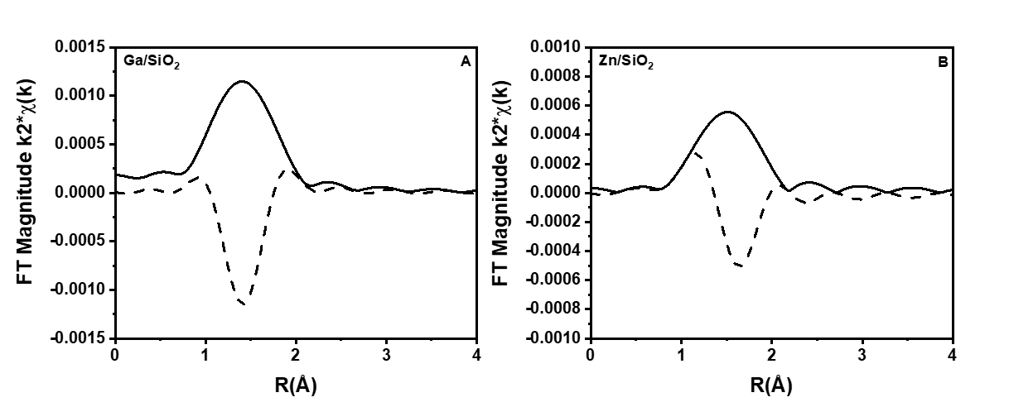
Figure S5. Difference EXAFS for Ga/SiO₂ (black) and Zn/SiO₂ (red) after treatments 250°C in C₂H₄- 250°C in H₂

Table S8. Difference EXAFS (C₂H₄ - H₂) fitting parameters at the Ga K and Zn K edges to identify the number of metal-carbon bonds at 250°C
Sample | Scattering Path | CN | R (Å) | $Δσ$² (Å²) | $Δ$E_{o} (eV)
Ga/SiO₂ | Ga-C | 0.4 | 1.94 | 0.005 | 6.1
Zn/SiO₂ | Zn-C | 0.2 | 2.01 | 0.005 | 3.2

Isotopic Exchange
H₂/D₂ isotopic exchange experiments were used to count the number of metal sites that formed a metal hydride. Each sample was dehydrated at 550°C in He. The sample was cooled to 250°C in He before being exposed to 5% H₂/Ar, thus forming some M-H bonds. After 1 hour, the H₂ feed was replaced with 5% D₂/Ar to form M-D bonds and gaseous HD. After 1 hour, the D₂ feed was replaced by H₂ to form M-H bonds and gaseous HD. This was performed to quantify the number of species that reversibly exchange isotopes. Figure S6 shows the time on stream for gaseous HD formation after sequential H₂ – D₂ – H₂ switches. The measured HD molar flow was baseline corrected and normalized by the mass of metal (Ga or Zn) used for the experiment. The area under the curve corresponds to the number of metal sites which reversibly undergo H/D exchange.

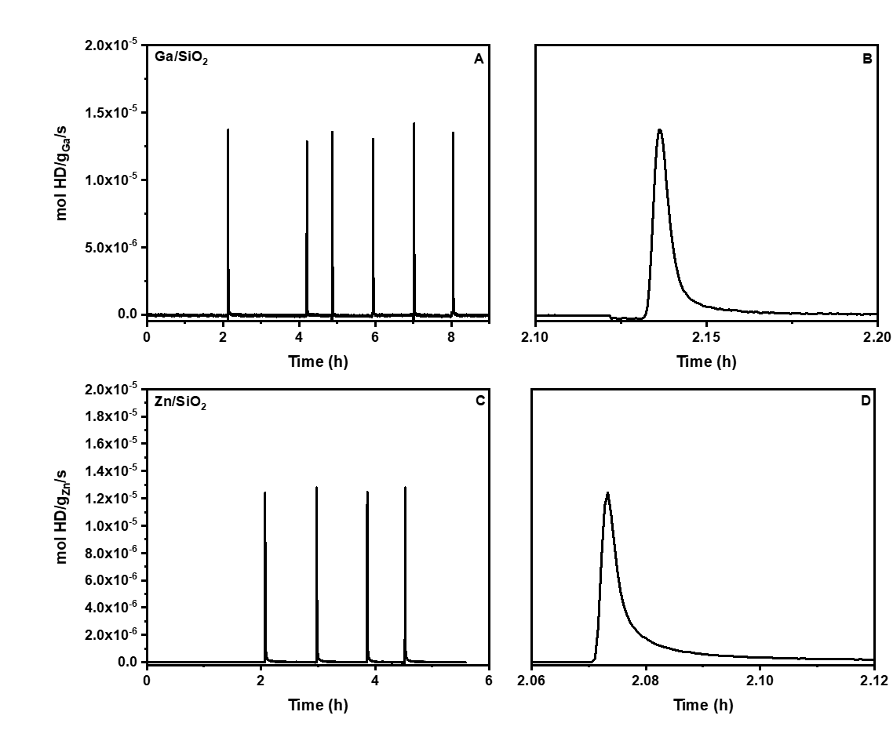
Figure S6. Time on stream for gaseous HD formation on A,B) Ga/SiO₂ and C,D) Zn/SiO₂ at 250°C

For Ga/SiO₂, it was found that 0.70 mol HD/ mol Ga was formed (Table S9), corresponding to 70% of the Ga sites on the catalyst at 250°C. At the same temperature, there were only 0.19 mol HD/mol Zn formed (Table S9), corresponding to 19% of the Zn sites. This is consistent with the XAS results in Table S7 showing that Ga/SiO₂ loses more Ga-O bonds than Zn/SiO₂ does Zn-O bonds and suggests that at 250°C, Ga³⁺ forms a larger concentration of Ga-H than Zn²⁺ does Zn-H.
At higher temperatures, the fraction of sites forming metal hydrides increases. For Ga/SiO₂ at 450°C, nearly 100% of the Ga sites formed a Ga-H (Figure S7, Table S10).

Table S9. HD moles quantified by H₂/D₂ exchanges at 250°C and corrected to remove non-metal contributions
Sample | Moles HD evolved in consecutive H₂ or D₂ step changes / mol/ g
 | H₂ D₂ | D₂ H₂
Ga/SiO₂ | 0.74 | 0.73
 | 0.64 | 0.71
 | 0.64 | 0.76
Zn/SiO₂ | 0.21 | 0.22
 | 0.16 | 0.18

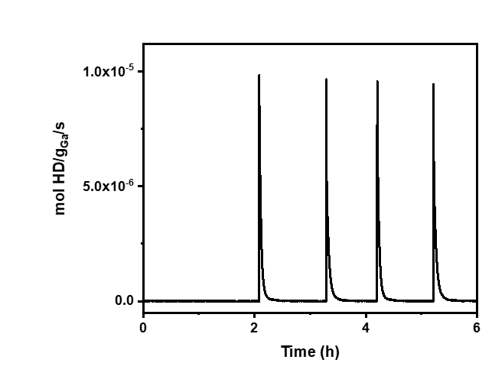
Figure S7. Time on stream for gaseous HD formation on Ga/SiO₂ at 450°C

Table S10. HD moles quantified by H₂/D₂ exchanges at 450°C and corrected to remove non-metal contributions
Sample | Moles HD evolved in consecutive H₂ or D₂ step changes / mol/ g
 | H₂ D₂ | D₂ H₂
Ga/SiO₂ | 1.12 | 1.10
 | 1.04 | 1.07

Fourier Transform Infrared Spectroscopy (FTIR)
FTIR was performed on Ga/SiO₂ by 1) treatment at increasing temperature in pure H₂ up to 550°C and then subsequent exposure to pure C₂H₄ at 250°C and 2) treatment in pure C₂H₄ at increasing temperature up to 250°C. All IR spectra reported for the treated samples are difference spectra in which that of the dehydrated sample was subtracted (i.e. Ga/SiO_{2;} _{treated} – Ga/SiO_{2;} _{dehydrated}).
When Ga/SiO₂ was treated at increasing temperature in H₂, it was apparent that there was an increase in features at 3745 cm⁻¹, 2034 cm⁻¹, and 1875 cm⁻¹ with increasing temperature. The feature at 3745 cm⁻¹ corresponds to Si-OH vibrations while those at 2034 cm⁻¹ and 1875 cm⁻¹ have been reported to correspond to Ga-H. The heterolytic dissociation of H₂ would facilitate the formation of a hydride and proximal surface silanol group. The spectra do not show evidence of Bronsted acid vibrations (3670 cm⁻¹), consistent with the nonacidic nature of SiO₂. As the catalyst was cooled back to room temperature in H₂, the features disappeared, like with XAS. Subsequent exposure to C₂H₄ results in the formation of an increasing feature at 2955 cm⁻¹ with temperature, corresponding to C-H vibrations.
When Ga/SiO₂ was treated directly in C₂H₄, the 2955 cm⁻¹ grew in with temperature. However, there was also an increase in an additional peak at 2970 cm⁻¹, corresponding to a vinylic alkyl (Figure S8). Because these are difference spectra, it can be interpreted that any changes are due to changes to Ga/SiO₂ rather than excess ethylene in the cell. This indicates that Ga/SiO₂ can heterolytically cleave C-H bonds without the H₂ pretreatment leading to the pre-formation of a Ga-H.

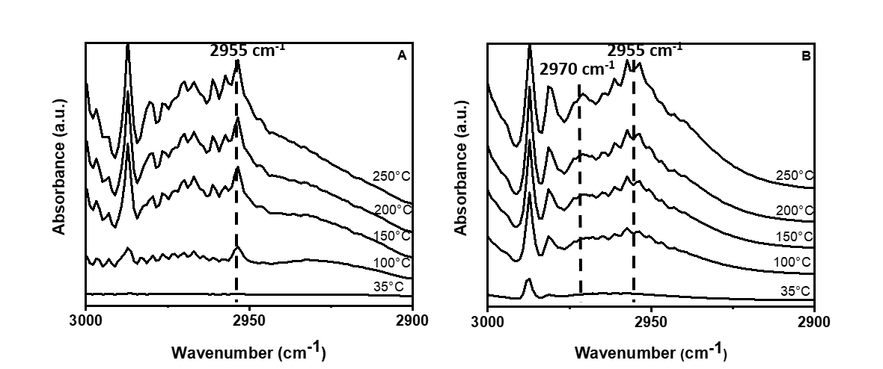
Figure S8. IR C-H region A) H₂ treated Ga/SiO₂ and B) dehydrated Ga/SiO₂ were exposed to pure C₂H₄ at increasing temperatures from 35°C to 250°C and the spectrum reflect the treated catalyst- the dehydrated catalyst (Ga/SiO_{2; C2H4}-Ga/SiO_{2;} _{dehydrated})

Density Functional Theory (DFT)
Ga Site Creation
A model for single site Ga³⁺ ions in an amorphous silica was created by substitution of Si atoms by Ga atoms. To account for the local charge balance, a proton was added onto the oxygen atom adjacent to the Ga, resulting in a silanol group. Multiple such DFT optimizations were performed to develop the basis structures for modeling ethylene oligomerization on Ga/SiO₂.

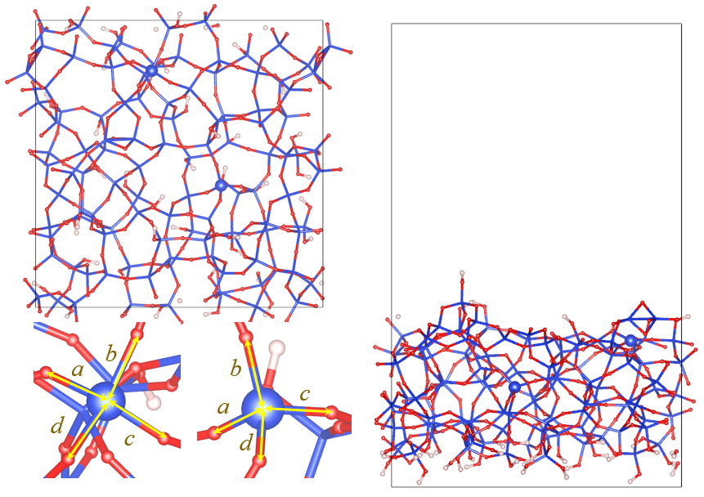
Figure S9. Amorphous silica model with highlighted Si atoms to be substituted with Ga (Si = blue, O = red; H= white)

During the optimizations, nearby Si-OH groups were generated. Two representative Ga sites, including a three-coordinated (3CN) and four-coordinated (4CN), were then evaluated (Figure S10). The different coordination environments are attributed to the original local binding condition of the Si atoms substituted. For the 3CN site, the Si atom is in a less constrained framework, where the Si-O bonds were elongated (a=1.80 Å, b=1.66 Å, c=1.76 Å, and d=1.69 Å). The cleavage of the Si-O bond (a) to generate the 3CN Ga site led to Ga-O bond distances of 4.51 Å, 1.86 Å, 1.82 Å, and 1.86 Å. A bond distance of 4.51 Å is sufficiently far away that it does not interact with the 3CN Ga site. In contrast, the Si atom used for creating the 4CN site is in a more constrained environment containing shorter Si-O bonds (a=1.62 Å, b=1.67 Å, c=1.64 Å, and d=1.66 Å). Consequently, the Si-OH formed on the 4CN Ga site is nearer to the metal center, and there are 4 Ga-O bonds at 2.02 Å, 1.85 Å, 1.82 Å, and 1.88 Å. The average Ga-O bond distance of the 4CN Ga site is 1.89 Å, which agrees with the experimental characterization (XAS).

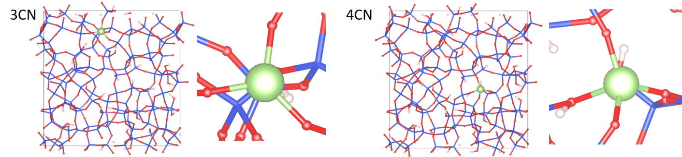
Figure S10. Amorphous silica model with highlighted Si atoms to be substituted with Ga (Si = blue, O = red, H= white, Ga = green)

Ga-H Formation and Subsequent Oligomerization
Ga-H is considered as a key intermediate in facilitating olefin oligomerization. The free energy landscape of Ga-H formation, and the subsequent ethylene oligomerization on the Ga sites containing different geometries, are outlined in Figures S11-S16 and Tables S11-S14. The heterolytic cleavage of the C(sp²)-H bond in ethylene results in a loss of a Ga-O bond and the formation of both a vinylic alkyl containing a C atom (bearing a negative charge) and a neighboring hydroxyl group. The resulting hydroxyl group becomes distant from the Ga site such that the resulting Ga-O bond distance increases from 1.88 Å to 2.92 Å.
A subsequent ethylene can then insert into the Ga-vinyl intermediate. A migratory insertion reaction leads to the Ga-butenyl species. β-H elimination causes butadiene to desorb from the metal center, thus forming a Ga-H intermediate. Here, the migratory insertion of ethylene is likely the rate limiting step, with an intrinsic activation barrier of 2.53 eV. This is a similar magnitude to energy barriers previously reported for Zn/SiO₂ for elementary steps with a similar geometry of transition states for propane dehydrogenation.³ Once the Ga-H site is formed, it can facilitate subsequent oligomerization.
The formation of Ga-H and butadiene is made favorable on the 4CN Ga site (consistent with experimental evidence) by implementing an initial dehydration step between two adjacent Si-OH groups (Figure S12). With a low chemical potential of water in the environment, there is high thermodynamic favorability in a dehydration reaction initiated by the two adjacent Si-OH groups. The intrinsic enthalpy of dehydration is +1.62 eV, and the result is consistent with the dehydration calculations based on a similar silica model.¹ Also, the partial pressure of water is estimated to be 10⁻⁹ atm, consistent with the value used in the prior dehydration study of silica.¹ Dehydration results in the activation free energy of the ethylene insertion decreasing from 2.53 eV to 2.30 eV (Figure S16, Table S15).
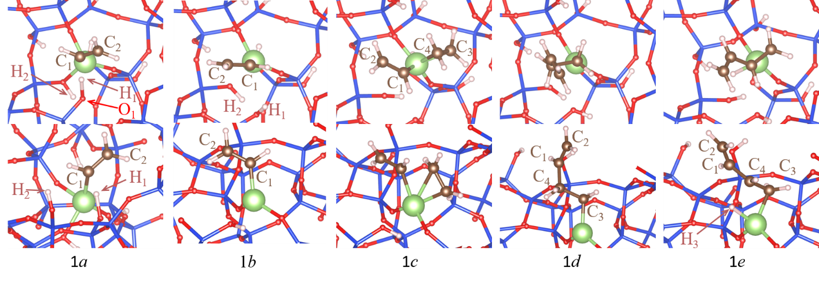
Figure S11. Top and side views of key intermediates and transition states for Ga-H formation at a 4CN Ga site (Si = blue, O = red, H= white, Ga = green).

Table S11. Bond distances and free energies of key intermediates and transition states during Ga-H formation at a 4CN Ga site. The calculation of adsorption energy used the reference of the empty Ga site and the gaseous ethylene molecule at 1 atm and 250°C. See below for the entropy calculation procedure. TS indicates a transition state.
Intermediate* | Bond | Length (Å) | Free Energy (eV) | Energy (eV) | Entropy (J mol⁻¹ K⁻¹)
Empty Ga site | - | - | 0 | 0 | 66.8
1a (TS) | Ga – C₁ | 2.22 | 1.19 | 0.97 | 238.19 (product-like geometry)
 | O₁ – H₁ | 1.33
1b | Ga – C₁ | 1.98 | 0.15 | -0.07 | 238.19
 | O₁ – H₁ | 0.96
1c (TS) | Ga – C₁ | 2.16 | 2.68 | 1.73 | 322.03(product-like geometry)
 | Ga – C₃ | 2.03
 | Ga – C₄ | 2.36
1d | Ga – C₃ | 2.00 | -0.21 | -1.14 | 322.03
1e (TS) | Ga – C₃ | 2.05 | 2.20 | 1.27 | 322.03 (reactant-like geometry)
 | Ga – H₃ | 1.68
Ga-H | Ga – H₃ | 1.56 | 0.50 | 0.09 | 134.3
* Intermediates shown in Figure S11

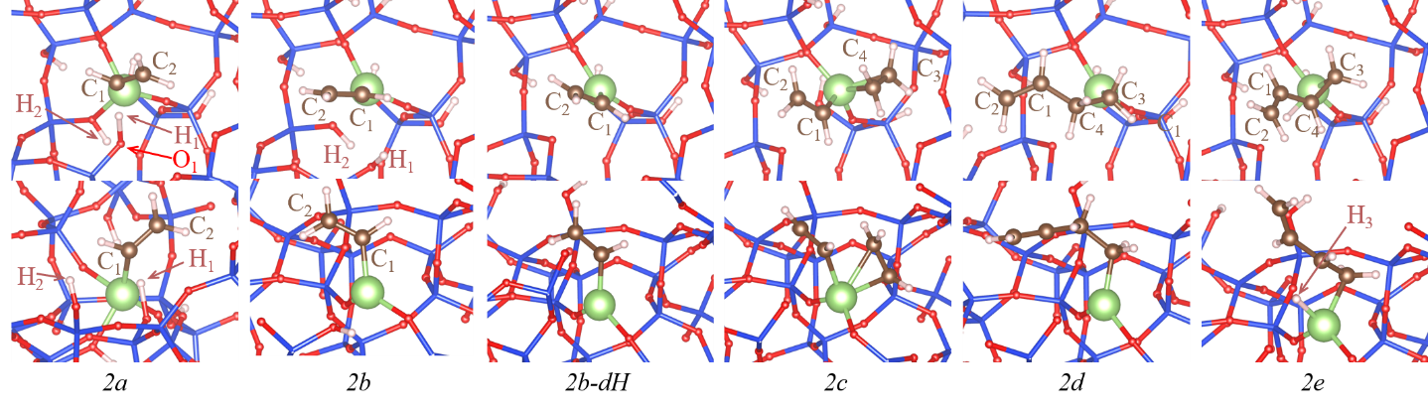
Figure S12. Top and side views of key intermediates and transition states for Ga-H formation on a dehydrated 4CN Ga site (Si = blue, O = red, H= white, Ga = green).

Table S12. Bond distances and free energies of key intermediates and transition states during Ga-H formation on a dehydrated 4CN Ga site. The calculation of adsorption energy used the reference of the empty Ga site and the gaseous ethylene molecule at 1 atm and 250°C. See below for the entropy calculation procedure. TS indicates a transition state.
Intermediate* | Bond | Length (Å) | Free Energy (eV) | Energy (eV) | Entropy (J mol⁻¹ K⁻¹)
Empty Ga site | - | - | 0 | 0 | 66.8
2a (TS) | Ga – C₁ | 2.22 | 1.19 | 0.97 | 238.2 (product-like geometry)
 | O₁ – H₁ | 1.33
2b | Ga – C₁ | 1.98 | 0.16 | -0.07 | 238.2
 | O₁ – H₁ | 0.96
2b – dH | Ga – C₁ | 1.96 | -0.07 | 1.55 | 218.5
2c (TS) | Ga – C₁ | 2.10 | 2.23 | 3.13 | 321.9(product-like geometry)
 | Ga – C₃ | 2.04
 | Ga – C₄ | 2.34
2d | Ga – C₃ | 2.00 | -0.47 | 0.43 | 321.9
2e (TS) | Ga – C₃ | 2.06 | 1.97 | 2.87 | 321.9(reactant-like geometry)
 | Ga – H₃ | 1.71
Ga-H, butadiene | Ga – H₃ | 1.57 | 0.46 | 0.89 | 107.9
* Intermediates shown in Figure S12

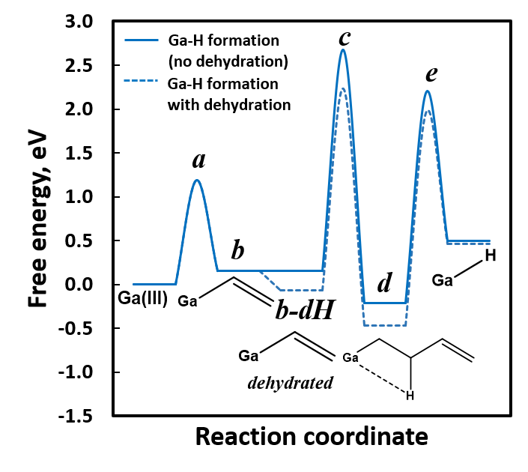
Figure S13. Free energy landscapes of hydride formation on 4CN site with and without dehydration (see text for a description of the dehydration process). The calculation of adsorption energy used the reference of the empty Ga site and the gaseous ethylene molecule at 1 atm and 250°C.

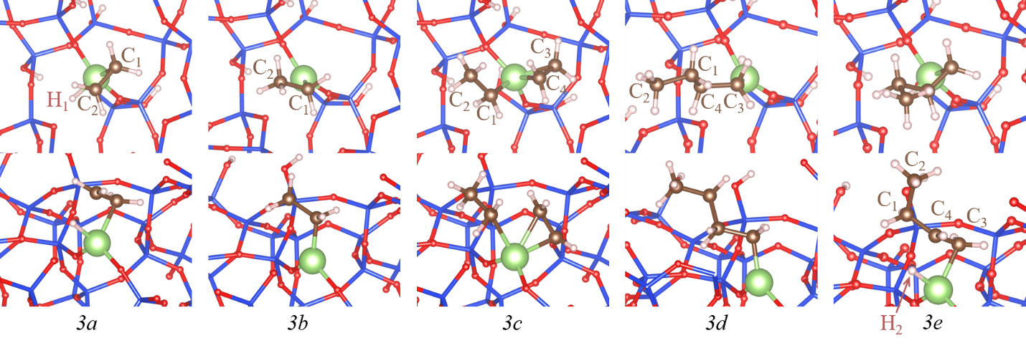
Figure S14. Top and side views of key intermediates and transition states of ethylene oligomerization on Ga-H formed on a dehydrated 4CN Ga (Si = blue, O = red, H= white, Ga = green).

Table S13. Bond distances and free energies of key intermediates during ethylene oligomerization on Ga-H generated from dehydrated 4CN Ga. The calculation of adsorption energy used the reference of the empty Ga-H site and the gaseous ethylene molecule at 1 atm and 250°C. See below for the entropy calculation procedure. TS indicates a transition state.
Intermediate* | Bond | Length (Å) | Free Energy (eV) | Energy (eV) | Entropy (J mol⁻¹ K⁻¹)
Ga-H | Ga – H₁ | 1.56 | 0 | 0 | 52.3
3a (TS) | Ga – C₁ | 2.11 | 1.85 | 1.07 | 146.7 (product-like geometry)
 | Ga – H₁ | 1.68
3b | Ga – C₁ | 1.99 | -0.82 | -1.61 | 146.7
3c (TS) | Ga – C₁ | 2.20 | 1.71 | 0.43 | 285.8 (product-like geometry)
 | Ga – C₃ | 2.03
 | Ga – C₄ | 2.22
3d | Ga – C₃ | 1.99 | -1.43 | -2.71 | 285.8
3e (TS) | Ga – C₃ | 2.09 | 1.14 | -0.14 | 285.8 (reactant-like geometry)
 | Ga – H₂ | 1.67
Ga-H | Ga – H₂ | 1.56 | -0.11 | -1.08 | 52.3
* Intermediates shown in Figure S14

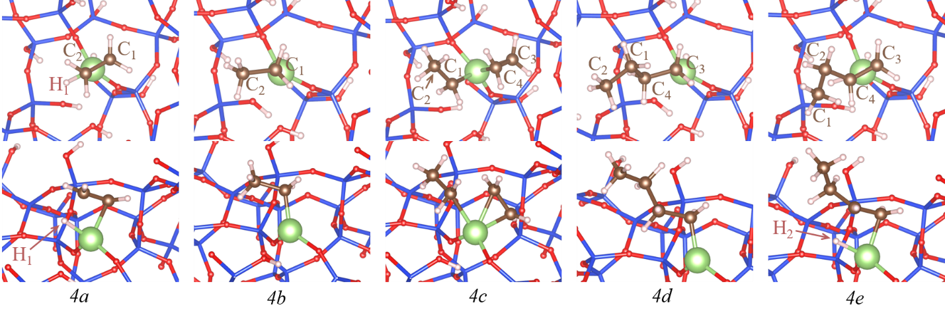
Figure S15. Top and side views of key intermediates and transition states of ethylene oligomerization on Ga-H generated from 4CN Ga without dehydration (Si = blue, O = red, H= white, Ga = green).

Table S14. Bond distances and free energies of key intermediates during ethylene oligomerization on Ga-H generated from 4CN Ga without dehydration. The calculation of adsorption energy used the reference of the empty Ga-H site and the gaseous ethylene molecule at 1 atm and 250°C. See below for the entropy calculation procedure. TS indicates a transition state.
Intermediate* | Bond | Length (Å) | Free Energy (eV) | Energy (eV) | Entropy (J mol⁻¹ K⁻¹)
Ga-H | Ga – H₁ | 1.57 | 0 | 0 | 68.3
4a | Ga – C₁ | 2.10 | 1.76 | 1.02 | 165.1 (product-like geometry)
 | Ga – H₁ | 1.69
4b | Ga – C₁ | 2.00 | -0.68 | -1.42 | 165.1
4c | Ga – C₁ | 2.28 | 1.93 | 0.69 | 300.2 (product-like geometry)
 | Ga – C₃ | 2.00
 | Ga – C₄ | 2.24
4d | Ga – C₃ | 2.00 | -1.19 | -2.43 | 300.2
4e | Ga – C₃ | 2.09 | 1.13 | 0.11 | 300.2 (reactant-like geometry)
 | Ga – H₂ | 1.69
Ga-H | Ga – H₂ | 1.57 | -0.11 | -1.08 | 68.3
* Intermediates shown in Figure S15

While the experimental evidence suggests that 4CN Ga sites are prominent in the pre-catalyst, it is possible to have a small concentration of sites that are less constrained in the silica framework (for example, in a 3CN Ga site). Because of the local environment on the SiO₂ framework, the Ga center is more geometrically available to bind with C₂H₄ (a less constrained environment). Therefore, lower reaction energetics following the same energy landscape are possible on the Ga-H formed using the less constrained site. The lower strain conditions reduce the intrinsic barrier of the C₂H₄ insertion step by 0.67 eV (Figure S16, Table S15). Because the Ga site may locate in a wide range of strain conditions in the amorphous silica, it is possible that a small concentration of less constrained Ga sites exist in the catalyst and could contribute to the catalytic activity.

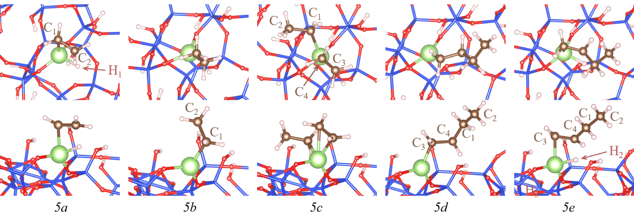
Figure S16. Top and side views of key intermediates and transition states of ethylene oligomerization on a Ga-H located in a 3CN environment (Si = blue, O = red, H= white, Ga = green).

Table S15. Bond distances and free energies of key intermediates during ethylene oligomerization on Ga-H generated from 3CN Ga. The calculation of adsorption energy used the reference of the empty Ga-H site and the gaseous ethylene molecule at 1 atm and 250°C. See below for the entropy calculation procedure. TS indicates a transition state.
Intermediate* | Bond | Length (Å) | Free Energy (eV) | Energy (eV) | Entropy (J mol⁻¹ K⁻¹)
Ga-H | Ga – H₁ | 1.55 | 0 | 0 | 49.9
5a | Ga – C₁ | 2.10 | 1.49 | 0.87 | 179.3 (product-like geometry)
 | Ga – H₁ | 1.71
5b | Ga – C₁ | 1.98 | -0.75 | -1.36 | 179.3
5c | Ga – C₁ | 2.28 | 1.12 | -0.02 | 303.5 (product-like geometry)
 | Ga – C₃ | 2.04
 | Ga – C₄ | 2.26
5d | Ga – C₃ | 1.98 | -1.25 | -2.39 | 303.5
5e | Ga – C₃ | 2.09 | 1.11 | -0.03 | 303.5 (reactant-like geometry)
 | Ga – H₂ | 1.70
Ga-H | Ga – H₂ | 1.55 | -0.11 | -1.08 | 49.9
* Intermediates shown in Figure S16

Entropy Calculations
Harmonic vibrational state analysis formed as the basis for estimating entropies of the adsorbates. However, for vibrational modes with low wavenumbers (< 150 cm⁻¹), particle-in-a-box (PIB) and free rotor schemes were used for calculating their contributions to the entropies. For the low frequency modes that resemble translations of a molecule, the PIB model is used with a length scale corresponding to the size of the cavity where the Ga site is located; this approximation should produce a lower limit of the entropy of these modes. For low frequency modes that resemble rotations, the free rotor approximation is used and likely represents a small overestimate of the corresponding entropies. We note that, for all intermediates in the oligomerization cycle, two modes representing the vibrations of the Ga site are found below 170 cm⁻¹. However, we do not consider their contributions to the entropy since the same vibrations (± 21.5 cm⁻¹) are found for bare Ga-H sites, and hence the entropy contributions will cancel. Finally, the entropies of the transition states are approximated as being equivalent to the entropies of the corresponding reactants or products, depending upon whether the geometry of the transition state more closely resembles that of reactants or products.

Table S16 outlines examples of entropy calculations for Ga-n-butyl and Ga-ethyl intermediates.

Table S16. Examples of entropy contributions from the vibrations with wavenumbers less than 150 cm⁻¹ (T = 250 °C)
Ga-ethyl (3b, Fig. S14) |  |  | Ga-n-butyl (3d, Fig. S14)
Wavenumber, cm⁻¹ | Description | Entropy contribution, J mol⁻¹ K⁻¹ | Wavenumber, cm⁻¹ | Description | Entropy contribution, J mol⁻¹ K⁻¹
64.4 | Translation (adsorbate + Ga) | 40.5 | 23.5 | Translation | 38.2
70.1 | Ga vibration | - | 46.8 | Ga vibration | -
101.4 | Rotation | 25.6 | 63.3 | Translation | 38.2
137.4 | Ga vibration | - | 81.9 | Rotation | 34.2
152.5 | Rotation | 25.6 | 120.0 | Ga vibration | -
 |  |  | 127.3 | Translation (adsorbate + Ga) | 41.53
 |  |  | 137.4 | Rotation | 34.2

Discussion
Single site Ga/SiO₂ and Zn/SiO₂ have been previously shown to be active for propane dehydrogenation and propylene hydrogenation reactions.^{2,3} These reactions are proposed to have similar elementary steps as required for olefin oligomerization; however, different reaction conditions are required.

Similarities of Alkane Dehydrogenation, Olefin Hydrogenation and Oligomerization Reactions on Single Site Main Group and Post Transition Metal Catalysts
Ga/SiO₂ and Zn/SiO₂ have the same 4-coordinate (Td) structure as Ni/SiO₂ and are stable at high temperature, even in the presence of H₂. Whereas, Ni²⁺ reduces to Ni⁰ at temperatures higher than 350°C in reducing conditions, losing oligomerization activity.⁴ This work shows that Ga/SiO₂ and Zn/SiO₂ perform oligomerization with varying product distributions and the catalytic performance was investigated through a mechanistic understanding of the elementary steps and reaction intermediates required for oligomerization to occur. The ability to heterolytically activate C-H bonds is important for catalyst activation.^{13–16} This capability is known through the previously reported dehydrogenation activity.^{2,3}
In dehydrogenation (550°C, 1 atm), one C(sp3)-H bond is heterolytically cleaved across a M-O bond to form a metal-alkyl and a surface Si-OH (Figure S17). Subsequent β-hydride elimination produces the olefin and forms a metal hydride intermediate. In hydrogenation (200°C, 1 atm), the microscopic reverse of dehydrogenation that occurs at lower reaction temperatures, the single site catalyst can activate H₂ to form a metal hydride. Olefin insertion to the metal hydride forms a metal alkyl which produces a paraffin when it is desorbed from the metal surface, reforming the initial catalyst, thus restarting the catalytic cycle.

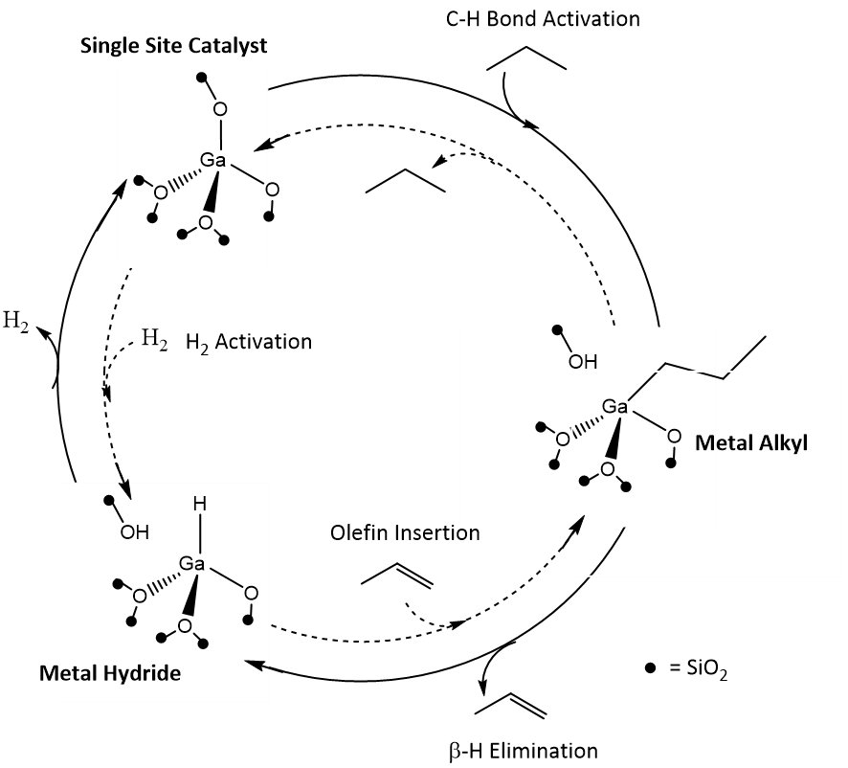

Figure S17. Dehydrogenation (solid line) and hydrogenation (dashed line) reaction pathways

Oligomerization occurs at 250°C, where the cleavage of the C(sp2)-H bond of ethylene occurs. The C(sp2)-H bond of ethylene is typically easier to cleave than the C(sp3)-H bond of propane because the resulting C(sp2)-M is more stable than the latter C(sp3)-M. IR demonstrates that higher reaction temperatures increase the C-H bond activation forming metal alkyls. For instance, at 250°C, the intensity of the C-H vibrations is notable, consistent with the oligomerization reactivity observed at that temperature on both Ga/SiO₂ and Zn/SiO₂.
From this, it is interpreted that hydrogenation/dehydrogenation (Figure S17) and the proposed oligomerization reactions on main group single site catalysts (Figure 4) are related through the formation of the same reaction intermediates and the ability to perform the same elementary reaction steps. However, different reaction conditions are required. While dehydrogenation and hydrogenation can be performed at atmospheric pressure with high rates, oligomerization requires higher pressure to obtain high conversion and reasonable rates.
Understanding the reaction intermediates and elementary steps is critical for identifying novel oligomerization catalysts with tunable product selectivity for targeted applications. Ga/SiO₂ and Zn/SiO₂ are not traditionally used for olefin oligomerization. Though reports on Ga/ZSM-5 suggest the possibility of oligomerization on Ga ions, the acidic character of the support complicates the understanding of the metal activity.^{17,18} ZSM-5 will protonate ethylene at room temperature and perform oligomerization at higher temperature. The lack of linear olefins and observation of high Bronsted activity suggest that the acid character dominates performance on Ga/ZSM-5. Whereas the SiO₂ support in our study is nonreactive and the activity comes only from Ga³⁺ and Zn²⁺ sites respectively, thus forming linear olefins.

References
1. Comas-Vives, A. Amorphous SiO2 surface models: energetics of the dehydroxylation process, strain, ab initio atomistic thermodynamics and IR spectroscopic signatures. Phys. Chem. Chem. Phys. 2016, 18, 7475–7482.
2. Cybulskis, V. J.; Pradhan, S.U.; Lovon-Quintana, J.J.; Hock, A.S.; Hu, B.; Zhang, G.; Delgass, W.N.; Ribeiro, F.H.; Miller, J.T. The Nature of the Isolated Gallium Active Center for Propane Dehydrogenation on Ga/SiO2. Catal Lett.2017, 147, 1252–1262.
3. Schweitzer, N. M.; Hu, B.; Das, U.; Kim, H.; Greeley, J.; Curtiss, L.A.; Stair, P.C.; Miller, J.T.; Hock, A.S. Propylene Hydrogenation and Propane Dehydrogenation by a Single-Site Zn2+ on Silica Catalyst. ACS Catal. 2014, 4, 1091–1098.
4. Zhang, G.; Yang, C.; Miller, J. T. Tetrahedral Nickel(II) Phosphosilicate Single‐Site Selective Propane Dehydrogenation Catalyst. ChemCatChem. 2017, 10, 961–964.
5. Joshi, R., Zhang, G., Miller, J. T. & Gounder, R. Evidence for the Coordination–Insertion Mechanism of Ethene Dimerization at Nickel Cations Exchanged onto Beta Molecular Sieves. ACS Catal. 2018, 8, 11407–11422.
6. Brogaard, R. Y.; Olsbye, U. Ethene Oligomerization in Ni-Containing Zeolites: Theoretical Discrimination of Reaction Mechanisms. ACS Catal. 2016, 6, 1205–1214.
7. Phadke, N. M.; Van der Mynsbrugge, J.; Mansoor, E.; Getsoian, A.B.; Head-Cordon, M.; Bell, A.T. Characterization of Isolated Ga3+ Cations in Ga/H-MFI Prepared by Vapor-Phase Exchange of H-MFI Zeolite with GaCl3. ACS Catal. 2018, 8, 6106–6126.
8. Getsoian, A.B.; Das, U.; Camacho-Bunquin, J.; Zhang, G.; Gallagher, J.R.; Hu, B.; Cheah, S.; Schaidle, J.A.; Ruddy, D.A.; Hensley, J.E.; Krause, T.R.; Curtiss, L.A.; Miller, J.T.; Hock, A.S. Organometallic model complexes elucidate the active gallium species in alkane dehydrogenation catalysts based on ligand effects in Ga K-edge XANES. Catalysis Science & Technology. 2016, 6, 6339–6353.
9. Geller, S. Crystal Structure of β‐Ga2O3. J. Chem. Phys.1960, 33, 676–684.
10. Britovsek, G. J. P.; Malinowski, R.; McGuinness, D.S.; Nobbs, J.D.; Tomov, A.K.; Wadsley, A.W.; Young, C.T. Ethylene Oligomerization beyond Schulz−Flory Distributions. ACS Catal. 2015, 4, 6922-6925.
11. Martínez, A.; Arribas, M. A.; Concepción, P.; Moussa, S. New bifunctional Ni–H-Beta catalysts for the heterogeneous oligomerization of ethylene. Applied Catalysis A: General. 2013, 467, 509–518.
12. Schreiber, M. W.; Plaisance, C.P.; Baumgartl, M.; Reuter, K.; Jentys, A.; Bermejo-Deval, R.; Lercher, J.A. Lewis–Brønsted Acid Pairs in Ga/H-ZSM-5 To Catalyze Dehydrogenation of Light Alkanes. J. Am. Chem. Soc. 2018, 140, 4849–4859.

13. Pidko, E. A.; Hensen, E. J. M.; van Santen, R. A. Anionic Oligomerization of Ethylene over Ga/ZSM-5 Zeolite: A Theoretical Study. J. Phys. Chem. C. 2008, 112, 19604–19611.
14. Conley, M. P.; Delley, M. F.; Núñez-Zarur, F.; Comas-Vives, A.; Copéret, C. Heterolytic Activation of C-H Bonds on Cr(III)-O Surface Sites Is a Key Step in Catalytic Polymerization of Ethylene and Dehydrogenation of Propane. Inorg Chem. 2015, 54, 5065–5078.
15. Delley, M. F.; Silaghi, M.C.; Nunez-Zarur, F.; Kovtunov, K.V.; Salnikov, O.G.; Estes, D.P.; Koptyug, I.V.; Comas-Vives, A.; Copéret, C. X–H Bond Activation on Cr(III),O Sites (X = R, H): Key Steps in Dehydrogenation and Hydrogenation Processes. Organometallics. 2017, 36, 234–244.
16. Copéret , C.; Comas-Vives, A.; Conley, M.; Estes, D.P.; Fedorov, A.; Mougel, V.; Nagae, H.; Nunez-Zarur, F.; Zhizhko, P.A. Surface Organometallic and Coordination Chemistry toward Single-Site Heterogeneous Catalysts: Strategies, Methods, Structures, and Activities. Chem. Rev. 2016, 116, 323–421.
17. Kuz´min, I. V.; Sokolova, N. A.; Subbotina, I. R.; Zhidomirov, G. M. Ethylene adsorption and transformation on zeolite Ga+/ZSM-5. Russ Chem Bull. 2015, 64, 278–283.

