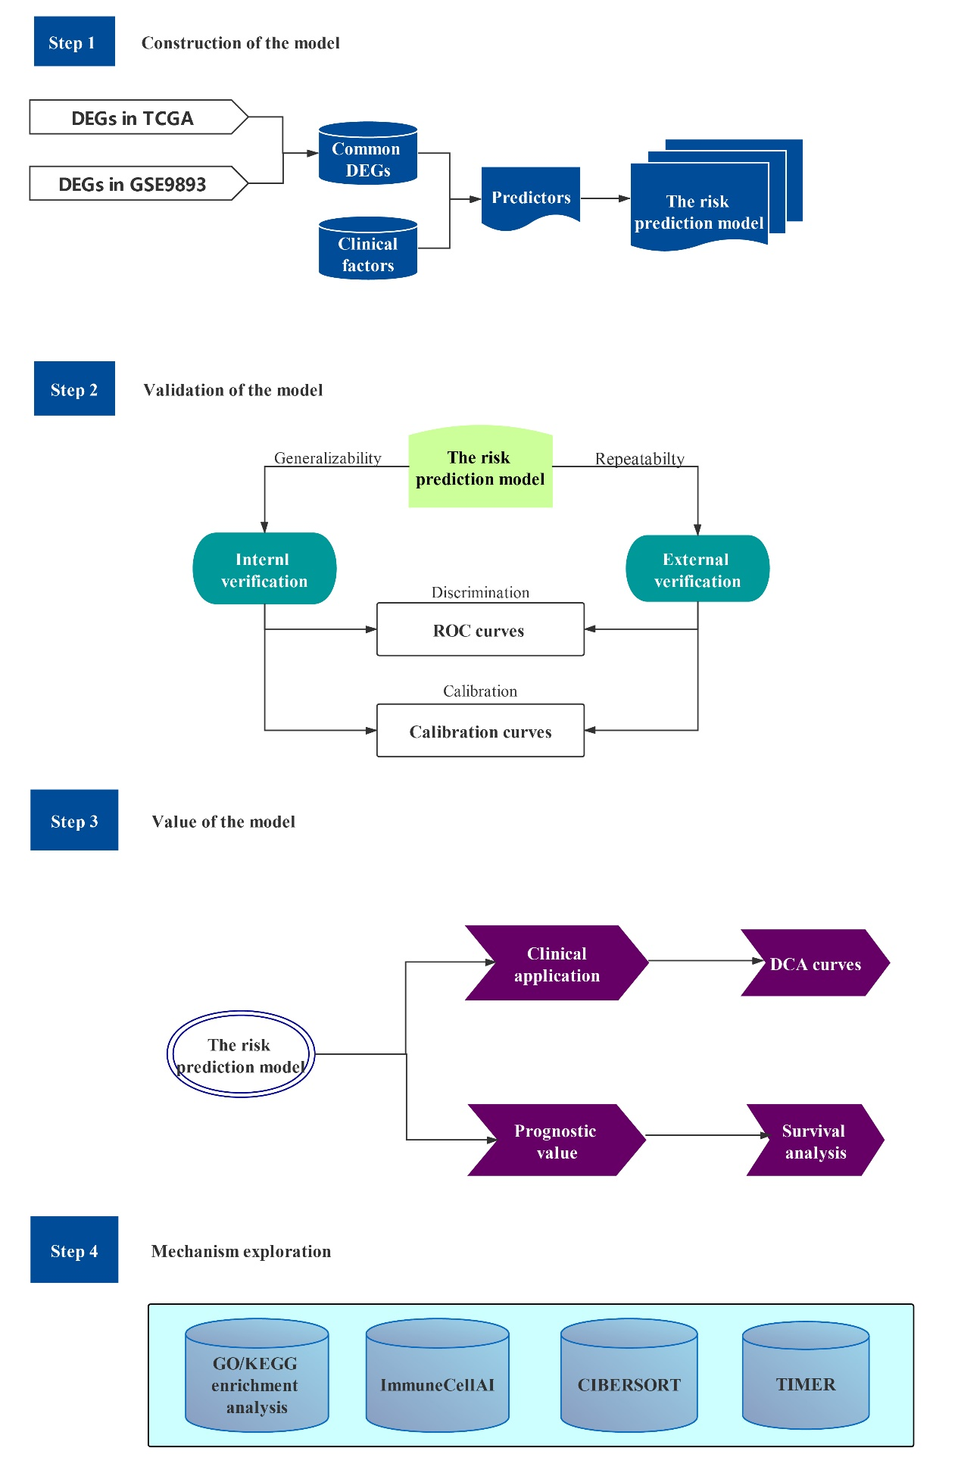
Supplementary Figure 1 Flow chart of this study.
Supplementary Figure 2 Calibration curves of the risk prediction model in T1-2 invasive breast cancer.

