Thermoresponsive polymer encapsulated gold nanorods for single continuous wave laser-induced photodynamic/photothermal tumor therapy

Beilei Gong, Yuanbing, Huiyan Li, Xiaojun Li, XiaHuan, Jihong Zhou, Yuqing Chen, Jian Wu, Wei Li

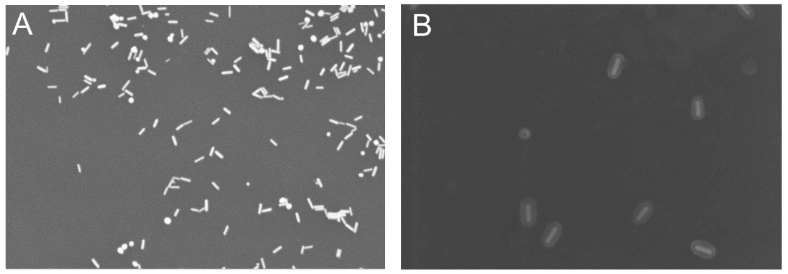
Figure S1 (A) SEM images of AuNRs, (B) SEM images of AuNRs@SiO₂.

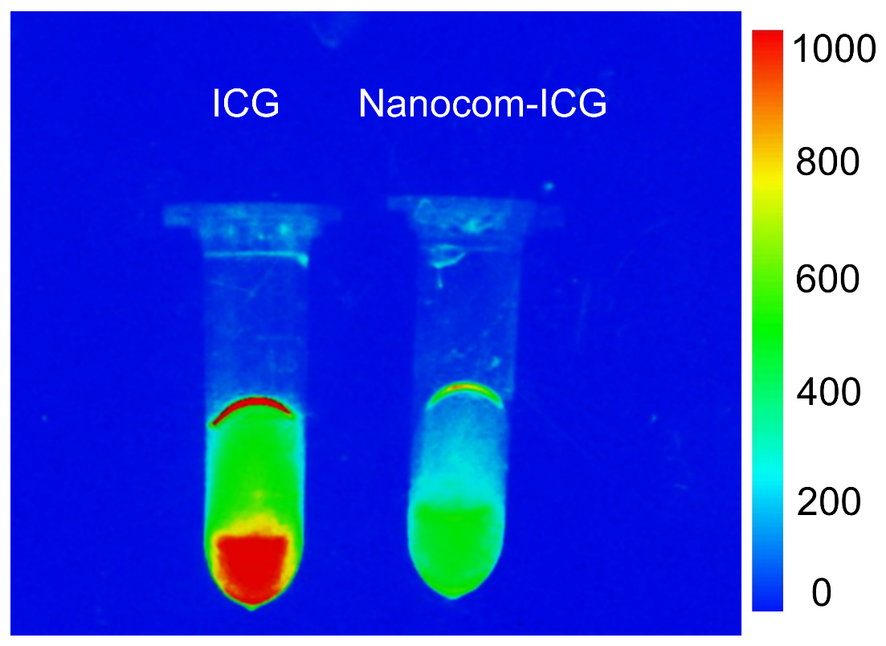
Figure S2. The fluorescence pictures of ICG and Nanocom-ICG (excitation=710 nm, emission=815 nm).
Figure S3. Digital photo of Nanocom-ICG dispered in different solutions at different pH values for 2 weeks.

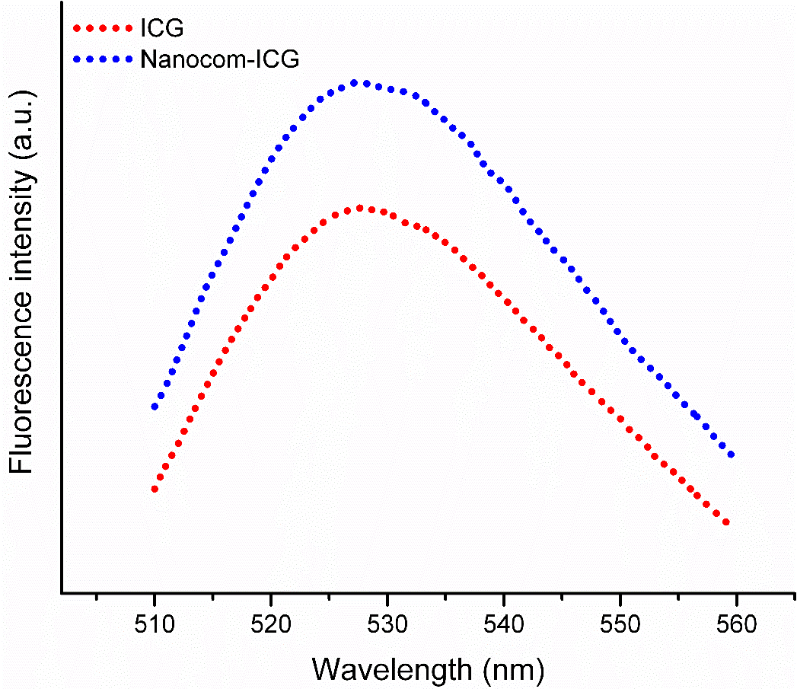
Figure S4. The SOSG fluorescence spectra of ICG and nanocom-ICG after laser irradiation for 5 minutes (0.8 W/cm²).
Figure S5. Statistical analysis of singlet oxygen content generated by ICG and the material after 5 minutes of laser irradiation (0.8 W/cm²). n = 3, *p< 0.05.

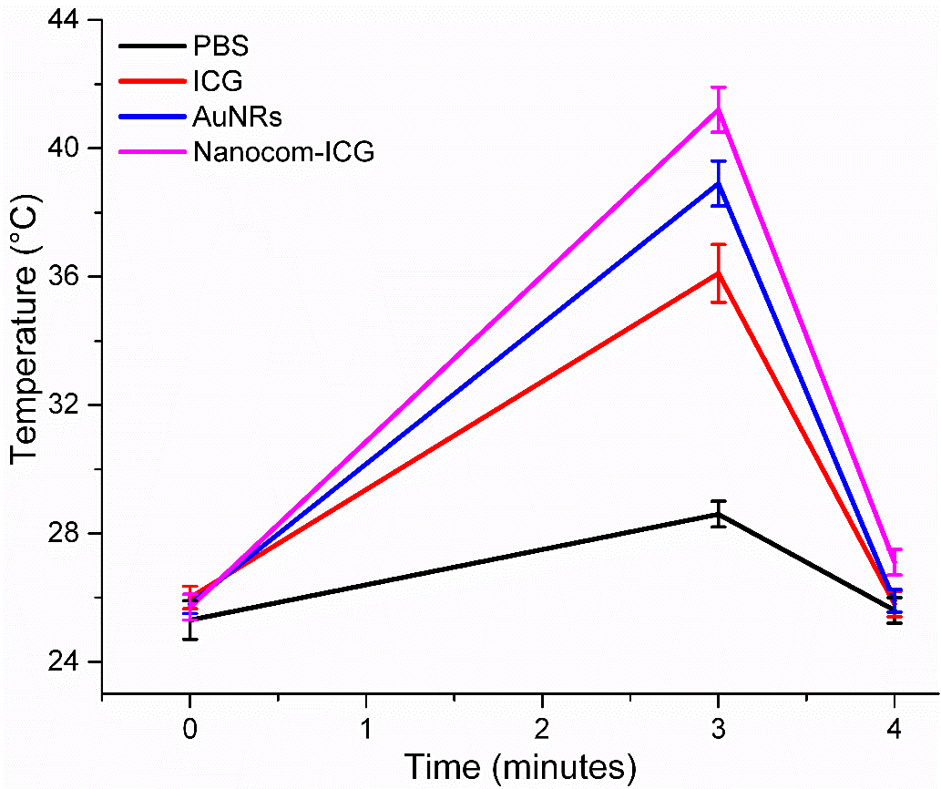
Figure S6. The temperature curves of tumor tissue regions of tumor-bearing mice during laser irradiation.

