Table of Contents | Page
SUPPLEMENTARY FIGURES | 3-11
Supplementary Figure 1. Standardized mean difference of predefined and algorithmically selected high dimensional variables between COVID-19 and contemporary control | 3
Supplementary Figure 2. Standardized mean difference of predefined and algorithmically selected high dimensional variables by care setting of the acute infection between COVID-19 and contemporary control | 4
Supplementary Figure 3. Standardized mean difference of predefined and algorithmically selected high dimensional variables between COVID-19 and historical control | 5
Supplementary Figure 4. Risks and 12-month burdens of post-acute COVID-19 cardiovascular outcomes compared to historical control | 6
Supplementary Figure 5. Risks and 12-month burdens of post-acute COVID-19 composite cardiovascular outcomes compared to historical control | 7
Supplementary Figure 6. Standardized mean difference of predefined and algorithmically selected high dimensional variables by care setting of the acute infection between COVID-19 and historical control | 8
Supplementary Figure 7. Risks and 12-month burdens of post-acute COVID-19 cardiovascular outcomes by care setting of the acute infection compared to historical control | 9
Supplementary Figure 8. Risks and 12-month burdens of post-acute COVID-19 composite cardiovascular outcomes by care setting of the acute infection compared to historical control | 10
Supplementary Figure 9. Cohort construction flowchart | 11
SUPPLEMENTARY TABLES | 12-36
Supplementary Table 1. Demographic and health characteristics of COVID-19, contemporary, and historical cohorts before weighting | 12-13
Supplementary Table 2. Demographic and health characteristics of COVID-19, contemporary, and historical cohorts after weighting | 14-15
Supplementary Table 3. Risks and 12-month burdens of post-acute COVID-19 cardiovascular outcomes compared to contemporary control | 16-17
Supplementary Table 4. Demographic and health characteristics of the COVID-19 and contemporary cohorts by care setting of the acute infection before weighting | 18-19
Supplementary Table 5. Demographic and health characteristics of the COVID-19 and contemporary cohorts by care setting of the acute infection after weighting | 20-21
Supplementary Table 6. Risks and 12-month burdens of post-acute COVID-19 cardiovascular outcomes by care setting of the acute infection compared to contemporary control | 22-24
Supplementary Table 7. Risks and 12-month burdens of post-acute COVID-19 cardiovascular outcomes compared to historical control | 25-26
Supplementary Table 8. Demographic and health characteristics of the COVID-19 and historical cohorts by care setting of the acute infection before weighting | 27-28
Supplementary Table 9. Demographic and health characteristics of the COVID-19 and historical cohorts by care setting of the acute infection after weighting | 29-31
Supplementary Table 10. Risks and 12-month burdens of post-acute COVID-19 cardiovascular outcomes by care setting of the acute infection compared to historical control | 32-33
Supplementary Table 11. Sensitivity analysis for MACE and any cardiovascular outcome compared to contemporary and historical controls | 34
Supplementary Table 12. Sensitivity analyses for MACE and any cardiovascular outcome by care setting of the acute infection compared to contemporary and historical controls | 35
Supplementary Table 13. Positive and negative outcome controls | 36

Supplementary Figure 1. Standardized mean difference of predefined and algorithmically selected high dimensional variables between COVID-19 and contemporary control

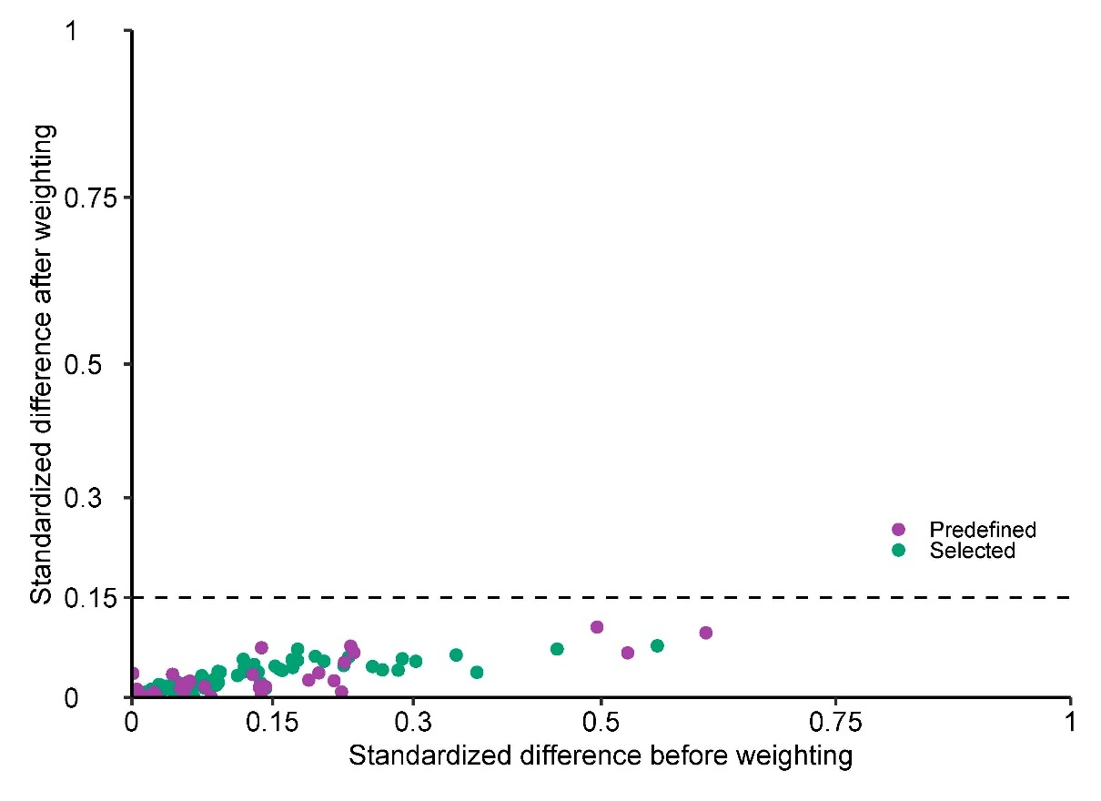

Supplementary Figure 2. Standardized mean difference of predefined and algorithmically selected high dimensional variables by care setting of the acute infection between COVID-19 and contemporary control
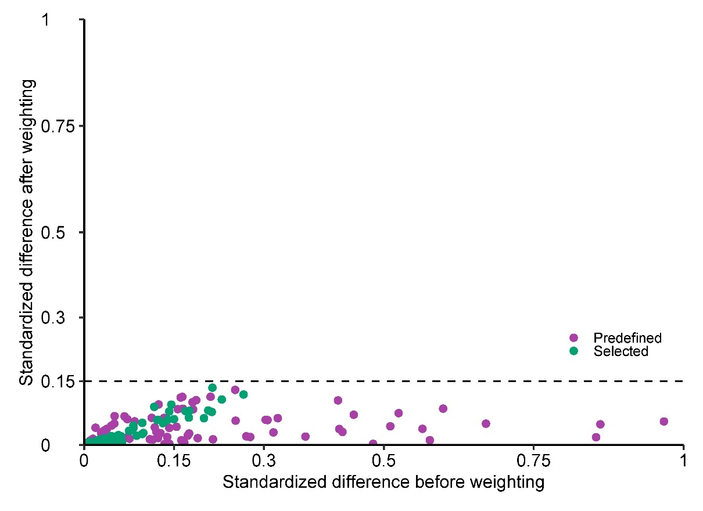
Supplementary Figure 3. Standardized mean difference of predefined and algorithmically selected high dimensional variables between COVID-19 and historical control

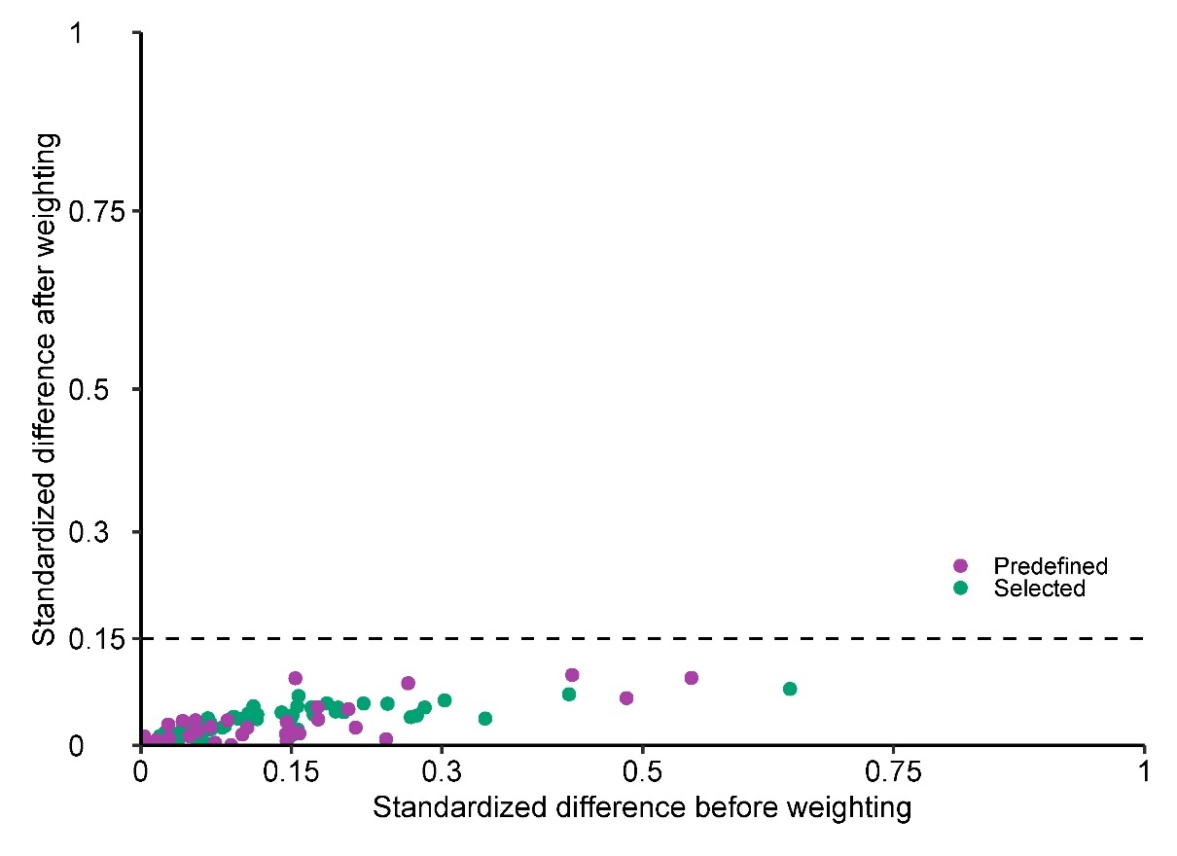

Supplementary Figure 4. Risks and 12-month burdens of post-acute COVID-19 cardiovascular outcomes compared to historical control

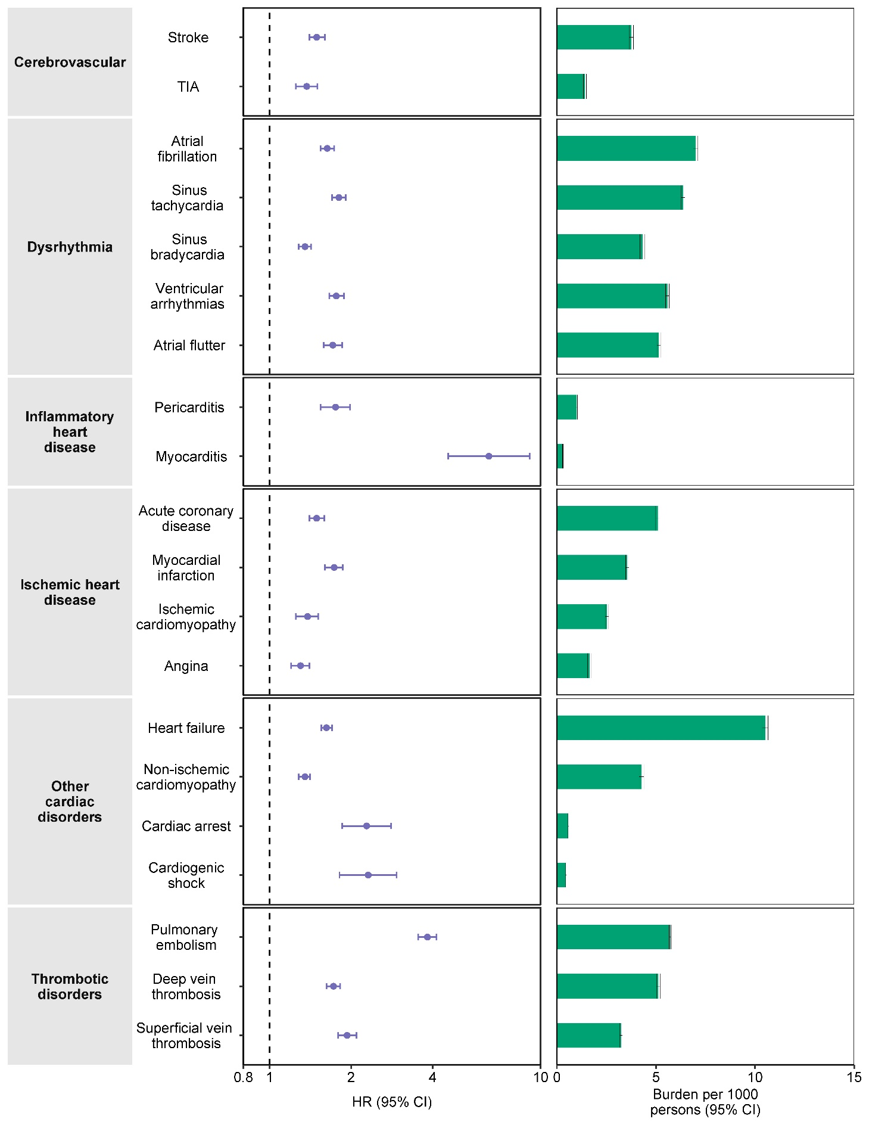
Supplementary Figure 5. Risks and 12-month burdens of post-acute COVID-19 composite cardiovascular outcomes compared to historical control.

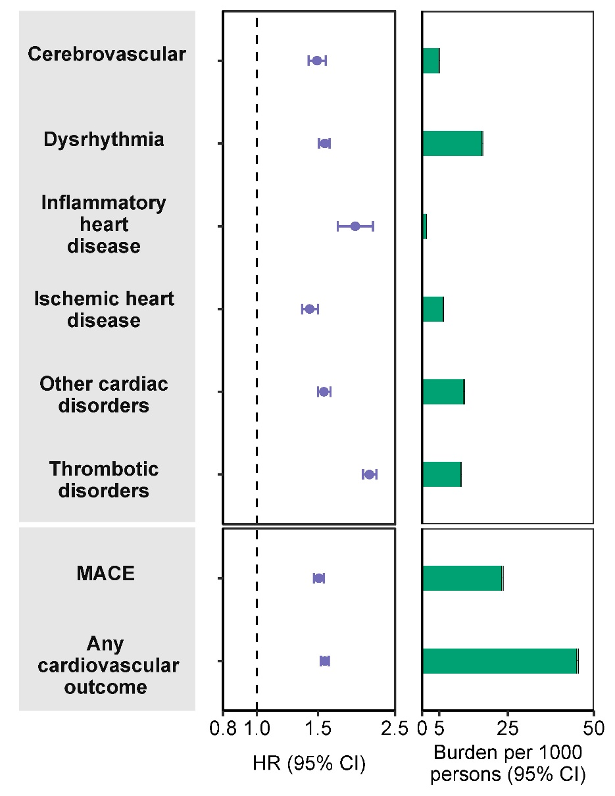

Supplementary Figure 6. Standardized mean difference of predefined and algorithmically selected high dimensional variables by care setting of the acute infection between COVID-19 and historical control

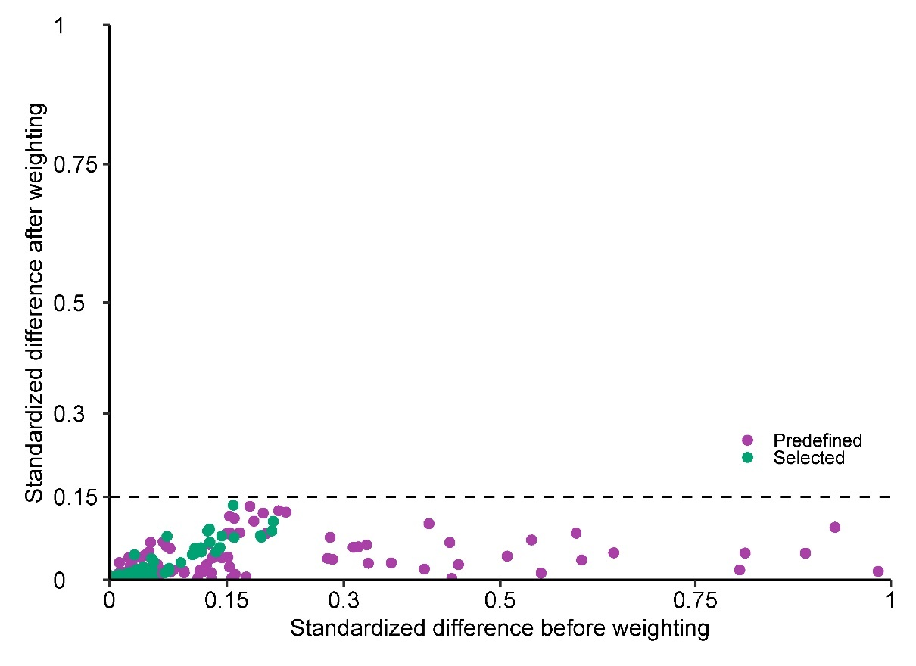

Supplementary Figure 7. Risks and 12-month burdens of post-acute COVID-19 cardiovascular outcomes by care setting of the acute infection compared to historical control.

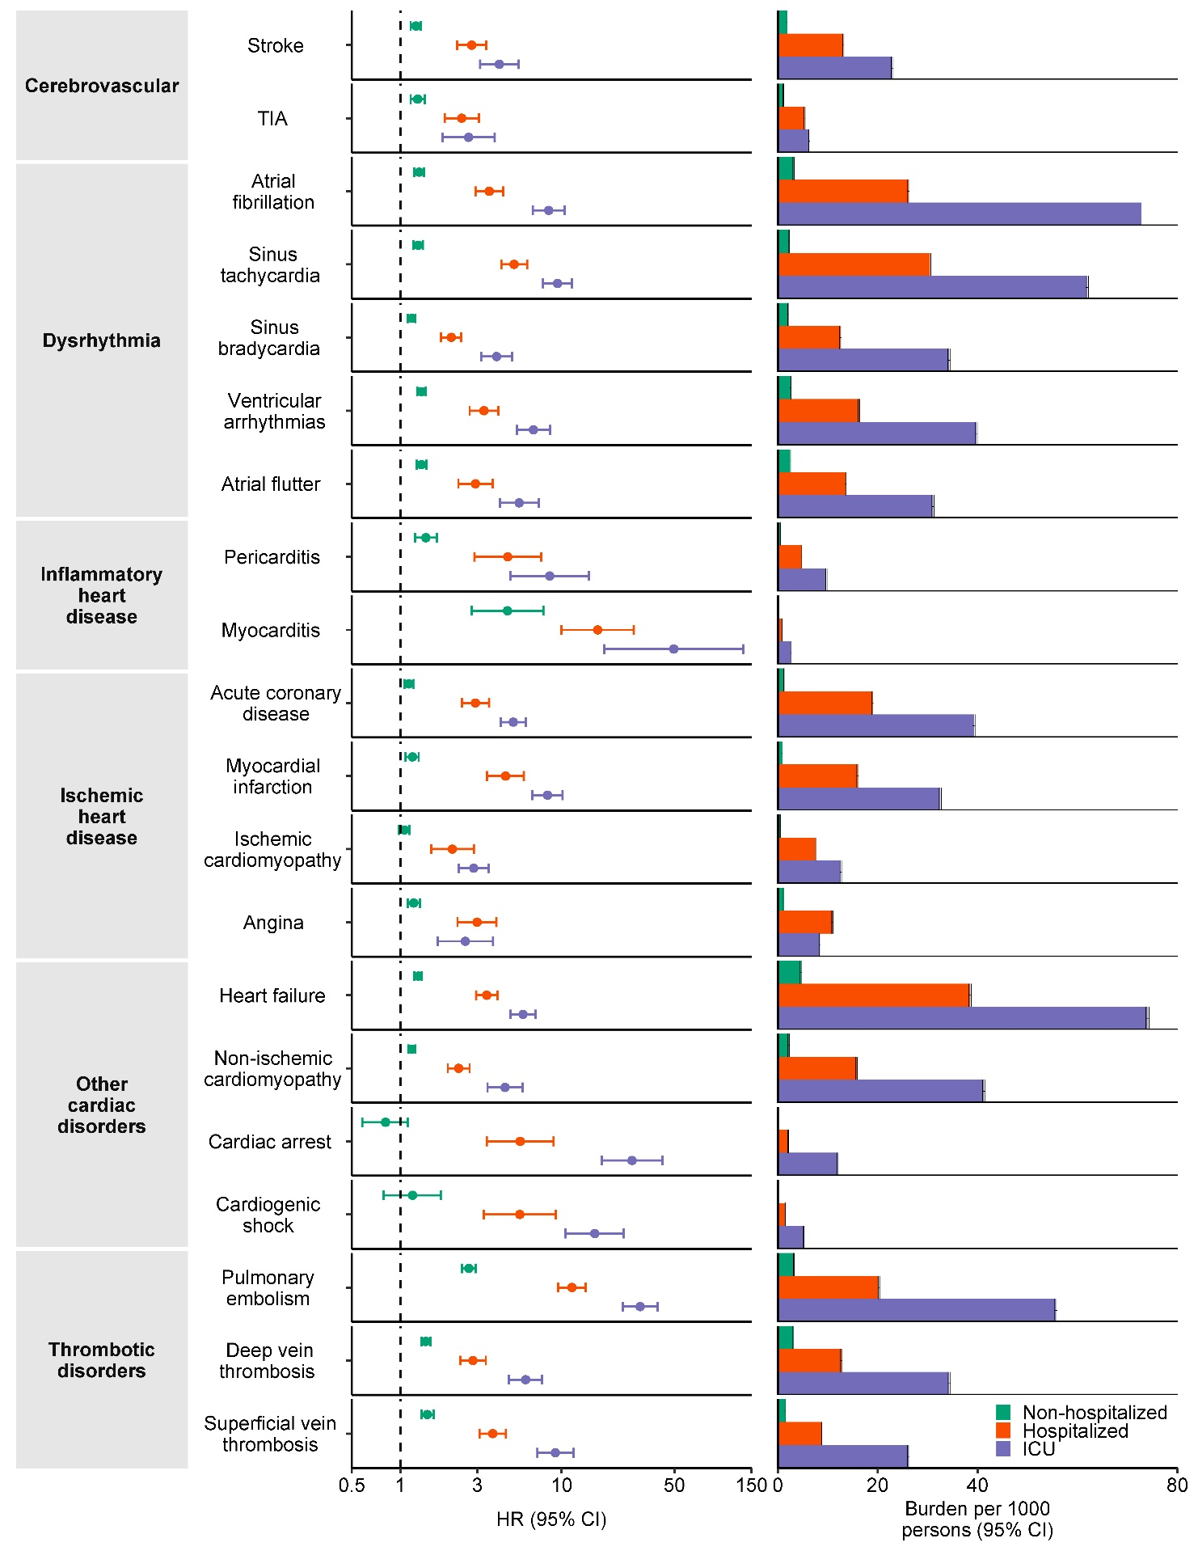
Supplementary Figure 8. Risks and 12-month burdens of post-acute COVID-19 composite cardiovascular outcomes by care setting of the acute infection compared to historical control.

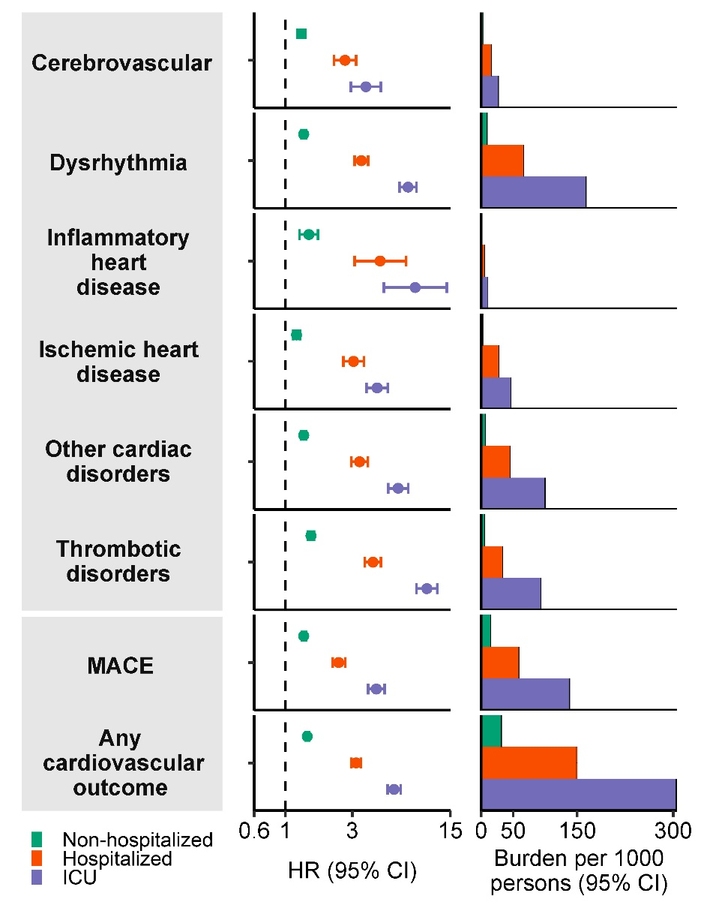

Supplementary Figure 9. Cohort construction flowchart

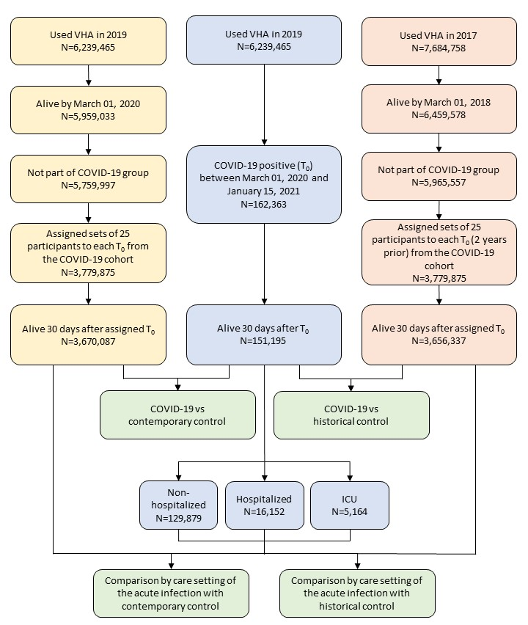
Supplementary Table 1. Demographic and health characteristics of COVID-19, contemporary, and historical cohorts before weighting

Baseline Characteristics | COVID-19 (N=151,195) | Contemporary control (N=3,670,087) | Historical control (N=3,656,337) | Absolute standardized difference – COVID-19 and Contemporary  control | Absolute standardized difference – COVID-19 and Historical  control
Age, mean (std), yr | 61.31 (15.62) | 63.48 (16.23) | 62.94 (16.49) | 0.14 | 0.10
Race, no. (%)
White | 106,988 (70.77) | 2,820,388 (76.85) | 2,829,639 (77.39) | 0.14 | 0.14
Black | 36,669 (24.26) | 676,176 (18.43) | 654,484 (17.90) | 0.14 | 0.16
Other | 7,535 (4.99) | 173,521 (4.73) | 172,213 (4.70) | 0.01 | 0.01
Sex, no. (%)
Male | 134,565 (89.01) | 3,315,042 (90.33) | 3,313,007 (90.61) | 0.04 | 0.04
Female | 16,629 (11.00) | 355,044 (9.68) | 341,904 (9.39) | 0.04 | 0.05
BMI category, no. (%), kg/m²
Underweight/Normal | 21,728 (14.38) | 716,914 (19.54) | 730,536 (19.98) | 0.14 | 0.15
Overweight | 47,989 (31.74) | 1,406,487 (38.33) | 1,434,381 (39.23) | 0.14 | 0.15
Obese | 81,477 (53.89) | 1,546,684 (42.15) | 1,493,979 (40.86) | 0.24 | 0.27
Smoking status, no. (%)
Never | 81,628 (53.99) | 1,867,927 (50.90) | 1,787,218 (48.88) | 0.06 | 0.11
Former | 42,668 (28.23) | 944,533 (25.74) | 989,770 (27.07) | 0.06 | 0.03
Current | 26,899 (17.80) | 857,589 (23.37) | 879,715 (24.06) | 0.14 | 0.15
Area Deprivation Indexª, mean (std) | 52.52 (15.22) | 51.69 (15.89) | 51.68 (15.97) | 0.05 | 0.05
Clinical Characteristics

Outpatient encounter*, no. (%)
Zero | 29,224 (19.33) | 1,577,696 (42.99) | 1,501,658 (41.07) | 0.53 | 0.48
One | 43,276 (28.63) | 1,048,213 (28.57) | 989,770 (27.49) | 0.00 | 0.03
Two or more | 78,693 (52.05) | 1,044,176 (28.46) | 1,145,530 (31.44) | 0.50 | 0.43
Long-term care, no. (%) | 5,961 (3.95) | 21,690 (0.60) | 29,579 (0.81) | 0.23 | 0.21
eGFR, mean (std), ml/min/1.73m² | 77.71 (22.22) | 78.27 (19.63) | 79.27 (19.90) | 0.03 | 0.07
Systolic blood pressure, mean (std), mmHg | 132.65 (12.30) | 132.58 (12.79) | 132.61 (12.66) | 0.01 | 0.00
Diastolic blood pressure, mean (std), mmHg | 78.19 (7.66) | 77.54 (7.74) | 77.49 (7.93) | 0.08 | 0.09
Cancer, no. (%) | 11,906 (7.88) | 216,865 (5.91) | 208,447 (5.71) | 0.08 | 0.09
Chronic kidney disease, no. (%) | 15,290 (10.12) | 240,574 (6.56) | 224,718 (6.15) | 0.13 | 0.15
Chronic lung disease, no. (%) | 338 (0.23) | 4,587 (0.13) | 5,703 (0.16) | 0.02 | 0.02
Dementia, no. (%) | 622 (0.42) | 3,816 (0.11) | 4,387 (0.12) | 0.06 | 0.06
Diabetes mellitus type 2, no. (%) | 48,471 (32.06) | 826,026 (22.51) | 828,526 (22.66) | 0.22 | 0.21
Dysautonomia, no. (%) | 2,756 (1.83) | 43,784 (1.20) | 45,082 (1.24) | 0.05 | 0.05
Hyperlipidemia, no. (%) | 51,403 (34.00) | 932,826 (25.42) | 1,128,711 (30.87) | 0.19 | 0.07
Hypertension, no. (%) | 82,392 (54.50) | 1,635,941 (44.58) | 1,676,796 (45.86) | 0.20 | 0.18
ªArea Deprivation Index is a measure of socioeconomic disadvantage, with a range from low to high disadvantage of 0 to 100.
*.Data collected within one year of cohort enrollment
std, standard deviation; BMI, body mass index; eGFR, estimated glomerular filtration rate.

Supplementary Table 2. Demographic and health characteristics of COVID-19, contemporary, and historical cohorts after weighting

Baseline Characteristics | COVID-19 (N=151,195) | Contemporary control (N=3,670,087) | Historical control (N=3,656,337) | Absolute standardized difference - COVID-19 and Contemporary control | Absolute standardized difference -COVID-19 and Historical control
Age, mean (std), yr | 63.14 (16.15) | 63.39 (16.22) | 63.40 (16.45) | 0.02 | 0.02
Race, no. (%)
White | 114,764 (75.91) | 2,811,837 (76.62) | 2,800,827 (76.61) | 0.02 | 0.02
Black | 29,173 (19.30) | 684,397 (18.65) | 681,285 (18.64) | 0.02 | 0.02
Other | 7,257 (4.80) | 173,852 (4.74) | 173,090 (4.74) | 0.00 | 0.00
Sex, no. (%)
Male | 134,876 (89.21) | 3,313,060 (90.28) | 3,299,917 (90.26) | 0.04 | 0.03
Female | 16,318 (10.80) | 357,026 (9.73) | 355,286 (9.72) | 0.04 | 0.04
BMI category, no. (%), kg/m²
Underweight/Normal | 29,611 (19.59) | 709,978 (19.35) | 707,245 (19.35) | 0.01 | 0.01
Overweight | 52,195 (34.53) | 1,398,927 (38.12) | 1,428,384 (39.07) | 0.07 | 0.09
Obese | 69,386 (45.90) | 1,561,181 (42.54) | 1,519,573 (41.56) | 0.07 | 0.09
Smoking status, no. (%)
Never | 75,243 (49.77) | 1,872,074 (51.01) | 1,864,987 (51.01) | 0.02 | 0.02
Former | 39,752 (26.30) | 948,130 (25.84) | 944,651 (25.84) | 0.01 | 0.01
Current | 36,199 (23.95) | 849,882 (23.16) | 845,564 (23.13) | 0.02 | 0.02
Area Deprivation Indexª, mean (std) | 52.06 (15.72) | 51.72 (15.87) | 51.72 (15.85) | 0.02 | 0.02
Clinical Characteristics

Outpatient encounter*, no. (%)
Zero | 58,610 (38.77) | 1,543,565 (42.06) | 1,536,795 (42.04) | 0.07 | 0.07
One | 40,775 (26.97) | 1,049,461 (28.6) | 1,034,158 (28.29) | 0.04 | 0.03
Two or more | 51,808 (34.27) | 1,077,060 (29.35) | 1,084,250 (29.66) | 0.11 | 0.10
Long-term care, no. (%) | 1,886 (1.25) | 26,644 (0.73) | 27,130 (0.75) | 0.05 | 0.05
eGFR, mean (std), ml/min/1.73m² | 78.30 (20.34) | 78.25 (19.73) | 78.23 (19.89) | 0.00 | 0.00
Systolic blood pressure, mean (std), mmHg | 132.42 (12.77) | 132.58 (12.77) | 132.59 (12.83) | 0.01 | 0.01
Diastolic blood pressure, mean (std), mmHg | 77.56 (7.76) | 77.57 (7.74) | 77.56 (7.77) | 0.00 | 0.00
Cancer, no. (%) | 9,700 (6.42) | 220,608 (6.02) | 203,913 (5.58) | 0.02 | 0.04
Chronic kidney disease, no. (%) | 11,474 (7.59) | 245,822 (6.70) | 246,437 (6.74) | 0.01 | 0.03
Chronic lung disease, no. (%) | 241 (0.16) | 4,734 (0.13) | 4,789 (0.14) | 0.03 | 0.01
Dementia, no. (%) | 302 (0.20) | 4,294 (0.12) | 4,424 (0.13) | 0.02 | 0.02
Diabetes mellitus type 2, no. (%) | 36,226 (23.96) | 839,789 (22.89) | 837,154 (22.90) | 0.03 | 0.03
Dysautonomia, no. (%) | 2,078 (1.38) | 44,738 (1.22) | 44,717 (1.23) | 0.01 | 0.01
Hyperlipidemia, no. (%) | 40,689 (26.92) | 945,194 (25.76) | 942,018 (25.77) | 0.03 | 0.03
Hypertension, no. (%) | 70,783 (46.82) | 1,650,401 (44.97) | 1,645,095 (45.00) | 0.04 | 0.04
ªArea Deprivation Index is a measure of socioeconomic disadvantage, with a range from low to high disadvantage of 0 to 100.
*.Data collected within one year before cohort enrollment
std, standard deviation; BMI, body mass index; eGFR, estimated glomerular filtration rate.

Supplementary Table 3. Risks and 12-month burdens of post-acute COVID-19 cardiovascular outcomes compared to contemporary control

Outcome* | Hazard Ratio (95% CI)† | COVID-19 burden per 1000 persons at 12 months (95% CI) † | Contemporary control burden per 1000 persons at 12 months (95% CI) † | Absolute burden difference per 1000 persons at 12 months (95% CI) †
 | COVID-19 vs Contemporary control
Cerebrovascular | 1.48 (1.40, 1.57) | 15.36 (15.21, 15.51) | 10.40 (10.29, 10.52) | 4.95 (4.84, 5.07)
Stroke | 1.48 (1.38, 1.58) | 11.42 (11.29, 11.54) | 7.73 (7.63, 7.83) | 3.69 (3.59, 3.78)
TIA | 1.40 (1.27, 1.53) | 5.21 (5.13, 5.30) | 3.74 (3.67, 3.81) | 1.48 (1.41, 1.54)
Dysrhythmia | 1.66 (1.60, 1.72) | 49.49 (49.22, 49.75) | 30.17 (29.98, 30.37) | 19.31 (19.12, 19.51)
Atrial fibrillation | 1.79 (1.69, 1.90) | 18.18 (18.01, 18.34) | 10.19 (10.07, 10.31) | 7.99 (7.87, 8.10)
Sinus tachycardia | 1.82 (1.72, 1.93) | 14.38 (14.23, 14.52) | 7.92 (7.82, 8.01) | 6.46 (6.36, 6.56)
Sinus bradycardia | 1.49 (1.42, 1.57) | 16.75 (16.60, 16.90) | 11.27 (11.15, 11.39) | 5.48 (5.36, 5.60)
Ventricular arrhythmia | 1.56 (1.47, 1.66) | 12.91 (12.78, 13.05) | 8.30 (8.20, 8.40) | 4.61 (4.51, 4.71)
Atrial flutter | 1.57 (1.45, 1.70) | 12.39 (12.27, 12.52) | 7.90 (7.80, 8.00) | 4.49 (4.40, 4.59)
Inflammatory heart disease | 1.77 (1.57, 1.99) | 2.65 (2.59, 2.71) | 1.50 (1.46, 1.54) | 1.15 (1.10, 1.19)
Pericarditis | 1.62 (1.43, 1.83) | 2.34 (2.28, 2.39) | 1.45 (1.40, 1.49) | 0.89 (0.85, 0.93)
Myocarditis | 5.22 (3.71, 7.35) | 0.35 (0.33, 0.38) | 0.07 (0.06, 0.08) | 0.29 (0.28, 0.29)
Ischemic heart disease | 1.47 (1.40, 1.56) | 20.89 (20.72, 21.06) | 14.22 (14.09, 14.35) | 6.67 (6.54, 6.80)
Acute coronary disease | 1.48 (1.38, 1.58) | 15.53 (15.38, 15.67) | 10.54 (10.43, 10.65) | 4.99 (4.87, 5.10)
Myocardial infarction | 1.61 (1.49, 1.73) | 8.46 (8.35, 8.57) | 5.27 (5.19, 5.35) | 3.19 (3.11, 3.27)
Ischemic cardiomyopathy | 1.41 (1.28, 1.55) | 9.27 (9.16, 9.38) | 6.58 (6.49, 6.67) | 2.69 (2.60, 2.78)
Angina | 1.48 (1.37, 1.60) | 7.20 (7.10, 7.30) | 4.87 (4.79, 4.95) | 2.33 (2.25, 2.41)
Other cardiac disorders | 1.64 (1.58, 1.71) | 34.28 (34.07, 34.50) | 21.01 (20.85, 21.17) | 13.28 (13.11, 13.44)
Heart failure | 1.73 (1.65, 1.81) | 27.61 (27.41, 27.81) | 16.04 (15.90, 16.18) | 11.57 (11.43, 11.72)
Non-ischemic cardiomyopathy | 1.35 (1.28, 1.41) | 16.66 (16.51, 16.80) | 12.39 (12.27, 12.51) | 4.26 (4.14, 4.38)
Cardiac arrest | 2.15 (1.75, 2.65) | 1.03 (0.99, 1.07) | 0.48 (0.45, 0.50) | 0.55 (0.53, 0.58)
Cardiogenic shock | 2.17 (1.70, 2.77) | 0.82 (0.78, 0.85) | 0.38 (0.35, 0.40) | 0.44 (0.42, 0.46)
Thrombotic disorders | 1.92 (1.84, 2.01) | 21.73 (21.56, 21.90) | 11.37 (11.25, 11.48) | 10.36 (10.25, 10.48)
Pulmonary embolism | 3.06 (2.83, 3.31) | 7.75 (7.64, 7.85) | 2.54 (2.48, 2.59) | 5.21 (5.15, 5.26)
Deep vein thrombosis | 1.62 (1.53, 1.71) | 12.32 (12.19, 12.44) | 7.63 (7.54, 7.72) | 4.69 (4.59, 4.78)
Superficial vein thrombosis | 1.73 (1.61, 1.87) | 6.74 (6.64, 6.83) | 3.89 (3.83, 3.96) | 2.84 (2.77, 2.91)
MACE | 1.55 (1.50, 1.60) | 70.65 (70.35, 70.95) | 46.26 (46.03, 46.50) | 24.39 (24.15, 24.62)
Any cardiac outcome | 1.64 (1.60, 1.68) | 129.87 (129.45, 130.28) | 81.55 (81.23, 81.87) | 48.32 (48.00, 48.64)
*. Outcomes were ascertained from day 30 after the initial positive COVID-19 test result until end of follow up
†. Adjustment through inverse probability weighting using predefined and algorithmically selected high-dimensional variables.
CI, confidence interval; TIA, transient ischemic attack; MACE, major adverse cardiac events.

Supplementary Table 4. Demographic and health characteristics of the COVID-19 and contemporary cohorts by care setting of the acute infection before weighting

Baseline Characteristics | Non-hospitalized (N=129,879) | Hospitalized (N=16,152) | Admitted to intensive care (N=5,164) | Contemporary control (N=3,670,087) | Absolute standardized difference - Non-hospitalized and Contemporary control | Absolute standardized difference - Hospitalized and Contemporary control | Absolute standardized difference - Admitted to intensive care and Contemporary control
Age, mean (std), yr | 60.14 (15.70) | 68.32 (13.34) | 68.75 (12.00) | 63.48 (16.23) | 0.21 | 0.33 | 0.37
Race, no. (%)
White | 93,607 (72.08) | 11,966 (74.09) | 3,815 (73.89) | 2,820,388 (76.85) | 0.11 | 0.31 | 0.32
Black | 29,951 (23.07) | 3,394 (21.02) | 1,023 (19.82) | 676,176 (18.43) | 0.11 | 0.30 | 0.32
Other | 6,319 (4.87) | 791 (4.91) | 324 (6.29) | 173,521 (4.73) | 0.01 | 0.04 | 0.05
Sex, no. (%)
Male | 114,474 (88.14) | 14,767 (91.43) | 4,785 (92.67) | 3,315,042 (90.33) | 0.07 | 0.14 | 0.16
Female | 15,404 (11.87) | 1,384 (8.57) | 378 (7.34) | 355,044 (9.68) | 0.07 | 0.14 | 0.16
BMI category, no. (%), kg/m²
Underweight/ Normal | 17,346 (13.36) | 3,232 (20.02) | 977 (18.94) | 716,914 (19.54) | 0.17 | 0.04 | 0.02
Overweight | 41,514 (31.97) | 5,282 (32.71) | 1,719 (33.30) | 1,406,487 (38.33) | 0.13 | 0.16 | 0.18
Obese | 71,016 (54.68) | 7,636 (47.28) | 2,467 (47.78) | 1,546,684 (42.15) | 0.25 | 0.12 | 0.19
Smoking status, no. (%)
Never | 71,015 (54.68) | 7,909 (48.98) | 2,716 (52.60) | 1,867,927 (50.90) | 0.08 | 0.02 | 0.03
Former | 35,955 (27.69) | 4,057 (25.12) | 1,341 (25.98) | 944,533 (25.74) | 0.04 | 0.12 | 0.14
Current | 22,908 (17.64) | 4,184 (25.91) | 1,106 (21.43) | 857,589 (23.37) | 0.14 | 0.11 | 0.12
Area Deprivation Indexª, mean (std) | 52.59 (15.26) | 51.81 (15.00) | 52.80 (14.91) | 51.69 (15.89) | 0.06 | 0.01 | 0.07
Clinical Characteristics

Outpatient encounter*, no. (%)
Zero | 27,420 (21.12) | 7,183 (44.48) | 2,219 (42.98) | 1,577,696 (42.99) | 0.48 | 0.86 | 0.85
One | 39,183 (30.17) | 3,814 (23.62) | 1,184 (22.93) | 1,048,213 (28.57) | 0.04 | 0.21 | 0.25
Two or more | 63,275 (48.72) | 5,153 (31.91) | 1,760 (34.10) | 1,044,176 (28.46) | 0.43 | 0.97 | 1.01
Long-term care, no. (%) | 3,723 (2.87) | 236 (1.47) | 99 (1.93) | 21,690 (0.60) | 0.18 | 0.45 | 0.42
eGFR, mean (std), ml/min/1.73m² | 79.37 (21.05) | 68.42 (25.94) | 65.07 (26.62) | 78.27 (19.63) | 0.05 | 0.43 | 0.56
Systolic blood pressure, mean (std), mmHg | 132.34 (12.22) | 134.49 (12.55) | 134.65 (12.83) | 132.58 (12.79) | 0.02 | 0.15 | 0.16
Diastolic blood pressure, mean (std), mmHg | 78.39 (7.61) | 77.06 (7.84) | 76.88 (7.99) | 77.54 (7.74) | 0.11 | 0.06 | 0.08
Cancer, no. (%) | 8,926 (6.88) | 1,051 (6.52) | 334 (6.48) | 216,865 (5.91) | 0.04 | 0.27 | 0.28
Chronic kidney disease, no. (%) | 10,586 (8.16) | 1,209 (7.49) | 449 (8.70) | 240,574 (6.56) | 0.06 | 0.43 | 0.52
Chronic lung disease, no. (%) | 267 (0.21) | 24 (0.15) | 7 (0.15) | 4,587 (0.13) | 0.02 | 0.04 | 0.04
Dementia, no. (%) | 310 (0.24) | 51 (0.32) | 32 (0.64) | 3,816 (0.11) | 0.03 | 0.15 | 0.16
Diabetes mellitus type 2, no. (%) | 38,455 (29.61) | 3,999 (24.77) | 1,372 (26.58) | 826,026 (22.51) | 0.16 | 0.51 | 0.60
Dysautonomia, no. (%) | 2,093 (1.62) | 200 (1.25) | 79 (1.55) | 43,784 (1.20) | 0.04 | 0.13 | 0.13
Hyperlipidemia, no. (%) | 44,212 (34.05) | 4,004 (24.80) | 1,360 (26.35) | 932,826 (25.42) | 0.19 | 0.58 | 0.22
Hypertension, no. (%) | 66,869 (51.49) | 7,171 (44.40) | 2,451 (47.48) | 1,635,941 (44.58) | 0.14 | 0.17 | 0.67
ªArea Deprivation Index is a measure of socioeconomic disadvantage, with a range from low to high disadvantage of 0 to 100.
*.Data collected within one year before cohort enrollment
std, standard deviation; BMI, body mass index; eGFR, estimated glomerular filtration rate.

Supplementary Table 5. Demographic and health characteristics of the COVID-19 and contemporary cohorts by care setting of the acute infection after weighting

Baseline Characteristics | Non-hospitalized (N=129,879) | Hospitalized (N=16,152) | Admitted to intensive care (N=5,164) | Contemporary control (N=3,670,087) | Absolute standardized difference - Non-hospitalized and Contemporary control | Absolute standardized difference - Hospitalized and Contemporary control | Absolute standardized difference - Admitted to intensive care and Contemporary control
Age, mean (std), yr | 63.23 (16.32) | 63.21 (15.78) | 63.72 (15.81) | 63.39 (16.22) | 0.01 | 0.01 | 0.02
Race, no. (%)
White | 98,747 (76.03) | 11,966 (74.09) | 3,815 (73.89) | 2,811,837 (76.62) | 0.01 | 0.06 | 0.06
Black | 24,873 (19.16) | 3,394 (21.02) | 1,023 (19.82) | 684,397 (18.65) | 0.01 | 0.06 | 0.03
Other | 6,257 (4.82) | 791 (4.91) | 324 (6.29) | 173,852 (4.74) | 0.00 | 0.01 | 0.07
Sex, no. (%)

Male | 116,556 (89.75) | 14,767 (91.43) | 4,785 (92.67) | 3,313,060 (90.28) | 0.02 | 0.04 | 0.09
Female | 13,322 (10.26) | 1,384 (8.57) | 378 (7.34) | 357,026 (9.73) | 0.02 | 0.04 | 0.09
BMI category, no. (%), kg/m²

Underweight/ Normal | 25,413 (19.57) | 3,232 (20.02) | 977 (18.94) | 709,978 (19.35) | 0.01 | 0.02 | 0.01
Overweight | 45,522 (35.05) | 5,282 (32.71) | 1,719 (33.30) | 1,398,927 (38.12) | 0.06 | 0.11 | 0.10
Obese | 58,942 (45.39) | 7,636 (47.28) | 2,467 (47.78) | 1,561,181 (42.54) | 0.06 | 0.10 | 0.11
Smoking status, no. (%)
Never | 65,270 (50.26) | 7,909 (48.98) | 2,716 (52.60) | 1,872,074 (51.01) | 0.02 | 0.04 | 0.03
Former | 34,364 (26.46) | 4,057 (25.12) | 1,341 (25.98) | 948,130 (25.84) | 0.01 | 0.02 | 0.00
Current | 30,243 (23.29) | 4,184 (25.91) | 1,106 (21.43) | 849,882 (23.16) | 0.00 | 0.06 | 0.04
Area Deprivation Indexª, mean (std) | 51.96 (15.73) | 52.17 (15.86) | 52.69 (15.75) | 51.72 (15.87) | 0.01 | 0.03 | 0.06
Clinical Characteristics
Outpatient encounter*, no. (%)

Zero | 54,440 (41.92) | 7,183 (44.48) | 2,219 (42.98) | 1,543,565 (42.06) | 0.00 | 0.05 | 0.02
One | 35,060 (27.00) | 3,814 (23.62) | 1,184 (22.93) | 1,049,461 (28.6) | 0.04 | 0.11 | 0.13
Two or more | 40,378 (31.09) | 5,153 (31.91) | 1,760 (34.10) | 1,077,060 (29.35) | 0.04 | 0.06 | 0.10
Long-term care, no. (%) | 1,267 (0.98) | 236 (1.47) | 99 (1.93) | 26,644 (0.73) | 0.03 | 0.07 | 0.10
eGFR, mean (std), ml/min/1.73m² | 78.16 (20.14) | 78.01 (21.05) | 77.46 (21.60) | 78.25 (19.73) | 0.00 | 0.01 | 0.04
Systolic blood pressure, mean (std), mmHg | 132.51 (12.82) | 133.16 (12.80) | 134.03 (13.12) | 132.58 (12.77) | 0.01 | 0.05 | 0.11
Diastolic blood pressure, mean (std), mmHg | 77.56 (7.80) | 78.10 (8.03) | 78.00 (7.80) | 77.57 (7.74) | 0.00 | 0.07 | 0.06
Cancer, no. (%) | 7,674 (5.91) | 1,051 (6.52) | 334 (6.48) | 220,608 (6.02) | 0.00 | 0.02 | 0.02
Chronic kidney disease, no. (%) | 9,260 (7.13) | 1,209 (7.49) | 449 (8.70) | 245,822 (6.70) | 0.02 | 0.03 | 0.08
Chronic lung disease, no. (%) | 167 (0.13) | 24 (0.15) | 7 (0.15) | 4,734 (0.13) | 0.00 | 0.01 | 0.00
Dementia, no. (%) | 183 (0.15) | 51 (0.32) | 32 (0.64) | 4,294 (0.12) | 0.01 | 0.04 | 0.08
Diabetes mellitus type 2, no. (%) | 30,335 (23.36) | 3,999 (24.77) | 1,372 (26.58) | 839,789 (22.89) | 0.01 | 0.04 | 0.09
Dysautonomia, no. (%) | 1,654 (1.28) | 200 (1.25) | 79 (1.55) | 44,738 (1.22) | 0.00 | 0.00 | 0.03
Hyperlipidemia, no. (%) | 34,376 (26.47) | 4,004 (24.80) | 1,360 (26.35) | 945,194 (25.76) | 0.02 | 0.01 | 0.01
Hypertension, no. (%) | 59,637 (45.92) | 7,171 (44.40) | 2,451 (47.48) | 1,650,401 (44.97) | 0.02 | 0.02 | 0.05
ªArea Deprivation Index is a measure of socioeconomic disadvantage, with a range from low to high disadvantage of 0 to 100.
*.Data collected within one year before cohort enrollment
std, standard deviation; BMI, body mass index; eGFR, estimated glomerular filtration rate.

Supplementary Table 6. Risks and 12-month burdens of post-acute COVID-19 cardiovascular outcomes by care setting of the acute infection compared to contemporary control

Outcome* | Care setting† | Hazard ratio (95% CI) ‡ | COVID-19 burden per 1000 persons at 12 months (95% CI) ‡ | Contemporary control burden per 1000 persons at 12 months (95% CI) ‡ | Burden difference per 1000 persons at 12 months (95% CI) ‡
Cerebrovascular | Non-hospitalized | 1.30 (1.22, 1.38) | 13.14 (13.02, 13.27) | 10.12 (10.02, 10.23) | 3.02 (2.89, 3.14)
 | Hospitalized | 2.66 (2.22, 3.19) | 26.74 (26.56, 26.92) |  | 16.62 (16.43, 16.80)
 | Admitted to intensive care | 3.75 (2.93, 4.79) | 37.42 (37.20, 37.64) |  | 27.29 (27.07, 27.52)
Stroke | Non-hospitalized | 1.24 (1.16, 1.34) | 9.33 (9.23, 9.44) | 7.50 (7.41, 7.59) | 1.83 (1.72, 1.93)
 | Hospitalized | 2.77 (2.24, 3.42) | 20.61 (20.45, 20.77) |  | 13.11 (12.95, 13.27)
 | Admitted to intensive care | 4.10 (3.11, 5.41) | 30.40 (30.20, 30.61) |  | 22.90 (22.70, 23.10)
TIA | Non-hospitalized | 1.32 (1.19, 1.45) | 4.93 (4.85, 5.01) | 3.75 (3.68, 3.81) | 1.18 (1.11, 1.26)
 | Hospitalized | 2.47 (1.92, 3.17) | 9.22 (9.11, 9.32) |  | 5.47 (5.36, 5.58)
 | Admitted to intensive care | 2.72 (1.86, 3.96) | 10.14 (10.02, 10.26) |  | 6.39 (6.27, 6.51)
Dysrhythmia | Non-hospitalized | 1.35 (1.30, 1.40) | 37.80 (37.59, 38.01) | 28.10 (27.92, 28.27) | 9.70 (9.50, 9.91)
 | Hospitalized | 3.48 (3.12, 3.89) | 94.43 (94.10, 94.76) |  | 66.33 (66.00, 66.66)
 | Admitted to intensive care | 7.49 (6.50, 8.62) | 192.12 (191.65, 192.58) |  | 164.02 (163.56, 164.49)
Atrial fibrillation | Non-hospitalized | 1.45 (1.36, 1.55) | 13.53 (13.41, 13.66) | 9.34 (9.24, 9.44) | 4.19 (4.07, 4.32)
 | Hospitalized | 3.96 (3.25, 4.83) | 36.50 (36.29, 36.71) |  | 27.16 (26.95, 27.37)
 | Admitted to intensive care | 9.25 (7.35, 11.64) | 83.14 (82.82, 83.46) |  | 73.80 (73.48, 74.12)
Sinus tachycardia | Non-hospitalized | 1.33 (1.25, 1.42) | 9.83 (9.73, 9.94) | 7.41 (7.32, 7.50) | 2.43 (2.32, 2.53)
 | Hospitalized | 5.22 (4.34, 6.28) | 38.05 (37.84, 38.26) |  | 30.65 (30.44, 30.86)
 | Admitted to intensive care | 9.70 (7.88, 11.93) | 69.54 (69.25, 69.83) |  | 62.13 (61.84, 62.42)
Sinus bradycardia | Non-hospitalized | 1.31 (1.24, 1.38) | 13.99 (13.86, 14.12) | 10.69 (10.58, 10.80) | 3.30 (3.17, 3.43)
 | Hospitalized | 2.30 (1.99, 2.66) | 24.44 (24.27, 24.61) |  | 13.75 (13.58, 13.92)
 | Admitted to intensive care | 4.40 (3.52, 5.50) | 46.19 (45.95, 46.44) |  | 35.50 (35.26, 35.74)
Ventricular arrhythmia | Non-hospitalized | 1.22 (1.14, 1.30) | 9.67 (9.56, 9.77) | 7.17 (7.08, 7.25) | 1.70 (1.60, 1.81)
 | Hospitalized | 2.96 (2.42, 3.64) | 23.42 (23.26, 23.59) |  | 15.46 (15.30, 15.63)
 | Admitted to intensive care | 6.01 (4.74, 7.62) | 46.89 (46.65, 47.13) |  | 38.93 (38.68, 39.17)
Atrial flutter | Non-hospitalized | 1.26 (1.18, 1.35) | 9.59 (9.48, 9.69) | 7.61 (7.52, 7.70) | 1.98 (1.87, 2.08)
 | Hospitalized | 2.73 (2.14, 3.49) | 20.63 (20.48, 20.78) |  | 13.02 (12.87, 13.17)
 | Admitted to intensive care | 5.09 (3.86, 6.72) | 38.13 (37.91, 38.35) |  | 30.52 (30.30, 30.74)
Inflammatory heart disease | Non-hospitalized | 1.47 (1.26, 1.71) | 2.12 (2.08, 2.17) | 1.45 (1.41, 1.49) | 0.68 (0.63, 0.73)
 | Hospitalized | 4.74 (3.11, 7.25) | 6.84 (6.75, 6.93) |  | 5.39 (5.30, 5.49)
 | Admitted to intensive care | 8.43 (5.02, 14.16) | 12.12 (11.99, 12.25) |  | 10.67 (10.55, 10.80)
Pericarditis | Non-hospitalized | 1.36 (1.16, 1.59) | 1.89 (1.85, 1.94) | 1.39 (1.35, 1.43) | 0.50 (0.45, 0.54)
 | Hospitalized | 4.37 (2.72, 7.02) | 6.08 (5.99, 6.17) |  | 4.68 (4.60, 4.77)
 | Admitted to intensive care | 7.96 (4.52, 14.01) | 11.04 (10.92, 11.16) |  | 9.65 (9.52, 9.77)
Myocarditis | Non-hospitalized | 3.77 (2.27, 6.25) | 0.25 (0.23, 0.27) | 0.07 (0.06, 0.08) | 0.18 (0.17, 0.20)
 | Hospitalized | 13.64 (8.19, 22.71) | 0.91 (0.88, 0.94) |  | 0.84 (0.81, 0.87)
 | Admitted to intensive care | 40.40 (15.00, 108.8) | 2.69 (2.63, 2.75) |  | 2.62 (2.57, 2.68)
Ischemic heart disease | Non-hospitalized | 1.20 (1.14, 1.27) | 16.41 (16.27, 16.54) | 13.66 (13.53, 13.78) | 2.75 (2.61, 2.89)
 | Hospitalized | 3.06 (2.59, 3.63) | 41.26 (41.04, 41.48) |  | 27.60 (27.38, 27.82)
 | Admitted to intensive care | 4.51 (3.79, 5.37) | 60.15 (59.87, 60.42) |  | 46.49 (46.22, 46.77)
Acute coronary disease | Non-hospitalized | 1.13 (1.06, 1.20) | 11.30 (11.19, 11.41) | 10.04 (9.93, 10.14) | 1.26 (1.15, 1.37)
 | Hospitalized | 2.92 (2.41, 3.55) | 29.06 (28.88, 29.24) |  | 19.02 (18.84, 19.20)
 | Admitted to intensive care | 5.00 (4.19, 5.98) | 49.24 (48.99, 49.49) |  | 39.20 (38.95, 39.45)
Myocardial infarction | Non-hospitalized | 1.12 (1.03, 1.23) | 5.48 (5.40, 5.56) | 4.88 (4.80, 4.95) | 0.60 (0.52, 0.68)
 | Hospitalized | 4.25 (3.27, 5.53) | 20.56 (20.41, 20.72) |  | 15.68 (15.53, 15.84)
 | Admitted to intensive care | 7.74 (6.22, 9.62) | 37.12 (36.90, 37.34) |  | 32.24 (32.03, 32.46)
Ischemic cardiomyopathy | Non-hospitalized | 1.11 (1.03, 1.19) | 7.29 (7.19, 7.38) | 6.59 (6.50, 6.67) | 0.70 (0.61, 0.79)
 | Hospitalized | 2.20 (1.62, 2.98) | 14.43 (14.3, 14.56) |  | 7.85 (7.71, 7.98)
 | Admitted to intensive care | 2.98 (2.41, 3.69) | 19.52 (19.36, 19.68) |  | 12.93 (12.77, 13.09)
Angina | Non-hospitalized | 1.40 (1.28, 1.52) | 6.71 (6.61, 6.80) | 4.81 (4.73, 4.89) | 1.90 (1.80, 1.99)
 | Hospitalized | 3.44 (2.60, 4.54) | 16.44 (16.29, 16.59) |  | 11.63 (11.48, 11.78)
 | Admitted to intensive care | 2.91 (1.95, 4.34) | 13.94 (13.80, 14.08) |  | 9.13 (8.99, 9.27)
Other cardiac disorders | Non-hospitalized | 1.35 (1.29, 1.41) | 26.64 (26.46, 26.81) | 19.85 (19.70, 20.00) | 6.79 (6.61, 6.96)
 | Hospitalized | 3.38 (2.95, 3.87) | 65.49 (65.21, 65.76) |  | 45.64 (45.36, 45.91)
 | Admitted to intensive care | 6.37 (5.40, 7.53) | 119.94 (119.56, 120.31) |  | 100.09 (99.71, 100.47)
Heart failure | Non-hospitalized | 1.39 (1.32, 1.46) | 20.91 (20.75, 21.06) | 15.10 (14.97, 15.23) | 5.81 (5.65, 5.96)
 | Hospitalized | 3.70 (3.18, 4.31) | 54.78 (54.52, 55.03) |  | 39.68 (39.42, 39.93)
 | Admitted to intensive care | 6.22 (5.20, 7.44) | 90.28 (89.94, 90.61) |  | 75.17 (74.84, 75.51)
Non-ischemic cardiomyopathy | Non-hospitalized | 1.19 (1.13, 1.25) | 14.42 (14.30, 14.55) | 12.15 (12.03, 12.26) | 2.28 (2.15, 2.40)
 | Hospitalized | 2.33 (1.99, 2.72) | 28.03 (27.85, 28.21) |  | 15.88 (15.70, 16.07)
 | Admitted to intensive care | 4.50 (3.50, 5.78) | 53.52 (53.26, 53.78) |  | 41.37 (41.11, 41.63)
Cardiac arrest | Non-hospitalized | 0.85 (0.63, 1.14) | 0.37 (0.35, 0.39) | 0.44 (0.41, 0.46) | 0.00 (0.00, 0.00)
 | Hospitalized | 5.82 (3.68, 9.22) | 2.54 (2.48, 2.59) |  | 2.10 (2.05, 2.16)
 | Admitted to intensive care | 28.74 (19.00, 43.47) | 12.46 (12.34, 12.59) |  | 12.03 (11.90, 12.15)
Cardiogenic shock | Non-hospitalized | 1.15 (0.77, 1.72) | 0.40 (0.38, 0.43) | 0.35 (0.33, 0.37) | 0.05 (0.03, 0.08)
 | Hospitalized | 5.34 (3.20, 8.91) | 1.87 (1.82, 1.92) |  | 1.52 (1.47, 1.57)
 | Admitted to intensive care | 15.59 (10.29, 23.62) | 5.45 (5.36, 5.53) |  | 5.10 (5.01, 5.18)
Thrombotic disorders | Non-hospitalized | 1.52 (1.45, 1.60) | 16.27 (16.14, 16.40) | 10.70 (10.59, 10.81) | 5.57 (5.44, 5.70)
 | Hospitalized | 4.21 (3.69, 4.80) | 44.30 (44.08, 44.52) |  | 33.60 (33.38, 33.82)
 | Admitted to intensive care | 10.21 (8.59, 12.13) | 104.04 (103.70, 104.38) |  | 93.34 (93.00, 93.68)
Pulmonary embolism | Non-hospitalized | 2.19 (1.99, 2.41) | 5.13 (5.06, 5.21) | 2.35 (2.30, 2.40) | 2.79 (2.71, 2.86)
 | Hospitalized | 9.55 (7.85, 11.61) | 22.18 (22.02, 22.33) |  | 19.83 (19.67, 19.98)
 | Admitted to intensive care | 25.26 (19.68, 32.43) | 57.62 (57.36, 57.88) |  | 55.27 (55.02, 55.53)
Deep vein thrombosis | Non-hospitalized | 1.38 (1.29, 1.47) | 10.14 (10.04, 10.25) | 7.38 (7.29, 7.47) | 2.77 (2.66, 2.87)
 | Hospitalized | 2.70 (2.24, 3.24) | 19.76 (19.61, 19.91) |  | 12.38 (12.23, 12.53)
 | Admitted to intensive care | 5.71 (4.50, 7.23) | 41.36 (41.13, 41.58) |  | 33.98 (33.76, 34.21)
Superficial vein thrombosis | Non-hospitalized | 1.33 (1.21, 1.45) | 4.80 (4.73, 4.87) | 3.61 (3.55, 3.68) | 1.18 (1.11, 1.26)
 | Hospitalized | 3.37 (2.79, 4.08) | 12.14 (12.02, 12.25) |  | 8.52 (8.40, 8.64)
 | Admitted to intensive care | 8.24 (6.38, 10.64) | 29.41 (29.22, 29.60) |  | 25.79 (25.60, 25.98)
MACE | Non-hospitalized | 1.35 (1.31, 1.40) | 59.47 (59.22, 59.73) | 44.31 (44.09, 44.53) | 15.16 (14.91, 15.42)
 | Hospitalized | 2.40 (2.17, 2.67) | 103.22 (102.88, 103.55) |  | 58.91 (58.58, 59.25)
 | Admitted to intensive care | 4.45 (3.89, 5.10) | 182.64 (182.20, 183.08) |  | 138.33 (137.89, 138.77)
Any cardiovascular outcome | Non-hospitalized | 1.43 (1.40, 1.47) | 109.29 (108.94, 109.64) | 77.55 (77.26, 77.85) | 31.74 (31.39, 32.09)
 | Hospitalized | 3.19 (2.95, 3.45) | 227.16 (226.68, 227.65) |  | 149.61 (149.13, 150.09)
 | Admitted to intensive care | 5.96 (5.36, 6.64) | 382.03 (381.46, 382.61) |  | 304.48 (303.90, 305.06)
*. Outcomes were ascertained from day 30 after the initial positive COVID-19 test result until end of follow up.
†. Based on care received within the first 30 days after a positive COVID-19 test result.
‡. Adjustment through inverse probability weighting using predefined variables and algorithmically selected high-dimensional variables.
CI, confidence interval; TIA, transient ischemic attack; MACE, major adverse cardiac events.

Supplementary Table 7. Risks and 12-month burdens of post-acute COVID-19 cardiovascular outcomes compared to historical control

Outcome* | Hazard Ratio (95% CI)† | COVID-19 burden per 1000 persons at 12 months (95% CI) † | Contemporary control burden per 1000 persons at 12 months (95% CI) † | Burden difference per 1000 persons at 12 months (95% CI) †
 | COVID-19 vs Historical control
Cerebrovascular | 1.49 (1.41, 1.58) | 15.36 (15.21, 15.51) | 10.33 (10.21, 10.44) | 5.03 (4.92, 5.15)
Stroke | 1.49 (1.40, 1.60) | 11.42 (11.29, 11.54) | 7.65 (7.56, 7.75) | 3.76 (3.66, 3.86)
TIA | 1.37 (1.25, 1.50) | 5.21 (5.13, 5.30) | 3.80 (3.73, 3.87) | 1.41 (1.34, 1.48)
Dysrhythmia | 1.57 (1.51, 1.62) | 49.49 (49.22, 49.75) | 31.90 (31.70, 32.10) | 17.58 (17.38, 17.78)
Atrial fibrillation | 1.63 (1.54, 1.73) | 18.18 (18.01, 18.34) | 11.18 (11.06, 11.30) | 7.00 (6.88, 7.12)
Sinus tachycardia | 1.80 (1.70, 1.91) | 14.38 (14.23, 14.52) | 8.01 (7.91, 8.11) | 6.36 (6.27, 6.46)
Sinus bradycardia | 1.35 (1.28, 1.42) | 16.75 (16.60, 16.90) | 12.43 (12.31, 12.56) | 4.32 (4.19, 4.44)
Ventricular arrhythmia | 1.76 (1.66, 1.88) | 12.91 (12.78, 13.05) | 7.34 (7.25, 7.44) | 5.57 (5.48, 5.66)
Atrial flutter | 1.71 (1.58, 1.85) | 12.39 (12.27, 12.52) | 7.26 (7.16, 7.35) | 5.14 (5.05, 5.23)
Inflammatory heart disease | 1.92 (1.71, 2.16) | 2.65 (2.59, 2.71) | 1.38 (1.34, 1.42) | 1.27 (1.23, 1.31)
Pericarditis | 1.75 (1.54, 1.98) | 2.34 (2.28, 2.39) | 1.34 (1.30, 1.38) | 1.00 (0.96, 1.04)
Myocarditis | 6.44 (4.56, 9.10) | 0.35 (0.33, 0.38) | 0.05 (0.05, 0.06) | 0.30 (0.29, 0.31)
Ischemic heart disease | 1.42 (1.35, 1.50) | 20.89 (20.72, 21.06) | 14.74 (14.60, 14.87) | 6.15 (6.02, 6.29)
Acute coronary disease | 1.49 (1.40, 1.59) | 15.53 (15.38, 15.67) | 10.43 (10.32, 10.54) | 5.09 (4.98, 5.20)
Myocardial infarction | 1.73 (1.60, 1.86) | 8.46 (8.35, 8.57) | 4.91 (4.83, 4.99) | 3.55 (3.47, 3.63)
Ischemic cardiomyopathy | 1.38 (1.25, 1.51) | 9.27 (9.16, 9.38) | 6.75 (6.66, 6.84) | 2.52 (2.44, 2.61)
Angina | 1.30 (1.20, 1.40) | 7.20 (7.10, 7.30) | 5.56 (5.48, 5.64) | 1.64 (1.55, 1.72)
Other cardiac disorders | 1.56 (1.50, 1.63) | 34.28 (34.07, 34.50) | 22.06 (21.90, 22.22) | 12.22 (12.06, 12.39)
Heart failure | 1.62 (1.55, 1.70) | 27.61 (27.41, 27.81) | 17.10 (16.95, 17.24) | 10.52 (10.37, 10.66)
Non-ischemic cardiomyopathy | 1.35 (1.28, 1.41) | 16.66 (16.51, 16.80) | 12.38 (12.26, 12.50) | 4.27 (4.15, 4.39)
Cardiac arrest | 2.28 (1.85, 2.81) | 1.03 (0.99, 1.07) | 0.45 (0.43, 0.48) | 0.58 (0.56, 0.60)
Cardiogenic shock | 2.31 (1.81, 2.94) | 0.82 (0.78, 0.85) | 0.35 (0.33, 0.37) | 0.46 (0.44, 0.48)
Thrombotic disorders | 2.11 (2.02, 2.21) | 21.73 (21.56, 21.90) | 10.35 (10.25, 10.46) | 11.38 (11.27, 11.48)
Pulmonary embolism | 3.82 (3.53, 4.13) | 7.75 (7.64, 7.85) | 2.03 (1.98, 2.08) | 5.71 (5.66, 5.76)
Deep vein thrombosis | 1.72 (1.62, 1.82) | 12.32 (12.19, 12.44) | 7.20 (7.11, 7.29) | 5.12 (5.03, 5.21)
Superficial vein thrombosis | 1.93 (1.79, 2.09) | 6.74 (6.64, 6.83) | 3.49 (3.43, 3.55) | 3.25 (3.18, 3.31)
MACE | 1.51 (1.46, 1.56) | 70.65 (70.35, 70.95) | 47.27 (47.03, 47.50) | 23.38 (23.15, 23.62)
Any cardiac outcome | 1.57 (1.53, 1.61) | 129.87 (129.45, 130.28) | 84.67 (84.35, 85.00) | 45.19 (44.87, 45.51)
*. Outcomes were ascertained from day 30 after the initial positive COVID-19 test result until end of follow up
†. Adjustment through inverse probability weighting using predefined and algorithmically selected high-dimensional variables.
CI, confidence interval; TIA, transient ischemic attack; MACE, major adverse cardiac events.

Supplementary Table 8. Demographic and health characteristics of the COVID-19 and historical cohorts by care setting of the acute infection before weighting

Baseline Characteristics | Non-hospitalized (N=129,879) | Hospitalized (N=16,152) | Admitted to intensive care (N=5,164) | Historical control (N=3,656,337) | Absolute standardized difference - Non-hospitalized and Historical control | Absolute standardized difference - Hospitalized and Historical control | Absolute standardized difference - Admitted to intensive care and Historical control
Age, mean (std), yr | 60.14 (15.70) | 68.32 (13.34) | 68.75 (12.00) | 62.94 (16.49) | 0.17 | 0.36 | 0.40
Race, no. (%)
White | 93,607 (72.08) | 11,966 (74.09) | 3,815 (73.89) | 2,829,639 (77.39) | 0.12 | 0.31 | 0.33
Black | 29,951 (23.07) | 3,394 (21.02) | 1,023 (19.82) | 654,484 (17.90) | 0.13 | 0.32 | 0.33
Other | 6,319 (4.87) | 791 (4.91) | 324 (6.29) | 172,213 (4.70) | 0.01 | 0.04 | 0.05
Sex, no. (%)

Male | 11,4474 (88.14) | 14,767 (91.43) | 4,785 (92.67) | 3,313,007 (90.61) | 0.07 | 0.14 | 0.17
Female | 15,404 (11.87) | 1,384 (8.57) | 378 (7.34) | 341,904 (9.39) | 0.08 | 0.13 | 0.15
BMI category, no. (%), kg/m²

Underweight/Normal | 17,346 (13.36) | 3,232 (20.02) | 977 (18.94) | 730,536 (19.98) | 0.17 | 0.03 | 0.03
Overweight | 41,514 (31.97) | 5,282 (32.71) | 1,719 (33.30) | 1,434,381 (39.23) | 0.15 | 0.18 | 0.20
Obese | 71,016 (54.68) | 7,636 (47.28) | 2,467 (47.78) | 1,493,979 (40.86) | 0.28 | 0.15 | 0.22
Smoking status, no. (%)
Never | 71,015 (54.68) | 7,909 (48.98) | 2,716 (52.60) | 1,787,218 (48.88) | 0.12 | 0.02 | 0.01
Former | 35,955 (27.69) | 4,057 (25.12) | 1,341 (25.98) | 989,770 (27.07) | 0.02 | 0.10 | 0.11
Current | 22,908 (17.64) | 4,184 (25.91) | 1,106 (21.43) | 879,715 (24.06) | 0.16 | 0.13 | 0.13
Area Deprivation Indexª, mean (std) | 52.59 (15.26) | 51.81 (15.00) | 52.80 (14.91) | 51.68 (15.97) | 0.06 | 0.01 | 0.07
Clinical Characteristics
Outpatient encounter*, no. (%)
Zero | 27,420 (21.12) | 7,183 (44.48) | 2,219 (42.98) | 1,501,658 (41.07) | 0.44 | 0.81 | 0.81
One | 39,183 (30.17) | 3,814 (23.62) | 1,184 (22.93) | 989,770 (27.49) | 0.06 | 0.18 | 0.23
Two or more | 63,275 (48.72) | 5,153 (31.91) | 1,760 (34.10) | 1,145,530 (31.44) | 0.36 | 0.89 | 0.93
Long-term care, no. (%) | 3,723 (2.87) | 236 (1.47) | 99 (1.93) | 29,579 (0.81) | 0.15 | 0.44 | 0.41
eGFR, mean (std), ml/min/1.73m² | 79.37 (21.05) | 68.42 (25.94) | 65.07 (26.62) | 79.27 (19.90) | 0.00 | 0.47 | 0.60
Systolic blood pressure, mean (std), mmHg | 132.34 (12.22) | 134.49 (12.55) | 134.65 (12.83) | 132.61 (12.66) | 0.02 | 0.15 | 0.16
Diastolic blood pressure, mean (std), mmHg | 78.39 (7.61) | 77.06 (7.84) | 76.88 (7.99) | 77.49 (7.93) | 0.12 | 0.05 | 0.08
Cancer, no. (%) | 8,926 (6.88) | 1,051 (6.52) | 334 (6.48) | 208,447 (5.71) | 0.05 | 0.28 | 0.29
Chronic kidney disease, no. (%) | 10,586 (8.16) | 1,209 (7.49) | 449 (8.70) | 224,718 (6.15) | 0.08 | 0.45 | 0.54
Chronic lung disease, no. (%) | 267 (0.21) | 24 (0.15) | 7 (0.15) | 5,703 (0.16) | 0.01 | 0.04 | 0.04
Dementia, no. (%) | 310 (0.24) | 51 (0.32) | 32 (0.64) | 4,387 (0.12) | 0.03 | 0.15 | 0.15
Diabetes mellitus type 2, no. (%) | 38,455 (29.61) | 3,999 (24.77) | 1,372 (26.58) | 828,526 (22.66) | 0.16 | 0.51 | 0.60
Dysautonomia, no. (%) | 2,093 (1.62) | 200 (1.25) | 79 (1.55) | 45,082 (1.24) | 0.03 | 0.13 | 0.12
Hyperlipidemia, no. (%) | 44,212 (34.05) | 4,004 (24.80) | 1,360 (26.35) | 1,128,711 (30.87) | 0.07 | 0.55 | 0.10
Hypertension, no. (%) | 66,869 (51.49) | 7,171 (44.40) | 2,451 (47.48) | 1,676,796 (45.86) | 0.12 | 0.05 | 0.65
ªArea Deprivation Index is a measure of socioeconomic disadvantage, with a range from low to high disadvantage of 0 to 100.
*.Data collected within one year before cohort enrollment
std, standard deviation; BMI, body mass index; eGFR, estimated glomerular filtration rate.

Supplementary Table 9. Demographic and health characteristics of the COVID-19 and historical cohorts by care setting of the acute infection after weighting

Baseline Characteristics | Non-hospitalized (N=129,879) | Hospitalized (N=16,152) | Admitted to intensive care (N=5,164) | Historical control (N=3,656,337) | Absolute standardized difference - Non-hospitalized and Historical control | Absolute standardized difference - Hospitalized and Historical control | Absolute standardized difference - Admitted to intensive care and Historical control
Age, mean (std), yr | 63.23 (16.32) | 63.21 (15.78) | 63.72 (15.81) | 63.40 (16.45) | 0.01 | 0.01 | 0.02
Race, no. (%)

White | 98,747 (76.03) | 11,966 (74.09) | 3,815 (73.89) | 2,800,827 (76.61) | 0.01 | 0.06 | 0.06
Black | 24,873 (19.16) | 3,394 (21.02) | 1,023 (19.82) | 681,285 (18.64) | 0.01 | 0.06 | 0.03
Other | 6,257 (4.82) | 791 (4.91) | 324 (6.29) | 173,090 (4.74) | 0.00 | 0.01 | 0.07
Sex, no. (%)

Male | 116,556 (89.75) | 14,767 (91.43) | 4,785 (92.67) | 3,299,917 (90.26) | 0.02 | 0.04 | 0.09
Female | 13,322 (10.26) | 1,384 (8.57) | 378 (7.34) | 355,286 (9.72) | 0.02 | 0.04 | 0.09
BMI category, no. (%), kg/m²

Underweight/Normal | 25,413 (19.57) | 3,232 (20.02) | 977 (18.94) | 707,245 (19.35) | 0.01 | 0.02 | 0.01
Overweight | 45,522 (35.05) | 5,282 (32.71) | 1,719 (33.30) | 1,428,384 (39.07) | 0.08 | 0.13 | 0.12
Obese | 58,942 (45.39) | 7,636 (47.28) | 2,467 (47.78) | 1,519,573 (41.56) | 0.08 | 0.12 | 0.13
Smoking status, no. (%)

Never | 65,270 (50.26) | 7,909 (48.98) | 2,716 (52.60) | 1,864,987 (51.01) | 0.02 | 0.04 | 0.03
Former | 34,364 (26.46) | 4,057 (25.12) | 1,341 (25.98) | 944,651 (25.84) | 0.01 | 0.02 | 0.00
Current | 30,243 (23.29) | 4,184 (25.91) | 1,106 (21.43) | 845,564 (23.13) | 0.00 | 0.06 | 0.04
Area Deprivation Indexª, mean (std) | 51.96 (15.73) | 52.17 (15.86) | 52.69 (15.75) | 51.72 (15.85) | 0.02 | 0.03 | 0.06
Clinical Characteristics
Outpatient encounter*, no. (%)

Zero | 54,440 (41.92) | 7,183 (44.48) | 2,219 (42.98) | 1,536,795 (42.04) | 0.00 | 0.05 | 0.02
One | 35,060 (27.00) | 3,814 (23.62) | 1,184 (22.93) | 1,034,158 (28.29) | 0.03 | 0.11 | 0.12
Two or more | 40,378 (31.09) | 5,153 (31.91) | 1,760 (34.10) | 1,084,250 (29.66) | 0.03 | 0.05 | 0.10
Long-term care, no. (%) | 1,267 (0.98) | 236 (1.47) | 99 (1.93) | 27,130 (0.75) | 0.02 | 0.07 | 0.10
eGFR, mean (std), ml/min/1.73m² | 78.16 (20.14) | 78.01 (21.05) | 77.46 (21.60) | 78.23 (19.89) | 0.00 | 0.01 | 0.04
Systolic blood pressure, mean (std), mmHg | 132.51 (12.82) | 133.16 (12.80) | 134.03 (13.12) | 132.59 (12.83) | 0.01 | 0.05 | 0.11
Diastolic blood pressure, mean (std), mmHg | 77.56 (7.80) | 78.10 (8.03) | 78.00 (7.80) | 77.56 (7.77) | 0.00 | 0.07 | 0.06
Cancer, no. (%) | 7,674 (5.91) | 1,051 (6.52) | 334 (6.48) | 203,913 (5.58) | 0.01 | 0.04 | 0.04
Chronic kidney disease, no. (%) | 9,260 (7.13) | 1,209 (7.49) | 449 (8.70) | 246,437 (6.74) | 0.01 | 0.03 | 0.07
Chronic lung disease, no. (%) | 167 (0.13) | 24 (0.15) | 7 (0.15) | 4,789 (0.14) | 0.00 | 0.00 | 0.00
Dementia, no. (%) | 183 (0.15) | 51 (0.32) | 32 (0.64) | 4,424 (0.13) | 0.00 | 0.04 | 0.08
Diabetes mellitus type 2, no. (%) | 30,335 (23.36) | 3,999 (24.77) | 1,372 (26.58) | 837,154 (22.90) | 0.01 | 0.04 | 0.08
Dysautonomia, no. (%) | 1,654 (1.28) | 200 (1.25) | 79 (1.55) | 44,717 (1.23) | 0.00 | 0.00 | 0.03
Hyperlipidemia, no. (%) | 34,376 (26.47) | 4,004 (24.8) | 1,360 (26.35) | 942,018 (25.77) | 0.02 | 0.01 | 0.01
Hypertension, no. (%) | 59,637 (45.92) | 7,171 (44.4) | 2,451 (47.48) | 1,645,095 (45.00) | 0.02 | 0.02 | 0.05
ªArea Deprivation Index is a measure of socioeconomic disadvantage, with a range from low to high disadvantage of 0 to 100.
*.Data collected within one year before cohort enrollment
std, standard deviation; BMI, body mass index; eGFR, estimated glomerular filtration rate.

Supplementary Table 10. Risks and 12-month burdens of post-acute COVID-19 cardiovascular outcomes by care setting of the acute infection compared to historical control

Outcome* | Care setting† | Hazard ratio (95% CI) ‡ | COVID-19 burden per 1000 persons at 12 months (95% CI) ‡ | Historical control burden per 1000 persons at 12 months (95% CI) ‡ | Burden difference per 1000 persons at 12 months (95% CI) ‡
Cerebrovascular | Non-hospitalized | 1.30 (1.22, 1.38) | 13.14 (13.02, 13.27) | 10.16 (10.05, 10.27) | 2.98 (2.86, 3.11)
 | Hospitalized | 2.65 (2.21, 3.18) | 26.74 (26.56, 26.92) |  | 16.58 (16.40, 16.76)
 | Admitted to intensive care | 3.73 (2.93, 4.76) | 37.42 (37.20, 37.64) |  | 27.26 (27.04, 27.48)
Stroke | Non-hospitalized | 1.25 (1.16, 1.34) | 9.33 (9.23, 9.44) | 7.50 (7.41, 7.59) | 1.83 (1.72, 1.94)
 | Hospitalized | 2.77 (2.24, 3.42) | 20.61 (20.45, 20.77) |  | 13.11 (12.95, 13.27)
 | Admitted to intensive care | 4.10 (3.12, 5.40) | 30.40 (30.20, 30.61) |  | 22.90 (22.70, 23.11)
TIA | Non-hospitalized | 1.28 (1.16, 1.42) | 4.93 (4.85, 5.01) | 3.84 (3.78, 3.91) | 1.09 (1.01, 1.16)
 | Hospitalized | 2.40 (1.88, 3.08) | 9.22 (9.11, 9.32) |  | 5.37 (5.26, 5.48)
 | Admitted to intensive care | 2.65 (1.82, 3.85) | 10.14 (10.02, 10.26) |  | 6.30 (6.18, 6.41)
Dysrhythmia | Non-hospitalized | 1.27 (1.22, 1.31) | 37.80 (37.59, 38.01) | 29.99 (29.81, 30.17) | 7.81 (7.60, 8.02)
 | Hospitalized | 3.26 (2.92, 3.64) | 94.43 (94.10, 94.76) |  | 64.44 (64.11, 64.77)
 | Admitted to intensive care | 7.01 (6.09, 8.06) | 192.12 (191.65, 192.58) |  | 162.13 (161.66, 162.59)
Atrial fibrillation | Non-hospitalized | 1.31 (1.22, 1.40) | 13.53 (13.41, 13.66) | 10.39 (10.28, 10.49) | 3.15 (3.02, 3.27)
 | Hospitalized | 3.56 (2.92, 4.34) | 36.50 (36.29, 36.71) |  | 26.11 (25.90, 26.32)
 | Admitted to intensive care | 8.31 (6.61, 10.45) | 83.14 (82.82, 83.46) |  | 72.75 (72.43, 73.08)
Sinus tachycardia | Non-hospitalized | 1.29 (1.21, 1.38) | 9.83 (9.73, 9.94) | 7.62 (7.53, 7.71) | 2.21 (2.11, 2.32)
 | Hospitalized | 5.07 (4.22, 6.10) | 38.05 (37.84, 38.26) |  | 30.43 (30.23, 30.64)
 | Admitted to intensive care | 9.42 (7.67, 11.58) | 69.54 (69.25, 69.83) |  | 61.92 (61.63, 62.21)
Sinus bradycardia | Non-hospitalized | 1.18 (1.11, 1.24) | 13.99 (13.86, 14.12) | 11.90 (11.78, 12.01) | 2.10 (1.97, 2.22)
 | Hospitalized | 2.07 (1.79, 2.39) | 24.44 (24.27, 24.61) |  | 12.54 (12.37, 12.72)
 | Admitted to intensive care | 3.95 (3.17, 4.93) | 46.19 (45.95, 46.44) |  | 34.30 (34.05, 34.54)
Ventricular arrhythmia | Non-hospitalized | 1.35 (1.27, 1.44) | 9.67 (9.56, 9.77) | 7.96 (7.87, 8.06) | 2.50 (2.40, 2.60)
 | Hospitalized | 3.30 (2.69, 4.04) | 23.42 (23.26, 23.59) |  | 16.26 (16.09, 16.42)
 | Admitted to intensive care | 6.68 (5.27, 8.46) | 46.89 (46.65, 47.13) |  | 39.72 (39.48, 39.97)
Atrial flutter | Non-hospitalized | 1.35 (1.26, 1.45) | 9.59 (9.48, 9.69) | 7.10 (7.02, 7.19) | 2.48 (2.38, 2.58)
 | Hospitalized | 2.92 (2.29, 3.73) | 20.63 (20.48, 20.78) |  | 13.52 (13.37, 13.68)
 | Admitted to intensive care | 5.45 (4.14, 7.19) | 38.13 (37.91, 38.35) |  | 31.02 (30.81, 31.24)
Inflammatory heart disease | Non-hospitalized | 1.57 (1.35, 1.83) | 2.12 (2.08, 2.17) | 1.36 (1.32, 1.39) | 0.77 (0.72, 0.82)
 | Hospitalized | 5.06 (3.31, 7.73) | 6.84 (6.75, 6.93) |  | 5.48 (5.39, 5.58)
 | Admitted to intensive care | 8.99 (5.36, 15.06) | 12.12 (11.99, 12.25) |  | 10.76 (10.64, 10.89)
Pericarditis | Non-hospitalized | 1.44 (1.23, 1.68) | 1.89 (1.85, 1.94) | 1.32 (1.28, 1.35) | 0.58 (0.53, 0.62)
 | Hospitalized | 4.63 (2.88, 7.43) | 6.08 (5.99, 6.17) |  | 4.76 (4.68, 4.85)
 | Admitted to intensive care | 8.43 (4.80, 14.80) | 11.04 (10.92, 11.16) |  | 9.72 (9.60, 9.85)
Myocarditis | Non-hospitalized | 4.61 (2.77, 7.70) | 0.25 (0.23, 0.27) | 0.05 (0.05, 0.06) | 0.20 (0.18, 0.21)
 | Hospitalized | 16.71 (9.99, 27.93) | 0.91 (0.88, 0.94) |  | 0.85 (0.82, 0.89)
 | Admitted to intensive care | 49.50 (18.38, 133.28) | 2.69 (2.63, 2.75) |  | 2.64 (2.58, 2.70)
Ischemic heart disease | Non-hospitalized | 1.15 (1.10, 1.22) | 16.41 (16.27, 16.54) | 14.23 (14.11, 14.36) | 2.17 (2.04, 2.31)
 | Hospitalized | 2.94 (2.48, 3.48) | 41.26 (41.04, 41.48) |  | 27.02 (26.80, 27.25)
 | Admitted to intensive care | 4.33 (3.64, 5.14) | 60.15 (59.87, 60.42) |  | 45.91 (45.64, 46.19)
Acute coronary disease | Non-hospitalized | 1.13 (1.06, 1.20) | 11.30 (11.19, 11.41) | 10.03 (9.93, 10.14) | 1.27 (1.15, 1.38)
 | Hospitalized | 2.92 (2.41, 3.55) | 29.06 (28.88, 29.24) |  | 19.03 (18.84, 19.21)
 | Admitted to intensive care | 5.01 (4.20, 5.98) | 49.24 (48.99, 49.49) |  | 39.21 (38.96, 39.46)
Myocardial infarction | Non-hospitalized | 1.19 (1.08, 1.30) | 5.48 (5.40, 5.56) | 4.62 (4.55, 4.69) | 0.86 (0.78, 0.94)
 | Hospitalized | 4.49 (3.45, 5.83) | 20.56 (20.41, 20.72) |  | 15.94 (15.78, 16.10)
 | Admitted to intensive care | 8.17 (6.58, 10.14) | 37.12 (36.90, 37.34) |  | 32.50 (32.28, 32.72)
Ischemic cardiomyopathy | Non-hospitalized | 1.06 (0.98, 1.14) | 7.29 (7.19, 7.38) | 6.88 (6.80, 6.97) | 0.40 (0.31, 0.50)
 | Hospitalized | 2.10 (1.55, 2.85) | 14.43 (14.30, 14.56) |  | 7.55 (7.41, 7.68)
 | Admitted to intensive care | 2.85 (2.31, 3.53) | 19.52 (19.36, 19.68) |  | 12.63 (12.47, 12.79)
Angina | Non-hospitalized | 1.21 (1.11, 1.32) | 6.71 (6.61, 6.80) | 5.54 (5.46, 5.62) | 1.17 (1.08, 1.26)
 | Hospitalized | 2.99 (2.26, 3.94) | 16.44 (16.29, 16.59) |  | 10.90 (10.76, 11.05)
 | Admitted to intensive care | 2.53 (1.70, 3.76) | 13.94 (13.80, 14.08) |  | 8.41 (8.27, 8.55)
Other cardiac disorders | Non-hospitalized | 1.27 (1.21, 1.32) | 26.64 (26.46, 26.81) | 21.07 (20.92, 21.22) | 5.57 (5.39, 5.74)
 | Hospitalized | 3.18 (2.77, 3.65) | 65.49 (65.21, 65.76) |  | 44.42 (44.14, 44.69)
 | Admitted to intensive care | 6.00 (5.08, 7.08) | 119.94 (119.56, 120.31) |  | 98.87 (98.49, 99.24)
Heart failure | Non-hospitalized | 1.29 (1.22, 1.35) | 20.91 (20.75, 21.06) | 16.29 (16.16, 16.42) | 4.62 (4.46, 4.77)
 | Hospitalized | 3.43 (2.95, 3.99) | 54.78 (54.52, 55.03) |  | 38.49 (38.23, 38.74)
 | Admitted to intensive care | 5.76 (4.82, 6.88) | 90.28 (89.94, 90.61) |  | 73.99 (73.65, 74.32)
Non-ischemic cardiomyopathy | Non-hospitalized | 1.18 (1.12, 1.24) | 14.42 (14.30, 14.55) | 12.27 (12.15, 12.38) | 2.16 (2.03, 2.28)
 | Hospitalized | 2.30 (1.97, 2.69) | 28.03 (27.85, 28.21) |  | 15.77 (15.59, 15.95)
 | Admitted to intensive care | 4.46 (3.47, 5.72) | 53.52 (53.26, 53.78) |  | 41.25 (40.99, 41.51)
Cardiac arrest | Non-hospitalized | 0.81 (0.58, 1.11) | 0.37 (0.35, 0.39) | 0.46 (0.44, 0.48) | 0.00 (0.00, 0.00)
 | Hospitalized | 5.53 (3.43, 8.92) | 2.54 (2.48, 2.59) |  | 2.08 (2.02, 2.13)
 | Admitted to intensive care | 27.29 (17.72, 42.04) | 12.46 (12.34, 12.59) |  | 12.00 (11.88, 12.13)
Cardiogenic shock | Non-hospitalized | 1.19 (0.79, 1.78) | 0.40 (0.38, 0.43) | 0.34 (0.32, 0.36) | 0.06 (0.04, 0.09)
 | Hospitalized | 5.50 (3.29, 9.18) | 1.87 (1.82, 1.92) |  | 1.53 (1.48, 1.58)
 | Admitted to intensive care | 16.03 (10.58, 24.28) | 5.45 (5.36, 5.53) |  | 5.11 (5.02, 5.19)
Thrombotic disorders | Non-hospitalized | 1.65 (1.57, 1.74) | 16.27 (16.14, 16.40) | 9.88 (9.78, 9.98) | 6.39 (6.26, 6.52)
 | Hospitalized | 4.56 (4.00, 5.20) | 44.30 (44.08, 44.52) |  | 34.42 (34.20, 34.64)
 | Admitted to intensive care | 11.06 (9.32, 13.14) | 104.04 (103.70, 104.38) |  | 94.16 (93.82, 94.50)
Pulmonary embolism | Non-hospitalized | 2.66 (2.41, 2.93) | 5.13 (5.06, 5.21) | 1.93 (1.89, 1.98) | 3.20 (3.13, 3.27)
 | Hospitalized | 11.58 (9.51, 14.10) | 22.18 (22.02, 22.33) |  | 20.24 (20.09, 20.40)
 | Admitted to intensive care | 30.65 (23.87, 39.34) | 57.62 (57.36, 57.88) |  | 55.69 (55.43, 55.94)
Deep vein thrombosis | Non-hospitalized | 1.44 (1.35, 1.54) | 10.14 (10.04, 10.25) | 7.04 (6.96, 7.13) | 3.10 (3.00, 3.21)
 | Hospitalized | 2.82 (2.35, 3.39) | 19.76 (19.61, 19.91) |  | 12.72 (12.56, 12.87)
 | Admitted to intensive care | 5.98 (4.72, 7.57) | 41.36 (41.13, 41.58) |  | 34.31 (34.09, 34.54)
Superficial vein thrombosis | Non-hospitalized | 1.47 (1.35, 1.61) | 4.80 (4.73, 4.87) | 3.26 (3.20, 3.32) | 1.54 (1.47, 1.61)
 | Hospitalized | 3.74 (3.09, 4.52) | 12.14 (12.02, 12.25) |  | 8.88 (8.76, 9.00)
 | Admitted to intensive care | 9.14 (7.08, 11.8) | 29.41 (29.22, 29.60) |  | 26.15 (25.96, 26.34)
MACE | Non-hospitalized | 1.31 (1.27, 1.36) | 59.47 (59.22, 59.73) | 45.65 (45.43, 45.87) | 13.83 (13.57, 14.08)
 | Hospitalized | 2.33 (2.10, 2.59) | 103.22 (102.88, 103.55) |  | 57.57 (57.24, 57.91)
 | Admitted to intensive care | 4.32 (3.77, 4.94) | 182.64 (182.20, 183.08) |  | 136.99 (136.56, 137.43)
Any cardiovascular outcome | Non-hospitalized | 1.37 (1.33, 1.40) | 109.29 (108.94, 109.64) | 81.25 (80.95, 81.55) | 28.04 (27.69, 28.39)
 | Hospitalized | 3.04 (2.81, 3.29) | 227.16 (226.68, 227.65) |  | 145.91 (145.43, 146.40)
 | Admitted to intensive care | 5.68 (5.10, 6.32) | 382.03 (381.46, 382.61) |  | 300.78 (300.21, 301.36)
*. Outcomes were ascertained from day 30 after the initial positive COVID-19 test result until end of follow up.
†. Based on care received within the first 30 days after a positive COVID-19 test result.
‡. Adjustment through inverse probability weighting using predefined variables and algorithmically selected high-dimensional variables.
CI, confidence interval; TIA, transient ischemic attack; MACE, major adverse cardiac events.

Supplementary Table 11. Sensitivity analysis for MACE and any cardiovascular outcome compared to contemporary and historical controls

Analysis | MACE Hazard ratio (95% CI)* |  | Any cardiovascular outcome Hazard ratio (95% CI)*
 | Contemporary | Historical | Contemporary | Historical
Used 300 algorithmically selected high dimensional variables | 1.59 (1.53, 1.64) | 1.57 (1.52, 1.63) | 1.62 (1.58, 1.66) | 1.57 (1.53, 1.61)
Did not use any high dimensional variables | 1.54 (1.50, 1.59) | 1.55 (1.50, 1.59) | 1.66 (1.63, 1.70) | 1.64 (1.60, 1.67)
Doubly robust | 1.45 (1.41, 1.50) | 1.49 (1.45, 1.54) | 1.66 (1.63, 1.70) | 1.64 (1.60, 1.67)
*. Outcomes were ascertained from day 30 after the initial positive COVID-19 test result until end of follow up.
CI, confidence interval.

Supplementary Table 12. Sensitivity analyses for MACE and any cardiovascular outcome by care setting of the acute infection compared to contemporary and historical controls

Analysis | Care Setting† | MACE Hazard ratio (95% CI)* |  | Any cardiovascular outcome Hazard ratio (95% CI)*
 |  | Contemporary | Historical | Contemporary | Historical
Used 300 algorithmically selected high dimensional variables | Non-hospitalized | 1.35 (1.31, 1.40) | 1.32 (1.27, 1.37) | 1.43 (1.40, 1.47) | 1.37 (1.34, 1.41)
 | Hospitalized | 2.40 (2.17, 2.67) | 2.34 (2.11, 2.60) | 3.19 (2.95, 3.45) | 3.06 (2.83, 3.30)
 | Admitted to intensive care | 4.45 (3.89, 5.10) | 4.34 (3.79, 4.97) | 5.96 (5.36, 6.64) | 5.71 (5.13, 6.35)
Did not use any high dimensional variables | Non-hospitalized | 1.36 (1.31, 1.41) | 1.35 (1.30, 1.40) | 1.44 (1.41, 1.48) | 1.41 (1.37, 1.44)
 | Hospitalized | 2.41 (2.17, 2.68) | 2.39 (2.16, 2.66) | 3.21 (2.97, 3.47) | 3.13 (2.89, 3.38)
 | Admitted to intensive care | 4.47 (3.90, 5.11) | 4.43 (3.87, 5.07) | 5.99 (5.39, 6.67) | 5.85 (5.25, 6.50)
Doubly robust | Non-hospitalized | 1.32 (1.27, 1.37) | 1.33 (1.28, 1.38) | 1.44 (1.40, 1.47) | 1.39 (1.35, 1.43)
 | Hospitalized | 2.33 (2.10, 2.58) | 2.34 (2.11, 2.59) | 3.17 (2.93, 3.42) | 3.06 (2.84, 3.31)
 | Admitted to intensive care | 4.41 (3.90, 4.99) | 4.44 (3.93, 5.02) | 5.99 (5.40, 6.64) | 5.79 (5.23, 6.42)
*. Outcomes were ascertained from day 30 after the initial positive COVID-19 test result until end of follow up.
†. Based on care received within the first 30 days after a positive COVID-19 test result.
CI, confidence interval.

Supplementary Table 13. Positive and negative outcome controls

Outcome* | Hazard Ratio (95% CI)
 | COVID-19 vs contemporary control (as the reference) | COVID-19 vs historical control (as the reference)
Positive outcome control
Fatigue | 1.87 (1.81, 1.92) | 1.87 (1.82,1.92)
Negative outcome controls
Hypertrichosis | 0.90 (0.66, 1.21) | 0.84 (0.62, 1.14)
Melanoma in situ | 0.94 (0.76, 1.15) | 0.94 (0.76, 1.16)
Perforation of the tympanic membrane | 1.09 (0.87, 1.37) | 0.91 (0.73, 1.15)
Sickle cell disorder | 1.03 (0.82, 1.29) | 1.02 (0.81, 1.29)
*. Outcomes were ascertained from day 30 after the initial positive COVID-19 test result until end of follow up.
CI, confidence interval

