Supplementary Data 2
Cluster corrected Rest-Blink correlations
Voxels above or below absolute t-value of 3.54 are shown. Cluster corrected voxels are marked with a thick borderline.

REST 2TR BEFORE BLINK
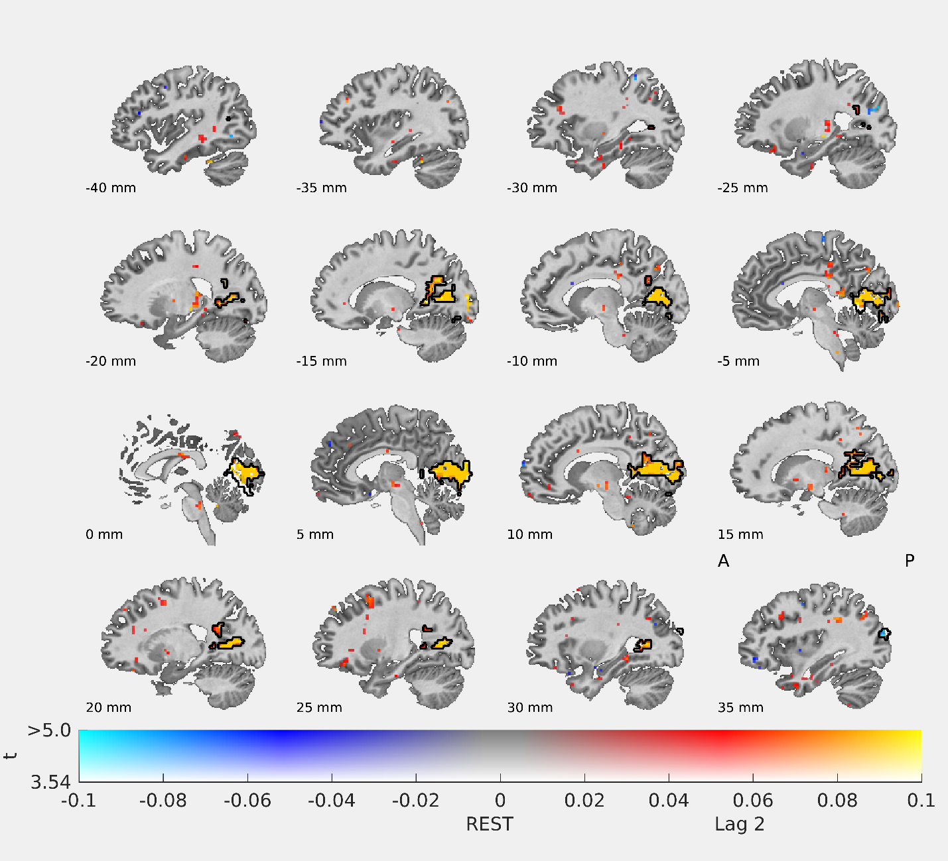

REST 1TR BEFORE BLINK
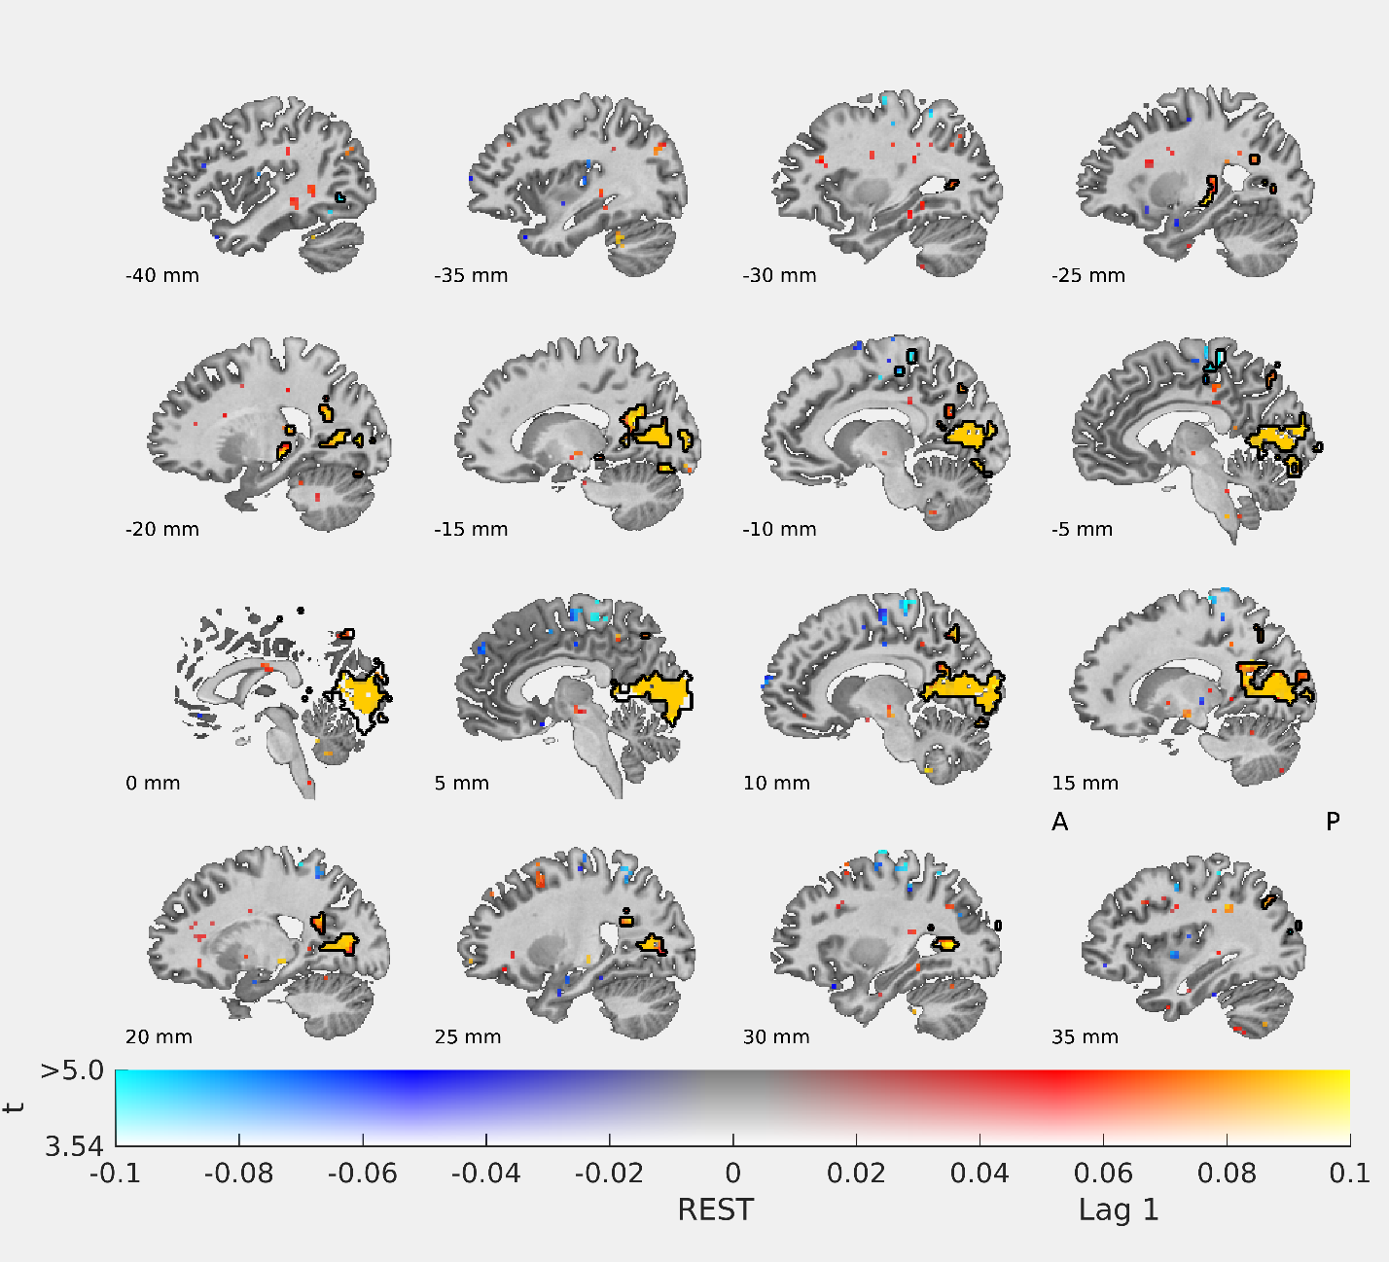

AT BLINK
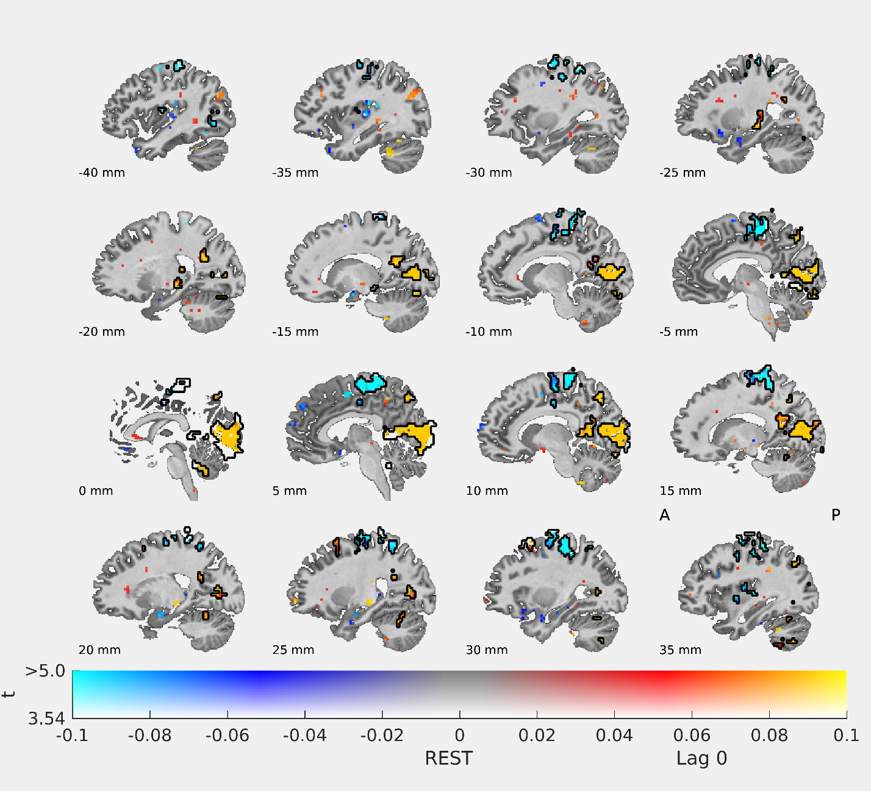

REST 1TR AFTER BLINK
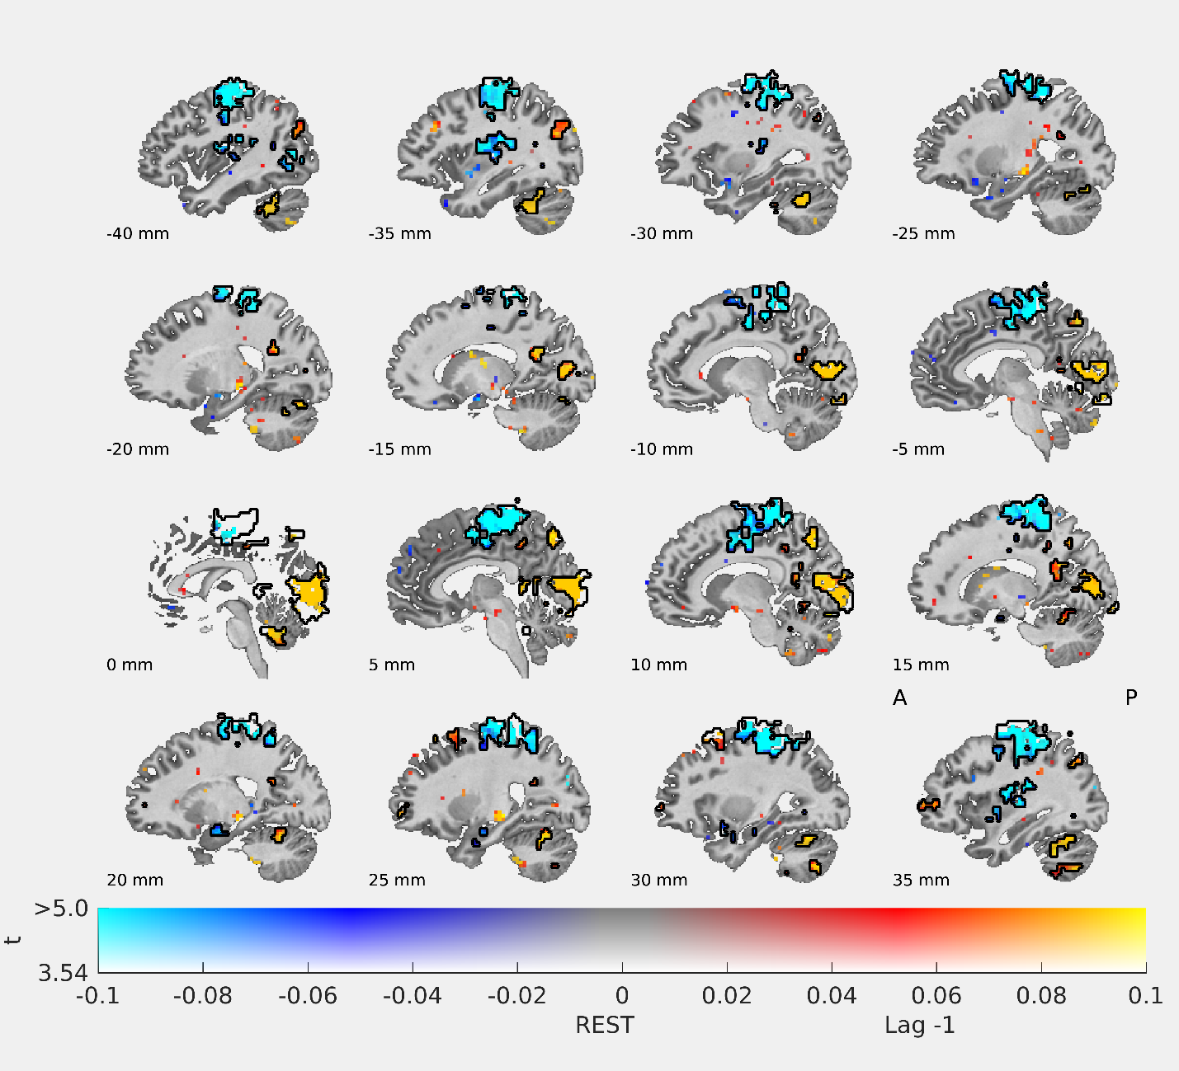

REST 2TR AFTER BLINK
