Discriminators of pseudoprogression and true progression in high-grade gliomas: A systematic review and meta-analysis

Supplementary Material

Chris Taylor BSc^{1*}, Justyna O. Ekert MPhil², Viktoria Sefcikova MSc¹, Naomi Fersht MB BChir PhD MRCP FRCR³, George Samandouras MD, FRCS^{1,4}

- UCL Queen Square Institute of Neurology, University College London, Queen Square, London, United Kingdom
- Wellcome Centre for Human Neuroimaging, University College London, 12 Queen Square, London, United Kingdom
- Department of Oncology, University College London Hospitals NHS Foundation Trust, London, United Kingdom.
- Victor Horsley Department of Neurosurgery, The National Hospital for Neurology and Neurosurgery, Queen Square, London, United Kingdom

*Corresponding Author:
Chris Taylor
UCL Queen Square Institute of Neurology
Gower St, Bloomsbury, London
WC1E 6BT
skgtayl@ucl.ac.uk
07523016269
0000-0002-3289-5860

Supplementary Material A

Search Strategy
1. exp oligodendroglioma/ or oligodendroglioma$.mp. or exp astrocytoma/ or astrocytoma$.mp. or exp glioblastoma/ or glioblastoma$.mp. or GBM.mp. or exp glioma/ or glioma$.mp. or brain tumour$.mp. or brain tumor$.mp. or LGG.mp. or HGG.mp. or exp low-grade-glioma/ or low-grade-glioma.mp. or exp high-grade-glioma/ or high-grade-glioma.mp.
2. pseudoprogression.mp. or pseudo-progression.mp. or treatment-related change$.mp. or treatment related change$.mp. or psPD.mp. or PsP.mp.
3. (progressive supranuclear palsy or primary spontaneous pneumothorax).mp.
4. (1 and 2) not 3

Supplementary Material B1

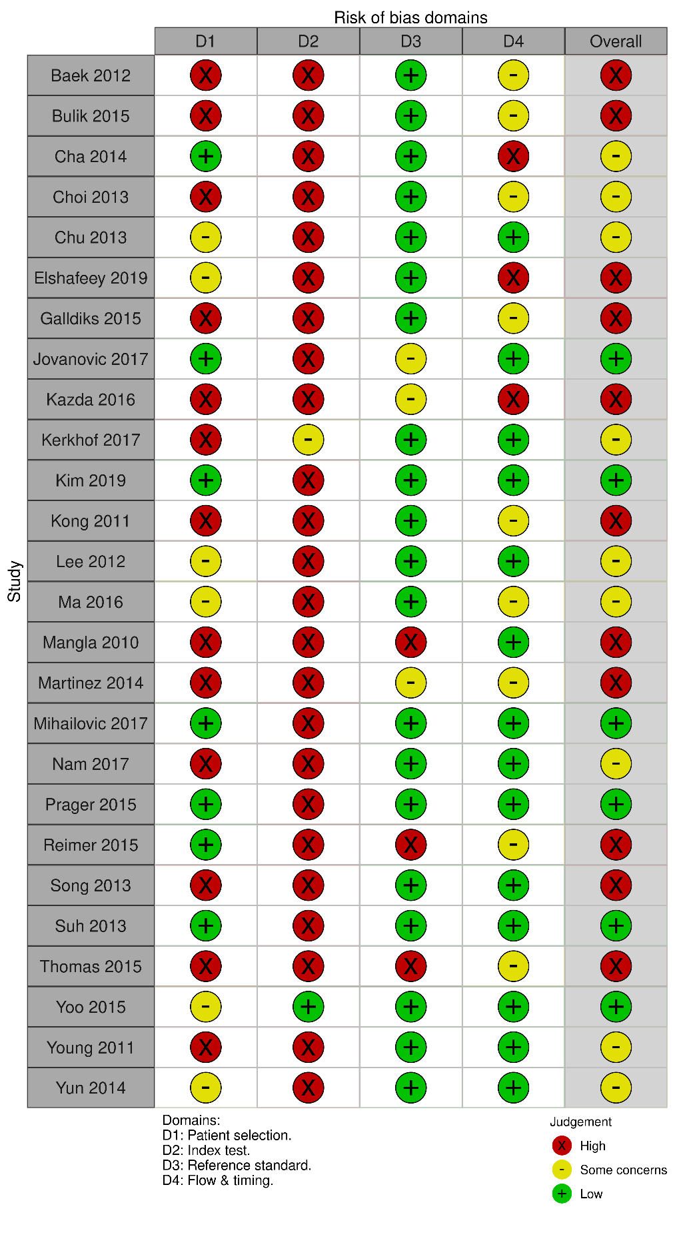
Risk of bias and applicability table assessing the quality of included studies according to the Quality Assessment of Diagnostic Accuracy Studies-2 (QUADAS-2) tool. Martinez et al., Kerkhof et al., Kong et al., Mangla 2010 et al., Song et al., and Thomas et al., were all found to include at least one patient that had received steroid treatment.

Supplementary Material B2

Summary of risk of bias across all studies according to the risk of bias table in Figure 5 assessing the quality of included studies according to the Quality Assessment of Diagnostic Accuracy Studies-2 (QUADAS-2) tool.
