**Additional file 2: Figure S1**

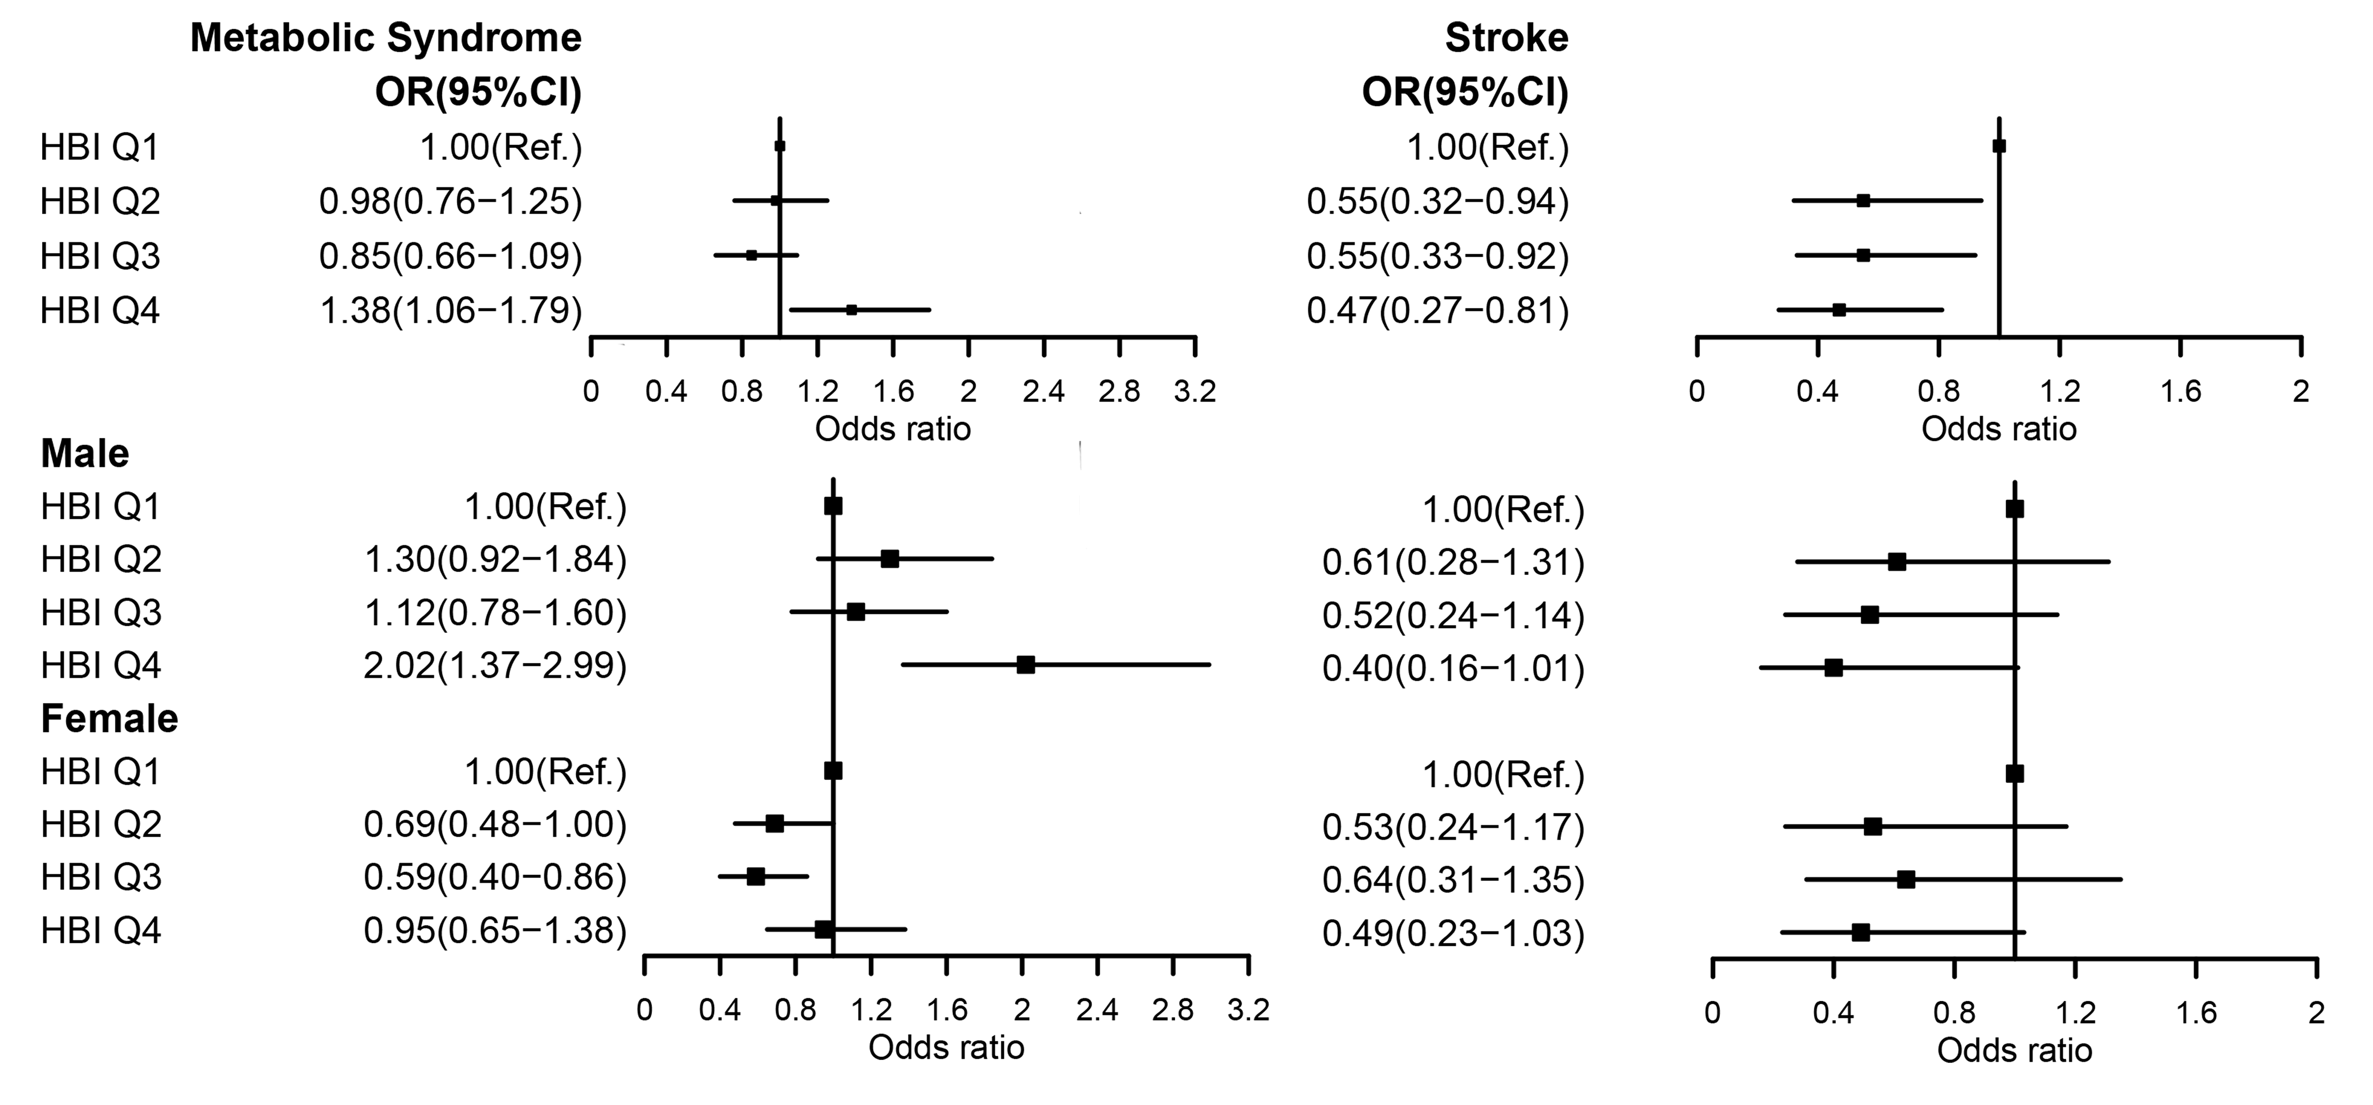

**Additional file 2: Figure S2**

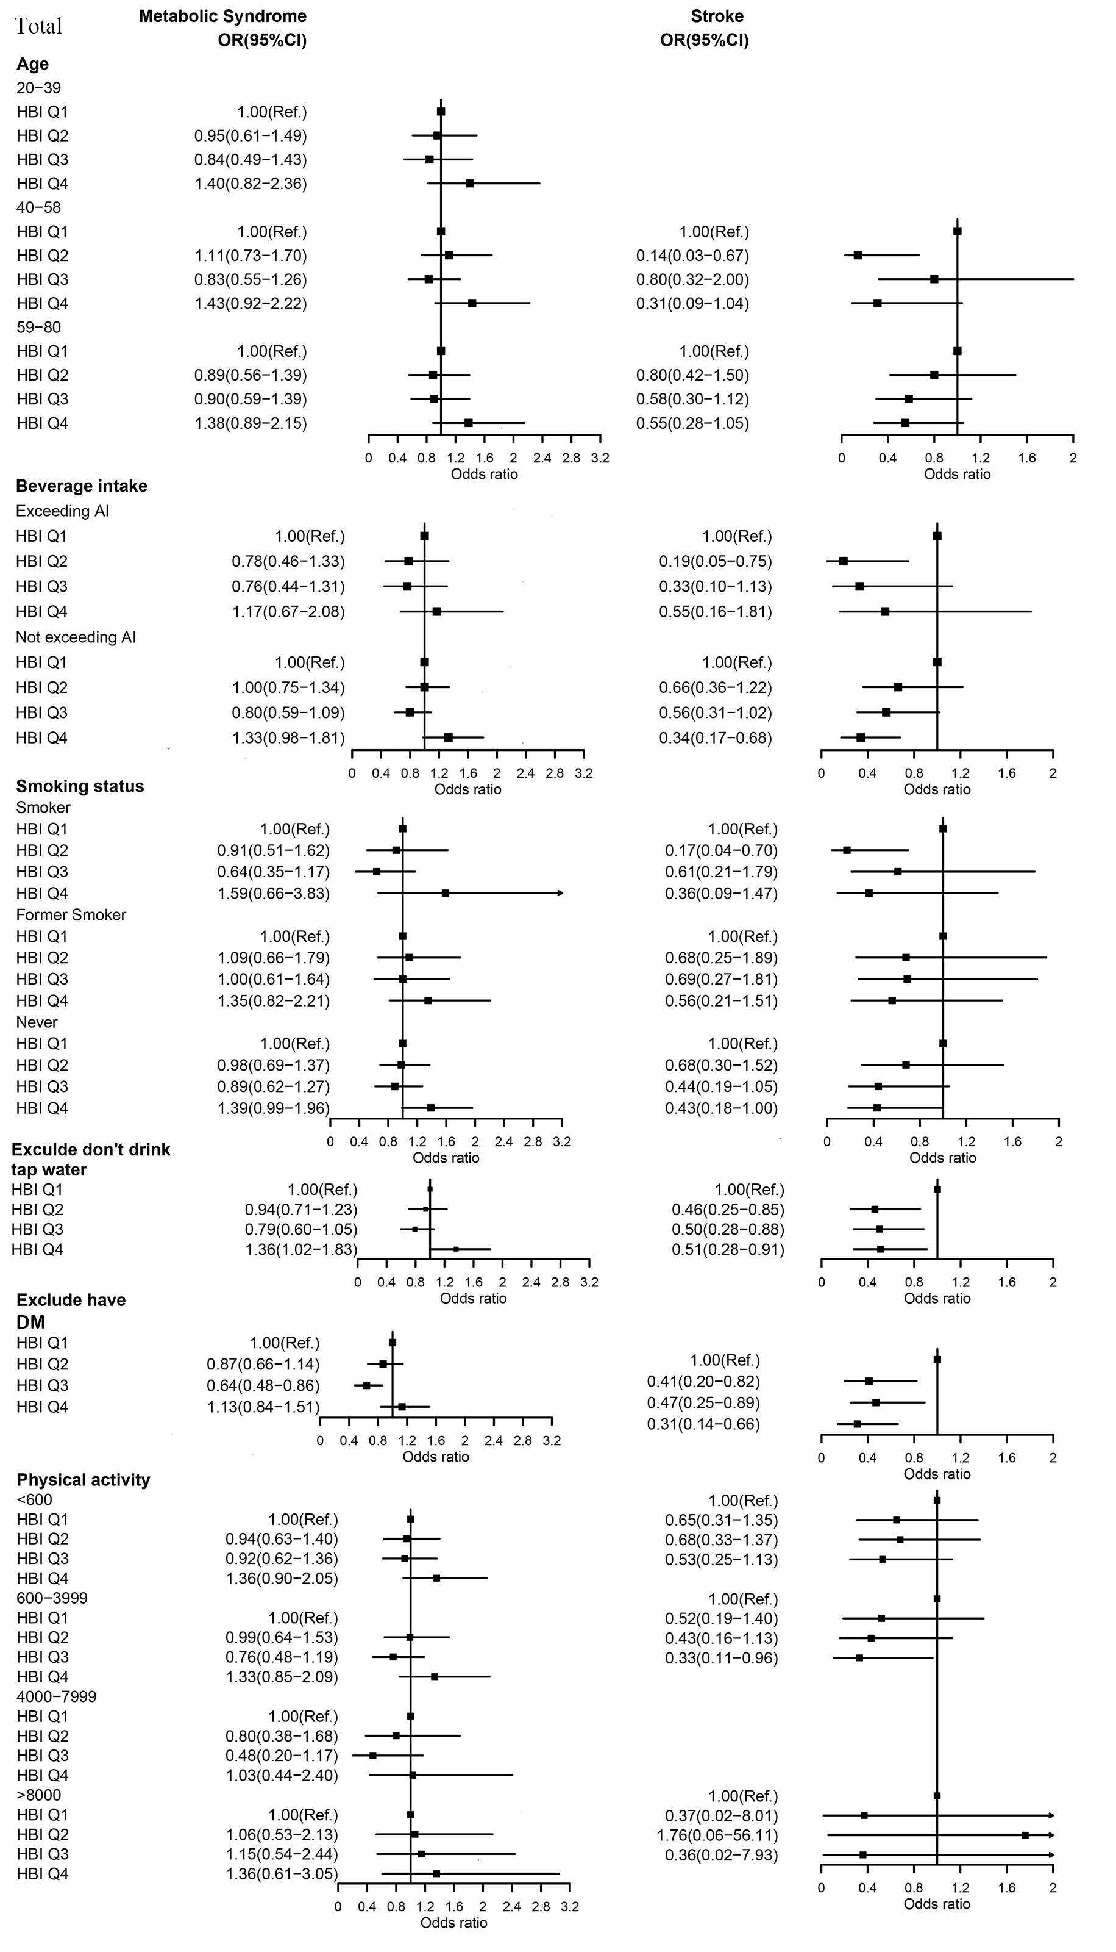

**Additional file 2: Figure S3**

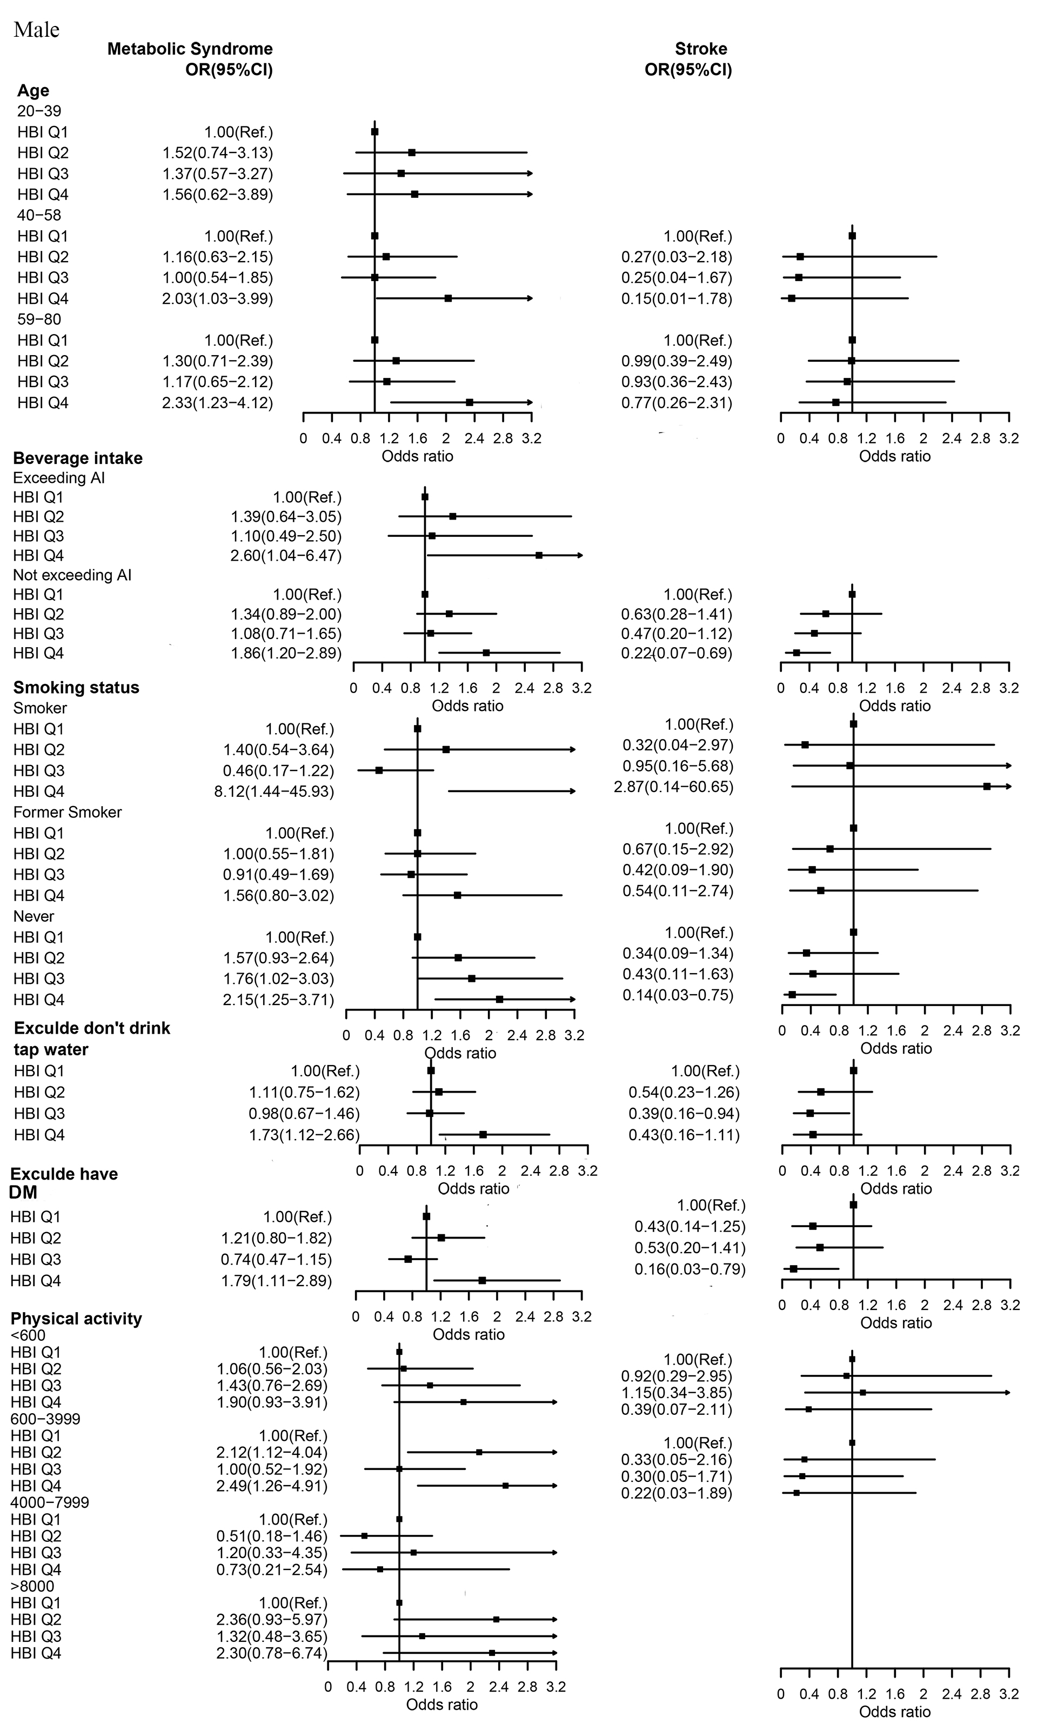

**Additional file 2: Figure S4**

