**Additional files**

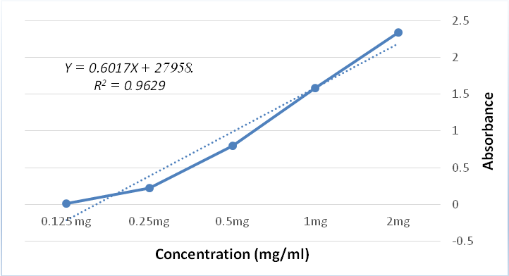

Additional file1: Tamoxifen solubility curve in Methanol



Additional file 2: The Tamoxifen cytotoxicity in the MCF-7 cell line



Additional file 3: The ASO cytotoxicity in the MCF-7 cell line



Additional file 4: The ASO, Niosome and PEI cytotoxicity in the MCF-7 cell line



Additional file 5: The Tamoxifen cytotoxicity in the MDA-MB-231 cell line

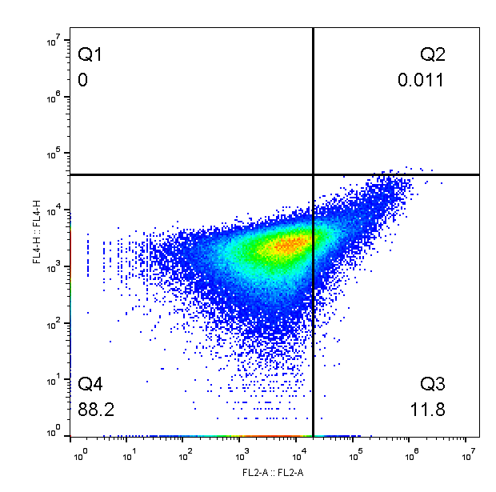

Additional file 6: The Tamoxifen apoptosis in the MDA-MB-231 cell line



Additional file 7: The ASO cytotoxicity in The MDA-MB-231 cell line



Additional file 8: The *Bcl-2* expression level in the MDA-MB-231 cell line after 48 hr with different ASO concentrations (Mean± Standard error, N=3, Statistical significance: P-value *less than 0.05, **less than 0.01, ***less than 0.001).

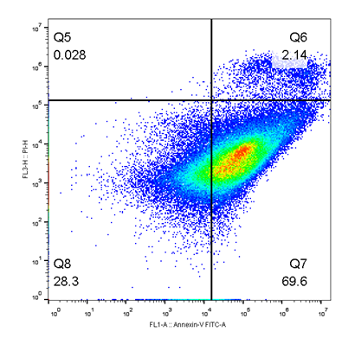

Additional file 9: The ASO apoptosis in The MDA-MB-231 cell line.



Additional file 10: The ASO, Niosome and PEI cytotoxicity in The MDA-MB-231cell line.



Additional file 11: The *Bcl-2* expression level in the MDA-MB-231 cell line after 48 hr with different ASO, Niosome and PEI complex (Mean± Standard error, N=three, Statistical significance: P value *less than 0.05, **less than 0.01, ***less than 0.001).

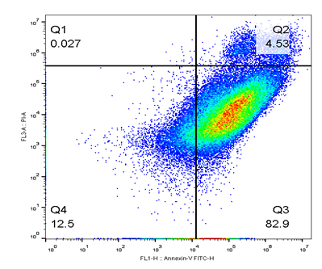

Additional file 12: The ASO, Niosome and PEI apoptosis in the MDA-MB-231cell line

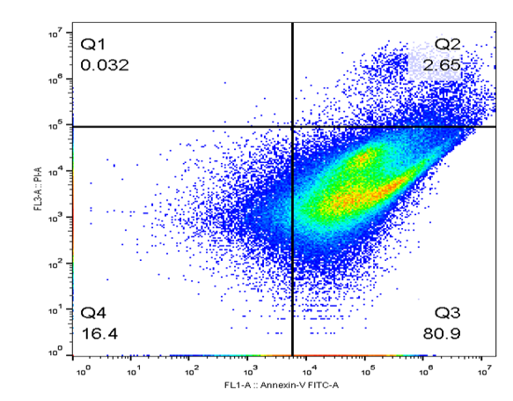

Additional file 13: The ASO and Lipofectamine apoptosis in the MDA-MB-231 cell line.

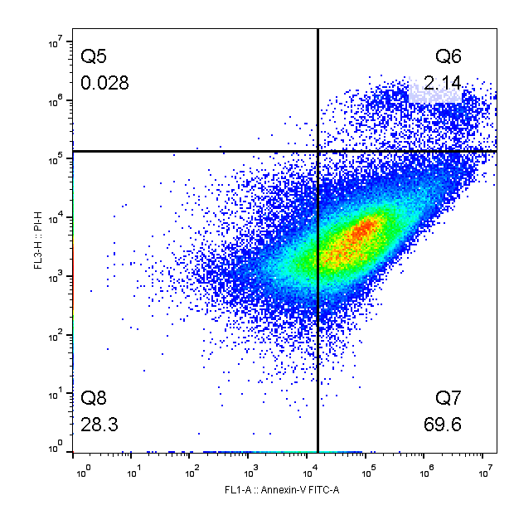

Additional file 14: The ASO and Tamoxifen apoptosis in the MDA-MB-231 cell line.

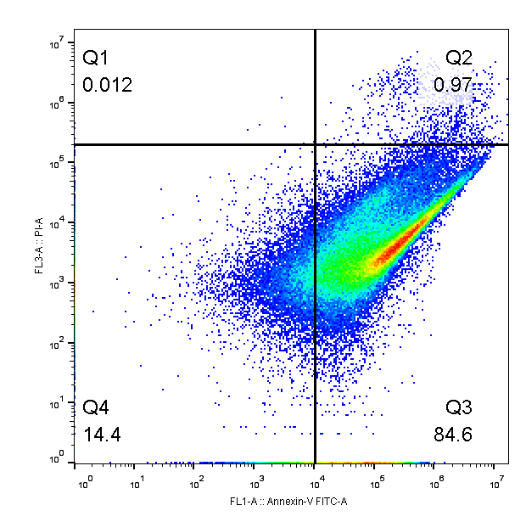

Additional file 15: The ASO, Tamoxifen and Lipofectamine apoptosis in the MDA-MB-231cell line

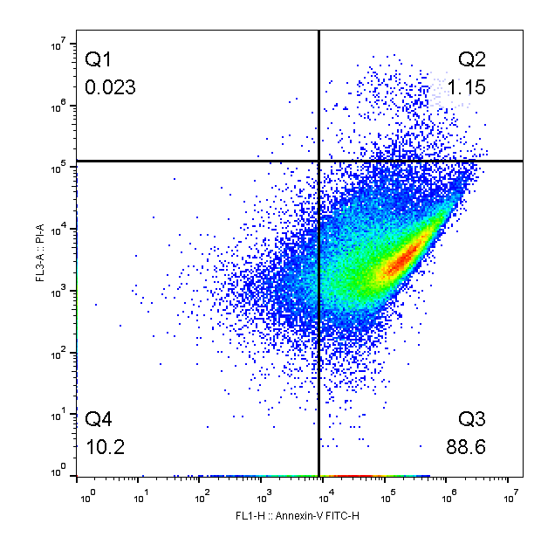

Additional file 16: The ASO, Tamoxifen and Niosome apoptosis in the MDA-MB-231 cell line