Pollen-mimicking, enzyme-loaded microparticles to reduce organophosphate toxicity in managed pollinators

Jing Chen, James Webb, Kaavian Shariati, Shengbo Guo, Jin-Kim Montclare, Scott McArt, and Minglin Ma*

Section S1 -Materials
NaCl, CaCl₂, NaCO₃, CoCl₂, KCl, Tris⋅HCl, DTNB, acetylthiocholine, imidazole, glycerol, NTA-Nickel beads, paraoxon, malaoxon, gelatin from porcine skin and human serum albumin (HSA), ampicillin, chloramphenicol and IPTG were purchased from Sigma-Aldrich. Sugar was purchased from Domino Foods. BCA protein assay kit, Cy5.5-NHS and FITC-NHS were purchased from Thermo Fisher. B. impatiens (bumble bees) were acquired from Biobest. Apis melifera (honey bees) were acquired from colonies of the McArt Lab at Cornell. Bee pollen was acquired from CC Pollen.
Section S2 - Methodology
OPT synthesis
Ampicillin, chloramphenicol, and IPTG solutions were sterilized before use. E. coli bearing pQE30-PTE was cultured in Miller Grade LB broth containing 100 μg/mL ampicillin and 25 μg/mL chloramphenicol at 37℃. Once cultures in 5,000 mL flasks reached OD 0.4, 500 μL CoCl₂ (1M) and at OD 0.8-1.0, 500 μL IPTG (200 mg/mL), was added for every litre of culture. The culture was left for a further 3 hours before harvesting. The culture was then centrifuged for 10 minutes at 4,000 rpm in 1L centrifuge tubes, the supernatant was removed, and the cell pellet was resuspended in 40 mL resuspension buffer (3.15g Tris⋅HCl, 29.22g NaCl, 56g glycerol, 44 μL CoCl₂ (1M), 144 mg imidazole, 1L H₂O). The solution was then sonicated at 65% amplitude, 5s on, 25s off for 20 minutes in an ice bath. The solution was subsequently centrifuged for 1.5 hours at 13,000 rpm and the supernatant collected as crude OPT. Crude OPT was purified using a HIS-select NTA-nickel bead affinity column. The column was equilibrated using an equilibration buffer (20 mM phosphate buffer, 300 mM NaCl, 10 mM imidazole), before crude OPT was run through the column and washed with further equilibration buffer. Captured OPT was then eluted with elution buffer (20 mM phosphate buffer, 300 mM NaCl, 250 mM imidazole). OPT was concentrated using Amicon Ultra 15 mL 3 kDa-membrane tubes and washed with saline three times. OPT concentration was determined using a BCA protein assay kit. Confirmation of OPT production was confirmed using SDS-PAGE.

OPT-PMM fabrication
In a 10 mL vial, 1 mL of each of the following was added in order, and mixed continuously for 10 seconds using a magnetic stirrer at 6,000 rpm: 24 mg/mL gelatin from porcine skin, OPT 3.364 mg/mL (5% microparticle mass) or OPT 1.345 mg/mL (2% microparticle mass), 0.33 M CaCl₂ and 0.33 M NaCO₃, to form OPT-PMMs. The solution was centrifuged at 3000 rpm for 3 minutes and the supernatant subsequently removed. The remaining microparticles were suspended in either distilled water or 2 g/mL sucrose to form 0.5 mg/mL OPT.

Microparticle morphology
Microparticle morphology was analyzed by resuspending PMMs in 1mL of distilled H₂O following centrifugation and analyzing a drop of the solution under an evos FL microscope. To produce CaCO₃ microparticles to compare as a standard, the microparticle fabrication process was repeated without gelatin, distilled H₂O was added in substitute. Lyophilized microparticles were furthered analyzed under SEM.

Microparticle size and pore size distribution
Microparticles were prepared as above, samples were either resuspended in pH 4.8, 0.1M citric acid/sodium citrate buffer for 30 minutes or resuspended as usual in DI water. Samples were analyzed under an evos FL microscope, before size distribution analysis using imageJ software. Pore size distribution was analyzed by a Micromeritics ASAP 2460.
Microparticle loading characterization
FITC-NHS was conjugated to human serum albumin (HSA) by amide reaction and dialysis according previous report¹, followed by lyophilization to gain a known concentration. A standard curve of FITC-HSA was then prepared in the following concentrations; 2/1.5/1/0.5/0.25/0.125/0.625/0.03125/0 mg/mL. Microparticles were synthesized as described above using FITC-HSA in lieu of OPT, at 15, 10 and 5% of the microparticle mass (10.092, 6.724 and 3.364 mg/mL), in triplicates. Following centrifugation, the supernatant was collected and analyzed together with standard curve samples using a Biotek Synergy 4 spectrophotometric plate reader at 405 nm to determine protein loading efficiency. The process was repeated using OPT conjugated with FITC, at 5 and 2% of the microparticle mass. For microparticle fluorescent imaging, gelatin was conjugated to Cy5.5 in amide reaction as previously mentioned and used in substitute for regular gelatin and imaged under an evos FL microscope.

Enzyme-release testing
FITC-HSA loaded into PMMs and unmodified CaCO₃ microparticles were suspended in 100% sucrose, separated into multiple samples and placed on an orbital shaker at 400 rpm. A standard curve of FITC-HSA was made in previously mentioned concentrations, yet dissolved in sucrose. Every 24hrs for 7 days, sample triplicates were centrifugated at 3000 rpm for 5 minutes, before spectrophotometric analysis at 405 nm. Fluorescence readings were indicative of protein released microparticles at each time point.

Suspension stability
Same concentration of PMMs and non-modified microparticles were suspended in sucrose (2 g/mL) and separated into multiple samples of 10 mL volumes. One mL was taken from the upper layer of samples every 24 hrs for 7 days and analyzed for optical density using an Eppendorf Biophotometer Plus at OD 600. Optical density values were indicative of microparticle concentration.

OPT-PMM pH stability
OPT-PMM was synthesized as previously described in 2% OPT loading concentrations. 1.21 mg/mL OPT-PMM and free OPT samples were diluted with 1.42 mL and 1.22 mL 0.1M 4.8 pH citric acid/sodium citrate buffer or 1x PBS 7.4 pH respectively and incubated for 30 minutes. Following incubation, sample pH was taken using BDH indicator strips. 0.2 mL 0.1M NaOH was added to free-OPT samples incubated at pH 4.8 to attain pH 7.4. Standard curves of nitrophenol at concentrations 0.25, 0.125, 0.0613, 0.0313, 0.0156, 0.0062, 0.0031, 0.0007 mg/mL were prepared in 2mg/mL sucrose containing blank CaCO₃ microparticles at equal concentrations to that of 5% and 2% OPT-PMM. 100 μL of paraoxon at 0.5 mM and 100 μL of free OPT, 2% OPT-PMM following pH treatment were added to a 96-well plate in triplicates. Enzyme activity was measured using Biotek Synergy 4 spectrophotometric plate reader at 405 nm every 5 seconds for 2 minutes.

OPT-PMM thermal stability
OPT-PMM 2% were prepared as previously described, both samples and free OPT were diluted to 0.5 mg/mL OPT in 2 g/mL sucrose. Samples were incubated in 30, 40, 50 and 60℃ for 20 minutes, before 100 μL of each sample and 100 μL 0.5 mM paraoxon was added to a 96-well plate in triplicates. Absorbance at 405 nm was measured spectrophotometrically as previously described^{2,3} after 2 minutes.

Gastro-intestinal fluorescent imaging
24 bumblebees were individually placed in 4oz, ventilated plastic cups and starved for 2 hours. Bumblebees were subsequently fed FITC-HSA-PMM or free FITC-HSA in sucrose at 0.5 mg/mL HSA using 1.5 mL Eppendorf tubes, in triplicates. Following 30 minutes of feeding, treatments were removed and bumblebees from each treatment group were anesthetized after 0, 1, 4 and 12 hours, and then immediately beheaded using dissection scissors. GI tracts were removed by cutting the perimeter of the abdomen before removing the crop and ventriculus and placing it on a glass slide. The process was repeated for 3 bumblebees fed plain sucrose for 30 minutes before anesthesia after 0 hrs. Samples were analyzed for FITC fluorescence under an evos FL microscope.

AChE activity characterization
Honey bees were homogenized in 1x PBS and filtered using a 70 µm cell strainer. 2 mL samples of the filtrate were combined with 1mL 0.5 mg/mL OPT of OPT-PMMs, free OPT, and DI water, followed by the addition of 1 mL 0.5 mM paraoxon, or 1ml DI water (positive control). AChE assays were performed in accordance with previously described protocol⁴. An assay medium of 50 mM Tris·HCl, 20 mM KCl, 2 mM DTNB, and 2 mM acetylthiocholine was prepared. 100 μL of each experimental sample and 100 μL of the assay medium was added in triplicates to a 96-well plate. Absorbance was measured at 412nm in a Biotek Synergy 4 spectrophotometric plate reader every 30s for 20 minutes. AChE activity was defined as the change of absorbance during the 20 minutes of reading.

Mortality testing
Pollen balls were prepared by mixing 5 mL of one of 3 OP conditions, (malathion 1500 μg/mL, paraoxon 100 μg/mL, paraoxon 30 μg/mL, distilled H₂O), with 10 g of high desert bee pollen granules. The mixture was shaken until a homogeneous slurry was formed, then left at room temperature to allow full absorption of the OPs. The contaminated pollen was then crushed in a pestle and mortar. The mixture containing pollen and sucrose was rolled by hand into equally sized 3g pollen balls. Treatments were prepared by diluting OPT-PMM and free OPT in sucrose (2 g/mL) to either 500 µg/mL or 800 µg/mL OPT. Groups of 50 bumblebees (Bombus impatiens) were placed in microcolony rearing cages and treated with various combinations of either contaminated or non-contaminated pollen balls and one of the following: 500 µg/mL OPT-PMM sucrose, 800 µg/mL OPT-PMM sucrose, 500 µg/mL free-OPT sucrose or pure sucrose. Each microcolony cage was given one pollen ball and 5 mL of OPT or plain sucrose solution provided in a centrifugal tube with a small aperture for feeding. Microcolonies were monitored every 12 hours for mortalities until all bees had deceased or 10 days had elapsed. In the case of the acute mortality test, the trial was terminated after 12 hours.
Section S3 - Supplementary Figures
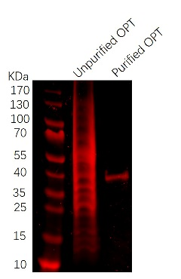
Supplementary Figure 1. SDS-PAGE of OPT (molecular weight 39 kDa)

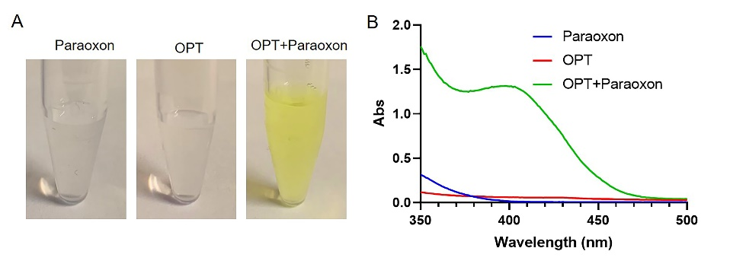
Supplementary Figure 2. A. Formation of nitrophenol from paraoxon. B. UV spectrum of paraoxon and paraoxon degraded by OPT.

Time (day) | 0 | 2 | 4 | 7
Protein leaking percentage of OPT-PMMs (%) | 0 | 0 | 0 | 0
Supplementary Figure 3. Protein leaking testing over one week.

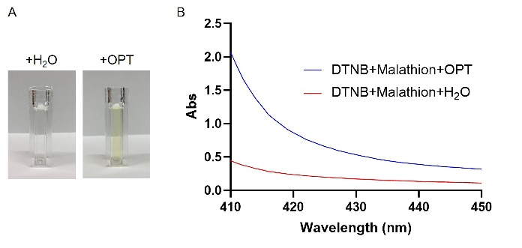
Supplementary Figure 4. A. Picture of malathion with and without OPT. B. UV spectrum of malathion and malathion degraded by OPT.
References
1 Chaganti, L. K., Venkatakrishnan, N. & Bose, K. An efficient method for FITC labelling of proteins using tandem affinity purification. Biosci. Rep. 38, 8 (2018).
2 Yang, C. Y. et al. Improved Stability and Half-Life of Fluorinated Phosphotriesterase Using Rosetta. ChemBioChem 15, 1761-1764 (2014).
3 Baker, P. J. & Montclare, J. K. Enhanced Refoldability and Thermoactivity of Fluorinated Phosphotriesterase. ChemBioChem 12, 1845-1848 (2011).
4 Ellman, G. L., Courtney, K. D., Andres, V. & Featherstone, R. M. A new and rapid colorimetric determination of acetylcholinesterase activity. Biochem. Pharmacol. 7, 88-95 (1961).

