List of Supplemental Figure Captions

Fig. S1. Location map of 11 sampling sites in the costal region of the South China Sea

Fig. S2. Concentration profiles of individual PFAS components in all samples

List of Supplemental Table Captions

Table S1. Specific sample information of locations, categories and quantity

Table S2. Concentration range, ∑PFAS and frequency of detected PFASs in all samples

Table S3. Concentration range, ∑PFAS and frequency of detected PFASs in samples collected from 3 provinces

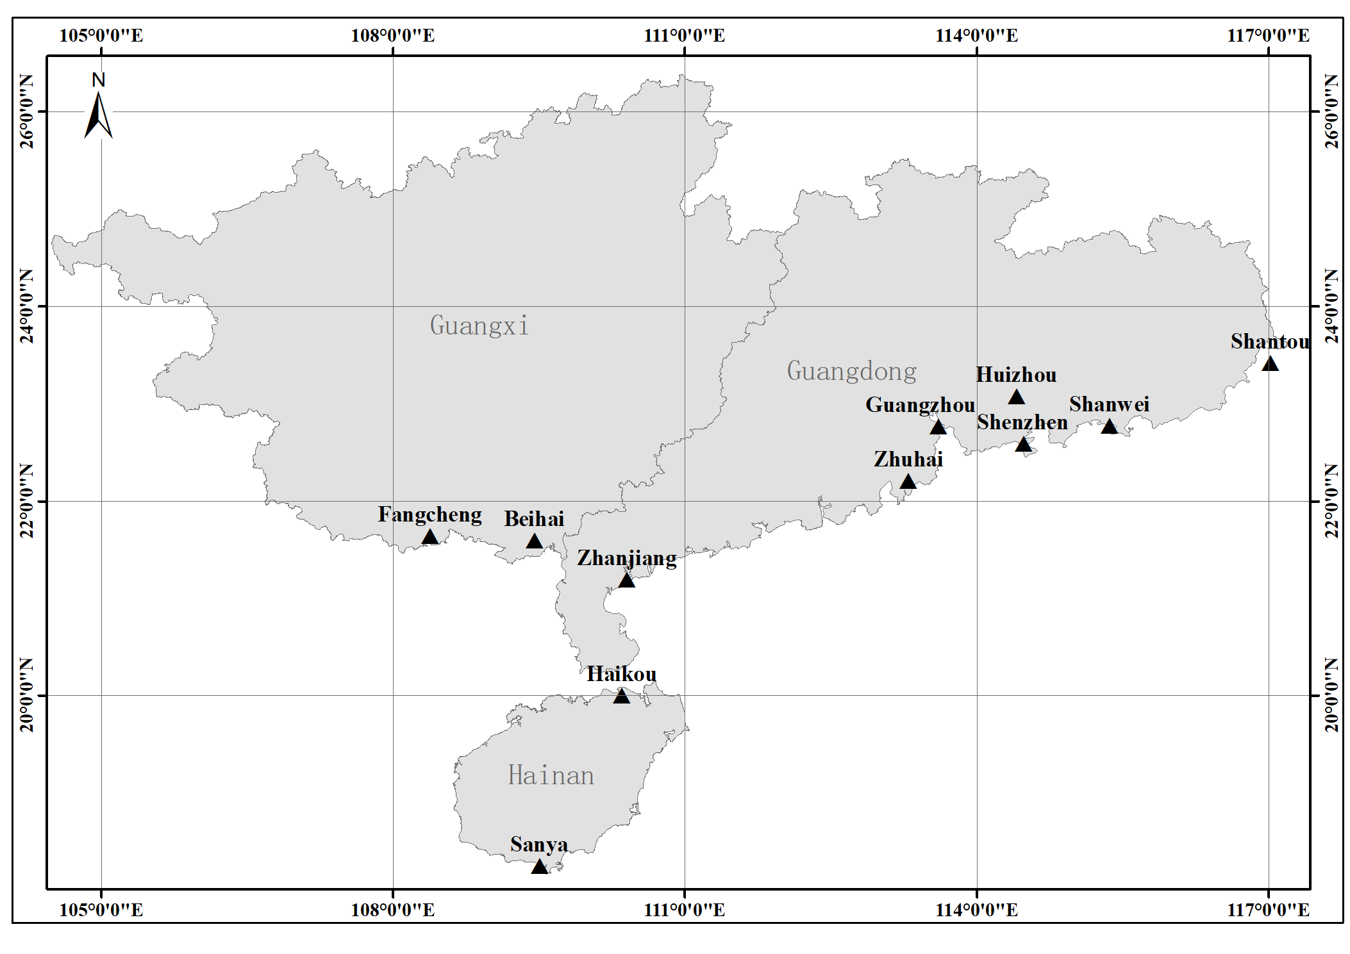
Fig. S1. Location map of 11 samplng sites in the costal region of the South China Sea

Fig. S2. Concentration profiles of individual PFAS components in all samples

Table S1. Specific sample information of locations, categories and quantity

Sampling locations |  | Sample categories |  |  | Sampling year
Province | City | Fish | Shellfish | Crustacean | 2014 | 2015 | 2016
Guangdong | Guangzhou | 53 | 25 | 11 | 25 | 17 | 27
 | Zhuhai | 49 | 29 | 11 | 27 | 21 | 21
 | Shenzhen | 42 | 27 | 10 | 31 | 18 | 24
 | Huizhou | 26 | 24 | 7 | 14 | 7 | 10
 | Shantou | 42 | 24 | 13 | 23 | 12 | 24
 | Shanwei | 27 | 77 | 6 | 15 | 88 | 47
 | Zhanjiang | 24 | 34 | 8 | 56 | 81 | 29
Guangxi | Beihai | 42 | 64 | 9 | 34 | 53 | 28
 | Fangchenggang | 13 | 26 | 8 | 22 | 7 | 11
Hainan | Haikou | 15 | 29 | 5 | 10 | 8 | 10
 | Sanya | 26 | 12 | 6 | 12 | 10 | 22
Total |  | 359 | 391 | 94 | 269 | 305 | 270

Table S2. Concentration range, ∑PFAS and frequency of detected PFASs in all samples

PFAS components | Detection concentration rage (μg/kg) | Mean concentration (μg/kg) | Medium concentration (μg/kg) | ∑PFAS (μg/kg)* | Frequency (%)
PFBA | 0.01-6.07 | 0.72 | 0.43 | 410.93 | 62.44
PFPeA | 0.01-2.40 | 0.14 | 0.06 | 18.11 | 15.99
PFHxA | 0.02-13.15 | 0.78 | 0.32 | 177.28 | 24.89
PFHpA | 0.01-0.31 | 0.04 | 0.02 | 2.19 | 6.17
PFOA | 0.01-1.80 | 0.09 | 0.04 | 52.22 | 65.86
PFNA | 0.01-8.07 | 0.35 | 0.05 | 152.87 | 47.47
PFDA | 0.01-1.62 | 0.10 | 0.05 | 37.71 | 43.06
PFUdA | 0.01-2.65 | 0.18 | 0.09 | 77.09 | 46.92
PFDoA | 0.01-0.94 | 0.08 | 0.04 | 19.49 | 28.19
PFTrDA | 0.01-1.97 | 0.18 | 0.09 | 46.40 | 28.30
PFTeDA | 0.01-0.30 | 0.05 | 0.04 | 5.90 | 12.11
PFBS | 0.01-3.89 | 0.11 | 0.06 | 54.89 | 37.22
PFHxS | 0.02-0.13 | 0.07 | 0.06 | 1.42 | 2.31
PFHpS | 0.01-0.13 | 0.03 | 0.02 | 2.42 | 10.68
PFOS | 0.01-20.96 | 0.75 | 0.22 | 484.51 | 72.40
PFOSA | 0.01-15.84 | 0.19 | 0.08 | 119.37 | 67.95
*: Total concentration value of individual PFAS component in all detected samples
Table S3. Concentration range, ∑PFAS and frequency of detected PFASs in samples collected from 3 provinces

PFAS components | Guangdong |  |  | Guangxi |  |  | Hainan
 | Mean value (μg/kg) | Medium value (μg/kg) | Frequency (%) | Mean value (μg/kg) | Medium value (μg/kg) | Frequency (%) | Mean value (μg/kg) | Medium value (μg/kg) | Frequency (%)
PFBA | 0.68 | 0.39 | 62.10 | 0.76 | 0.47 | 70.72 | 1.11 | 0.62 | 41.85
PFPeA | 0.13 | 0.06 | 14.95 | 0.28 | 0.18 | 17.95 | 0.06 | 0.04 | 17.93
PFHxA | 0.86 | 0.30 | 23.57 | 0.54 | 0.32 | 24.57 | 0.74 | 0.19 | 37.18
PFHpA | 0.02 | 0.02 | 5.86 | 0.04 | 0.03 | 2.21 | 0.02 | 0.01 | 17.95
PFOA | 0.09 | 0.05 | 73.94 | 0.09 | 0.03 | 43.09 | 0.06 | 0.04 | 58.97
PFNA | 0.20 | 0.04 | 44.22 | 0.88 | 0.25 | 55.80 | 0.15 | 0.06 | 55.97
PFDA | 0.11 | 0.05 | 44.68 | 0.06 | 0.04 | 28.73 | 0.07 | 0.06 | 62.82
PFUdA | 0.18 | 0.08 | 50.39 | 0.15 | 0.09 | 29.28 | 0.20 | 0.16 | 58.97
PFDoA | 0.09 | 0.04 | 28.97 | 0.05 | 0.03 | 16.57 | 0.05 | 0.04 | 48.72
PFTrDA | 0.09 | 0.05 | 14.36 | 0.23 | 0.13 | 48.72 | 0.15 | 0.10 | 48.64
PFTeDA | 0.06 | 0.04 | 14.18 | 0.06 | 0.05 | 1.10 | 0.04 | 0.02 | 20.51
PFBS | 0.11 | 0.03 | 35.90 | 0.26 | 0.03 | 41.99 | 0.34 | 0.11 | 37.18
PFHxS | 0.05 | 0.04 | 0.77 | — | — | — | 0.07 | 0.06 | 20.51
PFHpS | 0.03 | 0.02 | 11.86 | 0.02 | 0.01 | 8.29 | 0.01 | 0.01 | 6.41
PFOS | 0.77 | 0.19 | 78.43 | 0.74 | 0.27 | 41.43 | 0.57 | 0.33 | 84.62
PFOSA | 0.16 | 0.07 | 66.26 | 0.34 | 0.08 | 62.98 | 0.14 | 0.07 | 93.59
—: No detection concentrations for PFHxS of samples in Guangxi

