Supplementary Material Cover Sheet

Hydrochemical characteristics and quality assessment of shallow groundwater in Yangtze River Delta of eastern China

Taotao Lu ^{1, 5}, Runzhe Li ², Aira Sacha Nadine Ferrer ¹, Shuang Xiong ³,
Pengfei Zou ², Hao Peng ^{5,} *

¹ Department of Hydrology, Bayreuth Center of Ecology and Environmental Research (BAYCEER), University of Bayreuth, Bayreuth, 95440, Germany
² Faculty of Public Administration, Shandong Agriculture University, Taian, 71011, China
^{3.}Wuhan Zondy W&R Environmental Technology Co., Ltd, Wuhan, 430078, China
^{4.}Yantai New Era Health Industry Chemical Commodity Co., Ltd., Yantai 264000, China
⁵ School of Environmental Studies, China University of Geoscience, Wuhan, 430078, China

Manuscript prepared for Environmental Science and Pollution Research

* Corresponding author: Hao Peng (penghao@cug.edu.cn; Tel. +86 (0)27-87057085)

Number of pages: 18
Number of tables: 5
Number of figures: 7

Procedures for groundwater sample collection
Before sample collection, the inside of the well was cleaned by pumping the groundwater for 5–10 mins. Then, the groundwater was collected in a beaker for the next filtration run. The filtered groundwater was preserved in two 50 mL HDPE bottles for ion analysis and one 200 mL HDPE bottle for carbonic acid titration. These HDPE bottles had been cleaned thoroughly to remove impurities based on the method in our previous studies (Peng et al., 2021a; Peng et al., 2021b), and prior to collection, these bottles had been rinsed by filtered groundwater several times. Groundwater in one 50 mL HDPE bottle was acidified to pH < 2 by adding concentrated nitric acid for cation analysis. The groundwater in another 50 mL and 200 mL HDPE bottles was prepared for anion analysis and carbonic acid titration. These bottles were placed in the incubator with ice bags after collection, then transported immediately to the laboratory. All groundwater samples were preserved in the cold room at 4°C for further analysis.

Water sample measurement
Since some indicators are sensitive to environmental changes, parameters such as TDS and pH were measured on-site using a portable analyzer (HQ40D). The concentration of anions like F⁻, Cl⁻, NO₃⁻, Br⁻ and SO₄²⁻ were measured by ion chromatography (IC,761COMPACTIC, Metrohm AG) after the groundwater was filtered by 0.22 μm membrane (Sartorius Minisart). Besides, the concentration of CO₃²⁻ and HCO₃⁻ were detected by standard HCl titration using methyl orange and phenolphthalein as indicators. The contents of cations like Ca, Mg, Na, K, As, Cd, Cr, Pb, Fe, Mn, Cu, Zn, Ag, Al, Sr, Se, Ba, Be, B, Li, Mo, Hg, Co, Sb, and Rb were obtained by the inductively coupled plasma emission mass spectrometer (ICP-MS, Agilent 7700, Agilent). In order to guarantee the reliability of the measurement, except for the initial calibration curve, new calibration lines were established after measuring every 10 samples. In addition, the standard solutions (8500-6940, Agilent) were applied to check the accuracy of the measurement. It turned out that the recovery rate of standard solution ranged from 90% to 110%, which indicated that the relative standard deviations of the samples were all < 10%. For further checking and improving the data quality, the charge balance errors of all groundwater samples were within 5%, and the electrical conductivity values of the samples were linearly related to the calculated TDS values. It is worth note that the chemical reagents used in this research were analytical grade.

Method to calculate the HI
HI could be obtained by the following Eqs.(1–5) (Dippong et al., 2020; Peng et al., 2021a):
Chronic daily intake by oral ingestion: ${\text{CDI}}_{\text{o}}\text{=}\frac{\text{C×IR×EF×ED}}{\text{BW×AT}}$ (1)
Chronic daily intake by dermal absorption: ${\text{CDI}}_{\text{d}}\text{=}\frac{\text{C×Kp×ET×SA×EF×ED×CF}}{\text{BW×AT}}$ (2)
Non-carcinogenic risk is expressed by hazard quotient: $\text{HI=}{\text{HQ}}_{\text{oral}}\text{+}{\text{HQ}}_{\text{dermal}}$ (3)
${\text{HQ}}_{\text{oral}}\text{=}\frac{{\text{CDI}}_{\text{o}}}{{\text{RfD}}_{\text{o}}}$ (4)
${\text{HQ}}_{\text{dermal}}\text{=}\frac{{\text{CDI}}_{\text{d}}}{{\text{RfD}}_{\text{d}}}$ (5)
Where ${\text{HQ}}_{\text{oral}}$ and ${\text{HQ}}_{\text{dermal}}$ are the health risk caused by oral ingestion and dermal absorption; C is chemical concentration in water; IR is ingestion rate; EF is exposure frequency; ED is exposure duration; BW is body weight; AT is averaging time; SA is skin surface area available for contact; ET is exposure time. CF is the volume conversion factor. K_{P} is the dermal permeability coefficient of a compound in water; RfD_{o} is the reference dose oral; RfD_{d} is the absorbed reference dose. The values of these parameters could be found in Table S4 and Table S5.

Table S1. Weight indicator of element i ranging from 1 to 5
Indicator j | CNS | P_{j} | P_{j} reference | w_{j1} | w_{j2} | W_{j}
TH(mg/L) | 450 | 2 | (Xiao et al. 2014; Xiao et al. 2019) | 0.0364 | 0.0891 | 0.0487
TDS(mg/L) | 1000 | 4 |  | 0.0727 | 0.0638 | 0.0698
Na(mg/L) | 200 | 2 |  | 0.0364 | 0.0673 | 0.0368
Fe(mg/L) | 0.3 | 4 |  | 0.0727 | 0.0339 | 0.0371
As(mg/L) | 0.01 | 5 |  | 0.0909 | 0.0830 | 0.1135
Ni(mg/L) | 0.02 | 1 |  | 0.0182 | 0.0487 | 0.0133
Cr(mg/L) | 0.05 | 5 |  | 0.0909 | 0.0585 | 0.0800
B(mg/L) | 0.5 | 3 |  | 0.0545 | 0.0974 | 0.0799
Al(mg/L) | 0.2 | 2 |  | 0.0364 | 0.0635 | 0.0347
Cl⁻(mg/L) | 250 | 3 |  | 0.0545 | 0.0325 | 0.0267
SO₄²⁻(mg/L) | 250 | 4 |  | 0.0727 | 0.1306 | 0.1429
NO₃⁻(mg/L) | 88.57 | 5 |  | 0.0909 | 0.0910 | 0.1244
Mn(mg/L) | 0.1 | 5 |  | 0.0909 | 0.0337 | 0.0461
F⁻(mg/L) | 1.0 | 5 |  | 0.0909 | 0.0822 | 0.1124
Se(mg/L) | 0.01 | 5 | (Sahu and Sikdar 2008) | 0.0909 | 0.0246 | 0.0336
Note: CNS is China National Standard for Drinking Water Quality (GB5749-2006)

Table S2. The calculated values of WQI and HI
Sample NO. | WQI | HQ_{dermal} | HQ_{oral} | HI | Sample NO. | WQI | HQ_{dermal} | HQ_{oral} | HI
1 | 103.59 | 0.0116 | 4.6898 | 4.7014 | 32 | 37.30 | 0.0053 | 1.0074 | 1.0127
2 | 30.37 | 0.0039 | 0.7369 | 0.7409 | 33 | 32.10 | 0.0030 | 0.4926 | 0.4957
3 | 36.86 | 0.0080 | 0.5038 | 0.5118 | 34 | 46.45 | 0.0029 | 0.4766 | 0.4795
4 | 17.42 | 0.0021 | 0.2953 | 0.2974 | 35 | 42.82 | 0.0019 | 0.5361 | 0.5380
5 | 61.36 | 0.0076 | 2.7948 | 2.8024 | 36 | 110.20 | 0.0204 | 9.5341 | 9.5545
6 | 23.11 | 0.0062 | 0.2620 | 0.2682 | 37 | 37.90 | 0.0042 | 0.7343 | 0.7385
7 | 43.29 | 0.0078 | 1.1920 | 1.1998 | 38 | 33.79 | 0.0033 | 0.9589 | 0.9622
8 | 32.43 | 0.0046 | 0.4999 | 0.5045 | 39 | 67.05 | 0.0074 | 1.4381 | 1.4455
9 | 140.20 | 0.0403 | 8.9340 | 8.9744 | 40 | 26.54 | 0.0018 | 0.2618 | 0.2637
10 | 53.94 | 0.0133 | 0.7210 | 0.7344 | 41 | 39.72 | 0.0036 | 0.9733 | 0.9769
11 | 96.18 | 0.0143 | 3.6184 | 3.6328 | 42 | 42.00 | 0.0032 | 0.8051 | 0.8084
12 | 24.72 | 0.0042 | 0.5141 | 0.5182 | 43 | 40.36 | 0.0063 | 0.7759 | 0.7822
13 | 53.86 | 0.0039 | 1.3576 | 1.3614 | 44 | 44.53 | 0.0117 | 0.8268 | 0.8385
14 | 49.23 | 0.0084 | 1.2543 | 1.2627 | 45 | 42.72 | 0.0056 | 1.6067 | 1.6123
15 | 88.69 | 0.0120 | 4.7793 | 4.7913 | 46 | 41.25 | 0.0082 | 2.2809 | 2.2891
16 | 91.59 | 0.0074 | 2.8637 | 2.8711 | 47 | 45.70 | 0.0031 | 1.1541 | 1.1571
17 | 63.87 | 0.0027 | 0.6781 | 0.6808 | 48 | 48.37 | 0.0017 | 0.6301 | 0.6318
18 | 38.57 | 0.0069 | 1.4813 | 1.4882 | 49 | 33.61 | 0.0011 | 0.3203 | 0.3214
19 | 48.12 | 0.0216 | 0.5178 | 0.5394 | 50 | 54.99 | 0.0022 | 0.6461 | 0.6483
20 | 49.19 | 0.0068 | 0.5938 | 0.6006 | 51 | 59.32 | 0.0095 | 4.0962 | 4.1057
21 | 50.69 | 0.0053 | 0.6747 | 0.6800 | 52 | 22.11 | 0.0020 | 0.5676 | 0.5696
22 | 120.01 | 0.0212 | 9.3072 | 9.3284 | 53 | 43.55 | 0.0058 | 2.4451 | 2.4509
23 | 97.22 | 0.0245 | 1.7751 | 1.7996 | 54 | 64.48 | 0.0122 | 5.2552 | 5.2674
24 | 72.27 | 0.0067 | 1.5459 | 1.5526 | 55 | 22.72 | 0.0030 | 0.5402 | 0.5431
25 | 65.49 | 0.0103 | 3.1624 | 3.1727 | 56 | 27.75 | 0.0049 | 1.2219 | 1.2268
26 | 38.30 | 0.0051 | 0.8627 | 0.8677 | 57 | 54.91 | 0.0036 | 0.9386 | 0.9422
27 | 30.32 | 0.0045 | 1.3166 | 1.3211 | 58 | 58.58 | 0.0043 | 0.9520 | 0.9564
28 | 45.45 | 0.0031 | 0.9726 | 0.9757 | 59 | 32.76 | 0.0049 | 0.5240 | 0.5289
29 | 21.19 | 0.0027 | 0.6846 | 0.6873 | 60 | 35.87 | 0.0018 | 0.3817 | 0.3835
30 | 83.66 | 0.0120 | 5.2296 | 5.2416 | 61 | 80.71 | 0.0130 | 2.2524 | 2.2654
31 | 31.68 | 0.0031 | 0.5603 | 0.5634

Table S3. Correlation coefficients between element concentrations in groundwater in the study area
 | Na | Mg | K | Ca | Cl⁻ | HCO₃⁻ | SO₄²⁻ | NO3- | Br⁻ | F | B | Sr | Al | Fe | Mn | As | Se | Ni
Na | 1.000
Mg | .432* | 1.000
K | .406* | .305 | 1.000
Ca | -.428* | .065 | -.447* | 1.000
Cl⁻ | .830* | .464* | .281 | -.125 | 1.000
HCO₃⁻ | .543* | .782* | .328* | .025 | .481* | 1.000
SO₄²⁻ | .197 | .556* | .065 | .359* | .321 | .430* | 1.000
NO₃⁻ | -.043 | .039 | .128 | .308 | .029 | -.027 | .220 | 1.000
Br⁻ | .793* | .594* | .345* | -.251 | .816* | .622* | .295 | -.019 | 1.000
F⁻ | .425* | -.228 | .549* | -.692* | .180 | -.144 | -.310 | .018 | .241 | 1.000
B | .776* | .476* | .650* | -.534* | .578* | .520* | .147 | .132 | .761* | .557* | 1.000
Sr | .058 | .586* | -.176 | .556* | .267 | .522* | .393* | .007 | .237 | -.568* | -.099 | 1.000
Al | .200 | .134 | .096 | -.018 | .078 | .209 | .048 | .239 | .099 | .046 | .206 | .030 | 1.000
Fe | .319 | .477* | .183 | -.151 | .218 | .383* | .133 | -.115 | .358* | -.078 | .346* | .284 | .410* | 1.000
Mn | .302 | .293 | .128 | -.030 | .273 | .316 | .124 | -.216 | .336* | -.130 | .180 | .240 | .383* | .748* | 1.000
As | .210 | .179 | .139 | -.319 | .265 | .105 | -.173 | -.336* | .240 | .010 | .235 | .116 | .027 | .416* | .377* | 1.000
Se | .361* | .225 | .242 | -.274 | .114 | .331* | -.054 | -.107 | .224 | .213 | .429* | -.017 | .267 | .408* | .277 | .282 | 1.000
Ni | .197 | -.003 | -.036 | -.052 | .161 | .044 | -.010 | .030 | .189 | .152 | .158 | .041 | .128 | .254 | .178 | .071 | .031 | 1.000
Note: * means significant correlation at the 0.01 level.

Table S4. Parameters for health risk assessment calculation
Parameter | Unit | Value（Children） | References
IR (ingestion rate) | L/d | 1.0 | Chinese Ministry of Environment Protection (2013)
EF (exposure frequency) | days/year | 350 | USEPA (2004); USEPA (1991)
ED (exposure duration) | year | 6 | USEPA (2004); USEPA (1991)
BW (body weight) | kg | 26.8 | Chinese Ministry of Environment Protection (2013)
AT (average lifespan) | days | AT = ED *365 d/y | USEPA (1991)
ET(exposure time) | h/day | 0.22 | Chinese Ministry of Environment Protection (2013)
SA (skin surface area) | cm² | 9400 | Chinese Ministry of Environment Protection (2013)

Table S5. Values of skin permeability coefficient (K_{p}) and the reference dose (RfD) of each element
Element | K_{p}  (cm/h) | RfD_{o}  (mg/kg/day) | RfD_{d}  (mg/kg/day)
Cr | 2×10⁻³ | 0.003 | 0.000075
As | 1×10⁻³ | 0.0003 | 0.000285
Cd | 1×10⁻³ | 0.0005 | 0.000025
Pb | 1×10⁻⁴ | 0.0014 | 0.00042
Sr | 1×10⁻³ | 0.6 | 0.12
Li | 1×10⁻³ | 0.02 | 0.01
Be | 1×10⁻³ | 0.002 | 0.001
Al | 1×10⁻³ | 1 | 0.2
V | 1×10⁻³ | 0.005 | 0.00001
Mn | 1×10⁻³ | 0.14 | 0.00096
Fe | 1×10⁻³ | 0.7 | 0.14
Ni | 2×10⁻⁴ | 0.02 | 0.0008
Cu | 1×10⁻³ | 0.04 | 0.012
Zn | 6×10⁻⁴ | 0.3 | 0.06
Se | 1×10⁻³ | 0.005 | 0.0022
Mo | 1×10⁻³ | 0.005 | 0.0019
Ba | 1×10⁻³ | 0.2 | 0.014
B | 1×10⁻³ | 0.2 | 0.18
Ag | 6×10⁻⁴ | 0.005 | 0.0009
Sn | 1×10⁻³ | 0.6 | 0.06
Sb | 1×10⁻³ | 0.0004 | 0.000008
Co | 4×10⁻⁴ | 0.0003 | 0.00006
Tl | 1×10⁻³ | 0.00001 | 0.00001
Note: data from USEPA (2004), USEPA (2016), USEPA (2019), Xiao et al. (2019) and Wu et al. (2009)

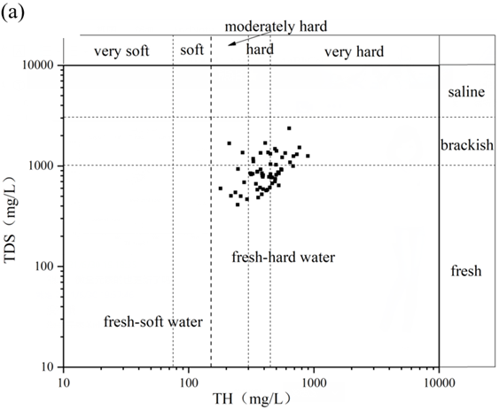
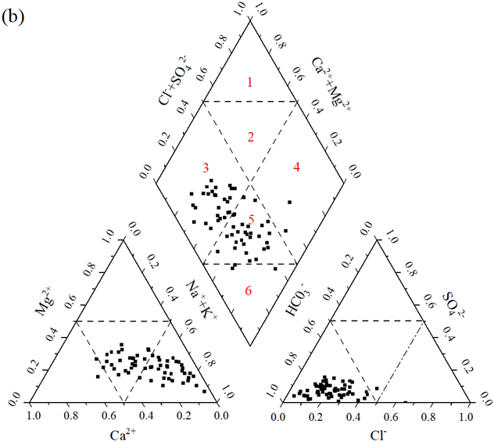
Fig. S1 (a) The evaluation of groundwater hardness in the study area; (b) Piper diagrams showing proportions among the major chemical components for all water samples. Hydrochemical facies (Piper diagram): 1: Ca-Cl, 2: Ca/Mg-Cl, 3: Ca/Mg-HCO₃, 4: Na-Cl, 5: Ca/Na-HCO₃, 6: Na-HCO₃.

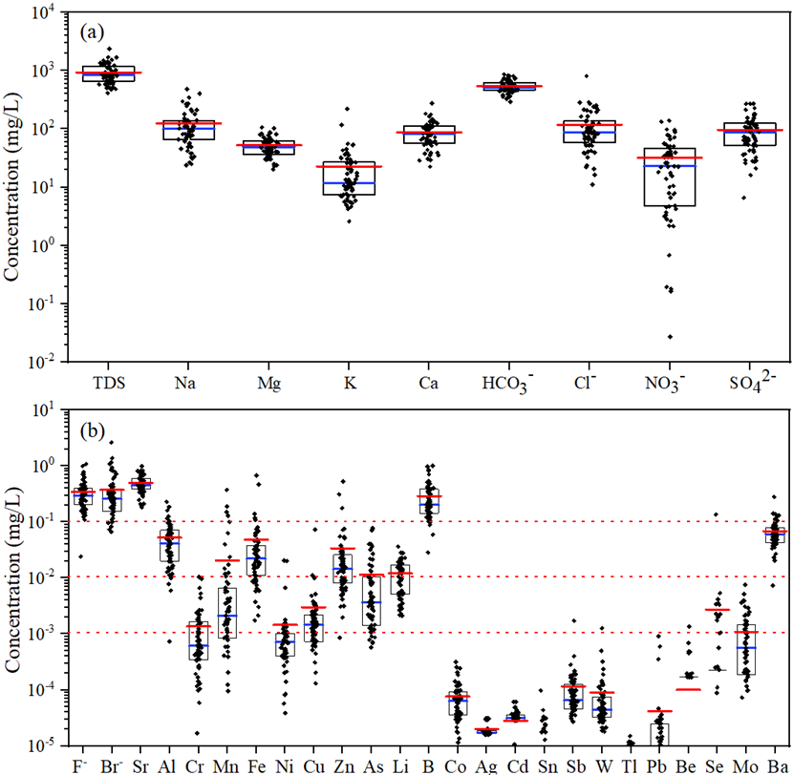
Fig. S2 Box plots of major elements (a) and trace elements (b).

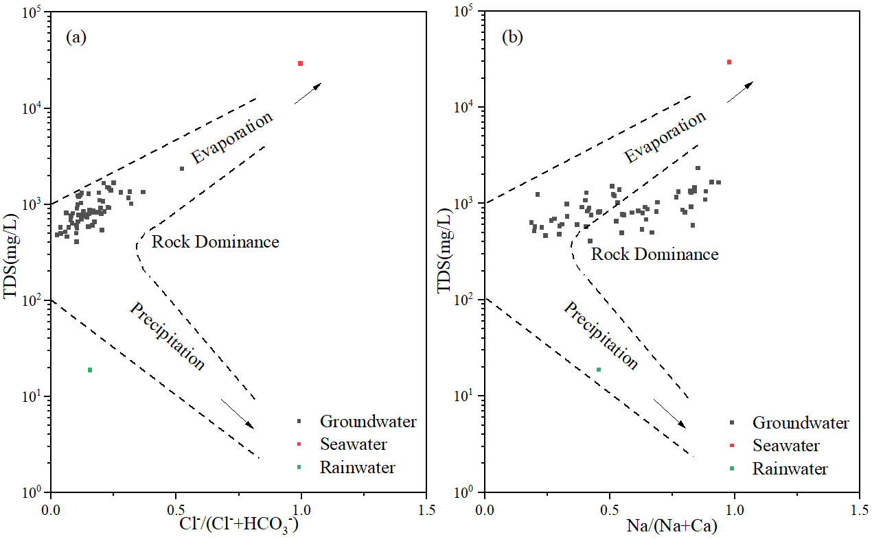
Fig. S3 Gibbs diagrams of groundwater in the study area: (a) TDS vs. Cl⁻/(Cl⁻+HCO₃⁻); (b) TDS vs. Na/(Na+Ca).

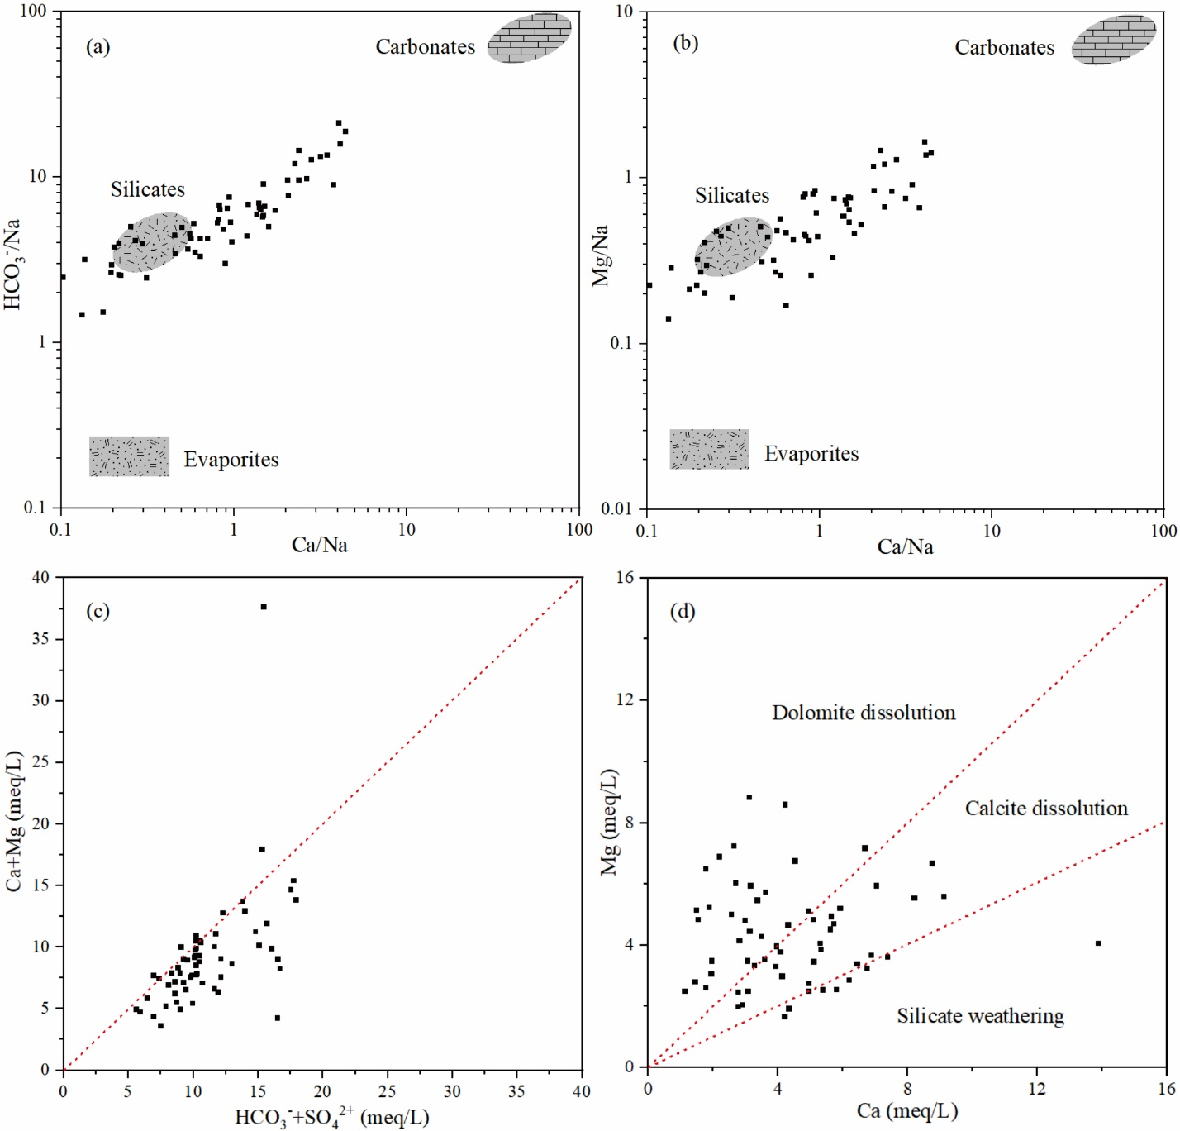
Fig. S4 Ion ratios in groundwater in the study area: (a) HCO₃⁻/Na vs. Ca/ Na; (b) Mg/Na vs. Ca/Na; (c) (Ca+Mg)/(HCO₃⁻+SO₄²⁻ ratio; (d) Mg/Ca ratio.

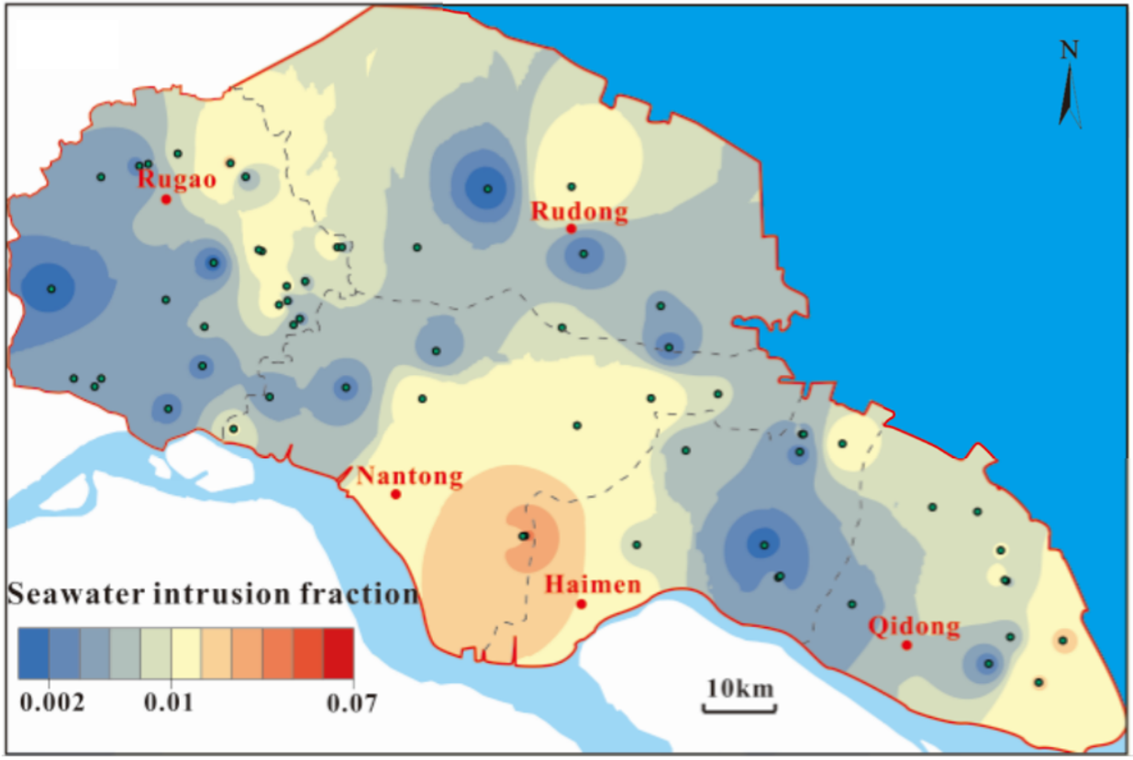
Fig. S5 The spatial distributions of the seawater intrusion fraction in the study area.

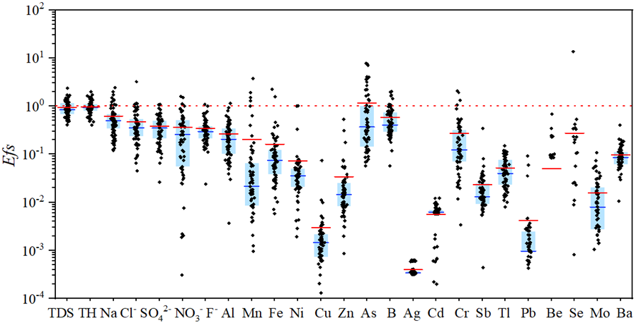
Fig. S6 Enrichment patterns of elements in the groundwater samples in the study area, compared to those in standards for drinking water quality (GB5749-2006). Efs=elements of the studied water samples vs. those of the Chinese national standard for drinking water quality.

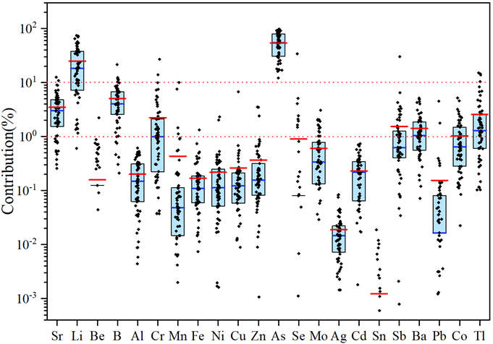
Fig. S7 The contribution of trace elements in groundwater samples to the non-carcinogenic risks.

Reference
Chinese Ministry of Environment Protection (2013) Exposure Factors Handbook of Chinese Population. China Environment Publishing Group
Dippong T, Hoaghia MA, Mihali C, Cical E, Calugaru M (2020) Human health risk assessment of some bottled waters from Romania. Environ Pollut 267:115409
Gao B, Gao L, Gao J, Xu D, Wang Q, Sun K (2019) Simultaneous evaluations of occurrence and probabilistic human health risk associated with trace elements in typical drinking water sources from major river basins in China. Sci Total Environ 666:139–146
Peng H, Yao F, Xiong S, Wu Z, Niu G, Lu T (2021a) Strontium in public drinking water and associated public health risks in Chinese cities. Environ Sci Pollut Res 28:23048–23059
Peng H, Zou P, Ma C, Xiong S, Lu T (2021b) Elements in potable groundwater in Rugao longevity area, China: Hydrogeochemical characteristics, enrichment patterns and health assessments. Ecotoxicol Environ Saf 218:112279
Sahu P, Sikdar P (2008) Hydrochemical framework of the aquifer in and around East Kolkata Wetlands, West Bengal, India. Environ Geol 55:823–835
USEPA (1991) Risk Assessment Guidance for Superfund, Volume I: Human Health Evaluation Manual (Part B, Development of Risk- Based Preliminary Remediation Goals) . Office of Emergency and Remedial Response. EPA/540/R-92/003. December 1991
USEPA (2004) Risk Assessment Guidance for Superfund Volume I: Human Health EvaluationManual (Part E, Supplemental Guidance for Dermal Risk Assessment). EPA/540/R/99/005Washington, DC: Office of Superfund Remediation and Technology Innovation U.S. Environmental Protection Agency. Available from bhttp://www.epa.gov/superfund/programs/risk/ragse/index.htmN.
USEPA (2016) Regional Screening Levels (RSLs) -user's guide. United States Environmental Protection Agency.
USEPA (2019) Integrated Risk Information System (IRIS). U.S. EPA,Washington, DC. https://www.epa.gov/iris.
Wu B, Zhao D, Jia H, Zhang Y, Zhang X, Cheng S (2009) Preliminary risk assessment of trace metal pollution in surface water from Yangtze River in Nanjing Section, China. Bull Environ Contam Toxicol 82:405–409
Xiao J, Jin Z, Wang J (2014) Geochemistry of trace elements and water quality assessment of natural water within the Tarim River Basin in the extreme arid region, NW China. J Geochem Explor 136:118–126
Xiao J, Wang L, Deng L, Jin Z (2019) Characteristics, sources, water quality and health risk assessment of trace elements in river water and well water in the Chinese Loess Plateau. Sci Total Environ 650:2004–2012

