Supplementary data
- Supplementary tables
- Flow chart for patient inclusion
- Missing data
- CVVHF protocol

Supplementary tables
Other causes of AKI in non-COVID patients
- Drug overdose/ poisoning (2)
- Pulmonary oedema secondary to acute cardiac decompensation (2)
- Hypercalcaemia secondary to haematological malignancy (1)
- Multi-organ failure secondary to haematological malignancy/ tumour lysis syndrome (2)
- Severe malaria (1)
- Pre-chemo filtration to reduce risk of tumour lysis syndrome (1)
- Contrast nephropathy on background chronic kidney disease (1)
- Rhabdomyolysis secondary to crush injury (1)

Supplementary Table 1: Other causes of AKI on non-COVID patients

Initiation of RRT | Non-COVID | COVID-19 | p-value
Cumulative fluid balance (mL) | 3236 (1061-6705) | 4779 (2516-7864) | 0.301
24hr urine output (mL/24hr) | 511 (170 – 1024) | 407 (252 – 945) | 0.347
pH | 7.23 (7.18 – 7.33) | 7.20 (7.11 – 7.27) | 0.115
Base excess (mmol/L) | -10.2 (-15.4 - -5.3) | -2.3 (-6.4 – 1.3) | <0.001
Lactate (mmol/L) | 5.15 (2.15 – 7.90) | 1.0 (0.7 – 1.6) | <0.001
Potassium (mmol/L) | 5.0 (4.6- 5.7) | 5.5 (4.9-6.1) | 0.835
Creatinine (μmol/L) | 288 (162 – 342) | 318 (205 – 408) | 0.282
Urea (mmol/L) | 18.8 (12.8 – 29.2) | 22.6 (17.0 – 34.4) | 0.075
PaO₂: FiO₂ Ratio (mmHg) | 195 (150-323) | 128 (83-173) | <0.001
Bicarbonate (mmol/L) | 18 (14 – 21) | 21 (18- 25) | 0.009
PaCO₂ (mmHg) | 41 (30 – 52) | 65 (55 – 80) | <0.001

Supplementary Table 2: Biochemical variables on initiation of RRT

 | Difference over time  (p-value) | Difference between groups  (p-value) | Interaction  p-value
Fluid balance (mL) | <0.001 | <0.001 | 0.077
PaO₂: FiO₂ ratio | 0.797 | <0.001 | 0.771
Creatinine (μmol/L) | <0.001 | 0.005 | 0.964
Arterial pH | <0.001 | <0.001 | 0.171
Base excess (mmol/L) | <0.001 | <0.001 | <0.001
Bicarbonate (mmol/L) | <0.001 | <0.001 | <0.001
PaCO₂ (kPa) | 0.933 | <0.001 | 0.425

Supplementary Table 3: Biochemical variables following initiation of RRT.

 | Non-COVID | COVID-19 | p-value
Packed red cell transfusion per filter day | 0.10 (0.00-0.56) | 0.13 (0.00 – 0.31) | 0.050
Clots per filter day | 0.00 (0.00-0.00) | 0.09 (0.00-0.25) | 0.001
New circuits per filter day | 0.40 (0.26 – 0.59) | 0.44 (0.33 – 0.60) | .0848

Supplementary Table 4: Data on transfusion and coagulation on RRT

Flow chart for patient inclusion
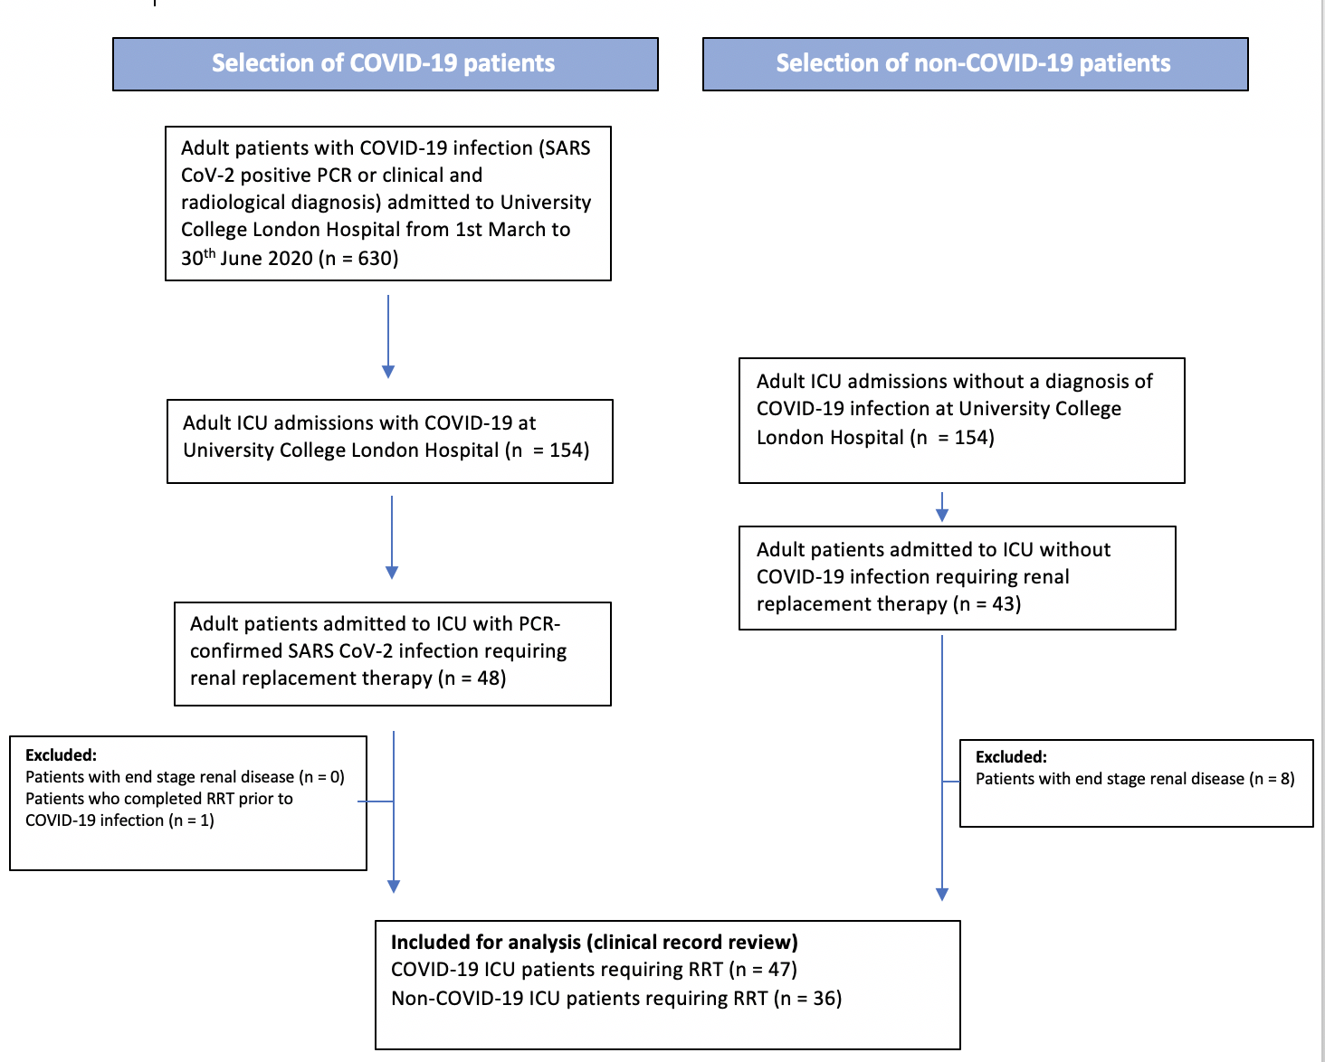

Missing data
Data | Non-COVID  (n = 36) | COVID-19  (n = 47)
Age | 0 (0%) | 0 (0%)
Sex | 0 (0%) | 0 (0%)
Body mass index | 14 (38.9%) | 12 (25.5%)
Past medical history:  - Chronic kidney disease  - Diabetes mellitus  - Hypertension | 0 (0%)  0 (0%)  0 (0%) | 0 (0%)  0 (0%)  0 (0%)
Renal replacement therapy (RRT):  - Requirement for RRT  - RRT duration  - Requirement for long-term haemofiltration | 0 (0%)  0 (0%)  0 (0%) | 0 (0%)  0 (0%)  0 (0%)
Invasive mechanical ventilation (IMV):  - Requirement for IMV  - IMV duration | 0 (0%)  0 (0%) | 0 (0%)  0 (0%)
Vasopressors:  - Requirement for vasopressors  - Vasopressor duration | 0 (0%)  0 (0%) | 0 (0%)  0 (0%)
Creatinine on admission | 1 (2.8%) | 1 (2.1%)
Creatinine day filter started | 1 (2.8%) | 0 (0%)
Urea day filter started | 6 (16.7%) | 9 (19.1%)
pH day filter started | 1 (2.8%) | 0 (0%)
Potassium day filter started | 0 (0%) | 0 (0%)
Lactate day filter started | 0 (0%) | 0 (0%)
Bicarbonate day filter started | 2 (5.6%) | 0 (0%)
Base deficit day filter started | 0 (0%) | 0 (0%)
Cumulative fluid balance day filter started | 0 (0%) | 3 (6.4%)
Urine output in preceding 24 hours | 0 (0%) | 0 (0%)
PaO₂:FiO₂ ratio on day filter started | 1 (2.8%) | 2 (4.3%)
Biochemistry day -1 from RRT initiation to day +3  (all values present) | 15 (41.2%) | 15 (31.9%)
24-hour fluid balance day -1 from RRT initiation to day +3  (all values present) | 16 (44.4%) | 13 (27.7%)
Venous thromboembolism during admission | 0 (0%) | 0 (0%)
Anticoagulation:  - Regional citrate anticoagulation and prophylactic LMWH  - Systemic therapeutic LMWH | 0 (0%)  N/A | 0 (0%)  0 (0%)
Filter clotting | 0 (0%) | 0 (0%)
Red cell transfusions | 0 (0%) | 0 (0%)
ICU length of stay | 0 (0%) | 0 (0%)
Time from RRT cessation to hospital discharge | 0 (0%) | 0 (0%)
Hospital mortality | 0 (0%) | 0 (0%)
Creatinine on hospital discharge (survivors) | 0 (0%) | 0 (0%)
Requirement for long-term RRT | 0 (0%) | 0 (0%)
LMWH = low molecular weight heparin; RRT

CVVHF protocol
Citrate-based regional anticoagulation is in routine use since 2015. Initiation settings are dialysis rate 1000 ml/hr, replacement rate (post-filter) 200 ml/hr with 1000 ml/hr citrate regional anticoagulation. A weight-based algorithm is not used; this however equates to a renal dose of 31 ml/kg/hr for a 70 kg patient. At consultant discretion this can be incremented for a further two stages, each equating to a 40% increase in renal dose compared to baseline. During the COVID-19 pandemic citrate regional anticoagulation was given when possible. A COVID-19 RRT protocol was drawn up to account for several scenarios: (i) filter set loss due to recurrent clotting; (ii) systemic anticoagulation with low molecular weight heparin (LMWH) in the event of a lack of citrated fluids or syringe drivers to administer unfractionated heparin) and (iii) supply issues with dialysis or replacement fluid. In the event of rationing of RRT (filter fluids, filter sets or RRT devices), stricter criteria were advocated for initiation of therapy (K⁺ >6.0 mmol/l, arterial pH <7.20 (metabolic), oliguric renal failure with volume overload or creatinine >500 μmol/l). The COVID-19 protocol consisted of stage I haemofiltration with 1000 ml/hr replacement fluid; and stages II & III using 1000 ml/hr dialysis and either 1000 or 2000 ml/hr replacement fluid. Post-filter replacement fluid occurred in two-thirds. . Stages II and III were initiated at consultant discretion, equating to 29 and 44 ml/kg/hr, respectively. LMWH was used for anticoagulation; 0.75 mg/kg enoxaparin ideal body weight, 12 hourly for stages I and II, and 1 mg/kg for stage III (maximum 100 mg single dose); this was commenced if practical at 1 hour before commencing RRT. The circuit was primed with 5000 IU unfractionated heparin. For patients with recurring filter clotting, LMWH doses were adjusted based on anti-Xa levels where necessary, filter blood pump speed was increased, predilution ratio changed to 50%, and adding parenteral epoprostenol considered.

