Supplementary Appendix

Effect modification by sex and BMI
In our analyses, both sex and BMI modified how a genetically predicted CETP reduction influenced lipid and lipoprotein levels. There is also evidence that there are sex differences in the interaction between adiposity and lipids hinting at a possible three-way interaction.
The three way interaction term including sex, BMI and genetic CETP reduction was significant for LDL-c levels (p = 4.1 × 10⁻⁴) and had concordant effects on apoB levels (p = 0.001). As seen on the marginal effect plots (Supplementary Figure 10), BMI influences the effect of CETP on LDL-c and apoB in men with higher BMI values associated with a smaller decrease in LDL-c. This pattern is not seen in women and BMI does not influence the reduction of LDL-c with genetically lower CETP concentration. We did not detect a significant three-way interaction (sex, BMI, genetic CETP reduction) for cardiovascular outcomes, but statistical power was likely limited. In the analysis based on rs1800775, results for biomarkers were similar to those obtained with the score (Supplementary Figure 11).
We also estimated how sex and BMI may modifiy the effect of a genetically lower CETP on cholesterol efflux in the MHI Biobank. There was evidence for a three-way interaction between sex, BMI and the CETP score on basal efflux (p = 0.037) and stimulated efflux (p = 0.007). The marginal effects in men and women with fixed BMI are presented in Supplementary Figure 12. In men, increasing BMI may increase the CETP associated cAMP-stimulated cholesterol efflux (subgroup CETP by BMI interaction p = 0.11) but not its effect on basal efflux (p = 0.53), whereas in women increasing BMI reduced the effect of the CETP score on both stimulated (p = 0.045) and basal efflux (p = 0.050).
For cardiovascular events, the three-way interaction p-values with the genetic score were 0.43 for revascularization procedures, 0.062 for MI, 0.058 for CAD (“soft” definition) and 0.15 for CAD (“hard” definition). In results based on rs1800775, the direction of the interaction in men was inconsistent with the observed effects on biomarkers (increasing BMI conferred a stronger protective effect for all cardiovascular endpoints). The slope of the effect modification of CETP by BMI was inverted in women compared to men for cardiovascular endpoints.

Results from power analyses

Effect modification by sex
We conducted power analyses to assess our limit of detection based on the sample size and the prevalence of CAD in men and women in the UK Biobank dataset. For the association of one s.d. reduction in the CETP genetic score with CAD, we calculated that for an OR of 0.98 in men an OR of 0.95 or less in women was sufficient to reach 80% power to detect a significant interaction effect between the CETP genetic score and sex (Supplementary Figure 3).

Effect modification by BMI
Using simulations, we estimated the smallest detectable effect modification by BMI of the association between genetically-predicted CETP levels and cardiovascular outcomes (Supplementary Figure 8) at 80% power to be 𝛽_{itx} = 0.015. This represents an OR per s.d. decrease in the CETP score of 0.96 for the normal BMI range versus 0.99 for obese individuals. In our analyses, the product term between the CETP score and BMI was 0.010 (95% CI -0.00042, 0.020) and we estimate our power to detect a statistically significant effect of this magnitude at 48%.

Supplementary Tables and Figures

Supplementary Table 1. Correlation coefficient between the different CETP genetic scores or the rs1800775 variant. The upper triangular matrix shows the Pearson correlation coefficient and the lower triangular shows the squared coefficients. All scores were calculated using the p-value thresholding and LD clumping approach, except for the “Blauw et al. condi. indep.” score which is based on the conditionally independent variants reported in the original study.
 | MAGNETIC HDL diameter | MAGNETIC L-HDL-CE | MAGNETIC S-VLDL-TG | Blauw et al. GRS | Blauw et al. condi. Indep. | SNP rs1800775
MAGNETIC HDL diameter | 1 | 1.00 | -1.00 | -0.87 | -0.94 | 0.72
MAGNETIC L-HDL-CE | 1.00 | 1 | -1.00 | -0.87 | -0.94 | 0.72
MAGNETIC S-VLDL-TG | 0.99 | 0.99 | 1 | 0.87 | 0.93 | -0.71
Blauw et al. GRS | 0.76 | 0.76 | 0.76 | 1 | 0.87 | -0.71
Blauw et al. condi. Indep. | 0.89 | 0.89 | 0.86 | 0.75 | 1 | -0.74
SNP rs1800775 | 0.51 | 0.51 | 0.51 | 0.51 | 0.55 | 1

Supplementary Table 2. Codes used to define cardiovascular endpoint events in the UK Biobank. Events from either the hospitalization or death records were used and the procedure codes (OPCS codes) are from the hospitalization records.
Variable | Definition
Myocardial infarction (MI) | ICD10 codes: I21, I22, I23, I25.2 or ICD9 codes: 410, 412, 411.0, 429.79
Percutaneous coronary intervention or coronary artery bypass graft (PCI/CABG) | OPCS codes: K40, K41, K42, K43, K44, K45, K46, K49, K50, K75
Coronary artery disease (CAD) - soft | PCI/CABG or ICD9 codes 410-414 (except for aneurysms: 414.1) or ICD10 codes I20-I25
Coronary artery disease (CAD) - hard | Combination of MI, PCI/CABG or hospitalization or death for unstable angina coded a I20.0 as the primary cause of death or hospitalization. For this variable, cases for the “soft” CAD definition that would be controls for the “hard” CAD definition are set as missing so that they are excluded from the analyses.

Supplementary Table 3. Effect per alternative allele of rs1800775 (CETP -629C>A) on biomarkers and cardiovascular events. Coefficients for continuous variables are from a linear regression model adjusted for age, sex and the first 10 principal components and are expressed in standard deviation of the outcome per “A” allele of the rs1800775 SNP. Odds ratios for cardiovascular outcomes are estimated using a logistic regression model adjusted for the same covariates.
Outcome | n or n cases | Coefficient or odds ratio (95% CI) | p-value
Biomarkers
lipoprotein(a) | 315,214 | -0.0143 (-0.0182, -0.0106) | 1.4 × 10⁻¹³
C-reactive protein | 394,165 | 0.0041 (-0.0003, 0.0084) | 0.070
HDL cholesterol | 362,468 | 0.198 (0.194, 0.203) | <10⁻³⁰⁰
Apolipoprotein A | 360,451 | 0.156 (0.151, 0.160) | <10⁻³⁰⁰
LDL cholesterol | 394,287 | -0.028 (-0.033, -0.024) | 3.2 × 10⁻³⁶
Apolipoprotein B | 393,089 | -0.041 (-0.045, -0.037) | 1.4 × 10⁻⁷³
Basal cholesterol efflux (MHI Biobank) | 5,213 | 0.120 (0.0835, 0.156) | 1.1 × 10⁻¹⁰
cAMP-stimulated cholesterol efflux (MHI Biobank) | 5,212 | 0.0919 (0.0547, 0.129) | 1.3 × 10⁻⁶
Cardiovascular outcomes
Coronary artery disease (“soft”) | 44,713 | 0.973 (0.959, 0.987) | 0.00015
Coronary artery disease (“hard”) | 26,342 | 0.968 (0.950, 0.986) | 0.00047
Myocardial infarction | 18,559 | 0.982 (0.962, 1.000) | 0.10
Percutaneous coronary intervention or coronary artery bypass graft | 16,941 | 0.970 (0.948, 0.992) | 0.0068

Supplementary Table 4. Drug codings to define statin users in the UK Biobank.
UK biobank Data-Coding 4 | Prescription
1140861958 | simvastatin
1141146234 | atorvastatin
1141146138 | lipitor 10mg tablet
1141192410 | rosuvastatin
1141192736 | ezetimibe
1140888648 | pravastatin
1141188146 | simvador 10mg tablet
1141192414 | crestor 10mg tablet
1140881748 | zocor 10mg tablet
1141200040 | zocor heart-pro 10mg tablet

Supplementary Table 5. Interaction between the CETP genetic score and sex on the additive scale (RERI and interaction contrast) based on the logistic regression model in the UK Biobank.
Outcome | Odds ratio RERI (95% CI) | Interaction contrast (bootstrap 95% CI)
Coronary artery disease (“soft”) | 0.031 (-0.006, 0.070) | 0.0011 (-0.00074, 0.0029)
Coronary artery disease (“hard”) | 0.082 (0.020, 0.146) | 0.0017 (0.00024, 0.0032)
Myocardial infarction | 0.050 (-0.018, 0.121) | 0.00078 (-0.00042, 0.0019)
Percutaneous coronary intervention or coronary artery bypass graft | 0.091 (-0.003, 0.188) | 0.00099 (-0.00012, 0.0021)

Supplementary Table 6. ANOVA results for the nonlinear interaction models of the CETP genetic score and BMI on biomarkers and cardiovascular outcomes. Linear regression was used for biomarkers and logistic regression was used for cardiovascular outcomes. The presented association statistics are F statistics for the former and 𝜒² for the latter. Both the CETP score and BMI are modeled using restricted cubic splines with 4 knots.
Outcome | Factor | Statistic (F or chi2) | d.f. | P-value
Biomarkers (modeled using linear regression)
Lipoprotein(a)* | All interactions (BMI and CETP) | 2.14 | 9 | 0.0233
 | BMI | 15.55 | 12 | < 0.0001
 | Nonlinear effects | 22.09 | 8 | < 0.0001
 | CETP genetic score | 6.91 | 12 | < 0.0001
 | Nonlinear effects | 0.94 | 8 | 0.4793
C-reactive protein | All interactions (BMI and CETP) | 0.89 | 9 | 0.5299
 | BMI | 7662.84 | 12 | < 0.0001
 | Nonlinear effects | 19.81 | 8 | < 0.0001
 | CETP genetic score | 1.47 | 12 | 0.1265
 | Nonlinear effects | 0.66 | 8 | 0.7247
HDL cholesterol | All interactions (BMI and CETP) | 37.41 | 9 | < 0.0001
 | BMI | 4975.76 | 12 | < 0.0001
 | Nonlinear effects | 189.61 | 8 | < 0.0001
 | CETP genetic score | 1242.72 | 12 | < 0.0001
 | Nonlinear effects | 8.51 | 8 | < 0.0001
Apolipoprotein A | All interactions (BMI and CETP) | 11.72 | 9 | < 0.0001
 | BMI | 2632.38 | 12 | < 0.0001
 | Nonlinear effects | 77.75 | 8 | < 0.0001
 | CETP genetic score | 683.50 | 12 | < 0.0001
 | Nonlinear effects | 2.05 | 8 | 0.0365
LDL cholesterol | All interactions (BMI and CETP) | 3.68 | 9 | 0.0001
 | BMI | 521.46 | 12 | < 0.0001
 | Nonlinear effects | 704.12 | 8 | < 0.0001
 | CETP genetic score | 20.57 | 12 | < 0.0001
 | Nonlinear effects | 3.17 | 8 | 0.0013
Apolipoprotein B | All interactions (BMI and CETP) | 2.29 | 9 | 0.0147
 | BMI | 733.80 | 12 | < 0.0001
 | Nonlinear effects | 638.04 | 8 | < 0.0001
 | CETP genetic score | 38.91 | 12 | < 0.0001
 | Nonlinear effects | 2.70 | 8 | 0.0058
Basal cholesterol efflux (MHI Biobank) | All interactions (BMI and CETP) | 0.66 | 9 | 0.7473
 | BMI | 17.55 | 12 | < 0.0001
 | Nonlinear effects | 1.91 | 8 | 0.0537
 | CETP genetic score | 5.84 | 12 | < 0.0001
 | Nonlinear effects | 0.64 | 8 | 0.7437
cAMP-stimulated cholesterol efflux (MHI Biobank) | All interactions (BMI and CETP) | 0.49 | 9 | 0.8815
 | BMI | 4.27 | 12 | < 0.0001
 | Nonlinear effects | 0.50 | 8 | 0.8537
 | CETP genetic score | 3.67 | 12 | < 0.0001
 | Nonlinear effects | 0.64 | 8 | 0.7439
Cardiovascular outcomes (modeled using logistic regression)
Coronary artery disease (“soft”) | All interactions (BMI and CETP) | 8.10 | 9 | 0.5244
 | BMI | 4892.66 | 12 | < 0.0001
 | Nonlinear effects | 128.51 | 8 | < 0.0001
 | CETP genetic score | 30.67 | 12 | 0.0022
 | Nonlinear effects | 4.84 | 8 | 0.7742
Coronary artery disease (“hard”) | All interactions (BMI and CETP) | 6.16 | 9 | 0.72
 | BMI | 2798.71 | 12 | < 0.0001
 | Nonlinear effects | 68.01 | 8 | < 0.0001
 | CETP genetic score | 25.36 | 12 | 0.0132
 | Nonlinear effects | 3.19 | 8 | 0.9219
Myocardial infarction | All interactions (BMI and CETP) | 8.64 | 9 | 0.4716
 | BMI | 1857.02 | 12 | < 0.0001
 | Nonlinear effects | 69.72 | 8 | < 0.0001
 | CETP genetic score | 15.49 | 12 | 0.2157
 | Nonlinear effects | 5.71 | 8 | 0.6798
Percutaneous coronary intervention or coronary artery bypass graft | All interactions (BMI and CETP) | 5.49 | 9 | 0.7893
 | BMI | 1254.46 | 12 | < 0.0001
 | Nonlinear effects | 122.46 | 8 | < 0.0001
 | CETP genetic score | 22.25 | 12 | 0.0349
 | Nonlinear effects | 3.37 | 8 | 1
* The Lp(a) genetic score was added as a covariate.

Supplementary Table 7. Interaction between the CETP genetic score and body mass index on the additive scale (RERI and interaction contrast) based on the logistic regression model in the UK Biobank.
Outcome | Odds ratio RERI (95% CI) | Interaction contrast (bootstrap 95% CI)
Coronary artery disease (“soft”) | -0.002 (-0.017, 0.012) | -0.00030 (-0.0013, 0.00076)
Coronary artery disease (“hard”) | -0.001 (-0.020, 0.018) | -9.5 × 10⁻⁵ (-0.00090, 0.00068)
Myocardial infarction | -0.005 (-0.025, 0.016) | -0.00014 (-0.00073, 0.00043)
Percutaneous coronary intervention or coronary artery bypass graft | 0.00039 (-0.021, 0.022) | -5.8 × 10⁻⁶ (-0.00051, 0.00051)

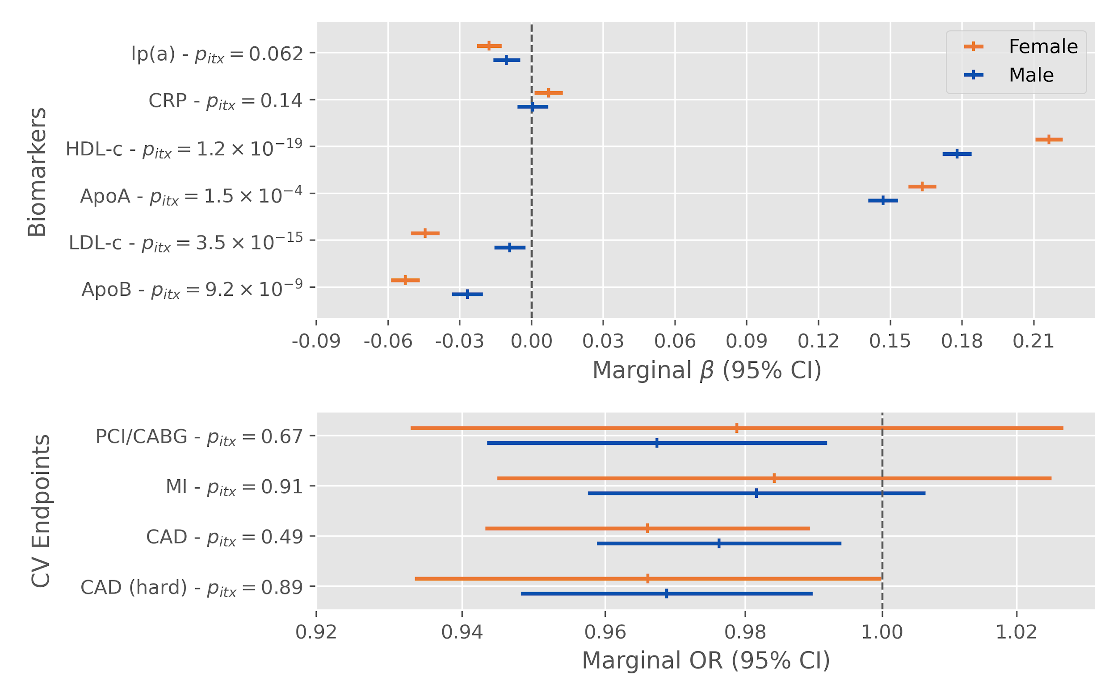
Supplementary Figure 1. Effect modification of rs1800775 (CETP -629C>A) alternative alleles by sex on biomarkers and cardiovascular endpoints in the UK Biobank. Displayed p-values (p_{itx}) are for the two-sided test of the product term between the SNP and a binary sex indicator variable.

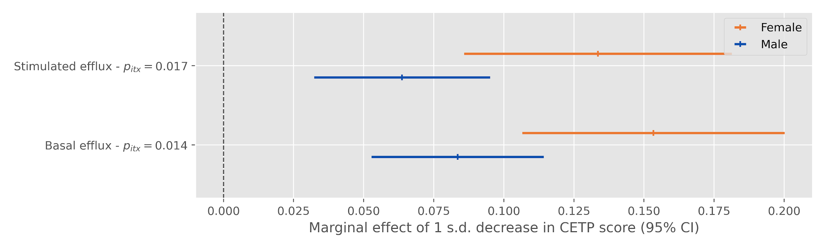
Supplementary Figure 2. Effect modification of a 1 standard deviation decrease in the CETP concentration genetic score by sex on cholesterol efflux in the MHI Biobank. Displayed p-values (p_{itx}) are for the two-sided test of the product term between the CETP score and a binary sex indicator variable.

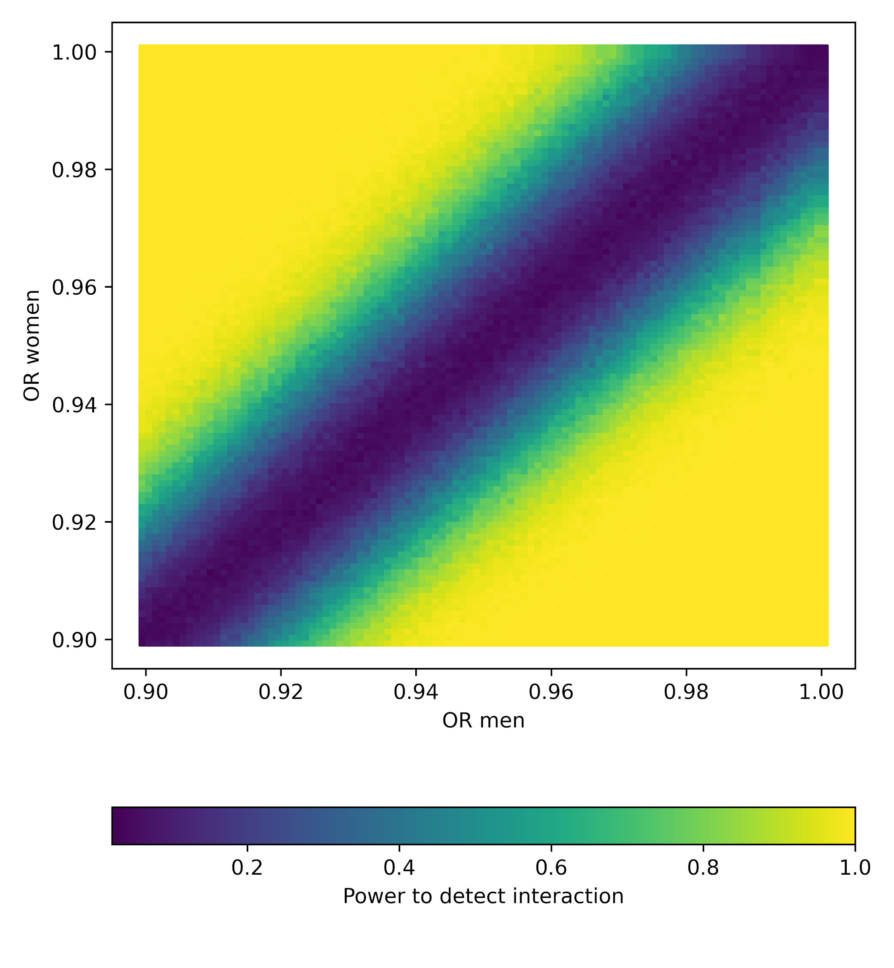
Supplementary Figure 3. Power to detect a difference between men and women in the association between a standardized genetic score and a coronary artery disease. The results of this simulation are for 500 simulated datasets for different combinations of OR in men and women and given the sample size (n=413,138) and prevalence of coronary artery disease (“soft” definition, 10.8%) in our dataset.

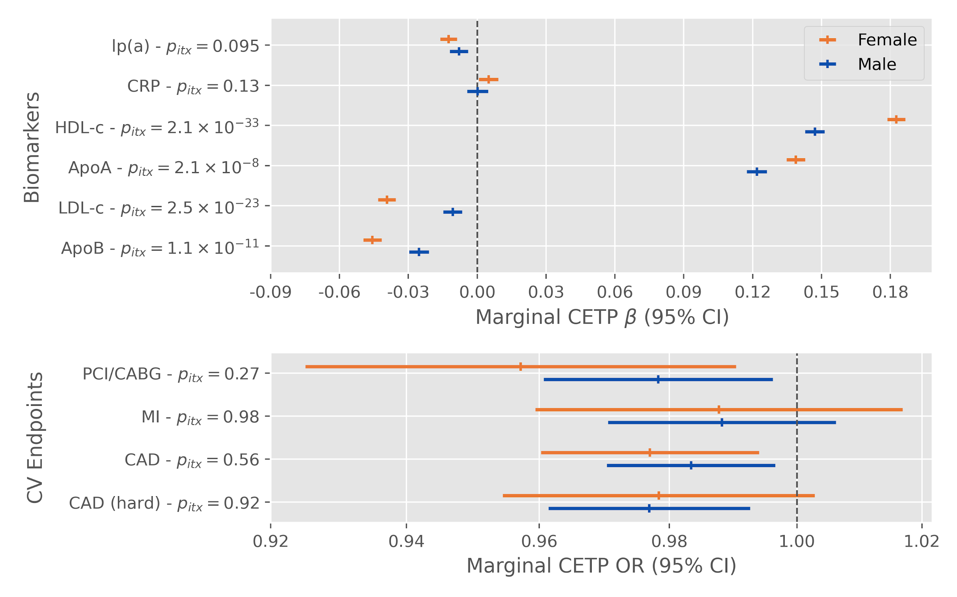
Supplementary Figure 4. Effect modification of a 1 standard deviation decrease in the CETP concentration genetic score by sex on biomarkers and cardiovascular endpoints adjusting for self-reported statin use in the UK Biobank. Displayed p-values (p_{itx}) are for the two-sided test of the product term between the CETP score and a binary sex indicator variable.

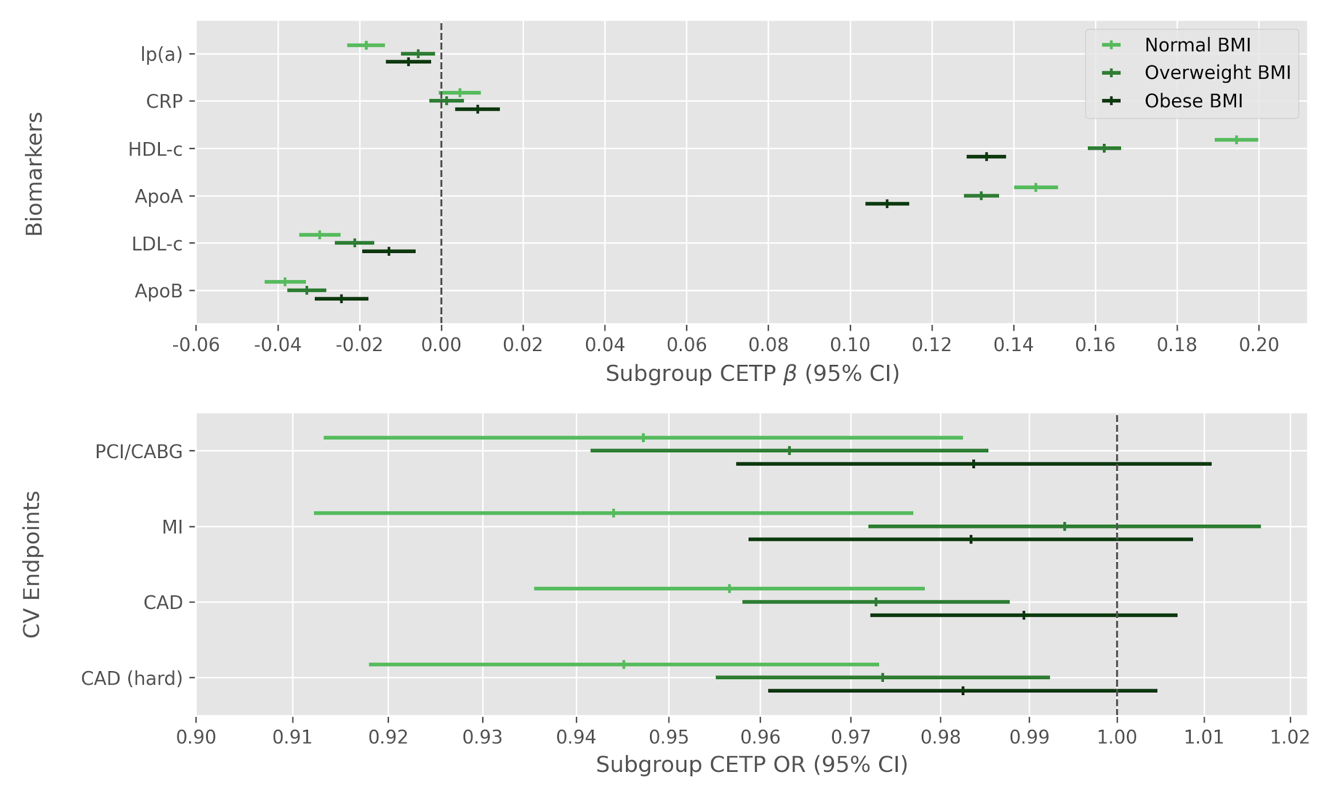
Supplementary Figure 5. Subgroup effect of a 1 standard deviation decrease in the CETP concentration genetic score on biomarkers and cardiovascular endpoints by BMI class in the UK Biobank.

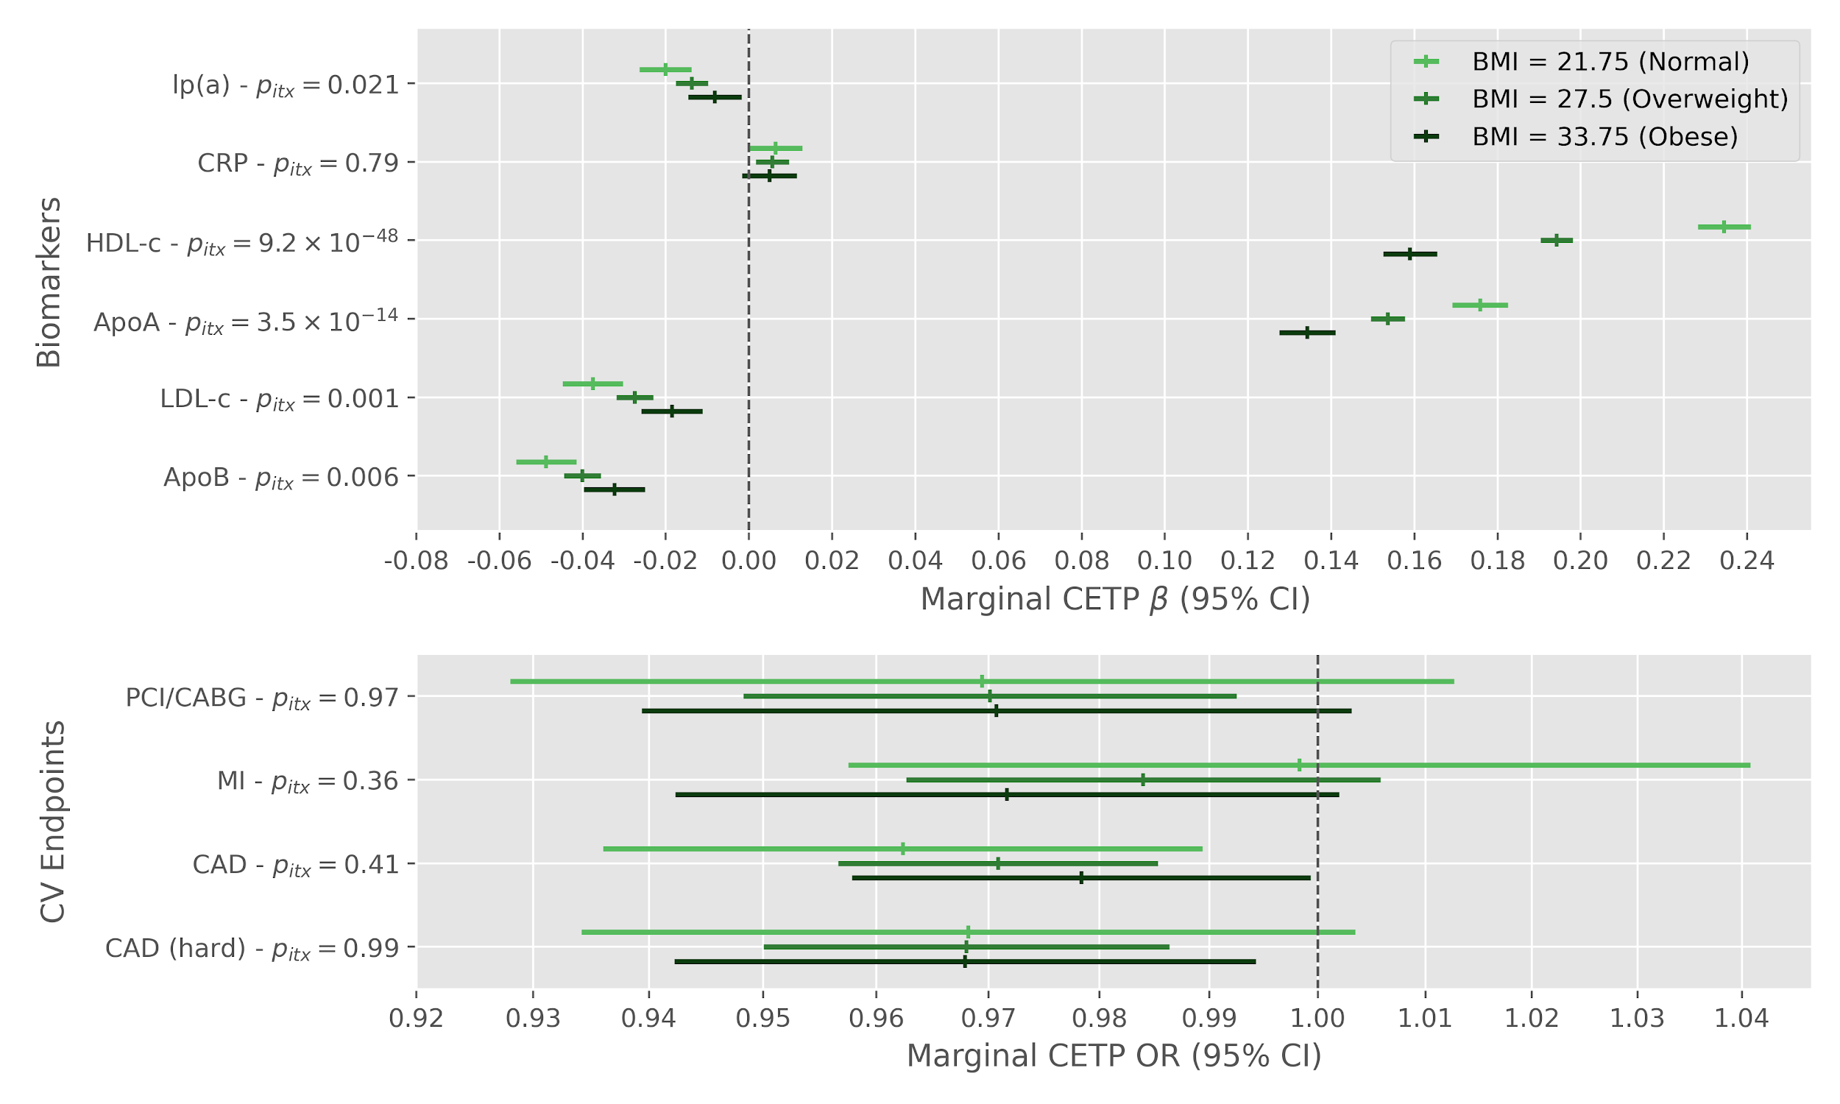
Supplementary Figure 6. Effect modification of rs1800775 (CETP -629C>A) alternative alleles by BMI on biomarkers and cardiovascular endpoints in the UK Biobank. Displayed p-values (p_{itx}) are for the two-sided test of the product term between the SNP and standardized body mass index.

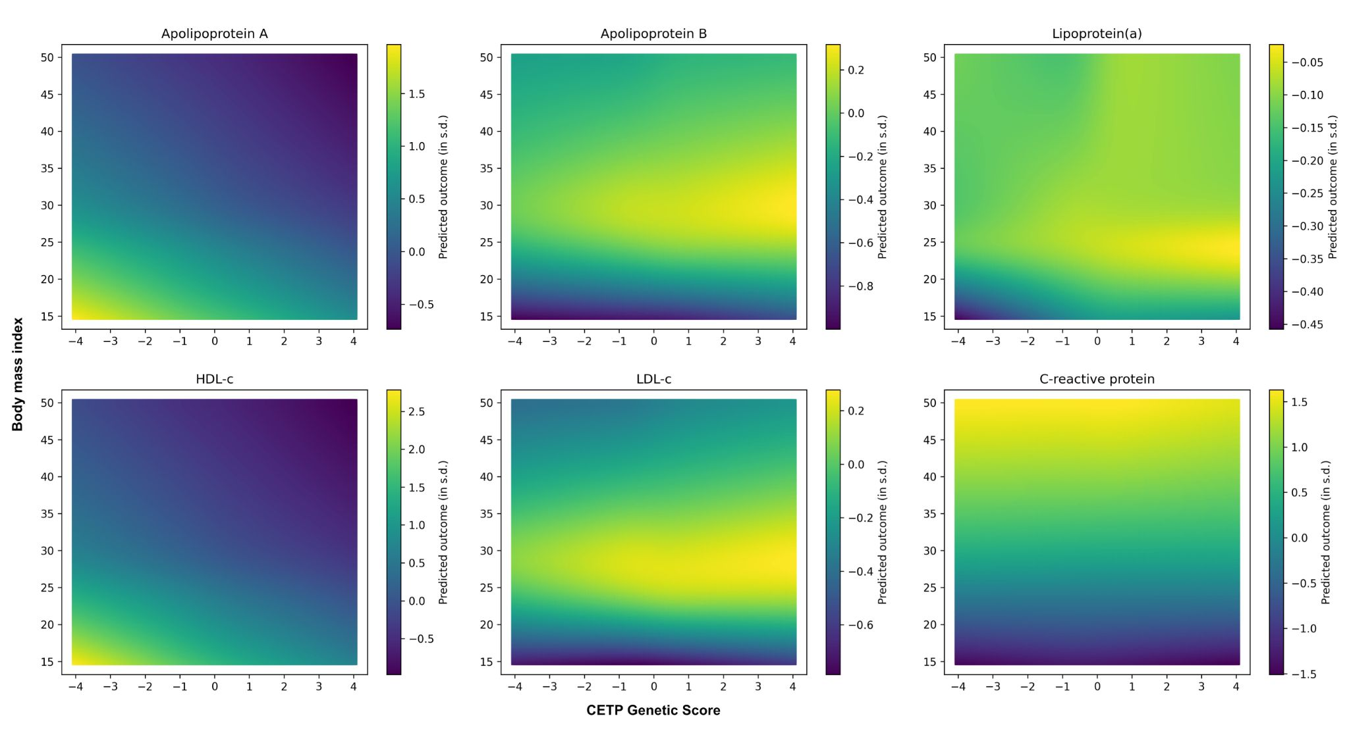
Supplementary Figure 7. Expected value of the standardized biomarkers predicted by linear regression models including interacting splines for the BMI and the genetic score. The CETP genetic score was set to values between -4 and 4 (x axis) and the BMI was set to values between 15 and 50 (y axis).

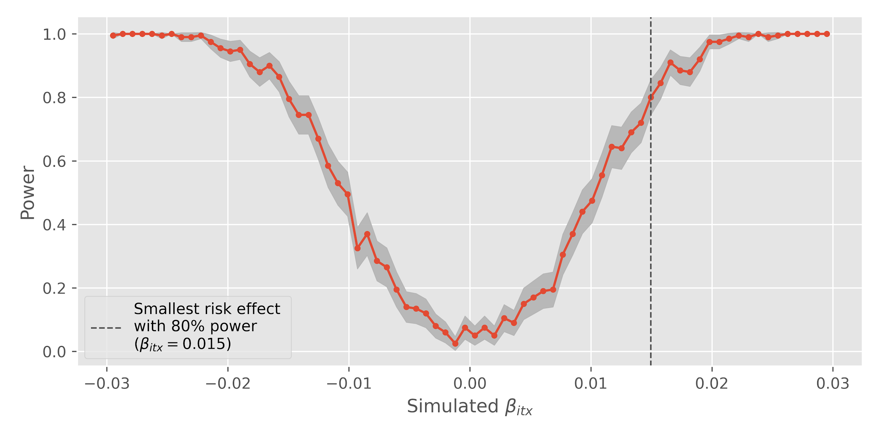
Supplementary Figure 8. Simulation-based power analysis to detect an additive interaction effect between a continuous CETP score and standardized BMI. This simulation sets as static parameters the prevalence of CAD and the mean effect of a reduction in the CETP score. Results are based on 200 simulation replicates of 413,138 individuals.

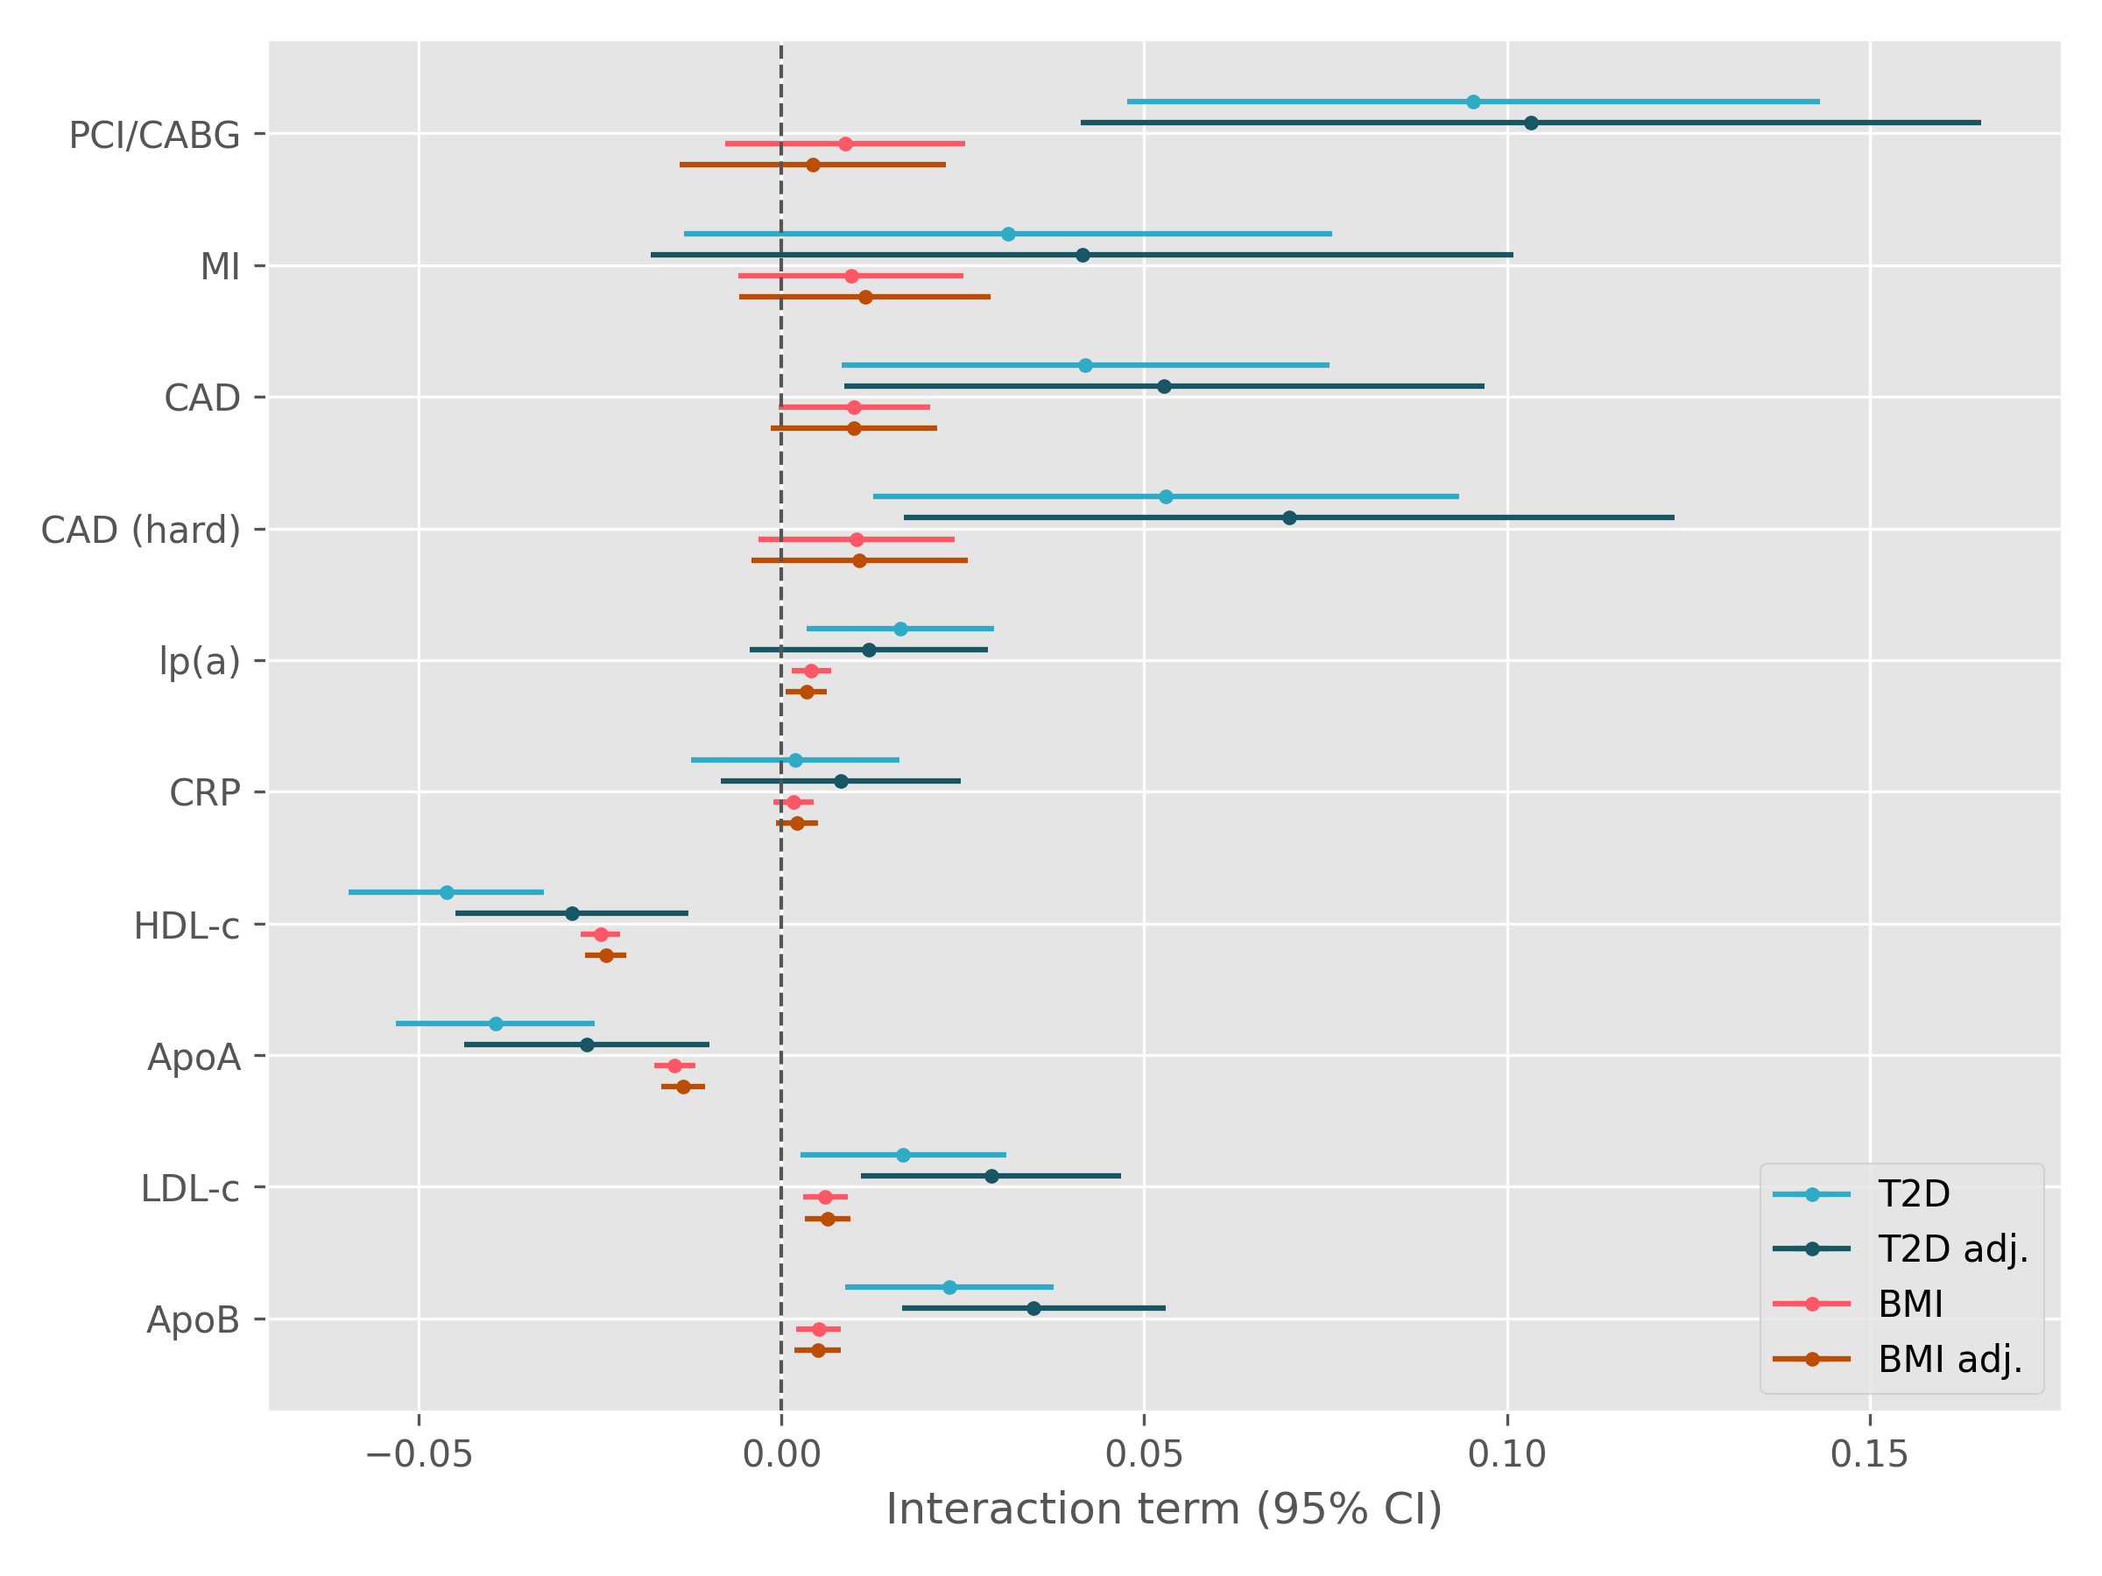
Supplementary Figure 9. Interaction coefficients between the CETP genetic score and type II diabetes and BMI with and without adjustment for the other variable in the UK Biobank. The unadjusted model includes the product interaction term between CETP and type II diabetes or BMI whereas the adjusted model includes the three-way product interaction.

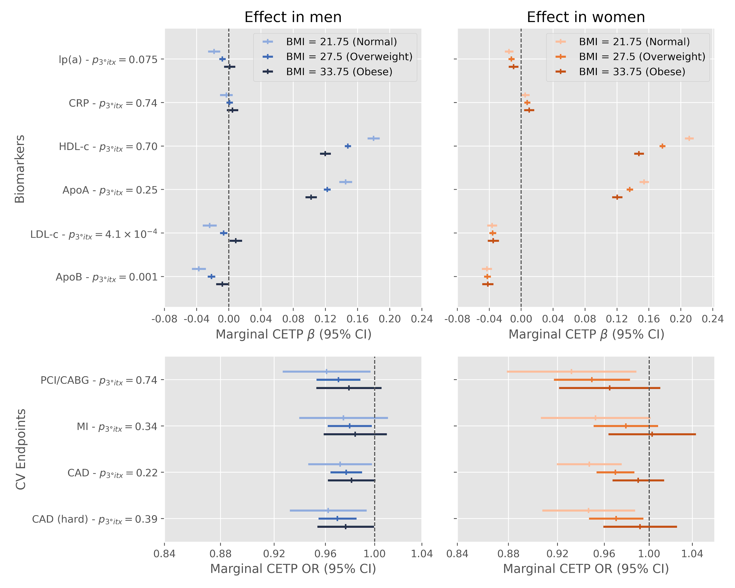
Supplementary Figure 10. Effect modification of a 1 standard deviation decrease in the CETP concentration genetic score by BMI and sex on biomarkers and cardiovascular endpoints in the UK Biobank. Displayed p-values (p_{3°itx}) are for the two-sided test of the three way product term between the CETP score, standardized body mass index and a binary variable for sex.

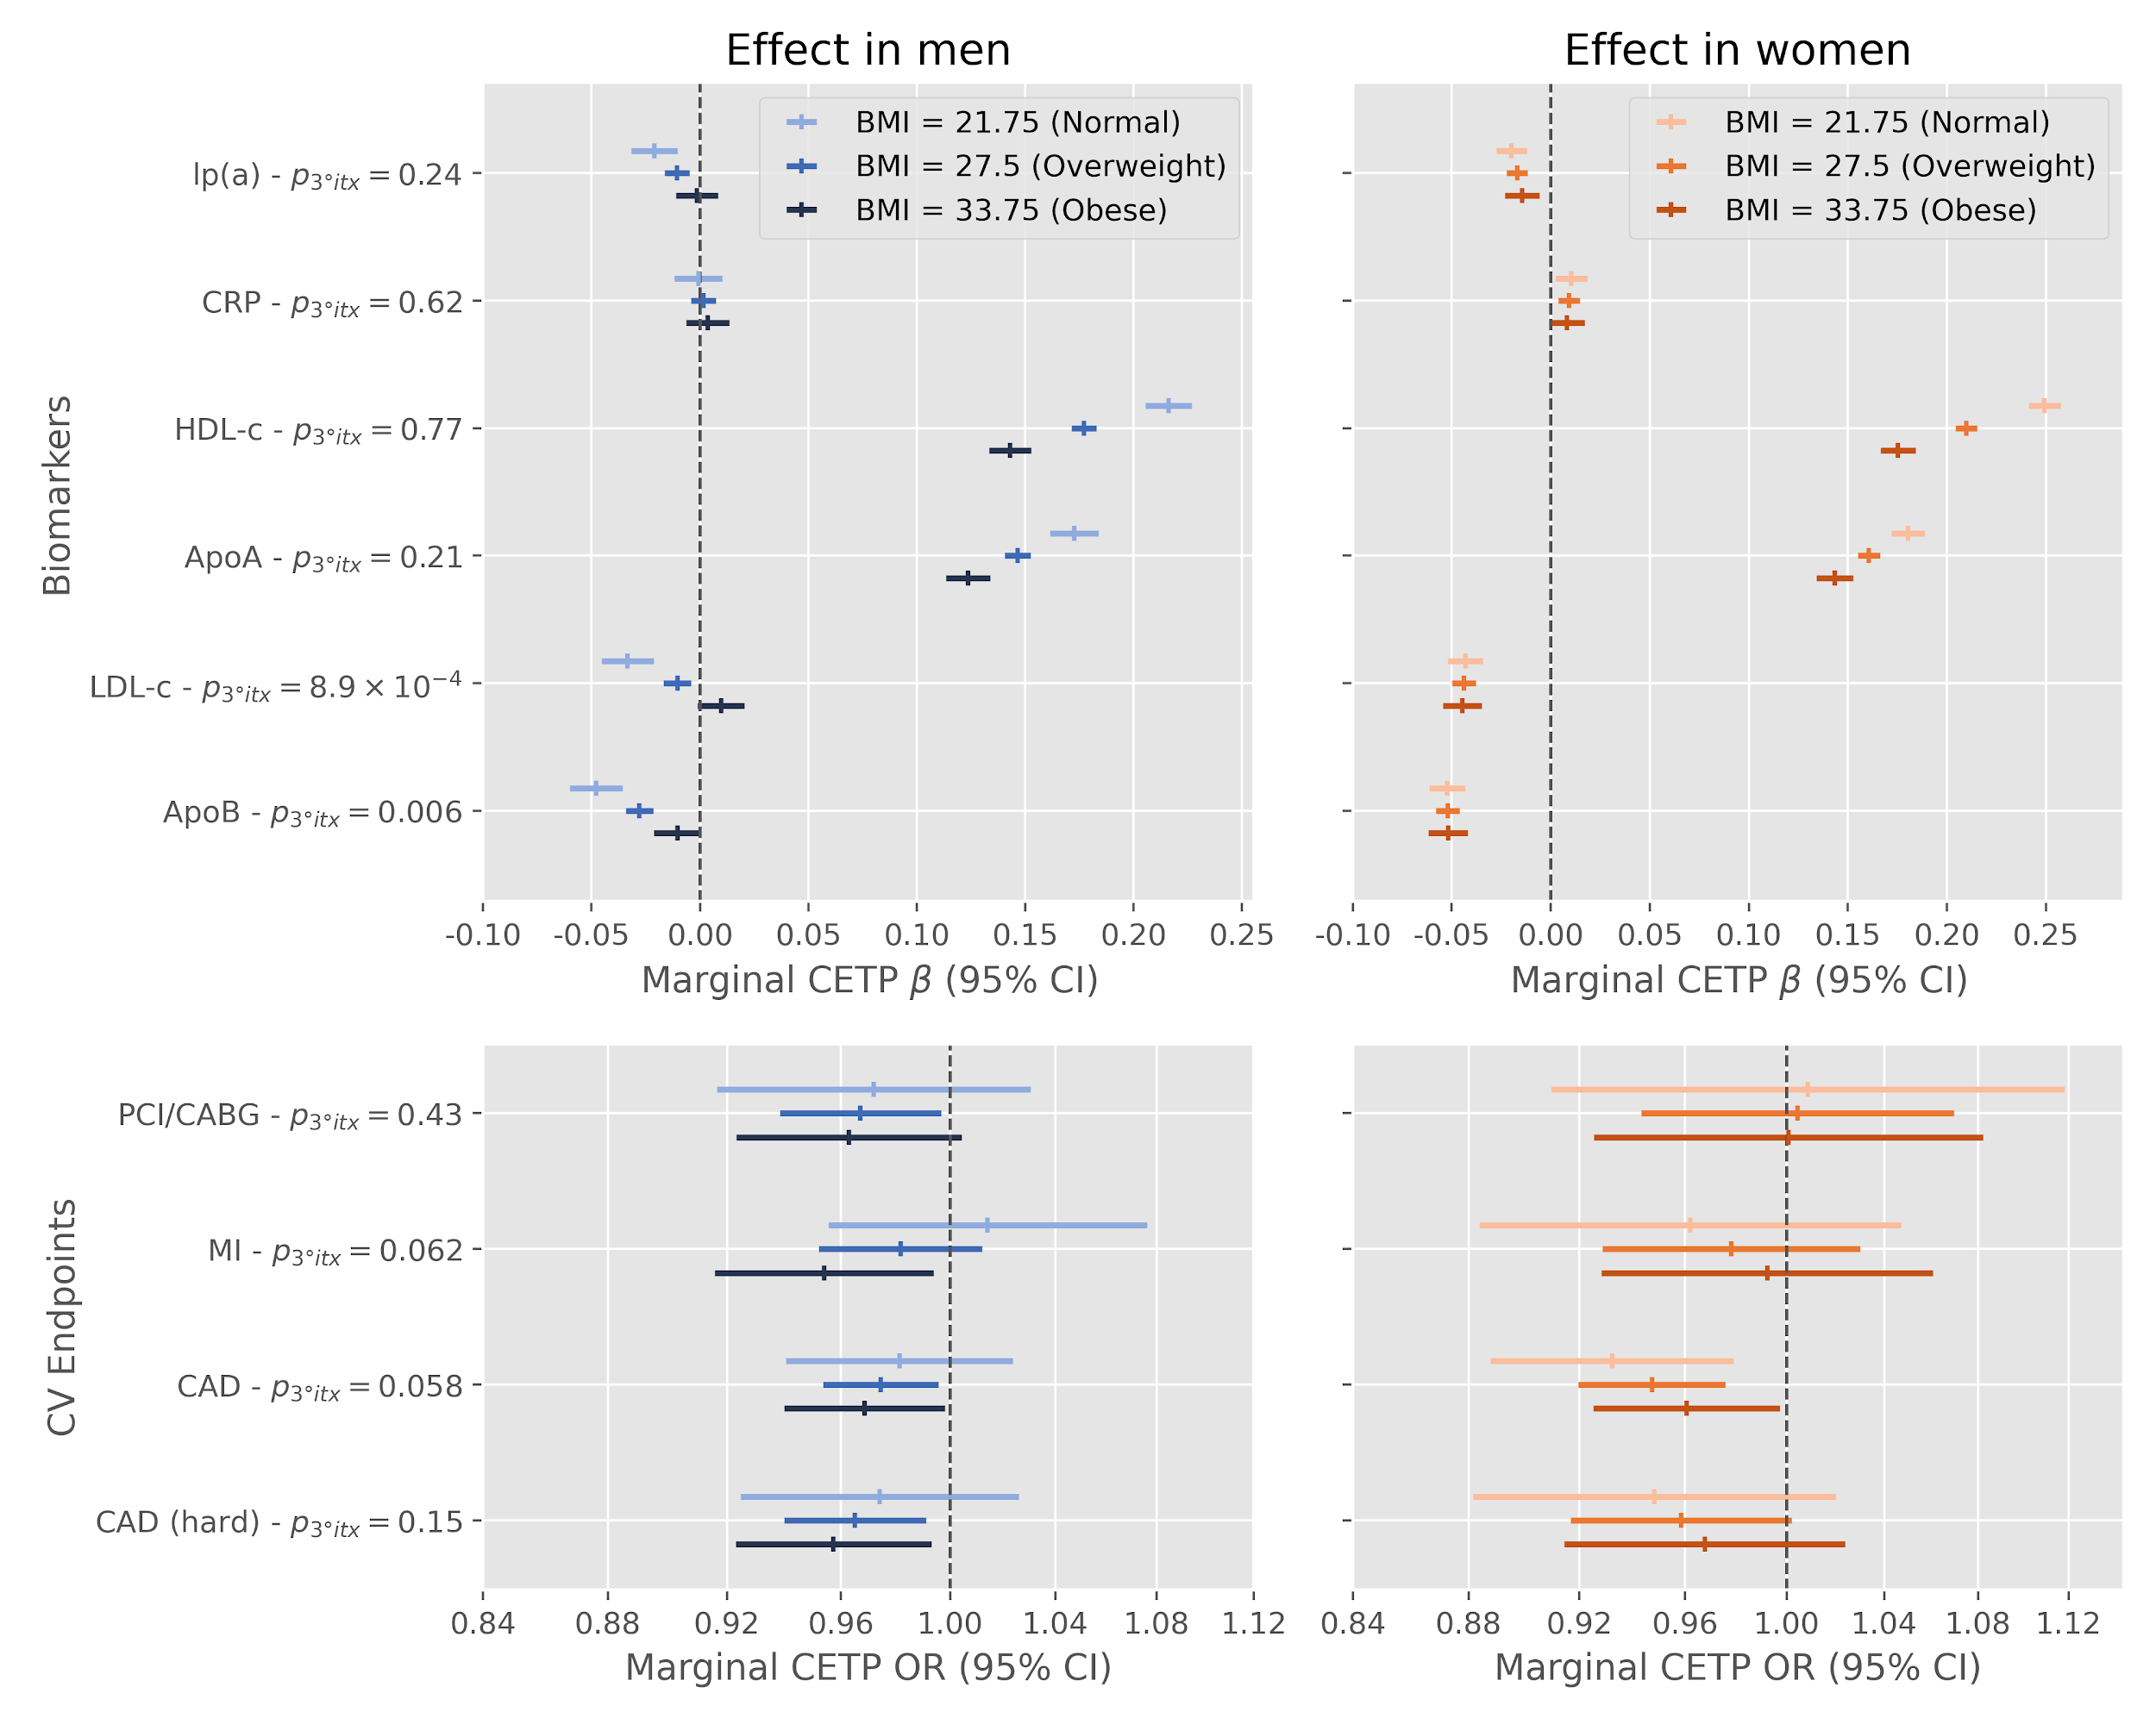
Supplementary Figure 11. Effect modification of rs1800775 (CETP -629C>A) alternative alleles by BMI and sex on biomarkers and cardiovascular endpoints in the UK Biobank. Displayed p-values (p_{3°itx}) are for the two-sided test of the three-way product term between the SNP, a binary variable for sex and standardized body mass index.

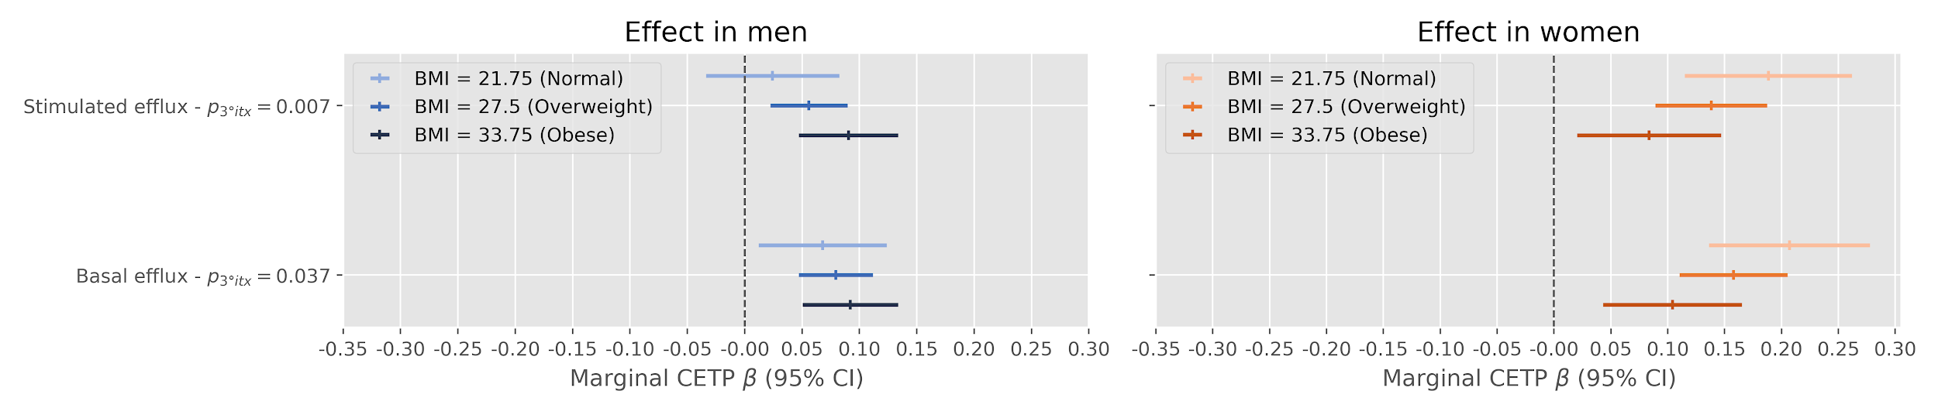
Supplementary Figure 12 Effect modification of the CETP score on cholesterol efflux in the MHI Biobank by sex and BMI.

