Appendices for manuscript

Appendix 1: Contact angle on mica for CO₂-brine-mica systems (Jafari and Jung (2018)
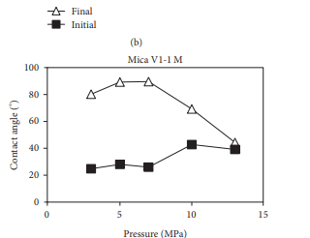
Appendix 2: CO2-brine contact angle on quartz surface versus pressure (Farokhpoor et al., 2013)

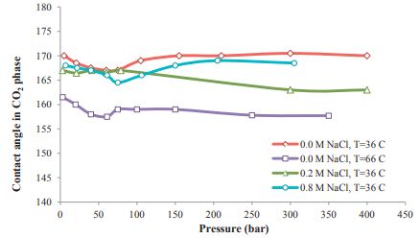
Appendix 3: Receding contact angles for sandstone/CO2/DI water as a function of pressure and temperature; RMS = 540 nm, SD = 3. Alnili, et al., (2018)

