SUPPLIMENDARY INFORMATIONS –**Growth of D614G Virus – Regression Analysis**

Jaydip Datta

**__________________________________________________________________________________**

Figure-I (Plot of Scattered Data of freq D614G vs Number of Months )

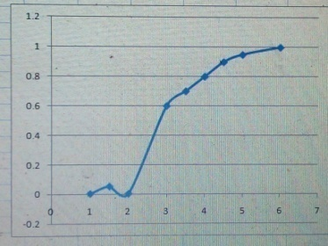

Figure – II ( Curve Finder –v.1.4 ) – Regression Analysis

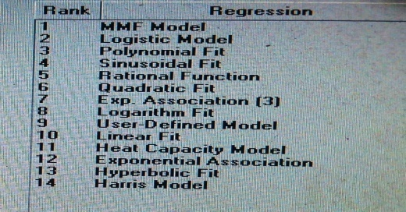

Figure –III( MMF Model Fit)

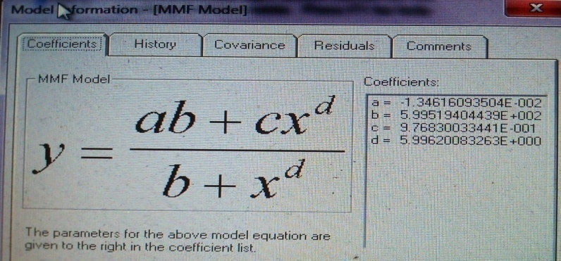

Figure – IV( 4 th Order Polynomial Fit )

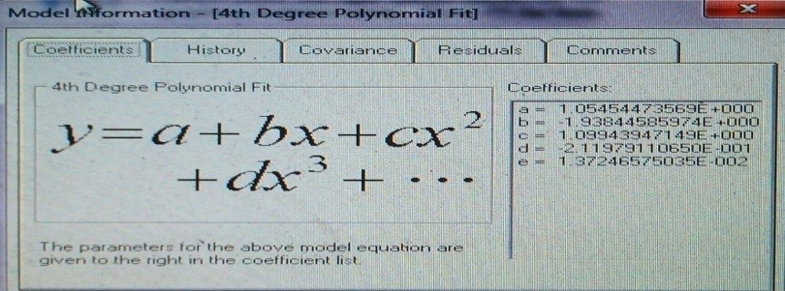

Figure – V (Covariance Matrix – 4x 4 )

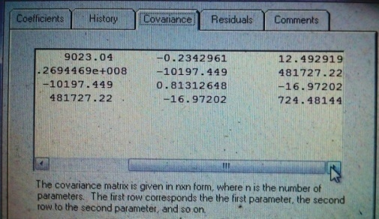

Figure – VI ( Chi-sq Hypothesis )

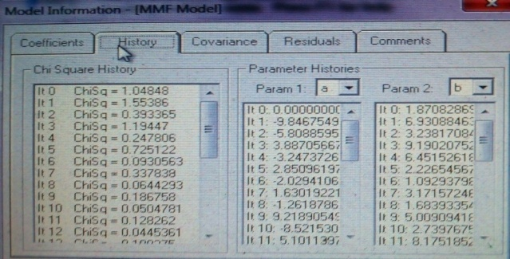

Figure – VII (Covariance Matrix – 5 x 5 )

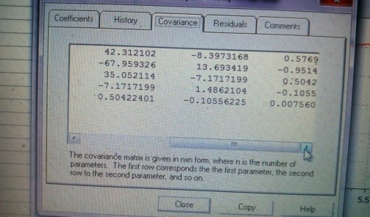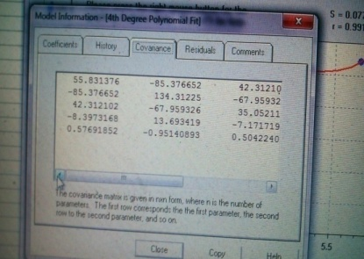

Figure –VIII( 4th Degree Polynomial Fit – r and s value )

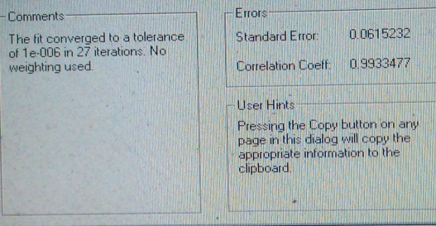

Figure – IX

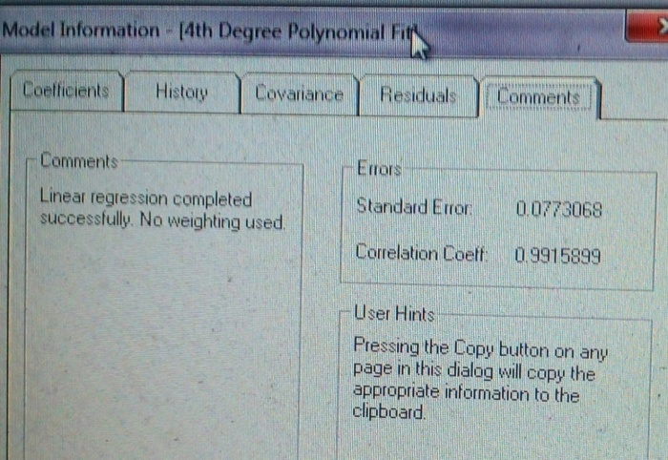

**Figure – X** ( 2x 2 Matrix )



Dataset (Bioenergetics data of DEL2G in Kcal /mole) of D614G , N501Y

([*https://zenodo.org/record/4514192*](https://zenodo.org/record/4514192) )

**Figure – XI**  ( Exponential fit – r and s value )





    
    
    

  
  
  