Internet addiction and factors associated with internet addiction during COVID-19

 | Normal Internet  Users  N= 703 (61.4%) | Problematic Internet Users  N= 313 (27.3%) | Addictive Internet Users  N= 129 (11.3%) | x² | p value
Socio-demographic factors (Table 1a)
 | n (%) | n (%) | n (%)
Gender
Male | 286 (40.7) | 119 (38.0) | 54 (41.9) | 0.8 | 0.66
Female | 417 (59.3) | 194 (62.0) | 75 (58.1)
Age
Teenager | 140 (19.9) | 76 (24.3) | 28 (21.7) | 5.6 | 0.46
Youth | 349 (49.6) | 160 (51.1) | 62 (48.1)
Young adult | 133 (18.9) | 50 (16.0) | 27 (20.9)
Middle/older adult | 81 (11.5) | 27 (8.6) | 12 (9.3)
Marital status
Never married | 561 (79.8) | 274 (87.5) | 109 (84.5) | 9.4 | <0.01
Ever Married | 142 (20.2) | 39 (12.5) | 20 (15.5)
Education
Less than higher secondary | 57 (8.1) | 11 (3.5) | 12 (9.3) | 14.0 | 0.03
Higher secondary | 234 (33.3) | 126 (40.3) | 46 (35.7)
Under grad degree | 265 (37.7) | 126 (40.3) | 47 (36.4)
Post grad degree | 147 (20.9) | 50 (16.0) | 24 (18.6)
Family system
Extended | 250 (35.6) | 120 (38.3) | 49 (38.0) | 0.8 | 0.65
Nuclear family | 453 (64.4) | 193 (61.7) | 80 (62.0)
Family income
<50k | 237 (33.7) | 73 (23.3) | 17 (13.2) | 28.9 | 0.00
50-100k | 134 (19.1) | 63 (20.1) | 32 (24.8)
100-200k | 124 (17.6) | 65 (20.8) | 30 (23.3)
>200k | 208 (29.6) | 112 (35.8) | 50 (38.8)
Family size
Small | 162 (23.0) | 72 (23.0) | 30 (23.3) | 8.1 | 0.08
Medium | 419 (59.6) | 166 (53.0) | 68 (52.7)
Large | 122 (17.4) | 75 (24.0) | 31 (24.0)
Health related factors
Depression Anxiety Stress Scale – 21 items (DASS-21) (Table 1b)
Depression
Normal | 367 (52.2) | 78 (24.9) | 26(20.2) | 219.4 | <0.01
Mild | 119 (16.9) | 33(10.5) | 8(6.2)
Moderate | 119 (16.9) | 79(25.2) | 17(13.2)
Severe | 50 (7.1) | 44(14.1) | 17(13.2)
Extremely severe | 48 (6.8) | 79 (25.2) | 61(47.3)
Anxiety
Normal | 350 (49.8) | 80 (25.6) | 24 (18.6) | 199.6 | <0.01
Mild | 83 (11.8) | 22 (7.0) | 4 (3.1)
Moderate | 156 (22.2) | 67 (21.4) | 19 (14.7)
Severe | 34 (4.8) | 39 (12.5) | 10 (7.8)
Extremely severe | 80 (11.4) | 105 (33.6) | 72 (55.8)
Stress
Normal | 532 (75.7) | 144 (46.0) | 39(30.2) | 234.3 | <0.01
Mild | 51 (7.3) | 35 (11.2) | 4 (3.1)
Moderate | 63 (9.0) | 54 (17.3) | 14(10.9)
Severe | 41 (5.8) | 53 (16.9) | 39 (30.2)
Extremely severe | 16 (2.3) | 27 (8.6) | 33 (25.6)
History of any mental health problems (Table 1c)
No | 366 (52.1) | 119 (38.0) | 58 (45.0) | 17.9 | <0.01
Yes | 260 (37.0) | 146 (46.7) | 53 (41.1)
I don’t know | 77 (11.0) | 48 (15.3) | 18 (14.0)
Family members suffering from mental problem during Covid (Table 1c)
No | 485 (69.0) | 173 (55.3) | 74 (57.4) | 23.4 | <0.01
Yes | 146 (20.8) | 82 (26.2) | 36 (27.9)
I don’t know | 72 (10.2) | 58 (18.5) | 19 (14.7)
Behavioral and environmental factors during pandemic (Table 1d)
Work situation during pandemic
No, I do not work | 321 (45.7) | 172 (55.0) | 69 (53.5) | 21.8 | <0.01
No, looking for job | 62 (8.8) | 19 (6.1) | 5 (3.9)
No, short time work | 55 (7.8) | 29 (9.3) | 16 (12.4)
Yes, on work site and teleworking | 98 (13.9) | 46 (14.7) | 12 (9.3)
Yes, on worksite exclusively | 167 (23.8) | 47 (15.0) | 27 (20.9)
Workload during pandemic
Not working | 221 (31.4) | 121 (38.7) | 48 (37.2) | 11.3 | 0.18
Higher than before | 137 (19.5) | 62 (19.8) | 27 (20.9)
Highly variable | 66 (9.4) | 31 (9.9) | 15 (11.6)
Less than before | 164 (23.3) | 51 (16.3) | 23 (17.8)
Same as before | 115 (16.4) | 48 (15.3) | 16 (12.4)
Financial impact on budget due to pandemic
No | 214 (30.4) | 82 (26.2) | 33 (25.6) | 7.0 | 0.13
Yes a little | 336 (47.8) | 146 (46.7) | 57 (44.2)
Yes a lot | 153 (21.8) | 85 (27.2) | 39 (30.2)
Describe your mood during pandemic
Negative | 321 (45.7) | 178 (56.9) | 96 (74.4) | 43.6 | <0.01
No change | 224 (31.9) | 70 (22.4) | 14 (10.9)
Positive | 158 (22.5) | 65 (20.8) | 19 (14.7)
Table 1 showing sociodemographic factors, health related factors and behavioral and environmental factors of participants (n=1145)

 | Normal Internet Users  Mean (SD) |  |  | Problematic Internet Users Mean (SD) |  |  | Addictive Internet Users Mean (SD) |  |  | F factor |  |  | P value
 | M | F | Overall | M | F | Overall | M | F | Overall | M | F | Overall | M | F | Overall
Depression Anxiety Stress Scale -21 (DASS-21) scores
Depression score | 9.1  (8.2) | 11.4  (10.1) | 10.5 (9.5) | 17.3 (10.8) | 18.8 (11.8) | 18.2 (11.4) | 21.0 (13.3) | 25.2  (12.4) | 23.4  (12.9) | 53.1 | 67.1 | 117.4 | <0.01 | <0.01 | <0.01
Anxiety score | 7.8 (7.1) | 9.2 (8.5) | 8.6 (8.0) | 14.3 (9.2) | 15.6  (10.5) | 15.1 (10.0) | 17.9 (12.2) | 22.0  (11.9) | 20.2  (12.1) | 48.0 | 72.2 | 118.6 | <0.01 | <0.01 | <0.01
Stress Score | 9.5 (7.9) | 11.6 (9.4) | 10.8 (8.9) | 17.0 (10.0) | 18.3  (10.6) | 17.8 (10.4) | 20.6 (12.8) | 25.5  (11.8) | 23.5  (12.4) | 50.2 | 75.7 | 123.2 | <0.01 | <0.01 | <0.01
Table 2 showing DASS -21 scores of participants as a function of gender. (M=male; F=female; SD=standard deviation)

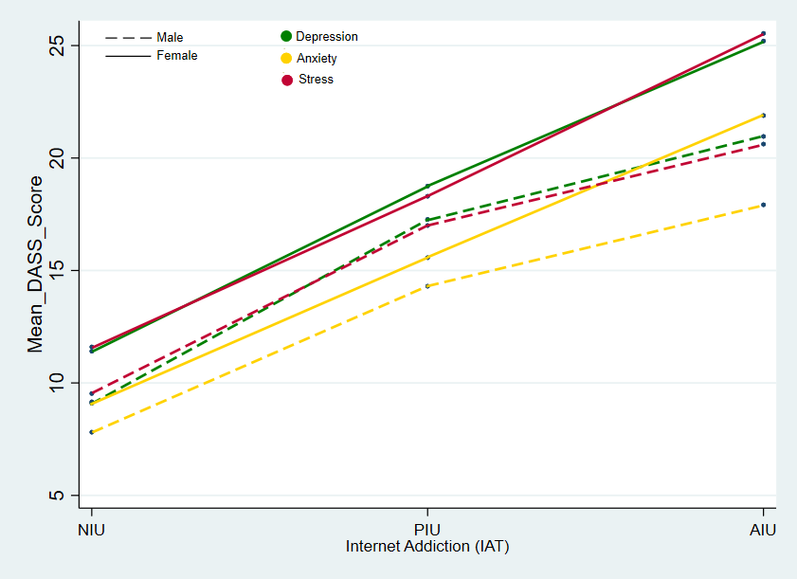
Figure 1 showing mean DASS scores of participants as a function of gender.

Variable | Problematic internet User (PIU) | Addictive Internet User (AIU)
 | Adjusted OR (95% CI) | Adjusted OR (95% CI)
Sociodemographic factors
Gender
Male | 1.2 (0.8-1.6) | 1.7 (1.1-2.7) *
Marital status
Never married | 1.6 (1.0-2.5) * | 1.5 (0.8-2.8)
Family income
50-100k | 1.3 (0.9-2.1) | 2.8 (1.4-5.7) *
100-200k | 1.3 (0.9-2.1) | 2.6 (1.3-5.2) *
>200k | 1.3 (0.9-2.0) | 2.3 (1.2-4.4) *
Family size
Small | 1.2 (0.8-1.7) | 1.1 (0.7-2.0)
Large | 1.8 (1.3-2.7) * | 1.8 (1.1-3.2) *
Health related factors
Depression Anxiety Stress Scale – 21 (DASS-21)
Depression
Mild | 1.1 (0.7-1.8) | 0.8 (0.3- 1.8)
Moderate | 2.0(1.3-3.2) * | 1.1 (0.4- 2.3)
Severe | 2.1 (1.1-3.9) * | 1.1 (0.4-3.3)
Extremely severe | 3.1 (1.5-6.4) * | 1.9 (0.7-5.7)
Stress
Mild | 1.2 (0.7-2.0) | 0.5 (0.2-1.7)
Moderate | 1.1 (0.6-1.9) | 1.2 (0.5-3.0)
Severe | 1.2 (0.6-2.5) | 3.3 (1.2-8.9) *
Extremely severe | 1.2 (0.5-3.2) | 5.4 (1.7-17.7) *
Anxiety
Mild | 1.1 (0.6- 1.7) | 0.7 (0.2-2.2)
Moderate | 1.2 (0.8-1.9) | 1.4 (0.7-3.1)
Severe | 2.6 (1.4-4.9) * | 2.1 (0.7-6.3)
Extremely severe | 2.0 (1.1-3.9) * | 2.6 (1.1-7.1)
Family members suffering from mental problem during Covid
Yes | 1.4(1.0-2.0) | 1.1 (0.7-1.9)
I don’t know | 1.7 (1.1-2.6) * | 1.3 (0.7-2.5)
Behavioral and environmental factors during pandemic
Work situation during pandemic
Do not work | 1.3 (0.8-2.0) | 2.2 (1.0-4.6) *
Looking for job | 0.7 (0.3- 1.3) | 0.7 (0.2- 2.2)
Part-time job | 1.2 (0.7-2.3) | 2.6 (1.0-6.5) *
Work in person | 0.7 (0.4- 1.1) | 1.5 (0.7-3.4)
Describe your mood changes during pandemic
Negative | 1.2 (0.8-1.7) | 2.9 (1.5-5.6) *
Positive | 1.1 (0.7-1.8) | 1.5 (0.7-3.3)
Table 3 showing crude and adjusted odds ratio (OR) along with 95% confidence interval (CI) of factors associated with internet addiction using multinominal logistic regression. * indicates results with P value <0.05.

